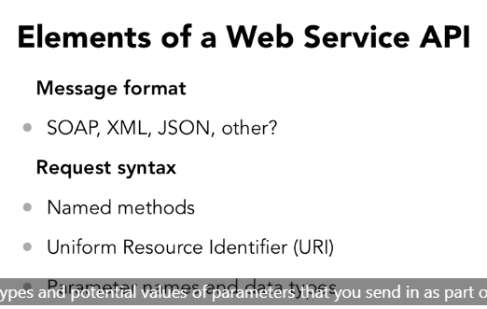

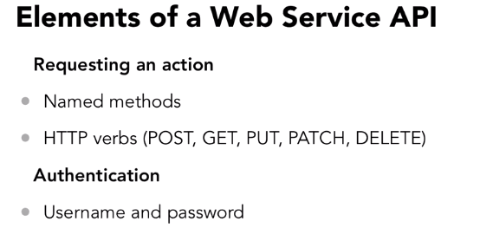

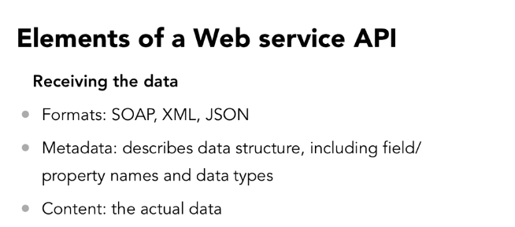

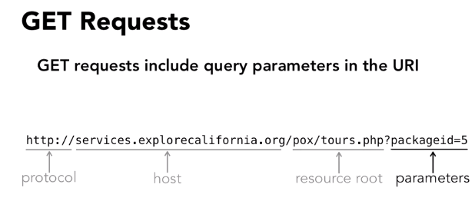

200-everything ok

404- resource not found



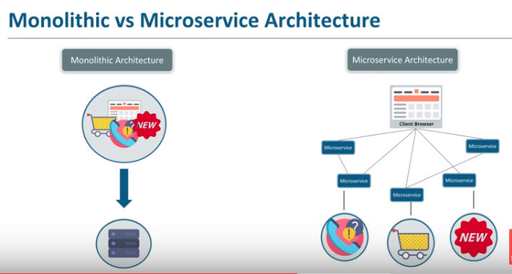

The microservices connected through restapi

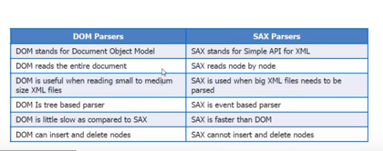

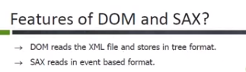

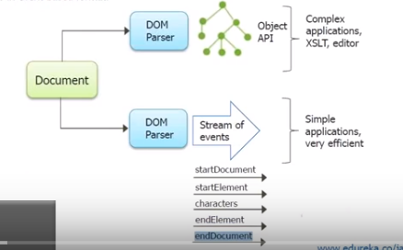

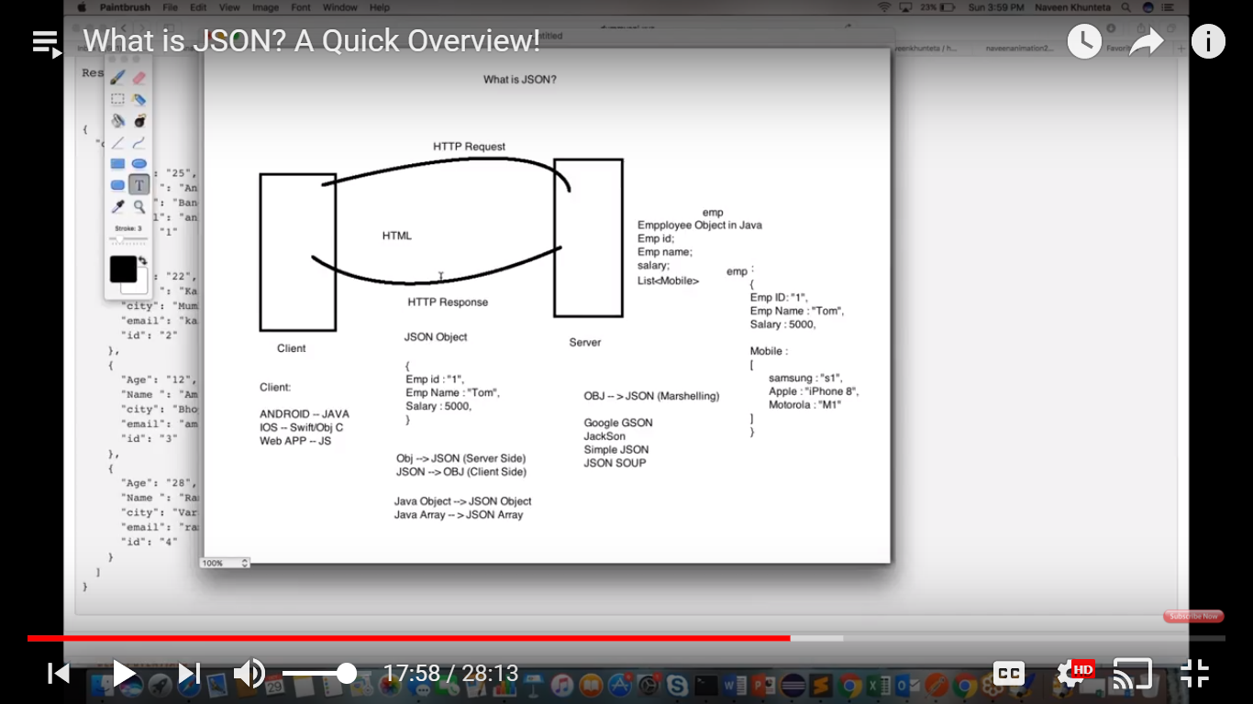

I have 3.6 years of experience in backend testing in retail ecommerce domain.Working knowledge of return and cancellation flows,Financial processing,Inventory management,Point of sale EMV processing.I have goodd knowledge on Java and Data Strutures.Worked in Order management system and Sterling OMS.I am interested to switch in development.

Thanks,

Uma