CASE STUDY REPORT

ONLINE RETAIL SALES ANALYTICS
Interactive Sales Performance & KPI Dashboard

Project Information | Details
Project Type | IBM Internship Case Study
Domain | Data Science
Academic Level | UG Level 3
Project Focus | Retail Sales Analytics & Business Intelligence
Primary Tool | Microsoft Power BI
Dataset | Online Retail Transaction Dataset
Prototype | Interactive Power BI Dashboard
IBM Student ID | IBMP3298
Student Name | Umanagesh Duda
Institution | Anil Neerukonda Institute of Technology and Sciences (ANITS)
Prepared for IBM Internship / UG Level 3 Case Study Evaluation

TABLE OF CONTENTS

Content | Page No
1. Introduction | 3
2. Case Study Background | 3
3. Problem Statement | 3
4. Objectives | 3
5. Dataset Description | 4
6. Data Preparation and Methodology | 4
7. Proposed System | 5
8. Technology Stack | 5
9. Functional Modules | 5
10. Dashboard Design and Visual Analytics | 6
11. KPI Framework | 7
12. Analytical Workflow | 7
13. Results and Key Insights | 7
14. Business Recommendations | 8
15. Testing and Validation | 8
16. Benefits | 8
17. Limitations and Future Enhancements | 9
18. Case Study Outcomes | 9
19. Conclusion | 9

Introduction
Online retail businesses generate large volumes of transactional data covering products, orders, quantities, prices, customers, dates and geographical markets. Converting these raw records into clear business information is essential for understanding sales performance and supporting data-driven decisions.
This case study presents an interactive Online Retail Sales Analytics solution developed using Microsoft Power BI. The project transforms transactional retail data into a visual analytical environment containing key performance indicators, revenue trends, product performance, yearly revenue distribution and country-wise sales analysis.
The prototype is intentionally focused on analytics and business intelligence rather than predictive machine learning. Its primary purpose is to make historical retail performance easier to explore, compare and communicate.

Case Study Background
In a conventional retail reporting process, business users may need to inspect spreadsheets or static reports to answer questions about revenue, orders, customers and product performance. Such reporting can become time-consuming when the transaction volume is large and when users need to investigate different time periods or markets.
A business intelligence dashboard addresses this challenge by combining data preparation, calculation and interactive visualization into a single analytical interface. In this project, Power BI is used to provide an interactive view of retail performance while allowing users to filter the analysis using Year-Month, StockCode and Country slicers.

Problem Statement
The raw online retail transaction dataset contains a large number of records and includes data-quality challenges such as missing customer identifiers, duplicate records, cancelled transactions and negative quantities. Directly interpreting the raw records makes it difficult to obtain a consolidated view of business performance.
The project therefore addresses the need for an interactive analytical solution that prepares retail transaction data, calculates meaningful KPIs and presents sales performance through clear visualizations. The solution should help users understand revenue trends, order activity, customer reach, product contribution and geographical sales distribution.

Objectives
- Analyze historical online retail transaction data to understand overall sales performance.
- Prepare and transform transactional data into a format suitable for business analysis.
- Develop KPIs for revenue, quantity, orders, customers and average order value.
- Analyze revenue trends across time and compare yearly performance.
- Identify high-performing products and major geographical markets.
- Build an interactive Power BI dashboard with filters that support exploratory analysis.
- Present actionable observations and business recommendations from the analyzed data.

Dataset Description
The project uses the original Online Retail transactional dataset supplied for the analysis. The source file contains 541,909 transaction records and eight fields.

Field | Description
InvoiceNo | Unique invoice or transaction identifier; cancellation records use invoice numbers beginning with C.
StockCode | Product or stock identifier.
Description | Text description of the product.
Quantity | Number of units recorded in the transaction.
InvoiceDate | Date and time of the transaction.
UnitPrice | Price per unit.
CustomerID | Identifier of the customer associated with the transaction; some records are missing this value.
Country | Country associated with the customer/transaction.

The dataset covers transactions from December 2010 through December 2011. The available attributes support analysis from product, customer, time, revenue and geographical perspectives.

Data Preparation and Methodology

Stage | Activity | Purpose
Source Loading | Import the Online Retail CSV into Power BI. | Establish the analytical source.
Data Quality Review | Inspect missing values, duplicates, cancellations and invalid numeric records. | Identify records requiring treatment.
Transaction Filtering | Exclude records that do not represent valid positive sales for the intended sales analysis. | Avoid misleading sales totals.
Data Type Preparation | Ensure dates, numeric fields and identifiers use appropriate data types. | Support reliable calculations.
Revenue Calculation | Revenue = Quantity × UnitPrice. | Create a transaction-level sales field.
Time Derivation | Create Year, Month and Year-Month analytical fields. | Support time-series analysis.
KPI Development | Create measures for revenue, quantity, orders, customers and average order value. | Provide executive-level indicators.
Visualization | Build interactive Power BI visuals and slicers. | Communicate insights and enable exploration.
The original dataset contains 5,268 exact duplicate rows, 135,080 records without CustomerID, 10,624 records with negative quantity and 9,288 cancellation invoices. These characteristics were considered during preparation so that the dashboard focuses on meaningful sales activity.

Proposed System
The proposed system is an interactive retail analytics dashboard. Users interact with the dashboard rather than inspecting individual transaction rows. The solution follows a simple analytics pipeline: source data preparation → calculated metrics → interactive visualizations → business insights.

Component | Role
Online Retail Dataset | Provides transactional sales records.
Power Query / Data Preparation | Supports data cleaning, transformation and derived fields.
DAX Measures | Calculates dashboard KPIs and analytical metrics.
Power BI Visual Layer | Presents trends, product performance, yearly contribution and geographic sales.
Interactive Slicers | Allow users to filter the dashboard by Year-Month, StockCode and Country.
Business User | Uses the dashboard to explore performance and identify opportunities.

Technology Stack

Technology / Component | Purpose
Microsoft Power BI Desktop | Dashboard development and interactive visualization.
Power Query | Data loading, transformation and preparation.
DAX | KPI and analytical measure development.
CSV Dataset | Original transactional data source.
Azure Maps for Power BI | Country-wise geographical sales visualization.

Functional Modules

Executive KPI Layer
Displays Total Revenue, Total Quantity, Total Orders, Total Customers and Average Order Value.

Revenue Trend Analysis
Shows how revenue changes over the available time period, supporting identification of high- and low-performing periods.

Yearly Revenue Analysis
Provides a year-level view of revenue contribution.

Product Performance
Highlights the Top 10 Products by Revenue for quick identification of high-value products.

Geographical Sales Analysis
Uses Azure Maps to visualize country-wise sales contribution, with Total Revenue controlling marker size.

Interactive Filtering
Provides Year-Month, StockCode and Country slicers so users can investigate subsets of the data.

Dashboard Design and Visual Analytics
The final dashboard is designed as a single-page executive analytics view. The upper section contains KPI cards for rapid performance assessment. The analytical section combines a revenue trend, yearly revenue distribution, top-product analysis and country-wise sales map. Slicers provide interactive filtering without requiring users to modify the underlying data.

Visual | Business Question Addressed
Total Revenue | What is the overall sales value represented in the dashboard?
Total Quantity | How many units were sold?
Total Orders | How many distinct orders are represented?
Total Customers | How many customers are represented in the analyzed data?
Average Order Value | What is the average revenue per order?
Revenue Trend | How does revenue change over time?
Revenue by Year | How is revenue distributed across years?
Top 10 Products by Revenue | Which products contribute most to revenue?
Sales by Country | Which countries contribute to retail sales?
Slicers | How does performance change when the user filters time, product or country?

Final Dashboard Prototype
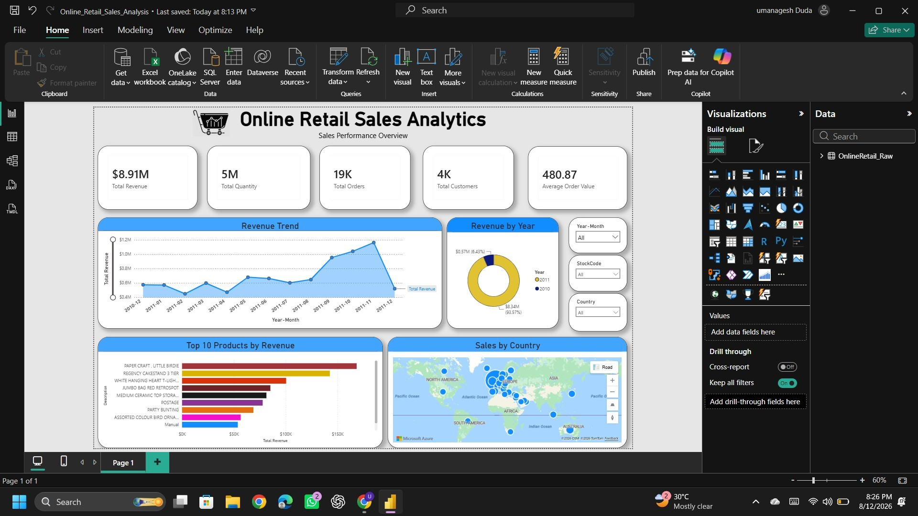
Figure 1. Final Online Retail Sales Analytics Power BI dashboard.

KPI Framework

KPI | Dashboard Value / Interpretation
Total Revenue | Approximately $8.91M in the completed dashboard.
Total Quantity | Approximately 5M units in the completed dashboard.
Total Orders | Approximately 19K orders in the completed dashboard.
Total Customers | Approximately 4K customers in the completed dashboard.
Average Order Value | Approximately 480.87 in the completed dashboard.
The displayed values above are the final dashboard KPIs observed in the completed prototype. Exact values can vary if the underlying transformation/filtering logic is changed, so the report treats the completed PBIX dashboard as the final implementation artifact.

Analytical Workflow
- Load the original Online Retail transaction dataset.
- Inspect the schema and data-quality characteristics.
- Apply the established Power BI transformation logic used by the prototype.
- Create the Revenue field from Quantity × UnitPrice.
- Derive time-related fields required for monthly and yearly analysis.
- Develop DAX measures for the executive KPI layer.
- Construct the dashboard visualizations and interactive slicers.
- Validate the dashboard by checking KPI values, filters and visual interactions.
- Use the final dashboard to communicate business observations.

Results and Key Insights
The completed prototype provides a consolidated view of retail performance. The dashboard indicates an overall revenue value of approximately $8.91M, with approximately 5M units, 19K orders and 4K customers represented in the final KPI layer.
- Revenue can be examined over time through the Revenue Trend visual, helping identify changes in sales performance across the available period.
- The Top 10 Products by Revenue visual provides a focused view of products that contribute strongly to sales value.
- The yearly revenue visualization makes it easier to compare revenue contribution between years.
- The Azure Maps visual provides a geographical perspective, allowing users to identify countries associated with stronger sales contribution.
- Interactive slicers make the same dashboard useful for both high-level review and focused investigation of a particular period, product or country.
- The dashboard reduces the need to inspect hundreds of thousands of raw transaction records when answering common business-performance questions.

Business Recommendations
- Prioritize high-revenue products for inventory planning, merchandising and promotional decisions.
- Use monthly revenue trends to identify periods of stronger demand and plan campaigns or inventory accordingly.
- Investigate countries with high sales contribution for targeted marketing and customer-retention initiatives.
- Use the interactive filters during periodic business reviews to identify product- or market-specific performance changes.
- Combine the dashboard with operational data such as inventory, marketing spend and customer segments in future versions for deeper decision support.

Testing and Validation

Test Area | Validation Activity | Expected Outcome
Data Loading | Confirm source table loads into Power BI. | Dataset is available for transformation.
Revenue Measure | Compare KPI output with the established dashboard result. | Revenue displays correctly.
KPI Consistency | Check Total Revenue, Quantity, Orders, Customers and AOV. | Cards display valid values.
Slicer Interaction | Change Year-Month, StockCode and Country selections. | Related visuals respond to filtering.
Product Visual | Verify Top 10 Products responds to filters. | Product ranking updates correctly.
Map | Verify Country and Total Revenue fields render in Azure Maps. | Country-wise sales bubbles appear.
Dashboard Layout | Check alignment, titles, labels and readability. | Single-page dashboard remains clear and usable.

Benefits
- Transforms large transactional data into an accessible analytical interface.
- Provides a single view of major retail KPIs.
- Supports interactive exploration through slicers.
- Combines time, product and geographical analysis in one dashboard.
- Helps business users identify high-performing products and markets.
- Reduces dependence on manual spreadsheet-based reporting.
- Provides a strong foundation for future retail forecasting and customer analytics.

Limitations and Future Enhancements
The current prototype is primarily descriptive and diagnostic. It explains what happened in the historical transaction data but does not perform predictive forecasting or prescriptive optimization.
- Sales forecasting using time-series or machine-learning models.
- Customer segmentation using RFM or clustering techniques.
- Return and cancellation analytics as a dedicated business view.
- Profit and margin analysis if cost data becomes available.
- Inventory and stock-level integration.
- Marketing campaign and customer acquisition analysis.
- Role-based dashboards for executives, sales teams and operations teams.

Case Study Outcomes
- The completed prototype successfully converts large-scale online retail transaction data into an interactive Power BI business intelligence dashboard.
- The final dashboard provides five executive KPIs covering Total Revenue, Total Quantity, Total Orders, Total Customers and Average Order Value.
- The solution supports time-based, product-based and geographical analysis through revenue trends, yearly revenue comparison, Top 10 Products by Revenue and country-wise sales visualization.
- Interactive Year-Month, StockCode and Country slicers allow users to move from high-level performance review to focused analysis.
- The project establishes a practical foundation for future extensions such as sales forecasting, customer segmentation, profitability analysis and inventory integration.

Conclusion
The Online Retail Sales Analytics project demonstrates how transactional retail data can be converted into an interactive business intelligence solution using Microsoft Power BI. The prototype combines data preparation, calculated KPIs, time-based analysis, product analysis, geographical visualization and interactive filtering in a single dashboard.
The final dashboard provides a practical mechanism for monitoring retail performance and identifying business patterns without requiring users to work directly with the underlying transaction-level dataset. The project also establishes a foundation for future extensions such as forecasting, customer segmentation, profitability analysis and advanced decision-support capabilities.

