1) Install apache2/httpd

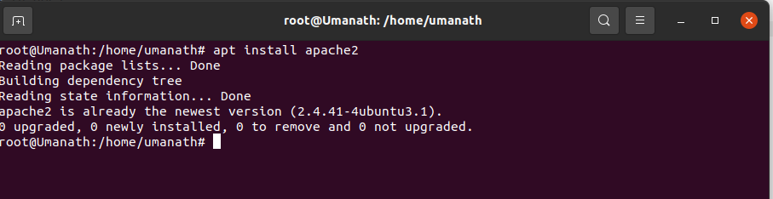

2) Install nginx

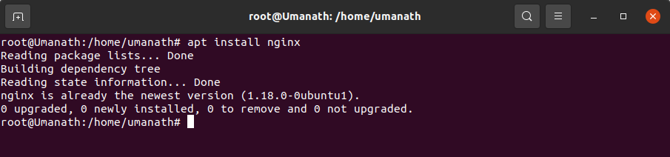

2.1) configure nginx - configure it to run as reverse proxy to apache

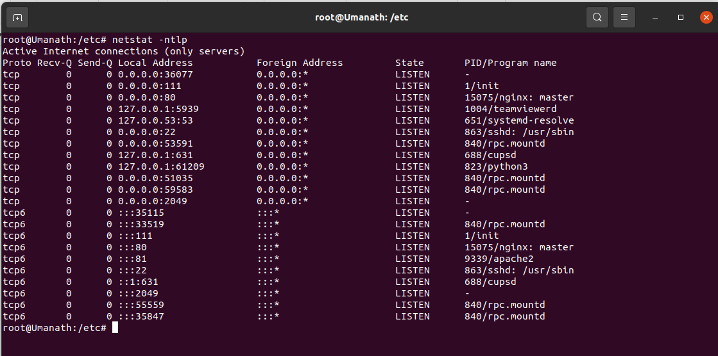
Here apache is running on Port 81 and Nginx is running is on Port 80

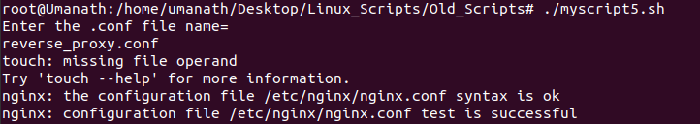
Script is allowed to run and is sucessful

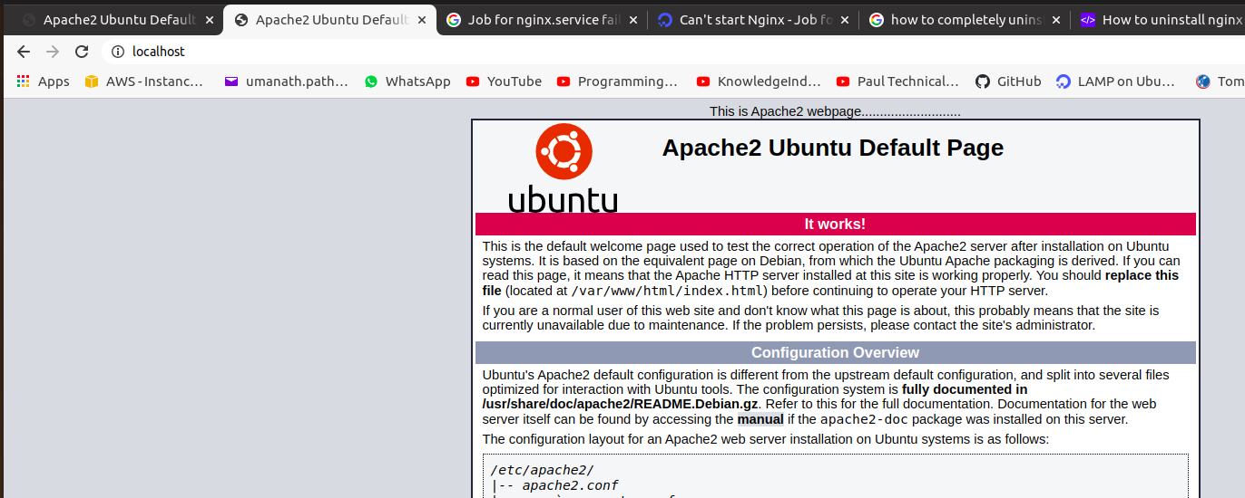
Apache webpage rungging on Port 80

Below script was run to achieve above output:-----

#!/bin/sh

systemctl start apache2
systemctl start nginx

unlink /etc/nginx/sites-enabled/default

echo "Enter the .conf file name= "
read filename

touch > /etc/nginx/sites-available/$filename

chmod 777 /etc/nginx/sites-available/$filename

echo "server{

listen 80;
location / {
proxy_pass http://127.0.0.1:81;
}
}" > /etc/nginx/sites-available/$filename

ln -s /etc/nginx/sites-available/$filename /etc/nginx/sites-enabled/$filename

nginx -t

systemctl restart apache2
systemctl restart nginx

3) Install and configure 'ntp' - with singapore time zone

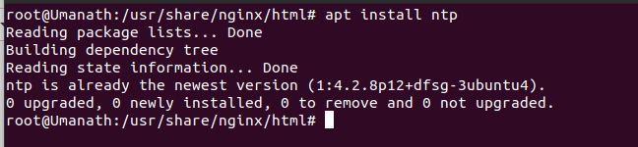
apt install ntp

Below is the output when-: configuration file of NTP is edited and pasted the singapore time server from the pool.

In Command line-
vim etc/ntp.conf
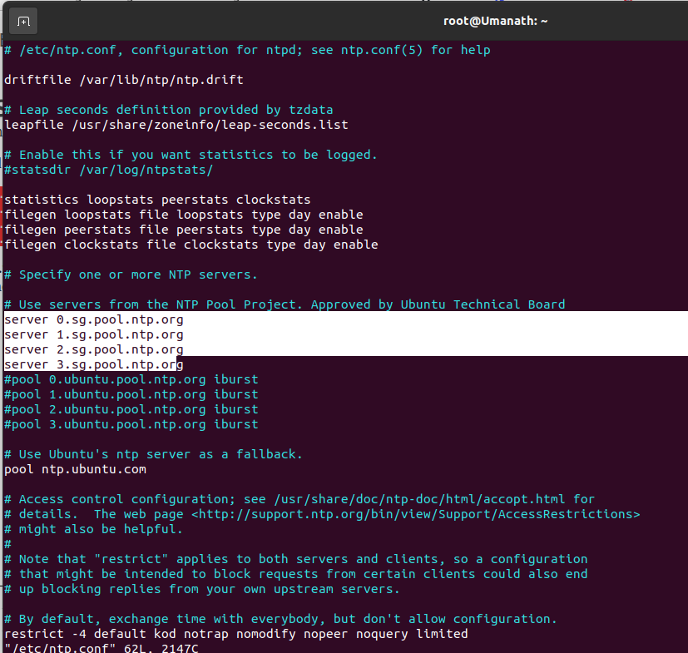

* Restart the NTP Server-
service ntp restart

* Verify that the NTP Server is running
service ntp status

