DAY 1 – AWS Assignment

### Task 1
> Create a vpc through wizard, having one public subnet and one private subnet. With 32 IP addresses each.

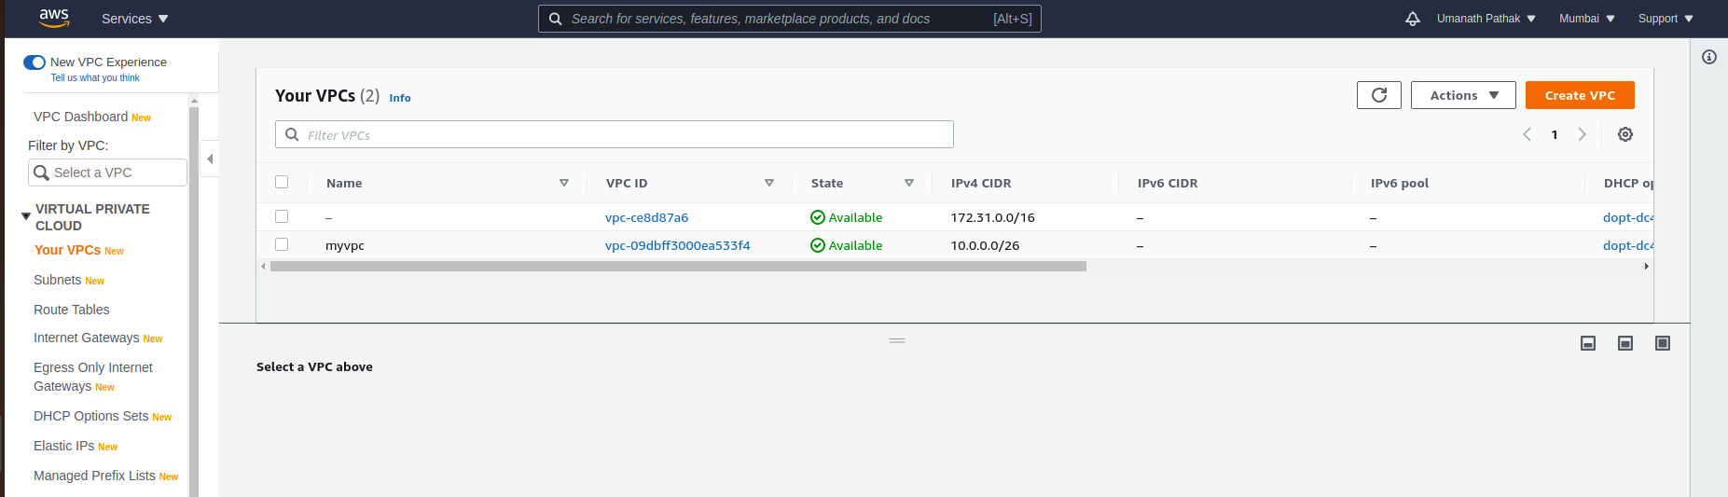
Created one VPC named – myvpc , with CIDR as 10.0.0.0/26 (64 IP addressess)

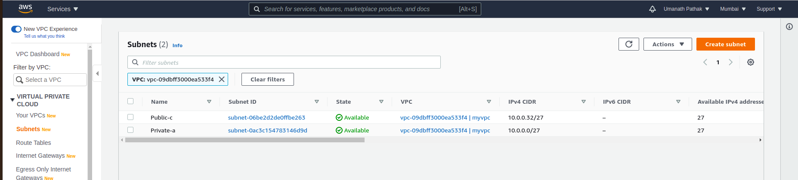
Created two Subnets – (1). Private-a , (2). Public-c

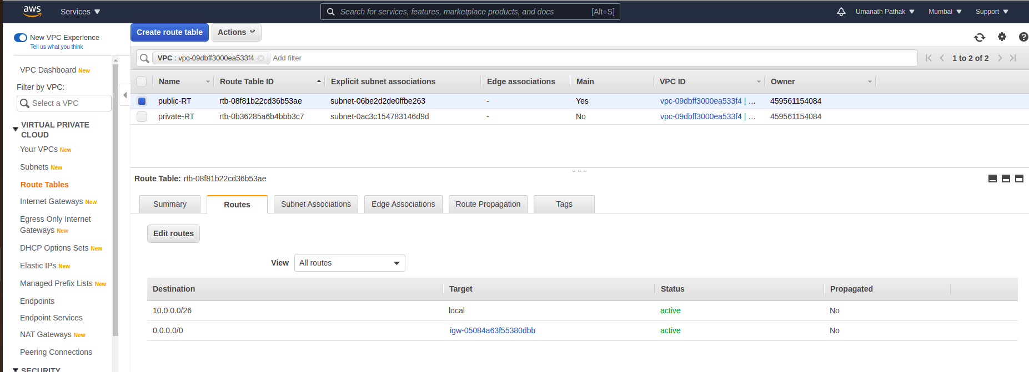
public-RT has Internet Gateway associated with it so Route table with subnet 10.0.0.32/27 as called Public subnet.
Private-RT has no IG associated with it so subnet 10.0.0.0/27 is called Private subnet.

### Task 2
> Create two instances within the vpc that you created in task 1:-
Ubuntu instance in public subnet and linux instance in private subnet.
> Check if linux is pingable from Ubuntu and vice versa.

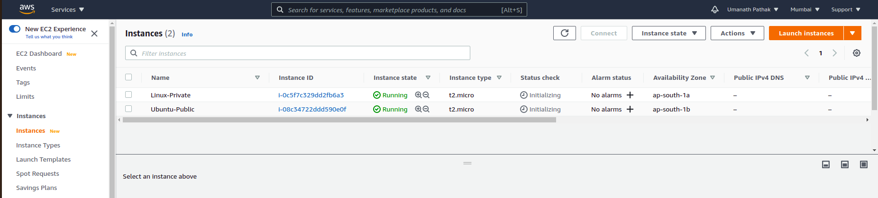
Launched two instances- (1). Linux instance in Private subnet and (2). Ubuntu instance in Public subnet

