Assignment – Day 1

1. Create a directory "exercise" inside your home directory and create nested(dir1/dir2/dir3) directory structure inside "exercise" with single command.

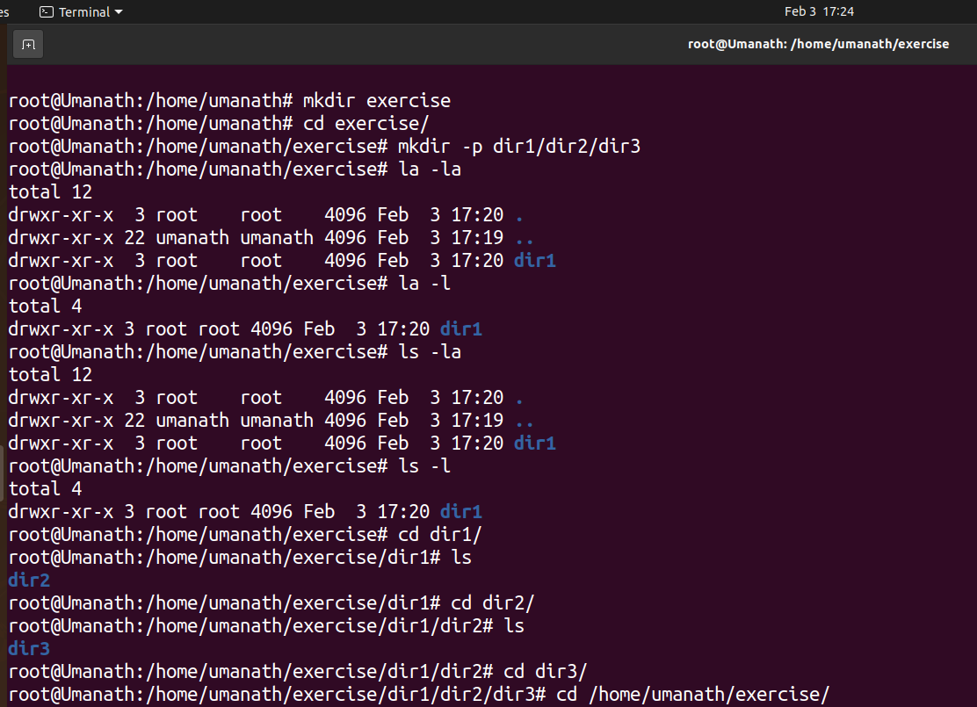
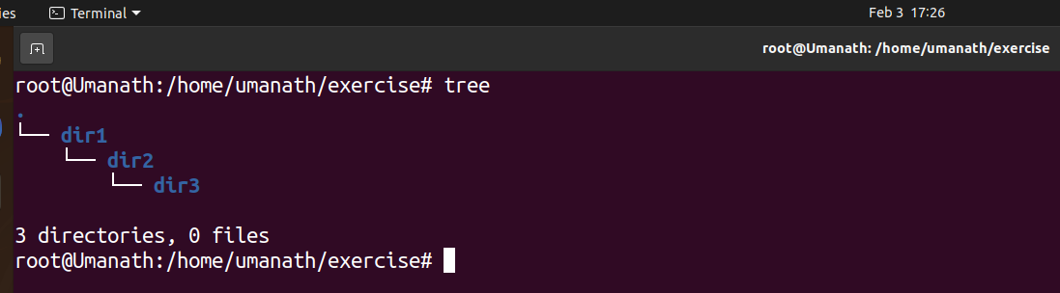

2. Create two empty files inside dir2 directory: emptyFile1,emptyFile2 in
single command

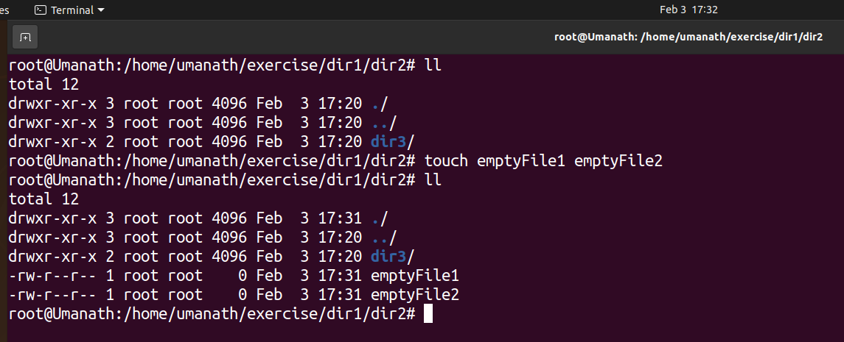

3. Create one file file1.txt containing text "hello world" and save it.

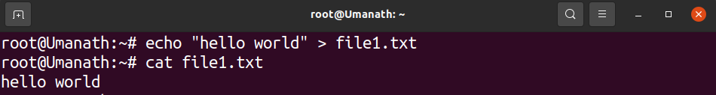

4. Find a "passwd" file using find command inside /etc. copy this files as
passwd_copy and then rename this file as passwd_backup.
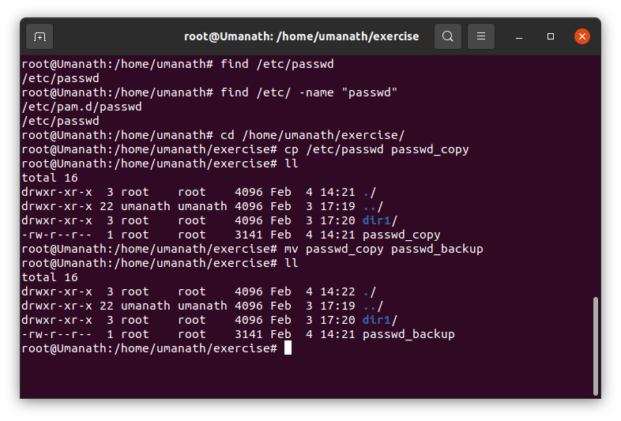

5. Try reading passwd_backup file in multiple tools: less,more,cat,strings etc and find the difference in their usage.

Difference between less and more is that :-
More command load the complete file and shows the result line by line manner but Less command is faster as compared to more as it does not load the complete file and allows it to navigate up/down.

Cat command is used to print standard output of file.

Strings command is used to print only the printable string objects in a particular file , it skips the binary part of file.

6. Find out the number of line in password_backup containing "/bin/false".

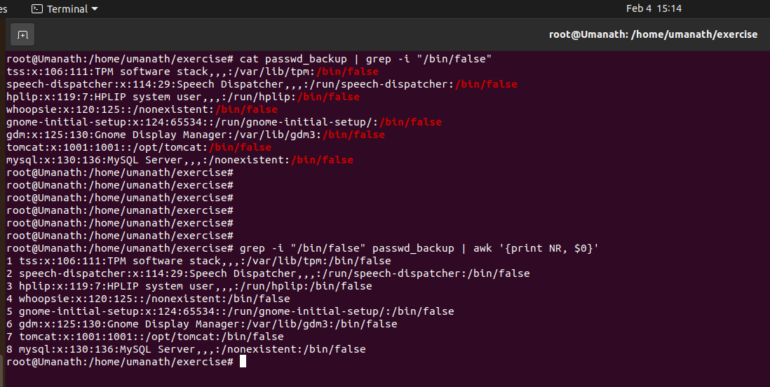

7. Redirect the output of the above commands into file "output".
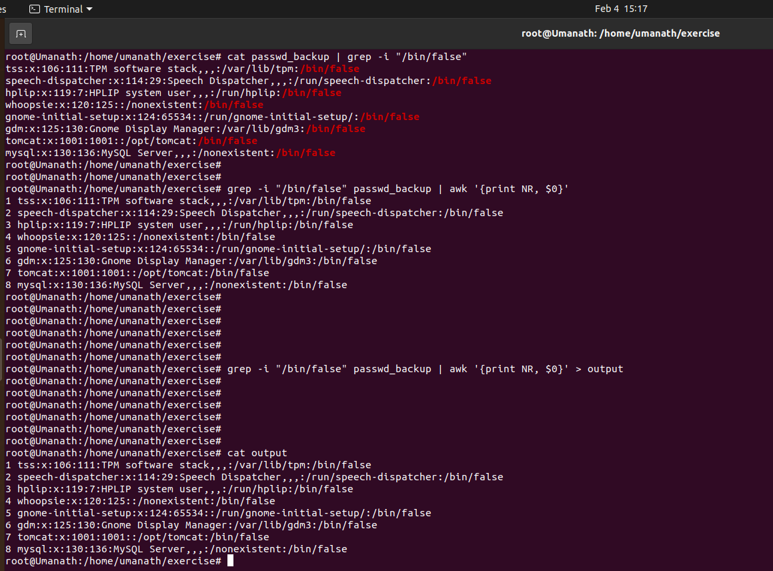
8. Create a "test" user,create its password and find out its uid and gid.

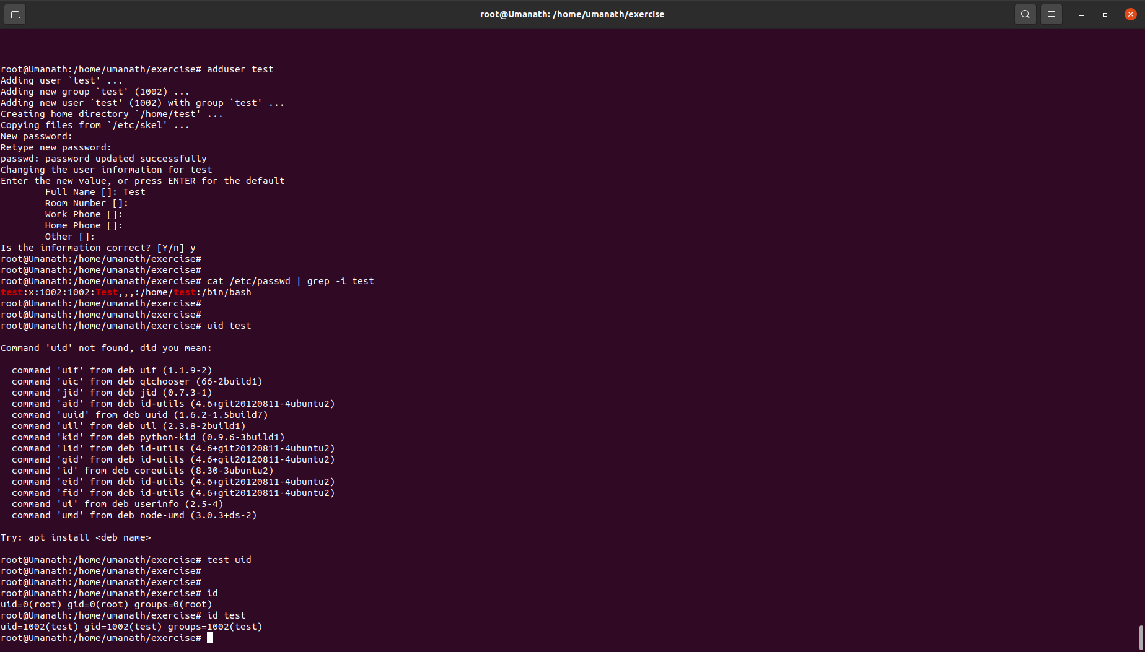

9. Login as test user and edit the "output" file created above. Since the permission wont allow you to save the changes.

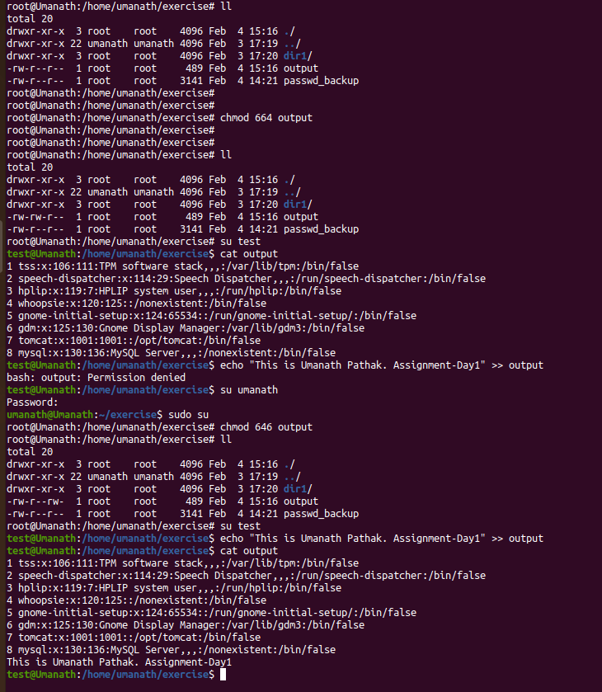

10. Configure such that test user can edit it.
a. Add group owner of the "output" file as the secondary group of testuser and check/change the "output" file permission if it is editable by group. Once
done revert the changes.
b. Make the file editable to the world so that test user can access it. Revert the changes after verification

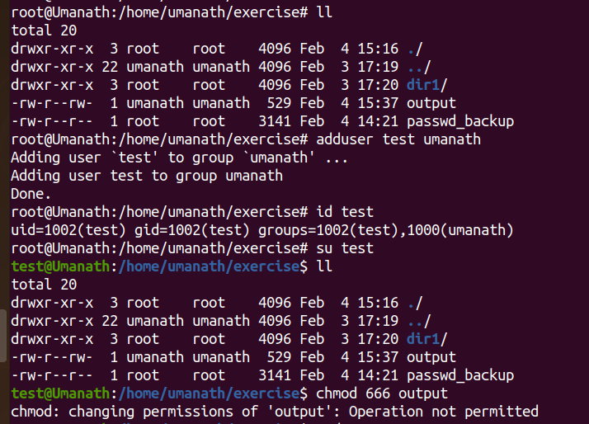

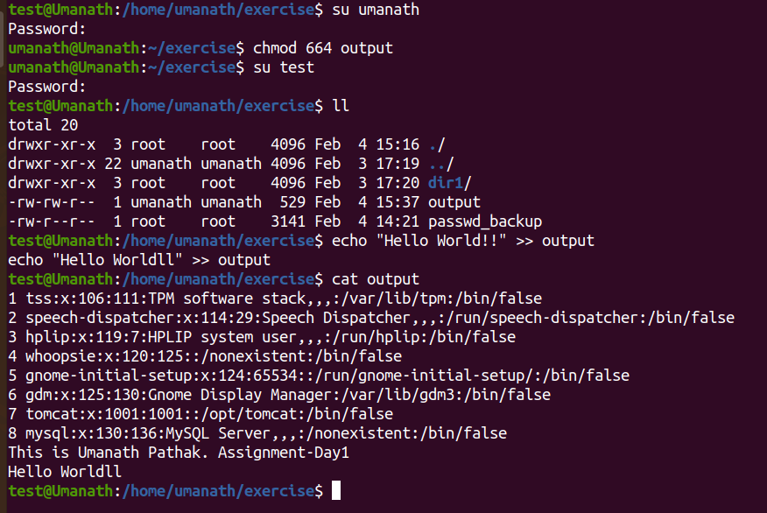

c. Change the ownership to edit the file.
Try all the options and recommend best of them.

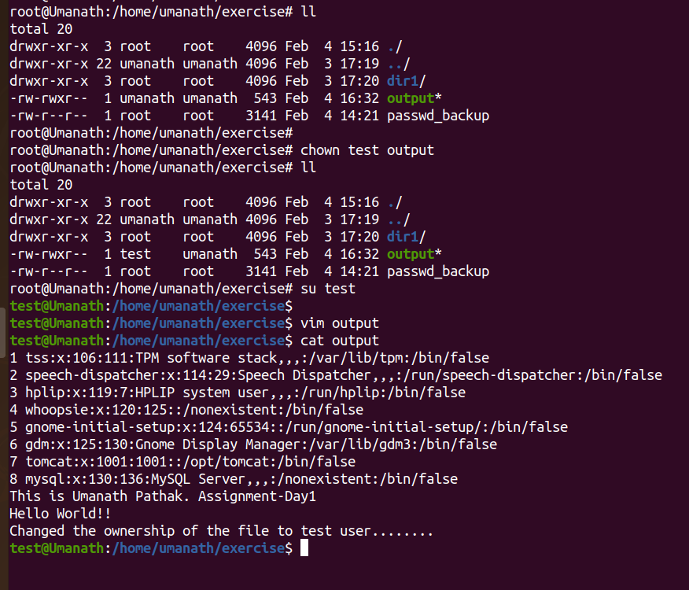

11. Create alias with your name so that it creates a file as "/tmp/aliastesting".
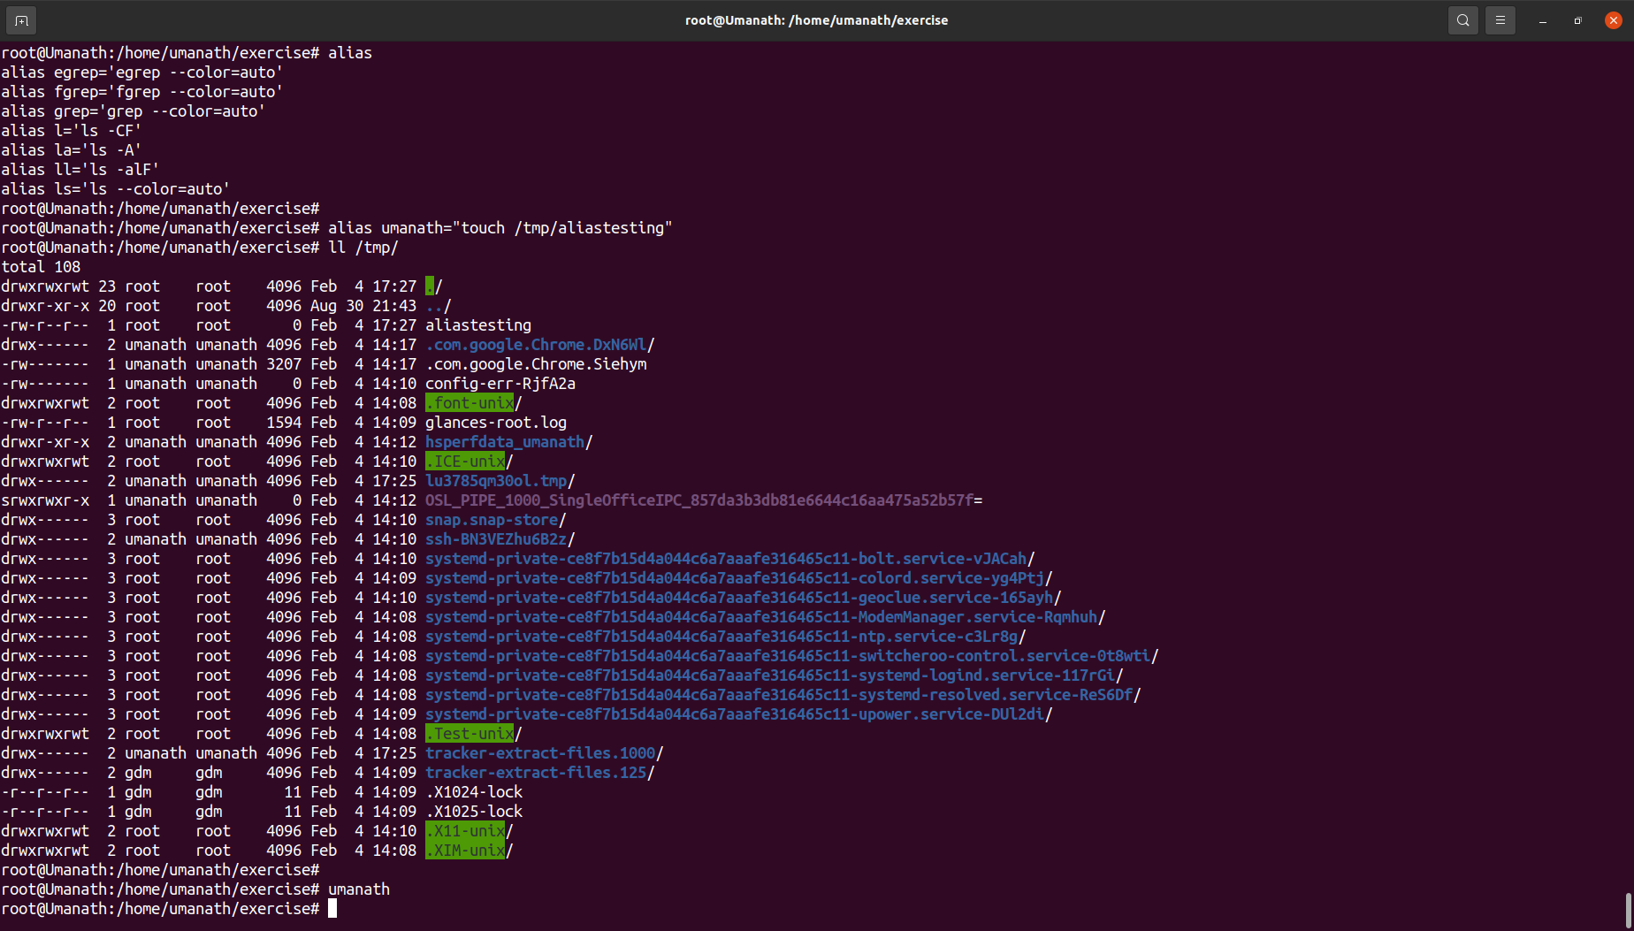
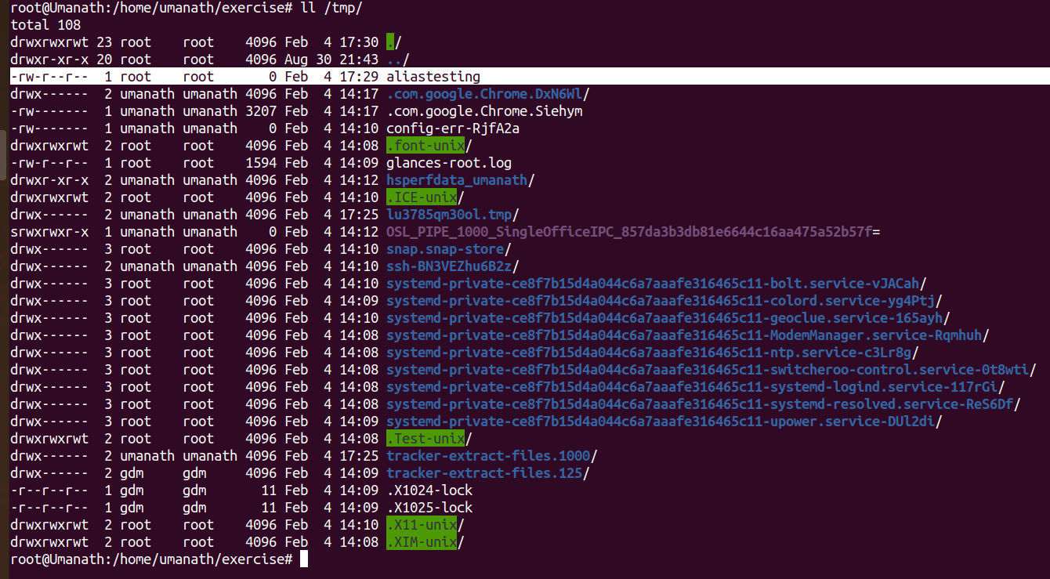

You can create two types of aliases – temporary ones and permanent.

Creating Temporary Aliases
What you need to do is type the word alias then use the name you wish to use to execute a command followed by "=" sign and quote the command you wish to alias.
The syntax is as follows:
$ alias shortName="your custom command here"
Here is an actual example:
$ alias wr=”cd /var/www/html”
You can then use "wr" shortcut to go to the webroot directory. The problem with that alias is that it will only be available for your current terminal session.
If you open new terminal session, the alias will no longer be available. If you wish to save your aliases across sessions you will need a permanent alias.

Creating Permanent Aliases
To keep aliases between sessions, you can save them in your user’s shell configuration profile file. This can be:
- Bash – ~/.bashrc
- ZSH – ~/.zshrc
- Fish – ~/.config/fish/config.fish
The syntax you should use is practically the same as creating a temporary alias. The only difference comes from the fact that you will be saving it in a file this time. So for example, in bash, you can open .bashrc file with your favorite editor like this:
$ vim ~/.bashrc
Find a place in the file, where you want to keep the aliases. For example, you can add them in the end of the file. For organizations purposes you can leave a comment before your aliases something like this:
#My custom aliases
alias home=”ssh -i ~/.ssh/mykep.pem tecmint@192.168.0.100”
alias ll="ls -alF"
Save the file. The file will be automatically loaded in your next session. If you want to use the newly defined alias in the current session, issue the following command:
$ source ~/.bashrc
To remove an alias added via the command line can be unaliased using unalias command.
$ unalias alias_name
$ unalias -a [remove all alias]

12. Edit ~/.bashrc file such that when you change to "test" user it should clear the screen and print "Welcome".

12.1. Method 1:- When we open New Terminal:
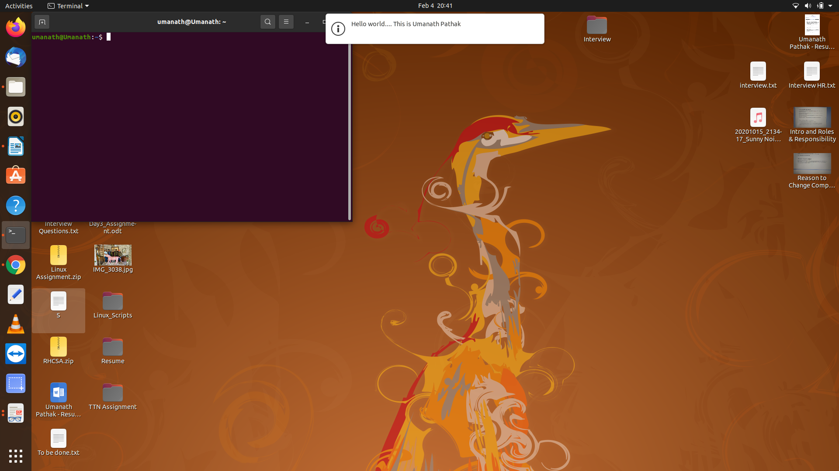
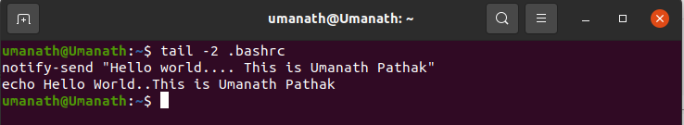
12.2. Method 2:- When we switch to Test user:
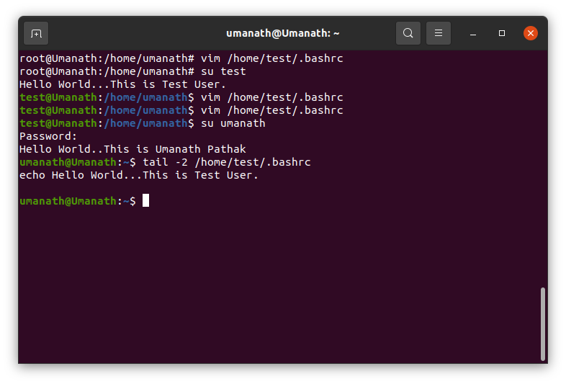

13.Install “zip” package.
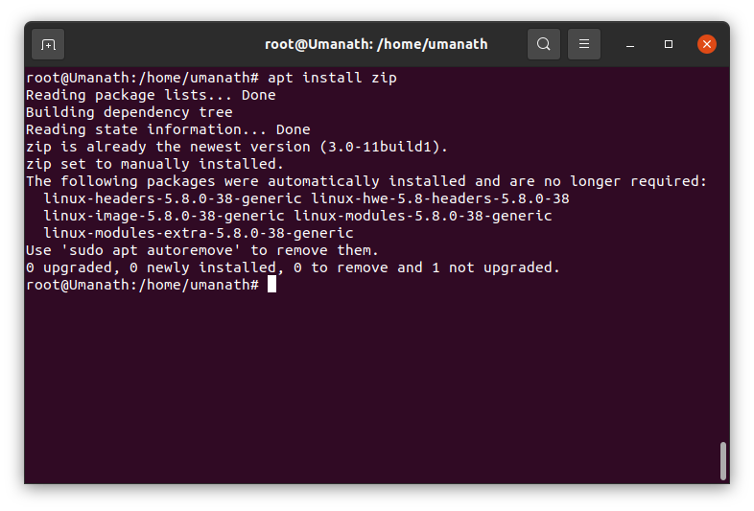

14.Compress "output" and "password_backup" files into a tar ball. List the files present inside the tar created.
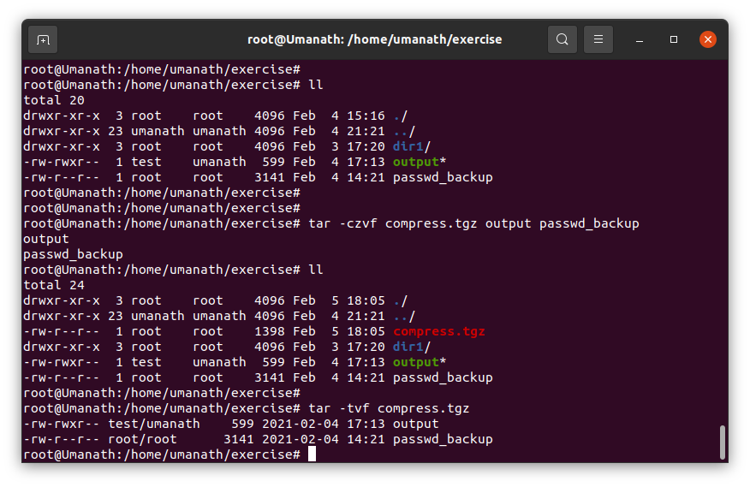

15. ‘scp’ this file (compress.tgz) to “test” user
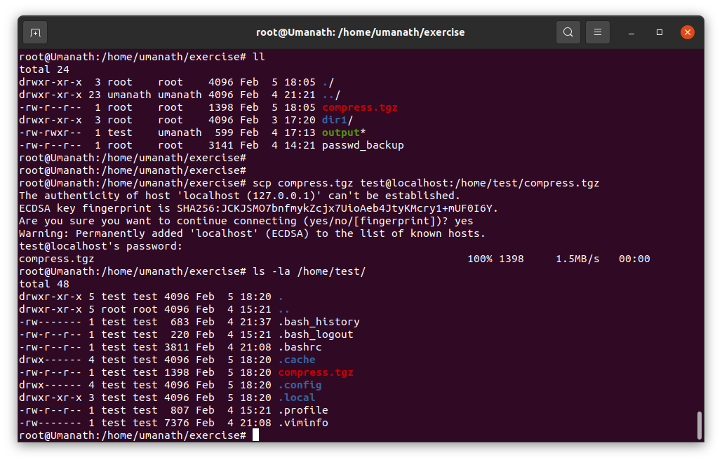

16.Unzip this tar bar by logging into the remote server
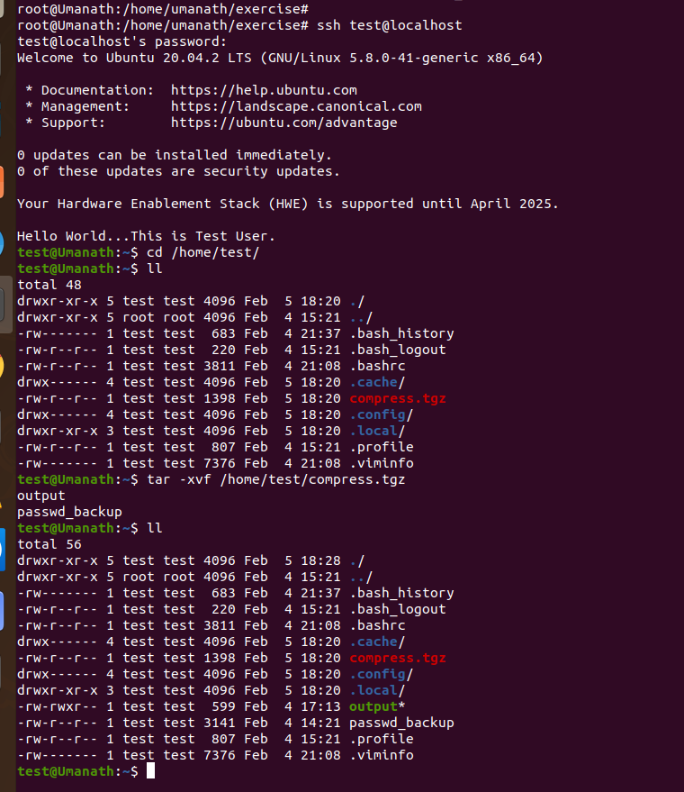

17. Download any image from web and move to desktop
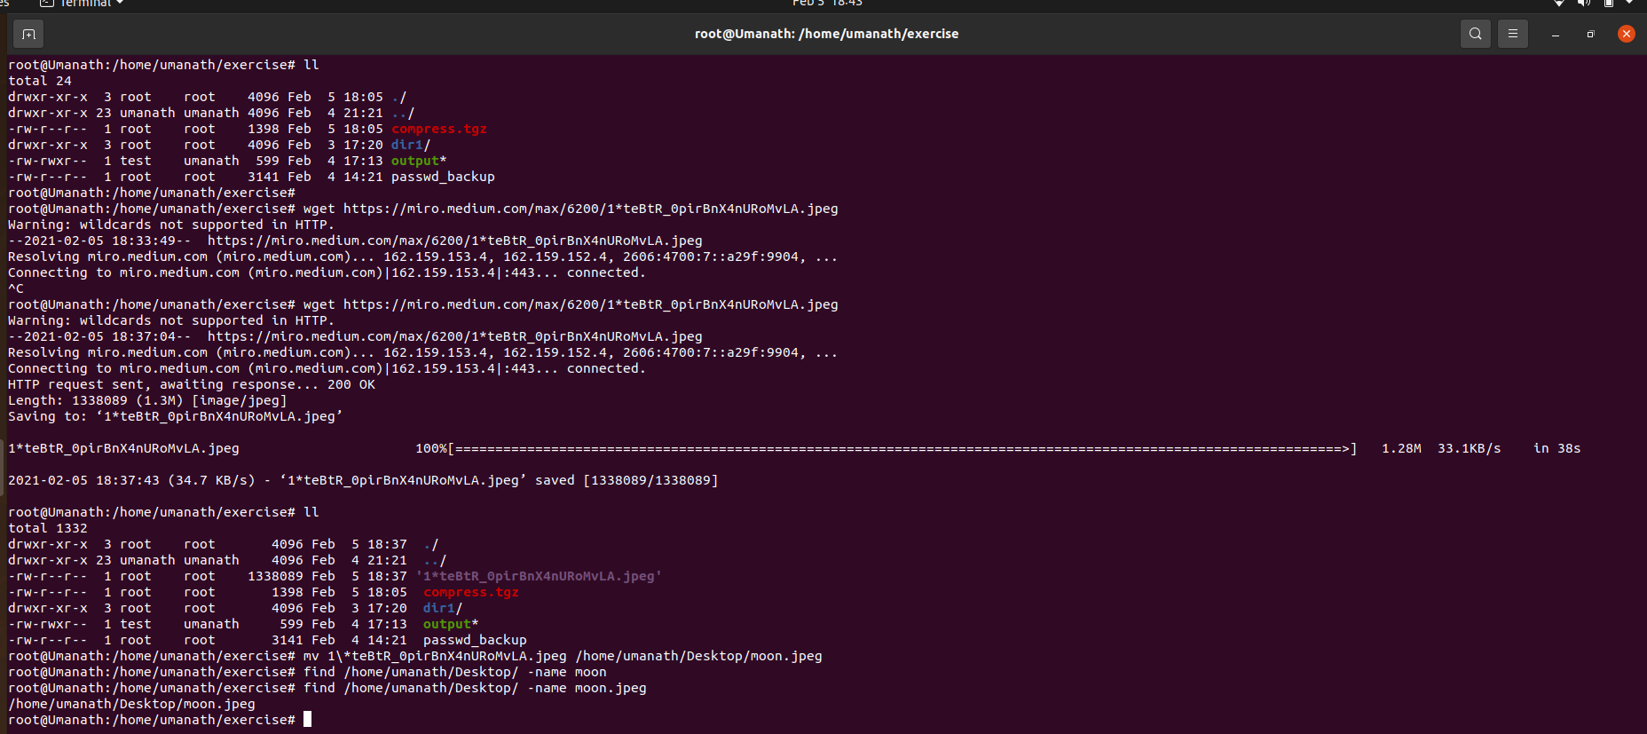

18.How to get help of commands usages.
We can get help by adding option --help to most of the commands and
manual by using:-
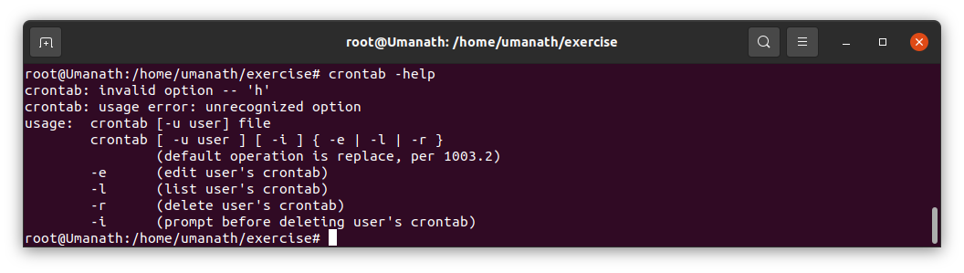

syntax: man <command>
man ssh
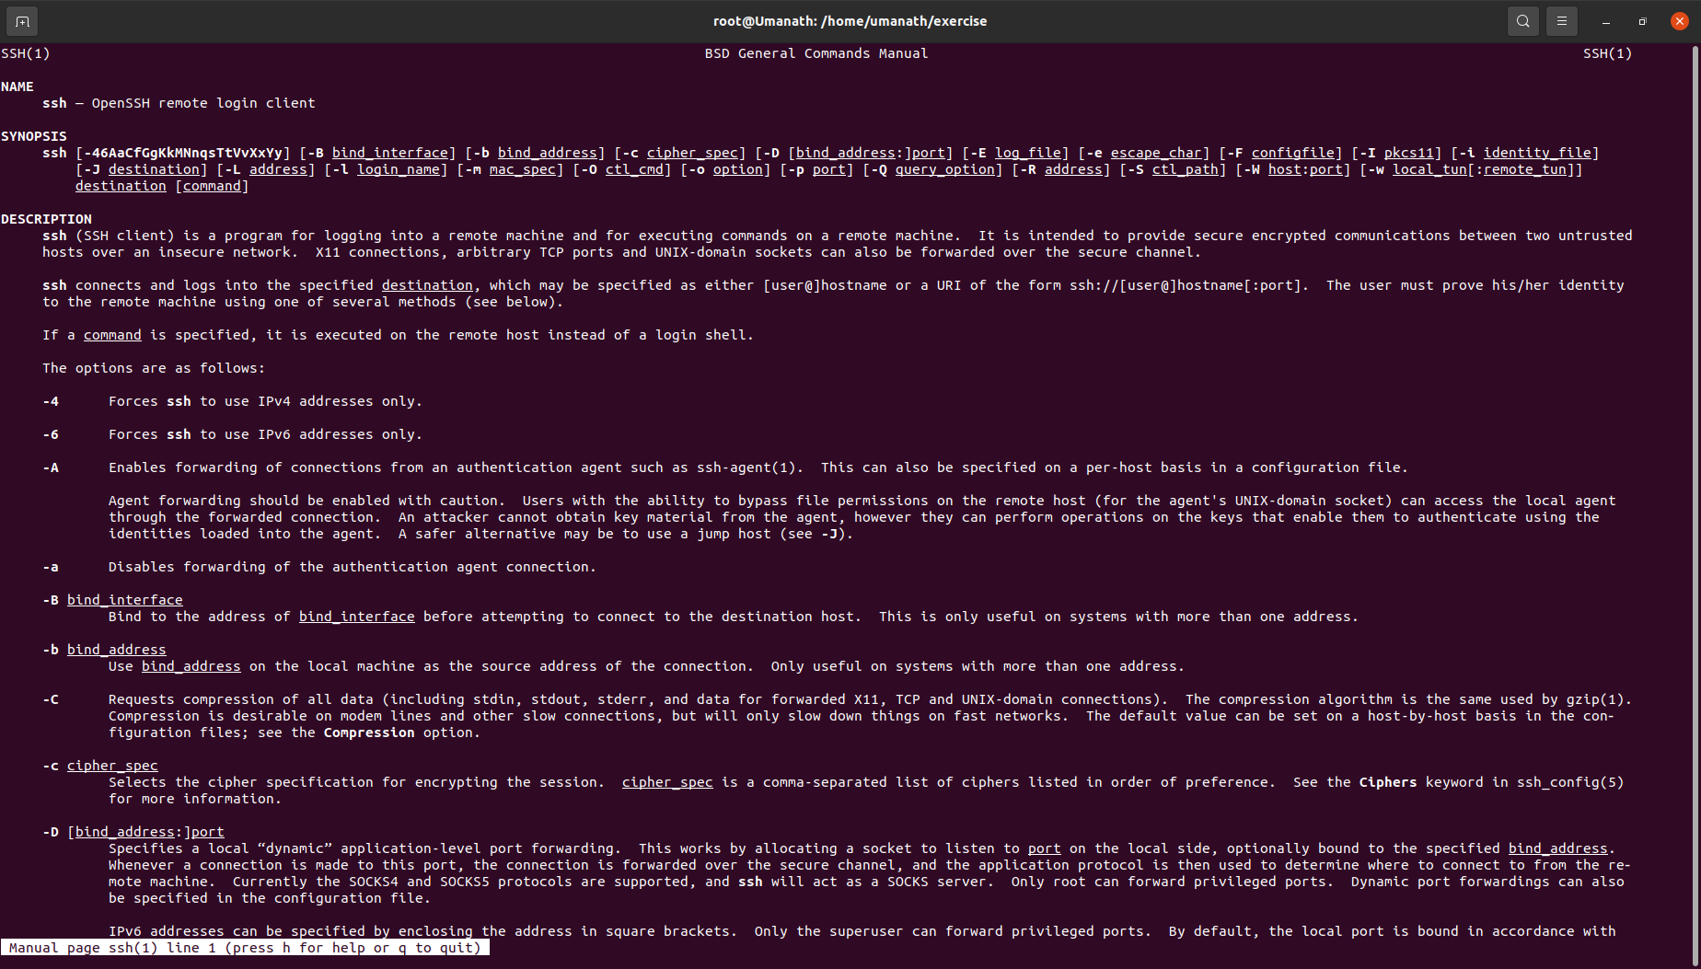
19.Create a symlink of /etc/services into /tmp/ports-info
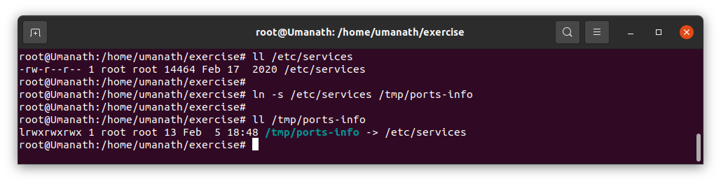

20.You are appointed as a Software/DevOps Engineer in ABC media
services. On your first day you need to troubleshoot a problem. There is
a command “xyz” somewhere installed in that linux system. But as a new
joinee you do not have any idea about where is that Installed. How can
you check that?
Ans)
The whereis command in Linux is used to locate the binary, source, and manual page files for a command. This command searches for files in a restricted set of locations (binary file directories, man page directories, and library directories).


