Task 1 Report — Gridworld RL (Random_Switch + Custom Varying Maze)
Course: Deep Reinforcement Learning | Prof. Dr.-Ing. Thomas Nierhoff
Name: Umang Dholakiya | Matriculation No.: 41537975 | Date: 30/12/2026
1. Task summary (what had to be done)
Task 1 required three things: (1) learn a policy that solves the provided environment Random_Switch in gridworld.py as quickly as possible (few episodes), (2) plot the real cumulative reward per episode averaged over 100 different environments, and (3) create a varying custom environment derived from GridworldEnv (e.g., maze/labyrinth), and show that it can be solved with a learning curve.
2. Why Random_Switch is difficult
Random_Switch is not a standard stationary gridworld. In addition to random obstacles/water, it has a special rule: every 5th step uses a different transition function and can end the episode immediately with reward −100 depending on the parity of the new position (x+y even). Also, valid_path_guaranteed=False means some generated maps may have no valid start→goal path, so the average return can be capped below 100 even for an optimal agent.
A critical consequence is that using only the observation (cell index) makes the learning problem non‑Markov, because the dynamics depend on time (step number). A correct agent must include the phase t mod 5 in its state representation.
3. Approaches tried (including what worked poorly)
The following approaches/ideas were considered or tested:
- Naive tabular Q-learning with state = obs only. This performed poorly because the same obs behaves differently depending on whether the next step is a switch step (non‑Markov).
- Tabular Q-learning with augmented state = (obs, t mod 5). This fixed the Markov issue, but learning was still sample-inefficient and required many episodes.
- Deep RL (e.g., DQN) was considered but not used as the final solution: the augmented state space is tiny (12×12×5 = 720 states), so tabular methods are faster and easier to tune.
Final choice: model-based tabular RL (Dyna‑Q) on the augmented state. This gave the best learning speed for this discrete, small state space.

4. Final best method: Dyna‑Q with time-augmented state + safety filters
4.1 State representation
State used for learning: s = (obs, t mod 5). obs is the environment observation (cell index). t is the step number within the episode. This makes the process Markov again, because the ‘switch’ behavior depends on step number.
4.2 Dyna‑Q (what it does, in simple words)
Dyna‑Q combines two ideas: (1) normal Q‑learning updates from real experience, and (2) additional ‘planning updates’ from a learned model. After each real step (s,a,r,s′), we store it in a model table (s,a)→(s′,r,done). Then we sample previously seen (s,a) pairs and replay them planning_steps times as extra Q‑updates. This improves sample efficiency because every real interaction produces multiple learning updates.
4.3 Random_Switch specific safety filters (not path-search)
Two optional filters were used only to reduce avoidable −100 terminations. These do not analyze the full grid, and they do not compute paths; they only use local mechanics or already observed transitions:
- switch_safety: on steps where the next step is a switch step (every 5th), prefer actions that land on odd parity (x+y odd) because even parity would terminate with −100.
- avoid_fatal: if the learned model has already seen that a certain action from the current state ends immediately with terminal −100, avoid it when alternatives exist.
4.4 Episode length cap
Because step_cost = 0, the agent could wander indefinitely. Therefore each episode is capped at max_steps (here: 600). This is not reward shaping; it is only a practical termination condition to keep training finite and comparable.
5. Experimental setup (required averaging over 100 environments)
For the required learning curve, the experiment is repeated over 100 independently created environments (different random seeds → different maps). For each environment instance, the agent is trained for 1000 episodes and the real cumulative reward (sum of true rewards in the episode) is recorded. Then the plotted curve is the episode-by-episode mean across the 100 environments, with a ±1 standard deviation band.
Important note from the task: the environments used for hyperparameter tuning should not be reused for the final plot. In practice this is achieved by using different seed ranges for tuning vs. final evaluation.

5.1 Why this code takes a lot of time to run
This experiment can take a long time because Dyna-Q does many extra “planning” Q-updates after every real environment step, and these updates are executed inside Python loops with dictionary lookups (model table). In the worst case (if episodes often run close to max_steps), the number of real environment steps is:
100 env * 1000 episodes * 600 steps = 60,000,000
So the agent performs about 60 million real env steps. If planning_steps = 150, then planning updates become:
60,000,000 * 150 = 9,000,000,000
That is 9 billion additional Q-updates, which dominates runtime. Since these planning updates involve repeated Python operations (loops + dict accesses), they are much slower than pure vectorized numerical code. In practice, episodes often terminate early (many −100 deaths), so the true runtime is usually lower than this worst-case estimate, but it can still be large.
6. Results
6.1 Random_Switch results (mean over 100 environments)
Reported numeric results (episode 1000):
• Final mean return: 82.00 ± 45.56
• Mean over last 50 episodes: 82.04 ± 44.13
Interpretation: The agent learns to reach the goal reliably on many solvable maps and avoids many catastrophic switch-step terminations. The mean return is below 100 because some maps are unsolvable (no valid start→goal path when valid_path_guaranteed=False) and because the switch-step mechanic can still cause occasional unavoidable failures.
6.2 Custom environment: VaryingMaze (description + results)
Goal: Create a varying environment (different layout per seed) with an interesting maze-like structure that is challenging for classical RL because rewards are sparse (+100 only at the goal, −100 at water traps, 0 otherwise) and exploration can easily lead into dead ends. More About the custom varying environment is explain in the readme.txt.

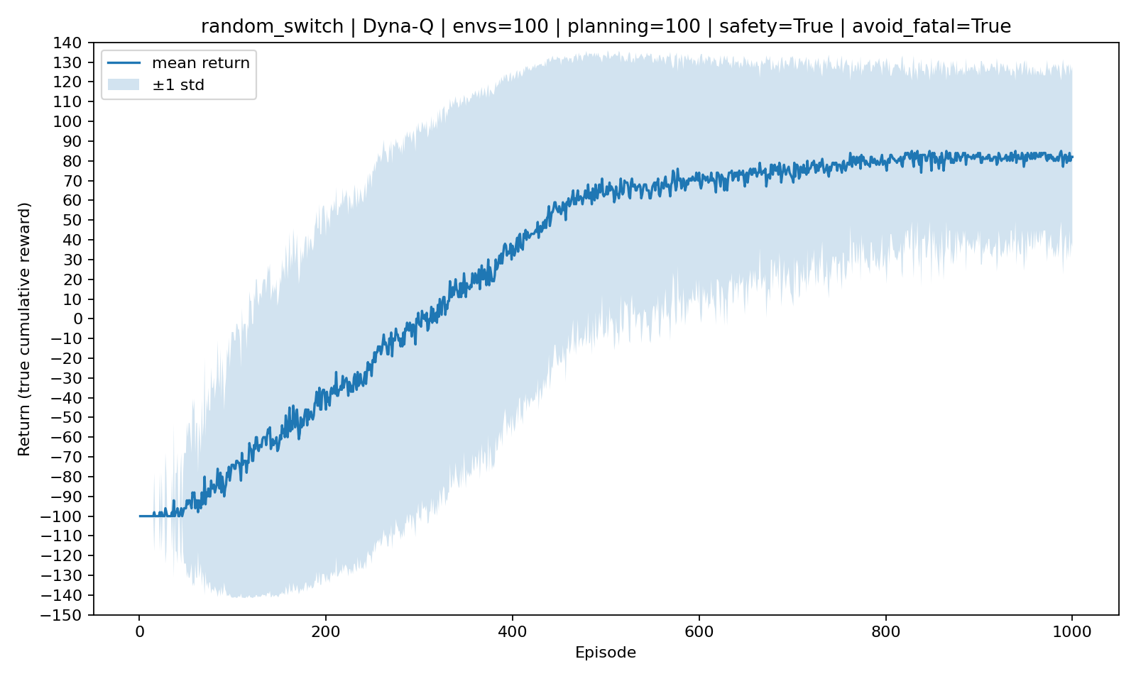
Figure 1: Random_Switch learning curve — mean true episode return over 100 environments (shaded: ±1 std).
Environment design (solvable-by-construction, no BFS/DFS)
The maze is generated in a way that guarantees at least one solution without any path-search algorithm:
1) Start with a grid of walls.
2) Carve a guaranteed corridor from S to G by constructing a sequence of right/down moves.
3) Add random side branches off the corridor (many become dead ends).
4) Place some water traps at branch ends and add extra random openings away from the corridor.
Because the corridor is never overwritten by obstacles, the maze always remains solvable, while still varying across random seeds.
Reported numeric results (episode 1000):
• Final mean return: 98.00 ± 19.90
• Mean over last 50 episodes: 96.88 ± 21.19
Interpretation: Since the environment is always solvable, the mean return can approach 100 as the agent learns the corridor-following behavior. The remaining variance comes mainly from exploration early in training and occasional trap terminations.
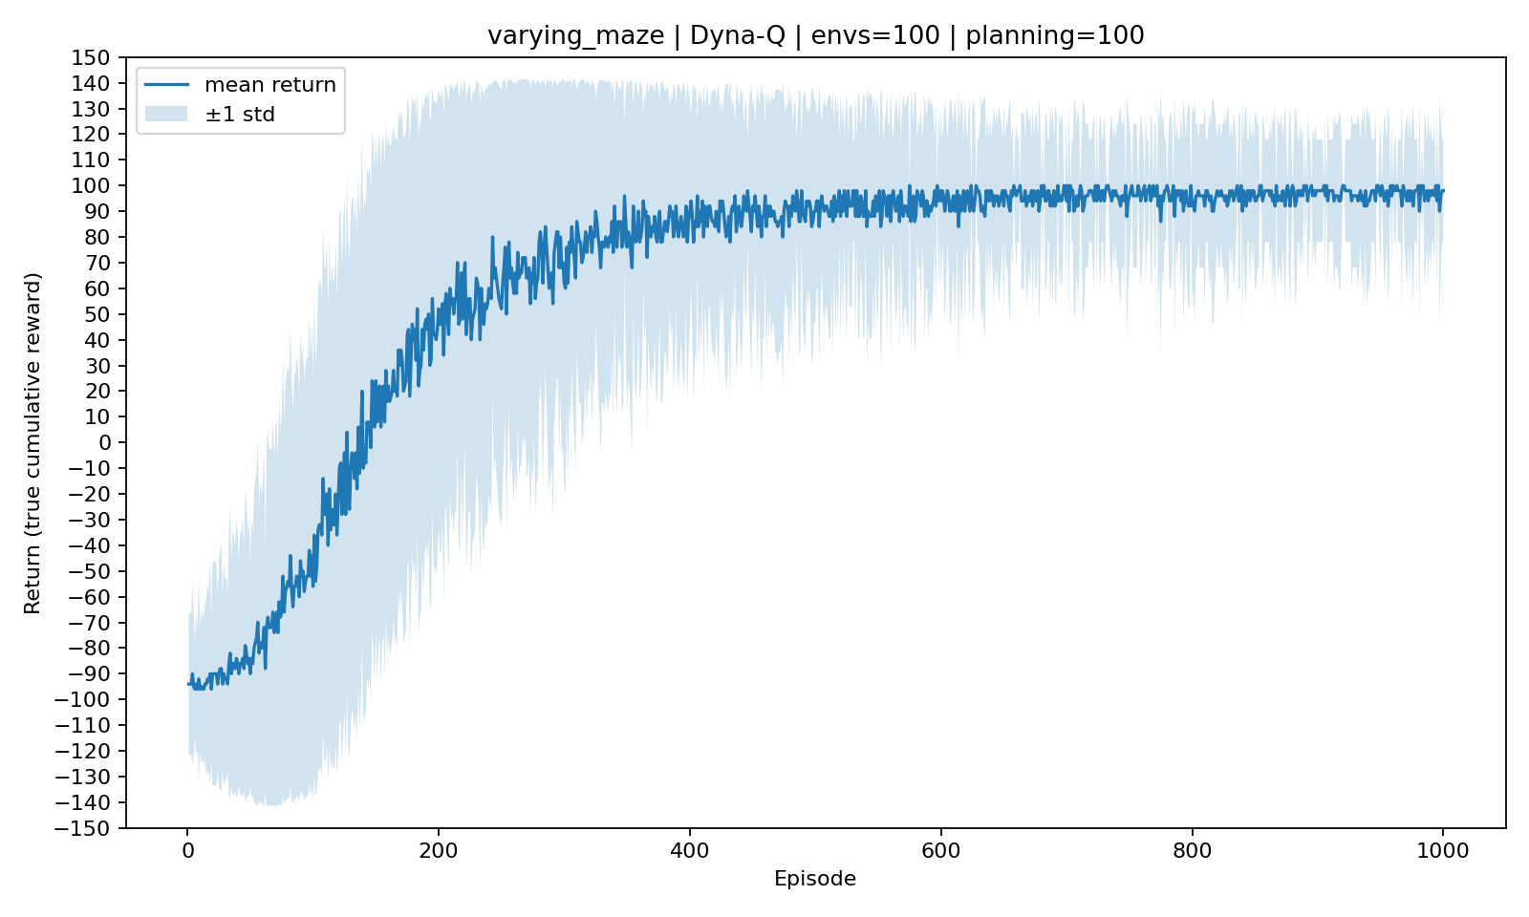
Figure 2: VaryingMaze learning curve — mean true episode return over 100 environments (shaded: ±1 std).
7. Discussion and compliance with task requirements
Requirement check:
• Random_Switch solved with a learning agent (Dyna‑Q) and evaluated over 100 environments.
• Plot shows real cumulative reward per episode (true env rewards), mean ± std over 100 environments.
• A varying custom environment derived from GridworldEnv was created and shown solvable via its learning curve.
• step_dp was not used.
• No algorithmic grid analysis (no BFS/DFS/path-search) was used to solve or filter environments.

