Assignment 1 : Simple SQL Query with a single table with where clause
1. Write a query to get a Product list (id, name, unit price) where current products cost less than $20.
->SELECT ProductID,ProductName,UnitPrice FROM Products WHERE UnitPrice<20 and Discontinued=0;
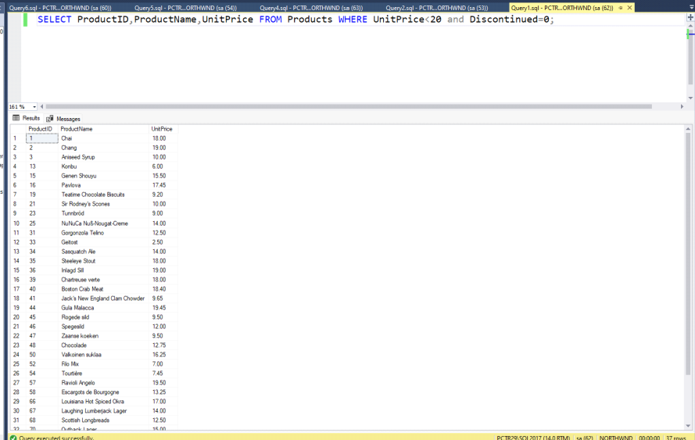

2. Write a query to get Product list (id, name, unit price) where products cost between $15 and $25
->SELECT ProductID,ProductName,UnitPrice FROM Products WHERE UnitPrice BETWEEN 15 AND 25;
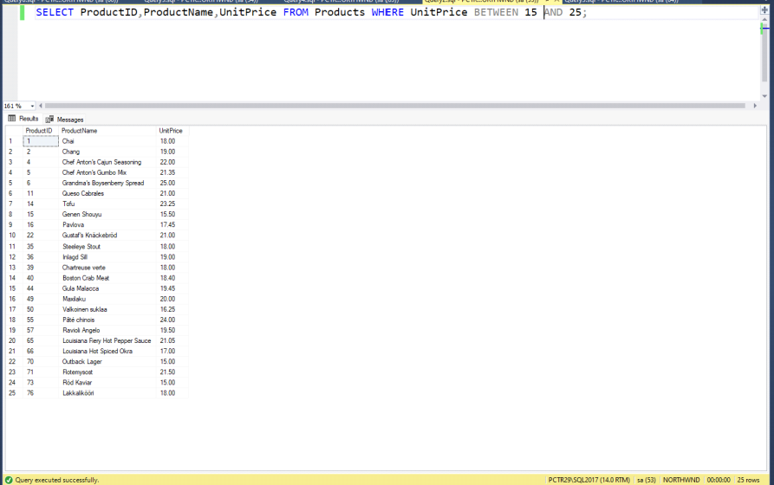

3. Write a query to get Product list (name, unit price) of above average price.
->SELECT ProductName,UnitPrice FROM Products WHERE UnitPrice > (SELECT AVG(UnitPrice) FROM Products);
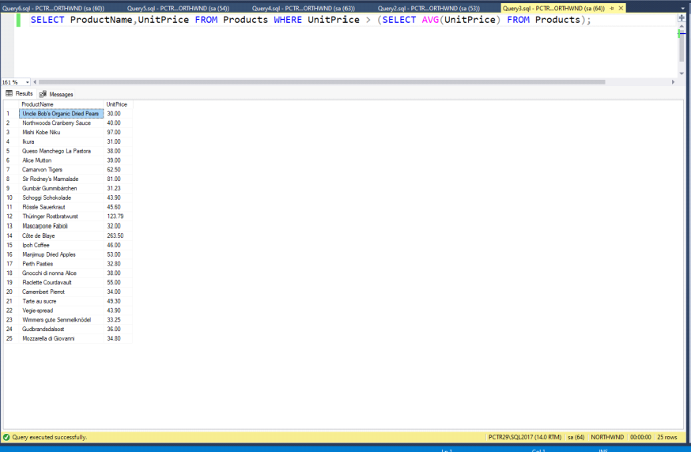

4. Write a query to get Product list (name, unit price) of ten most expensive products
->SELECT TOP(10) ProductName,UnitPrice FROM Products ORDER BY UnitPrice DESC;
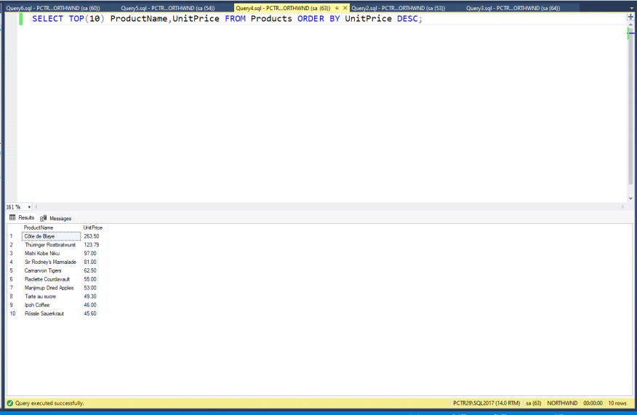

5. Write a query to count current and discontinued products
->SELECT Discontinued,COUNT(*) FROM Products GROUP BY Discontinued;
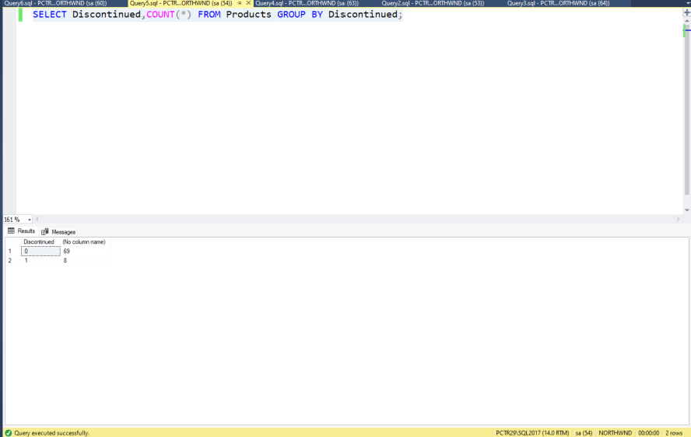

6. Write a query to get Product list (name, units on order , units in stock) of stock is less than the quantity on order
->SELECT ProductName,UnitsOnOrder,UnitsInStock FROM Products WHERE UnitsInStock < UnitsOnOrder;
