**Temperature Sensor**

The DHT11 is a digital temperature sensor that measures temperature and relative humidity. These sensors contain a chip that does analog to digital conversion and spit out a digital signal with the temperature and humidity. This makes them very easy to use with any microcontroller, including the Arduino.

By using the exclusive digital-signal-acquisition technique and temperature & humidity sensing technology, it ensures high reliability and excellent long-term stability

The DHT22 sensor also is a suitable alternative to get precise values however it is more expensive than DHT11.

DHT sensors have four pins as shown in the following figure. However, if you get your DHT sensor in a breakout board, it comes with only three pins and with an internal pull-up resistor on pin 2.

Why we chose DHT11:

* Low power consumption and excellent long-term stability.
* Relatively high measurement accuracy can be obtained at a very low cost.
* Single-bus digital signal output through the built-in ADC, which saves the I/O resources of the control board.

|  |  |
| --- | --- |
|  | **DHT11** |
|  |  |
| **Temperature range** | 0 to 50 ºC +/-2 ºC |
| **Humidity range** | 20 to 90% +/-5% |
| **Resolution** | Humidity: 1% Temperature: 1ºC |
| **Operating voltage** | 3 – 5.5 V DC |
| **Current supply** | 0.5 – 2.5 mA |
| **Sampling period** | 1 second |

* Humidity range of 5 to 95% RH with a ±5% and also a temperature range of -20 to 60℃ with a ±2%.

<https://www.electronicscomp.com/dht11-temprature-humidity-sensor-module-india?gclid=EAIaIQobChMIx-7OlbHh7wIVGxwrCh0gWwtUEAQYASABEgIdBPD_BwE>

<https://randomnerdtutorials.com/9-arduino-compatible-temperature-sensors-for-your-electronics-projects/>

<https://randomnerdtutorials.com/complete-guide-for-dht11dht22-humidity-and-temperature-sensor-with-arduino/>

<https://www.mouser.com/datasheet/2/758/DHT11-Technical-Data-Sheet-Translated-Version-1143054.pdf>

**Turbidity Sensor**

The turbidity sensor detects water quality by measuring the levels of turbidity. It uses light to detect suspended particles in water by measuring the light transmittance and scattering rate, which changes with the amount of total suspended solids (TSS) in water. As the TTS increases, the liquid turbidity level increases.

Turbidity Sensor provides analog and digital signal output modes. The threshold is adjustable when in digital signal mode. You can select the mode according to your MCU. This sensor is economical and is compatible with Arduino microcontroller therefore making it a preferred option for us.

* Operating Voltage: 5V DC
* Operating Current: 40mA (MAX)
* Response Time : <500ms
* Insulation Resistance: 100M (Min)
* Output Method:
  + Analog output: 0-4.5V
  + Digital Output: High/Low level signal (you can adjust the threshold value by adjusting the potentiometer)
* Operating Temperature: 5℃~90℃
* Storage Temperature: -10℃~90℃
* Weight: 30g
* Adapter Dimensions: 38mm*28mm*10mm/1.5inches *1.1inches*0.4inches

Why we chose this sensor:

* Compatible with Arduino, Raspberry Pi, AVR, PIC, etc.
* Measures turbidity of water in rivers.
* Detects and verifies water quality.
* Digital and analog output;
* Able to detect particles that are suspended in water.
* Trimpot for sensitivity adjustment.
* Ideal monitoring of water turbidity in rivers, streams, lakes, water boxes, catchment and research sites, laboratories, tanks with liquids and etc.
* Comes with module and jumpers

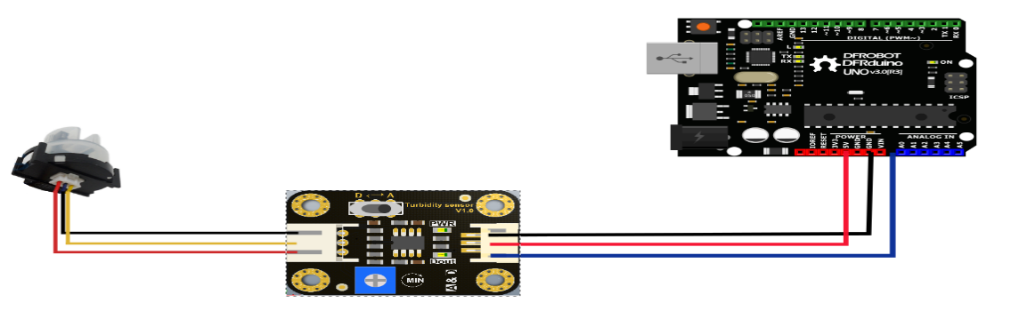

<https://robu.in/product/turbidity-sensor-module/?gclid=EAIaIQobChMIqrTV2rHh7wIVK4NLBR2v4wn_EAQYAyABEgIElfD_BwE>

<https://wiki.dfrobot.com/Turbidity_sensor_SKU__SEN0189>

<https://media.digikey.com/pdf/Data%20Sheets/DFRobot%20PDFs/SEN0189_Web.pdf>

**PH sensor**

The analog pH meter is specially designed for Arduino controllers and has built-in simple, convenient and practical connection and features. It has an LED which works as the Power Indicator, a BNC connector and PH2.0 sensor interface. You can just connect the pH sensor with BNC connector, and plug the PH2.0 interface into any analog input on Arduino controller to read pH value easily.

Specifications:

* Module Power: 5.00V
* Circuit Board Size: 43mm×32mm
* pH Measuring Range: 0-14
* Measuring Temperature: 0-60 􀔨
* Accuracy: ± 0.1pH (25 􀔨)
* Response Time: ≤ 1min
* pH Sensor with BNC Connector
* PH2.0 Interface ( 3 foot patch )
* Gain Adjustment Potentiometer
* Power Indicator LED

Features of pH sensor:

* hardware filtered output signal
* low jitter
* uniform size and connector
* convenient for the design of mechanical structures
* Gravity connector and BNC connector, plug and play, requires no welding

<https://thinkrobotics.in/products/liquid-ph-value-detection-detect-regulator-sensor?variant=28160821755976&currency=INR&utm_medium=product_sync&utm_source=google&utm_content=sag_organic&utm_campaign=sag_organic&gclid=EAIaIQobChMIn9b3z8nh7wIVsoNLBR0e0wJqEAQYAiABEgJxFvD_BwE>

<https://www.mouser.in/new/dfrobot/dfrobot-analog-pH-sensor-kit/>

<https://github.com/thinkrobotics/DATASHEET/blob/master/ELECTRONIC_COMPONENTS/ELC1057/Datasheet%20for%20ELC1057.pdf>

**Water flow Sensor**

Water flow sensor consists of a plastic valve from which water can pass. A water rotor along with a hall effect sensor is present the sense and measure the water flow. When water flows through the valve it rotates the rotor. By this, the change can be observed in the speed of the motor. This change is calculated as output as a pulse signal by the hall effect sensor. Thus, the rate of flow of water can be measured.

YF-S201 Hall Effect Water Flow sensor sits in line with your water line and contains a pinwheel sensor to measure how much liquid has moved through it. There's an integrated magnetic hall effect sensor that outputs an electrical pulse with every revolution. The hall effect sensor is sealed from the water pipe and allows the sensor to stay safe and dry. The sensor comes with three wires: red (5-24VDC power), black (ground) and yellow (Hall effect pulse output). By counting the pulses from the output of the sensor, you can easily calculate water flow. Each pulse is approximately 2.25 milliliters.

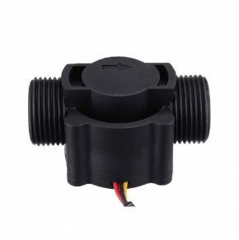Why we chose this sensor:

* The simple and compact module.
* Easy to Install.
* High Sealing Performance.
* High-Quality Hall Effect Sensor

Specifications:

* Model: YF-S201
* Sensor Type: Hall effect
* Working Voltage: 5 to 18V DC (min tested working voltage 4.5V)
* Max current draw: 15mA @ 5V
* Output Type: 5V TTL
* Working Flow Rate: 1 to 30 Liters/Minute
* Working Temperature range: -25 to +80℃
* Working Humidity Range: 35%-80% RH
* Accuracy: ±10%
* Maximum water pressure: 2.0 MPa
* Output duty cycle: 50% +-10%
* Output rise time: 0.04us
* Output fall time: 0.18us
* Flow rate pulse characteristics: Frequency (Hz) = 7.5 * Flow rate (L/min)
* Pulses per Liter: 450
* Durability: minimum 300,000 cycles
* Cable length: 15cm
* 1/2" nominal pipe connections, 0.78" outer diameter, 1/2" of thread
* Size: 2.5" x 1.4" x 1.4"

<https://robu.in/product/fs300a-water-flow-sensor/?gclid=EAIaIQobChMI4tHc3pji7wIVIzNyCh2BMwz2EAYYASABEgLJJvD_BwE>

<https://www.hobbytronics.co.uk/yf-s201-water-flow-meter>

<https://how2electronics.com/arduino-water-flow-sensor-measure-flow-rate-volume/#Bill_of_Materials>

<https://www.electroschematics.com/working-with-water-flow-sensors-arduino/>