**IoT based water quality assistant for Irrigation**

Capstone Project Proposal

**Submitted by:**

**(101983043) Umang Sharma**

**(101983044) Suryansh Bhardwaj**

**(101983045) Prakhar Srivastava**

**BE Third Year- COE CPG No. 101**

Under the Mentorship of Dr. Karun Verma

Assistant professor



**Computer Science and Engineering Department Thapar Institute of Engineering and Technology, Patiala**

**March, 2021**

Contents

Mentor Consent Form 3

Project Overview 4

1. Data Collection 4

2. Data Analysis and Visualization 4

3. Treatment of Water 5

Need Analysis 5

Literature Survey 6

Indices used for Water Quality Monitoring and Assessment: 6

Analysis of specific studies 7

Existing Systems and Solutions 9

Objectives 10

Methodology 10

Project Outcomes 11

Individual Roles 12

Workplan 12

Course Subjects 13

References 13

# Mentor Consent Form

I hereby agree to be the mentor of the following Capstone Project Team

|  |  |  |
| --- | --- | --- |
| **Project Title: IoT based water quality assistant for Irrigation** | | |
| **Roll Number** | **Name** | **Signature** |
| 101983043 | Umang Sharma |  |
| 101983044 | Suryansh Bhardwaj |  |
| 101983045 | Prakhar Srivastava |  |

Name of Mentor: Dr. Karun Verma

Signature of Mentor:

# Project Overview

The project focuses on the analysis of ground water quality by collecting data which can help arrive at a suitable conclusion for its treatment.

The quality of ground water used for irrigation varies with respect to location, time as well as weather conditions. This variation can result in unsuitable water, and consequently a lower yield for many crops.

Our project aims to control this variation with the use of sensors and learning algorithms in order to treat the unsuitable water before any drastic consequences.

It is divided into three major segments:

## 1. Data Collection

We will be collecting data related to the temperature, turbidity, Potential of Hydrogen (pH), and most importantly the Sodium Absorption Ratio (SAR) of the water [<1>,<2>].

## 2. Treatment of Water

This raw data will then be used to determine the water quality by using a model uploaded onto the Microcontroller. This will help minimize the complexity of our project component in the fields.

## 3. Data Analysis and Visualization

The raw data will also be uploaded onto an online dashboard where it will be visualized and analysed on a long-term basis. This phase is an ‘add on’, in order to keep the local apparatus independent from the remote website.

# Need Analysis

In present day water quality in general and microbial drinking and process water quality in particular, is monitored either through time consuming laboratory methods or various costly online sensors having low sensitivity. Water quality monitoring results are thus either delayed or insufficient to support proactive management action.

Our project aims to develop a monitoring system which aims to provide reliable sensors, an established IoT network to monitor water quality and a real time dashboard to analyse data and classify water as fit or unfit [<3>]. The monitoring established by our project will be scalable and cost effective which will resolve the issue of non-scalable and costly monitoring system.

Irrigation water quality is a critical aspect of crop production. There are many factors which determine water quality. Among the most important are alkalinity, pH and soluble salts. Poor quality water can be responsible for slow growth, poor aesthetic quality of the crop and, in some cases, can result in the gradual death of the plants. Poor water quality leads to major losses for farmers and can also affect soil health.

Our project apart from making a monitoring system to determine the presence unwanted elements in water will include an automated segregation element which will direct poor quality water into treatment plant and good quality water into the field. Hence the project will stop the poor-quality water from entering the fields and leading to losses for farmers. The system developed will be automated thereby eliminating the technical difficulties faced by farmers.

Water monitoring nano sensors have an increasing market to the extent that these nano sensors have a share of about 30% from the whole nano sensors market. In general, water monitoring nano sensors are very attractive for companies to invest, and they have a very bright future in markets.

Since our project includes water monitoring sensors and a cost-effective IoT network. This stands in parallel to the technologies being developed by many start-ups and hence is very much in demand.

# Literature Survey

Signs of deteriorating water quality can be seen all over the world, in both developed and developing countries. The types, magnitudes and extents of water quality problems differ from one country to another, and even from one part of a country to another. A number of private and public enterprises have been working in the field of water quality management and assessment. A number of companies working in this field have been surveyed to develop a proper understanding of this area.

## Indices used for Water Quality Monitoring and Assessment:

**1.** **Chemical oxygen demand (COD):** This is the equivalent amount of oxygen consumed (measured in mg/l) in the chemical oxidation of all organic and oxidisable inorganic matter contained in a water sample.

**2.** **Biochemical oxygen demand (BOD):** This is the oxygen requirement of all the organic content in water during the stabilisation of organic matter usually over a 3 or 5 day.

**3.** **pH**: This is the measure of the acidity or alkalinity of water. It is neutral (at 7) for clean water and ranges from 1 to 14.

**4.** **Dissolved oxygen (DO):** This is the amount of oxygen dissolved in a water sample (measured in mg/l).

**5.** **Turbidity:** This is the scattering of light in water caused by the presence of suspended solids. It can also be referred to as the extent of cloudiness in water measured in nephelometric turbidity units (NTU).

**6.** **Electrical conductivity (EC):** This is the amount of electricity that can flow through water (measured in Siemens), and it is used to determine the extent of soluble salts in the water. 248 J. O. Ighalo et al.

**7.** **Temperature:** The is the degree of hotness or coldness of the water and usually measured in degrees Celsius (°C) or Kelvin (K).

**8.** **Oxidation-reduction potential (ORP):** This is the potential required to transfer electrons from the oxidant to the reductant, and it is used as a qualitative measure of the state of oxidation in water.

**9.** **Salinity:** This is the salt content of the water (measured in parts per million).

**10.** **Total Nitrogen (TN):** This is the total amount of nitrogen in the water (in mg/l) and is a measure of its potential to sustain and eutrophication or algal bloom.

**11.** **Total phosphorus (TP):** This is the total amount of phosphorus in the water (in mg/l) and is a measure of its potential to sustain and eutrophication or algal bloom.

## Analysis of specific studies

Table 1 : Review of certain studies related to our Project

|  |  |  |  |
| --- | --- | --- | --- |
| Place/Name | Monitored | Tech used | Misc |
| Wang et al, Xinglin Bay in Xiamen, China [<4>]. |  |  | Their system was divided into three subsystems-  Data acquisition Digital data  Data processing |
| Shafi et al. investigated the of surface water across 11 locations in Pakistan [<5>]. | pH, turbidity and temperature | The algorithms considered were Support Vector Machine (SVM), k Nearest Neighbour (kNN), single-layer neural network and deep neural network. | It was observed from the learning process on the 667 lines of data that deep neural network had the highest accuracy (at about 93%). The model could accurately predict water quality in the future six months. |
| Saravanan et al , Tamilnadu, India [<6>]. | monitored the turbidity, temperature and colour | technology was usable in real-time and employed a GSM module for wireless data transfer. | Using a Supervisory Control and Data Acquisition Internet of Things for Water Quality Monitoring … 253 (SCADA) system that is enabled by IoT. |
| Liu et al. pumping station along the Yangtze river in Yangzhou, China [<7>]. | Temperature, pH, DO, Conductivity, Turbidity, COD and NH3 | IoT enabled but incorporated a Long Short-Term Memory (LSTM) deep learning neural network. |  |
| Zin et al. Curtin Lake, northern Sarawak in the Borneo island [<8>]. | pH, turbidity, temperature, water level and carbon dioxide | wireless sensor network enabled by IoT  system consisted of Zigbee wireless communication, protocol, Field Programmable Gate Array (FPGA) and a personal computer. |  |

The above table contains information from *‘Internet of Things for Water Quality Monitoring and Assessment: A Comprehensive Review’* in a simplified manner.

## Existing Systems and Solutions

**SWA1** [<9>]– Smart Water Analyzer, a highly sensitive, affordable spectrum sensor for continuous online monitoring and rapid detection of microbial contamination in water.

The water from the water source pipe is passed into the SWA-1 sensor, and flows through the sensor’s inner channel. Two LED sources are installed at one end of the channel and emit light at various wavelengths, 260-300 nm and 750-900 nm respectively. A special sensitive receiver is installed at the opposite end of the channel. Emitted light beams pass through the water medium in the channel and encounter particles of various origin. As a result, light energy is absorbed by the particles, and the receiver identifies reduction in the energy power, as compared to that measured when the “baseline” water quality reference was established (which may be referred to as a “reference light energy” level).

**VWM Solutions** [<10>]**-** ColiMinder technology is based on direct measurement of specific metabolic (enzymatic) activity of target organisms present in the sample. The enzymatic approach directly measures the specific enzymatic activity present in the sample. The measured enzymatic activity per sample volume is used as a measure of the contamination.

The enzymatic measurement approach is the only rapid measurement approach that allows:

->Technology independent determination if contamination limits

->Calibration of devices independent of their measurement technology

# Objectives

* To integrate different sensors and Wi-Fi module with an IoT device and build a cost-effective hardware setup [<11>].
* To process data from different sensors like SAR sensor, pH sensor humidity sensor etc. calibrate the readings and send it to web portal using the IoT device.
* To develop an interactive web dashboard to tabulate live readings from the sensors for the user.
* To perform analysis of data gathered from different sensors to classify water as good quality or bad quality and to generate a corresponding signal to IoT device to turn on the respective water pump i.e. treatment pump or field water pump.

# Methodology

As discussed in the Project Overview, the project will be divided into three segments or phases.

Initially the field component will collect the temperature, pH value, turbidity and flow of water.

Moreover, it will also be collecting data on the SAR value of the water.

$$SAR={\frac{Na}{\sqrt{\frac{{Ca}^{+2}+{Mg}^{+2}}{2}}}}^{+1}$$

The SAR value will be specifically calibrated in conjunction with the Electronics (ECE) and Chemistry (CHE) departments of TIET, wherein the ECE department will be helping in the creation of the sensor, while the CHE department will be helping to analysis samples of water to calibrate the sensor.

This data will be collected by the sensors being connected to transmitting LORA modules which transmit data wirelessly through a WAN network, with a receiver connected to a microcontroller.

Moving onto the next phase, this data will be analysed with the help of a Machine Learning model uploaded directly onto the Microcontroller.

Using this analysis, the water can be directed to a treatment facility if it is unsuitable for irrigation, or any other intended use.

The data will also be uploaded online in the next phase and this data will be accessible by other Users online.

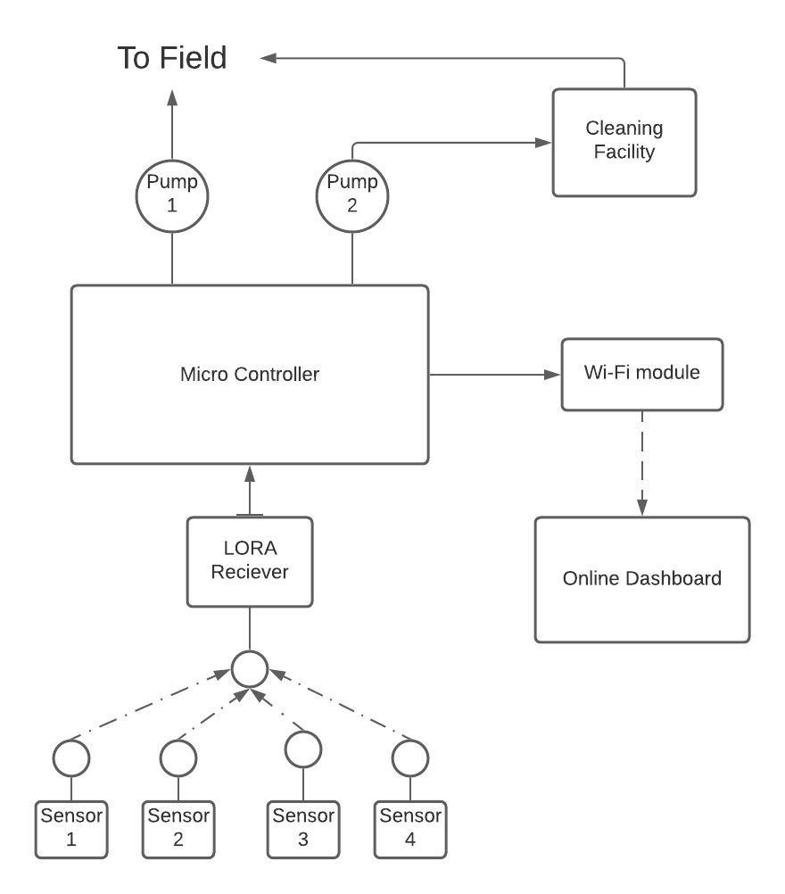

As can be seen, Figure 1 is showing the simple block diagram of the project architecture.

The sensors will communicate with the Microcontroller via the LORAWAN which will activate either Pump 1 or Pump 2 depending on the water quality and all the data will be sent to the online Dashboard [<12>].

Figure 1: Block Diagram of architecture

# Project Outcomes

* Using concepts of machine learning we would collect data regarding the quality of given water
* A working online dashboard would be designed where the user can upload data and can access it as and when required
* The capstone project will help determine if the water quality is good enough to be used for irrigation and therefore it would lead to increase in yield of crops

# Individual Roles

Umang Sharma (Team Leader): Implementation of the backend and collaborating the different technologies used in the project as well as the hardware and sensors used.

Suryansh Bhardwaj: Exploration and Implementation of the various Machine Learning algorithms that can be used and applied onto the data collected.

Prakhar Srivastava: Exploration and creation of the User Interface for the online Dashboard.

# Workplan

Table : Predicted Distribution of Capstone Work

Table 2 shows the predicted workplan for the Capstone project with the Yellow bars indicating exploration of the activity, and the green one as the Implementation of said activity.

# Course Subjects

The following subjects would be used for execution of Capstone project:

* For Pre-processing: Concepts of machine learning (regression analysis) will be used. (UCS409, UCS538, UML501)
* Computer programming will be used to write an efficient and neat code and basic html code will be used for the web interface. (UTA003, UTA018)
* The whole project will be put into a proper structure using the concepts of Software Engineering (UCS503)
* Arduino programming and microcontroller would be used for the sensors which will be designed in the capstone. The concept of IoT introduced in Engineering Design would be used. (UTA014)

# References

[9] Alex Keinan , New equipment allows for sampling, testing water in real time(2017).Available <https://www.foodengineeringmag.com/articles/96511-new-equipment-allows-for-sampling-testing-water-in-real-time>

[13] B. Das, P. Jain. Real-time water quality monitoring system using internet of things, in 2017 International Conference on Computer, Communications and Electronics (Comptelix), Jaipur, Rajasthan India, 1–2 July 2017. IEEE

[2] E. J. Williamson, Frank Wiersma ,L. O. Fine. A Study of the Sodium Adsorption Ratio and Residual Sodium Carbonate Concepts of Irrigation Waters as They Affect Exchangeable Sodium of Soil Under Semiarid Conditions. Available

<https://acsess.onlinelibrary.wiley.com/doi/abs/10.2136/sssaj1959.03615995002300040011x>

[14] G. Bruce Wiersma (2021). Environmental Monitoring and Assessment Vol.193. Available <https://www.springer.com/journal/10661>

[3] IEEE Internet of Things Journal. Issue 6, March15,-2021.Available <https://ieeexplore.ieee.org/xpl/mostRecentIssue.jsp?punumber=6488907>

[11] IEEE Wireless Communications.Issue 1, February-2021.Available <https://ieeexplore.ieee.org/xpl/mostRecentIssue.jsp?punumber=7742>

[12] Ismail Butun, Nuno Pereira, Mikael Gidlund. Analysis of LoRaWAN v1.1 security: research paper (2018). Available <https://www.researchgate.net/publication/325493576_Analysis_of_LoRaWAN_v11_security_research_paper>

[16] J. Shah, An internet of things based model for smart water distribution with quality monitoring. Int. J. Innov. Res. Sci. Eng. Technol. 6(3), 3446–3451 (2017). Available [http://dx.doi.org/10.15680/IJI RSET.2017.0603074](http://dx.doi.org/10.15680/IJI%20RSET.2017.0603074)

[15] Jeevan Jyoti Mohindru, Umesh Kumar Garg. Hydro-Chemical and Physico-Chemical Monitoring of Groundwater in North-West Region of Punjab, India- A Study Involving Analysis of Major Ions, Heavy Metal Ions and other Related Parameters, Vol. 33, No. 3.

[6] K. Saravanan, E. Anusuya, R. Kumar, Real-time water quality monitoring using Internet of Things in SCADA. Environ. Monit. Assess. 190(9), 556 (2018). [https://doi.org/10.1007/s10 661-018-6914-x](https://doi.org/10.1007/s10%20661-018-6914-x%20)

[8] M.C. Zin, G. Lenin, L.H.Chong, M. Prassana, Real-time water quality system in internet of things, in IOP Conference Series: Materials Science and Engineering, vol 495, no 1, p. 012021 (2019). <http://dx.doi.org/10.1088/1757-899X/495/1/012021>

[7] P. Liu, J. Wang, A.K. Sangaiah, Y. Xie, X. Yin, Analysis and prediction of water quality using LSTM deep neural networks in IoT environment. Sustainability 11(7), 2058 (2019).  [https:// doi.org/10.3390/su11072058/](%20https:/%20doi.org/10.3390/su11072058/%20)

[4] S. Wang, Z. Zhang, Z. Ye, X. Wang, X. Lin, S. Chen, Application of environmental internet of things on water quality management of urban scenic river. Int. J. Sustain. Dev. World Ecology. 20(3), 216–222 (2013). <https://doi.org/10.1080/13504509.2013.785040>

[1] Sophia Karastogianni, Stella T. Girousi. pH: Principles and Measurement. December 2016. Available <https://www.researchgate.net/publication/301702485_pH_Principles_and_Measurement>

[5] U. Shafi, R. Mumtaz, H. Anwar, A.M.Qamar, H. Khurshid, Surface water pollution detection using internet of things, in 2018 15th International Conference on Smart Cities: Improving Quality of Life Using ICT & IoT (HONET-ICT), Islamabad, Pakistan, 8–10h Oct 2018). IEEE

[10] VWM Vienna Water Monitoring Solutions. Source: [www.vienna-water-monitoring.com](http://www.vienna-water-monitoring.com/)