University of North Texas

Department of Computer Science and Engineering

Software Requirements Specification

October 2, 2019

Version 1.1

Point-of-sale system

Team: The QUADS

Members: Samikshya Luitel

Amit Pathak

Jenita Kawan

Umanga Mulmi

1.Introduction

    dfgsdgsdfgdfgdf

    In

**TABLE OF CONTENTS**

**1. INTRODUCTION….............................................................................................3**

1.1 PURPOSE..................................................................................................................................3

1.2 PRODUCT SCOPE ................................................................................................................3

1.3 DEFINITIONS, ACRONYMS AND ABBREVIATIONS.............................................3

1.4 REFERENCES AND ACKNOWLEDGMENTS............................................................4

**2. OVERALL DESCRIPTION..................................................................................4**

2.1 PRODUCT PERSPECTIVE..................................................................................................4

2.2PRODUCT FUNCTIONALITY..........................................................................................4

2.3INTENDED USERS AND CHARACTERISTICS.........................................................5

2.4 STAKEHOLDERS...................................................................................................................6

2.5 OPERATING ENVIRONMENT..........................................................................................6 2.6 DESIGN CONSTRAINTS.....................................................................................................6

**3. SPECIFIC REQUIREMENTS...............................................................................6**

3.1 EXTERNAL INTERFACE.......................................................................................................6

3.2 FUNCTIONAL REQUIREMENTS.......................................................................................7

**4. NON-FUNCTIONAL REQUIREMENTS............................................................8**

4.1 PERFORMANCE REQUIREMENTS...................................................................................8

4.2 OTHER REQUIREMENTS.....................................................................................................8

**1. Introduction**

**1.1 Purpose**

The specification document provides a complete elaboration of user interface and features of a Point of Sale

(POS) system. A POS system is a software that is used in managing sale of item in small retail shops and

restaurants. It servs as a central component for business where all the sales and inventory management are

performed. The main purpose of this project is to provide a web application for small business owners and

other retailers need a POS system. This web application is a simplified POS which makes daily retail

transactions including adding inventories, accepting cash payments and managing a team of employees.

**1.2 Product Scope**

This POS system is a web application that performs daily product sale transactions in retail business. Each item

in the inventory will have a fixed price set with it. It will also have feature of adding an inventory,

making a cash transaction which will allow customers to buy variety of items and sum it onto one total bill

which shows total amount due and the change amount due after the customer has paid.

This web application will also support employee clock-in feature which will allow employees to record their

work shift hour by entering their unique pin number. This will eventually help to eliminate the need to manual

shift hour recording and its verification.

The database of the application will just store the inventory items and also record the employee work hours.

The products will have their name and price stored in the system whereas the employee will have their name

and work time stored in the system.

**1.3 Definition, Acronyms and Abbreviations**

*POS* - Point-of-sale system, which is an application that manages a sale of items and products through various

means of hardware and software

*Administrator*- The person who has the highest control of the business and the system.

*MySQL*- A Structured Query Language (SQL) which used in management of database system.

*UI*- User Interface

phpMyAdmin- A database administration tool for web application hosting.

Scope

**1.4 References and Acknowledgement**

“What Are the System Requirements for Using the Web App?” *Browse Products*, support.logmeininc.com/gotowebinar/help/what-are-the-system-requirements-for-using-the-web-app-g2w090012.

Nicasio, Francesca. “Everything You Need to Know About POS Terminals.” *Vend Retail Blog*,19 Feb. 2019, <https://www.vendhq.com/blog/pos-terminals/>.

**2. Overall Description**

**2.1 Product perspective**

This web application basically serves the point of sale system where transactions take place within a retail

store more effectively and efficiently. The system will handle the product transaction process and cash payment

within the transaction. Also, this web application performs additional functions like managing inventories

and employees work shift to streamline the process of adding and removing products from the system and

recording the total hours worked by the employees. There exists numerous POS system in the market but

this web application is an add-on to the existing system with the main purpose of making the transactions

simple and easier.

The whole POS system will be entirely web based and any small business owners will be able to use and

maintain the system easily. The UI will consist of three grids to control the major functionalities using mouse

and keyboard.

The web application database will store the employee identification number to record their working hours

shift and also, the inventory of various products. The product register will be able to add various products

from the database in one transaction and add the total price of all products to be bought will be shown at the

bottom of the screen. The administrator control will work using the assigned admin id and will control the

functions like adding and removing employees and managing the inventory database.

**2.2 Product functionality**

* + 1. **Product Transaction System**

The transaction system will be the main function of this application which will allow employee to sell

the products to the customer. It will have the option of adding and deleting the product from customers

transaction and billing the customer in cash payment.

* + 1. **Employee Clock In/Out System**

The employee clock in/out system will provide a straightforward and easy process for employee to

record their work hour shift. Each employee will have a unique code assigned which will be used to

enter in the system to record the shift start and end time.

* + 1. **Administrator system**

This administrator system will allow the business owner or manager to manage their product

inventories, the administrator can add new products and delete or update the price of the product in

inventories anytime as per the need.

**2.3 Intended Users and Characteristics**

**2.3.1 Administrator**

Administrator is the person who will have the right to control everything in the system. While setting up as

administrator for the first time, the system will ask for his full name. After the name is set, a pin code will

appear in the screen. This pin needs to be entered every time the administrator tries to login otherwise, he

will not be able to access the system. As an administrator, he will be able to update the inventory of the store,

manage employee shifts, receive the payments from customers, authorize manager for the employee shifts.

[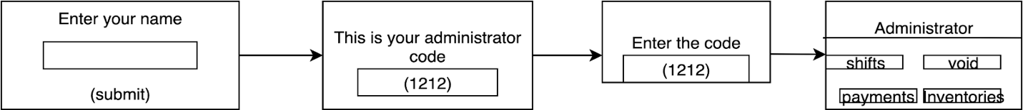](https://www.draw.io/?page-id=fWlRATEiqCHnJ2b5uzlt&scale=auto#G1WEIBaoVx0OahlHOXBmA80O_LmVbZtkq-)

**2.3.2 Manager**

Manager in the system is created by the administrator only. While setting up the manager for first time, the system will ask for his/her full name as well. The manager will be assigned with certain pin code by the administrator which s/he will need to log in the system. The managers can be changed depending on their work shifts. Once the manager is created, they will have authority to accept payments, void any transactions

.[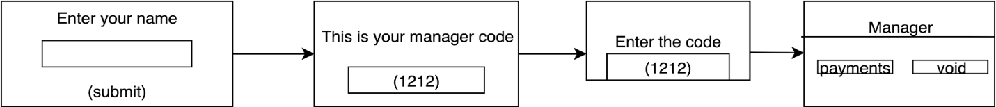](https://www.draw.io/?page-id=noL12HJ_MdzMALL3NhHl&scale=auto#G1MmIfz4kNzE43ZYF0ZYAZwktnTV-JEZ8S)

**2.3.3 Cashier**

Cashier in the system will also be created by the administrator. In the beginning of the setup, s/he will be asked with full name and then a pin code will be provided by the administrator. Cashier in the system will have minimal features. Cashier can only perform product sale to the customers.

[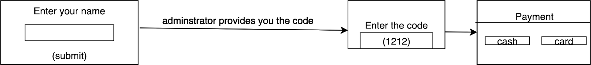](https://www.draw.io/?page-id=bt62ve3nZWHgjB3L7SEf&scale=auto#G17wR66fsVQx-Sz_9dkzsGunVt_cxJ3uxM)

* 1. **Stakeholders**

Business Owners

Administrators

Managers

Cashiers

Customers

* 1. **Operating Environment**

Operating System: Windows, Mac OS, Linux

Web Browser: Google Chrome, Firefox, Opera and other major web browsers.

**2.6 Design Constraints**

1. If we can have Android and IOS app or Windows app developed, the application can work without internet connection and faster with more end users.
2. Support for multiple language around the world.
3. Make the system and its content more secure.
4. Make the system load faster and smooth to use.

**3. Specific Requirements**

**3.1 External Interface**

External interface can be divided into four subdivisions. They are briefly described below:

**3.1.1 User Interface**

The user interface will be accessible via a computer web browser and the user interface will be easy to use and user friendly. This will make the application accessible to every people due to its simplistic nature and user-friendly interface.

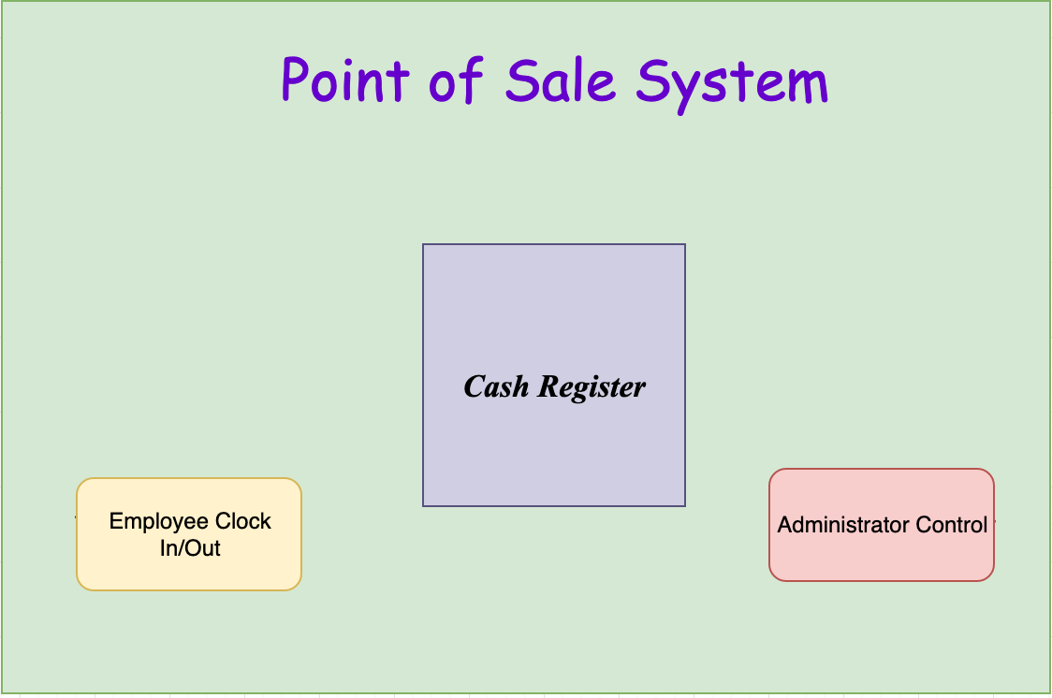

Fig: Main User Interface for POS

**3.1.2 Hardware Interface**

None

**3.1.3 Software Interface**

The system will be using phpMyAdmin for hosting our web application as we will be using MySQL for our database management.

* 1. **Functional Requirements**
     1. **Add and Remove Inventory**

The administrator will be able to add and delete the inventory items name and price in the system. This item can be then selected by cashier for transaction when the customer buys the item.

* + 1. **Perform Sale Transaction**

When the customer tries to bring the item for the buying the cashier should be able to perform the transaction. The cashier should be able to cash a sale by searching the item and adding it to the customers transaction.

* + 1. **Handle Employee Login**

The employee will be able to login and using their own unique pin. The employee will then be able to record their work hour shift into the system.

* + 1. **Process Cash Payment**

The system will be able to total the price of all item bough by the customer and then perform cash transaction. The cashier will be able to enter the total amount provided by the customer and the system will be able to display the change amount due to the customer at the bottom of the screen.

1. **Non-Functional Requirement**
   1. **Performance requirements**
2. The initial screen of the system will take time to load based on the speed of internet connection
3. The web application performance will also depend on hardware specification of the system used.
4. The product adding and deleting will be executed under 5 seconds.
5. The inventory database and employee database will be different.
6. The system has to support at least three users which are cashier, manager and administrator.

**4.2 Other requirements**

1. Usability

The web app will be easy to navigate, and its various button will be clear and easy to understand

so that any inexperienced person will also be able to use it with useful user experience.

1. Security requirements

Only the administrator will have full control of the system and any kind of authentication

should be saved in the system. All the users are uniquely identified with their pin number.