Web Design and Development

4COSC011W

Report

Author: Shashika Sellapperuma

Student ID:20221324

Group Number: P2

Student Role: 4

1. Introduction 2

2. Technical Discussion 7

Diagram (SVG) 7

Thumbnail Images 9

Page Editor Page 13

Extra content page relevant to topic 13

Use of provided navigation bar (adapted). 15

Challenges Faced 18

Solving Challenges 18

What I Learned 19

Addition CSS. 19

3. Webpage Validation Statement 20

4. Janet 20

References 20

Appendices 21

Appendix A: Code 21

Appendix B: Screenshots 21

Appendix C: Screenshots - Webpage Validation Evidence 21

Appendix D: Individual Statement 23

Appendix E: Task Completion Checklist 26

# Introduction

Abishanan Ganeshalingam

Student Role : 1

IIT NO :20220587

UoW NO : w1956085

Mohamad Mahdi

IIT NO :20221253

UoW NO :w1954064

Thananchjayan Mahendran

Student Role : 3

IIT NO: 20221235

UoW NO: w1954059

Shashika Sellapperuma

Student Role : 4

IIT NO :20221324

UoW NO:w1956104

Topic of the website : Sports

| **Group Coursework Meetings** (minimum 5 meetings, e.g., one per week) | | |
| --- | --- | --- |
| **1** | **Date & Time** | 25.02.2023  8.00 p.m. |
| **Objective:** | To agree website topic and assign student roles |
| **Attended:** | All students attended |
| **Your Contribution:** | **Gathering team members on time.** |
| **2** | **Date & Time:** | **26.02.2023**  **3.00 p.m.** |
| **Objective:** | **Finalize website topic and student roles.** |
| **Attended:** | All students attended |
| **Your Contribution:** | **Finalize the topic as the team leader.** |
| **3** | **Date & Time:** | **28.02.2023**  **8.00 p.m.** |
| **Objective:** | **Discussing individual task progression.** |
| **Attended:** | All students attended |
| **Your Contribution:** | **Discussing individual CW progression with the team.** |
| **4** | **Date & Time:** | **02.03.2023**  **8.00 p.m.** |
| **Objective:** | **Discussing individual task progression** |
| **Attended:** | All students attended |
| **Your Contribution:** | **Discussing individual CW progression with the team.** |
| **5** | **Date & Time:** | **04.03.2023**  **8.00 p.m.** |
| **Objective:** | **Updating individual task progression to the team** |
| **Attended:** | All students attended |
| **Your Contribution:** | **Discussing individual CW progression with the team.** |
| **6** | **Date & Time:** | **09.03.2023**  **8.00 p.m.** |
| **Objective:** | **Last meeting before a break for SDCW2** |
| **Attended:** | All students attended |
| **Your Contribution:** | **Giving everyone a break for SD2 CW.** |
| **7** | **Date & Time:** | **30.03.2023**  **8.00 p.m.** |
| **Objective:** | **Discussing individual task progression and when can everyone finish their work.** |
| **Attended:** | All students attended |
| **Your Contribution:** | **Discussing individual CW progression with the team.** |
| **8** | **Date & Time:** | **01.04.2023**  **3.00 p.m.** |
| **Objective:** | **Finalize website CSS** |
| **Attended:** | All students attended |
| **Your Contribution:** | **Suggesting nav bar css.** |
| **9** | **Date & Time:** | **03.04.2023**  **10.00 p.m.** |
| **Objective:** | **Final trial and error for the website** |
| **Attended:** | All students attended |
| **Your Contribution:** | **Doing final error checks.** |
| **10** | **Date & Time:** | **5.04.2023**  **3.00 p.m.** |
| **Objective:** | **Merging the website.** |
| **Attended:** | All students attended |
| **Your Contribution:** | **Finishing and submitting the CW.** |
|  | | |

# Technical Discussion

Student 4 Tasks:

# Diagram (SVG)

<ellipse cx="750" cy="400" rx="85" ry="55" stroke="red" stroke-width="3" fill="url(#grad-eclipse)" />

Creating an ellipse using svg ellipse element.

cx: for the x coordinate of the center of the ellipse

cy: for the y coordinate of the center of the ellipse

rx: for the horizontal radius of the ellipse

ry: for the vertical radius of the ellipse

stroke and stroke-width: for the color and the width of the ellipse border

fill: for the color in the interior of the ellipse

<circle cx="210" cy="700" r="40" stroke="red" stroke-width="3" fill="url(#grad-circle)" />

Creating a circle using svg ellipse element.

cx: for the x coordinate of the center of the circle

cy: for the y coordinate of the center of the circle

r: for the radius of the circle

stroke and stroke-width: for the color and width of the circle border

<radialGradient id="grad-eclipse" cx="50%" cy="50%" r="50%" fx="50%" fy="50%">

                <stop offset="0%" style="stop-color:rgb(241, 14, 14);stop-opacity:0" />

                <stop offset="100%" style="stop-color:rgba(26, 26, 2, 0.637);stop-opacity:1" />

              </radialGradient>

              <radialGradient id="grad-circle">

                <stop offset="10%" style="stop-color: red;"/>

                <stop offset="95%" style="stop-color: rgba(26, 26, 2, 0.637);"/>

              </radialGradient>

id: for the identifier of the gradient

fx and fy: for the x and y coordinate of the focal point of the gradient

offset: for the exact position the given color should stop and start

 <g id="gallery">

                <circle cx="1290" cy="700" r="40" stroke="red" stroke-width="3" fill="url(#grad-circle)" />

                <a href="w1956104_gallery.html">

                    <text x="1290" y="700" text-anchor="middle" fill="white" font-size="10px" font-family="Arial" dy=".3em">Gallery</text>

                </a>

id: for the identifier of the circle

fill url: is to implement the structured grad-circle color in the top

a href: when ‘clicked’ it goes to the relevant link

text: for the text inside the svg circle and ellipse

background-repeat: no-repeat;

background-attachment: fixed;

no repeat: to prevent the image from repeating

fixed: to keep the image in one position as the user scrolls

background-clip: text;

webkit-background-clip: text;

to clip the background image with the text of the header

svg g:hover polyline,

svg g:hover line{

    fill: none;

    stroke-width: 2;

    stroke: black;

}

Inside the svg element , when it is hovered over by a mouse, the fill will be ‘none’ and the stroke width will be increased to 2, color to black.

svg g:hover polygon,

svg g:hover rect,

svg g:focus polygon,

svg g:focus rect{

    fill: hsla(24, 63%, 26%, 0.3);

    stroke: rgb(172, 41, 41);

    stroke-width: 2;

When svg image is hovered fill color is set to hsla 24 64% 26% 0.3 color and the stroke color is set to rgb(172,41,41) ,stroke width to 2.

a{

    color: whitesmoke;

}

a: sets all the link colors to whitesmoke

# Thumbnail Images

<meta charset="UTF-8">

    <meta http-equiv="X-UA-Compatible" content="IE=edge">

    <meta name="viewport" content="width=device-width, initial-scale=1.0">

    <title>Gallery</title>

<meta charset = ”UTF-8”>: is for the character encoding in the code,UTF-8 supports a wide range of characters.

<meta http-equiv=”X-UA-Compatible” content =”IE-edge”>: is to use the latest version of the internet explorer.

viewport: is for the viewport properties of the webpage. This ensures the scale is correct on mobile devices.

<div class="buttons">

    <!-- Color scheme buttons -->

      <button class="color-scheme-btn" onclick="setColorScheme('1')">Grey</button>

<!-- Font size buttons -->

      <button class="font-size-btn" onclick="increaseFontSize()">Text Font Size+</button>

color-scheme-btn and font-size-button: when clicked using java script it will change background color and font size

<div class="gallery">

    <div class="thumbnail">

      <h2>Ben Stokes the world cup hero</h2>

      <div class="image"><img src="images/cricket (1).jpg" alt="Thumbnail1">

          <p class="description">The defining moment of Ben Stokes' ODI career intersects with that of English cricket - the 2019 World Cup final triumph. The Christchurch-born all-rounder was instrumental in England's win on boundary count in the summit clash against New Zealand</p>

      </div>

    </div>

      <div class="popupimage">

          <span>&times;</span>

          <img src="images/cricket (1).jpg" alt="Thumbnail1">

      </div>

div element with the class “gallery” contains all the images in the gallery.

div element with class “thumbnail” contains a thumbnail image and description.

alt attribute: displayed text if the image cannot be displayed.

div class=”pop up image” : contains the pop up image.

<span>&items;</span>: this is a ‘span’ element that displays a ’x’ to close the pop up image.

.color-scheme-btn {

    text-align: center;

    display: inline-block;

    padding: 10px;

    border-radius: 50%;

    margin: 40px;

    cursor: pointer;

    background-image: linear-gradient(45deg, #f4f3f6, #1c0905);

  }

The buttons will be centered horizontally.

Border radius 50% and padding 10px will give the buttons circular shape.

When hovered the cursor will change to a pointer.

Background button will be linear gradient (45degree angle, starting color #f4f3f6, ending color #1c0905)

.thumbnail img {

    position: absolute;

object-fit: cover;

    transition: transform .5s;

Position absolute, so it takes the entire space of the container.

Object fit cover: image contains the correct ratio without starching.

transform .5s : for a smooth transition when it changes the scale.

.thumbnail:hover img {

    transform: scale(1.1);

  }

When hovered the image will be scaled up by 10%(zoom effect).

transform : it is combined with ‘:hover’ to apply the zoom only when hovered around it.

  .thumbnail:hover .description {

    opacity: 1;

  }

  .popupimage{

    position: fixed;

    height: 100%;

    width: 100%;

    z-index: 100;

    display: none;

  }

  .popupimage img{

    position: absolute;

    top: 10%; left: 50%;

    height: 500px;

    width: 750px;

    transform: translate(-50%, -50%);

    object-fit: cover;

  }

  .popupimage span{

    color: #ffffff;

    position: absolute;

    cursor: pointer;

    font-size: 100px;

    left: 26%;

    z-index: 100;

    top: -28%;

  }

Thumbnail :hover .description: when hovered the .description will become visible by setting the opacity to 1.

z-index 100: to ensure that the pop up image is being displayed on top of other elements in the page.

display: none is to initially hide the pop up image.

object-fit: cover that the image fills the available space without damaging the ratio.

pop up span; to set the close button to the top left corner of the pop up image.

function setColorScheme(scheme) {

    const body = document.querySelector('body');

    if (scheme === '1') {

      body.style.color = '#333';

      body.style.backgroundColor = '#2F4F4F';

    } else if (scheme === '2') {

      body.style.color = '#333';

      body.style.backgroundColor = '#000000';

    } else if(scheme==='3'){

      body.style.color = '#333';

      body.style.backgroundColor = '#483D8B';

    } else if(scheme==='4'){

      body.style.color = '#333';

      body.style.backgroundColor = '#DC143C';

    } else if(scheme==='5'){

      body.style.color = '#333';

      body.style.backgroundColor = '#FF00FF';

    } else if(scheme==='6'){

      body.style.color = '#333';

      body.style.backgroundColor = '#008000';

    }

    else if(scheme==='7'){

      body.style.color = '#fff';

      body.style.backgroundColor = '#800080';

    }

  }

  function increaseFontSize() {

    const currentFontSize = parseFloat(getComputedStyle(document.body).fontSize);

    const newFontSize = currentFontSize + 1;

    document.body.style.fontSize = newFontSize + 'px';

  }

  function decreaseFontSize() {

    const currentFontSize = parseFloat(getComputedStyle(document.body).fontSize);

    const newFontSize = currentFontSize - 1;

    document.body.style.fontSize = newFontSize + 'px';

  }

  document.querySelectorAll('.thumbnail img').forEach(Image=>{

    Image.onclick=()=>{

        document.querySelector('.popupimage').style.display='block'

        document.querySelector('.popupimage img').src=Image.getAttribute('src');

    }

});

document.querySelector('.popupimage span').onclick=()=>{

    document.querySelector('.popupimage').style.display='none';

}

The ‘setColorScheme’ function takes a scheme parameter ,using a for loop it changes the color of the web page depending on the value of the parameter.

‘increaseFontSize’ and ‘decreaseFontSize’ function : when clicked it increases and decreases the font size by 1 pixel.

When an image is clicked it opens the attached image in a pop up window, window has a close button that hides the image when clicked.

  }

# Page Editor Page

<div class="background">

            <div class="the_main_image" >

                <img src="images/IMG_20221212_192800.jpg">

            </div>

Element class name=background.

<a href="#bottom">Jump to bottom</a>

 <a name="bottom" id="bottom"></a>

Two anchor elements, href attribute set to #bottom , when clicked on the link it will take the user to the element in the page that has id=bottom.

<a href="w1956104_SVG.html">Link to SVG Diagram</a>

<a href="w1956104_gallery.html">Link to Gallery</a>

<a href="esportsdemo.html">Link to Extra Conten</a>

This anchor elements has href attribute set to different html files.

When clicked on the link it will take the user to the relevant web page.

.background{

                text-align: center;

All the content text in the background will be centered.

# Extra content page relevant to topic

 <div class="Back_to_main"><a href="w1954064.html" target="_blank"><span>&#8592;</span> Home</a></div>

The anchor element with ‘href’ attribute is set to “w1956064.html” file.

When clicked it will open that html file in the web page.

Span element with ‘left arrow key’ character creates a left pointing arrow that appears with the HOME in the link.

        <div class="the_navigation">

          <nav>

            <ul>

              <li><a href="#about">About</a></li>

              <li><a href="#history">History</a></li>

              <li><a href="#games">Games</a></li>

              <li><a href="#teams">Teams</a></li>

              <li><a href="#events">Events</a></li>

            </ul>

          </nav>

Inside the div element using the ‘nav’ element , there is an unordered list containing five list items with anchor element ‘a’ with ‘href’ that works as a navigation bar in the web page.

        <div class="card"><img src="images/pexels-rodnae-productions-7915501.jpg" alt=""></div>

Creates a div element with a class name of ‘card’ that contains images.

<a href="#top">Jump to top</a>

Two anchor elements, href attribute set to #top , when clicked on the link it will take the user to the element in the page that has id=top.

p {

    color: whitesmoke;

}

All the paragraphs in the body will get color as whitesmoke.

.card {

    float: left;

    margin: 10px;

    width: 350px;

    height: 354px;

    background: rgb(236, 236, 236);

    box-shadow: rgba(0, 0, 0, 0.4) 0px 2px 4px, rgba(0, 0, 0, 0.3) 0px 7px 13px -3px, rgba(0, 0, 0, 0.2) 0px -3px 0px inset;

}

.card img{

    height: 100%;

    width: 100%;

}

a{

  color: whitesmoke;

}

float: left; floats the pictures left to it’s container.

box-shadow: element will give the card element a 3D appearance.

.card img: height100%;width 100% to fit the image neatly inside the card.

.a color: whitesmoke Change all link colors to whitesmoke.

# Use of provided navigation bar (adapted).

<header class="header">

            <div class="container_1">

                <div class="logo">

                    <a href="w1954064.html" target="_blank"><img src="images/logo-image.jpg" alt=""></a>

                </div>

                <nav class="navbar">

                    <a href="w1954064.html" class="active">

                        <button class="btn" id="dropbtn">

                            Home

                        </button>

                    </a>

                    <a href="w1954064_Comments.html">

                        <button class="btn">

                            Comments

                        </button>

                    </a>

                    <a href="#" target="_blank">

                        <button class="btn">

                            Shop

                        </button>

                    </a>

                    <a href="#" target="_blank">

                        <button class="btn">

                            Quiz

                        </button>

                    </a>

                    <a href="w1956104_SVG.html" target="">

                        <button class="btn">

                            Site-Map

                        </button>

                    </a>

                    <a href="w1956104_gallery.html" target="">

                        <button class="btn">

                            Gallery

                        </button>

                    </a>

                    <a href="#" target="_blank">

                        <button class="btn">

                            About-Us

                        </button>

                    </a>

                    <a href="#"></a>

                </nav>

            </div>

        </header>

Inside the header section there’s a container, logo, and navigation bar. Navigation bar includes links as buttons including Home,Shop,Comment,Site-Mpa,Gallery,Quiz.

* {

    margin: 0;

    padding: 0;

    font-family: 'poppins', sans-serif;

    box-sizing: border-box;

}

.header {

    height: 75px;

    position: fixed;

    top: 0;

    left: 0;

    width: 100%;

    background: #ffffff;

    display: list-item;

    justify-content: space-between;

    align-items: center;

    z-index: 100;

}

*/ .container_1 {

    z-index: 1;

    height: 90px;

    width: 150%;

    background: #ffffff;

    place-items: center;

    box-shadow: 0 3px 20px rgba(0, 0, 0, 0.5);

}

.navbar a {

    font-size: 18px;

    margin: 0 0px;

    font-weight: 400;

    position: relative;

    left: 680px;

    top: 18px;

}

.navbar {

    list-style: none;

    display: flex;

    flex-direction: row;

}

.logo img {

    position: absolute;

    top: 0px;

    left: 60px;

    height: 75px;

    width: 155px;

}

.btn {

    font-size: 15px;

    color: #000000;

    font-family: inherit;

    font-weight: 800;

    cursor: pointer;

    position: relative;

    border: none;

    margin-left: 40px;

    top: -30px;

    background: none;

    text-transform: uppercase;

    transition: 0.2s;

}

.btn:focus,

.btn:hover {

    color: #1640ca;

}

.btn:focus:after,

.btn:hover:after {

    width: 100%;

    left: 0%;

}

.btn:after {

    content: "";

    bottom: -28px;

    left: 50%;

    position: absolute;

    width: 0%;

    height: 2px;

    background-color: #1640ca;

    transition-duration: 400ms;

    transition-property: width, left;

}

The header has a white background, navigation links are styled as buttons.

The logo is positioned at the left hand side in the header .

Navigation links are vertically cantered within it.

## Challenges Faced

While adapting nav bar for the site map ,nav bar text and logo position changed.

When merging all the web sites we had technical difficulties and styling theme was not the same for everyone.

Creating the pop-up using java script was challenging due to lack of information on it.

After creating svg elements using java script I could not get the location of the file that needed to the link.

## Solving Challenges

For the site map nav bar, I had to change the position of the links , background color of the logo in order to match the original nav bar.

We had to change the styling after merging , so that the web site looks the same.

Asked a friend for help and got the answers, then studied it by my self. After I fully understood the java script method for the pop up image I used it in my code.

I had to change the folder in order to find the correct html file, but then all the html files will not be in the same folder. So I changed the method using <a href=””> attribute instead of java script.

## What I Learned

Learned how to create a website according to Janet Regulations.

Learned how to give and receive feedback to team members.

Learned advanced html, CSS throughout the course work.

# Addition CSS.

<radialGradient id="grad-eclipse" cx="50%" cy="50%" r="50%" fx="50%" fy="50%">

                <stop offset="0%" style="stop-color:rgb(241, 14, 14);stop-opacity:0" />

                <stop offset="100%" style="stop-color:rgba(26, 26, 2, 0.637);stop-opacity:1" />

              </radialGradient>

              <radialGradient id="grad-circle">

                <stop offset="10%" style="stop-color: red;"/>

                <stop offset="95%" style="stop-color: rgba(26, 26, 2, 0.637);"/>

              </radialGradient>

Id: for the identifier of the gradient

Fx and Fy: for the x and y coordinate of the focal point of the gradient

Offset: for the exact position the given color should stop and start

.thumbnail img {

    position: absolute;

object-fit: cover;

    transition: transform .5s;

Position absolute, so it takes the entire space of the container.

Object fit cover: image contains the correct ratio without starching.

transform .5s : for a smooth transition when it changes the scale.

.thumbnail:hover img {

    transform: scale(1.1);

  }

When hovered the image will be scaled up by 10%(zoom effect).

transform : it is combined with ‘:hover’ to apply the zoom only when hovered around it.

  .thumbnail:hover .description {

    opacity: 1;

Thumbnail :hover .description: when hovered the .description will become visible by setting the opacity to 1.

z-index 100: to ensure that the pop up image is being displayed on top of other elements in the page.

# Webpage Validation Statement

Only error: Html file naming was not long enough. But we have to use the naming convention given in the CW description.

# Janet

Joint Academic Network, or the JANET regulations and guidelines were used in the website.

Security, data protection, acceptable use, accessibility are some key areas that we considered .

Website has appropriate security measures in order to protect itself from unauthorized access.

Website complies with data protection legislation.

JANET’s acceptable Use Policy, used the guidelines for appropriate network and services.

# References

GettyImages,Cricket,Sports,<https://www.gettyimages.com/search/2/image?family=creative&phrase=cricket>[Accessed on 5.03.2023]

GettyImages,Football,Sports,<https://www.gettyimages.com/search/2/image?family=creative&phrase=cricket>[Accessed on 5.03.2023]

GettyImages,E-Sports,Sports,<https://www.gettyimages.com/search/2/image?family=creative&phrase=cricket>[Accessed on 5.03.2023]

GettyImages,Badminton,Sports,<https://www.gettyimages.com/search/2/image?family=creative&phrase=cricket>[Accessed on 5.03.2023]

Wallpaper Free,Sports, [https://wallpapercave.com/search?q=badminton [Accessed](https://wallpapercave.com/search?q=badminton%20%5bAccessed) on 6.03.2023]

# Appendices

## Appendix A: Code

Provide a full listing of your files, with well indented and commented code in the following format:

* Filename
* Code

## Appendix B: Screenshots

Provide a screenshot of all your web pages, in the following format:

* Filename
* Screenshot(s)

## Appendix C: Screenshots - Webpage Validation Evidence

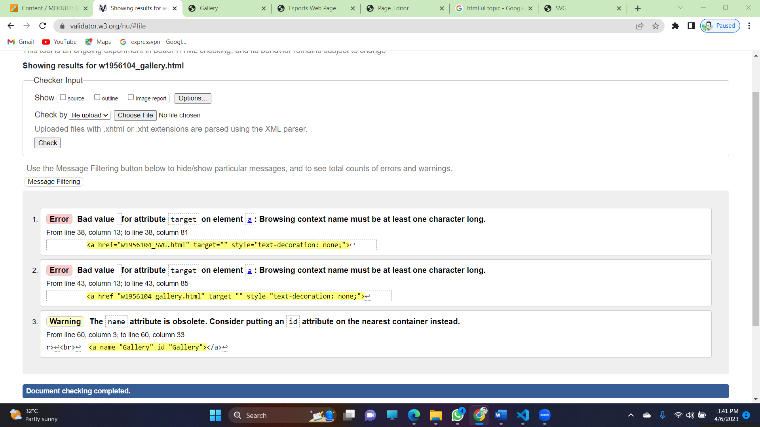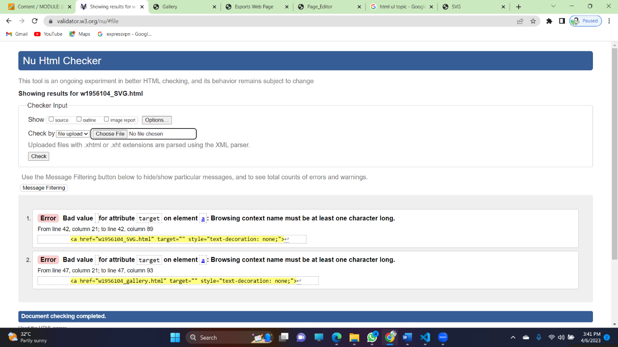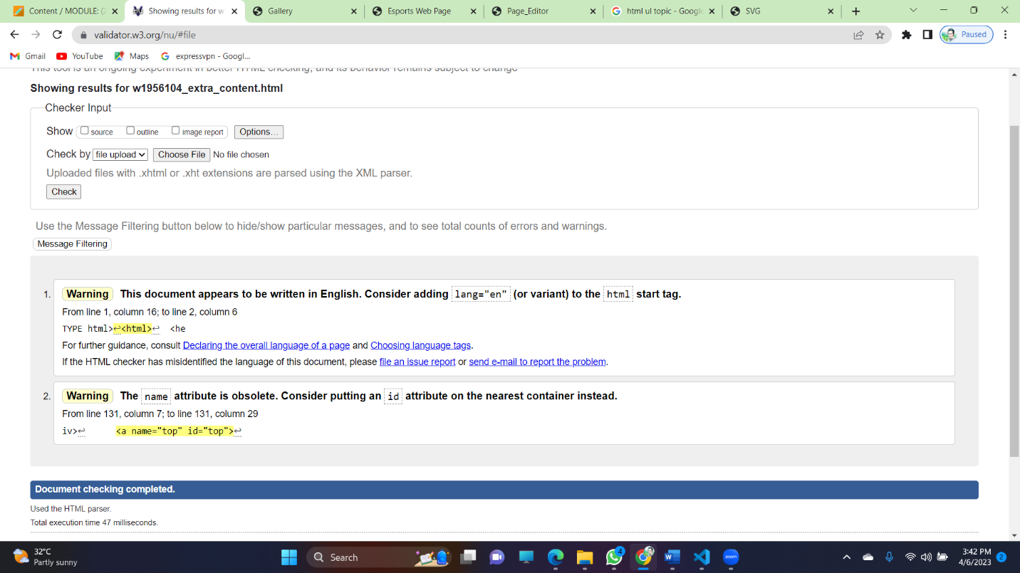

## Appendix D: Individual Statement

| Student Name: | Shashika Sellapperuma | Student Id: | 20221324 |
| --- | --- | --- | --- |
| State what tasks you carried out in the project. | | | |
| Gallery  SVG Site Map  Extra-Content-Page(E-Sports)  Page-Editor | | | |
| State what you enjoyed and did not enjoy about teamwork. | | | |
| Making new friends. | | | |
| State what you learnt about teamwork. | | | |
| Time management, work load management. | | | |
| State what skills you gained/learnt from undertaking the project. | | | |
| Time management | | | |
| State any strengths about yourself that emerged whilst undertaking the project. | | | |
| Leadership | | | |
| State any weaknesses about yourself that emerged whilst undertaking the project. | | | |
| Doing validations in the last minute. | | | |
| State how you would do things better if you were to undertake the project again. | | | |
| Do the validations while doing the code not after. | | | |
| Additional general or project specific comments: | | | |
|  | | | |

## Appendix E: Task Completion Checklist

Complete the table to indicate if any of your tasks were not completed or partially completed.

| **Student 1 Tasks** | **Completed** | | | **Student Comments** |
| --- | --- | --- | --- | --- |
| **Yes** | **No** | **Partially** |
| 1 - Presentation Page |  |  |  |  |
| 2a - Main (Home) Page |  |  |  |  |
| 4 - Buy products |  |  |  |  |
| 9b - External CSS (9a reused) |  |  |  |  |
| 10 - Extra content page/anchors |  |  |  |  |
| 11 - Page Editor |  |  |  |  |
| 12 - Logo/Page Editor |  |  |  |  |
| 13 - Additional Interactivity |  |  |  |  |
| 14 - Uploaded to Server |  |  |  |  |

| **Student 2 Tasks** | **Completed** | | | **Student Comments** |
| --- | --- | --- | --- | --- |
| **Yes** | **No** | **Partially** |
| 2a - Main (Home) Page |  |  |  |  |
| 2b - Main site navigation |  |  |  |  |
| 3 - Query Form |  |  |  |  |
| 9b - External CSS (9a reused) |  |  |  |  |
| 10 - Extra content page/anchors |  |  |  |  |
| 11 - Page Editor |  |  |  |  |
| 12 - Logo/Page Editor |  |  |  |  |
| 13 - Additional Interactivity |  |  |  |  |
| 14 - Uploaded to Server |  |  |  |  |

| **Student 3 Tasks** | **Completed** | | | **Student Comments** |
| --- | --- | --- | --- | --- |
| **Yes** | **No** | **Partially** |
| 2a - Main (Home) Page |  |  |  |  |
| 6 – Quiz |  |  |  |  |
| 8 - Student details |  |  |  |  |
| 9b - External CSS (9a reused) |  |  |  |  |
| 10 - Extra content page/anchors |  |  |  |  |
| 11 - Page Editor |  |  |  |  |
| 12 - Logo/Page Editor |  |  |  |  |
| 13 - Additional Interactivity |  |  |  |  |
| 14 - Uploaded to Server |  |  |  |  |

| **Student 4 Tasks** | **Completed** | | | **Student Comments** |
| --- | --- | --- | --- | --- |
| **Yes** | **No** | **Partially** |
| 2a - Main (Home) Page | **Yes** |  |  |  |
| 5 - Diagram (SVG) | **Yes** |  |  |  |
| 7 - Thumbnail images | **Yes** |  |  |  |
| 9b - External CSS (9a reused) | **Yes** |  |  |  |
| 10 - Extra content page/anchors | **Yes** |  |  |  |
| 11 - Page Editor | **Yes** |  |  |  |
| 12 - Logo/Page Editor | **Yes** |  |  |  |
| 13 - Additional Interactivity | **Yes** |  |  |  |
| 14 - Uploaded to Server | **Yes** |  |  |  |