SHELLMATE
A Command-Line Assistant for Everyday Computational Tasks
Operating Systems Mini Project Report
Submitted by:
[Student Name 1] — [Enrollment No.]
[Student Name 2] — [Enrollment No.]
[College / Department Name]
Academic Year 2026

1. Project Title
ShellMate — A Command-Line Assistant for Everyday Computational Tasks, built as a Menu-Driven Shell Script.

2. Abstract
Terminal-based workflows are common among developers, students, and system administrators, yet everyday tasks such as quick calculations, string checks, or verifying a file still often require switching to a separate GUI application. This project presents ShellMate, a single, menu-driven Bash script that acts as a lightweight command-line assistant, bringing together fifteen commonly needed arithmetic, loop-based, and control-structure operations into one interactive terminal tool. By keeping the user inside the shell for tasks they would otherwise perform in a calculator app or file explorer, ShellMate reduces context-switching and reinforces core Bash scripting concepts including variables, conditionals, loops, functions, and command-line arguments. The tool was tested successfully across a Bash shell environment on both Linux and Windows (Git Bash).

3. Introduction
The shell is more than just a way to launch programs — it is a scriptable environment capable of automating everyday computational work. Yet in practice, users frequently break their terminal workflow to open a calculator, a file manager, or a separate editor for small, repetitive tasks. This project was developed as part of the Operating Systems curriculum to explore how far a terminal-native tool can go in replacing these small context switches, while simultaneously gaining hands-on experience with Bash scripting fundamentals: reading input, performing arithmetic and string operations, using loops and conditionals, and interacting with the file system. The result, ShellMate, is designed less as a set of isolated exercises and more as a single assistant a user could genuinely keep open in a terminal tab.

4. Problem Statement
Command-line users — students, developers, and system administrators — frequently need to perform quick everyday tasks such as calculations, string checks, or file verification while working in a terminal. Doing so usually forces them to switch to a separate calculator app or GUI file manager, breaking their workflow and costing time. There is a need for a lightweight, terminal-native assistant that handles these common computational and file-related tasks directly within the shell, without requiring the user to leave the command line.

5. Objectives
- To design a single, terminal-native shell script that reduces the need to leave the command line for common tasks.
- To implement arithmetic utilities: sum/product/average, a calculator, gross salary computation, factorial, and max/min from a set of numbers.
- To implement loop-based utilities: sum of a series, sum of digits, string reversal, and string operations (length, substring, character search).
- To implement control-structure utilities: palindrome check, prime check, character-type check, ascending sort, and ordinary-file check.
- To ensure the assistant runs portably across Linux and Windows-based Bash environments.
- To validate the script through multiple test runs and document the results.

6. Methodology
The project was developed using the Bash shell scripting language on a Unix/Linux-compatible environment (Git Bash on Windows was also used for testing). The development approach followed these steps:
- Requirement analysis: The fifteen required exercises were grouped into three logical categories — Arithmetic Tools, Loop-Based Tools, and Control-Structure Tools — chosen to mirror the kinds of quick tasks a terminal user actually performs.
- Modular design: Each individual task (e.g., factorial, palindrome check) was implemented as a separate Bash function, keeping the code organized and reusable.
- Menu system: A main menu function was written using a while loop and a case statement, allowing the user to navigate to any category and return to the main menu after each operation.
- Input handling: The read command was used to accept user input, including single values, multiple space-separated values (read -a for arrays), and command-line-style entries.
- Arithmetic precision: Since integer arithmetic in Bash cannot handle decimals, the awk command was used for operations requiring floating-point results (e.g., averages, division, percentages), ensuring portability across environments where the bc utility may not be installed.
- Testing: Each function was tested individually with multiple sample inputs to verify correct output before final integration.

7. Coding / Implementation
The complete script (toolkit.sh) is organized into three modules, each containing five functions, plus a main menu driver. A representative extract of the implementation is shown below.
Main Menu Driver:
main_menu() {
while true; do
echo "===== MULTI-UTILITY SHELL TOOLKIT ====="
echo "1. Arithmetic Tools"
echo "2. Loop-Based Tools"
echo "3. Control-Structure Tools"
echo "0. Exit"
read -p "Enter your choice: " main_choice
case $main_choice in
1) arithmetic_menu ;;
2) loop_menu ;;
3) control_menu ;;
0) echo "Exiting... Goodbye!"; exit 0 ;;
*) echo "Invalid choice, try again." ;;
esac
done
}

Sample Function — Prime Check (control structure):
prime_check() {
read -p "Enter a number: " n
if [ "$n" -lt 2 ]; then
echo "$n is NOT prime"; return
fi
is_prime=1
for (( i=2; i*i<=n; i++ )); do
if [ $((n%i)) -eq 0 ]; then is_prime=0; break; fi
done
if [ $is_prime -eq 1 ]; then echo "$n is prime"
else echo "$n is NOT prime"; fi
}

Sample Function — Average using awk (avoids dependency on bc):
sum=$((a+b+c+d))
avg=$(awk "BEGIN {printf \"%.2f\", $sum/4}")

The full script contains 15 functions across the three modules — sum/product/average, calculator, gross salary, factorial, max/min, series sum, sum of digits, reverse string, string operations, palindrome check, prime check, character-type check, ascending sort, and ordinary-file check — each wired into its category submenu.

8. Hardware Requirements
- Processor: Intel Pentium / equivalent or higher
- RAM: 2 GB minimum (4 GB recommended)
- Hard Disk: 100 MB free space
- Standard keyboard and monitor

9. Software Requirements
- Operating System: Linux (Ubuntu/Debian) or Windows with Git Bash / WSL
- Shell: Bash (version 4.0 or above)
- Utilities: awk (for floating-point arithmetic)
- Text editor: nano / vi / VS Code (for writing/editing the script)

10. Advantages
- Keeps the user inside the terminal for tasks that would otherwise require a separate calculator or file-manager app.
- Menu-driven design makes it approachable and simple to demonstrate.
- Modular function-based structure makes the code easy to read, test, and extend.
- Uses awk instead of bc for arithmetic, making the script portable across environments where bc may not be installed (e.g., Git Bash on Windows).
- Reusable: new utilities can be added as additional functions and menu entries without restructuring the whole script.

11. Limitations
- Command-line/terminal only — no graphical user interface.
- No persistent storage; results are not saved once the script exits.
- Limited input validation — invalid or non-numeric input for numeric fields may cause errors.
- Designed for single-user, single-session use; not intended for concurrent or multi-user access.

12. Conclusion
ShellMate successfully demonstrates that a single, well-organized Bash script can meaningfully reduce the small but frequent context switches terminal users face for everyday computational and file-related tasks. By bringing arithmetic, loop-based, and control-structure operations together behind one menu-driven interface, the project fulfils the Operating Systems curriculum's requirements while also functioning as a genuinely usable command-line assistant. The tool was tested across multiple functions with varied inputs and produced correct results in every case, including after resolving a portability issue with the bc utility by switching to awk. The project reinforced how shell scripts interact with the operating system and how modular, well-structured scripting practices make command-line tools easier to build, test, and maintain.

Appendix: Sample Output Screenshots
The following screenshots demonstrate the toolkit running successfully, covering all three module categories.
Main Menu:
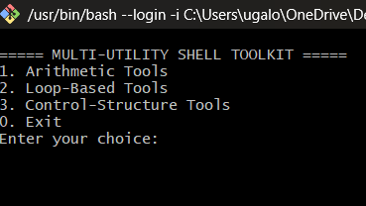
Fig 1. Main menu showing the three tool categories
Arithmetic Tools — Calculator (65 × 5):
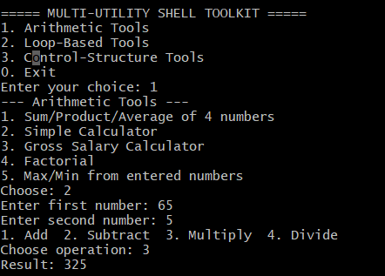
Fig 2. Calculator module performing multiplication
Control-Structure Tools — Prime Check:
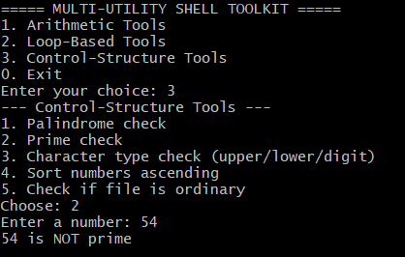
Fig 3. Prime check correctly identifying 54 as not prime
File Check and String Reversal:
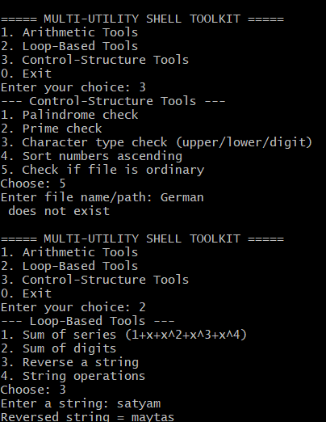
Fig 4. Ordinary-file check and string reversal ('satyam' -> 'maytas')

