Steps to open VDI
Important Note –
- Make sure your C drive or D drive has atleast 100GB space (as shown below)

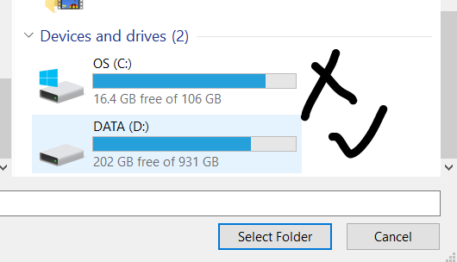
- Download the below ZIPPED file on your laptop
- https://vsd-labs.sgp1.cdn.digitaloceanspaces.com/vsd- labs/cmos.zip
- Unzip the downloaded file which is having 7nm virtual disk image. This is very important in setting up the virtual machine.
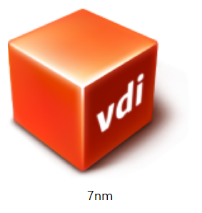
- Follow the below instructions starting from the next page.

Windows

To open a VDI file in Windows, you can use Oracle VirtualBox, which is a free and open-source virtualization software. Here are the steps to open a VDI file in Windows using VirtualBox:

  - Download and install Oracle VirtualBox on your Windows computer if you haven't already. You can download it from the official website: https://www.virtualbox.org/wiki/Downloads
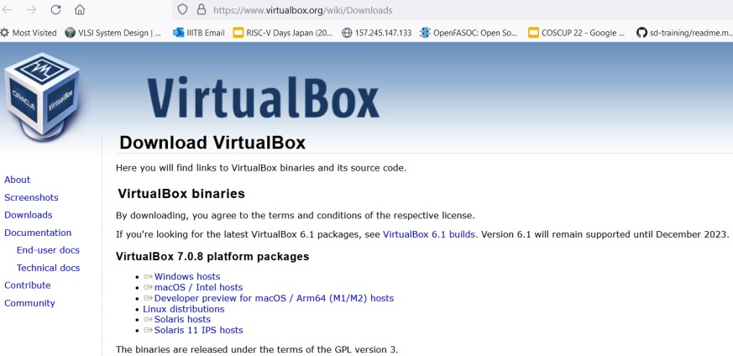

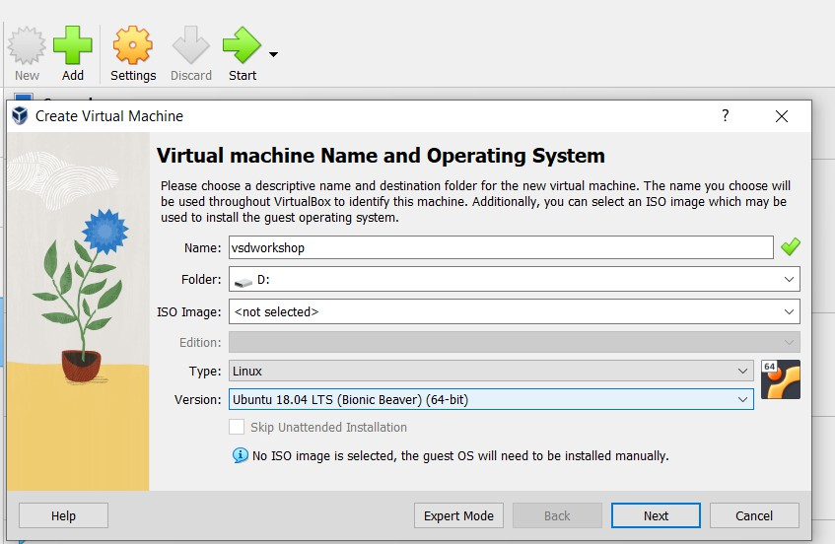
  - Launch VirtualBox and click on the "New" button to create a new virtual machine. Fill up the details as shown in the image below.

  - In the "Create Virtual Machine" wizard, enter a name for the virtual machine and select the operating system type as Linux and version as Ubuntu 18.04 that matches the one installed in the VDI file you want to open
  - On the next screen, allocate memory
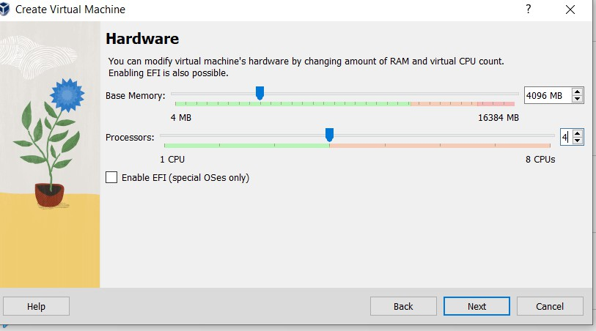
  - Create a virtual hard disk. Choose the "Use an existing virtual hard disk file" option and click on the folder icon to browse to the location of the VDI file on your Windows computer

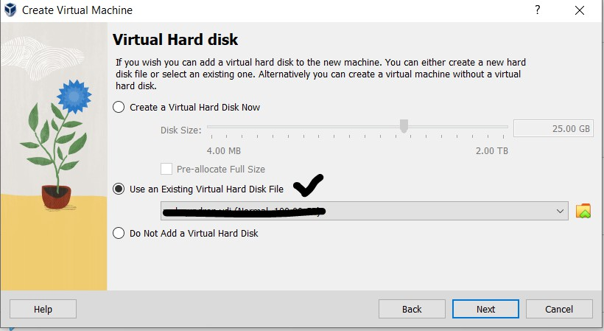
  - Select the VDI file which you have download/unzipped and click "Open" to add it to the virtual machine configuration. Follow steps in order of 1, 2, 3, 4 as shown in below image

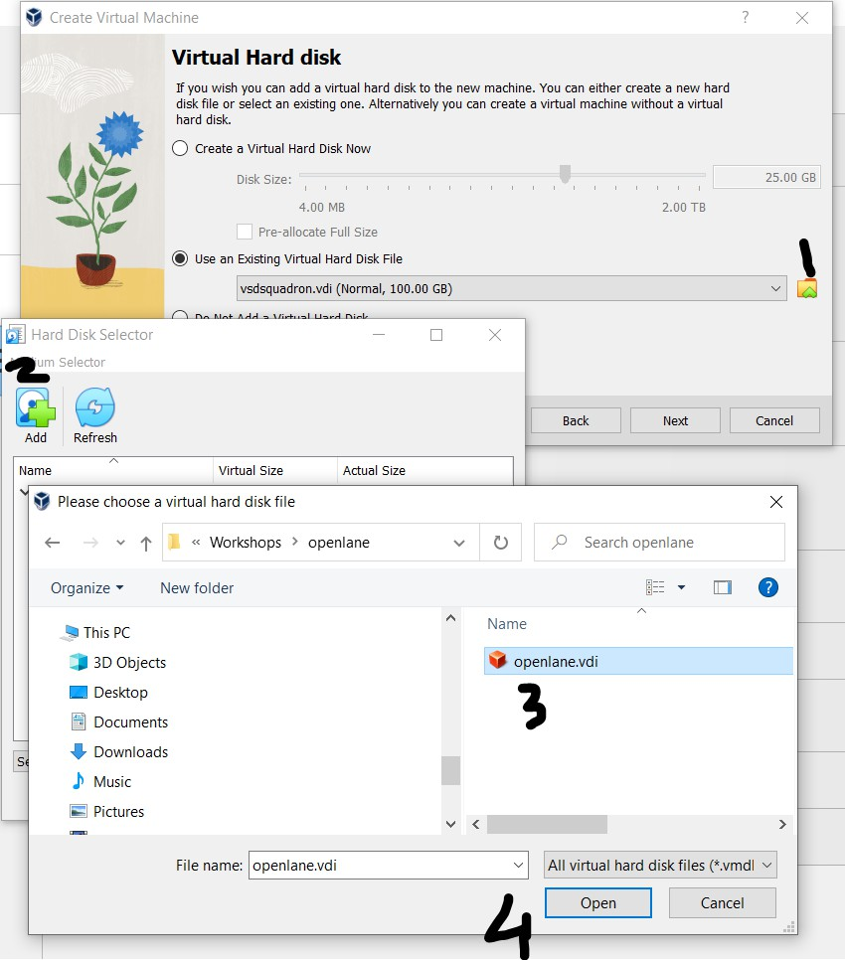

  - Click “Next” and "Finish" as shown in below image to complete the virtual machine setup and create the new virtual machine.
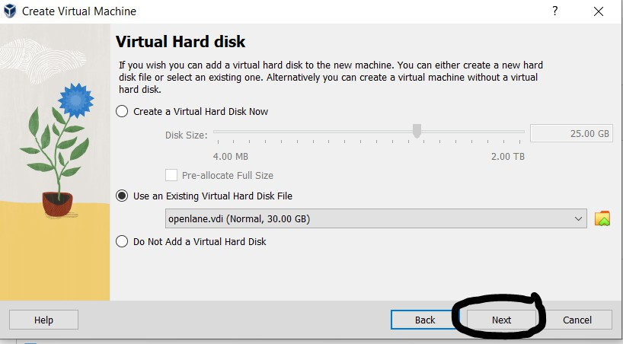

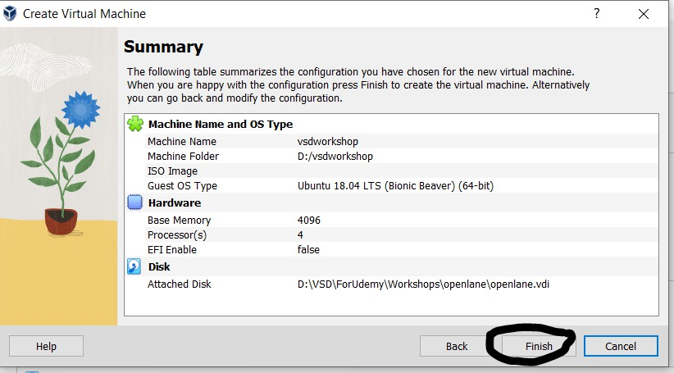

  - Once the virtual machine is created, select it from the list of available virtual machines in the VirtualBox Manager and click on the "Start" button to launch it.
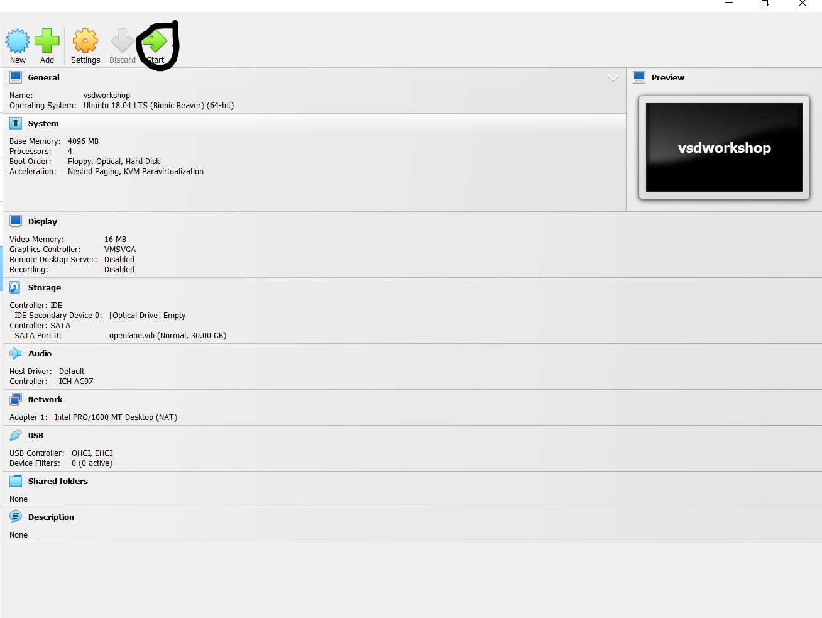

  - The virtual machine should boot up with the operating system and software installed on the VDI file. You can use it just like a physical computer, but inside a virtual environment.

That's it! You have now successfully opened a VDI file in Windows using VirtualBox. YOU CAN START YOUR WORKSHOP
---------------------------------------------------------------------------------

(Below steps are for users with Ubuntu OS) Ubuntu (images remain same as above)
To open a VDI file in Ubuntu, you can use Oracle VirtualBox, which is a free and open-source virtualization software. Here are the steps to open a VDI file in Ubuntu using VirtualBox:

- Open a terminal window on your Ubuntu computer.
- Install VirtualBox by running the following command in the terminal:
  - sudo apt install virtualbox
- Once VirtualBox is installed, launch it by typing the following command in the terminal:
  - virtualbox
- Click on the "New" button to create a new virtual machine.
- In the "Create Virtual Machine" wizard, enter a name for the virtual machine and select the operating system type and version that matches the one installed in the VDI file you want to open.
- On the next screen, allocate memory and create a virtual hard disk. Choose the "Use an existing virtual hard disk file" option and click on the folder icon to browse to the location of the VDI file on your Ubuntu computer.
- Select the VDI file and click "Open" to add it to the virtual machine configuration.
- Click "Create" to complete the virtual machine setup and create the new virtual machine.
- Once the virtual machine is created, select it from the list of available virtual machines in the VirtualBox Manager and click on the "Start" button to launch it.
- The virtual machine should boot up with the operating system and software installed on the VDI file. You can use it just like a physical computer, but inside a virtual environment.

That's it! You have now successfully opened a VDI file in Ubuntu using VirtualBox.

Open Ubuntu
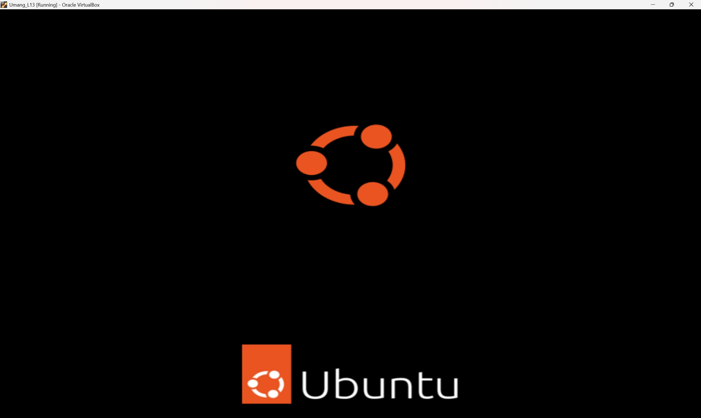
User Id and PWD
