This is a mini python project which makes use of **BeautifulSoap** and **Selenium** in order to automate the job of Data Entry to forms.

In order to successfully run the project, you need the following:

1.) A google form as follows:

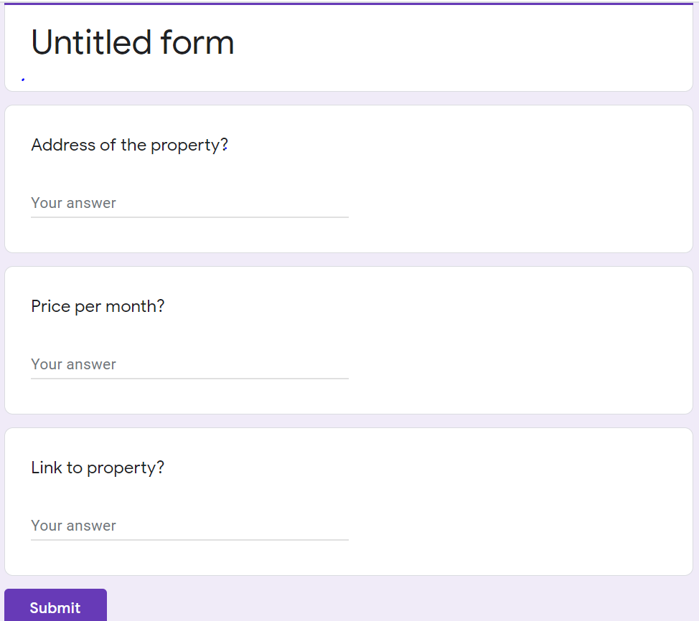

The Google form can be created by going on the following link:

[***https://docs.google.com/forms/u/0/***](https://docs.google.com/forms/u/0/)

2.) A custom search link from Zillow (as used by me).

(Any other site could be used but you will need to change the code according to the search link used)

A custom search link can be generated from the following link:

[***https://www.zillow.com/***](https://www.zillow.com/)

**Please Reach out at** [***umangj107@gmail.com***](mailto:umangj107@gmail.com)**in case you require further clarifications on the project.**

**-------------Thanks-------------**