Assignment-4

Q-1:

Default.aspx:

<%@ Page Title="Home Page" Language="C#" MasterPageFile="~/Site.master" AutoEventWireup="true"

CodeBehind="Default.aspx.cs" Inherits="WebApplication1._Default" %>

<asp:Content ID="HeaderContent" runat="server" ContentPlaceHolderID="HeadContent">

</asp:Content>

<asp:Content ID="BodyContent" runat="server" ContentPlaceHolderID="MainContent">

<asp:TextBox ID="TextBox1" runat="server"></asp:TextBox>

<br />

<asp:Button ID="Button1" runat="server" onclick="Button1_Click" Text="Push" />

<br />

<asp:Label ID="Label1" runat="server"></asp:Label>

<br />

<br />

</asp:Content>

Default.aspx.cs:

using System;

using System.Collections.Generic;

using System.Linq;

using System.Web;

using System.Web.UI;

using System.Web.UI.WebControls;

namespace WebApplication1

{

public partial class _Default : System.Web.UI.Page

{

protected void Button1_Click(object sender, EventArgs e)

{

string str = TextBox1.Text;

Label1.Text = str;

}

}

}

Output:

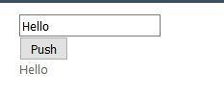

Q-2:

Default.aspx

<%@ Page Title="Home Page" Language="C#" MasterPageFile="~/Site.master" AutoEventWireup="true"

CodeBehind="Default.aspx.cs" Inherits="WebApplication1._Default" %>

<asp:Content ID="HeaderContent" runat="server" ContentPlaceHolderID="HeadContent">

</asp:Content>

<asp:Content ID="BodyContent" runat="server" ContentPlaceHolderID="MainContent">

<br />

<asp:RadioButtonList ID="RadioButtonList1" runat="server">

<asp:ListItem Value="Information Technology">IT</asp:ListItem>

<asp:ListItem Value="Computer Engineering">CE</asp:ListItem>

<asp:ListItem Value="Mechanical Engineering">Mech</asp:ListItem>

</asp:RadioButtonList>

<br />

<asp:Button ID="Button1" runat="server" onclick="Button1_Click" Text="Push" />

<br />

<br />

<asp:Label ID="Label1" runat="server"></asp:Label>

<br />

</asp:Content>

Default.aspx.cs:

using System;

using System.Collections.Generic;

using System.Linq;

using System.Web;

using System.Web.UI;

using System.Web.UI.WebControls;

namespace WebApplication1

{

public partial class _Default : System.Web.UI.Page

{

protected void Button1_Click(object sender, EventArgs e)

{

string s = RadioButtonList1.SelectedItem.Value;

Label1.Text = "Your Are Selected:" + s;

}

}

}

Output:

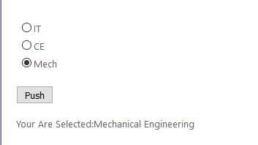

Q-3:

Default.aspx:

<%@ Page Title="Home Page" Language="C#" MasterPageFile="~/Site.master" AutoEventWireup="true"

CodeBehind="Default.aspx.cs" Inherits="WebApplication1._Default" %>

<asp:Content ID="HeaderContent" runat="server" ContentPlaceHolderID="HeadContent">

</asp:Content>

<asp:Content ID="BodyContent" runat="server" ContentPlaceHolderID="MainContent">

<br />

<asp:FileUpload ID="FileUpload1" runat="server" />

<br />

<asp:Button ID="Button1" runat="server" onclick="Button1_Click" Text="Push" />

<br />

<br />

<asp:Label ID="Label1" runat="server"></asp:Label>

<br />

</asp:Content>

Default.aspx.cs:

using System;

using System.Collections.Generic;

using System.Linq;

using System.Web;

using System.Web.UI;

using System.Web.UI.WebControls;

using System.IO;

namespace WebApplication1

{

public partial class _Default : System.Web.UI.Page

{

protected void Button1_Click(object sender, EventArgs e)

{

string fileName = Path.GetFileName(FileUpload1.PostedFile.FileName);

FileUpload1.SaveAs(Server.MapPath("Images/" + fileName));

Label1.Text = fileName+" File Uploded Successfully!";

}

}

}

Output:

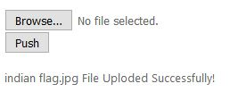

Q-4:

Default.aspx:

<%@ Page Title="Home Page" Language="C#" MasterPageFile="~/Site.master" AutoEventWireup="true"

CodeBehind="Default.aspx.cs" Inherits="WebApplication1._Default" %>

<asp:Content ID="HeaderContent" runat="server" ContentPlaceHolderID="HeadContent">

</asp:Content>

<asp:Content ID="BodyContent" runat="server" ContentPlaceHolderID="MainContent">

<br />

<asp:Label ID="Label1" runat="server" Text="Name"></asp:Label>

&nbsp;<asp:TextBox ID="TextBox1" runat="server"></asp:TextBox>

<asp:RequiredFieldValidator ID="RequiredFieldValidator1" runat="server"

ControlToValidate="TextBox1" ErrorMessage="Required Field"></asp:RequiredFieldValidator>

<br />

Branch :<asp:TextBox ID="TextBox2" runat="server"></asp:TextBox>

<asp:RequiredFieldValidator ID="RequiredFieldValidator2" runat="server"

ControlToValidate="TextBox2" ErrorMessage="RequiredField"></asp:RequiredFieldValidator>

<br />

Enrollment No:<asp:TextBox ID="TextBox3" runat="server"></asp:TextBox>

<asp:RegularExpressionValidator ID="RegularExpressionValidator1" runat="server"

ControlToValidate="TextBox3" ErrorMessage="Enter Proper Enroll No"

ValidationExpression="[0-9]{12}"></asp:RegularExpressionValidator>

<br />

Select City:<asp:DropDownList ID="DropDownList1" runat="server">

<asp:ListItem>Ahmedabad</asp:ListItem>

<asp:ListItem>Vadodara</asp:ListItem>

<asp:ListItem>Surat</asp:ListItem>

<asp:ListItem>Gandhinagar</asp:ListItem>

<asp:ListItem>Surendranagar</asp:ListItem>

<asp:ListItem>Himmatnagar</asp:ListItem>

</asp:DropDownList>

<br />

E-mail:<asp:TextBox ID="TextBox4" runat="server"></asp:TextBox>

<asp:RegularExpressionValidator ID="RegularExpressionValidator2" runat="server"

ControlToValidate="TextBox4" ErrorMessage="Wrong Email"

ValidationExpression="\w+([-+.']\w+)*@\w+([-.]\w+)*\.\w+([-.]\w+)*"></asp:RegularExpressionValidator>

<br />

Password:

<asp:TextBox ID="TextBox5" runat="server"></asp:TextBox>

<br />

Conform Password:<asp:TextBox ID="TextBox6" runat="server"></asp:TextBox>

<asp:CompareValidator ID="CompareValidator1" runat="server"

ControlToCompare="TextBox5" ControlToValidate="TextBox6"

ErrorMessage="Enter Valid Password"></asp:CompareValidator>

<br />

<br />

<asp:Button ID="Button1" runat="server" onclick="Button1_Click" Text="Submit"

Width="61px" />

<br />

<br />

<br />

</asp:Content>

Output:

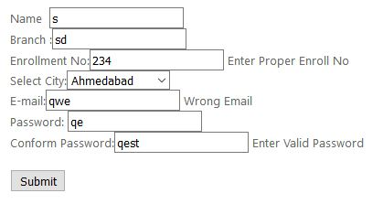

Q-5:

Default.aspx:

<%@ Page Title="Home Page" Language="C#" MasterPageFile="~/Site.master" AutoEventWireup="true"

CodeBehind="Default.aspx.cs" Inherits="WebApplication1._Default" %>

<asp:Content ID="HeaderContent" runat="server" ContentPlaceHolderID="HeadContent">

</asp:Content>

<asp:Content ID="BodyContent" runat="server" ContentPlaceHolderID="MainContent">

<asp:Calendar ID="Calendar1" runat="server"></asp:Calendar>

<br />

<asp:Button ID="Button1" runat="server" onclick="Button1_Click" Text="Submit"

Width="61px" />

<br />

<br />

<asp:Label ID="Label1" runat="server"></asp:Label>

</asp:Content>

Default.aspx.cs:

using System;

using System.Collections.Generic;

using System.Linq;

using System.Web;

using System.Web.UI;

using System.Web.UI.WebControls;

using System.IO;

namespace WebApplication1

{

public partial class _Default : System.Web.UI.Page

{

protected void Button1_Click(object sender, EventArgs e)

{

Label1.Text = "Selected Date Is:"+ Calendar1.SelectedDate.ToShortDateString();

}

}

}

Output:

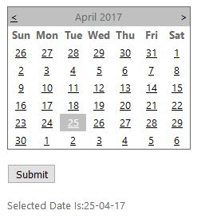

Q-6: