Service Design and Digital Platform Development for the DEFINE Innovation Hub
Internship Final Report, City of Riihimäki
Internship Final Report
Degree Programme in Sustainable Urban Design Engineering
Autumn 2026
Muhammad Uman Saeed

DP Degree Programme in Sustainable Urban Design Engineering
Author Muhammad Uman Saeed Year 2026
Subject Service Design and Digital Platform Development for the DEFINE Innovation Hub
Supervisors Sonja Heikkinen
This report describes a work placement completed for the City of Riihimäki within DEFINE, the Defence Innovation Network Finland, between 11 May and 21 August 2026 (405 hours). DEFINE is a municipally led defence and dual-use innovation ecosystem that operates an innovation hub, a free non-dilutive startup accelerator, a testing environment and a programme of hackathons and events in Riihimäki. The aim of the internship was to examine how DEFINE is experienced by companies and visitors, to identify gaps in its service model, and to design and prototype improvements.
The work combined service design methods with software development. Data were collected through interviews with participating companies, an intern survey, benchmarking of European defence innovation programmes and desk research verified against public sources. Based on the findings, the internship produced an analysis of DEFINE’s public presence, a feedback study from an accelerator event, a discovery report on the service system, two customer personas, an eight-stage service pathway, and DEFINE OS, a web-based platform prototype built with Next.js, React, TypeScript, Prisma and PostgreSQL for managing companies, applications, programmes, mentoring, testing and funding in one system.
The results indicate that DEFINE has strong front-of-funnel assets such as end-user access, testing infrastructure and founder-friendly economics, but would benefit from clearer audience-specific communication, published outcome metrics and unified operational tooling. The proposed service pathway and the DEFINE OS prototype offer a concrete starting point for this development.
Keywords Service design, innovation ecosystem, dual-use technology, defence innovation, digital platform
Pages 22 pages and appendices 2 pages

Table of Contents
1 Introduction 1
2 The Commissioning Organisation and Its Operating Environment 2
2.1 The City of Riihimäki as the Internship Provider 2
2.2 DEFINE – Defence Innovation Network Finland 2
2.3 Services and Infrastructure 3
2.4 Stakeholders, Funding and Expansion 4
3 Internship Objectives and Implementation 5
3.1 Objectives and Assignments 5
3.2 Methods and Tools 5
3.3 Progress of the Internship 6
4 Discovery and Service Design Work 7
4.1 Analysis of DEFINE’s Public Presence 7
4.2 Feedback Study on the Accelerator Event 7
4.3 Discovery Report on the Service System 8
4.4 Customer Personas 9
4.5 The Proposed Service Pathway 9
5 DEFINE OS: A Digital Platform Prototype 10
5.1 Background and Purpose 10
5.2 Technology Stack and Architecture 11
5.3 Core Modules and User Interface 11
5.4 Application Evaluation Workflow 13
5.5 Current Status and Further Development 14
6 Results and Recommendations 15
6.1 Summary of Deliverables 15
6.2 Recommendations for DEFINE 15
7 Evaluation of the Internship and Personal Development 16
7.1 Professional Development 16
7.2 Working in a Finnish Workplace and Learning the Language 16
7.3 Challenges and How They Were Addressed 17
8 Conclusion 17
References 18
Figures
Figure 1. The applications module of DEFINE OS listing incoming programme applications with status and score filters (prototype with sample data). 12
Figure 2. The application detail view with the applicant’s motivation, track record, contact information and programme details. 13
Figure 3. The review tab of an application with reviewer notes, scoring and a recommendation. 14
Tables
Table 1. The main service lines of DEFINE. 3
Table 2. DEFINE Accelerator cohort history compiled from public sources. 4
Table 3. The five phases of the internship. 6
Table 4. The proposed eight-stage service pathway. 9
Table 5. Core modules of the DEFINE OS prototype. 11
Appendices
Appendix 1. Internship timeline by week
Appendix 2. DEFINE OS data model overview

Introduction
This report presents the work placement that I completed for the City of Riihimäki between 11 May and 21 August 2026 as part of the Degree Programme in Sustainable Urban Design Engineering at Häme University of Applied Sciences (HAMK). The placement comprised 405 hours of work over approximately 15 weeks. I was assigned to the city’s technology and innovation sector and worked within DEFINE, the Defence Innovation Network Finland, at the DEFINE Innovation Hub next to Riihimäki railway station.
DEFINE is an innovation ecosystem initiated by the City of Riihimäki in spring 2023, in the immediate context of Finland’s accession to NATO. It brings together the Finnish Defence Forces, defence and security companies, educational institutions and research institutes to develop dual-use technologies that serve both military organisations and civil society (DEFINE, n.d.-a). For a city of Riihimäki’s size, the initiative is unusually ambitious: it combines local economic development, national security capability and startup acceleration in a single operating model. This made it an exceptionally interesting environment for an engineering student interested in how cities can build new service ecosystems.
The internship had two connected objectives. The first was to examine how DEFINE is actually experienced by the companies, visitors and partners it serves, and to identify where its service model and communication could be improved. The second was to turn those findings into concrete, usable outputs for the DEFINE team. Over the summer this produced a series of deliverables: an analysis of DEFINE’s website, hub and LinkedIn presence, a structured feedback study from an accelerator event, a discovery report on the whole service system, two customer personas, a proposed eight-stage service pathway, and finally DEFINE OS, a working software prototype of an operational platform for running the ecosystem’s day-to-day processes.
The report proceeds as follows. Chapter 2 introduces the commissioning organisation and its operating environment. Chapter 3 describes the objectives, methods and progress of the internship. Chapter 4 presents the discovery and service design work and its findings. Chapter 5 documents the DEFINE OS platform prototype. Chapter 6 summarises the results and recommendations handed over to DEFINE, and Chapter 7 evaluates the internship as a learning experience, including the development of my Finnish language skills. Chapter 8 concludes the report.

The Commissioning Organisation and Its Operating Environment

The City of Riihimäki as the Internship Provider
The formal internship provider was the City of Riihimäki, a town of approximately 30,000 residents in the Kanta-Häme region, about 40 to 55 minutes north of Helsinki by train (City of Riihimäki, n.d.). Riihimäki has a long garrison tradition and hosts several specialist research and development units of the Finnish Defence Forces, including competence centres for electronic warfare, cyber, digitalisation and command systems. The city coordinates DEFINE through its own organisation: DEFINE is a municipal programme and network rather than a separately incorporated company. During the placement I worked in the team of the city’s Director of Technology and Innovation, with weekly guidance meetings and regular reviews with the city’s development manager and project coordinator.

DEFINE – Defence Innovation Network Finland
DEFINE describes itself as an open innovation network that is developing a world-class defence and security innovation ecosystem. Its stated purpose is to create dual-use technologies that serve both military organisations and civil society, enhance the defence capabilities of Finland and NATO, strengthen Europe’s strategic autonomy, and drive the growth of participating companies (DEFINE, n.d.-a). The operating model is often described as a quattro helix: the city, businesses, research institutions and civil society working together (Invest in Riihimäki, n.d.).
By the most recent public figures, 36 companies have graduated from the DEFINE Accelerator, more than 150 companies have attended hackathons and open network events, and five startups have relocated to Riihimäki (Invest in Riihimäki, n.d.). In January 2026 DEFINE began a nationwide expansion, funded and steered by the Finnish innovation fund Sitra, to six cities and two universities of applied sciences, each with a regional technology specialisation (Sitra, 2026). Riihimäki will also host a NATO deployable communication and information systems module from early 2027 and acts as a co-organiser and command-and-control hub for the NATO Innovation Range Finland 2026 exercise (DEFINE, n.d.-a).
It is worth clarifying DEFINE’s position in the wider Finnish defence innovation landscape, because the distinction is often blurred in public discussion. The NATO DIANA accelerator site in Finland is operated by VTT, and the Finnish DIANA test centres are run by VTT and Aalto University in Espoo and by the University of Oulu (VTT, n.d.). DEFINE is a partner organisation that supports and feeds these efforts rather than the DIANA accelerator itself. Understanding this positioning became an important part of the discovery work described in Chapter 4.

Services and Infrastructure
DEFINE’s services can be grouped into six main lines, which are summarised in Table 1. The physical core is the DEFINE Innovation Hub at Pohjoinen Asemakatu 5, immediately next to the railway station. The hub offers co-working space, a 3D additive manufacturing laboratory and a generative AI laboratory with GPU resources. Since August 2025 the ecosystem has also included the DEFINE Testing Environment, a dual-use test centre operated by Millog Oy, where companies can test network solutions and software against the defence sector’s standards either independently or with expert support, on site or remotely (Millog, 2025).
Table 1. The main service lines of DEFINE.
Service line | What it provides
DEFINE Accelerator | A free, non-dilutive, roughly 12-week programme for dual-use and defence-tech startups and SMEs from NATO countries
Innovation Hub | Co-working space, 3D additive manufacturing and a generative AI laboratory next to Riihimäki station
Testing Environment | A dual-use test centre operated by Millog with virtual servers, mobile and containerised systems, sensors and a HAMK GPU server
Hackathons and events | Recurring hackathons, demo days and open network events; over 150 companies have taken part
Projects | Funded research, development and innovation projects with DEFINE partners
Network access | Introductions to the Defence Forces, industry primes, NATO allies and investors
The flagship service is the DEFINE Accelerator. It is free of charge, takes no equity, and is open to startups and SMEs from all NATO countries, with remote participation possible. The programme runs for about three months in three phases: validation and strategy development, technology development and prototyping, and go-to-market and investment readiness. Participants receive around twenty group sessions, weekly one-to-one coaching from experienced head coaches, access to the hub’s infrastructure and partner test facilities, and guidance on building partnerships with the Defence Forces, the defence industry and NATO allies (DEFINE, n.d.-b). Table 2 summarises the accelerator’s cohort history.
Table 2. DEFINE Accelerator cohort history compiled from public sources.
Batch | Timing | Companies and applicants
Fall 2024 | Demo day in February 2025 | 12 companies from 57 applicants in 13 countries
Spring 2025 | Launched March 2025 | 12 companies from over 100 applicants
Fall 2025 | August to November 2025, ending at Slush | About 12 companies
Spring 2026 | Kick-off March 2026, with VTT and NATO DIANA | 12 companies from over 100 applicants
Fall 2026 | Late August to November 2026 | Applications open during this internship

Stakeholders, Funding and Expansion
DEFINE is publicly funded through a combination of municipal money, European Regional Development Fund (ERDF) project funding, Sitra funding for the national expansion and industry partner contributions. The main disclosed figure is a joint HAMK and City of Riihimäki ERDF project with a total budget of €606,471 for January 2024 to June 2026 (HAMK, n.d.). HAMK is the formal project partner and contributes education, applied research and the GPU server used in the testing environment. Key industry partners include Millog, Sako and Patria, and the Finnish Defence Forces participate as the end user whose specialist units in Riihimäki give companies rare access to real military feedback. The accelerator’s early batches were operated together with Redstone, a Berlin-based venture capital firm with a Helsinki office (Tech.eu, 2025).

Internship Objectives and Implementation

Objectives and Assignments
The overall assignment given to me at the start of the placement was open by design: to look at DEFINE with fresh eyes, understand how it works and how it is experienced from the outside, and propose improvements to its services. Together with my supervisors this was refined into four concrete objectives. First, to analyse how DEFINE presents itself through its website, the physical hub and social media. Second, to collect and structure feedback from the companies participating in DEFINE’s programmes and events. Third, to map the whole service system into a documented service pathway that different customer types could follow. Fourth, to explore how digital tools could support the running of that pathway, which grew into the DEFINE OS prototype described in Chapter 5.

Methods and Tools
The work followed a service design approach, moving from discovery to definition to design. The main methods and tools were the following:
- Semi-structured interviews with companies at DEFINE events, with other interns and with DEFINE and Business Riihimäki staff.
- A survey designed for accelerator companies, iterated with the city’s development manager and project coordinator before distribution.
- Service design workshops held regularly with a facilitator, using canvases for value proposition, stakeholder mapping and journey mapping.
- Desk research and benchmarking of comparable programmes and communities, including NATO DIANA, European robotics meetups and the Clankers community in Berlin.
- Customer personas and an eight-stage service pathway synthesised from the research material.
- Software prototyping with Next.js, React, TypeScript, Prisma and PostgreSQL for the DEFINE OS platform.
All desk research findings were recorded with a source and confidence level, separating verified facts from inferences and open knowledge gaps. This discipline came directly from the discovery report work and proved valuable: several widely repeated claims about DEFINE, such as its relationship to NATO DIANA, turned out to need more careful wording.

Progress of the Internship
The placement ran from 11 May to 21 August 2026 and totalled 405 hours over 75 working days. The work divided naturally into five phases, summarised in Table 3. A detailed week-by-week timeline is provided in Appendix 1.
Table 3. The five phases of the internship.
Phase | Weeks | Main activities
Orientation | Weeks 1–2 | Introductions across the city organisation, a meeting with the mayor, first briefings on DEFINE, intern interviews and survey
Discovery | Weeks 3–6 | Service design workshops, accelerator programme observation, company interviews at the NATO innovation event, feedback analysis
Benchmarking | Weeks 7–8 | Research on competing hubs, robotics communities and business establishment support; a concept pitch for a Riihimäki robotics meetup
Design | Weeks 9–11 | Customer personas, service pathway flowcharts, discovery report writing, survey finalisation
Build and delivery | Weeks 12–15 | DEFINE OS development and demonstrations, final presentation, Finnish language portfolio, final reporting
Throughout the summer I had weekly check-in meetings with the city’s internship coordinators, which included an introduction to Finnish workplace culture, and weekly Finnish language sessions. Progress on the assignments was reviewed with the DEFINE team in dedicated meetings, including two reviews of the DEFINE OS prototype with the city’s development manager and project coordinator in late July.

Discovery and Service Design Work

Analysis of DEFINE’s Public Presence
The first deliverable was an analysis of how DEFINE presents itself through its website, the physical hub and LinkedIn. The website communicates DEFINE’s mission clearly and signals legitimacy through named partners and funders, which strengthens credibility for companies, researchers and investors evaluating whether the ecosystem is real. Its main weakness is the lack of an immediately obvious pathway for different user types: a startup founder, an investor, a test partner and a researcher all arrive with different goals, but the public pages do not offer a simple start-here flow that tells each audience what to do next. Operational details such as selection criteria, timelines, costs and confidentiality terms are also underexplained, and the terms network, ecosystem, hub and accelerator are used interchangeably in a way that can confuse a first-time visitor.
The physical hub makes a strong impression: DEFINE feels real rather than a concept on a website, and the location next to the station supports accessibility. At the same time, a first-time visitor may quickly ask practical questions about what can be done there on a normal day, how open the space is to different partner types, and how hub activity connects to concrete outcomes such as pilots and contracts. The LinkedIn page is active and professionally presented, with over 5,500 followers and recent posts about job openings, the accelerator, NATO-related experimentation and funding opportunities. Its messaging is strong on vision but more promotional than explanatory: it tells outsiders what DEFINE aims to be, but less about how engagement works in practice. The overall conclusion of the analysis was that DEFINE’s main outsider challenge is not a lack of vision but a lack of operational clarity.

Feedback Study on the Accelerator Event
In June I attended a NATO-related innovation event at the DEFINE hub and interviewed participating companies over two days, then compiled the results into a structured feedback summary for the DEFINE team. On the positive side, companies valued seeing what other participants were doing on site, the ease of direct conversations without formal introductions, the accessible venue and especially the visits from military representatives, which several considered the strongest feature of the event.
The critical feedback clustered into seven themes. End-user and buyer presence was felt to be too weak relative to the supplier side, and the Finnish military community was experienced as relatively closed. Media coverage was insufficient and uncoordinated because no dedicated media handler was present. On-site testing of products was not allowed, which companies felt was a missed opportunity, and existing operational results from the Oulu region were not showcased. Presentations lacked a large screen for showing test results and demonstration footage. Communication about where and when to send presentation materials came late, and the schedule should have been shared earlier in a clearer big-picture format. Finally, the auditorium was too small for the audience and the audio system was poor. Participants rated the overall event experience between 6 and 7 out of 10. The summary gave DEFINE a prioritised list of practical fixes for future events.

Discovery Report on the Service System
The largest research deliverable was a discovery report that mapped DEFINE’s whole service system from public evidence and internal artifacts, with every claim graded by source level and confidence. The report covered the organisation, governance, business model, service portfolio, customer journey, stakeholder and partner ecosystems, technology and testing infrastructure, funding, documented metrics and operational processes.
Four central tensions emerged. First, positioning: DEFINE actively associates itself with NATO DIANA, but the Finnish DIANA accelerator designation is held by VTT, so DEFINE’s role is that of a supporting partner, a distinction that is frequently blurred in secondary coverage. Second, operator ambiguity: the accelerator’s early batches were run by the venture capital firm Redstone, whose current role is not publicly clear. Third, outcome opacity: DEFINE publishes activity metrics such as graduates and event attendance but no cumulative outcome indicators such as capital raised by alumni, jobs created or contracts won, even though its stated aim is to increase participating companies’ turnover. Fourth, the procurement valley of death: DEFINE has strong front-end assets for attracting, convening and testing companies, but no publicly documented bridge from a validated prototype to a real defence contract, unlike, for example, NATO DIANA’s rapid adoption mechanisms. The report concluded that DEFINE is currently strongest as a front-of-funnel and validation engine and least evidenced at the back of the funnel, and framed this as a hypothesis for the service redesign to test.

Customer Personas
To make the research actionable, I condensed the interview and benchmarking material into two customer personas that represent DEFINE’s most important incoming audiences. The first is a Finnish founder of a dual-use deep-tech startup: an ex-industrial engineer in his late thirties from Tampere who saw the defence opportunity after Finland joined NATO but has no military network and no procurement knowledge, whose civilian revenue is plateauing while investors ask for a defence reference. He compares DIANA, other regional hubs and DEFINE, and decides on three questions: who will I meet, can I test with end users, and what does it cost in time and equity. His summary of the need was that he does not need another workshop but a test slot and someone who will pick up the phone.
The second persona is a German founder of a defence robotics startup: a robotics PhD in her early thirties in Munich with a field-ready unmanned ground vehicle, strong investors but zero end-user traction, hunting the fastest route to a NATO-country end-user reference. She judges every European ecosystem by one number, the days from arrival to field test, and values DEFINE’s remote-friendly format, Arctic test conditions and openness to companies from all NATO countries. Her scenario highlighted needs that a Finnish founder never encounters: soft-landing support, help with a legal entity, and cross-border export control questions. Together the personas made clear that DEFINE serves audiences with materially different needs through what is today a single shared pathway.

The Proposed Service Pathway
The design phase synthesised the findings into a proposed service pathway: a single documented route that any company can follow from first hearing about DEFINE to becoming a long-term member of the ecosystem. The pathway has eight stages and is summarised in Table 4. At the application stage companies are routed into one of five tracks depending on fit: the accelerator, a funded project, hub residency, light-touch network membership, or a challenge track in which a company solves a posted Defence Forces or partner problem and transitions to a pilot.
Table 4. The proposed eight-stage service pathway.
Stage | Company front stage | DEFINE back stage
01 Discover | Notices DEFINE via press, events or referral | Publishes the story through the website, events and partners
02 Qualify | Books a 30-minute scoping call | Responds within days, assigns an owner, checks fit
03 Apply and match | Applies to the fitting track | Reviews, scores and routes to the right track
04 Onboard | Signs the agreement, joins at the hub | Contracting, enrolment and kickoff
05 Engage | Mentoring, workshops, testing at Millog | Matches mentors and facilities, tracks milestones
06 Fund and prove | Pursues funding, pilots, demo day | Facilitates funding and investor introductions
07 Graduate | Graduates with a concrete outcome | Captures the outcome as a case study and metrics
08 Sustain | Stays active as alumni or partner | Runs the alumni network and re-engagement
For each stage the pathway defines the company-facing experience, DEFINE’s backstage work, the touchpoints used, and the supporting role of digital tooling. Working through the pathway stage by stage also exposed the operational load it implies: applications must be received and scored, enrolments contracted, milestones tracked, test slots booked and outcomes captured. Today much of this runs on manual and partly improvised processes. That observation motivated the final and largest piece of the internship, the DEFINE OS platform prototype.

DEFINE OS: A Digital Platform Prototype

Background and Purpose
DEFINE OS is a web-based operational platform that I designed and built during the last third of the internship. Its purpose is to give the DEFINE team one system for running the service pathway described in Chapter 4: managing companies and contacts, receiving and evaluating programme applications, running accelerator cohorts, coordinating mentors, experts and investors, booking testing, tracking funding opportunities and capturing outcomes. The name reflects the ambition: an operating system for the ecosystem. The idea grew directly out of the discovery work, which had flagged operational tooling as a pain point, with pipeline, application and testing information tracked manually in separate documents.

Technology Stack and Architecture
The platform is built as a modern full-stack web application. The frontend and backend share a single Next.js application written in TypeScript with React, using the App Router and server actions. Data is modelled with Prisma against a PostgreSQL database, and authentication is handled by the Better Auth library with email and password sign-in, session management and support for two-factor authentication. The user interface is built with Tailwind CSS and the shadcn/ui component library, with TanStack Table for data grids, Recharts for analytics charts, and React Hook Form with Zod for validated forms. The application also includes API routes for an AI assistant chat, automation suggestions and a generated monthly report.
The Prisma schema contains 44 data models covering the whole ecosystem: users with role-based access, companies with contacts, tags and metrics, programmes with enrolments, mentors and managers, applications with reviews, evaluation rounds, criteria and scores, projects with tasks and comments, mentor, expert and investor profiles, mentoring sessions, events with attendees, funding opportunities and applications, testing requests, documents, messages, notifications, activity and audit logs, invitations and automation rules. Roles distinguish administrators, staff and visiting users, and the dashboard adapts its content to the signed-in role. An onboarding wizard collects a new user’s organisation and interests on first login.

Core Modules and User Interface
The dashboard shell gives access to about twenty modules, grouped into overview, people, business and work sections in the navigation. Table 5 summarises the core modules. The user interface follows a clean, dark-sidebar dashboard layout with global search, notifications and a light and dark theme.
Table 5. Core modules of the DEFINE OS prototype.
Module group | Contents
Overview | Role-aware dashboard with key figures, analytics charts and an AI-generated monthly report
Startup pipeline | A CRM-style kanban of companies moving through pipeline stages from lead to alumni
Companies | A directory of ecosystem companies with profiles, contacts, tags and metrics
Applications and evaluator | Programme application intake, review workflow and a scoring engine with rounds, criteria and rankings
Programs | Accelerator cohorts and other programmes with enrolments, mentors and managers
People | Mentor, expert and investor directories with profiles and mentoring sessions
Work | Projects, tasks, calendar and events with attendee management
Services | Funding opportunities and applications, testing requests for the test environment
Communication | Documents, messages, notifications and an AI assistant available across the platform
Administration | Settings, automations, activity and audit logs, invitations and role management
Figure 1 shows the applications module, which acts as the intake for stage three of the service pathway. Staff see all incoming applications with their programme, status, submission date and score, can filter by state from draft to accepted, and get summary counts of the pipeline at the top of the page.
Figure 1. The applications module of DEFINE OS listing incoming programme applications with status and score filters (prototype with sample data).
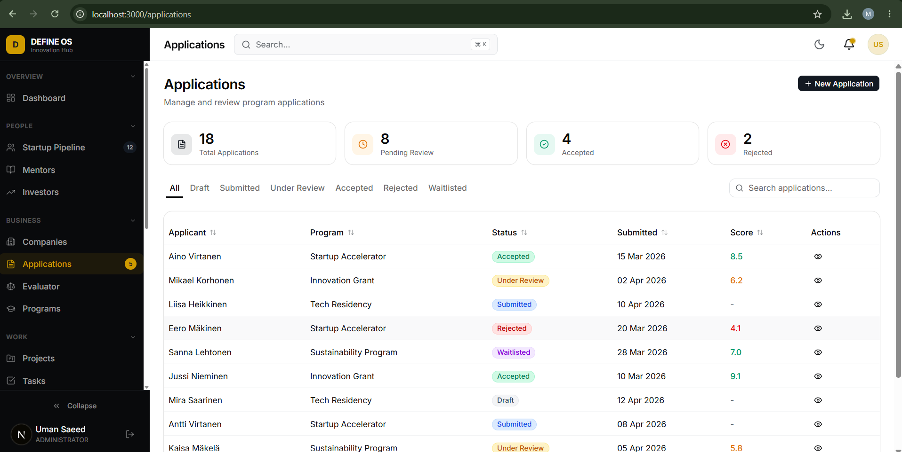
Each application opens into a detail view, shown in Figure 2, with tabs for details, review, documents and notes. The details tab presents the applicant’s motivation, experience and track record, goals and milestones, contact information and programme details such as team size and requested funding.
Figure 2. The application detail view with the applicant’s motivation, track record, contact information and programme details.
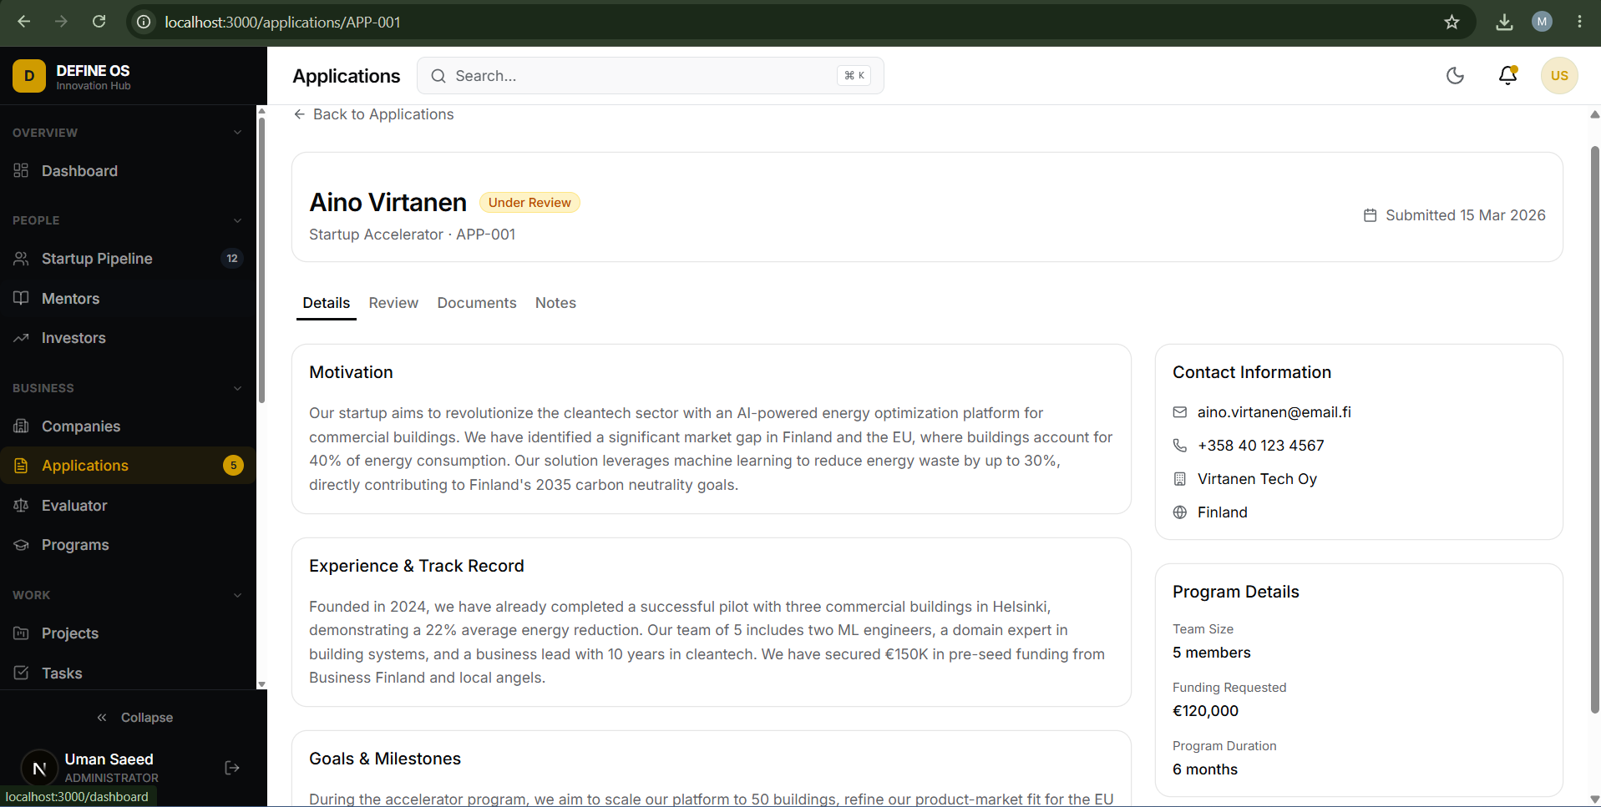

Application Evaluation Workflow
The evaluation workflow was built to replace spreadsheet-based application review. In the review tab, shown in Figure 3, a reviewer writes notes, gives a score out of ten and records a recommendation to accept, waitlist, reject or request more information. The separate evaluator module extends this into a full selection process: staff can define evaluation rounds with weighted criterion groups and criteria, assign evaluators, import applications in bulk from a spreadsheet, score candidates side by side and produce a ranked shortlist. This directly supports the accelerator’s selection process, which today is described publicly only as careful selection.
Figure 3. The review tab of an application with reviewer notes, scoring and a recommendation.
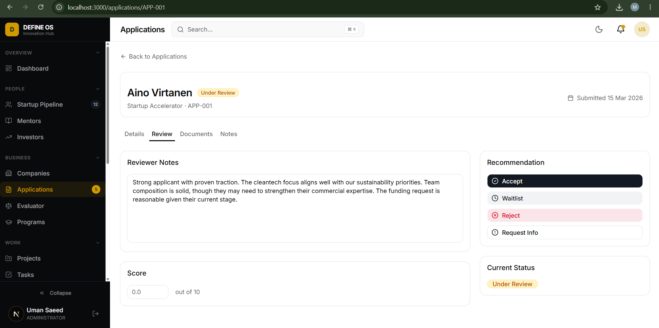

Current Status and Further Development
DEFINE OS is a working prototype rather than a production system. Authentication and the companies module are wired to a live PostgreSQL database, while the remaining modules run on realistic structured sample data so that the whole platform can be demonstrated end to end. The prototype was demonstrated to the city’s development manager and project coordinator in late July, and the feedback was used to refine the evaluation workflow and the directories. The codebase is version-controlled in a Git repository.
The natural next steps, which I documented for the DEFINE team, are to connect the remaining modules to the database, define which roles the Defence Forces and partner organisations would hold, pilot the application and evaluation workflow on a real accelerator round, and decide on hosting that meets the city’s information security requirements. Because the data model already mirrors the eight-stage pathway, the platform can grow with the service instead of being retrofitted to it.

Results and Recommendations

Summary of Deliverables
The internship handed over six concrete deliverables to the City of Riihimäki and the DEFINE team: the analysis of DEFINE’s public presence, the accelerator event feedback summary, the discovery report on the service system, two customer personas, the eight-stage service pathway with its five tracks, and the DEFINE OS platform prototype with its documentation. In addition, the survey designed for accelerator companies was left ready for future cohorts, and the benchmarking produced a concept pitch for a Riihimäki robotics community meetup inspired by the Clankers community in Berlin.

Recommendations for DEFINE
Based on the summer’s work, I made five recommendations. They are deliberately practical and sized so that a small team can act on them:
- Restructure the public website around audience-based entry paths for startups, established companies, investors and public partners, each explaining eligibility, services, process, timeline and the exact next step.
- Publish outcome metrics, not only activity metrics: capital raised by alumni, pilots and contracts won, and jobs created. Even a small verified set would strengthen credibility with both founders and funders.
- State the NATO DIANA relationship precisely in all communication, positioning DEFINE as the partner and feeder it is, which is a strong story in itself and avoids over-claiming.
- Design a documented procurement bridge from validated prototype to first contract, drawing on international reference models, because this valley of death is where the ecosystem’s value is ultimately proven.
- Adopt a unified operational platform along the lines of DEFINE OS, so that pipeline, applications, evaluation, testing and outcomes live in one system and reporting to funders becomes a by-product of daily work.
These recommendations echo the event feedback as well: clearer processes, earlier communication and more visible results were the most consistent asks from companies across every data source I worked with.

Evaluation of the Internship and Personal Development

Professional Development
Professionally, the internship stretched me in two directions at once. On the service design side I learned to run a discovery process end to end: framing research questions, interviewing companies whose time was scarce, separating verified facts from inference, and turning messy qualitative material into personas, pathways and prioritised recommendations. On the technical side, building DEFINE OS was the largest software project I have completed, and it forced me to make real architectural decisions about data modelling, authentication, role-based access and user interface design, and to defend those decisions in demonstrations to non-technical stakeholders. Presenting the final results to the DEFINE team at the end of the placement tied both strands together.
The placement also connected directly to my degree programme. Sustainable urban design is ultimately about how cities create the conditions for people and organisations to thrive, and DEFINE is a live example of a small city using an innovation ecosystem as an urban development strategy: attracting companies, creating jobs and giving old garrison infrastructure a new purpose. Working inside the city organisation showed me how strategy, EU funding instruments, partnerships and day-to-day service work actually meet.

Working in a Finnish Workplace and Learning the Language
The weekly check-in meetings included a deliberate introduction to Finnish workplace culture, and over the summer I experienced its features first hand: low hierarchy, direct but polite communication, real autonomy over one’s own work and a strong culture of trust. Being trusted to interview companies and to present to city management as an intern was initially surprising and very motivating.
Alongside the work I completed a Finnish language portfolio with four tasks: collecting workplace vocabulary, photographing and decoding the language visible in the urban environment, using Finnish in workplace situations, and examining language through a service design lens. By the end of the summer I could handle greetings, small purchases and simple workplace phrases, and I had learned to read the signs around me, from pelastustie to väestönsuoja. Fast speech and word inflection remain difficult, but the portfolio’s honest conclusion was that I became braver: I dare to speak. The most interesting crossover was realising that clear language is itself good service design, an insight I carried into the pathway work.

Challenges and How They Were Addressed
The main challenges were the openness of the assignment, the sensitivity of the domain and the limits of public information. An open brief meant I had to structure my own work, which the weekly supervision rhythm and the phase plan in Chapter 3 made manageable. The defence domain required care with confidentiality, so the discovery report was built strictly on public sources and clearly labelled internal artifacts. Where information was simply not available, such as programme outcome figures, I recorded it as a knowledge gap rather than guessing, which turned a frustration into one of the report’s most useful findings. Finally, scoping DEFINE OS was a lesson in restraint: the temptation was to build everything, and the discipline was to make the application and evaluation workflow genuinely good first.

Conclusion
This internship set out to look at a young, ambitious defence innovation ecosystem with fresh eyes and to leave behind something useful. The summer’s work showed that DEFINE’s foundations are genuinely strong: real end-user access, real testing infrastructure, founder-friendly economics and visible political backing. Its growing pains are equally real: communication that explains vision better than process, metrics that count activity rather than outcomes, and operations that still run on manual tools. The deliverables of this placement, from the discovery report and personas to the service pathway and the DEFINE OS prototype, were designed as one coherent answer to those pains. For me, the placement confirmed that the combination of service design thinking and hands-on software skills is a powerful toolkit for developing city services, and it gave me a working relationship with a Finnish city organisation, a portfolio of real deliverables and the courage to work in a second language. I am grateful to the City of Riihimäki and the DEFINE team for their openness and trust throughout the summer.

References
City of Riihimäki. (n.d.). Riihimäki. Retrieved 21 August 2026, from https://www.riihimaki.fi/
DEFINE. (n.d.-a). What is DEFINE? Defence Innovation Network Finland. Retrieved 21 August 2026, from https://definefinland.fi/en/what-is-define/
DEFINE. (n.d.-b). DEFINE Accelerator. Defence Innovation Network Finland. Retrieved 21 August 2026, from https://definefinland.fi/en/define-accelerator/
Häme University of Applied Sciences. (n.d.). DEFINE ecosystem project. Retrieved 21 August 2026, from https://www.hamk.fi/
Invest in Riihimäki. (n.d.). Defence. City of Riihimäki. Retrieved 21 August 2026, from https://investinriihimaki.com/defence/
Millog. (2025). Millog launches a test centre in connection with the DEFINE Innovation Hub. Retrieved 21 August 2026, from https://www.millog.fi/
Sitra. (2026). The DEFINE defence innovation model expands nationwide. Retrieved 21 August 2026, from https://www.sitra.fi/
Tech.eu. (2025, July 7). Riihimäki: The Finnish town building a defence innovation ecosystem. Retrieved 21 August 2026, from https://tech.eu/
VTT. (n.d.). NATO DIANA in Finland. Retrieved 21 August 2026, from https://www.vttresearch.com/

Appendix 1. Internship timeline by week
The table below summarises the main activities of the placement week by week, based on the daily tracker kept throughout the internship (11 May to 21 August 2026, 405 hours in total, with an average of about 5.4 hours per working day).
Weeks | Main activities
1–2 | Orientation across the city organisation, meeting with the mayor, briefings with the DEFINE team, intern interviews and an intern survey
3–4 | Service design workshops, a cross-cultural workshop, canvas work, accelerator programme observation, first survey draft and analysis
5–6 | NATO innovation event at the hub, company interviews on two days, cleaning and analysis of interview results, feedback summary
7–8 | Benchmarking of European robotics meetups, the Prototype Capital and ESRA networks and the Clankers Berlin community; research on business establishment support; concept pitch for a Riihimäki robotics meetup
9–10 | Customer personas, start of the service pathway, survey revisions based on staff comments, Finnish language preparation and sessions
11 | Service pathway flowcharts, competitor research on innovation hubs, dashboard research for the pathway
12–13 | DEFINE OS development: platform framework, data model, core modules; discovery report completed; DEFINE OS reviews with city staff
14–15 | DEFINE OS finalisation, final presentation to the DEFINE team, Finnish language portfolio, final report writing
Appendix 2. DEFINE OS data model overview
The DEFINE OS Prisma schema contains 44 data models. The table below groups them by functional area.
Functional area | Data models
Identity and access | user, session, account, verificationToken, twoFactor, invitation; roles for administrators, staff and visitors
Companies and CRM | company, userCompany, contact, companyTag, companyMetric; pipeline stages from lead to alumni
Programmes | program, programEnrollment, programMentor, programManager
Applications and evaluation | application, review, criterionGroup, criterion, criterionScore, groupComment, roundEvaluator
Projects and work | project, projectMember, task, comment
People networks | mentorProfile, expertProfile, investorProfile, mentoringSession
Events | event, eventAttendee
Funding and testing | fundingOpportunity, fundingApplication, testingRequest
Content and communication | document, sentMessages, notification, cmsPage, cmsBlogPost
Platform services | activityLog, auditLog, automationRule, aiConversation

