**Topics: Normal distribution, Functions of Random Variables**

1. The time required for servicing transmissions is normally distributed with *μ* = 45 minutes and *σ* = 8 minutes. The service manager plans to have work begin on the transmission of a customer’s car 10 minutes after the car is dropped off and the customer is told that the car will be ready within 1 hour from drop-off. What is the probability that the service manager cannot meet his commitment?
2. 0.3875
3. 0.2676
4. 0.5
5. 0.6987

**Ans: -** Mean=45, Std=8, They will begin the work from 10min then drop off time will be 50 min

Probability of service manager cannot meet his comment is 0.2676~26.76%

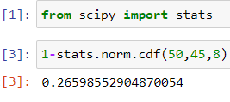

1. The current age (in years) of 400 clerical employees at an insurance claims processing center is normally distributed with mean *μ* = 38 and Standard deviation *σ* =6. For each statement below, please specify True/False. If false, briefly explain why.
2. More employees at the processing center are older than 44 than between 38 and 44.
3. A training program for employees under the age of 30 at the center would be expected to attract about 36 employees.

**Ans: -** A) False because only 15.86% people older than 44 & between 38 and 44 ,34.14% people exist there.

B) True because probability will be 9.1% then we can consider 9% of 400 it will be 36

1. If *X1* ~ *N*(μ, σ2) and *X*2 ~ *N*(μ, σ2) are *iid* normal random variables, then what is the difference between 2 *X*1 and *X*1 + *X*2? Discuss both their distributions and parameters.

**Ans: -** I unable to find any difference b/w them

Assume Mu=1 & Sigma=2

2X1=2(1,2*2) , 2X1=2(1,4) then 2X1=(2,8)

X1+X2=(1+1,2*2+2*2) then X1+ X2=(2,8)

2X1=X1+X2

In theory we can say:

2 $X_{1}$ is simply a larger scale version of the random variable X1. If $X_{1}$ is normally distributed then 2X1 is also normally distributed.

X1 and X2 are normal distributed, the associated sums and random samples are exactly (and not just approximately) normal, with the appropriate parameters.

1. Let X ~ N (100, 202). Find two values, *a* and *b*, symmetric about the mean, such that the probability of the random variable taking a value between them is 0.99.
2. 90.5, 105.9
3. 80.2, 119.8
4. 22, 78
5. 48.5, 151.5
6. 90.1, 109.9

Ans: - The probability of random variable is 0.99 range then P(a<X<b)=0.99

We have to calculate the probability 0.5th percentile and 99.5th percentile

Then we have to calculate the Z score for 0.5th percentile will be -2.57

& Z score for 99.5th percentile will be 2.57

Now The value will be Z=X-mean/std, X=std[Z]+mean

a=0.5th percentile then 20*(-2.57) +100=48.5

b=99.5th percentile then 20*(2.57) +100=151.6

Then D) 48.5, 151.5 will be right answer

1. Consider a company that has two different divisions. The annual profits from the two divisions are independent and have distributions Profit1 ~ N(5, 32) and Profit2 ~ N(7, 42) respectively. Both the profits are in $ Million. Answer the following questions about the total profit of the company in Rupees. Assume that $1 = Rs. 45
2. Specify a Rupee range (centered on the mean) such that it contains 95% probability for the annual profit of the company.
3. Specify the 5th percentile of profit (in Rupees) for the company
4. Which of the two divisions has a larger probability of making a loss in a given year?

**Ans: -**A)

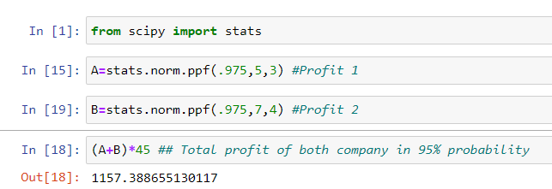

B)

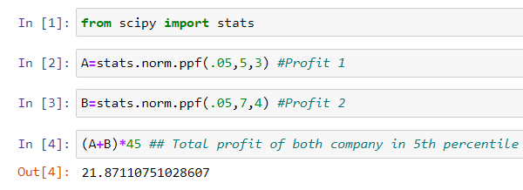

C) Profit1 ~ N (5, 3**2) and Profit2 ~ N (7, 4**2)

Profit1 mean=5 & Std=3 & Profit2 mean=7 & Std=4

P1=5/3= it will be fall in +1.67 and -1.67

P2=7/4= it will be fall in +1.75 and -1.75

Then we can say that

P2 is riskier than P1