Running the Application:

A Step-By-Step Guide

# Pre-requisites:

Docker, Docker-compose

Infrastructure Provisioning

### Steps to run the service through local:

1. Install docker and docker-compose in local environment
2. Navigate to the directory
3. The image umaparvathi/order_service_application:latest mentioned in docker-compose yml file is public docker image built with this code.
4. Open command prompt and run the following command

* docker-compose up

Test Application

1. Open server in browser by <http://localhost:5000/>

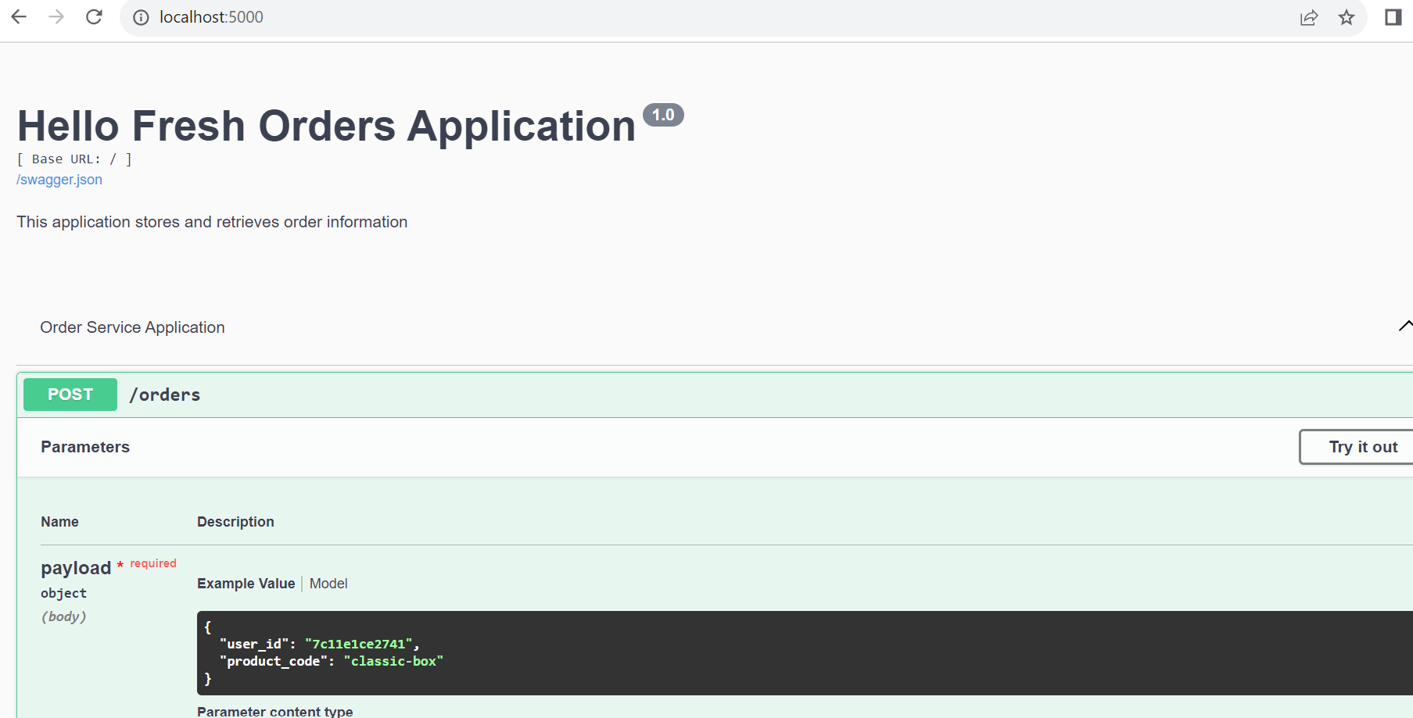

**Example Order request:**

{

"user_id": "7c11e1ce2741",

"product_code": "classic-box"

}

1. The Order service gets product details, user details from their endpoints and prepares payload.

**Example Payload:**

{

'producer': 'Order-Service',

'sent_at': '2023-11-29 19:37:58',

'type': 'json',

'payload': {

'order': {

'order_id': '20231129193759720751',

'customer_fullname': 'Ada Lovelace',

'product_name': 'Classic Box',

'total_amount': 9.99,

'created_at': '2023-11-29 19:37:59'

}

}

}

1. The service publishes payload to RabbitMQ broker and returns success message.

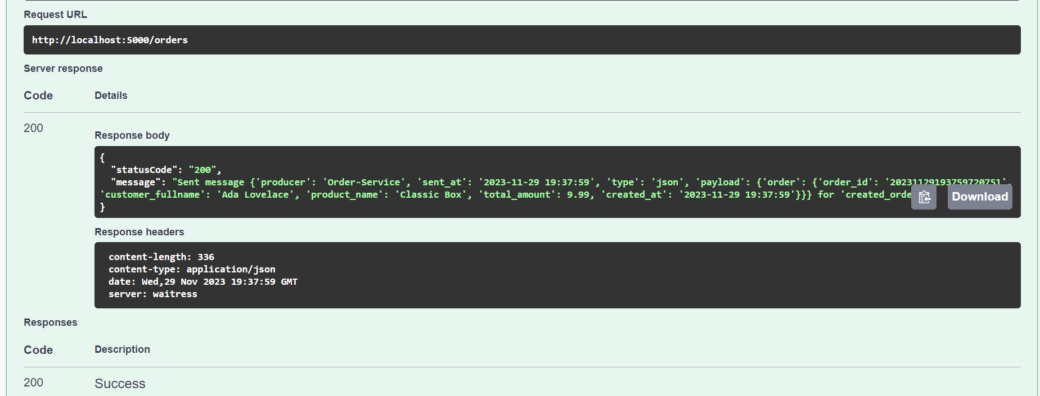

### Run Test Suite:

1. Navigate to directory and run the following command to run tests.

* python -m pytest tests/