**Ladder run**

**Goal**:   
**Starting position:**   
Both teams must sit on ground with legs stretched facing each other.(A ladder like structure)  
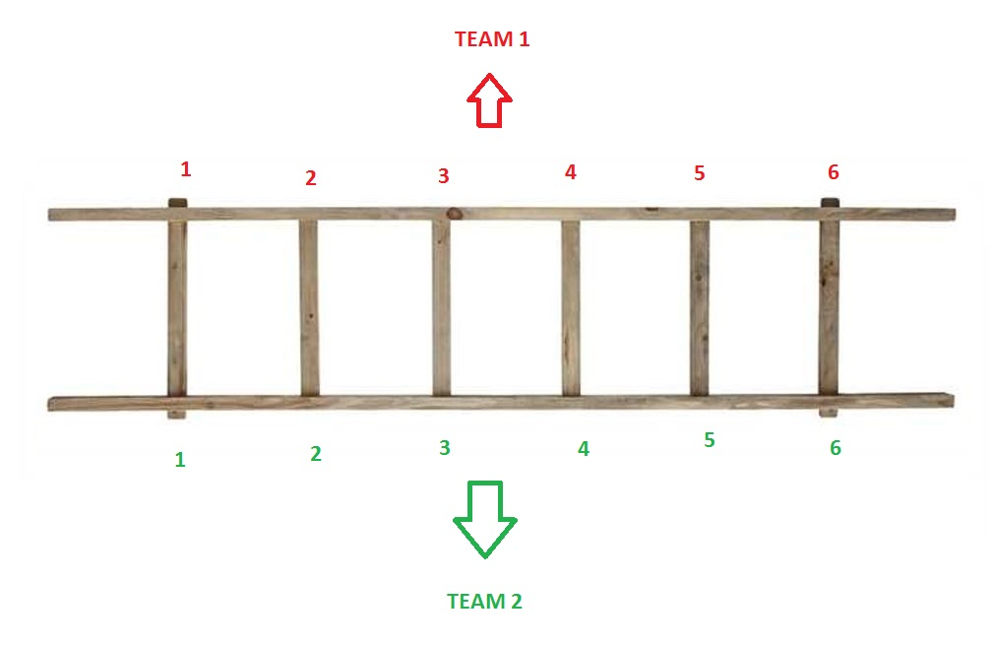

**Rounds**:  
3 rounds will be conducted.   
Round 1 – Team1, Team2.  
Round 2 – Team3, Team4  
Round 3 – Team5, Team6  
  
**How to play:**   
1) Both teams must sit on ground with legs stretched facing each other (A ladder like structure).  
2) Members in each team will be assigned a number sequentially starting from 1  
3) When the game conductor, says a number, the team member who was assigned that number from each teams must run outside chain till the end of the it and then return back to the original position inside the chain.

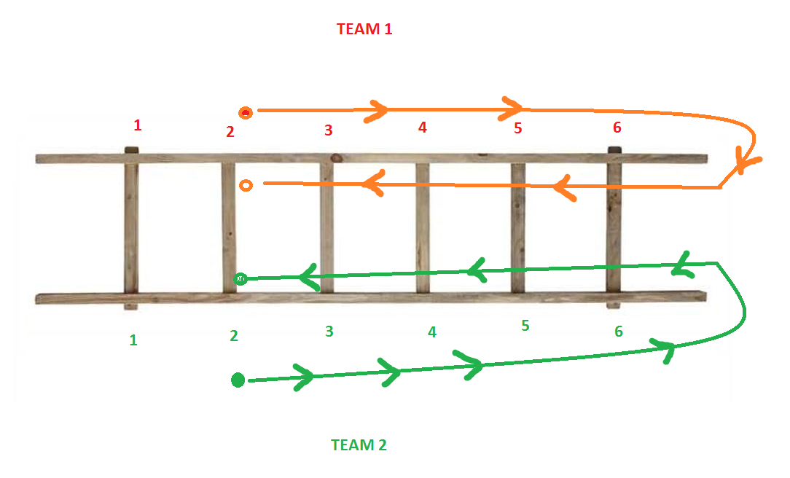

**Rules:**  
- Each round will be conducted for a maximum of 5 minutes.  
- Winnings in every lap by each team will be counted.   
- The team with most victory will be the winner.  
- During the return run, if the runner steps foot on the seated players, the victory goes to the opponent team.  
**-------------------------------------------------------------------------------------------------------------------------------------------------------------------------**

**POINTS: 1st Place – 60pts | 2nd Place – 50pts | 3rd Place – 40pts | 4th Place – 30pts | 5th Place – 20pts | 6th Place – 10pts   
  
-------------------------------------------------------------------------------------------------------------------------------------------------------------------------**