**Paper cup Pyramid**

**Goal**:   
The goal of this game is to build a pyramid using paper cups.

**Rounds**:  
2 rounds will be conducted.   
Round 1 – Team1, Team2, Team3  
Round 2 – Team4, Team5, Team6  
  
**How to play:**

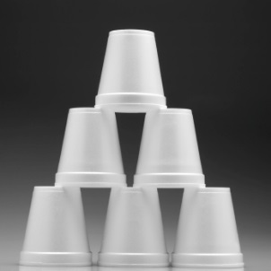

1) Each team member must carry the paper cups on top of their heads from Starting line to Finish line  
2) On the finish line, one team member must assemble the paper cups in a pyramid shape  
3) Only after a team member reaches the finish line, the next team member can start carrying his cup

**Rules:**  
- Each round will be conducted for a maximum of 5 minutes.  
- Time taken by each team to build the pyramid will be calculated.  
- The quickest team among the six teams will be announced the winner.  
- If all teams fail to complete the pyramid, teams will be scored based on the shape of the pyramid  
**-------------------------------------------------------------------------------------------------------------------------------------------------------------------------**

**POINTS: 1st Place – 60pts | 2nd Place – 50pts | 3rd Place – 40pts | 4th Place – 30pts | 5th Place – 20pts | 6th Place – 10pts   
  
-------------------------------------------------------------------------------------------------------------------------------------------------------------------------**