**The Hoopla ring game**

**Goal**:   
Form a human chain.  
Pass the hoopla ring from the first person to the last without breaking the chain as quickly as possible.

**Rounds**:  
2 rounds will be conducted.   
Round 1 – Team1, Team2, Team3  
Round 2 – Team4, Team5, Team6  
  
**How to play:**

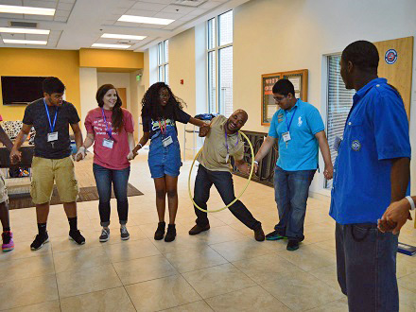

1) The whole team must form a human chain by holding hands  
2) The hoopla ring must be passed from the first person to the last person without breaking the chain  
3) Each member must pass the ring through their body. No other alternatives are allowed.

**Rules:**  
- Each round will be conducted for a maximum of 5 minutes.  
- Time taken by each team to pass the ring will be calculated.  
- The quickest team among the six teams will be announced the winner.  
- If a team breaks the chain while playing the game. They’ll be disqualified.  
**-------------------------------------------------------------------------------------------------------------------------------------------------------------------------**

**POINTS: 1st Place – 60pts | 2nd Place – 50pts | 3rd Place – 40pts | 4th Place – 30pts | 5th Place – 20pts | 6th Place – 10pts   
  
-------------------------------------------------------------------------------------------------------------------------------------------------------------------------**