
AIR UNIVERSITY
Aerospace and Aviation Campus, Kamra
Discipline: | Computer Science
Teacher: | Miss Muneeba
Course Name: | Operating Systems Lab
Course Code: | CS-325L
Semester: | 5B
Lab Number: | 05
Student Name: | Umar Abdullah
Registration No: | 245387

Task No:01
Problem Statement
Solve a student result and scholarship eligibility problem by developing a shell script that takes the student&#39;s name, marks, and attendance percentage as input. The script should: Use conditional statements to determine and display the student&#39;s grade according to the marks. Show Pass if marks are 50 or above; otherwise, show Fail. Use multiple conditions to determine scholarship eligibility. Display Eligible for Scholarship if marks are 85 or above and attendance is 90% or above. Report Not Eligible for Scholarship if the eligibility criteria are not satisfied. Demonstrate the use of if, if-else, if-elif-else, and &amp;&amp; in a single shell script.
Code:
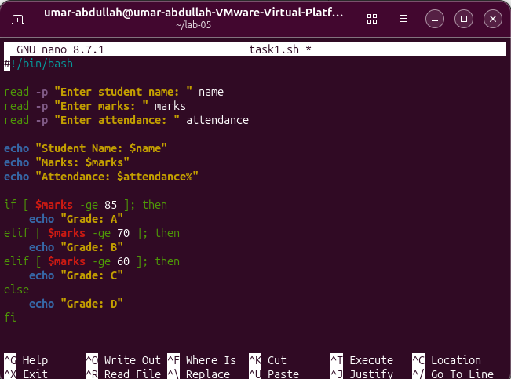

Output:
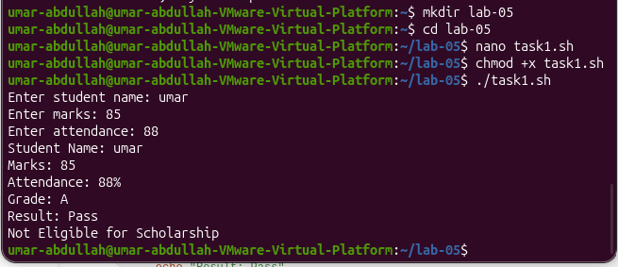
Task No:02
Employee Salary Category
Prepare a shell script that takes an employee&#39;s name, basic salary, and years of experience as input and calculates the employee&#39;s final salary and category. The script should:Use conditional statements to determine the bonus according to experience: 5 years or more → 20% bonus 3–4 years → 10% bonus Less than 3 years → 5% bonus Calculate and show the bonus amount.Calculate and display the final salary after adding the bonus.Relate years of experience with the appropriate employee category. Show Senior Employee if experience is 5 years or more.Report Junior/Mid-Level Employee otherwise.Demonstrate the use of if-elif-else for multiple conditions.
Code:
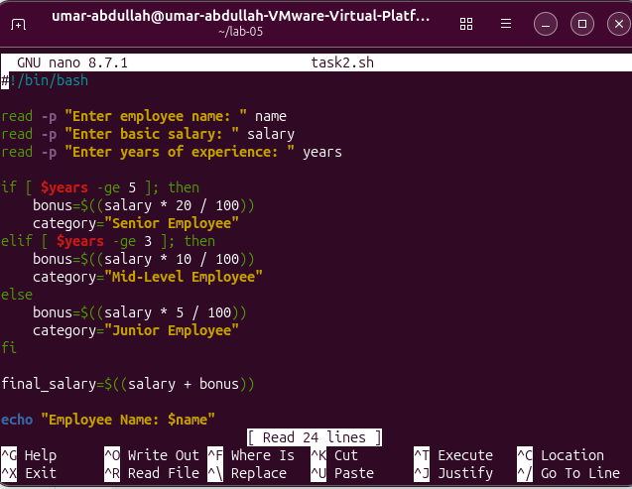

Output:
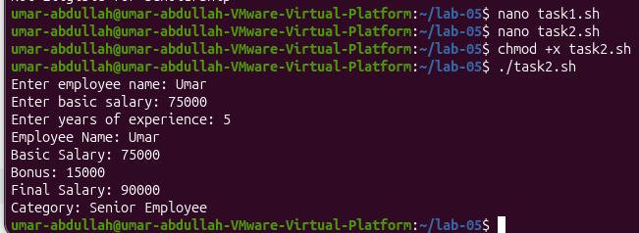

Task No:03
ATM Transaction Validation
Solve an ATM transaction validation problem by developing a shell script that takes the account balance and withdrawal amount as input. The script should: Use conditional statements to check whether the withdrawal amount is greater than zero.
Check whether the withdrawal amount is within the available account balance.
Use multiple conditions with &amp;&amp; to validate a withdrawal.
Calculate and show the remaining balance if the withdrawal is valid.
Report Insufficient Balance if the withdrawal amount is greater than the available balance.
Report Invalid Withdrawal Amount if the amount is zero or negative.
Demonstrate the use of comparison operators such as -gt, -le, and logical operator &amp;&amp;.
Code:
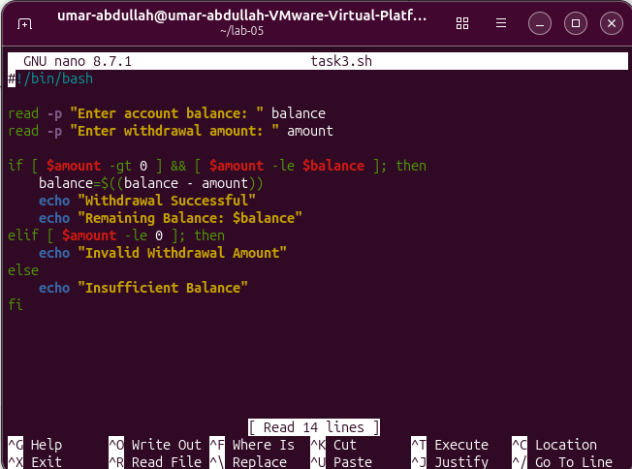
Outputs:
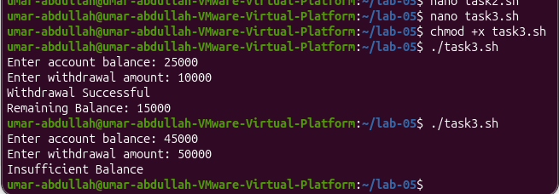
Task No:04
Electricity Bill Calculator
Produce a shell script that takes the number of electricity units consumed by a customer and calculates the total
electricity bill.
The script should:
Use conditional statements to identify the applicable electricity rate.
Calculate the bill according to the following rates:
Show the total number of consumed units.
Calculate and display the total bill.
Relate the number of consumed units with the appropriate usage category:
o Up to 100 → Low Usage
o 101–300 → Moderate Usage
o Above 300 → High Usage
Report Invalid Input if the number of units is zero or negative.
Demonstrate the use of if-elif-else and arithmetic expressions in shell scripting.

Code:
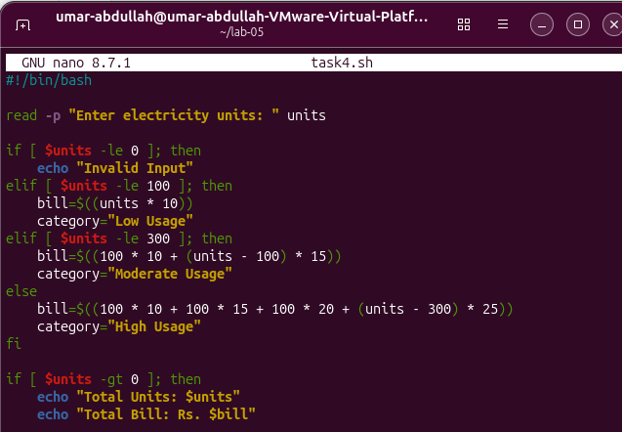

Outputs:
