
AIR UNIVERSITY
Aerospace and Aviation Campus, Kamra
Discipline: | Computer Science
Teacher: | Miss Muneeba
Course Name: | Operating Systems Lab
Course Code: | CS-325L
Semester: | 5B
Lab Number: | 06(Assigment)
Student Name: | Umar Abdullah
Registration No: | 245387

Task No:01
Solve the number analysis problem by developing a Bash script that accepts positive numbers until 0 is entered. Use an appropriate loop to calculate the sum and count of valid numbers. Change the program to handle negative numbers by displaying an error message without including them in the calculations. Show the final sum and count after the loop terminates.
Outputs:
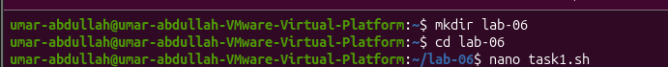
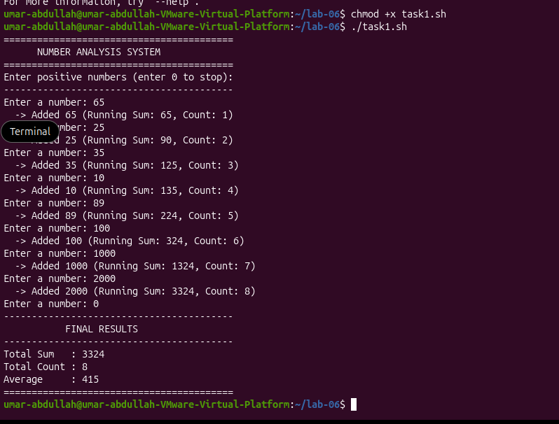

Code:
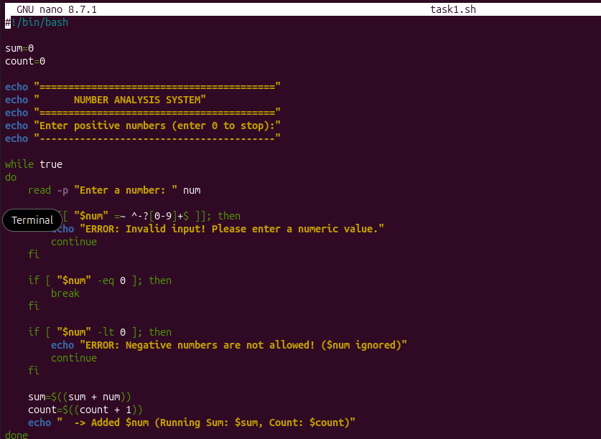
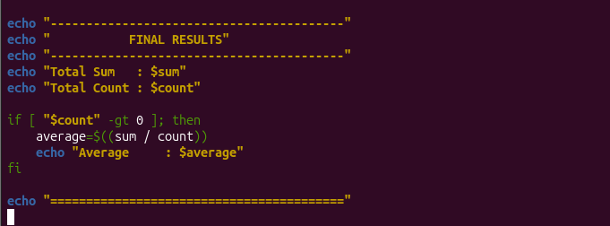

Task No:02
Prepare a Bash script that processes the marks and attendance records of five students. Use an appropriate loop and conditional statements to determine each students pass or fail status. Relate scholarship eligibility to the students performance by awarding a scholarship to students who obtain at least 85 marks and maintain 80% attendance. Produce a final report showing each students result and the total number of scholarship-eligible students.

Code:
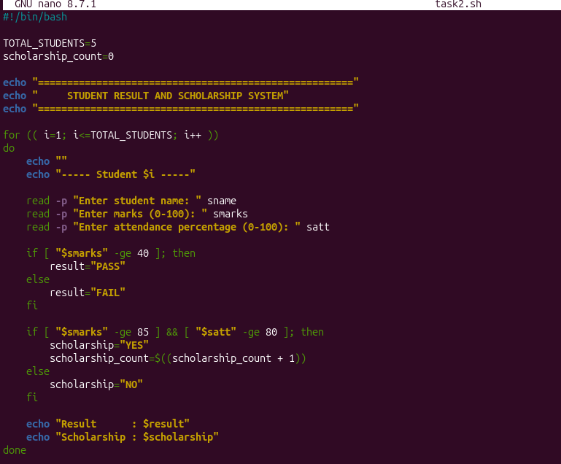
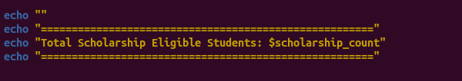

Outputs:
