

Air University Aerospace And Aviation Campuse Kamra

Name: Umar Abdullah
RegId: 245387
Section: BSCS F-24 5-B
Instructor: Miss Muneeba
Subject: OS LAB
Date: 14/09/2026
Lab No: 01(Assigment)
Question No:01
Solve a Linux file-management problem in which student records are stored in different files. Use suitable Linux commands to organize, copy, rename, and manage the files.
Output:
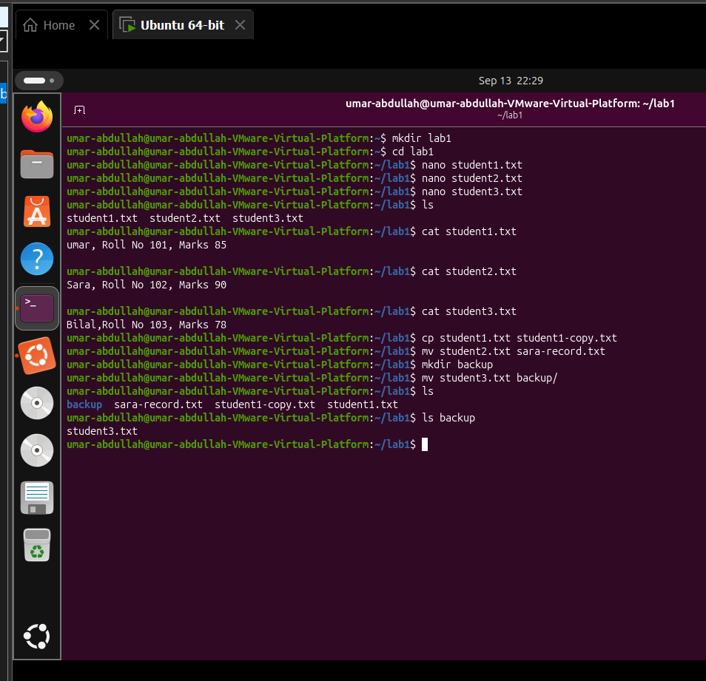

Question No:02
Change the information stored in a text file and Complete the required file operations. Relate the changes in the file with the final output displayed on the terminal.

Output:
Before Change:

After Change:
Add Grade in it
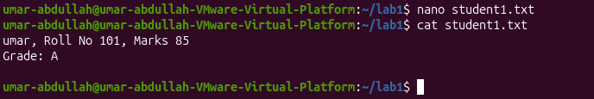

Question No:03
Discover specific student information from a text file and Use suitable Linux commands
to arrange, search, and display the required records. Articulate the difference between
the obtained outputs.

Output:
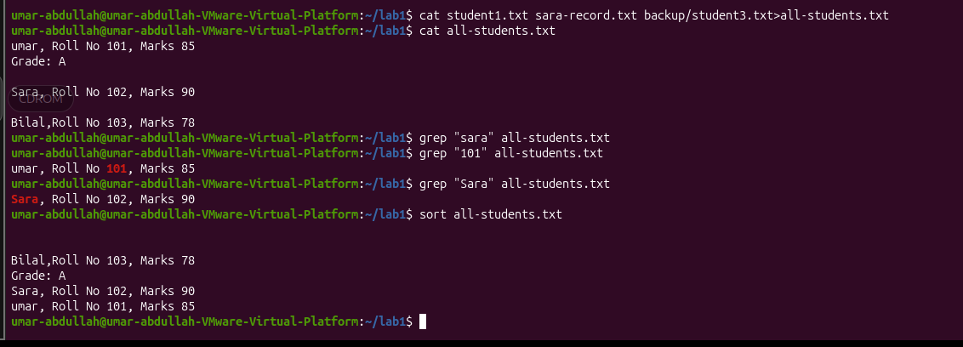

Question No:04
Transfer your knowledge of Linux commands to a C++ compilation task. Solve the problem by creating and executing a C++ source file, and Teach another student how the source file is converted into an executable program.

Output:
