

Air University Aerospace And Aviation Campuse Kamra

Name: Umar Abdullah
RegId: 245387
Section: BSCS F-24 5-B
Instructor: Miss Muneeba
Subject: OS LAB
Date: 16/09/2026
Lab No: 02
Task No:01
Basic Directory Commands
Use Windows CMsD and Ubuntu Terminal to:
1. Use the command to display the current working directory.
2. Use the command to list all files and folders.
3. Use the command to create a directory named OSLab.
4. Use the command to enter the OSLab directory.
5. Use the command to return to the previous directory.
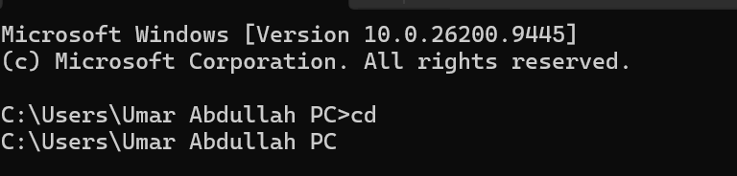
Outputs:

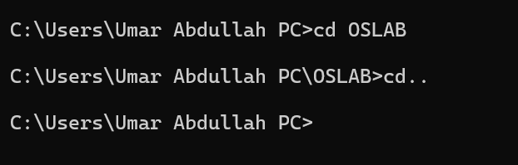
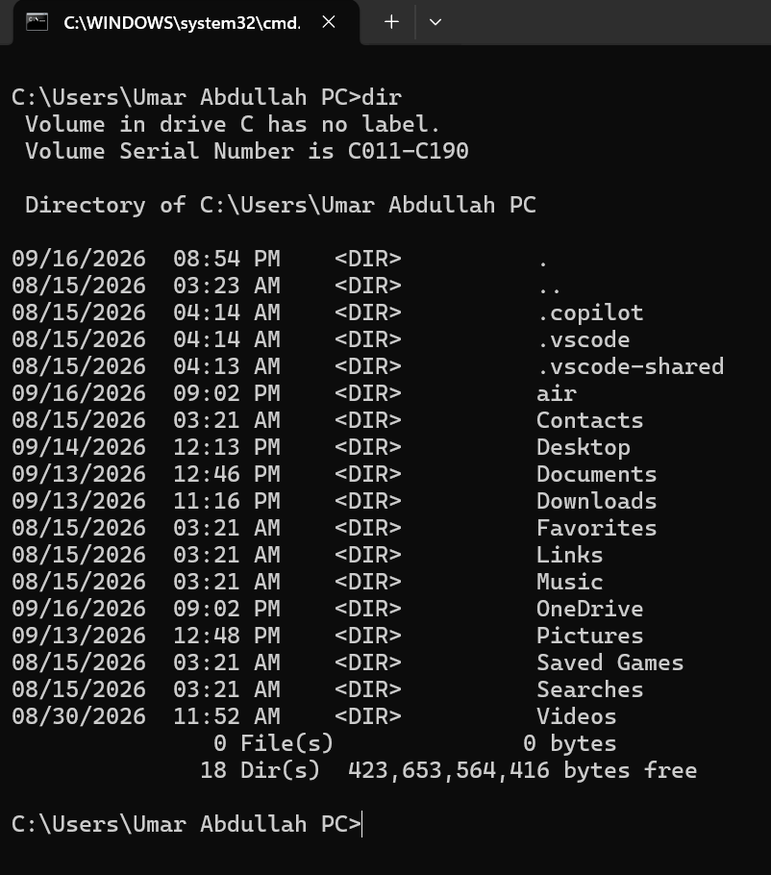
Task No:02
File Creation and Viewing
Use the appropriate commands in Windows CMD and Ubuntu Terminal to:
1. Use the command to create a file named student.txt.
2. Use the command to add the text “Operating Systems Lab” to the file.
3. Use the command to display the contents of the file.
4. Use the command to create a second file named backup.txt.
Output:
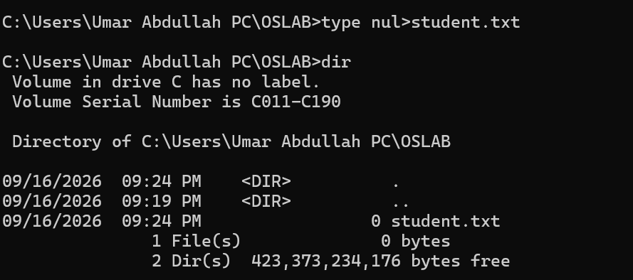

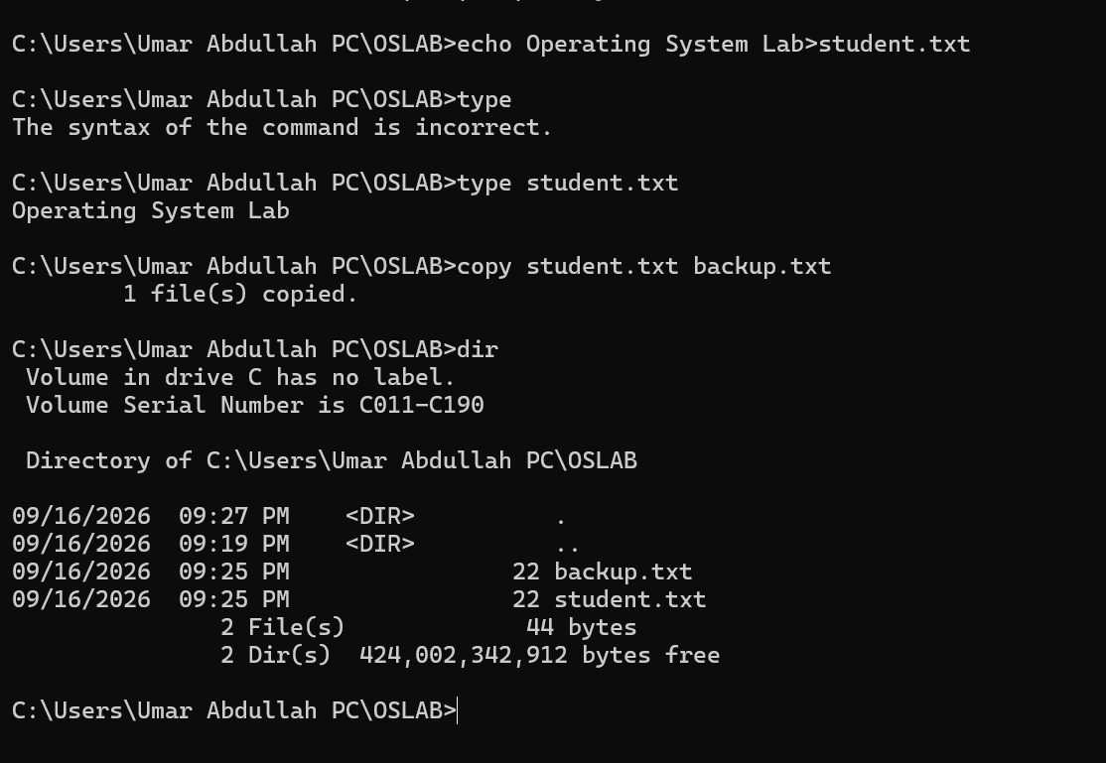

Task No:03
Copy, Move and Rename
Use the appropriate commands to:
1. Use the command to create a directory named Files.
2. Create a file named data.txt inside the directory.
3. Use the command to create a copy of data.txt named data_copy.txt.
4. Use the command to rename data_copy.txt to backup.txt.
5. Use the command to move backup.txt to another directory.

Output:
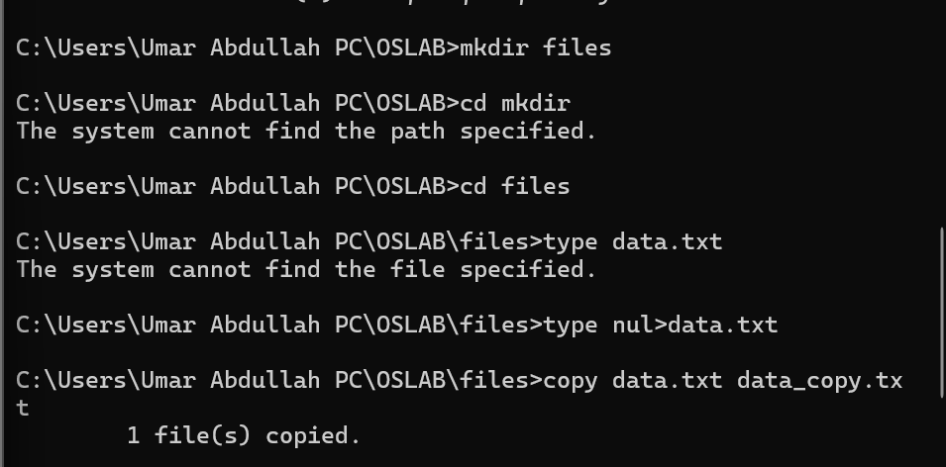
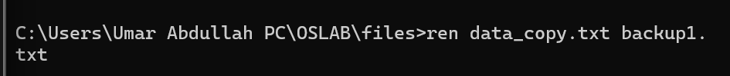

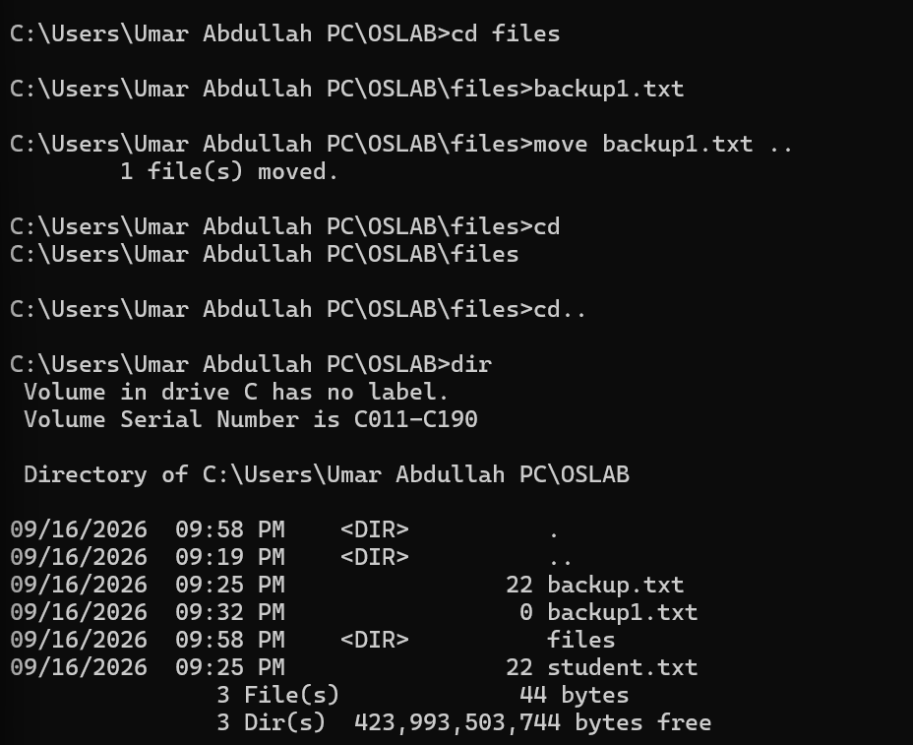

Task No:04
Delete and Clear
Use the appropriate commands to:
1. Use the command to delete backup.txt.
2. Use the command to display the contents of the current directory.
3. Use the command to remove the empty Files directory.
4. Use the command to clear the command-line screen.
Output:
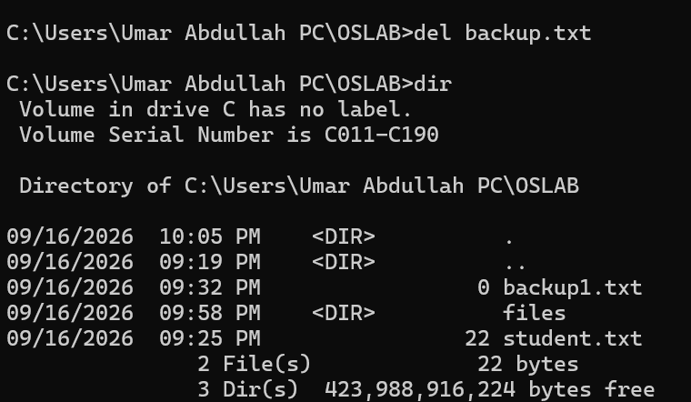
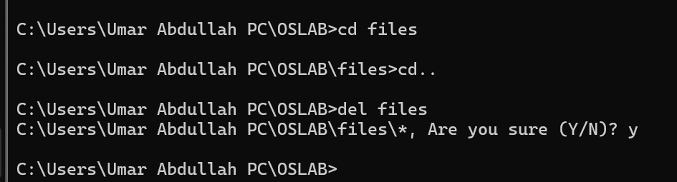

After Clear:
Task No:05
System Information
Use Windows CMD and Ubuntu Terminal to:
1. Use the command to display the computer/host name.
2. Use the command to display the current user.
3. Use the command to display the operating system information.
4. Use the command to check network connectivity with google.com.
5. Use the command to display the current date and time.
Outputs:
