

AIR UNIVERSITY
Aerospace and Aviation Campus, Kamra
Discipline: | Computer Science
Teacher: | Miss Muneeba
Course Name: | Operating Systems Lab
Course Code: | CS-325L
Semester: | 5B
Lab Number: | 03
Student Name: | Umar Abdullah
Registration No: | 245387

Task No:01
Create and Execute a C Program
Solve a C program that displays your name, registration number, and university.
1. Create a C source file named student.c.
2. Insert the required C program.
3. Save the source file.
4. Compile the program using the gcc compiler.
5. Modify the program if a compilation error occurs.
6. Execute the compiled program.
7. Verify the displayed output.

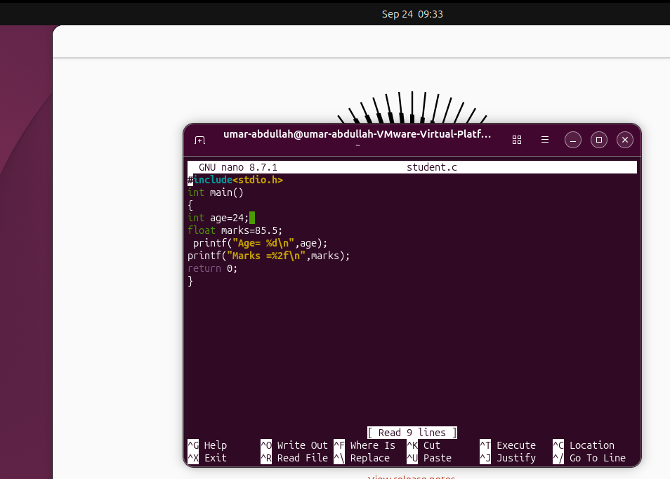
Output:

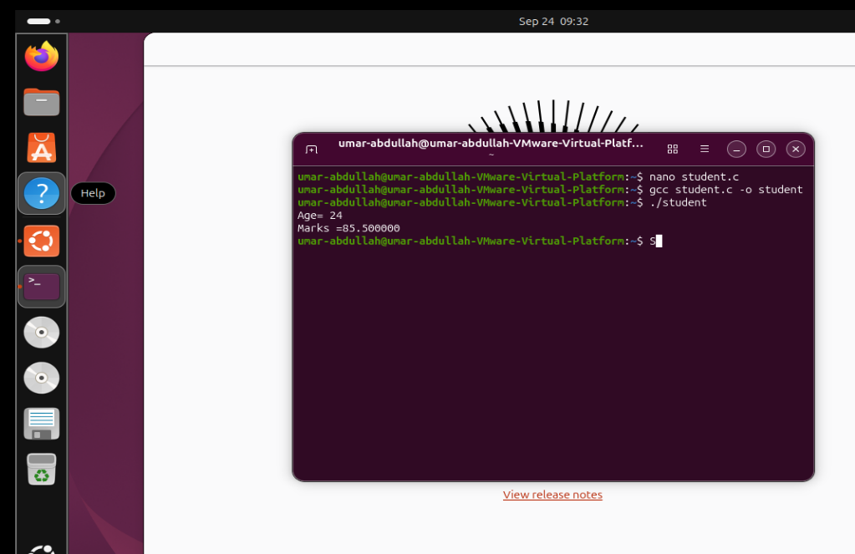
Task No:02
Create and Execute a C++ Program
Solve a C++ program that displays your name, registration number, and university.

1. Create a C++ source file named student.cpp.
2. Insert the required C++ program.
3. Apply cout statements to display the information.
4. Save the program.
5. Compile the program using g++.
6. Execute the compiled program.
7. Verify the output.

Outputs:

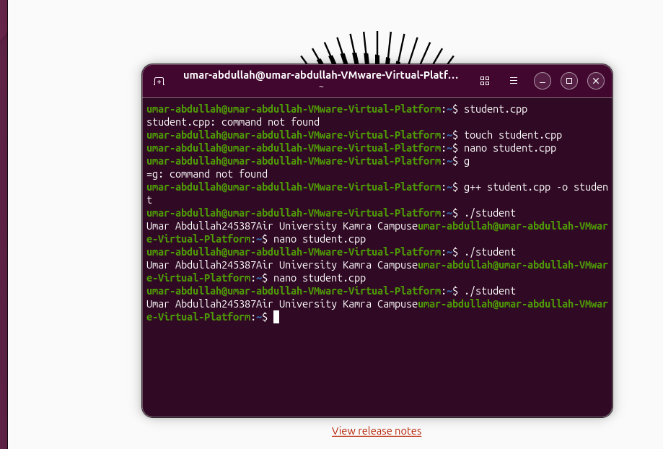

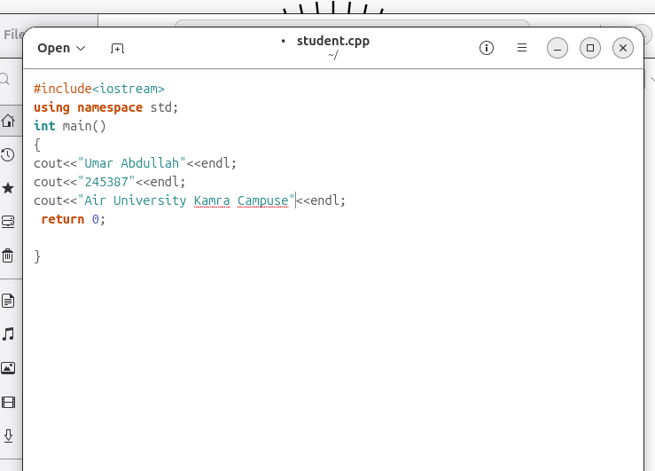

Task No:03
Arithmetic Operations in C and C++
Solve programs in both C and C++ that take two numbers from the user and display their sum, difference, product,
and quotient.
Instructions
1. Create a C file named calculator.c.
2. Create a C++ file named calculator.cpp.
3. Insert the required code in both files.
4. Apply arithmetic operators for the required calculations.
5. Compile the C program using gcc.
6. Compile the C++ program using g++.
7. Execute both programs.
8. Compare their outputs.

Outputs:
In C:
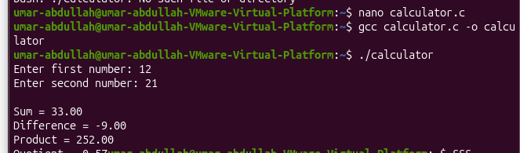
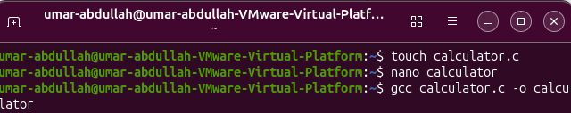
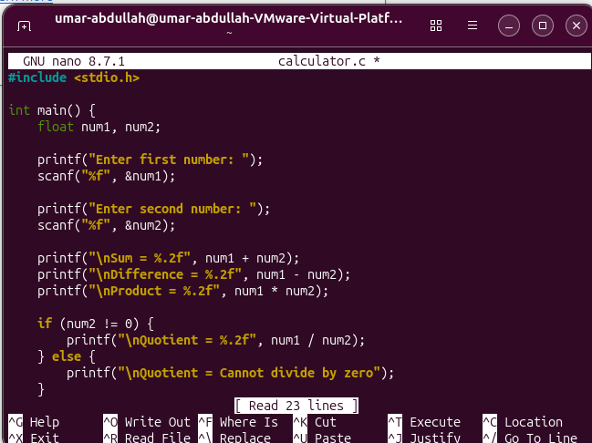

In C++:
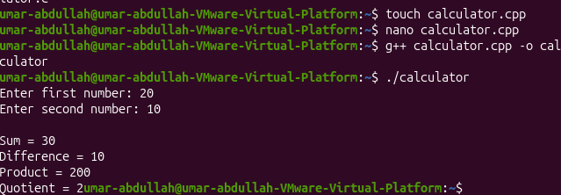
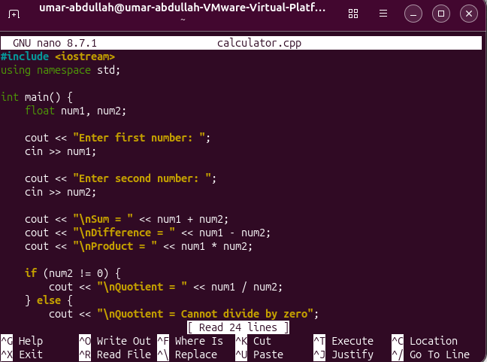

Task No:04
Conditional Statements
Create C and C++ programs to determine whether a student has passed or failed.
1. Create result.c.
2. Create result.cpp.
3. Insert an appropriate program in both files.
4. Apply an if-else statement.
5. Set the passing marks to 50.
6. Compile both programs using their respective compilers.
7. Execute both programs.
8. Verify the results for different marks.

Outputs:
In C:
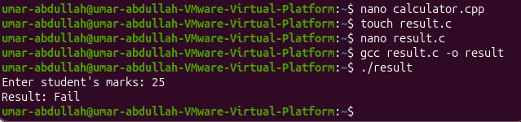

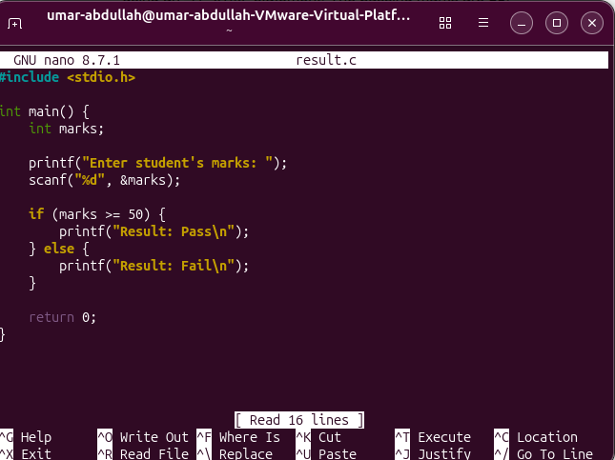

In C++;
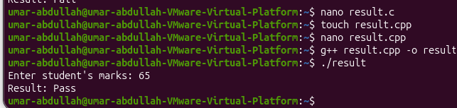

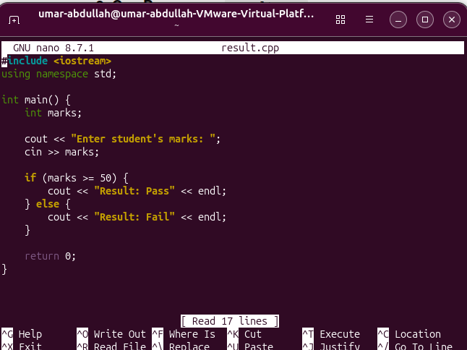

Task No:05
Debugging a C++ Program
1. Create a file named debug.cpp.
2. Insert the given program.
3. Compile the program using g++.
4. Identify the compilation error.
5. Modify the program to correct the error.
6. Compile the program again.
7. Execute the program.
8. Verify the output.

Outputs:
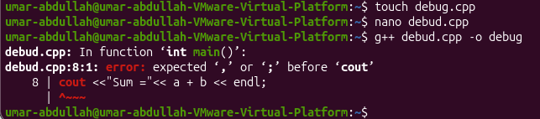

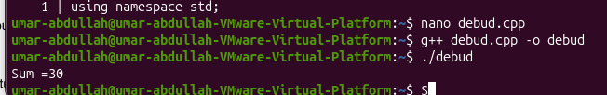

Error:
After intb=20 semicolon is missing

Task No: 06
Compile Using CC
Create a simple C program and compile it using the cc command.
1. Create a file named ccprogram.c.
2. Insert a C program that displays a message.
3. Save the file.
4. Compile the program using the cc compiler command.
5. Execute the generated executable.
6. Verify the output.

Outputs:

