
AIR UNIVERSITY
Aerospace and Aviation Campus, Kamra
Discipline: | Computer Science
Teacher: | Miss Muneeba
Course Name: | Operating Systems Lab
Course Code: | CS-325L
Semester: | 5B
Lab Number: | 04
Student Name: | Umar Abdullah
Registration No: | 245387

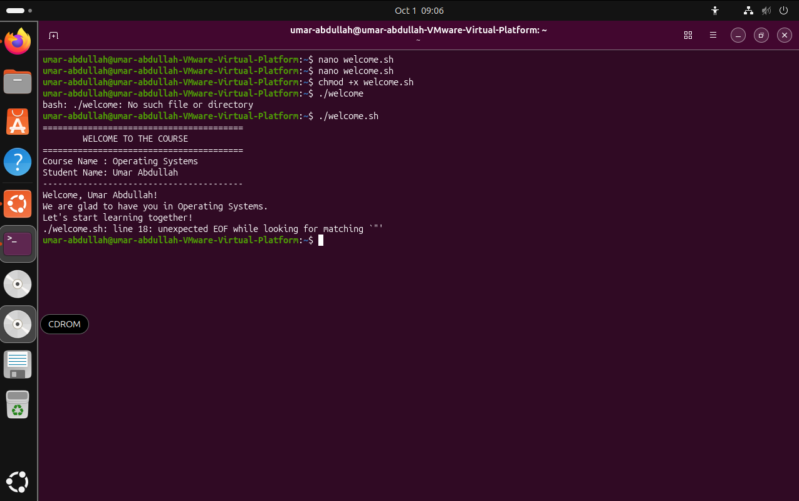
Task No:01
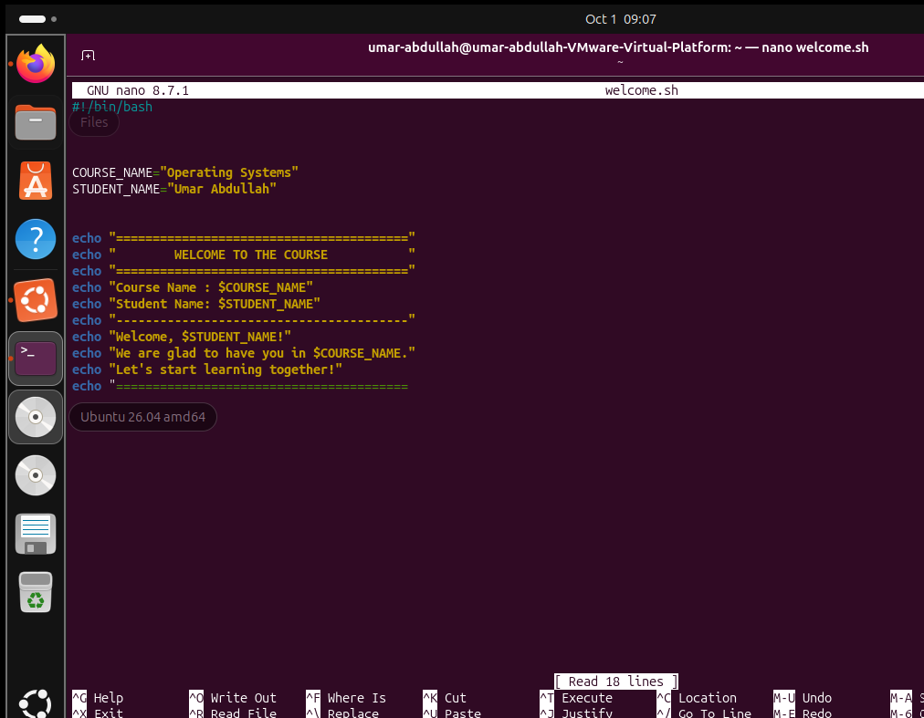

TasK No:02
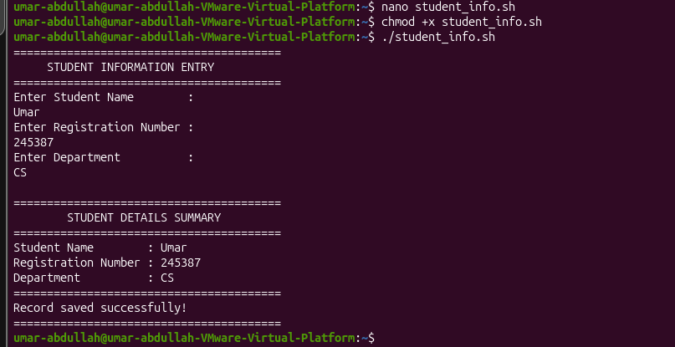
Code:
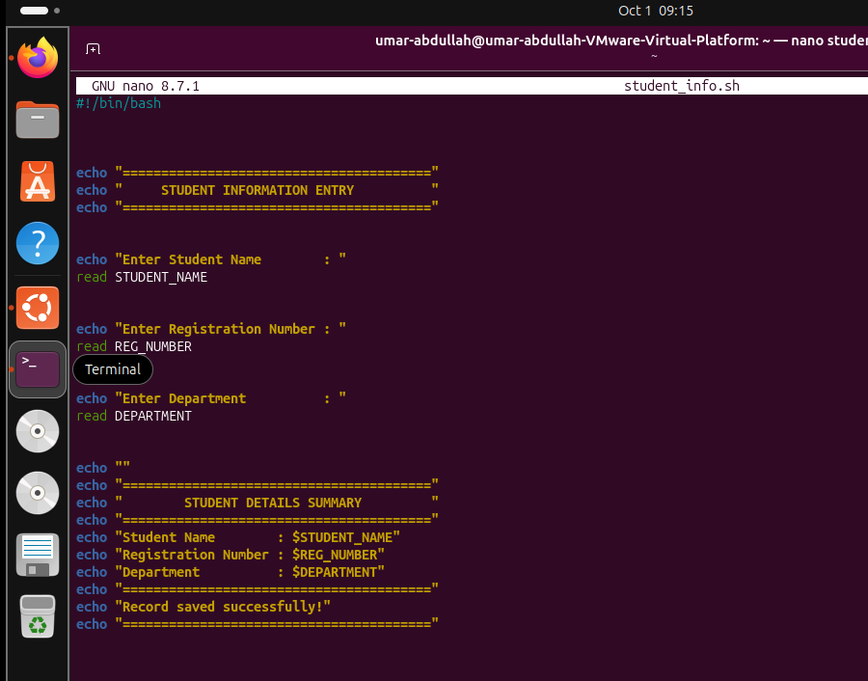

Task No:03
For Addition:
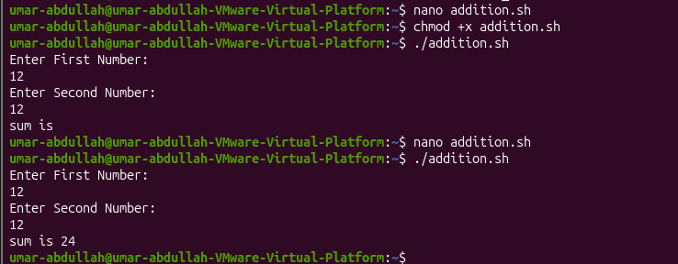
For Subtraction:
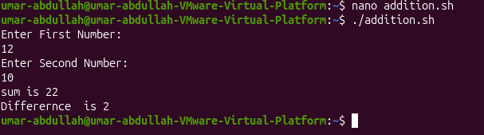
For Multiplication:
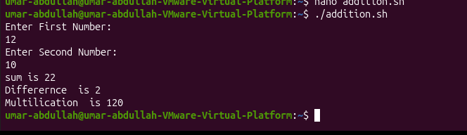

Code:
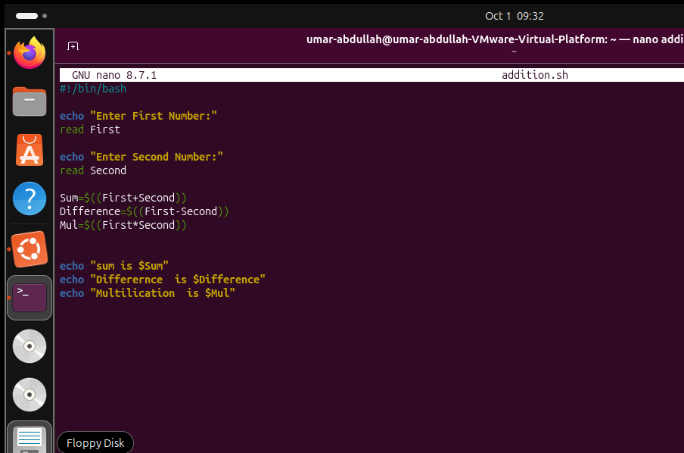

Task No:04
With Bash:
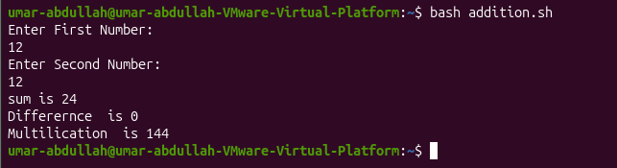
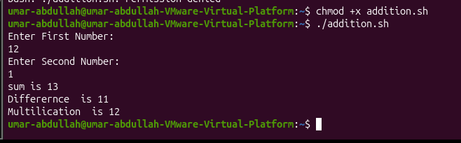
With Chmod:

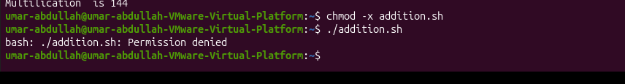
Permisssion Denied:

Task No:05
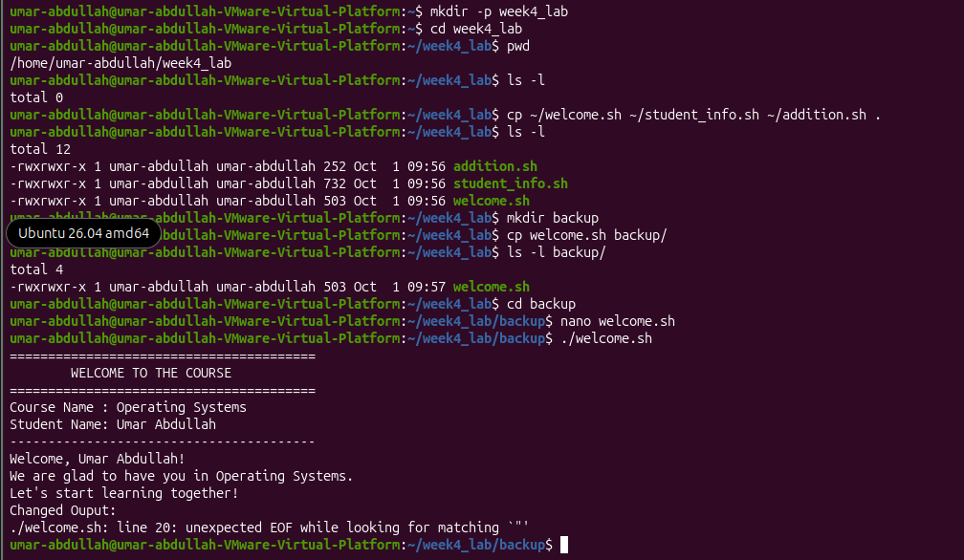

Code:
