
AIR UNIVERSITY
Aerospace and Aviation Campus, Kamra
Discipline: | Computer Science
Teacher: | Miss Muneeba
Course Name: | Operating Systems Lab
Course Code: | CS-325L
Semester: | 5B
Lab Number: | 07
Student Name: | Umar Abdullah
Registration No: | 245387
Task No:01
Solve the process creation problem by writing a C program that uses the fork() system call to create a child process.Show separate messages from the parent and child processes and demonstrate how both processes continue execution after the fork() statement.
Code:
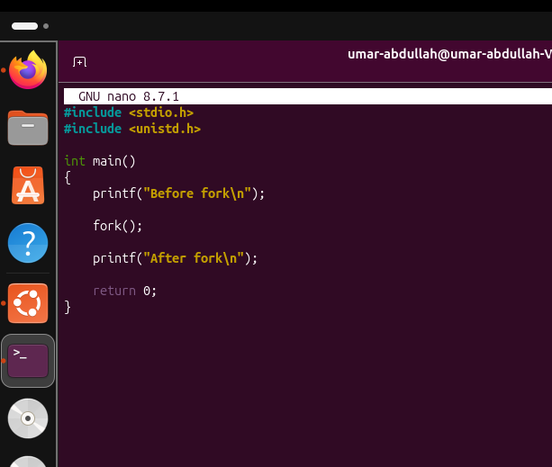
Output:
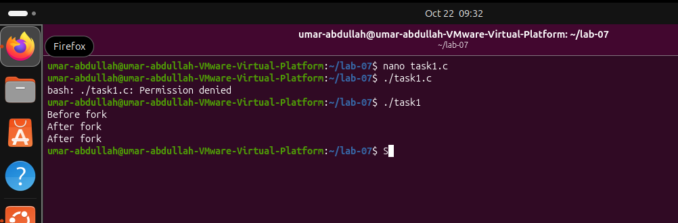

Task No:02
Use the getpid() and getppid() functions to identify the process ID and parent process ID of the parent and child processes. Relate the output of these functions to the process hierarchy and report the IDs displayed during program execution.
Code:
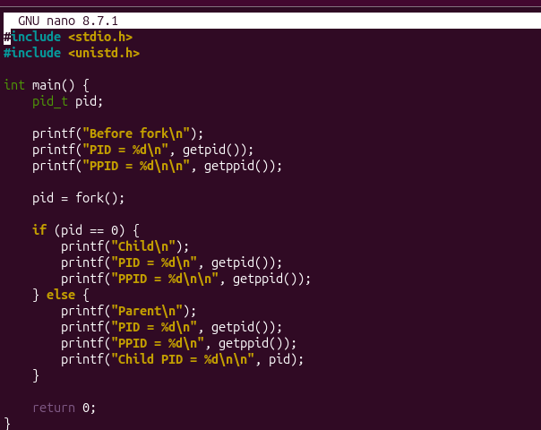
Output:
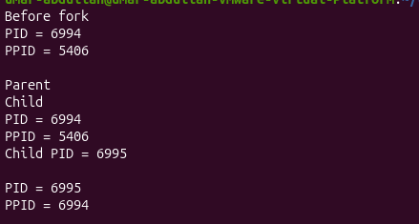

Task No:03
Complete a C program that stores the return value of fork() in a variable of type pid_t. Change the program to handle the three possible return values: negative for failure, zero for the child process, and positive for the parent process. Articulate the purpose of each condition and show the corresponding output.
Code:
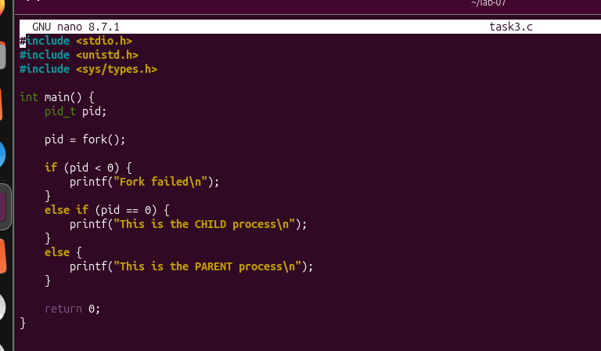
Output:
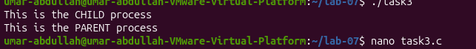

Task No:04
Prepare a C program in which the parent process creates a child process and uses wait() to wait for the child to terminate. Demonstrate the difference between execution without synchronization and execution with synchronization. Discover how wait() affects the order of the displayed messages.
Without Synchronization:
Code:
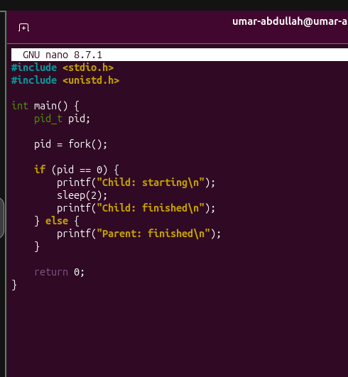
Output:
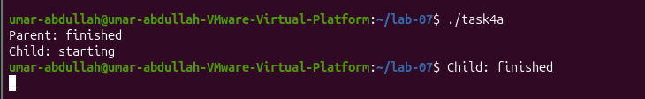
Without Synchronization:
Code:

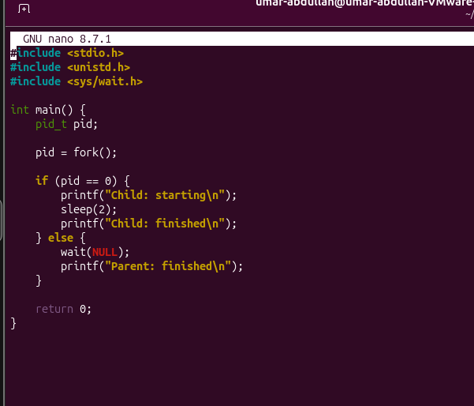
Output:
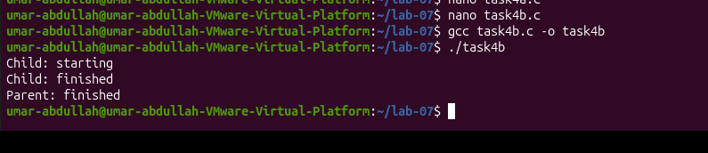

Task No:05
Produce a C program that creates a child process and uses waitpid() to wait for that specific child. Manipulate the program by changing the child PID argument and explain how waitpid() differs from wait().
Code:
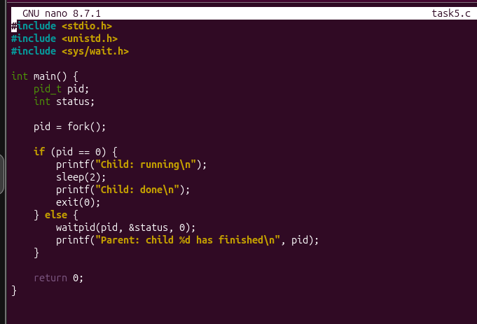
Output:
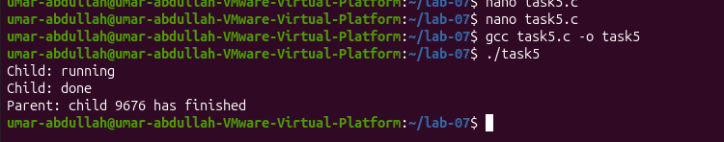

Task No:06
Demonstrate process termination by using exit(0) in the child process after displaying a message. Transfer the concept of successful termination to a program in which the parent waits for the child. Show that the parent continues after the child terminates, and explain the meaning of the exit status.
Part 1:
Code:
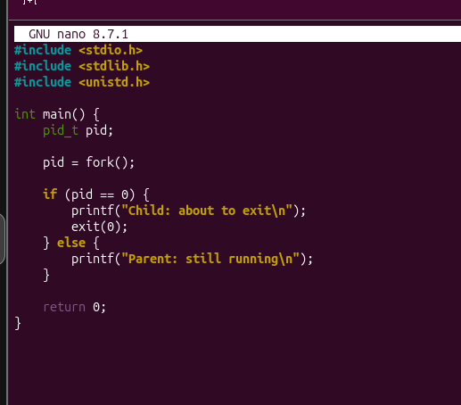
Output:
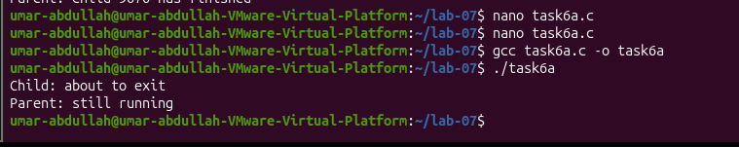

Part 2:
Code:
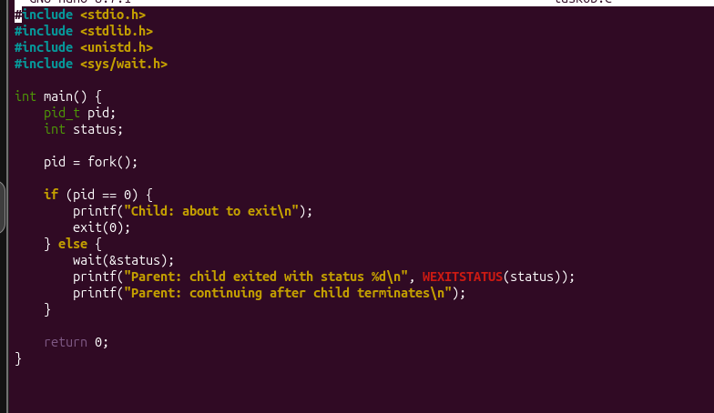
Output:
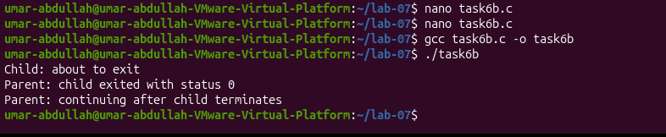
Task No:07
Sketch the execution flow of a program that initializes an integer variable before calling fork(). Change the variables value in the child process and show the values displayed by both processes. Relate the results to the separate memory spaces of parent and child processes.
Code:
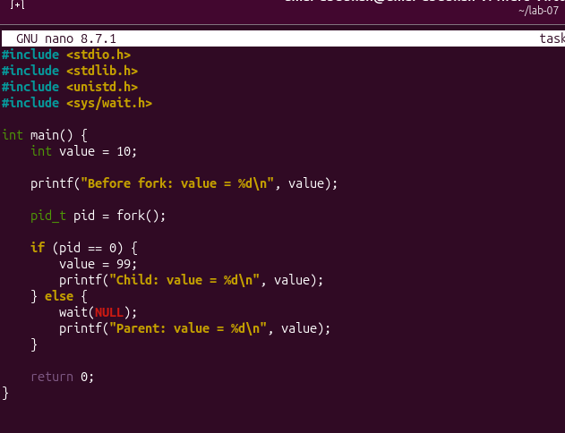
Output:
