## 

## e-Project

## Ryan Sports Club

## Batch Code

PR2-202205C

## Group Members

|  |  |  |
| --- | --- | --- |
| Serial Number | Enrollment Number | Student Name |
| 1 | 1376511 | Umar Farooq |
| 2 | 1379364 | Ahsan Rahim |

# **ACKNOWLEDGEMENT**

## 

The first, we would like to express my special thanks of gratitude to my teacher **Muhammed Aqueel**, who helped us a lot in finalizing this project within the limited time frame, valuable counseling and assistance for the accomplishment of this project.

Secondly, we would also like to thank the e-Project team at Aptech Head Office, who gave us the golden opportunity to do this wonderful project about A Sports Club and thirdly, we also thank the e-Project team, some of the benefits are as under:

* Re-enforcement of skills happens in the experiential learning process.
* A mentor, ensuring that we do not get drifted, constantly guides us.
* It gives us a lot of confidence to face an interview as we have worked on a project. We can explain virtually everything on the subject we have learnt.

# **SYNOPSIS**

Follow the strong development of the internet, technology watches and the sports development, every business needs a website design to display products on the internet.

* Ryan Sports Club is designed with many different designs, styles, fonts and much more.
* Ryan Sports Club have 3 sports each having 2 categories with an amount of variety.
* Which is the most special suggestion from Ryan Sports Club.
* So, the Ryan Sports Club provides with quality games and professional instructors.
* However, membership is available only through website.

# **PROBLEM STATEMENT**

“Ryan Sports Club” is a stylish and well designed web. Having user guide and most frequently solving queries of the users.

Ryan Sports are the one who always put the comfort on first ,which is a big source of trust between us and our members. But When it comes to comfort vs. skill and the qualities of our club, the instructors are one of the most important considerations.

The instructors and trainers are professional in their respective sports. So, we want you to feel comfortable and relaxed in our club. Being relaxed plays a big part in developing sports skills.

A sport that properly supports your body as you play. Students always get bored with the study but they get attracted to the games and sports. The sports make the environment feel happy and fresh.

"Ryan Sports Club" having its own website to provide information and also get connected with the customer:

Ryan Sports Club is an organization teaching Sports. They produce various players which are skillful enough to compete in the national and international platforms.

You are supposed to create a website for them with the below mentioned requirement specifications.

The website is to be developed for the Windows Platform using HTML5, JavaScript and Geolocation. The site should work well in all leading browsers including Chrome, IE, Firefox.

# **Requirement Specification:**

The Web site is to be created based on the following requirements.

1. The Home Page with some description about the club with proper template design and navbar.
2. The links for “outdoor sports”, “indoor sports” and “recreation” should be added .
3. Membership link must be added with a dummy form.
4. List of the arranged activities.
5. Suggestions and Complaints.
6. Feedback.
7. Contact Us.
8. Information about each sports played and timings.
9. List of top sports players.
10. Map for navigation purposes.

# **Hardware/ Software Requirements**

***Hardware:***

* A minimum computer system that will help you access all the tools in the courses is a Pentium 166 or better.
* 64 Megabytes of RAM or better Software Notepad/HTML editor VS-Code IE 5.0/ Netscape 6.0.

***Software:***

* Notepad/Html Editor.
* Dreamweaver
* IE 5.0/ Netscape 6.0

# **Objectives of the project**

The Objective of this program is to give a sample project to work on real life projects. These applications help you build a larger more robust application.

The Objective is not to teach you HTML/JavaScript/Dreamweaver/HTML5 but to provide you with a real-life scenario and help you create basic applications using the tools.

You can revise the chapters before you start with the project.

This project is meant for students who have completed the module of Dreamweaver. These programs should be done in the Lab sessions with assistance of the faculty if required.

It is very essential that a student has a clear understanding of the subject. Students should go through the project and solve the assignments as per requirements given.

Kindly get back to eProjects Team in case of any doubts regarding the application or its objectives.

# **SCOPE OF THE WORK**

The website is to be developed for the Windows Platform using HTML5, JavaScript and jQuery bootstrap 5.1.3. The site should work well in all leading browsers including Chrome, IE, Firefox etc.

Homepage show Top best **Ryan Sports Club** join us and advanced your skills, play something new and gain a experience of a life time...

Every content direct to relative content.

# ***Screen Shots***

## Home Page



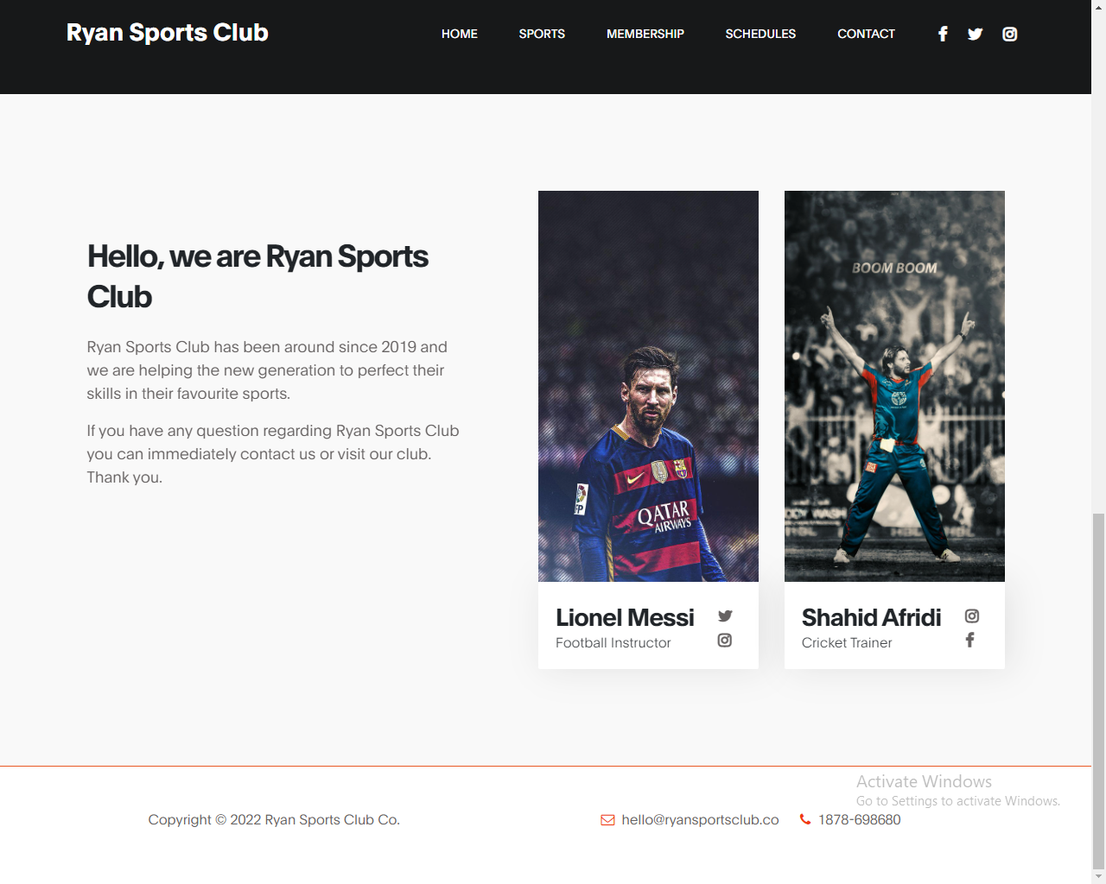

**Sports Page**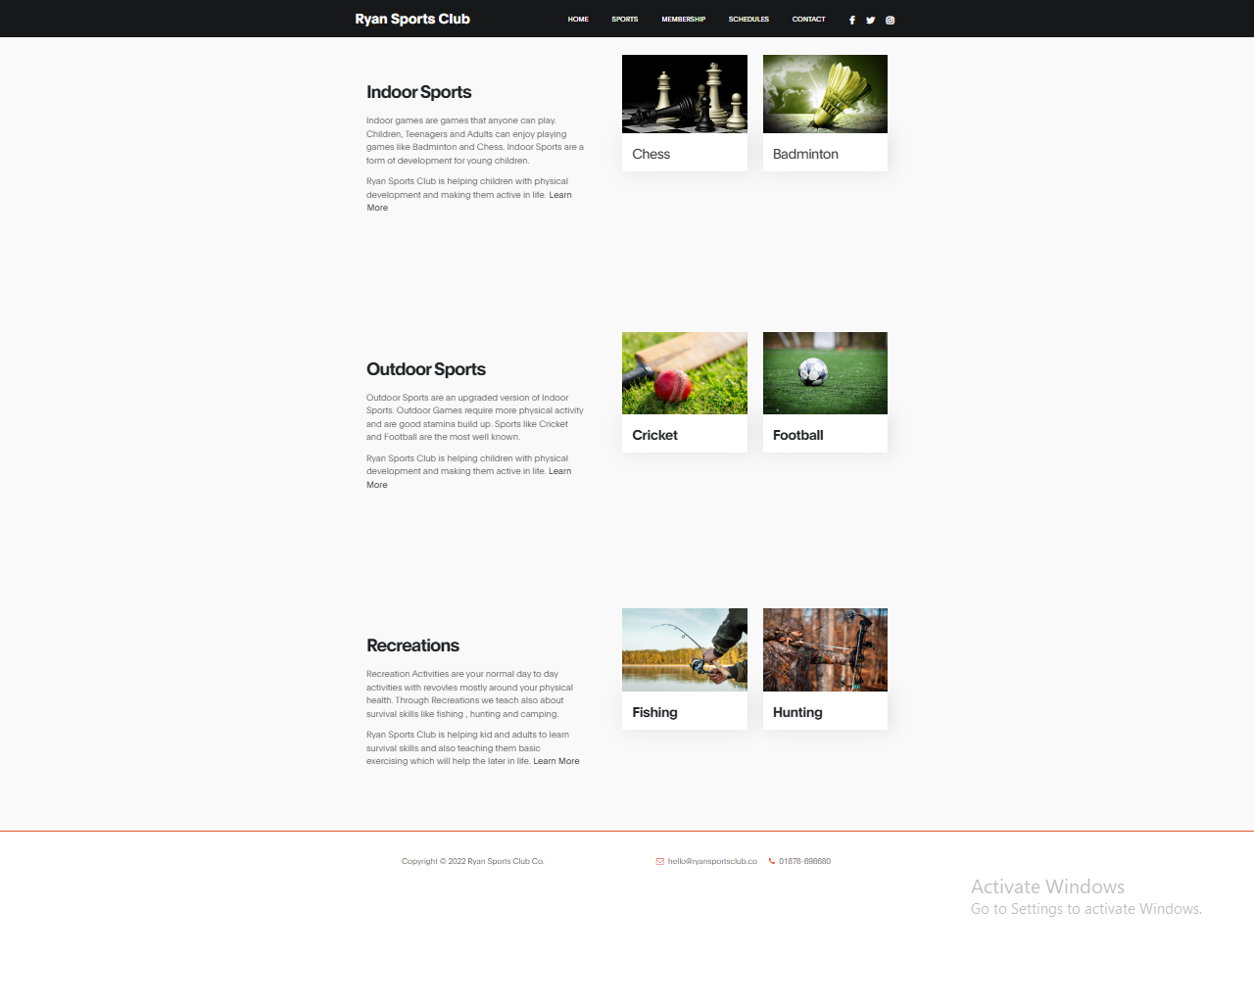

**Membership**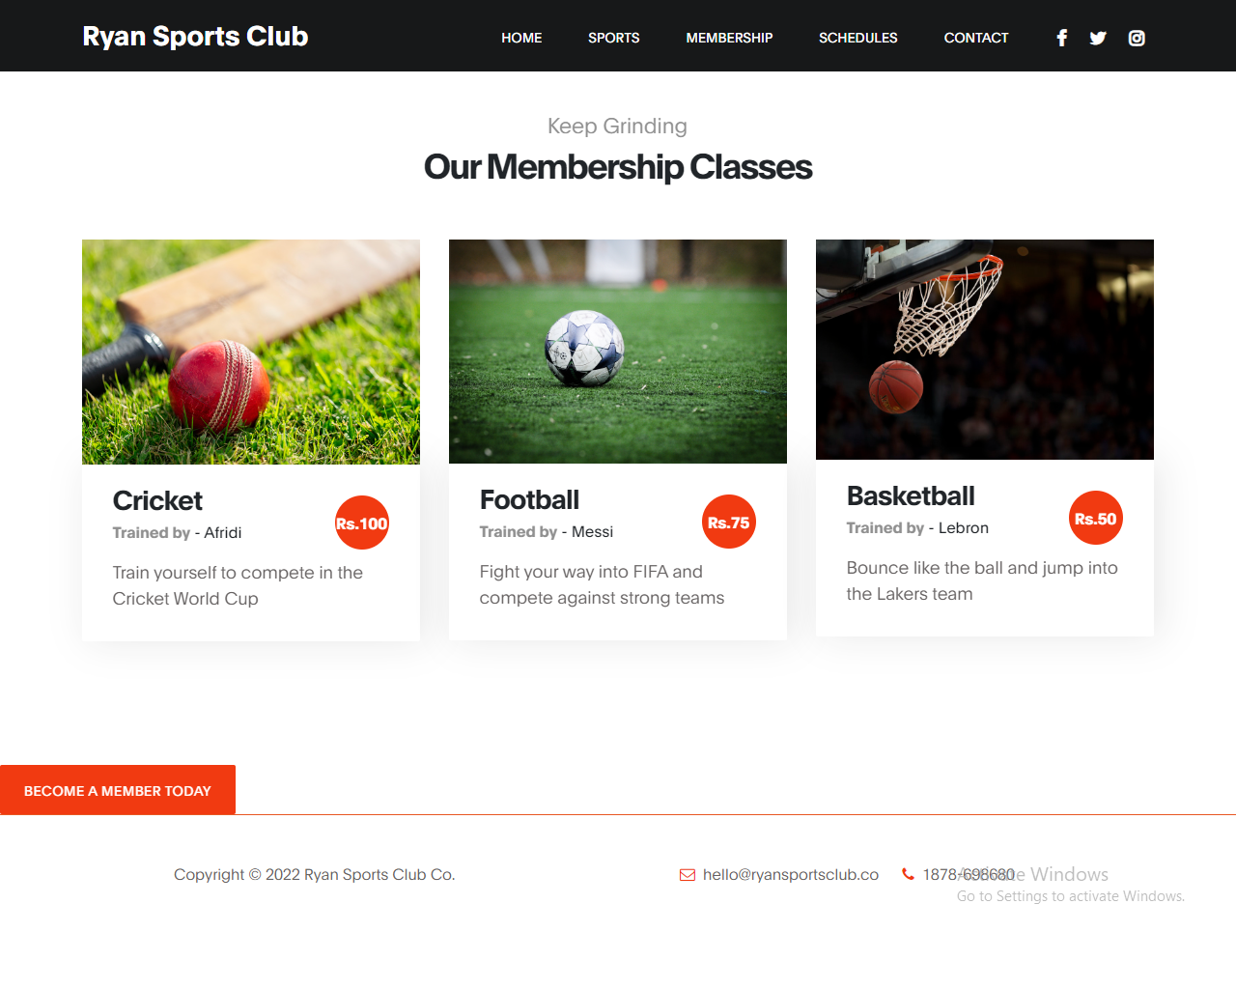

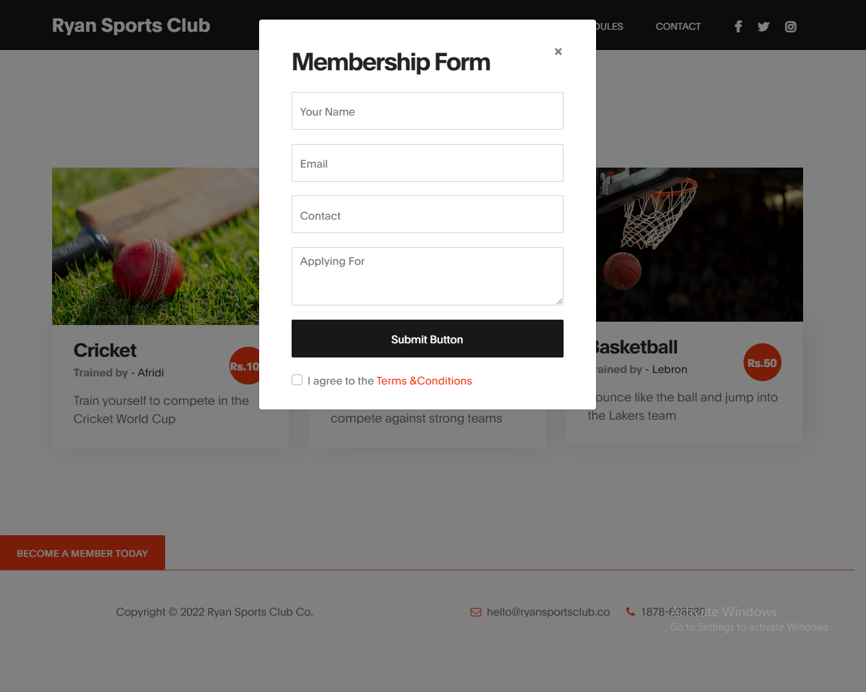

***Schedules***

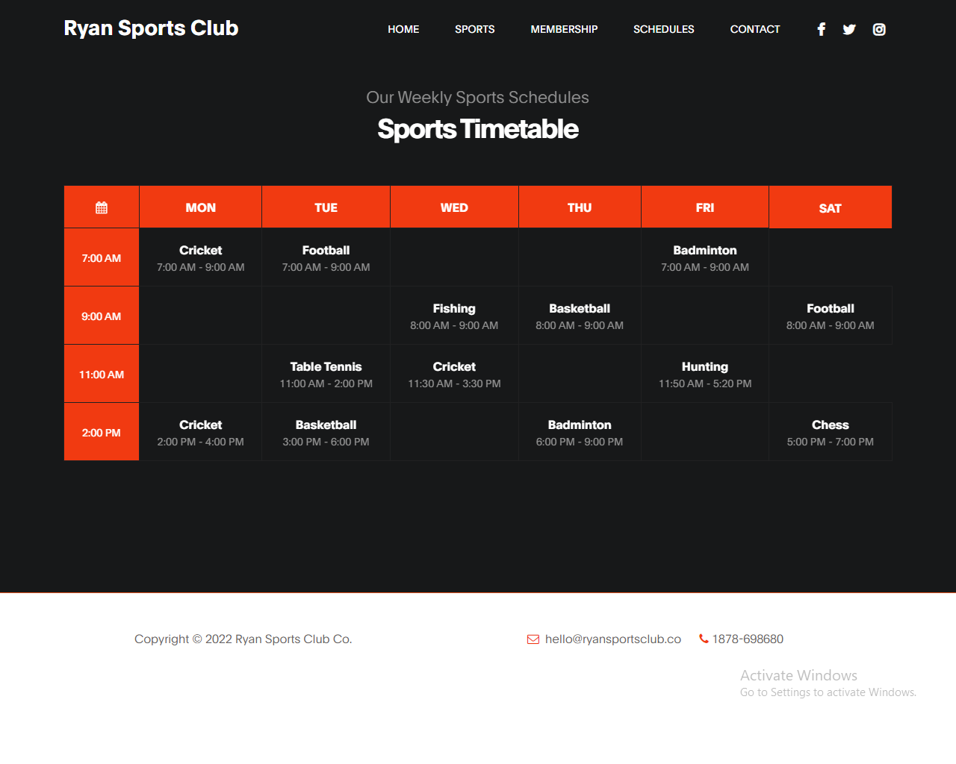

**Contact Us & Map**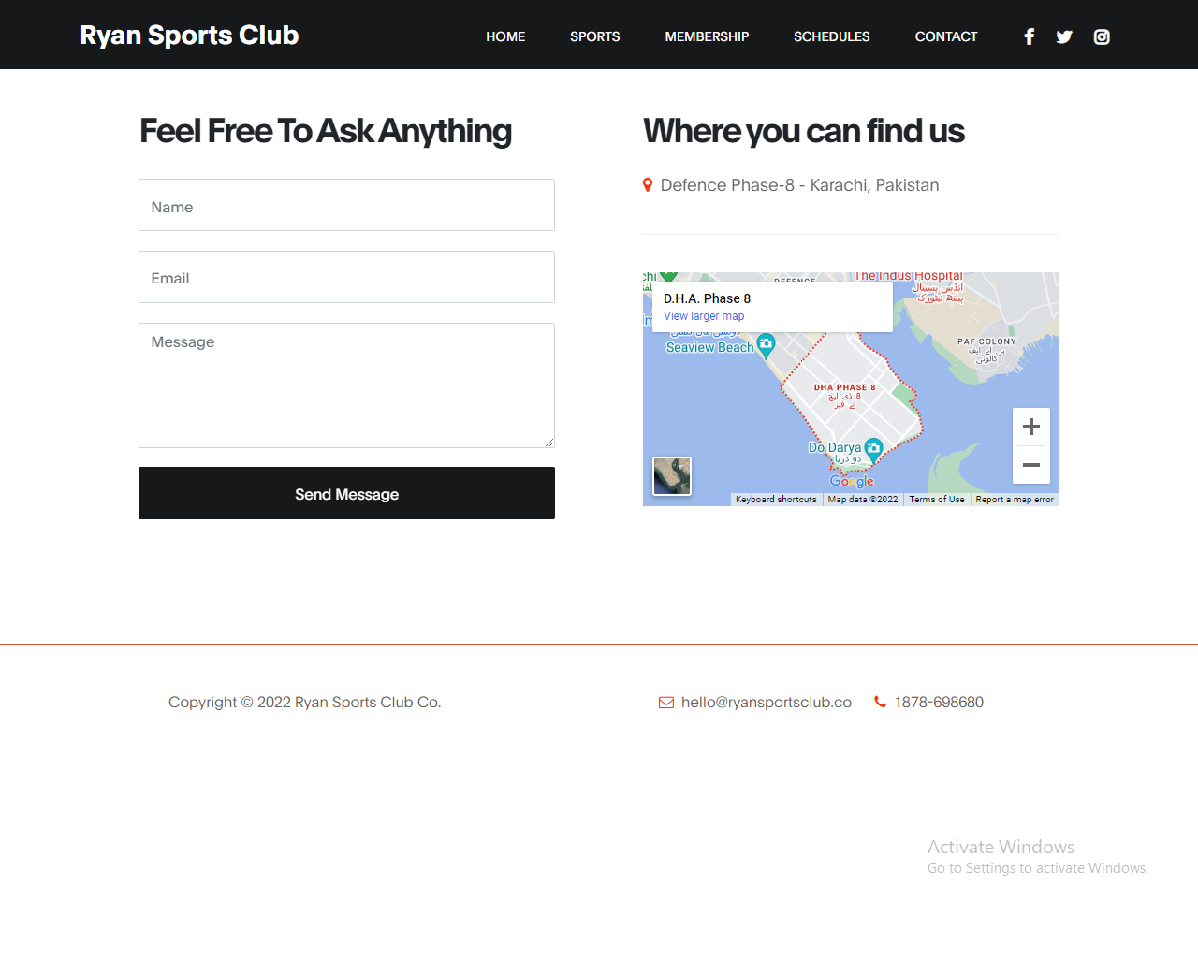

## WIRE FRAME

1. **Main Layout**

**Navbar**

**Button**

**Background Image**

**Text**

Products

**Text**

**Img**

**Img**

**Text**

**Text**

**Text**

**Img**

**Img**

**Membership**

**Sports**

**Footer**

**Button**

Text

Text

Text

Img

Img

Img

**Text**

**Footer**

**Img**

**Img**

**Text**

**Text**

**Img**

**Img**

**Table**

**Footer**

**Schedule**

|  |  |  |  |  |  |  |  |  |  |
| --- | --- | --- | --- | --- | --- | --- | --- | --- | --- |
|  |  |  |  |  |  |  |  |  |  |
|  |  |  |  |  |  |  |  |  |  |
|  |  |  |  |  |  |  |  |  |  |
|  |  |  |  |  |  |  |  |  |  |
|  |  |  |  |  |  |  |  |  |  |
|  |  |  |  |  |  |  |  |  |  |

**Form**

**Footer**

**Map**

**Contact US & Map**

## ­­Text Sheet Review

|  |  |  |  |
| --- | --- | --- | --- |
| **Serial Num** | **Names** | **Project Title** | **Task** |
|  | Umar Farooq | Ryan Sports Club | Home Page, Contact Us , Membership link and Schedules. |
|  | Ahsan Rahim | Ryan Sports Club | Sports Page , Map , Indoor Sports ,Outdoor Sports and Recreations. |