

CV231L – Soil Mechanics Lab
Spring 2026
Open Ended Lab

Soil Sampling, Classification, and Permeability Assessment

Sample Location: Charsadda, KPK

Submitted By: | Umar Gohar Ali – 2024645  Shehryar Ahmad – 2024587  Saifur Rahman – 2024558  Saad Ullah - 2024548
Instructor: | Engr. Hamza Qureshi
Course: | CV231L – Soil Mechanics Lab
Submission Date: | 1st May, 2026

Table of Contents
1. Scope of Work 3
2. Introduction 4
2.1 Background 4
2.2 Objectives 4
2.3 Site Description and Sampling 4
3. Experimental Procedure 5
3.1 Sample Preparation 5
3.2 Sieve Analysis (ASTM D6913) 5
3.3 Hydrometer Analysis (ASTM D7928) 6
3.4 Atterberg Limits (ASTM D4318) 6
3.4.1 Liquid Limit (LL) 6
3.4.2 Plastic Limit (PL) 7
3.5 Specific Gravity (ASTM D854-14) 7
3.6 Constant Permeability Test: (ASTM D2434) 7
4. Results 8
4.1 Sieve Analysis Results 8
4.2 Hydrometer Analysis Results 9
4.3 Atterberg Limits Results 11
Liquid Limit (LL) Data 11
Plastic Limit (PL) Data 11
4.4 Specific Gravity Results 12
4.5 Constant Permeability Test Results 12
5. Interpretation and Comparison of Results 13
5.1 Particle Size Distribution Analysis 13
5.2 Plasticity Characteristics 13
5.3 Specific Gravity Discussion 13
5.4 Soil Classification 13
5.4.1 USCS Classification (ASTM D2487) 13
5.4.2 AASHTO Classification (AASHTO M145) 14
5.5 Permeability Assessment and Dam Core Suitability 15
5.6 Summary of Results 15
6. Conclusion and Recommendations 16
7. References 17
8. Rubrics 18

List of Tables
Table 1. Sample and Site Description 6
Table 2. Sieve Analysis Result 9
Table 3. Basic Hydrometer Data 10
Table 4. Hydrometer Readings 10
Table 5. Liquid Limit Data Table 12
Table 6. Plastic Limit Data Table 12
Table 7. Specific Gravity Data Table 13
Table 8. Constant Permeability Test Results 13
Table 9. AASHTO Classification Summary 15
Table 10. Dam Core Suitability Criteria vs Test Soil 16
Table 11. Consolidated Summary of All Test Results 16

List of Figures
Figure 1. Soil Pit 5
Figure 2. Work Flow Diagram 6
Figure 3. Sieve Analysis 7
Figure 4. Hydrometer Analysis 7
Figure 5. Casagrande Apparatus 8
Figure 6. Plastic Limit Procedure 8
Figure 7. Constant Permeability Test 9
Figure 8. USCS Classification Summary 16

List of Graphs
Graph 1. Gradation Curve 10
Graph 2. Updated Gradation Curve 12
Graph 3. Flow Curve 13

1. Scope of Work
This Open-Ended Lab (OEL) was conducted as part of the CV231L – Soil Mechanics Laboratory course for Spring 2026. The primary objective of this investigation was to collect a soil sample from Charsadda, Khyber Pakhtunkhwa, Pakistan, and subject it to a comprehensive series of standard geotechnical laboratory tests to characterize and classify the soil.
The scope of this laboratory investigation encompasses the following tasks:
- Collection of a representative soil sample (4–5 kg) from a 2 ft × 2 ft pit excavated at a recorded geographic location in Charsadda, KPK.
- Determination of particle size distribution through both Sieve Analysis and Hydrometer Analysis to characterize the full grain-size spectrum of the soil.
- Evaluation of Atterberg Limits (Liquid Limit and Plastic Limit) to assess the consistency and plasticity characteristics of the fine-grained fraction.
- Determination of Specific Gravity of soil solids using the pycnometer method.
- Estimation of soil permeability using either the Constant Head or Falling Head method (as applicable).
- Classification of the soil according to both the Unified Soil Classification System (USCS – ASTM D2487) and the AASHTO Classification System (AASHTO M145).
- Construction of a complete particle size distribution (gradation) curve.
- Assessment of the soil's engineering suitability for use as an impermeable core material in an earthwork embankment dam.

All experimental procedures were carried out in strict accordance with relevant ASTM standards to ensure accuracy, reproducibility, and professional-grade data quality.

2. Introduction

2.1 Background
Soil mechanics is a branch of civil engineering that studies the engineering behavior of soil as a construction and foundation material. The proper characterization of soil is a prerequisite for any geotechnical design involving foundations, retaining structures, slopes, embankments, and hydraulic barriers such as earth dams. A thorough understanding of soil's physical and mechanical properties — including grain size, plasticity, permeability, and classification — forms the bedrock of sound engineering judgment.

2.2 Site Description and Sampling
Table 1. Sample and Site Description
Site Information | Details
Location | Charsadda, Khyber Pakhtunkhwa, Pakistan
Latitude | 34.19° N
Longitude | 71.85° E
Pit Dimensions | 2 ft × 2 ft
Sampling Depth | 2 ft
Sample Mass | 5 kg
Date of Collection | 10th April, 2024
Visual Description | Brownish, moist, fine-grained with some impurities (rocks, grass etc.)
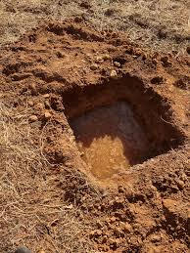
Figure 1. Soil Pit
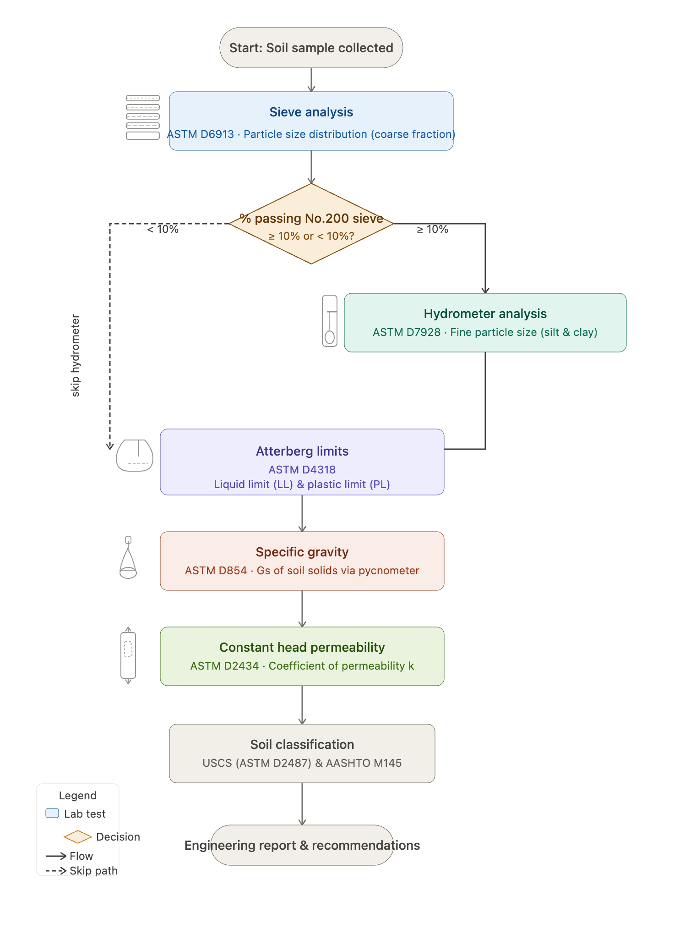
Figure 2. Work Flow Diagram

3. Experimental Procedure
All laboratory tests were conducted in the Soil Mechanics Laboratory, Department of Civil Engineering, following standard ASTM procedures. The following tests were performed:

3.1 Sample Preparation
The collected soil sample was air-dried at room temperature for 24 hours to remove excess moisture. The dried sample was then pulverized using a rubber hammer to break up lumps without crushing individual particles.

3.2 Sieve Analysis (ASTM D6913)
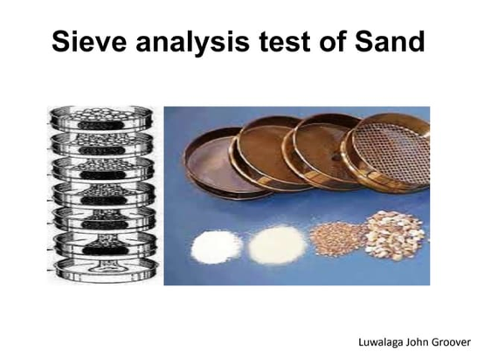
Sieve analysis was performed to determine the particle size distribution of the coarse-grained fraction (particles retained on the No. 200 sieve, i.e., > 0.075 mm).
Figure 3. Sieve Analysis
Procedure:
- A representative sample of approximately 500 g was weighed and oven-dried at 105°C for 24 hours.
- The dried soil was passed through a nested series of sieves arranged from largest to smallest opening: 4.75 mm (#4), 2.00 (#10), 0.425 mm (#40), 0.300 mm (#50), 0.150 mm (#100), 0.075 mm (#200), and Pan.
- The sieve stack was placed on a mechanical shaker and vibrated for 10 minutes.
- The mass of soil retained on each sieve was measured and recorded.
- Cumulative percent passing was computed for each sieve size to construct the gradation curve.

3.3 Hydrometer Analysis (ASTM D7928)
Hydrometer analysis was performed to determine the particle size distribution of the fine-grained fraction (particles passing the No. 200 sieve, i.e., < 0.075 mm), which cannot be captured by sieve analysis alone.
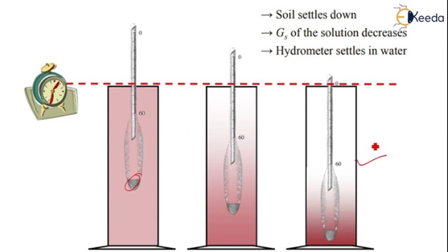
Procedure:
- Approximately 50 g of soil passing the No. 200 sieve was mixed with 125 mL of sodium hexametaphosphate (dispersing agent) solution.
- The mixture was mechanically stirred using a mixer and then transferred into a 1000 mL graduated cylinder, which was filled to the 1000 mL mark with distilled water.
Figure 4. Hydrometer Analysis
- Hydrometer readings were taken at specified time intervals: 0.5, 1, 2, 4, 8, 12, 14, 16, and 18 minutes.
- Temperature was recorded at each reading to apply the appropriate correction factor.
- The equivalent particle diameter and percent finer were calculated at each time interval using Stokes' Law and the hydrometer calibration charts.

3.4 Atterberg Limits (ASTM D4318)

3.4.1 Liquid Limit (LL)
The Liquid Limit was determined using the Casagrande percussion cup apparatus.
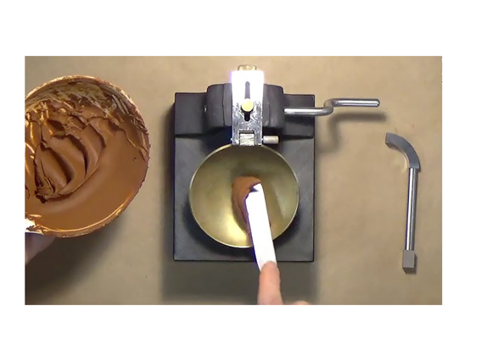
- Soil passing the No. 40 sieve was mixed with distilled water to form a uniform paste.
- The paste was placed in the Casagrande cup and a groove was formed using the standard grooving tool.
- The cup was dropped at a rate of 2 drops/second, and the number of blows required to close the groove over a 12.7 mm length was recorded.
- The water content at the time of testing was determined for each trial.
Figure 5. Casagrande Apparatus
- Tests were performed at least three different blow counts spanning the range of 15–35 blows. The flow curve (water content vs. log N) was plotted and the water content at N = 25 blows was reported as the Liquid Limit.

3.4.2 Plastic Limit (PL)
The Plastic Limit was determined by rolling soil threads.
- A small ball of moist soil was rolled on a glass plate using the palm of the hand.
- The Plastic Limit was taken as the water content at which the soil thread began to crumble when rolled to a diameter of 3.2 mm (1/8 inch).
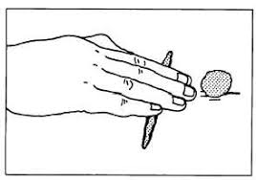
- At least three trials were performed, and the average water content was reported as the Plastic Limit.

Figure 6. Plastic Limit Procedure

3.5 Specific Gravity (ASTM D854-14)
The specific gravity of soil solids (Gs) was determined using the water pycnometer method.
- An oven-dried soil sample of approximately 100 g was placed in a calibrated pycnometer.
- Distilled water was added to submerge the soil. The soil sample was agitated to remove air entrapped.
- The pycnometer was filled to the calibration mark with distilled water and the total mass was recorded.
- The temperature of the water was also recorded for density correction.
- Specific gravity was calculated using the formula, with temperature correction applied:
$$G_{s}=\frac{W_{2}-W_{1} × α}{\left(W_{4}-W_{1}\right)-\left(W_{3}-W_{2}\right)}$$
Where,
W₁ = Weight of Empty Pycnometer
W₂ = Weight of Pycnometer + Dry Soil
W₃ = Weight of Pycnometer + Soil + Water
W₄ = Weight of Pycnometer + Water
$α$ = Temperature Correction Factor

3.6 Constant Permeability Test: (ASTM D2434)
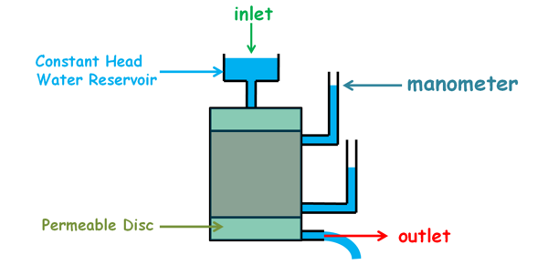
- Prepare a fully saturated soil specimen and place it in the permeameter between porous stones.
Figure 7. Constant Permeability Test
- Apply a constant head difference (h) across the sample using a continuous water supply.
- Allow water to flow until steady-state flow is achieved.
- Collect the discharged water (Q) over a measured time interval (t).
- Measure dimensions (L, A) and compute permeability using:
$$k=\frac{QL}{Aht}$$

4. Results

4.1 Sieve Analysis Results
The following table presents the data recorded during sieve analysis. The cumulative percent passing values were used to construct the gradation curve.
Table 2. Sieve Analysis Result
Sieve Size (mm) | Sieve No. | Mass Retained (g) | Cumulative Retained (g) | % Retained | % Passing
4.75 | #4 | 14.80 | 14.80 | 2.95 | 97.05
2.00 | #10 | 131.20 | 146.00 | 29.05 | 70.95
0.425 | #40 | 147.40 | 293.40 | 58.39 | 41.61
0.300 | #50 | 30.40 | 323.80 | 64.44 | 35.56
0.149 | #100 | 38.20 | 362.00 | 72.04 | 27.96
0.075 | #200 | 39.00 | 401.00 | 79.80 | 20.20
Pan | — | 101.50 | 502.50 | 100.00 | -

Graph 1. Gradation Curve

From the gradation curve, the following characteristic diameters were obtained:
- D60 = 1.12213 mm
- D30 = 0.17978 mm
D10, C_{u}, and C_{c} values were obtained after performing Hydrometer Analysis

4.2 Hydrometer Analysis Results
The hydrometer analysis extended the particle size distribution into the fine-grained range (silt and clay sizes), completing the Gradation Curve, and obtaining values of coefficients. The data recorded during the test are presented below.
Table 3. Basic Hydrometer Data
Hydrometer #: | 152-H
Dispersing Agent: | SHMP
G_{s}: | 2.75000
F200: | 20.19900
W_{s} (g): | 50.00000
Meniscus Correction: | 2.00000
Zero Correction: | -4.00000
Specific Gravity Correction (a): | 0.98000
Temperature Correction: | 1.30000
Total Correction: | -0.70000

Table 4. Hydrometer Readings
Time (min) | Temp (°C) | Hydrometer Reading |  | Corrected Reading | % Finer | Effective Depth, L(cm) | D (mm) | Adjusted % Finer
0.5 | 25 | 45.00 | 44.30 |  | 86.83 | 9.04 | 0.05315 | 17.54
1 | 25 | 43.00 | 42.30 |  | 82.91 | 9.34 | 0.03820 | 16.75
2 | 25 | 37.00 | 36.30 |  | 71.15 | 10.34 | 0.02842 | 14.37
4 | 25 | 33.00 | 32.30 |  | 63.31 | 11.04 | 0.02077 | 12.79
8 | 25 | 21.00 | 20.30 |  | 39.79 | 12.97 | 0.01592 | 8.04
12 | 25 | 10.00 | 9.30 |  | 18.23 | 14.77 | 0.01387 | 3.68
14 | 25 | 7.00 | 6.30 |  | 12.35 | 15.27 | 0.01305 | 2.49
16 | 25 | 2.00 | 1.30 |  | 2.55 | 16.07 | 0.01253 | 0.51
18 | 25 | 1.00 | 0.30 |  | 0.59 | 16.24 | 0.0187 | 0.12
24 | 25 | 1.00 | 0.30 |  | 0.59 | 16.24 | 0.0187 | 0.12

The Gradation Curve was updated as shown below:
Graph 2. Updated Gradation Curve

From the Gradation Curve the following characteristics were obtained:
- D₆₀ = 1.12213 mm
- D₃₀ = 0.17978 mm
- D₁₀ = 0.01777 mm
- C_{U} = 63.16
- C_{C} = 1.62

4.3 Atterberg Limits Results
The Atterberg Limits were determined for the fraction of soil passing the No. 40 sieve. The results are presented in the tables below.

Liquid Limit (LL) Data
Table 5. Liquid Limit Data Table
Trial No. | No. of Blows (N) | Mass of Wet Soil + Tin (g) | Mass of Dry Soil + Tin (g) | Mass of Tin (g) | Water Content (%)
1 | 16 | 50 | 45.63 | 27 | 23.46
2 | 25 | 40 | 36.34 | 19 | 21.11
3 | 35 | 64 | 59.07 | 35 | 20.48

Plastic Limit (PL) Data
Table 6. Plastic Limit Data Table
Trial No. | Mass of Wet Soil + Tin (g) | Mass of Dry Soil + Tin (g) | Mass of Tin (g) | Water Content (%)
1 | 22 | 21.57 | 19 | 16.73
2 | 25 | 24.39 | 21 | 17.99
3 | 21 | 20.08 | 15 | 18.11

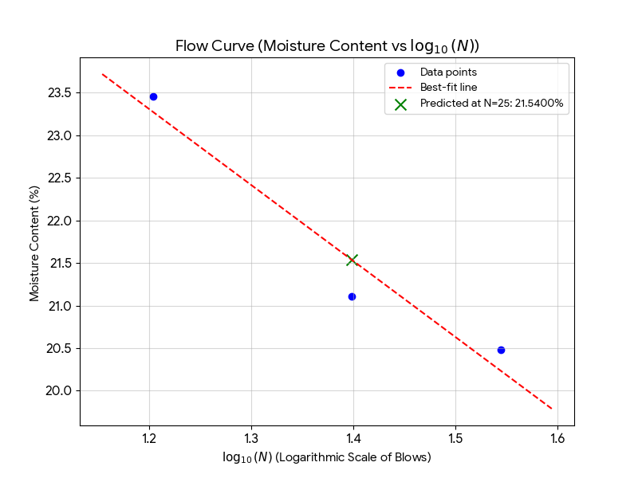

Graph 3. Flow Curve

Summary of Atterberg Limits:
- Liquid Limit (LL) = 21.54 %
- Plastic Limit (PL) = 17.61 %
- Plasticity Index (PI) = LL – PL = 3.93 %

4.4 Specific Gravity Results
The specific gravity of soil solids was determined using three trials. The results are presented below.
Table 7. Specific Gravity Data Table
Parameter | Trial 1 | Trial 2 | Trial 3
Mass of pycnometer – W1 (g) | 416.00 | 182.00 | 184.00
Mass of pycnometer + dry soil – W2 (g) | 516.00 | 281.90 | 283.20
Mass of pycnometer + soil + water – W3 (g) | 998.57 | 742.50 | 743.30
Mass of pycnometer + water – W4 (g) | 934.70 | 678.60 | 680.60
Temperature (°C) | 25 | 25 | 25
Specific Gravity (Gs) | 2.76 | 2.77 | 2.71
Average Specific Gravity | 2.75

4.5 Constant Permeability Test Results
Table 8. Constant Permeability Test Results
Volume (Q): | 0.226 mL
Length of specimen (L): | 7.5 cm
Diameter of specimen (d): | 7.5 mm
Area of specimen (A): | 44.16 $cm^{2}$
Time (t): | 120 sec
Head drop (h): | 0.601 cm
Coefficient of Permeability (k): | 5.32 x ${10}^{-4}$ cm/sec

5. Interpretation and Comparison of Results

5.1 Particle Size Distribution Analysis
The complete gradation curve, constructed by combining sieve analysis and hydrometer analysis data, provides a comprehensive picture of the soil's particle size distribution. The curve spans the full spectrum from gravel-sized particles down to the colloidal clay fraction.

Based on the gradation curve:
- Gravel content (retained on No. 4 sieve, > 4.75 mm): 2.95 %
- Sand content (between No. 4 and No. 200 sieves, 0.075–4.75 mm): 76.86%
- Fines content (passing No. 200 sieve, < 0.075 mm): 20.20 %
The coefficient of uniformity shows a very wide gradation, satisfying C_{u} > 6, for well-graded sand. The coefficient of curvature C_{c} = 1.62, lies withing the required range 1 < C_{c} < 3

5.2 Plasticity Characteristics
The Atterberg Limits define the range of water contents over which the soil exhibits plastic behavior. The Plasticity Index (PI) is a direct indicator of the clay content and activity of the soil.
Since LL = 21.54 % < 50 % , the soil plots left of the vertical line, indicating low plasticity (L).
Using the A-line equation PI = 0.73(LL-20) = 1.12, and since actual PI = 4.20 % > 1.12, it plots above A-line implying clay (C).
Thus, the soil is CL (low plasticity clay).

5.3 Specific Gravity Discussion
The measured average specific gravity (Gs) of 2.75 falls within the typical range for natural mineral soils (2.60–2.80). This value is used as an input in hydrometer analysis calculations and in the determination of void ratio and degree of saturation.

5.4 Soil Classification

5.4.1 USCS Classification (ASTM D2487)
The Unified Soil Classification System classifies soils based on the proportion of coarse and fine-grained particles, and for fine-grained soils, on their plasticity characteristics.
Classification Procedure:
- Step 1: If % fines < 50%, the soil is coarse-grained. If % fines ≥ 50%, the soil is fine-grained.
- Step 2: For coarse-grained soils, if % gravel > % sand, it is a Gravel (G); otherwise it is a Sand (S).
- Step 3: Apply Cu and Cc criteria to distinguish well-graded (W) from poorly-graded (P), or use Atterberg Limits to identify soils with fines (M or C).
- Step 4: For fine-grained soils, use the Casagrande Plasticity Chart to determine symbol (ML, CL, MH, CH, OL, OH, or Pt).
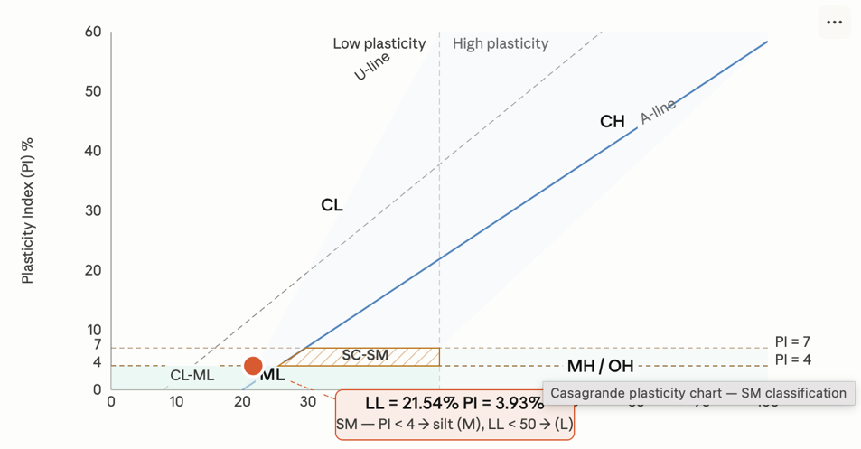

Figure 8. USCS Classification Summary

5.4.2 AASHTO Classification (AASHTO M145)
The AASHTO classification system evaluates soils based on particle size distribution and Atterberg Limits, primarily for highway subgrade suitability. Soils are classified into groups A-1 through A-8, with A-1 being the best and A-7 (or A-8 for peat/muck) the worst for use as highway subgrade material.
Group Index (GI) Calculation:
$$GI = (F – 35)[0.2 + 0.005(LL – 40)] + 0.01(F – 15)(PI – 10)$$
where F = percent passing the No. 200 sieve, LL = Liquid Limit, PI = Plasticity Index.
Calculated Group Index (GI) = 0

Table 9. AASHTO Classification Summary
AASHTO Group | Subgroup | Group Index (GI) | General Classification
A-1 | A-1-b | 0 | Silty or clayey gravel and sand

5.5 Permeability Assessment and Dam Core Suitability
The coefficient of permeability (k) is the most critical parameter for evaluating a soil's suitability for use in the impermeable core (clay core) of an earthwork dam. An effective dam core must prevent excessive seepage of water through and beneath the dam structure.
Table 10. Dam Core Suitability Criteria vs Test Soil
Parameter | Acceptable Range | This Soil
Permeability (k) | $<1 × {10}^{-5}$ cm/s | 5.32 x ${10}^{-4}$ cm/sec
Plasticity Index (PI) | 7 – 10 % | 3.93 %
% Fines (passing #200) | > 30 - 50 % preferred | 20.20 %
USCS Classification | CL, CH, SC, GC | SM

5.6 Summary of Results
Table 11. Consolidated Summary of All Test Results
Parameter | Value | Standard/Reference
D10 (mm) | 0.01777 | From Gradation Curve
D30 (mm) | 0.17978 | From Gradation Curve
D60 (mm) | 1.12213 | From Gradation Curve
Coefficient of Uniformity (Cu) | 63.1 | Cu = D60/D10
Coefficient of Curvature (Cc) | 1.62 | Cc = D30²/(D10×D60)
Liquid Limit (LL) | 21.54 % | ASTM D4318
Plastic Limit (PL) | 17.61 % | ASTM D4318
Plasticity Index (PI) | 3.93 % | PI = LL – PL
Specific Gravity (Gs) | 2.65 | ASTM D854
% Fines (passing #200) | 20.19 % | From Sieve Analysis
% Gravel (retained #4) | 2.95 % | From Sieve Analysis
% Sand | 76.86 % | From Sieve Analysis
USCS Classification | SM – Silty Sand | ASTM D2487
AASHTO Classification | A-1-b (0) | AASHTO M145
Permeability (k) | 5.32 x ${10}^{-4}$ cm/sec | Constant Head Permeability Test

6. Conclusion and Recommendations
The geotechnical investigation of the soil sample collected from Charsadda, Khyber Pakhtunkhwa, successfully characterized its engineering properties through sieve analysis, hydrometer analysis, Atterberg limits, specific gravity, and constant head permeability testing. The soil is classified as SM (Silty Sand) according to the Unified Soil Classification System (USCS) and A12-b (0) under the AASHTO system. It consists of approximately 77% sand, 20% fines, and 3% gravel, with a low plasticity index (PI = 3.93%), low liquid limit (LL = 21.54%), and an average specific gravity of 2.75. The coefficient of uniformity (Cu = 63.1) indicates a well-graded material, while the coefficient of permeability (k = 5.32 × 10⁻⁴ cm/sec) reflects moderate drainage characteristics.
Although the soil exhibits good gradation and falls within the typical range of specific gravity for mineral soils, its relatively low fines content (20.2%) and low plasticity make it unsuitable for use as an impermeable core in an earthwork embankment dam. Dam core materials typically require higher fines content (>30–50%), a plasticity index of 7–10% or more, and significantly lower permeability (usually ≤ 10⁻⁶ to 10⁻⁷ cm/s) to effectively control seepage.
Recommendations:
- This silty sand is suitable for use as a general embankment fill, backfill material, or subgrade in highway/road construction due to its reasonable strength and drainage properties.
- For applications requiring low permeability, such as dam cores or liners, the soil should be blended with higher-plasticity clay or replaced with a more suitable CL/CH material.
- Further tests, including compaction characteristics (Proctor test), shear strength parameters, and consolidation behavior, are recommended to fully evaluate its performance in field applications.
Overall, the laboratory results provide a reliable basis for preliminary geotechnical design decisions at the Charsadda site.

7. References
[1] B. M. Das, Principles of Geotechnical Engineering, 9th ed. Boston, MA, USA: Cengage Learning, 2021.

[2] ASTM International, ASTM D6913-17: Standard Test Methods for Particle-Size Distribution (Gradation) of Soils Using Sieve Analysis. West Conshohocken, PA, USA: ASTM International, 2017.

[3] ASTM International, ASTM D7928-21: Standard Test Method for Particle-Size Distribution (Gradation) of Fine-Grained Soils Using the Sedimentation (Hydrometer) Analysis. West Conshohocken, PA, USA: ASTM International, 2021.

[4] ASTM International, ASTM D4318-17: Standard Test Methods for Liquid Limit, Plastic Limit, and Plasticity Index of Soils. West Conshohocken, PA, USA: ASTM International, 2017.

[5] ASTM International, ASTM D854-14: Standard Test Methods for Specific Gravity of Soil Solids by Water Pycnometer. West Conshohocken, PA, USA: ASTM International, 2014.

[6] ASTM International, ASTM D2487-17: Standard Practice for Classification of Soils for Engineering Purposes (Unified Soil Classification System). West Conshohocken, PA, USA: ASTM International, 2017.

[7] American Association of State Highway and Transportation Officials (AASHTO), AASHTO M145-91 (2012): Standard Specification for Classification of Soils and Soil-Aggregate Mixtures for Highway Construction Purposes. Washington, DC, USA: AASHTO, 2012.

[8] U.S. Bureau of Reclamation, Earth Manual. Denver, CO, USA: U.S. Dept. of the Interior, Bureau of Reclamation. [Online]. Available: https://www.usbr.gov/tsc/techreferences/mands/mands-pdfs/earth.pdf

8. Rubrics
The following assessment rubrics were provided by the course instructor and are included as per the OEL submission requirements.

Performance Criteria | Poor (0–4) | Average (4–6) | Good (6–8) | Very Good (8–10) | Score
1. Report Format | Insufficient details, disorganized | Sufficient details but disorganized | All details present, some improvements needed | Well-organized, all deliverables accurate
2. Investigation | Not up to mark, problem not addressed | Some investigations, problem partly addressed | Sufficient investigations, room for improvement | Problem well-investigated and properly addressed
3. Methodology | Insufficient/critical errors | Some planning, not up to mark | Sufficient but room for improvement | Experimental design and data acquisition well-managed
4. Data Analysis, Results, Conclusions | Analysis incorrect, results misleading | Appropriate technique, some outcomes not discussed | Appropriate analysis, some gaps remain | Accurate technique, outcomes well-supported

