Ghulam Ishaq Khan Institute of Engineering Sciences and Technology, Topi, Pakistan



Department Of Civil Engineering

Course Title:
Construction Materials and Concrete Technology – CV215 L
Task Title:
Effect of Compaction Method on Concrete Density and Strength
Semester: 3rd
Instructor: Engr. Saad Ilyas
Submission Date: 19th December 2025

Group Members | Muhammad Khan | 2024420
 | Umar Gohar Ali | 2024645
 | Saif Ur Rehman | 2024558
 | Saad Ullah | 2024458

Table of Contents
1. Introduction 3
1.1 Background 3
1.2 Purpose 4
1.3 Objectives 4
2. Materials and Equipment 4
2.1 Concrete Materials 5
2.2 Equipment for Preparation and Casting 5
2.3 Equipment for Testing 6
3. Procedure 7
3.2 Mix Preparation 8
.3 Specimen Casting and Compaction 9
4. Results and Calculations 10
4.1 Mix Proportions and Workability 11
4.2 Masses and Fresh Concrete Data 11
4.3 Fresh and Hardened Densities 12
4.4 Compressive Strength Results 12
5. Graphs and Analysis: 13
5.1 Graphs: 13
5.2 Result Analysis: 15
5.3 Failure Patterns: 15
6. Conclusion and Recommendations: 17
8. References: 18

List Of Figures:

Figure 1 8
Figure 2 8
Figure 3 8
Figure 4 8
Figure 5 8
Figure 6 9
Figure 7 10
Figure 8 15
Figure 9 15
Figure 10 16
Figure 11 16

1. Introduction
Compaction, also called consolidation, is an important step in concrete placement. It involves removing trapped air from fresh concrete to make it dense and uniform. During mixing, air gets trapped inside the concrete, which increases porosity and reduces strength in the hardened state. Proper compaction helps the concrete fully fill the formwork, surround reinforcement, and achieve better strength and durability. ASTM C192/C192M describes standard laboratory procedures for making and curing concrete specimens and emphasizes the need for proper compaction [1]. This standard allows two compaction methods: manual rodding and mechanical vibration, which are studied in this experiment.

1.1 Background
Fresh concrete contains some entrapped air. In well-compacted concrete, air content is usually low, but in poorly compacted concrete it can be much higher. These air voids reduce strength and act as weak points under load. Studies [2] show that for non-air-entrained concrete, each 1% increase in air content reduces compressive strength by approximately 5%. Compaction reduces these voids and produces concrete with better strength, durability, and resistance to cracking.

Two compaction methods are considered in this study. Manual compaction is done using a steel rod, where the concrete is compacted in layers by inserting the rod multiple times, as recommended in ASTM C192/C192M [1]. This method is suitable for workable mixes but depends on the operator’s effort. Mechanical compaction uses vibration to help air escape and particles settle. According to ASTM C192/C192M [1], vibration is applied until the concrete stops settling. This method provides more uniform compaction, especially for stiffer mixes. Poor compaction in practice can cause defects such as honeycombing, which lowers the quality and strength of concrete structures.

1.2 Purpose
Proper compaction is as important as mix design. Even good-quality concrete materials will not perform well if air is not removed effectively. Trapped air makes concrete weak and porous, allowing water to enter and reduce durability.

The purpose of this experiment is to show how air voids affect concrete strength, compare manual and mechanical compaction methods, and study the relationship between density and compressive strength. Compressive strength testing is carried out according to ASTM C39/C39M [3].

1.3 Objectives
The objectives of this study are to measure and compare the fresh and hardened densities of concrete compacted by rodding and vibration, determine the compressive strength of specimens using ASTM C39/C39M [3], observe surface quality and visible defects after demolding, and compare the effort and consistency of both compaction methods.

2. Materials and Equipment
This section describes the materials and equipment used to study the effect of compaction methods on the fresh density and compressive strength of concrete. All materials and procedures were kept consistent for all specimens to ensure reliable and repeatable results. A mix proportion of 1:2:4 (Cement: Sand: Coarse Aggregate) by weight was used. The target water–cement ratio was 0.5 however, additional water was added to improve workability, resulting in an effective water–cement ratio of approximately 0.7. All materials were selected in accordance with relevant ASTM standards and standard laboratory practice.

2.1 Concrete Materials
- Cement: Ordinary Portland Cement (Type I) conforming to ASTM C150/C150M [4] was used as the binding material. Approximately 7 kg of cement was used, including extra quantity to allow for handling losses.

- Fine aggregate: It consisted of clean, locally available sand, which were freed from clay, organic matter, and other impurities. The sand was well graded and conformed to ASTM C33/C33M [5]. A total of 14 kg of fine aggregate was used.

- Coarse aggregate It consisted of crushed stone or gravel, the aggregate was clean, well graded, and in accordance with ASTM C33/C33M [5]. A total of 28 kg was used.
- Water: Potable water, free from harmful substances, was used for mixing. About 3.5 kg of water was added to achieve a water–cement ratio of 0.5, with an additional 1.4 kg added to improve workability giving a water-cement ratio of 0.7 approximately. The same water content was maintained for all specimens so that only the compaction method influenced the results.

The total quantity of fresh concrete prepared was approximately 44 kg, which was sufficient to cast four cylindrical specimens, two for each compaction method.

2.2 Equipment for Preparation and Casting

Table 1. Equipment for Preparation and Casting
S. No | Material | Purpose
1. | Weighing Balance | A weighing balance was used for accurate measurement of all materials and for determining the mass of fresh and hardened concrete during density calculations.
2. | Concrete Mixer | Concrete was mixed manually for about 15 minutes to achieve a uniform and homogeneous mix due to laboratory limitations.
3. | Cylindrical Molds | Standard cylindrical molds of 150 mm diameter and 300 mm height were used for casting specimens. These molds conformed to ASTM C470/C470M [6].
4. | Tamping Rod | A steel tamping rod of 16 mm diameter and 600 mm length with a rounded end was used for manual compaction by rodding, as specified in ASTM C192/C192M [1].
5. | Vibrator | Mechanical compaction was carried out using an external vibrator.
6. | Trowels and Shovels | Trowels and shovels were used for placing, transferring, and leveling concrete in the molds.
7. | Slump Cone | A slump cone apparatus was used to measure the workability of the fresh concrete following ASTM C143/C143M [7].

2.3 Equipment for Testing

Table 2. Equipment for Testing
S. No | Material | Purpose
1. | CTM | A compression testing machine was used to determine the compressive strength of concrete cylinders in accordance with ASTM C39/C39M [3]. The load was applied at a controlled rate until failure.
2. | Vernier Caliper | Vernier calipers or a measuring scale were used to measure the diameter and height of the specimens prior to testing to ensure accurate strength calculations.
3. | Curing Tank | A curing tank filled with clean water maintained at a temperature of 27 ± 2°C was used for curing the specimens, following the recommendations of ASTM C192/C192M [1].
4. | Safety Equipment’s | Standard safety equipment, including gloves, safety goggles, and dust masks, was used throughout the experiment to comply with laboratory safety requirements.

3. Procedure
This section describes the step-by-step procedure followed to study the effect of compaction methods on concrete density and compressive strength. The experiment followed ASTM C192/C192M, ASTM C143/C143M, and ASTM C39/C39M[1], [3], [7] . Two compaction methods, manual rodding and mechanical vibration, were used with two replicate cylinders per method, for a total of four specimens. The testing age was 7 days.

3.1 Experimental Plan Overview
A single uniform concrete mix was prepared and divided for casting under the two compaction methods. This allowed a direct comparison of how compaction affects density and compressive strength.

Table 3. Compaction Method Overview
Condition No | Compaction Method | Purpose | Key Measurements
1 | Standard Rodding | Baseline for manual compaction; evaluates consistency | Fresh and hardened density, compressive strength
2 | Poker Vibrator | Mechanical compaction expected to yield higher density and strength | Fresh and hardened density, compressive strength

3.2 Mix Preparation
- Batching: Materials were weighed accurately: cement 7 kg, fine aggregate 14 kg, coarse aggregate 28 kg, and water 3.5 kg with an additional 1.4 kg for workability, maintaining a 1:2:4 mix ratio by weight. Total mix was approximately 44 kg.

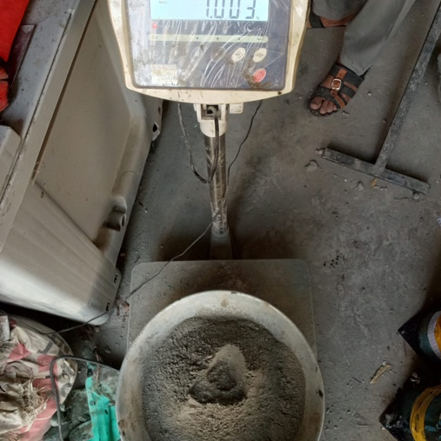
Figure 2
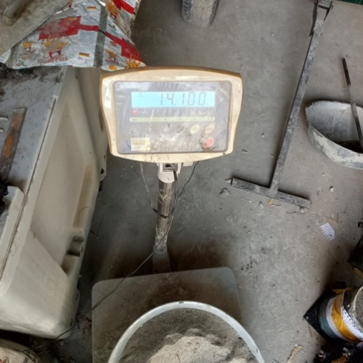
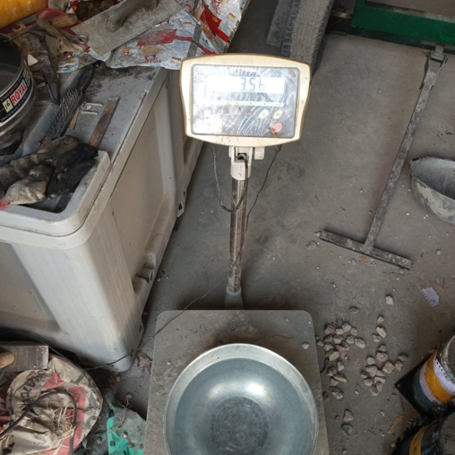
Figure 1
Figure 3

- Mixing: Dry ingredients were combined first, then water was added gradually. Hand mixing continued for 15 minutes until a homogeneous mix was achieved.
- Workability Test: Slump was measured according to ASTM C143/C143M [7], resulting in a slump of 40 mm indicating low workability mix suitable for use in foundations with slight reinforcement
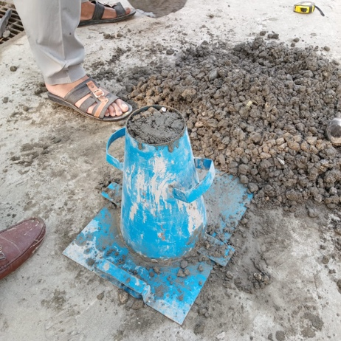

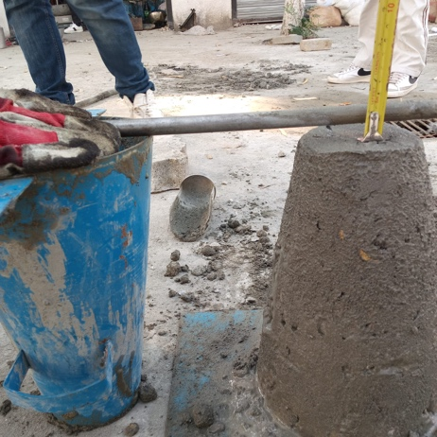

Figure 4
Figure 5

3.3 Specimen Casting and Compaction
Concrete was divided and cast into cylindrical molds of 150 mm diameter and 300 mm height. Two cylinders were prepared for each method.
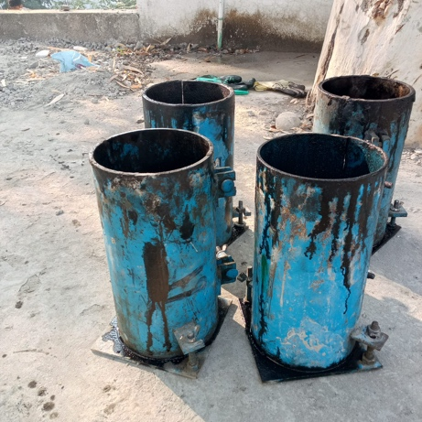
Figure 6
Condition 1: Standard Rodding
- Mold filled in three layers of about 100 mm each.
- Each layer was compacted with 25 strokes of a tamping rod in a spiral pattern, penetrating the full layer depth.
- Surface leveled with a trowel after the final layer.

Condition 2: Poker Vibrator
- Mold filled in three layers of about 100 mm each.
- Each layer was vibrated using a poker vibrator until air bubbles ceased and the surface cement paste appeared.
- Surface leveled carefully to prevent segregation.
3.4 Curing and Testing
- Fresh Density Measurement: Immediately after casting, each mold with concrete was weighed, and the mold mass was subtracted. Fresh density was calculated as mass divided by volume.
- Demolding: Specimens were removed after 24 hours and inspected for surface defects.
- Curing: Specimens were placed in a water tank at 24 ± 2°C for 7 days.
- Hardened Density Measurement: Specimens were weighed before testing to calculate hardened density.
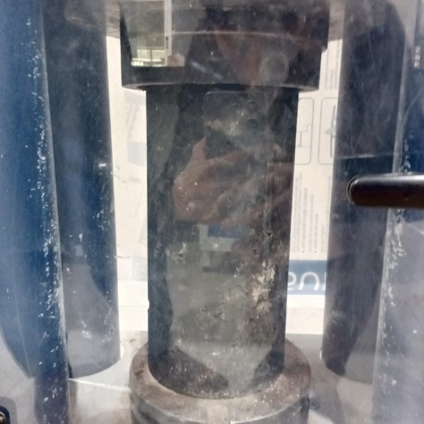
- Compression Test:
Figure 7
  - Dimensions measured with vernier calipers to calculate cross-sectional area.
  - Specimens tested in a compression machine at a controlled rate until failure.
  - Maximum load was recorded, and compressive strength calculated as load divided by area.
- Recording and Analysis: Observations of surface quality, failure patterns, and test data were recorded for analysis.

4. Results and Calculations
This section presents all measured and computed parameters from the experiment, including mix proportions, masses, fresh and hardened densities, and compressive strengths, following ASTM C192/C192M [1] and ASTM C39/C39M [3] standards. Two compaction methods were studied: standard rodding and poker vibration, with two replicate cylinders each. Calculations were performed using standard formulas
- Cylinder volume: $V=πr^{2}h$, for r = 0.15 m and h = 0.30 m
- Cross-sectional area: $A=πr^{2}$
- Density: $ρ=\frac{m}{V}$
- Compressive strength: $σ=\frac{P}{A}$
Averages in concrete testing, as per statistics, are calculated as simple arithmetic means of replicate specimens to represent the typical behavior of the mix. This approach ensures consistent comparison and reduces the effect of individual specimen variability on reported properties. Minor increases in mass after curing are attributed to water absorption during hydration. All values are rounded according to lab measurement precision.

4.1 Mix Proportions and Workability
Concrete was prepared using a nominal 1:2:4 mix (Cement: Sand: Coarse Aggregate) with a target w/c ratio of 0.5 and additional water for workability. Slump testing (ASTM C143/C143M) [7] yielded 4 cm, indicating low workability suitable for foundations with light reinforcement.

Table 4. Mix Proportions and Workability Data
Material | Quantity (kg) | Proportion
Cement (OPC) | 7 | 1
Fine Aggregate (Sand) | 14 | 2
Coarse Aggregate | 28 | 4
Water (initial + additional) | 3.5 + 1.4 = 4.9 | W/C = 0.7
Total Wet Mix | 53.9

4.2 Masses and Fresh Concrete Data
Concrete mass for each cylinder was determined by subtracting empty mold mass from post-casting mass.

Table 5. Fresh Concrete Data
Cylinder | Compaction Method | Pre-Casting Mass (kg) | Post-Casting Mass (kg) | Concrete Mass (kg)
C1 | Standard Rodding | 7.763 | 20.544 | 12.781
C2 | Standard Rodding | 6.783 | 19.434 | 12.651
C3 | Poker Vibrator | 11.244 | 24.701 | 13.457
C4 | Poker Vibrator | 11.405 | 24.438 | 13.033
Total | - |  |  | 51.922

The total concrete mass is slightly less than the prepared 53.9 kg because some mass remained left after filling the molds

4.3 Fresh and Hardened Densities
Fresh densities were calculated immediately after casting; hardened densities were measured after 7 days of curing.

Table 6. Fresh and Hardened Densities
Cylinder | Compaction Method | Fresh Density (kg/m³) | Hardened Mass (kg) | Hardened Density (kg/m³)
C1 | Standard Rodding | 2410.86 | 12.802 | 2414.82
C2 | Standard Rodding | 2386.33 | 12.677 | 2391.24
Average (Rodding) |  | 2398.60 | - | 2403.03
C3 | Poker Vibrator | 2538.37 | 13.543 | 2554.59
C4 | Poker Vibrator | 2458.39 | 13.129 | 2476.50
Average (Vibrator) |  | 2498.38 | - | 2515.54

The poker vibrator method yielded approximately 4.1% higher fresh density and 4.7% higher hardened density, indicating improved compaction.

4.4 Compressive Strength Results
Compressive strength tests were conducted at 7 days using a compression testing machine

Table 7. Compressive Strength Results
Cylinder | Compaction Method | Failure Load (kN) | Compressive Strength (MPa)
C1 | Standard Rodding | 157.107 | 8.890
C2 | Standard Rodding | 114.923 | 6.503
Average (Rodding) | - | 136.015 | 7.697
C3 | Poker Vibrator | 146.955 | 8.316
C4 | Poker Vibrator | 145.161 | 8.214
Average (Vibrator) | - | 146.058 | 8.265

The lower strength in one rodded specimen may indicate compaction inconsistency or internal defects. Overall, the results approximately align with expected M15 grade concrete at 7 days (~50–70% of 28-day strength)

5. Graphs and Analysis:

5.1 Graphs:
- Average Fresh and Hardened Density vs Compaction Method:
The bar chart compares concrete densities obtained using standard rodding and poker vibrator compaction methods. Average densities for standard rodding were 2399 kg/m³ (fresh) and 2404 kg/m³ (hardened), while vibrator compaction yielded 2499 kg/m³ (fresh) and 2516 kg/m³ (hardened). The vibrator bars are approximately 4 % higher, demonstrating the effectiveness of mechanical compaction in reducing entrapped air.
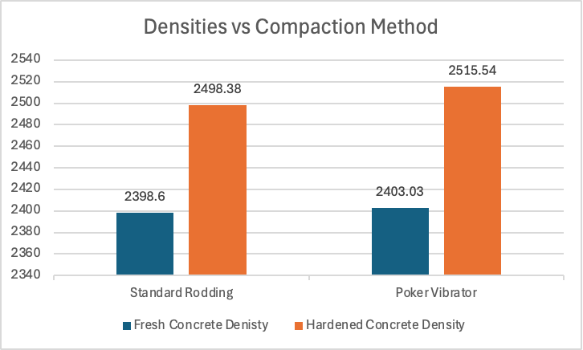
Graph 1. Average Fresh and Hardened Densities vs Compaction Method

- Compressive Strength vs Compaction Method:
The chart presents the 7-day compressive strengths for the two compaction methods. The average strength for standard rodding was 7.70 MPa, while poker vibrator compaction yielded 8.27 MPa. The vibrator bar is approximately 7 % higher, indicating improved strength due to better consolidation.
Graph 2. Compressive Strength vs Compaction Method

5.2 Result Analysis:
The results demonstrate a clear relationship between compaction method and concrete performance. Poker vibrator compaction produced higher fresh (4.1 % increase) and hardened (4.7 % increase) densities compared to standard rodding. This improvement is attributed to vibration’s ability to fluidize the mix and expel entrapped air more efficiently, reducing void content from approximately 5–10 % in manual methods to less than 3 %. These observations align with ASTM C192 guidelines, which recommend mechanical compaction for stiffer mixes (observed slump: 4 cm) to minimize honeycombing and improve uniformity.

Compressive strength followed a similar trend, with vibrator specimens averaging ~7.4 % higher values, supporting the density-strength correlation: denser concrete enhances particle packing and paste-aggregate bonding, increasing load resistance.
Variability in the rodding method (e.g., C2 density: 2392 kg/m³ vs. C1: 2415 kg/m³) highlights the influence of human error, whereas vibrator specimens showed greater consistency indicating repeatability.

For mix optimization, these findings support the use of mechanical compaction in critical applications to enhance durability and reduce permeability. Limitations include the stiff mix amplifying differences between methods; future studies could investigate admixtures to improve workability. Overall, the experiment confirms that effective compaction directly improves concrete strength, demonstrating the key relationship between density and performance in line with standard laboratory practices.

5.3 Failure Patterns:
The following failure patterns were observed when the cylinders were tested in Compressive Testing Machine:
- For Standard Rodded Cylinders:
Cylinders had jagged tops, broken pieces, and vertical cracks on the sides. Some end crushing was seen. Minor honeycombing and air voids were visible in some areas, showing that manual compaction may leave weak spots and trapped air in the concrete

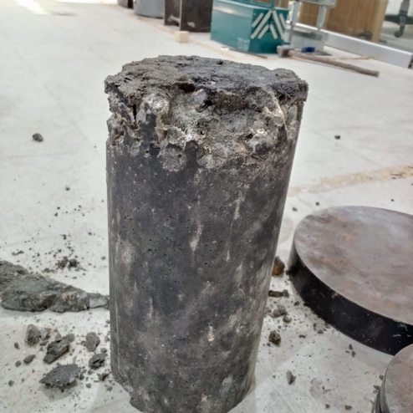
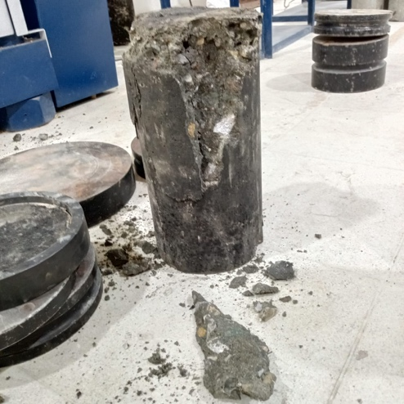
Figure 8
Figure 9

- For Vibrated Cylinders: Cylinders cracked cleanly along the vertical direction with slight bulging. The failure was uniform, and there were almost no honeycombing or voids. This shows that vibration improves density, reduces air pockets, and gives stronger concrete.
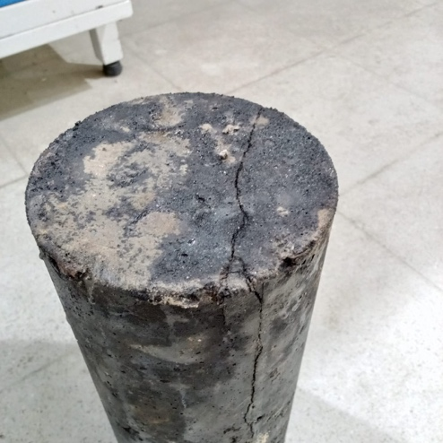
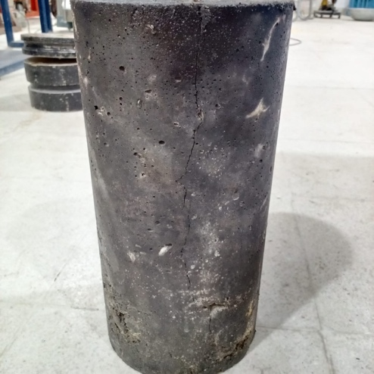
Figure 11

Figure 10

To summarize, Vibrated concrete is denser, stronger, and more uniform. Rodded concrete may have voids and uneven cracks. In both methods, vertical splitting along the cylinder is the main failure type, which is normal for concrete under compression.

6. Conclusion and Recommendations:
This experiment investigated the effects of compaction methods on concrete density and compressive strength, fulfilling the lab objectives of applying standard testing procedures and analyzing mix performance. A 1:2:4 mix with an effective w/c ratio of ~0.7 and a slump of 4 cm was used.

Key Findings:
- Density: Poker vibrator compaction achieved higher average fresh and hardened densities (2498 kg/m³ and 2516 kg/m³) compared to standard rodding (2399 kg/m³ and 2404 kg/m³).
- Strength: 7-day compressive strength was higher for vibrator specimens (8.27 MPa) than rodding (7.70 MPa).
- Rodding variability: Lower strength and possible honeycombing in some rodded specimens highlight the impact of inadequate compaction on concrete performance and durability.

Overall, mechanical compaction significantly improves consolidation and reduces voids, especially for stiff mixes, consistent with ASTM C192/C192M guidelines. Even a well-proportioned mix can underperform if proper placement and compaction are not applied.

Recommendations:
- Use mechanical compaction (poker vibrator) for structural applications to improve density and strength by 5–10%; standard rodding may be used for small-scale or highly workable mixes.
- Maintain a strict w/c ratio of 0.5; avoid excess water to prevent strength reduction. Consider superplasticizers to improve workability without compromising properties.
- Perform 28-day strength tests for full evaluation and include additional compaction methods (e.g., hand tamping) with at least three replicates to reduce variability.
- Control compaction energy (e.g., vibration 5–10 s per layer) to prevent segregation and use quality checks like ultrasonic pulse velocity to verify in-situ density.

Implementing these recommendations promotes durable, high-performance concrete, reduces material waste, and ensures structural longevity in real-world construction.

8. References:
[1] “Practice for Making and Curing Concrete Test Specimens in the Laboratory,” Dec. 2019, doi: 10.1520/C0192_C0192M-19.

[2] D. E. Dixon et al., “Standard Practice for Selecting Proportions for Normal, Heavyweight, and Mass Concrete (ACI 211.1-91) Chairman, Subcommittee A,” 1991.

[3] “Test Method for Compressive Strength of Cylindrical Concrete Specimens,” Mar. 2021, doi: 10.1520/C0039_C0039M-21.

[4] “Specification for Portland Cement,” Jul. 2022, doi: 10.1520/C0150_C0150M-22.

[5] “Specification for Concrete Aggregates,” Mar. 2018, doi: 10.1520/C0033_C0033M-18.

[6] “Specification for Molds for Forming Concrete Test Cylinders Vertically,” Feb. 2015, doi: 10.1520/C0470_C0470M-15.

[7] “Test Method for Slump of Hydraulic-Cement Concrete,” Jun. 2020, doi: 10.1520/C0143_C0143M-20.

