

- PERDS - Predictive Emergency Response Dispatch System

Author : 2412498
Course Title : Data Structures and Algorithms
Module Convenor : Harshil Joshi
Date : 19-12-2025
Table of Contents
1 Overview 5
1.1 Objectives 5
1.2 Architecture 6
2 Modules / Functionality 8
2.1 Core Architecture and Domain Model (System Snapshot + Commands) 8
2.2 Emergency Network Representation (Dynamic Graph) 10
2.3 Route Optimisation (Dijkstra/A* + Indexed Heap) 13
2.4 Dispatch, Reallocation, and Dynamic Updates 17
2.5 Predictive Analysis and Resource Pre-positioning 23
2.6 CLI, Scenario Loading, and Metrics Export 27
2.7 Complexity Analysis 29
2.8 Ethical Considerations 30
3 Recommendations 32
4 References 33
5 Appendices 34

Table of Figures
Figure 1: Architecture Diagram 7
Figure 2: System Snapshot 9
Figure 3: Dispatch Command 9
Figure 4: AdjacencyMapGraph Core Structure 11
Figure 5: Why node removal is expensive 11
Figure 6: Edge update behavior 12
Figure 7: Main Loop + Decrease Key 15
Figure 8: Stored Arrays 16
Figure 9: Decrease Key + Swim 16
Figure 10: Virtual-Source Allocation + Rationale Components 18
Figure 11: Virtual Node + Zero-Cost Edges 19
Figure 12: Event → Update → Dispatch Pipeline 20
Figure 13: Reroute-or-Cancel on Edge Change 21
Figure 14: Edge → Incident Indexing 22
Figure 15: Move Planning 25
Figure 16: Proportional Move Allocation 26
Figure 17: Nearest-Unit Choice via Virtual Source 26
Figure 18: Event Parsing to Commands 28
Figure 19: What is Exported 28
Figure 20: Decision Exports with Rationale Components 29
Figure 21: Complexity Analysis 29
Figure 22: Class Diagram 34
Figure 23: Controller Step Sequence 34
Figure 24: Edge Reroute Sequence 35
Figure 25: Prepositioning Sequence 35
Figure 26: Evaluation Sequence 36
Figure 27: Aggregate Results 36
Figure 28: Per-run summary 36
Figure 29: Mini Nodes 37
Figure 30: Mini Events 37
Figure 31: Mini Events 37
Figure 32: Edge Closure Events 37
Figure 33: Grid 4*4 Edges 38
Figure 34: Grid 4*4 Events 39
Figure 35: Grid 4*4 Nodes 39
Figure 36: Requirements Traceability Matrix 40

Index of Tables
Table 1: Project Overall Progress 7

Overview

Predictive Emergency Response Dispatch System (PERDS) is a Java-based simulation for NECA, modelling an emergency-response network to make dispatch decisions that prioritise rapid response while adapting to changing conditions.

Objectives

- Model the emergency network as a dynamic weighted graph, supporting runtime updates.
- Implement route optimisation using shortest-path algorithms (baseline Dijkstra, optional A*), supported by an efficient priority queue structure.
- Implement dispatch and reallocation: prioritise incidents (severity/age), allocate the nearest eligible unit by ETA, and reassign when incidents resolve, priorities change, or a unit becomes unavailable.
- Provide predictive analysis to forecast high-demand zones from observed incidents and pre-position available units to improve response times.
- Produce reproducible evaluation evidence via a CLI scenario runner, exporting metrics (CSV) for empirical testing and analysis.

Architecture

The system is modular, with clear separation between state, algorithms, and orchestration:
- Model layer defines domain entities/IDs.
- Graph layer provides a dynamic adjacency-map representation for efficient edge updates and neighbour iteration.
- Routing layer computes shortest paths using Dijkstra/A* with a custom indexed binary-heap priority queue.
- Dispatch layer prioritises incidents, selecting units using routing-based ETA, with policies that support efficient allocation.
- Simulation/controller layer runs an event-driven loop: scenario events apply state changes, then dispatch decisions are computed and applied; route changes can trigger reroute/cancel + reassignment.
- Prediction layer forecasts demand by zone and generates pre-positioning moves for idle units.
- Metrics/export + CLI provide repeatable runs and CSV outputs for evaluation and reporting.
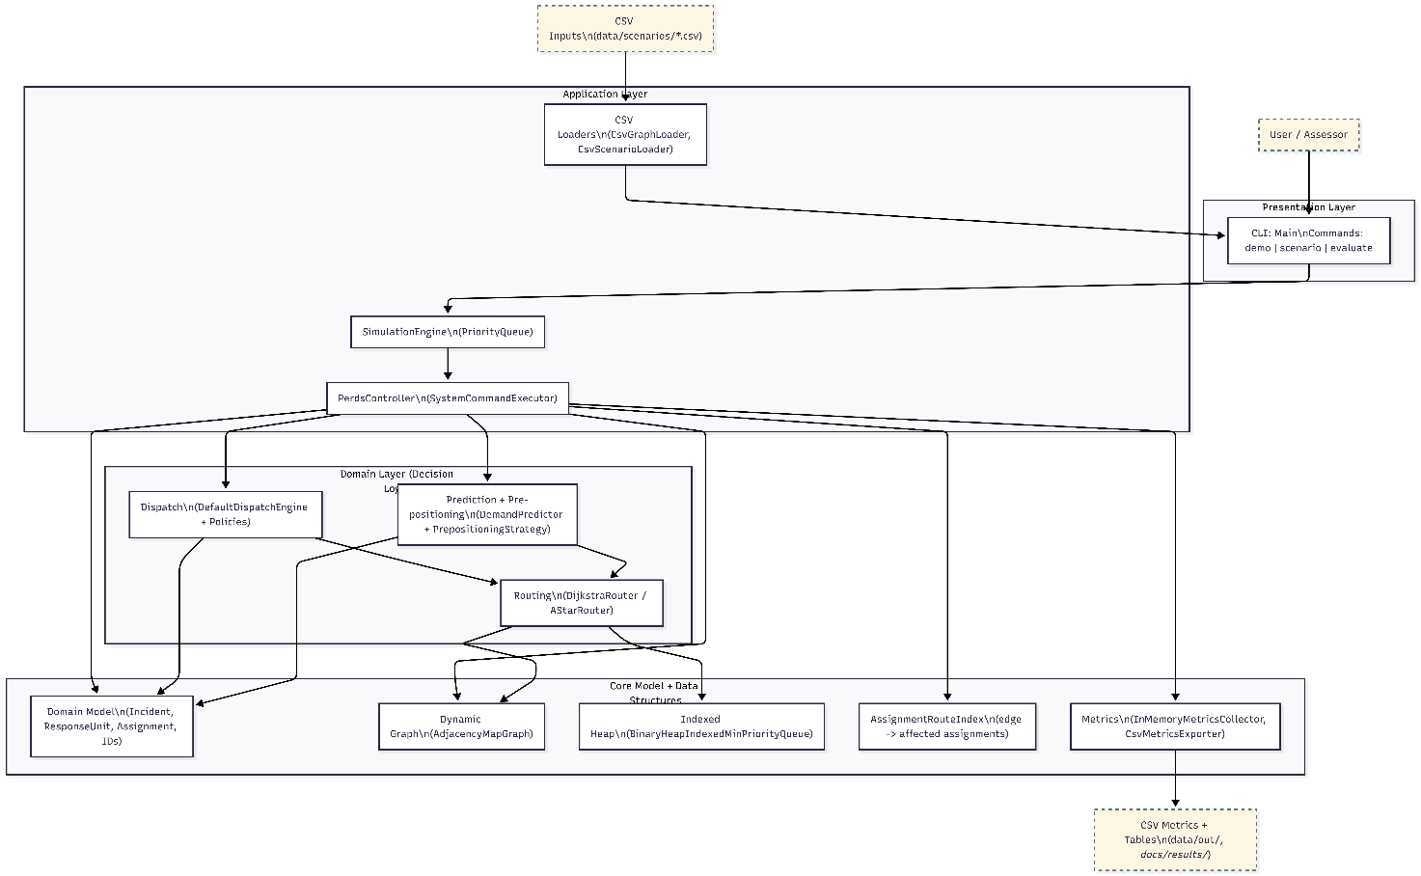
Figure 1: Architecture Diagram

Table 1: Project Overall Progress
Module | Tasks | Status
Graph representation | 1 | Completed
Routing | 2 | Completed
Dispatch + Reallocation | 2, 4 | Completed
Prediction +  Pre-Positioning | 3 | Completed
Adaptability | 4 | Completed

Section 2 details the implemented modules and functionality, explaining key design choices and providing supporting evidence. Sections 3–5 then summarise recommendations for future work, list references, and provide appendices.

Modules / Functionality

This section explains the implemented functionality by breaking the system into its main modules while explaining What/How/Why.

Core Architecture and Domain Model (System Snapshot + Commands)

PERDS separates state from decision logic which makes the decision-making easier to test and reason about, since dispatch algorithm does not directly mutate system state.

What it does
- Models the core entities: incidents, response units, assignments.
- Provides a stable “read view”(SystemSnapshot) for decision-making.
- Represents dispatch outcomes as explicit DispatchCommands (assign, reroute, cancel).

How it works
- Domain objects are small, immutable records (e.g., Incident, ResponseUnit, Assignment) with strongly typed ID wrappers (NodeId, IncidentId, UnitId, ZoneId), reducing accidental mixing of identifiers to keep state transitions explicit.
- The dispatch engine computes decisions from a snapshot and returns commands, which are then applied by the controller, enforcing a clean boundary between “decide” and “mutate”.

Why this approach
- Improves testability
- Reduces unintended side effects
- Helps explainability: commands and rationales can be logged/exported as evidence.
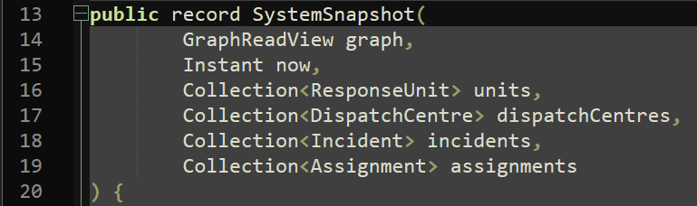
Figure 2: System Snapshot

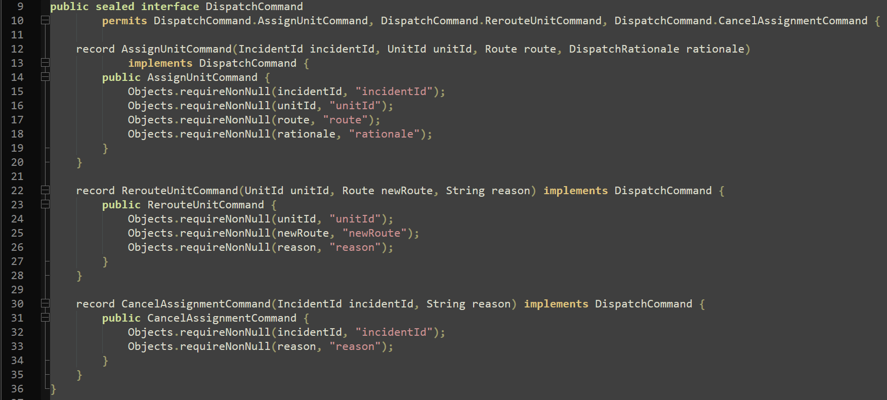
Figure 3: Dispatch Command

Emergency Network Representation (Dynamic Graph)

The emergency network is represented as a directed, weighted graph that supports dynamic updates at runtime (add/remove nodes, add/remove/update edges, and closures).

What it does
- Stores locations (nodes) and connections (edges) with weighted factors (distance, travel time, resource availability).
- Supports dynamic modifications without rebuilding the entire structure.

How it works
- The graph uses an adjacency-map structure:
- Map<NodeId, Node> nodes
- Map<NodeId, Map<NodeId, Edge>> outgoing
- This allows fast edge lookups/updates and efficient iteration over outgoing neighbours.
- Closures are represented by an EdgeStatus (OPEN/CLOSED), treating CLOSED edges as unreachable by returning +Infinity, so the edge can be reopened cheaply without recreating structure.
- The graph maintains a version() counter that increments on mutation, allowing algorithms/components to detect that cached results may be stale.

Why this approach

- Adjacency maps are appropriate for dynamic graphs: edge updates are typically O(1) average-case, and traversal is proportional to local degree.
- Keeping closed edges rather than deleting them supports fast reopen operations and consistent modelling of “temporarily unavailable routes”.
- Node removal is intentionally accepted as more expensive (O(V+E)) because it is rare compared to routing/dispatch operations.

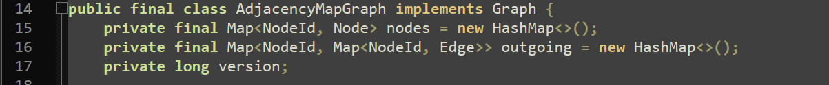
Figure 4: AdjacencyMapGraph Core Structure

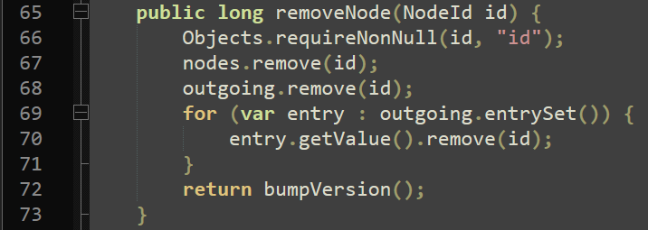
Figure 5: Why node removal is expensive
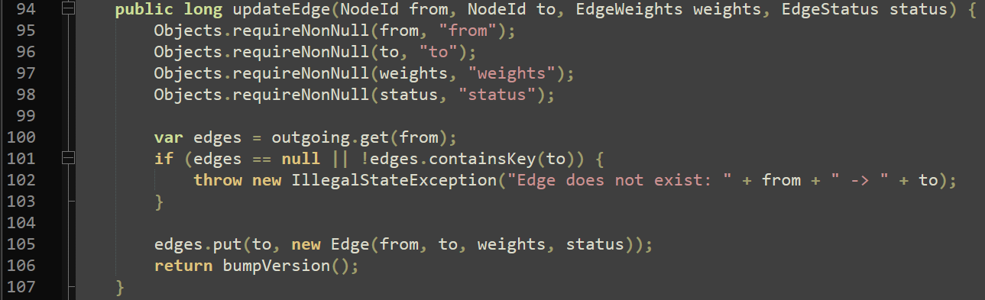
Figure 6: Edge update behavior

Route Optimisation (Dijkstra/A* + Indexed Heap)

Routing is implemented as shortest-path search over non-negative edge costs, with a pluggable cost function. The routing module is responsible for producing both the chosen path and the totals, which are then used by dispatch policies.

What it does

- Computes optimal routes between nodes for dispatch and rerouting.
- Supports different cost models through EdgeCostFunction.

How it works

- DijkstraRouter computes shortest paths when edge costs are non-negative (appropriate for travel time/distance).
- AStarRouter is available as an optimisation when a suitable heuristic exists.
- A custom priority queue (BinaryHeapIndexedMinPriorityQueue) is used because java.util.PriorityQueue does not support efficient decreaseKey, which is central for an efficient Dijkstra/A* implementation.
- For speed and predictability, routing maps NodeId -> int once per query and uses arrays (dist[], prev[]) rather than maps during the main loop. Paths are reconstructed by walking the prev[] links backward.

Why this approach

- Dijkstra/A* are standard, correct choices for shortest path with non- negative costs.
- The indexed heap enables decreaseKey in O(log V), avoiding the common workaround of inserting duplicates and doing extra work later.
- Using arrays keeps routing performance stable and makes the algorithm easier to analyse in complexity terms.

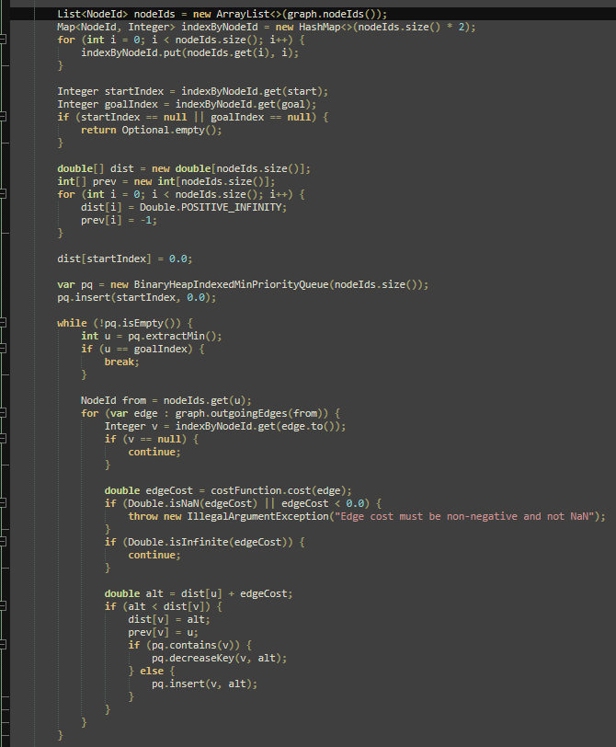
Figure 7: Main Loop + Decrease Key
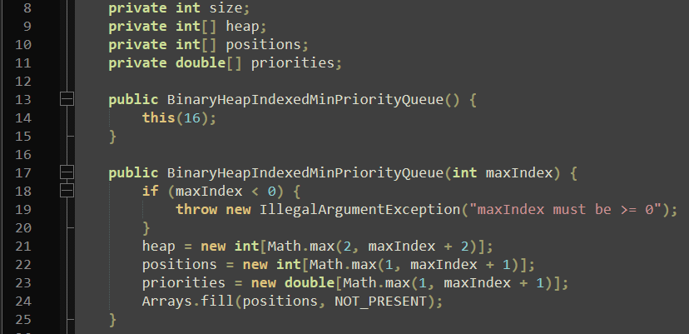
Figure 8: Stored Arrays
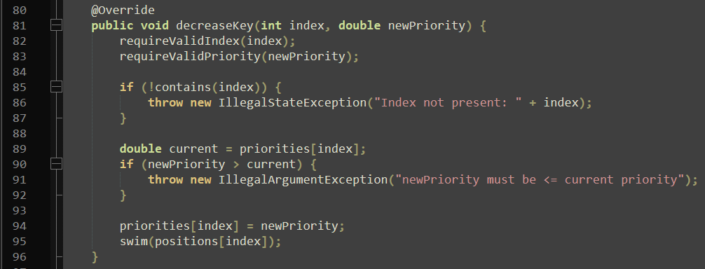
Figure 9: Decrease Key + Swim

Dispatch, Reallocation, and Dynamic Updates
Dispatch is split into a small orchestration layer and replaceable policies, keeping decision logic isolated and allowing the allocation strategy to improve without redesign.

What it does

- Prioritises incidents (severity, then age) and assigns the best available eligible unit.
- Adapts to unit outages and network changes via reroute or cancel + reassign.

How it works

- DefaultDispatchEngine orders incidents and produces DispatchCommands using a DispatchPolicy.
- Policies:
- NearestAvailableUnitPolicy: routes per eligible unit and chooses the minimum-cost route (simple, expensive).
- MultiSourceNearestAvailableUnitPolicy: routes once per incident using a virtual source connected to all eligible unit start nodes (VirtualSourceGraphView), then selects the unit at the nearest start node (deterministic tie-break).
- Real-time behaviour is driven by SimulationEngine (timed events) and PerdsController, which applies SystemCommands, runs dispatch, applies commands, and records metrics.
- Reallocation: if an assigned unit becomes unavailable, the assignment is cancelled and the incident is re-queued.
- Route changes: on edge update/removal, only affected assignments are rerouted/cancelled using AssignmentRouteIndex (edge → incident IDs).

Why this approach

- Supports incremental improvements while remaining testable.
- Virtual-source routing reduces “route per unit” to “route per incident”.
- Targeted invalidation avoids unnecessary re-computation on updates.
- DispatchRationale export improves auditability.

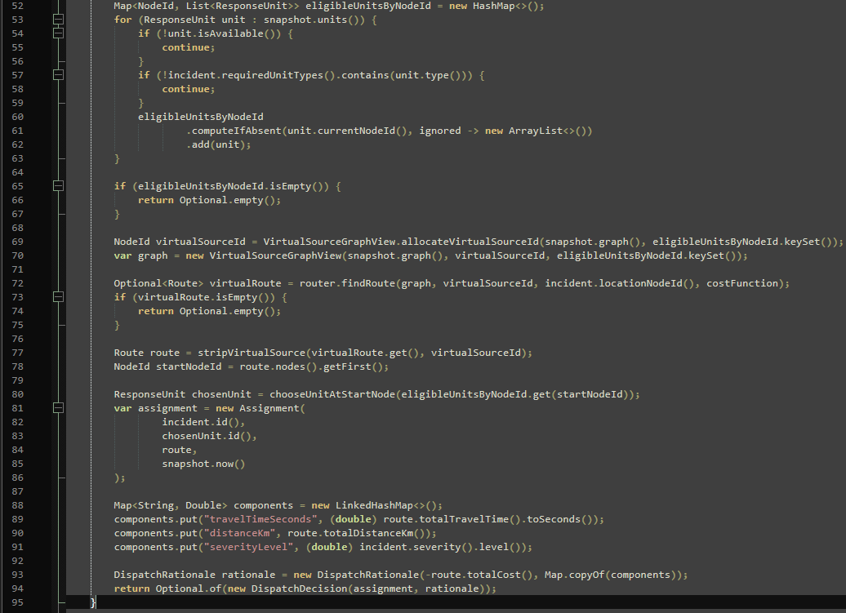
Figure 10: Virtual-Source Allocation + Rationale Components
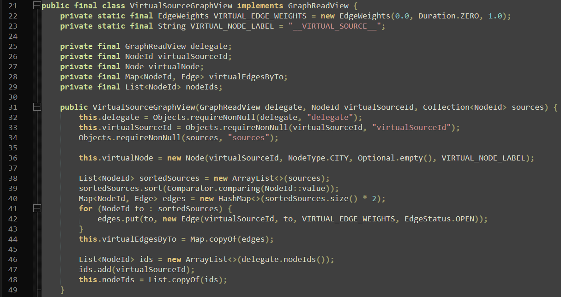
Figure 11: Virtual Node + Zero-Cost Edges
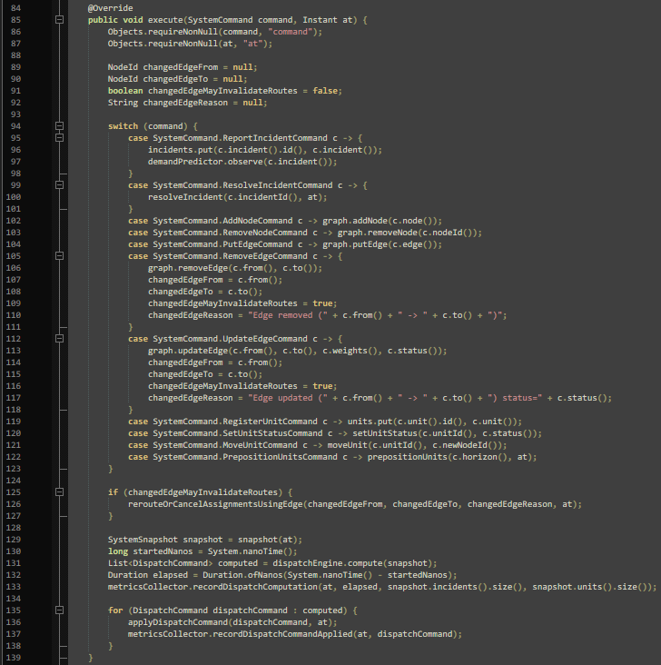
Figure 12: Event → Update → Dispatch Pipeline
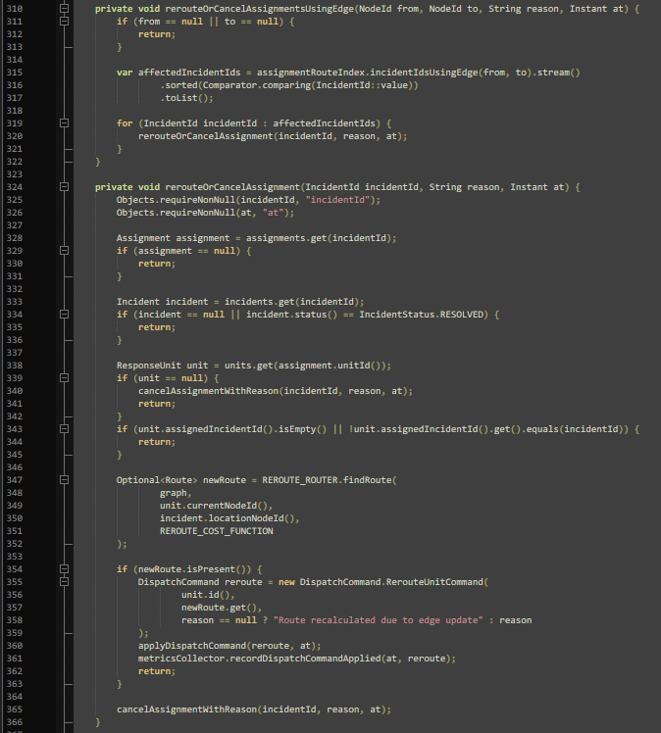
Figure 13: Reroute-or-Cancel on Edge Change
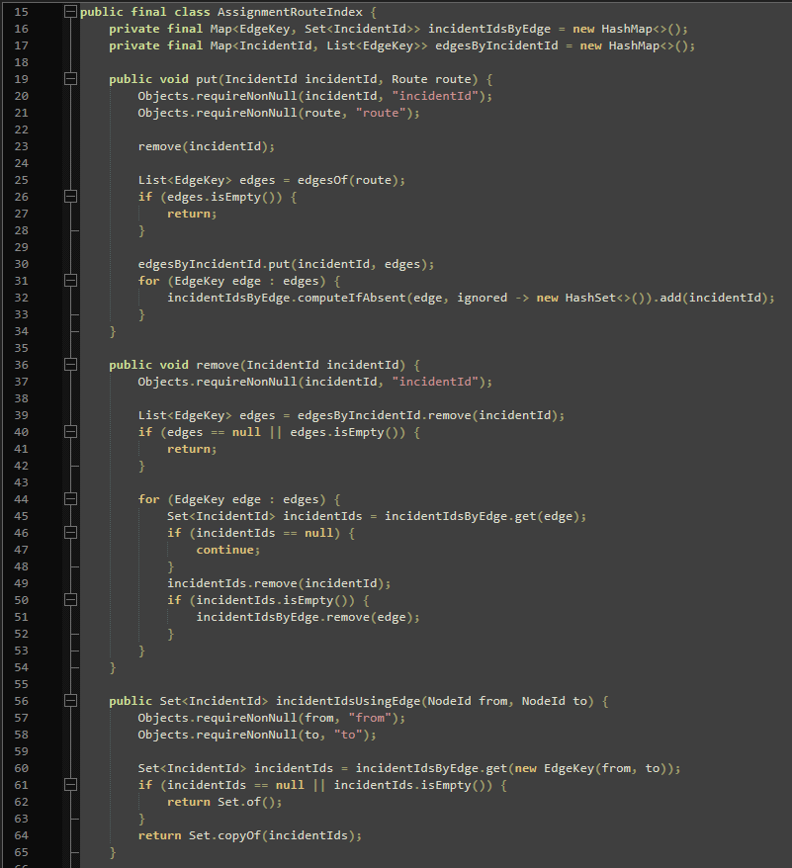
Figure 14: Edge → Incident Indexing

Predictive Analysis and Resource Pre-positioning

Prediction and pre-positioning are implemented as lightweight, explainable components, using predictive insight to proactively improve system efficiency and measure those effects.

What it does

- Forecasts demand per zone over a configurable horizon.
- Generates a reposition plan to move available units toward forecast hotspots.

How it works

- Predictors implement DemandPredictor:
- ExponentialSmoothingDemandPredictor: maintains a decaying score per zone.
- SlidingWindowDemandPredictor: counts recent incidents within a fixed window and scales into the forecast horizon.
- AdaptiveEnsembleDemandPredictor: combines multiple predictors and updates weights online using observed forecast error.
- Pre-positioning strategies implement PrepositioningStrategy:
- GreedyHotspotPrepositioningStrategy: moves idle units to the single highest-demand zone.
- MultiHotspotPrepositioningStrategy: allocates a limited number of moves across the top zones proportionally to forecast demand and selects nearest units using the same multi-source routing approach.

Why this approach

- Meets the “predictive + pre-positioning” requirement without violating the “no external ML libraries” constraint.
- Keeps behaviour explainable and measurable: predictions and moves can be inspected via exported metrics.
- Reuses existing routing/dispatch ideas (multi-source selection) to keep pre-positioning efficient.

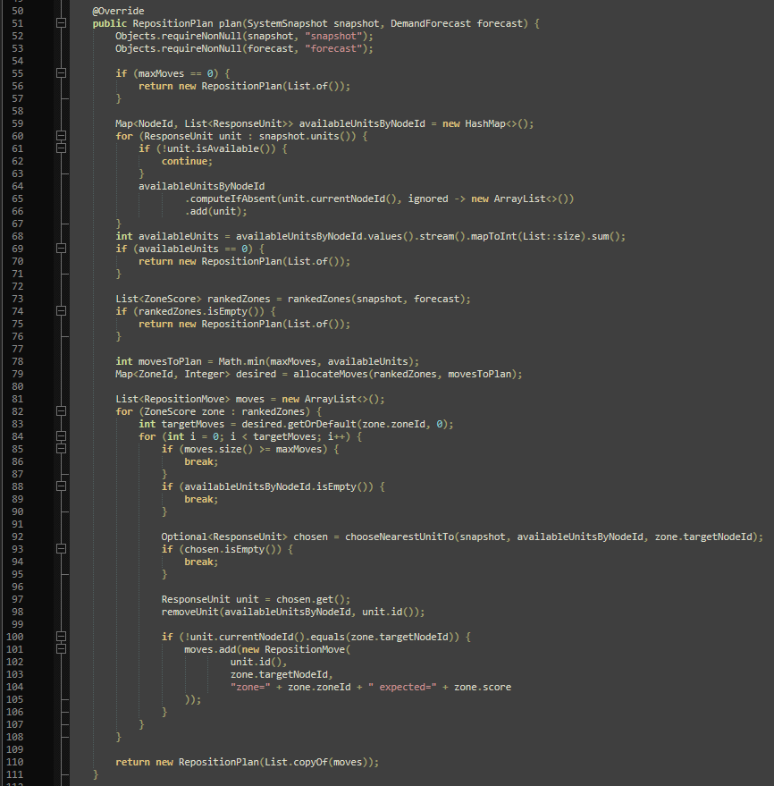
Figure 15: Move Planning
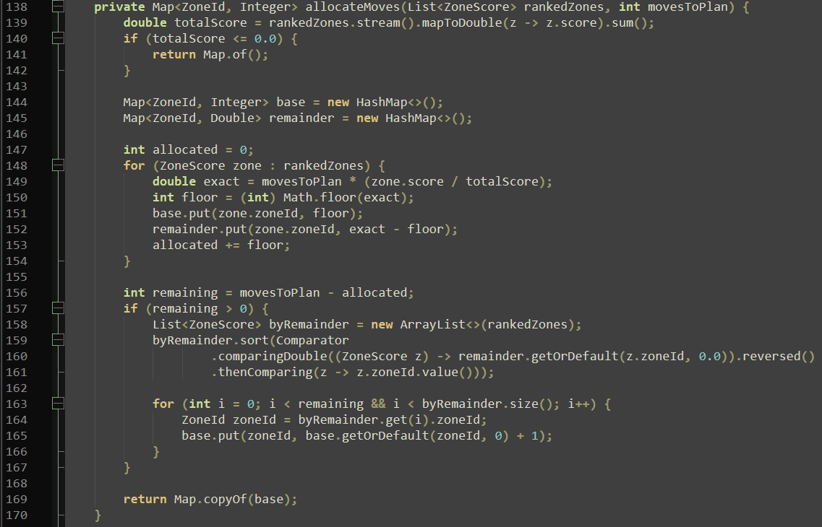
Figure 16: Proportional Move Allocation
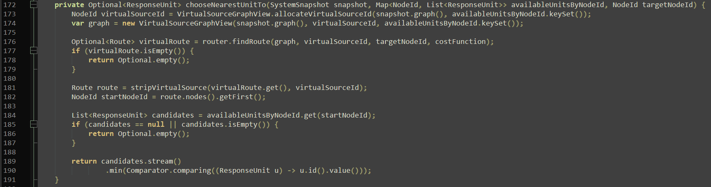
Figure 17: Nearest-Unit Choice via Virtual Source

CLI, Scenario Loading, and Metrics Export

The system is exercised end-to-end through a CLI and CSV-based scenario loading, enabling reproducible simulation runs. Metrics are exported to CSV so performance, stability, and decision quality can be evaluated empirically rather than described qualitatively.

What it does

- Runs demos, CSV scenarios, and synthetic evaluation runs via the CLI.
- Loads networks and event timelines from CSV.
- Records and exports metrics (compute time, decisions, applied commands).

How it works

- CSV loaders validate inputs and convert rows into domain objects and SystemCommands (e.g., REPORT_INCIDENT, UPDATE_EDGE, SET_UNIT_STATUS, PREPOSITION_UNITS).
- The metrics collector stores dispatch computation timing, decisions (with rationale components), and applied commands.
- CsvMetricsExporter writes report-friendly CSV outputs:
- dispatch_computations.csv
- dispatch_decisions.csv
- dispatch_commands_applied.csv

Why this approach

- CSV + CLI keeps evaluation lightweight and reproducible without needing a GUI framework.
- Exported metrics provide evidence for later report sections (evaluation and ethical auditability), e.g., comparing variants and checking stability under disruptions.
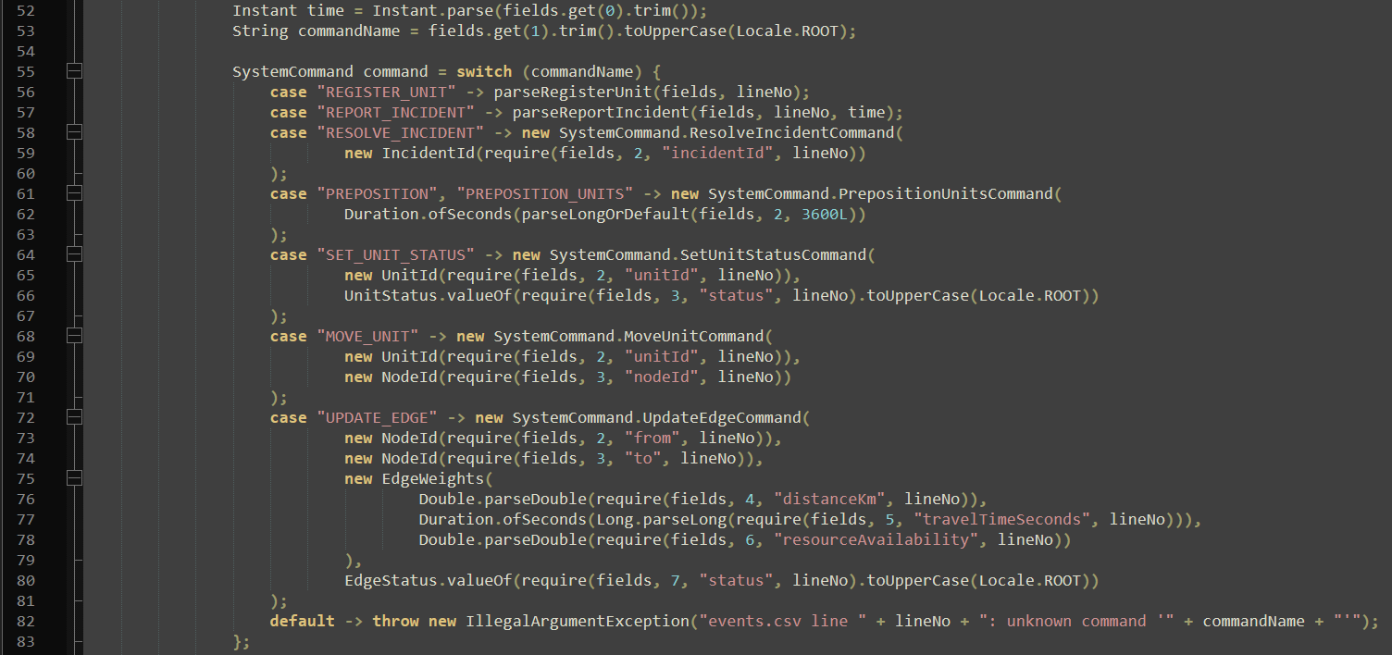
Figure 18: Event Parsing to Commands
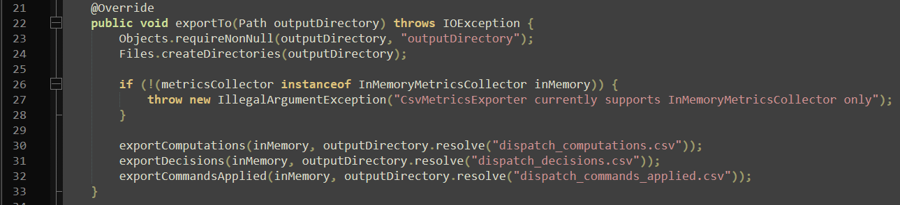
Figure 19: What is Exported
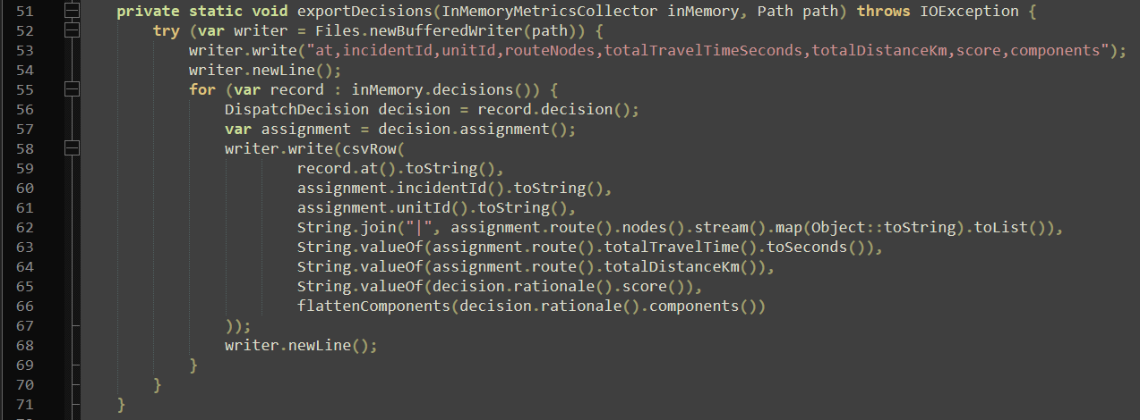
Figure 20: Decision Exports with Rationale Components

Complexity Analysis
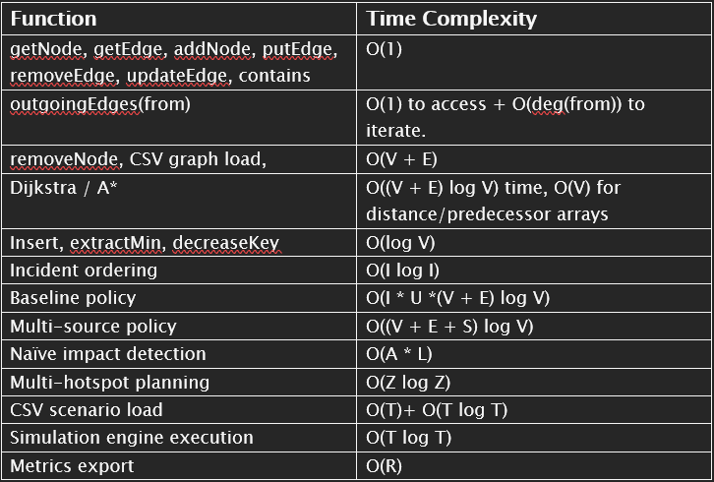
Figure 21: Complexity Analysis

Ethical Considerations
The system models decisions that, in real deployments, would affect safety-critical outcomes (allocation behaviour). Ethical considerations therefore focus following:

Fairness (coverage vs efficiency)

A “nearest-first” dispatch policy and hotspot-based pre-positioning improve average response time but can reduce coverage in low-demand areas (e.g., rural zones), systematically disadvantaging certain regions.

Reliability and failure modes

There is no continuous movement along edges, no partial-edge traversal, and no concurrency/human-override workflow.

Privacy / data minimisation

Real incident data would contain sensitive information, requiring minimal stored personal data, to restrict access, define retention policies, and ensure logs/exports avoid identifiable details.

Bias and feedback loops in prediction

Forecasting demand from historical data risks encoding reporting bias (some areas may be over/under-reported), making Pre-positioning on-top create feedback loops (resources concentrate in already- served regions, producing more data there, reinforcing the pattern).

Recommendations

- Improve movement realism: simulate edge-by-edge travel so congestion/
reroutes affect units mid-route, not only at node snapshots.
- Add fairness constraints: enforce minimum regional coverage and/or
penalties so hotspot moves don’t starve low-demand zones.
- Cut routing re-computation: reuse node indexing and add versioned route
caching/invalidation.
- Broaden evaluation: larger/closure-heavy graphs, overload experiments
(queue growth/recovery), simple plots from CSV outputs.
- Harden IO/config: stronger CSV validation, clearer CLI defaults/help,
more requirement-focused scenario fixtures.
- Tune multi-criteria dispatch: calibrate severity/ETA/distance/resource-
availability weights and run sensitivity tests.

References

- Dijkstra, E.W. A note on two problems in connexion with graphs. Numer. Math. 1, 269–271 (1959).
- P. E. Hart, N. J. Nilsson and B. Raphael, "A Formal Basis for the Heuristic Determination of Minimum Cost Paths," (1968).
- Introduction to Algorithms, fourth edition. (n.d.). Google Books.

Appendices
Appendix A — Design Diagrams
A1: System class diagram
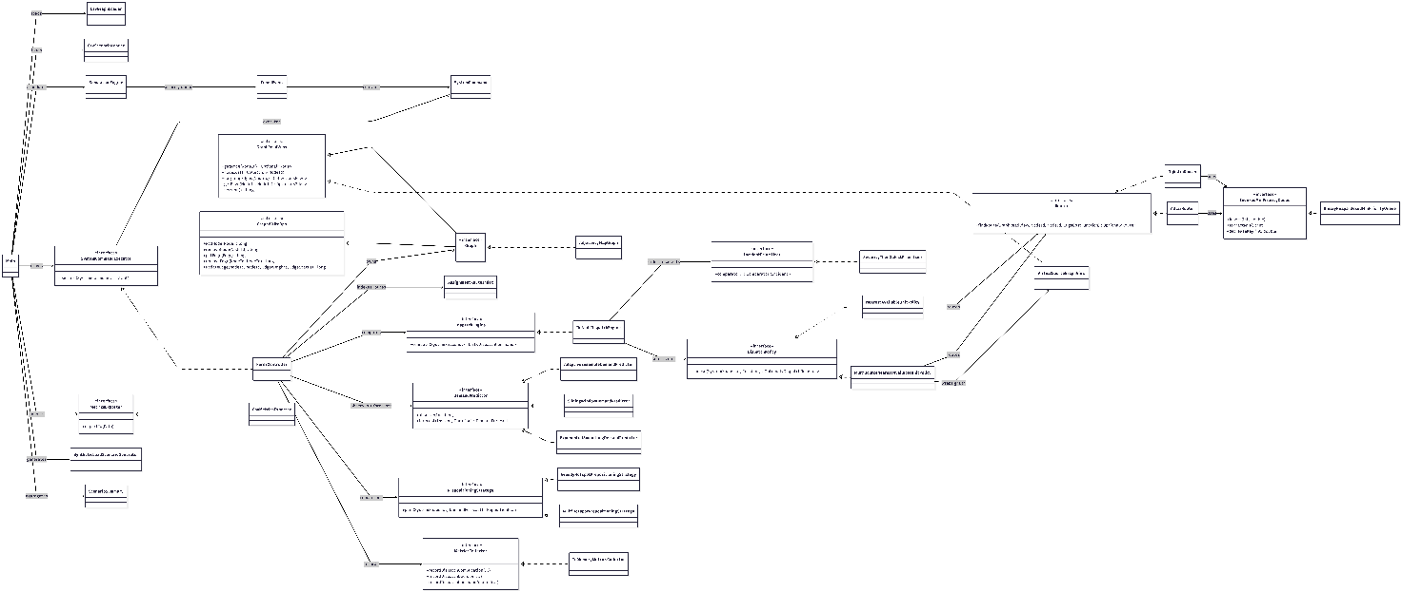
Figure 22: Class Diagram
A2: Per-event controller step
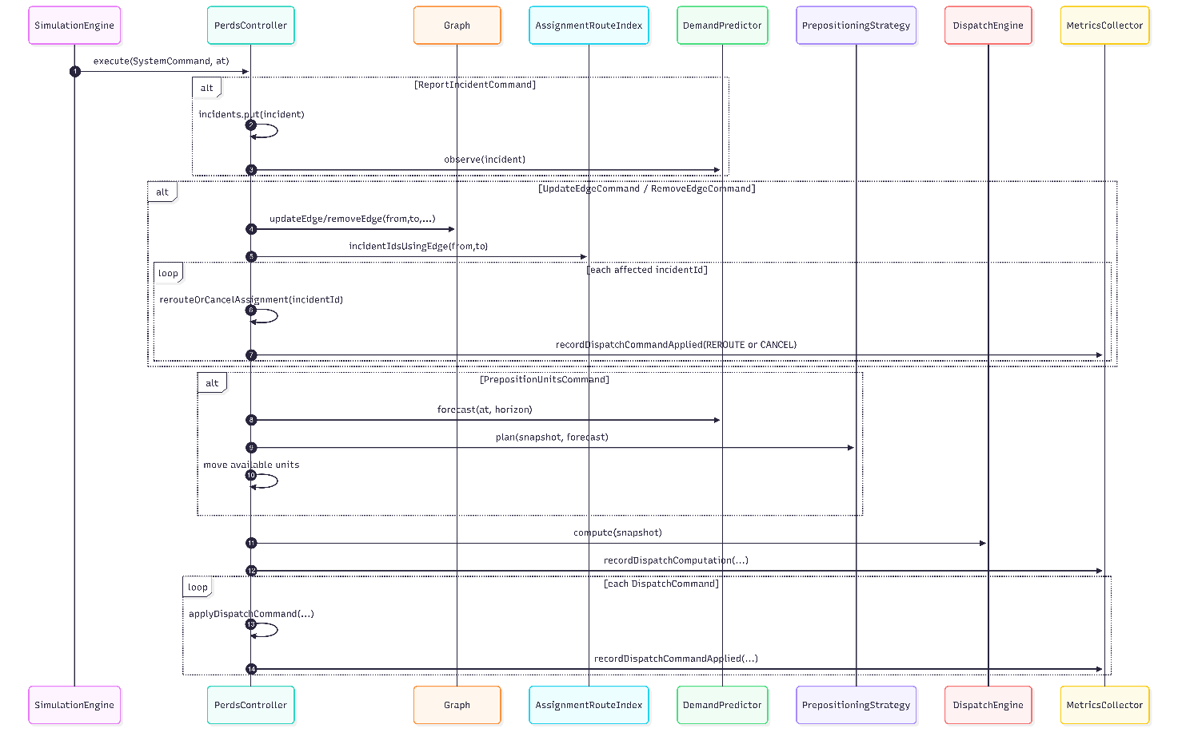
Figure 23: Controller Step Sequence
A3: Edge update reroute/cancel
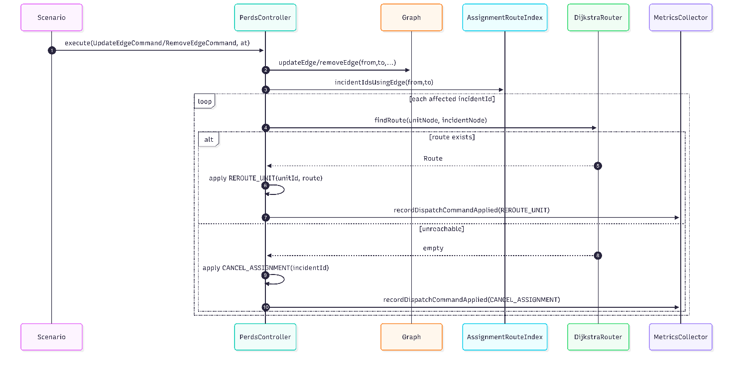
Figure 24: Edge Reroute Sequence
A4: Pre-positioning sequence
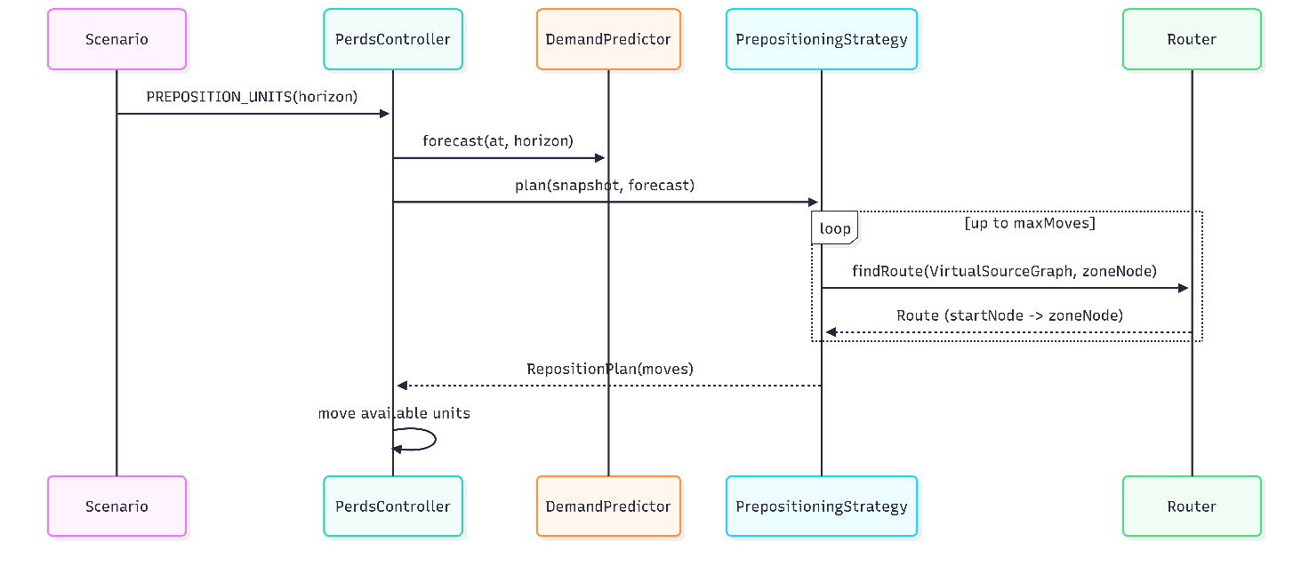
Figure 25: Prepositioning Sequence

A5: Synthetic evaluation runner
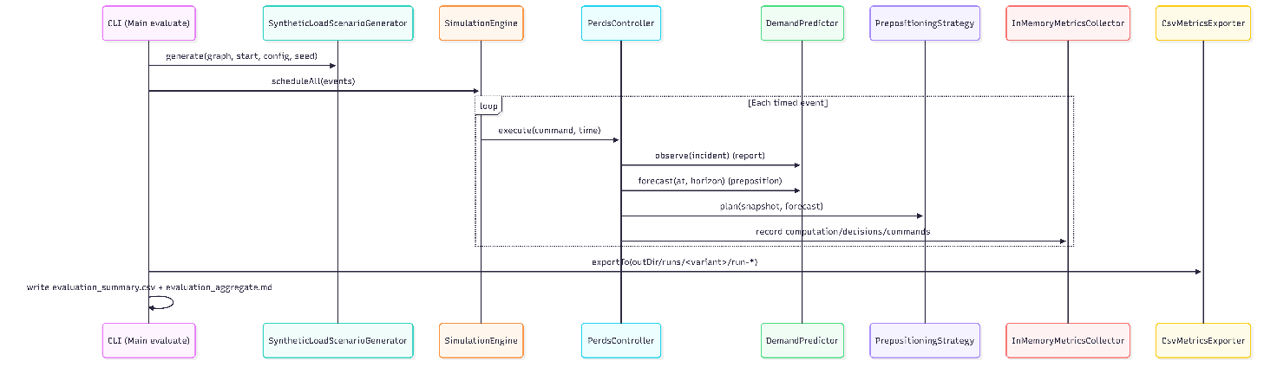
Figure 26: Evaluation Sequence

Appendix B — Empirical Evaluation Evidence (tables/CSVs)
B1: Aggregate results
Figure 27: Aggregate Results
B2: Per-run summary
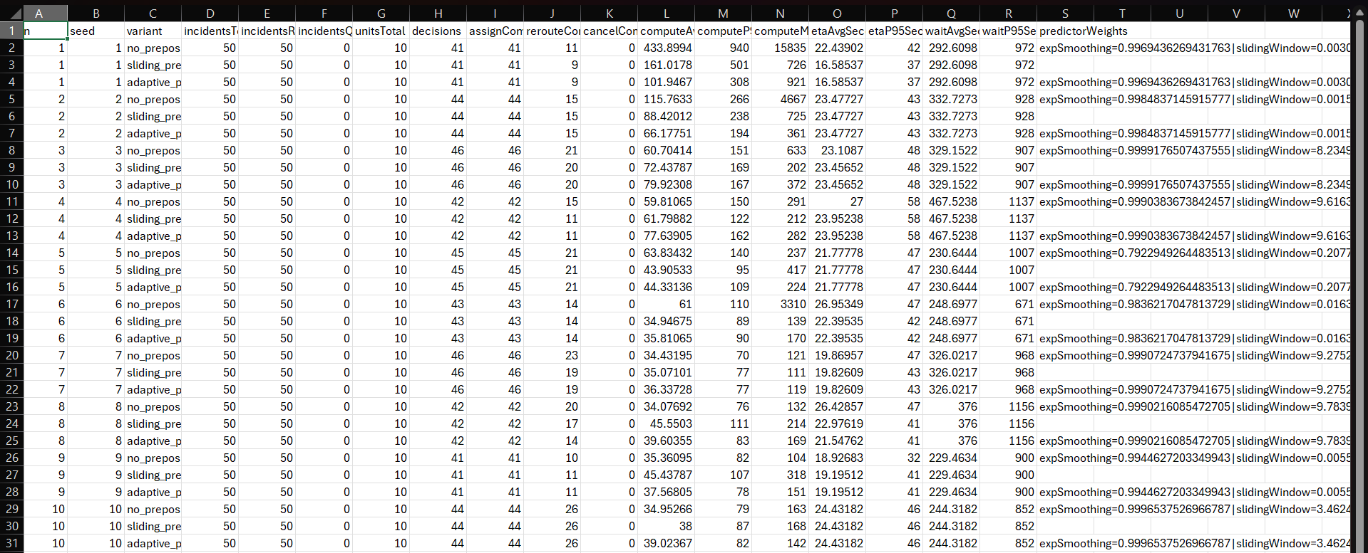
Figure 28: Per-run summary

Appendix C — Scenario Inputs (reproducibility)
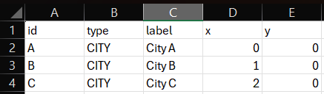
Figure 29: Mini Nodes
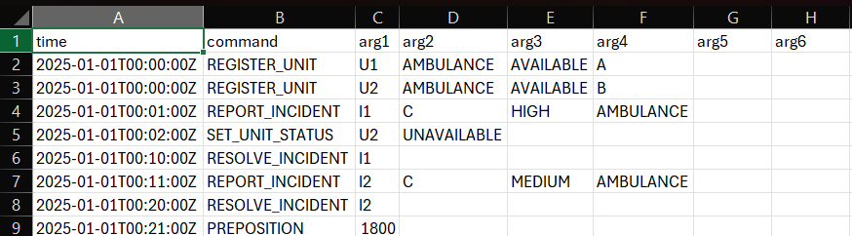
Figure 30: Mini Events
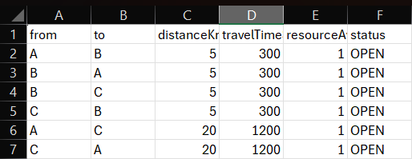
Figure 31: Mini Events
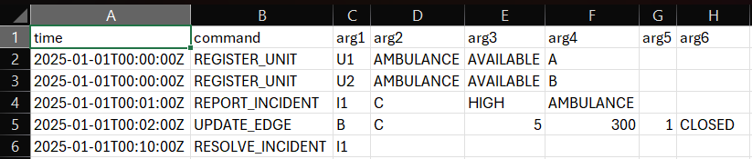
Figure 32: Edge Closure Events
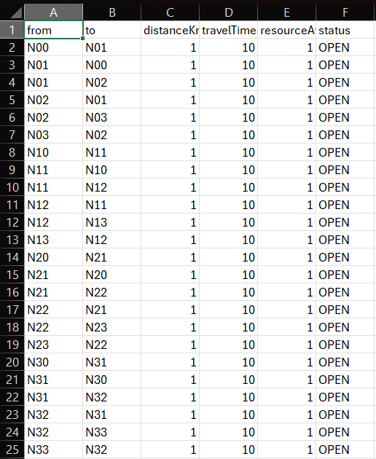
Figure 33: Grid 4*4 Edges
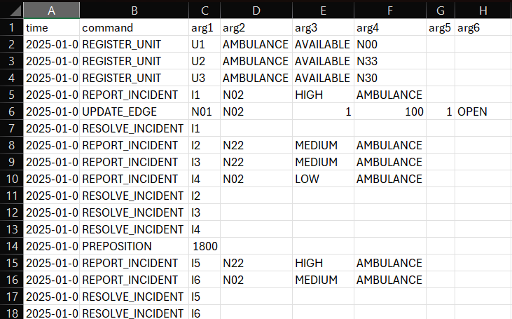
Figure 34: Grid 4*4 Events
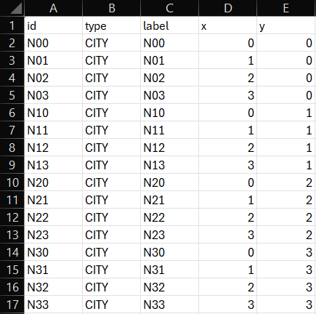
Figure 35: Grid 4*4 Nodes

Appendix D — Requirements Traceability Matrix

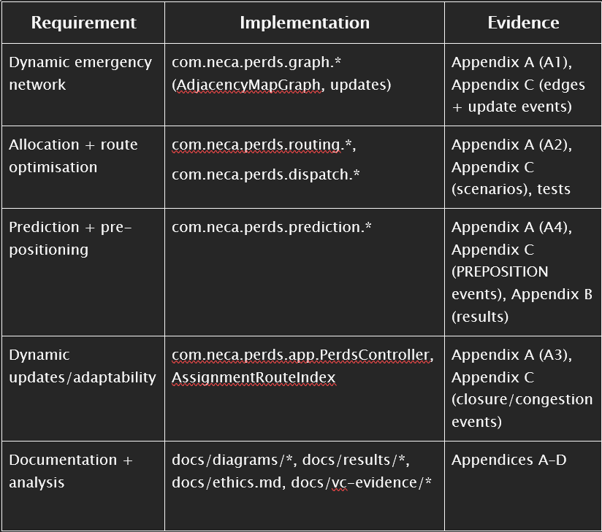
Figure 36: Requirements Traceability Matrix

