Creating Project in Visual C++
- Click on File -> New -> Project. Select C++ as desired language and ‘Empty Project’.

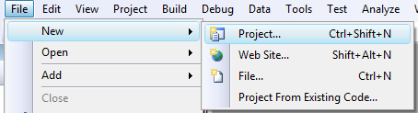
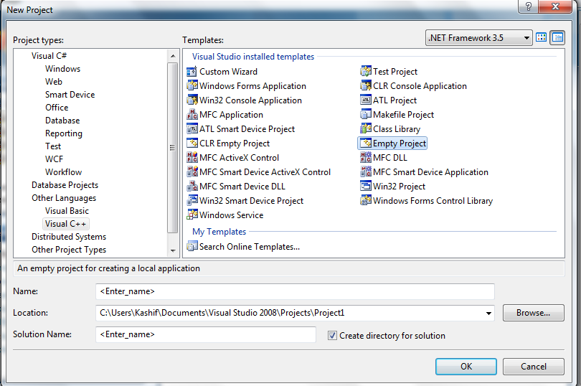
- Select View -> Solution Explorer. In Solution Explorer window you can see three sections. ‘Header Files’, ‘Resource Files’, ‘Source Files’.
- Right click the ‘Header File’ section, select ‘Add New Item’.
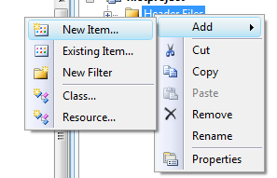
- Add a header file and write your code in it.
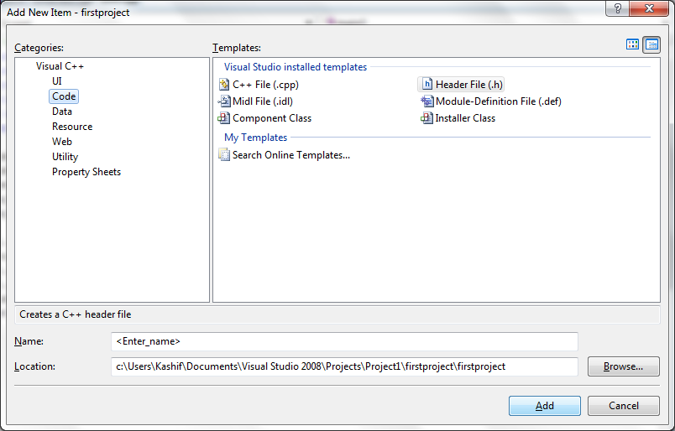
- Similarly add .cpp files to your sources folder and write code in them.
- Once done with the files, run the project by pressing F5.

