Ch1 Quantities and Units

# 1-1 UNITS OF MEASUREMENT

## Fundamental and Derived Units

The SI system is based on seven fundamental units (sometimes called base units) and two supplementary units. All measurements can be expressed as some combination of fundamental and supplementary units. Table 1-1 lists the fundamental units, and Table 1-2 lists the supplementary units.

The fundamental electrical unit, the ampere, is the unit for electrical current. Current is abbreviated with the letter I (for intensity) and uses the symbol A (for ampere). The ampere is unique in that it uses the fundamental unit of time (t) in its definition (second). All other electrical and magnetic units (such as voltage, power, and magnetic flux) use various combinations of fundamental units in their definitions and are called derived units.

For example, the derived unit of voltage, which is the volt (V), is defined in terms of fundamental units as m2 . kg . s-3. A-1. As you can see, this combination of fundamental units is very cumbersome and impractical. Therefore, volt is used as the derived unit

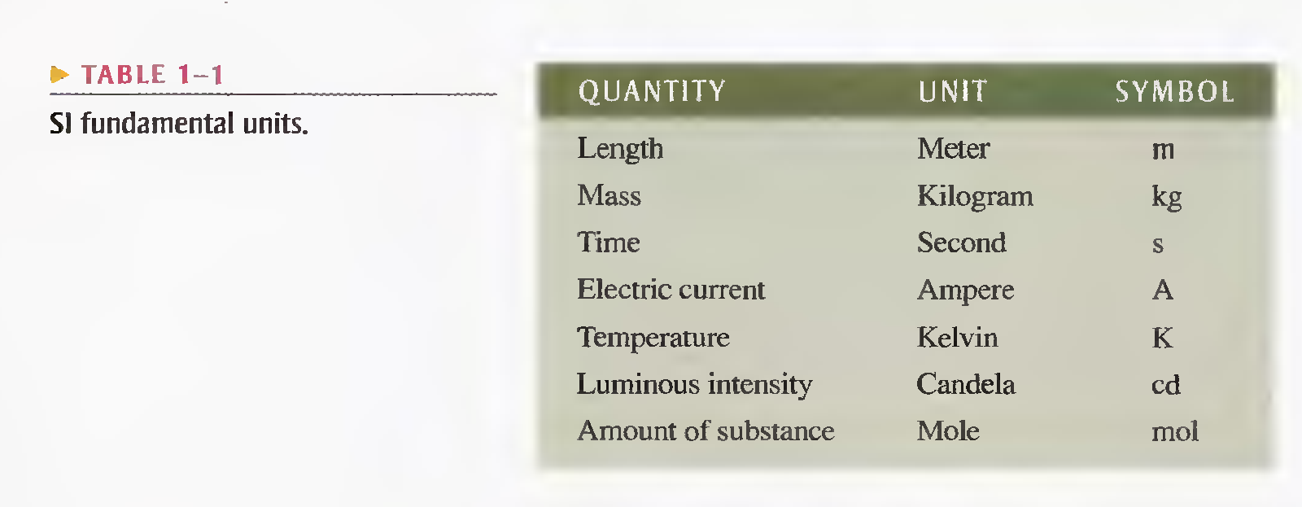 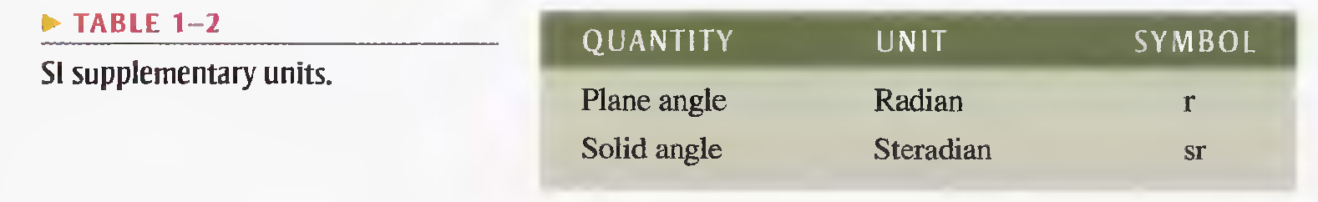

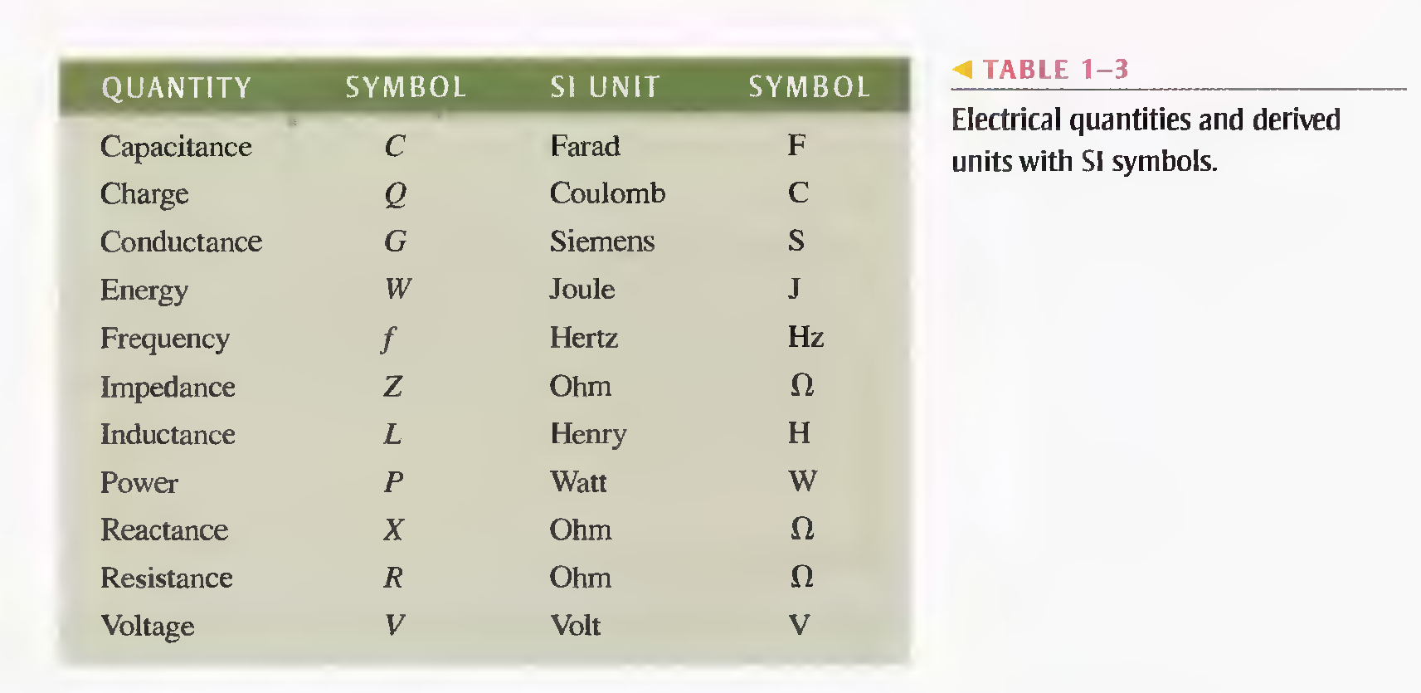

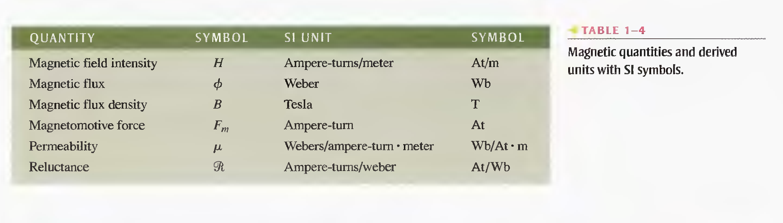

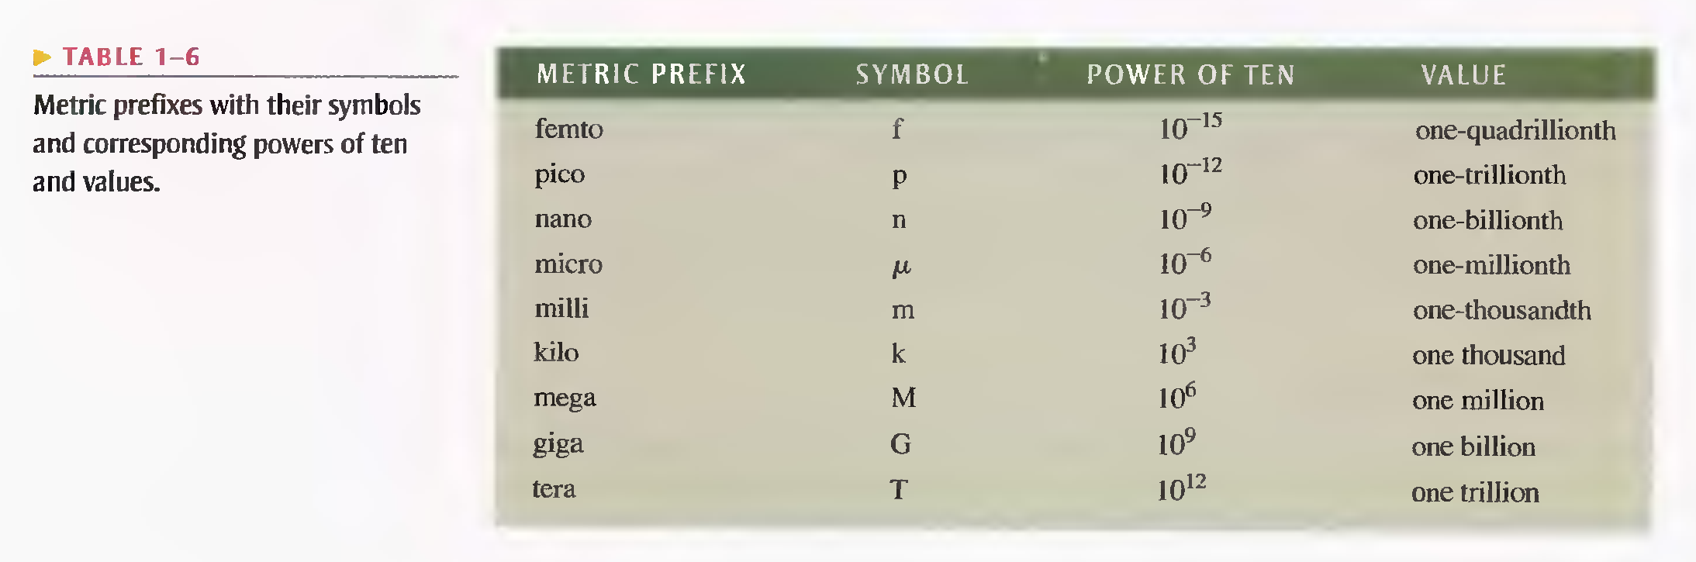

# Resistors:-

Resist or limit electrical current in a circuit.

# Inductors:-

Also known as coils are used to store energy in an electromagnetic field.

# Transformer:-

Are used to magnetically couple ac-voltages from one point to a circuit to another, or to increase or decrease the ac-voltage.

Ch2

**All matter is made of atoms; and all atoms are made of electrons, protons, and neutrons.**

**An atom is the smallest particle of an element that retains the characteristics of that element.**

# Atomic number:-

All elements are arranged in the periodic table of the elements in order according to their atomic number. The atomic number equals the number of protons in the nucleus.

# Electron Shells and Orbits:-

Electrons orbit the nucleus of an atom at certain distances from the nucleus. Electrons near the nucleus have less energy than those in more distant orbits. It is known that only discrete (separate and distinct) values of electrons energies exist within atomic structures. Therefore, electrons must orbit only at discrete distances from the nucleus.

The lowest level (n = 1) is called the ***ground state.***

The wave-mechanics model of the atom used the shell number, called the ***principal quantum number***, in the energy equation. Three other quantum numbers describe each electron within the atom. All electrons in an atom have a unique set of quantum numbers.

# Shells:-

In an atom, the orbits are grouped into energy bands known as shells.

# Valence electrons:-

Electrons with the highest energy levels exist in the outermost shell of an atom. This outermost shell is known as the **valence shell**, and electrons in this shell are called **valence electrons**.

# Ionization:-

When an atom absorbs energy from a heat source or from light, for example, the energy levels of the electrons are raised. The valence electrons possess more energy and are more loosely bound to the atom than inner electrons. So they can easily jump to higher orbits within the valence shell when external energy is absorbed.

The process of losing a valence electron is known as ***ionization***.

# The copper atom:-

Because Copper is the most commonly used metal in electrical applications. Let’s examine its atomic structure. The copper atom has 29 electrons that orbit the nucleus in four shells. The number of electrons in each shell follows a predictable pattern according to the formula, 2N2, where N is the number of the shell.

Notice that the fourth or outermost shell, the valence shell of a copper atom has only 1 valence electron. When this valence electron gains sufficient thermal energy, it can break away from the parent atom and become a free electron. In a piece of copper at room temperature, a “sea” of these free electrons is present. These free electrons make copper an excellent conductor and make electrical current possible.

# Categories of materials:-

## Conductors:-

Conductors are materials that readily allow current. They have a large number of free electrons and are characterized by one to three valence electrons in their structure. Most metals are good conductors. Silver is the best conductor, and copper is next.

## Semiconductors:-

Semiconductors are classed below the conductors in their ability to carry current because they have fewer free electrons than do conductors. They have four valence electrons in their atomic structure. Silicon and germanium are common semiconductive materials.

## Insulators:-

Insulators are materials that are poor conductors of electric current. In fact, insulators are used to prevent current where it is not wanted. They are characterized by more than four valence electrons in their atomic structures.

# Charge:-

Two types of charge are positive charge and negative charge. The electron is the smallest particle that exhibits negative electrical charge.

Electrical charge which is a fundamental characteristic of electrons and protons is symbolized by Q.

## Coulomb: the unit of charge:-

One coulomb is the total charge possessed by 6.25 x 1018 electrons.

A single electron has a charge of 1.6 x 10-19 C.

# Voltage:-

A force of attraction exists between a positive and a negative charge.

The difference in potential energy per charge is the potential difference or voltage.

V = W/Q

## Volt: the unit of voltage:-

One volt is the potential difference between two points when one joule of energy is used to move one coulomb of charge from one point to the other.

# Current:-

Voltage provides energy to electrons that allows them to move through a circuit. This movement of electrons is the current.

Electrical current is the rate of flow of charge.

I = Q/t

## Ampere: the unit of Current:-

One ampere (1 A) is the amount of current that exists when a number of electrons having a total charge of one coulomb (1 C) move through a give cross-sectional area in one second (1 s).

# Resistance:-

The property of a material that restricts the flow of electrons is called resistance.

## Ohm: the unit of resistance:-

One ohm of resistance exists if there is one ampere (1 A) of current in a material when one volt (1 V) is applied across the material.

## Conductance:-

The reciprocal of resistance. Symbol G.

G = 1/R

# Wire resistance:-

R = (p * L)/A

# Ground:-

The term ground comes from the method used in ac-power distribution where one side of the power line is neutralized by connecting it to a metal rod driven into the ground. This method of grounding is called ***earth ground***.

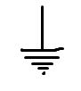

In electrical and electronic system, the metal chassis that houses the assembly or a large conductive area on a printed circuit board is used as the electrical reference point and is called ***chassis ground or circuit ground.*** Circuit ground may or may not be connected to earth ground.

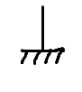

**Ground** is the reference point in electric circuits and has a potential of 0 V with respect to other points in the circuit. All of the ground points in a circuit are electrically the same and are therefore common points.

# Five-Band Color Code

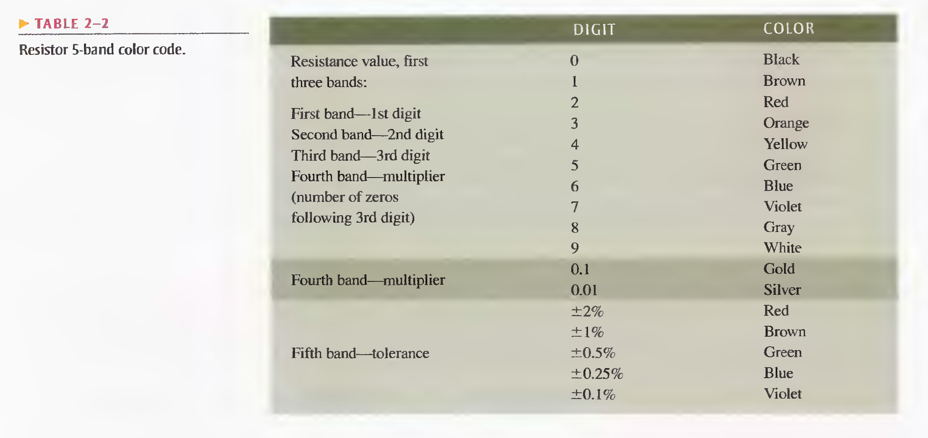

# Resistor Reliability Band

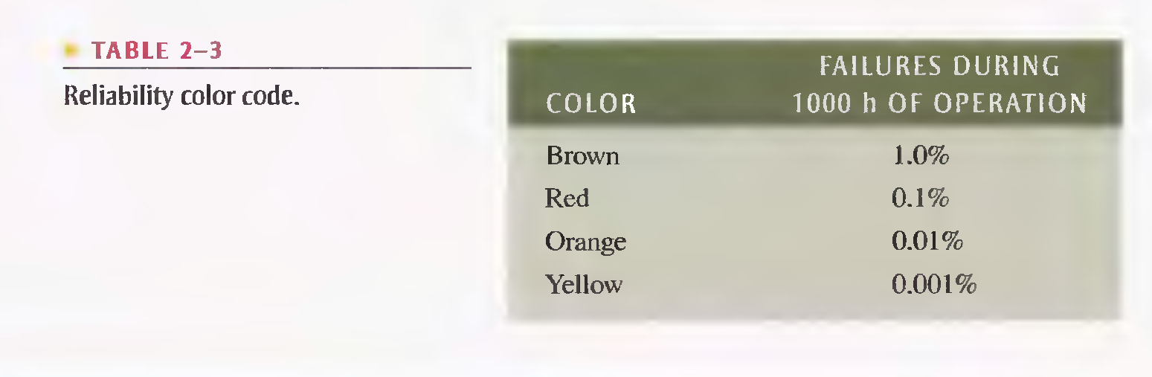

# Numeric Labeling

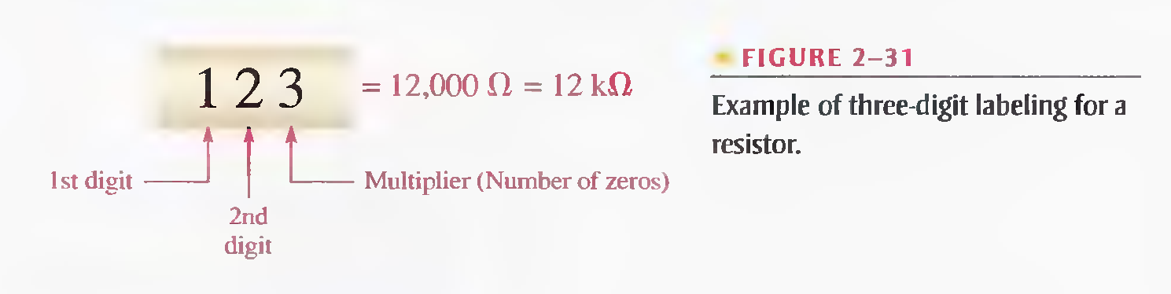

# Alphanumeric Labeling

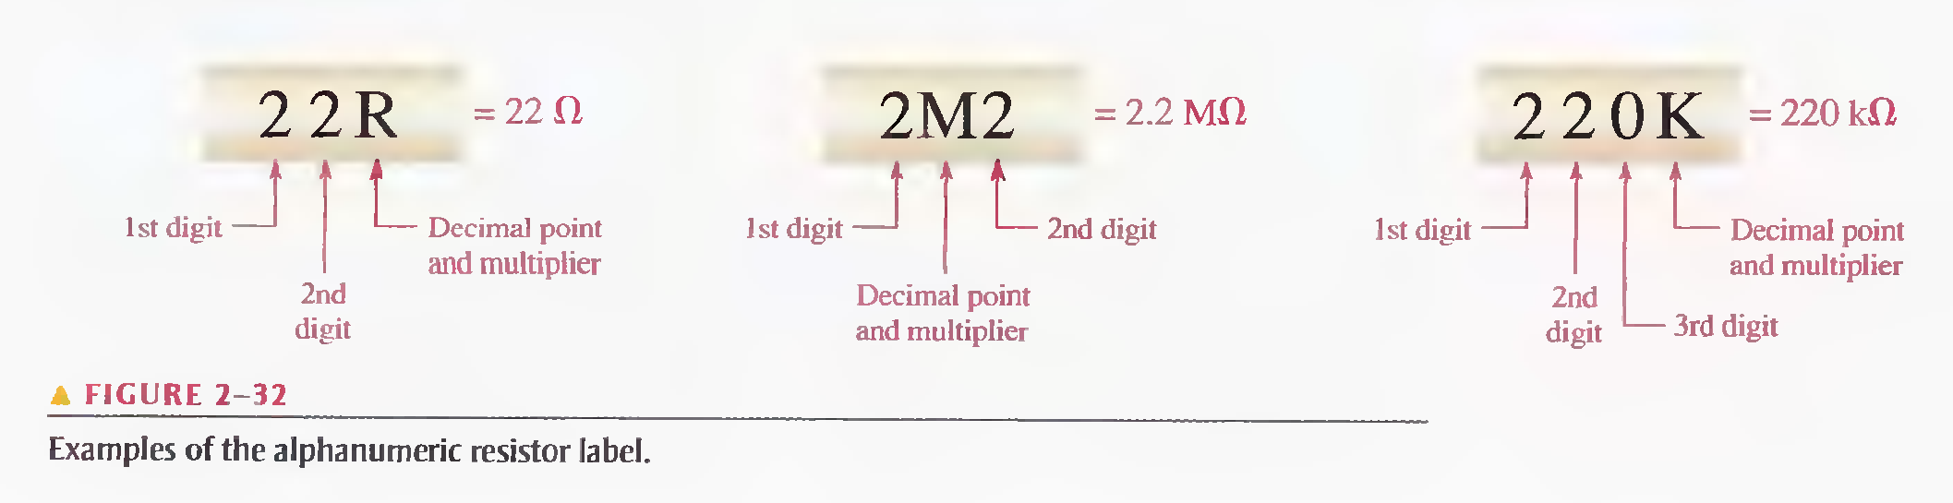

One system of labels for resistance tolerance values uses the letters F, G, and J:

­ F = ±1% G = ±2% J = ±5%

For example, 620F indicates a 620 Ω resistor with a tolerance of ±1%, 4R6G is a 4.6 Ω ±2% resistor, and 56KJ is a 56 k Ω ±5% resistor.

# Variable Resistors

Variable resistors are designed so that their resistance values can be changed easily with a manual or an automatic adjustment.

Two basic uses for variable resistors are to **divide voltage and to control current**. The variable resistor used to divide voltage is called a **potentiometer**. The variable resistor used to control current is called a **rheostat**.

Schematic symbols for these types are shown below.

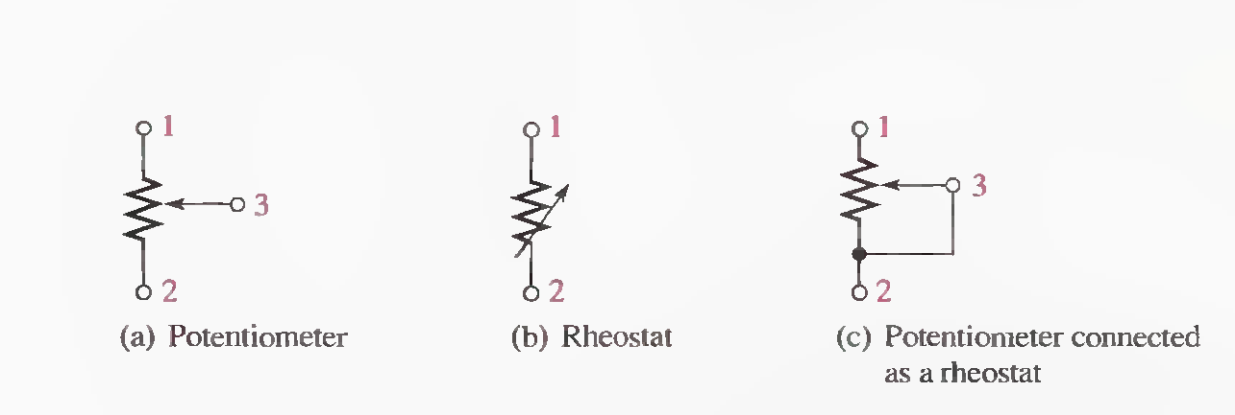

## Two Types of Automatically Variable Resistors

A **thermistor** is a type of variable resistor that is temperature sensitive. When its temperature coefficient is negative, the resistance changes inversely with temperature. When its temperature coefficient is positive, the resistance changes directly with temperature.

The resistance of a **photoconductive cell** changes with a change in light intensity. This cell also has a negative temperature coefficient.

Symbols for both of these devices are shown in below. Sometimes the Greek letter lambda  is used in conjunction with the photoconductive cell symbol.

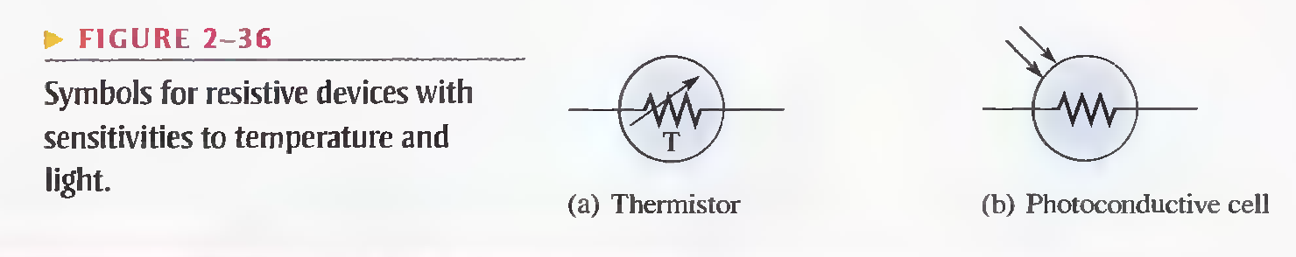

# Key Terms and theirs Definitions:

**Ammeter**: An electrical instrument used to measure current.

**Ampere (A)**: The unit of electrical current.

**Atom**: The smallest particle of an element possessing the unique characteristics of that element

**AWG:** American wire gauge; a standardization based on wire diameter.

**Charge:** An electrical property of matter that exists because of an excess or a deficiency of electrons. Charge can be either positive or negative.

**Circuit**: An interconnection of electrical components designed to produce a desired result. A basic circuit consists of a source, a load, and an interconnecting current path.

**Closed circuit**: A circuit with a complete current path.

**Conductance**: The ability of a circuit to allow current. The unit is the siemens (S).

**Conductor:** A material in which electric current is easily established. An example is copper.

**Coulomb (C)**: The unit of electrical charge; the total charge possessed by 6.25 X 1018 electrons.

**Current**: The rate of flow of charge (electrons).

**Current source**: A device that produces a constant current for a varying load.

**DMM:** Digital multimeter; an electronic instrument that combines meters for measurement of voltage, current, and resistance.

**Electrical shock**: The physical sensation resulting from electrical current through the body.

**Electron**: A basic particle of electrical charge in matter. The electron possesses negative charge.

**Free electron**: A valence electron that has broken away from its parent atom and is free to move from atom to atom within the atomic structure of a material.

**Ground**: The common or reference point in a circuit.

**Insulator**: A material that does not allow current under normal conditions.

**Load**: An element connected across the output terminals of a circuit that draws current from the source and upon which work is done.

**Ohm (Ω)**: The unit of resistance.

**Ohmmeter**: An instrument for measuring resistance.

**Open circuit**: A circuit in which there is not a complete current path.

**Potentiometer**: A three-terminal variable resistor. And used to divide voltage

**Resistance**: Opposition to current. The unit is the ohm (Ω)

**Resistor** An electrical component specifically designed to have a certain amount of resistance.

**Rheostat**: A two-terminal variable resistor. And used to control current

**Semiconductor**: A material that has a conductance value between that of a conductor and an insulator. Silicon and germanium are examples.

**Siemens (S)**: The unit of conductance.

**Volt:** The unit of voltage or electromotive force.

**Voltage:** The amount of energy per charge available to move electrons from one point to another in an electric circuit.

**Voltage source**: A device that produces a constant voltage for a varying load.

**Voltmeter:** An instrument used to measure voltage.

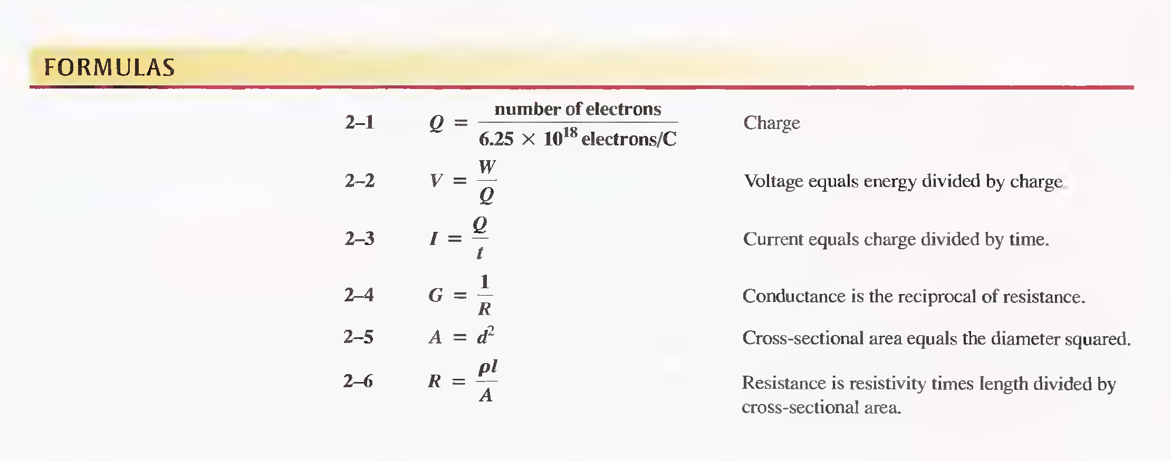

Ch3 OHM’S LAW

Ohm's law state that current is directly proportional to voltage and inversely proportional to resistance. The circuits in Figures 3-1 and 3-2 illustrate Ohm's law, which is given in the following formula:

I = V/R

­where:

I = current in amperes (A)

V = voltage in volts (V)

R = resistance in ohms (Ω)

# Key Terms

**Linear:** Characterized by a straight-line relationship.

**Ohm's law:** A law stating that current is directly proportional to voltage and inversely proportional to resistance.

**Troubleshooting:** A systematic process of isolating, identifying, and correcting a fault in a circuit or a system.

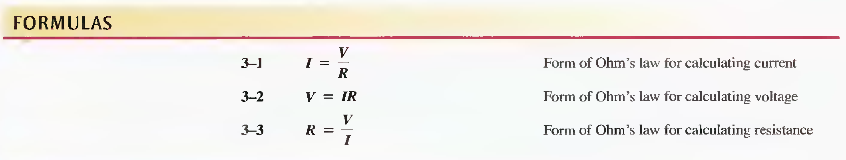

Ch4 Energy and Power

**Energy is the ability to do work, and power is the rate at which energy is used.**

**Power (P)** is a certain amount of energy (W) used in a certain length of time (t), expressed as follows:

P = W/t

Where:

P = power in watts (W)

W = energy in joules (J)

t = time in seconds (s)

## Watt: unit of power:

One watt (W) is the amount of power when one joule of energy is used in one second.

**Electric motors are commonly rated in horsepower (hp) where 1 hp = 746 W.**

# The Kilowatt-hour (kWh) Unit of Energy

The joule has been defined as a unit of energy. However, there is another way to express energy. Since power is expressed in watts and time in seconds, units of energy called the watt-second (Ws), watt-hour (Wh), and kilowatt-hour (kWh) can be used.

For example, a 100 W light bulb burning for 10 h uses 1 kWh of energy.

W = Pt = (100 W)(10 h) = 1000 Wh = 1 kWh

# RESISTOR POWER RATINGS

The power rating is the maximum amount of power that a resistor can dissipate without being damaged by excessive heat buildup.

# Key Terms:

**Ampere-hour (Ah) rating:** A number given in ampere-hours determined by multiplying the current (A) times the length of time (h) a battery can deliver that current to a load.

**Efficiency:** The ratio of the output power delivered to a load to the input power to a circuit, usually expressed as a percentage.

**Energy:** The ability to do work.

**Joule (J):** The SI unit of energy.

**Kilowatt-hour (kWh):** A large unit of energy used mainly by utility companies.

**Power:** The rate of energy usage.

**Power supply:** A device that provides power to a load.

**Voltage drop:** The decrease in voltage across a resistor due to a loss of energy.

**Watt (W):** The unit of power One watt is the power when I J of energy is used in 1 s­.

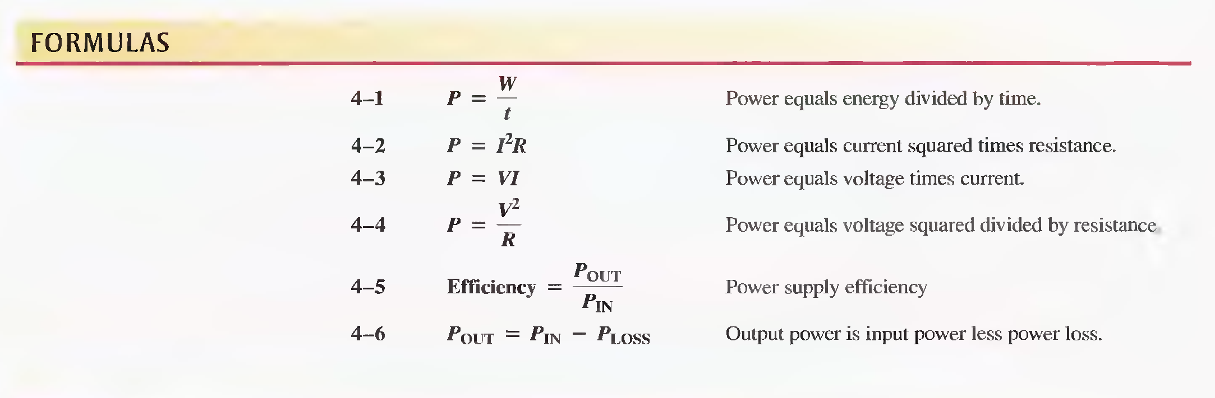

Ch5 Series Circuits

A **series circuit** provides only one path for current between two points so that the current is the same through each series resistor.

**Series Resistor Values Add**

**VOLTAGE SOURCES IN SERIES**

# KIRCHHOFF'S VOLTAGE LAW

1. The sum of all the voltage drops around a single closed path in a circuit is equal to the total source voltage in that loop.
2. The algebraic sum of all the voltages (both source and drops) around a single closed path is zero.

# VOLTAGE DIVIDERS

A circuit consisting of a series string of resistors connected to a voltage source acts as a voltage divider.

**A Potentiometer as an Adjustable Voltage Divider**

Application: The volume control of radio or TV receivers is a common application of a potentiometer used as a voltage divider.

# POWER IN SERIES CIRCUITS

The total amount of power in a series resistive circuit is equal to the sum of the powers in each resistor in series.

# Voltage Measuring

1. Measuring Voltages with Respect to Ground
2. Measuring Voltage Across an Ungrounded Resistor

# Key Terms

**Kirchhoff's voltage law:** A law stating that (1) the sum of the voltage drops around a single closed path equals the source voltage in that loop or (2) the algebraic sum of all the voltages (drops and source) around a single closed path is zero.

**Open:** A circuit condition in which the current path is broken.

**Reference ground:** A method of grounding whereby the metal chassis that houses the assembly or a large conductive area on a printed circuit board is used as the common or reference point.

**Series:** In an electric circuit, a relationship of components in which the components are connected such that they provide a single current path between two points.

**Short:** A circuit condition in which there is a zero or abnormally low resistance path between two points; usually an inadvertent condition.

**Voltage divider:** A circuit consisting of series resistors across which one or more output voltages are taken.

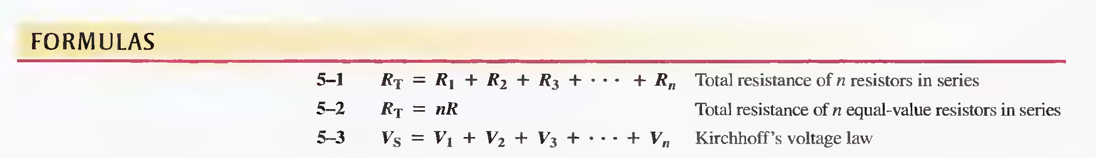

Ch6 Parallel Circuits

Each current path is called a **branch,** and a **parallel circuit** is one that has more than one branch.

**If there is more than one current path (branch) between two separate points and if the voltage between those two points also appears across each of the branches, then there is a parallel circuit between those two points.**

# KIRCHHOFF'S CURRENT LAW

The sum of the currents into a node (total current in) is equal to the sum of the currents out of that node (total current out).

A **node** is any point or junction in a circuit where two or more components are connected.

**CURRENT SOURCES IN PARALLEL**

# CURRENT DIVIDERS

A parallel circuit acts as a current divider because the current entering the junction of parallel branches "divides" up into several individual branch currents.

# POWER IN PARALLEL CIRCUITS

Total power in a parallel circuit is found by adding up the powers of all the individual resistors, the same as for series circuits.

# Key Terms

**Branch:** One current path in a parallel circuit.

**Current divider:** A parallel circuit in which the currents divide inversely proportional to the parallel branch resistances.

**Kirchhoff's current law:** A circuit law stating that the total current into a node equals the total current out of the node. Equivalently, the algebraic sum of all the currents entering and leaving a node is zero.

**­Node:** A point in a circuit at which two or more components are connected; also known as a junction.

**Parallel:** The relationship in electric circuits in which two or more current paths are connected between two separate nodes.

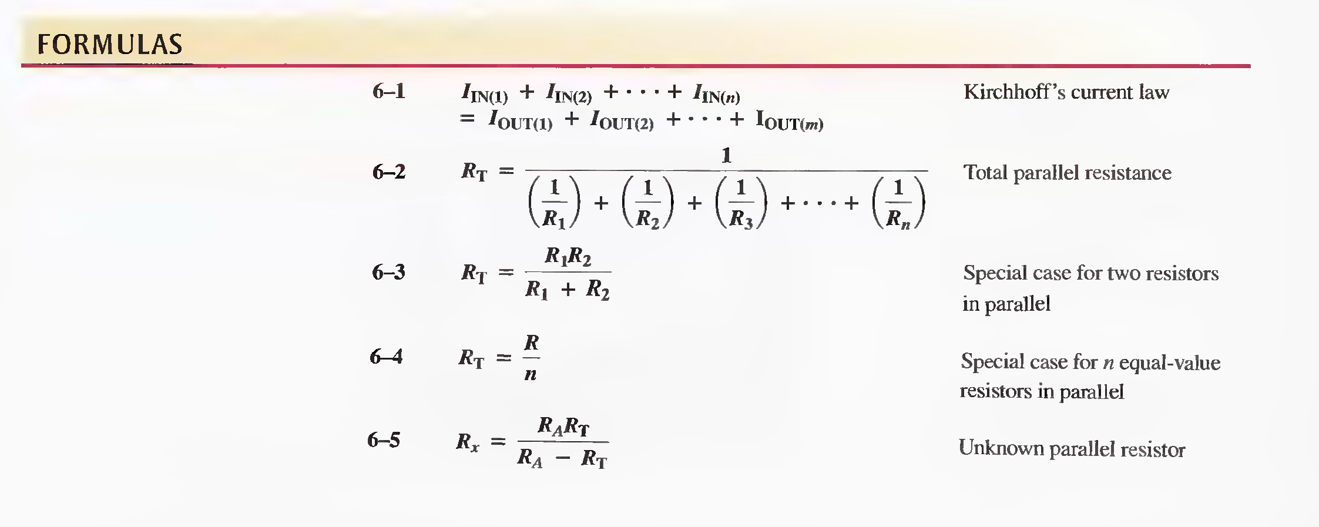 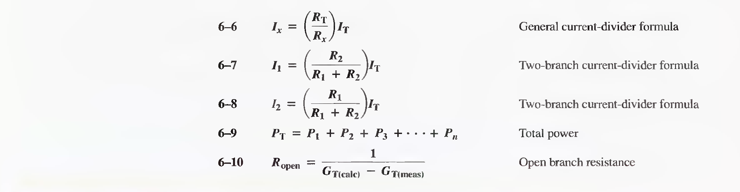

Ch7: Analysis of Series-Parallel Resistive Circuits

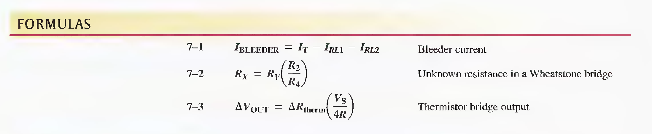

Ch8: CIRCUIT THEOREMS AND CONVERSIONS

# TERMINAL EQUIVALENCY

Equivalency of two sources means that for any given load resistance connected to the two sources, the same load voltage and load current are produced by both sources. This concept is called terminal equivalency.

# SUPERPOSITION THEOREM:

A general statement of the superposition theorem is as follows:

“The current in any given branch of a multiple-source circuit can be found by determining the currents in that particular branch produced by each source acting alone, with all other sources replaced by their internal resistances. The total current in the branch is the algebraic sum of the individual currents in that branch. “

The steps in applying the superposition method are as follows:

Step 1: Leave one voltage (or current) source at a time in the circuit and replace each of the other voltage (or current) sources with its internal resistance. For ideal sources a short represents zero internal resistance and an open represents infinite internal resistance.

Step 2: Determine the particular current (or voltage) that you want just as if there were only one source in the circuit.

Step 3: Take the next source in the circuit and repeat Steps 1 and 2. Do this for each source.

Step 4: To find the actual current in a given branch, algebraically sum the currents due to each individual source. (If the currents are in the same direction, they are added. If the currents are in opposite directions, they are subtracted with the direction of the resulting current the same as the larger of the original quantities.) Once you find the current, you can determine the voltage using Ohm's law.

# THEVENIN THEOREM:

The ***Thevenin equivalent voltage (VTH)*** is the open circuit (no-load) voltage between two output terminals in a circuit.

The ***Thevenin equivalent resistance (RTH )*** is the total resistance appearing between two terminals in a given circuit with all sources replaced by their internal resistances.

Step 1: Open the two terminals (remove any load) between which you want to find the Thevenin equivalent circuit.

Step 2: Determine the voltage (VTH ) across the two open terminals.

Step 3: Determine the resistance (RTH) between the two open terminals with all sources replaced with their internal resistances (ideal voltage sources shorted and ideal current sources opened).

Step 4: Connect VTH and RTH in series to produce the complete Thevenin equivalent for the original circuit.

Step 5: Replace the load removed in Step 1 across the terminals of the Thevenin equivalent circuit. You can now calculate the load current and load voltage using only Ohm's law. They have the same value as the load current and load voltage in the original circuit.

# NORTON THEOREM:

Like Thevenin's theorem, Norton's theorem provides a method of reducing a more complex circuit to a simpler equivalent form. The basic difference is that Norton's theorem results in an equivalent current source in parallel with an equivalent resistance.

***Norton's theorem*** is a method for simplifying a two-terminal linear circuit to an equivalent circuit with only a current source in parallel with a resistor. The form of Norton's equivalent circuit is shown in Figure 8-46.

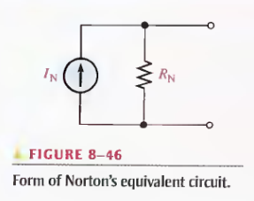

Norton's Equivalent Current (IN):

Norton's equivalent current (IN) is the short-circuit current between two output terminals in a circuit.

## Norton's Equivalent Resistance (RN ):

Norton's equivalent resistance (RN ) is defined in the same way as RTH . The Norton equivalent resistance, RN , is the total resistance appearing between two output terminals in a given circuit with all sources replaced by their internal resistances.

Step 1: Short the two terminals between which you want to find the Norton equivalent circuit.

Step 2: Determine the current (IN) through the shorted terminals.

Step 3: Determine the resistance (RN ) between the two open terminals with all sources replaced with their internal resistances (ideal voltage sources shorted and ideal current sources opened). RN = RTH .

Step 4: Connect IN and RN in parallel to produce the complete Norton equivalent for the original circuit.

# MAXIMUM POWER TRANSFER THEOREM

The ***maximum power transfer theorem*** is stated as follows:

“For a given source voltage, maximum power is transferred from a source to a load when the load resistance is equal to the internal source resistance.”

The source resistance, Rs , of a circuit is the equivalent resistance as viewed from the out- put terminals using Thevenin's theorem. A Thevenin equivalent circuit with its output resistance and load is shown in Figure 8-54. When RL = Rs , the maximum power possible is transferred from the voltage source to RL for a given value of Vs .

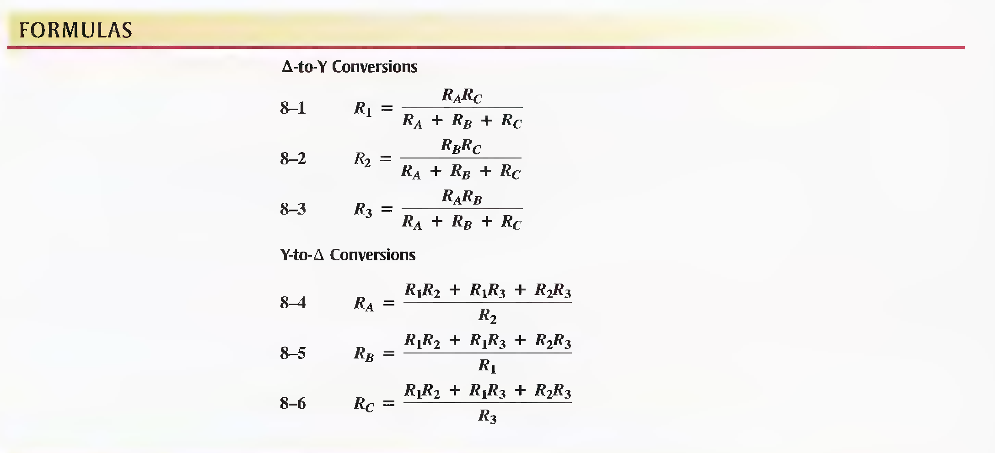

Ch9: BRANCH, LOOP, AND NODE ANALYSES

# BRANCH CURRENT METHOD

The following are the general steps used in applying the branch current method.

Step 1: Assign a current in each circuit branch in an arbitrary direction.

Step 2: Show the polarities of the resistor voltages according to the assigned branch current directions.

Step 3: Apply Kirchhoff's voltage law around each closed loop (algebraic sum of voltages is equal to zero).

Step 4: Apply Kirchhoff's current law at the minimum number of nodes so that all branch currents are included (algebraic sum of currents at a node equals zero).

Step 5: Solve the equations resulting from Steps 3 and 4 for the branch current values.

# Loop CURRENT METHOD

Step 1: Although direction of an assigned loop current is arbitrary, we will assign a Current in the clockwise (CW) direction around each nonredundant closed loop, for consistency. This may not be the actual current direction, but it does not matter. The number of loop-current assignments must be sufficient to include current through all components in the circuit.

Step 2: Indicate the voltage drop polarities in each loop based on the assigned current directions.

Step 3: Apply Kirchhoff's voltage law around each closed loop. When more than one loop current passes through a component, include its voltage drop. This results in one equation for each loop.

Step 4: Using substitution or determinants, solve the resulting equations for the loop currents.

# NODE VOLTAGE METHOD

The general steps for the node voltage method of circuit analysis are as follows:

Step 1: Determine the number of nodes.

Step 2: Select one node as a reference. All voltages will be relative to the reference node. Assign voltage designations to each node where the voltage is unknown.

Step 3: Assign currents at each node where the voltage is unknown, except at the reference node. The directions are arbitrary.

Step 4: Apply Kirchhoff's current law to each node where currents are assigned.

Step 5: Express the current equations in terms of voltages, and solve the equations for the unknown node voltages using Ohm's law.