COAL Fall 2023

Assignment 2

Due Thursday 30 November 2023.

Submit codes executable on Emu8086.

Name: ____________________________ Registration: ________________________________

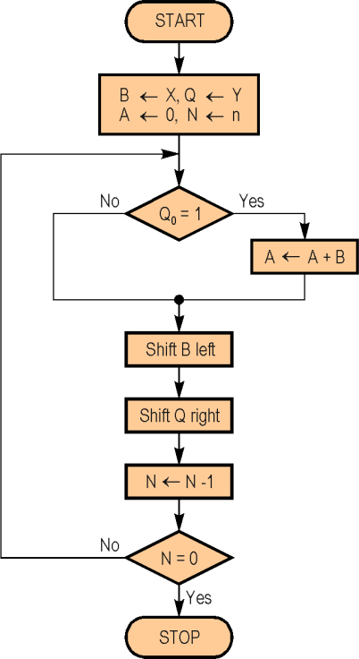

Question#1: Write a program that multiplies two 32-bit numbers using the shift-and-add method given below. The program will store 32-bit multiplicand and multiplier, as well as the 64-bit product in byte arrays.

Shift-and-Add Method

B ← Multiplicand B,

Q ← Multiplier Y,

A←0 initially (product),

N←32

Question#2: Consider your complete registration number declared as a string in memory. You are required to separate the alphabetical characters, hexadecimal numbers, and decimal numbers. These separated data should be stored in separate memory locations.

You can declare your registration number as a string as follows,

Registration db ‘L1F21BSCS1234’

**Try writing a generic program that would do the job for any registration number.**