Introduction to Large Language Models (LLMs) — with RNN Diagrams

1. Introduction
Large Language Models (LLMs) are advanced AI systems used in:
- conversational systems like ChatGPT
- translation engines
- summarization tools
- code assistants
They are fundamentally probabilistic models that predict the next token in a sequence based on context.

2. Tokens: The Foundation
Tokens are the smallest units processed by language models.
Examples:
- “cats” → cat + s
- “unwatched” → un + watch + ed
Key idea: models don’t “see words,” they see tokens.

3. N-Gram Models (Brief Recap)
N-grams predict the next word using the previous 𝑁−1N−1 words.
Example:
- Bigram: “you are”
- Trigram: “you are very”
Limitation: very short memory (limited context)

4. Why We Need Better Models
Language requires understanding long-range dependencies:
“The book that I bought yesterday is interesting.”
To understand “is”, the model must connect it to “book”, not “yesterday”.
N-grams fail here → enter RNNs.

5. Recurrent Neural Networks (RNNs)
RNNs process sequences step-by-step, maintaining a memory (hidden state).

5.1 Basic RNN Architecture
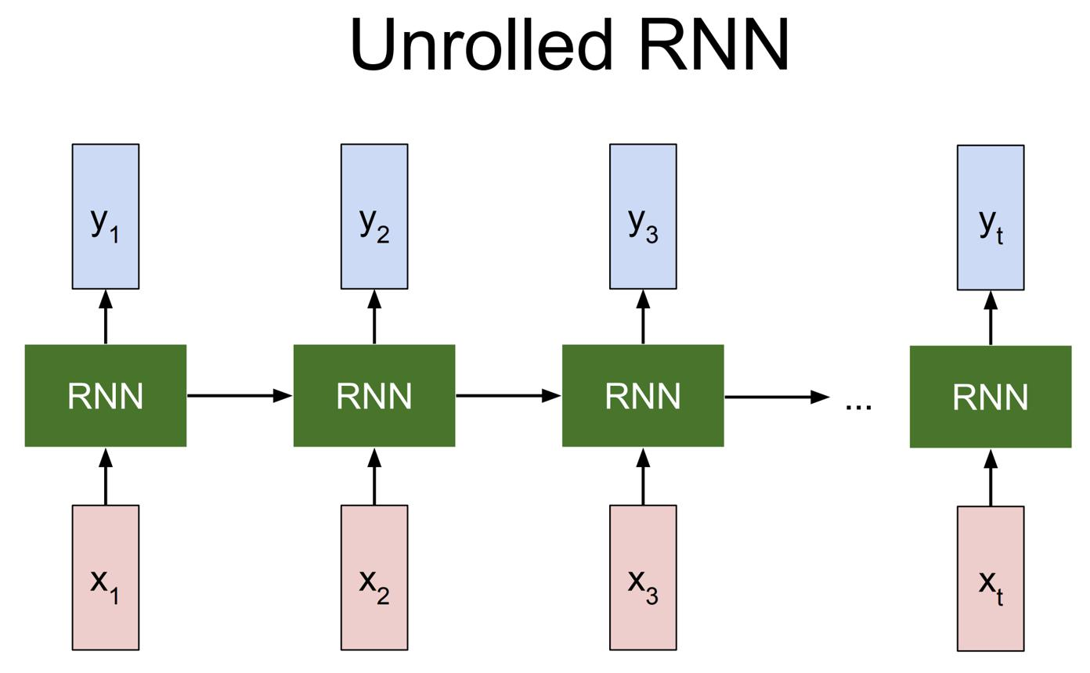
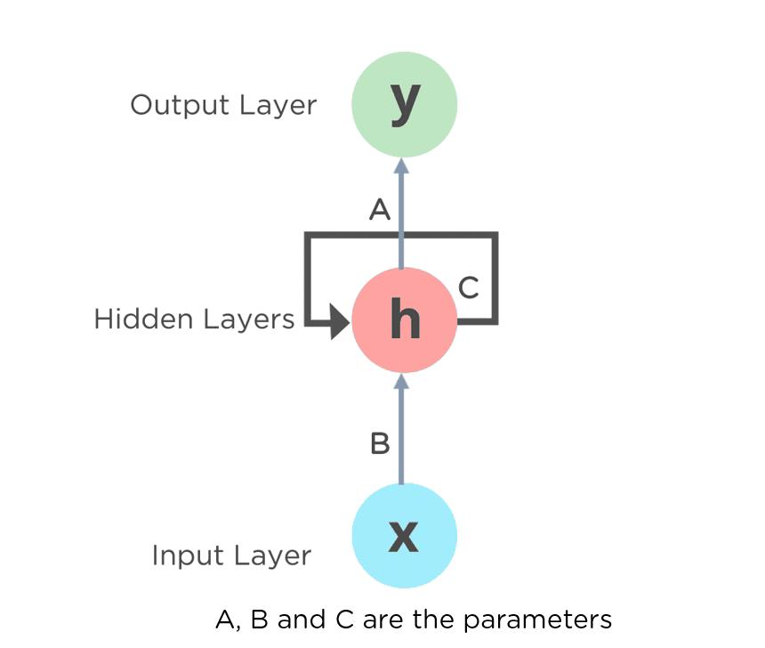
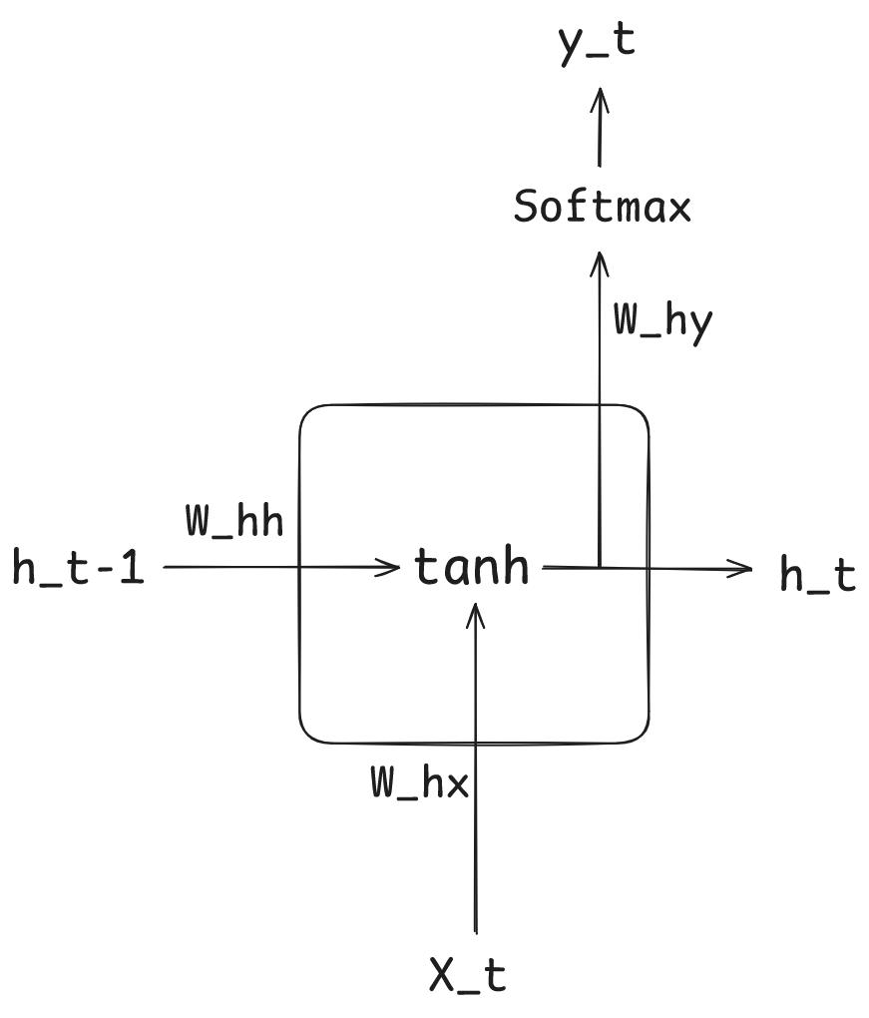
6

Explanation
An RNN can be visualized in two ways:

1. Folded Form (Compact View)
- One cell processes inputs repeatedly

2. Unrolled Form (Time Steps)
- Each step corresponds to a token

Mathematical Formulation
ℎ𝑡=𝑓(ℎ𝑡−1,𝑥𝑡)ht​=f(ht−1​,xt​)
Where:
- 𝑥𝑡xt​: current token
- ℎ𝑡−1ht−1​: previous memory
- ℎ𝑡ht​: updated memory

Intuition
Think of it as:
A running summary of everything seen so far

5.2 RNN Processing Example
Sentence:
“The cat sat on the mat”
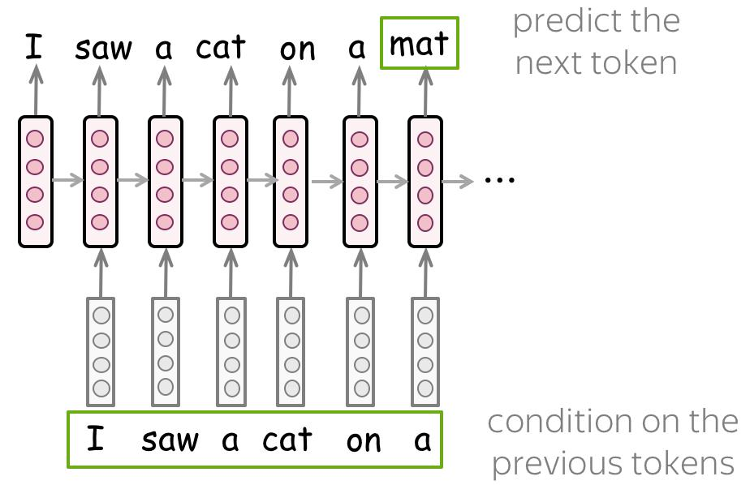
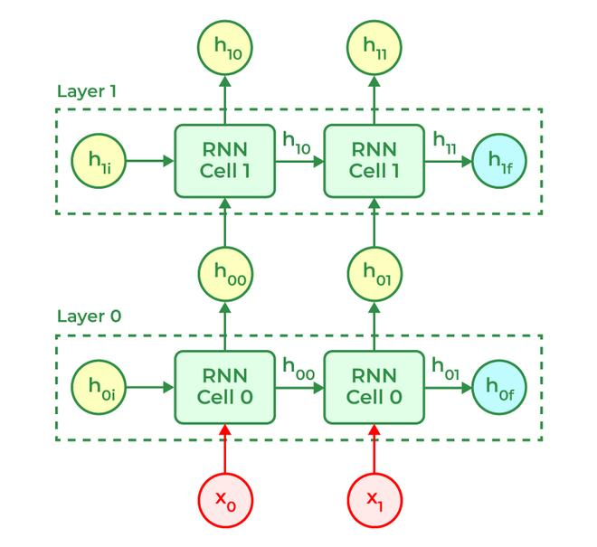
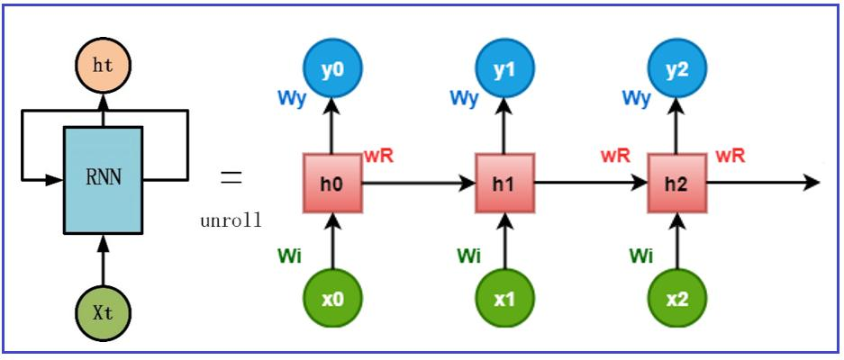
6

Step-by-step:
- Input: “The” → initial memory
- Input: “cat” → memory updated
- Input: “sat” → richer context
- Continues...
Each step refines understanding.

6. Strengths of RNNs
- Captures sequential dependencies
- Works on variable-length input
- Better than N-grams for context

7. Limitations of RNNs

7.1 Vanishing Gradient Problem
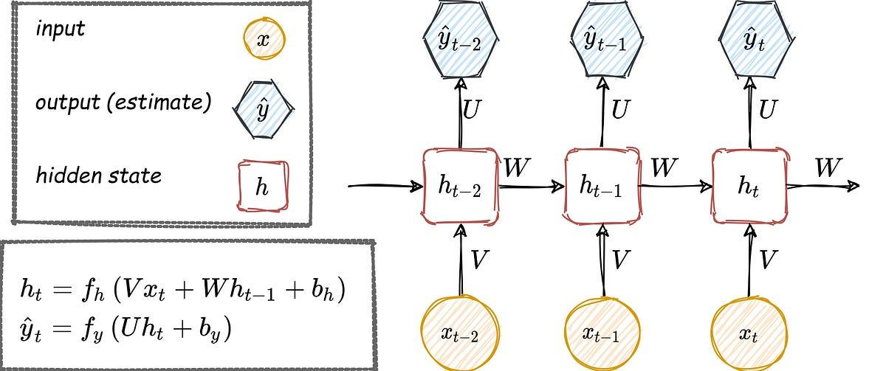
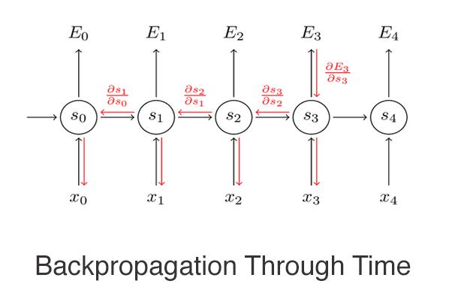
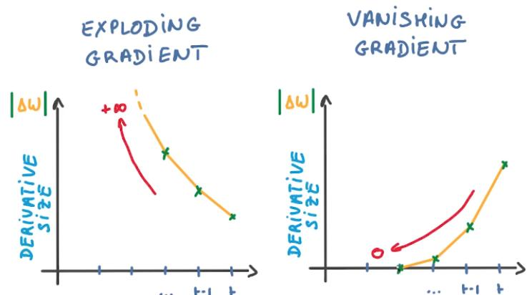
6

Problem
During training:
- Gradients shrink as they propagate backward
- Earlier words lose influence
Result:
- Model forgets long-range dependencies

7.2 Sequential Bottleneck
- Cannot parallelize easily
- Slow training

7.3 Limited Long-Term Memory
Even though RNNs have memory:
- It’s imperfect and unstable

8. Transition to Transformers
To overcome RNN limitations, researchers introduced the Transformer architecture:
- No recurrence
- No sequential bottleneck
- Full context access
Key contributors include Ashish Vaswani.

9. Self-Attention (Core of LLMs)
Unlike RNNs:
- RNN → reads sequentially
- Transformer → reads everything at once
Self-attention allows:
- each word to look at every other word
- dynamic weighting of importance

Example
Sentence:
“The animal didn’t cross the street because it was tired.”
Self-attention identifies:
- “it” → refers to “animal”

10. LLM Training Pipeline

Step 1: Data Collection
- books
- web pages
- articles

Step 2: Tokenization
Convert text → tokens

Step 3: Training Objective
Predict next token:
𝑃(𝑤𝑡∣𝑤1,𝑤2,...,𝑤𝑡−1)P(wt​∣w1​,w2​,...,wt−1​)

Step 4: Optimization
- billions of parameters
- trained via gradient descent
Examples include:
- GPT-4
- BERT

11. Context and Parameters

Context Window
- Defines how much text model can “see”
- Larger = better reasoning

Parameters
- Represent learned knowledge
- More parameters → higher capacity

12. Key Problems with LLMs

1. Hallucination
- Generates plausible but incorrect outputs

2. Bias
- Learns biases from training data

3. Computational Cost
- Expensive to train and deploy

13. Fine-Tuning
Adapts a general model to a specific domain.
Example:
- legal AI
- medical assistant

14. Distillation
Compresses a large model into a smaller one.
Benefits:
- faster
- cheaper
- deployable

15. Final Conceptual Comparison
Model | Context Handling | Speed | Limitation
N-gram | Very low | Fast | Data sparsity
RNN | Medium | Slow | Vanishing gradients
Transformer | High | Fast (parallel) | Expensive

16. Final Takeaway
RNNs were a crucial step toward modern LLMs:
- introduced sequence understanding
- enabled contextual learning
However, their limitations led to transformers, which now dominate AI systems like ChatGPT.

Large Language Models (LLMs) and Transformers — Complete Explanation

1. What is a Large Language Model (LLM)?
A Large Language Model (LLM) is a neural network trained to:
Predict the next token or sequence of tokens given a context
Tokens may be:
- words
- subwords
- characters
Unlike earlier models, LLMs can generate:
- full sentences
- paragraphs
- essays

Why Are LLMs Powerful?
LLMs outperform traditional models like N-grams and RNNs because:

1. Massive Number of Parameters
- Billions to trillions of weights
- Enables learning highly complex patterns

2. Large Context Windows
- Can consider long passages of text
- Improves coherence and reasoning

2. What is a Transformer?
The Transformer is the core architecture behind modern LLMs.
It was introduced by Ashish Vaswani and colleagues.
Transformers are widely used for:
- translation
- text generation
- summarization

Transformer Example: Translation
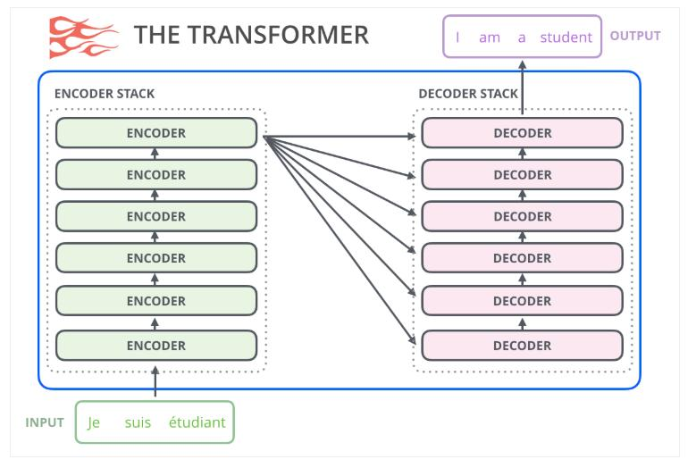
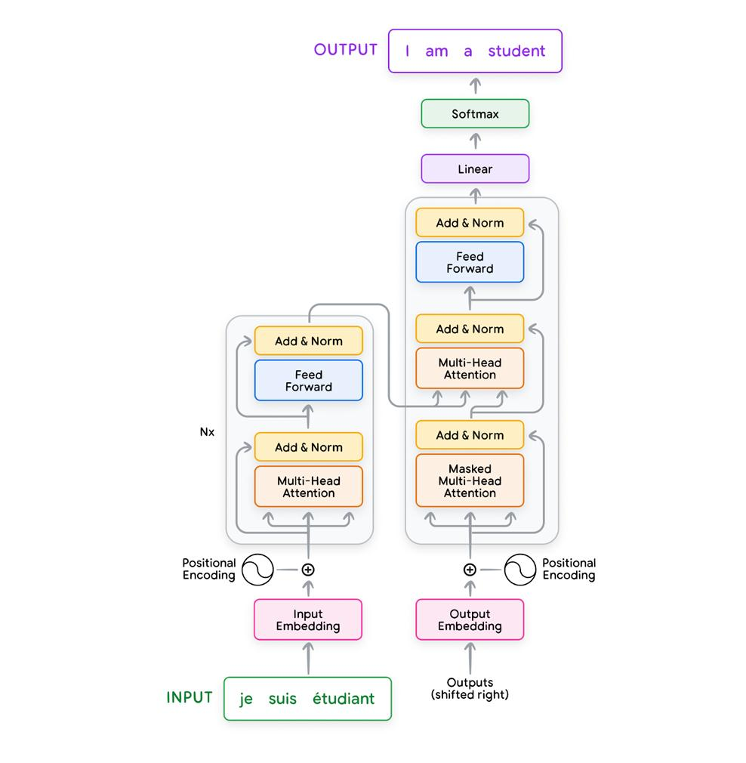
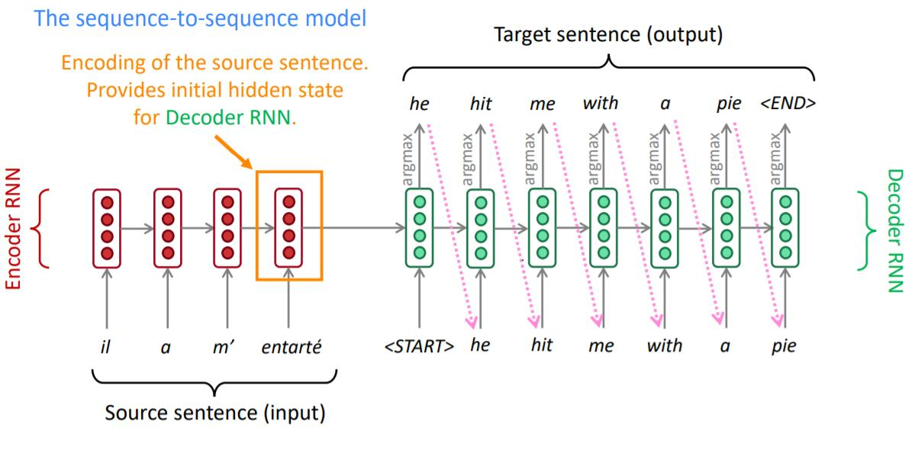
5
Example:
Input:
I am a good dog
Output:
Je suis un bon chien

3. Transformer Architecture
A full Transformer has two main components:

3.1 Encoder
- Takes input text
- Converts it into an intermediate representation
Think of it as:
Understanding the meaning of the sentence

3.2 Decoder
- Takes the encoder’s output
- Generates final text
Think of it as:
Producing the response or translation

Encoder–Decoder Flow
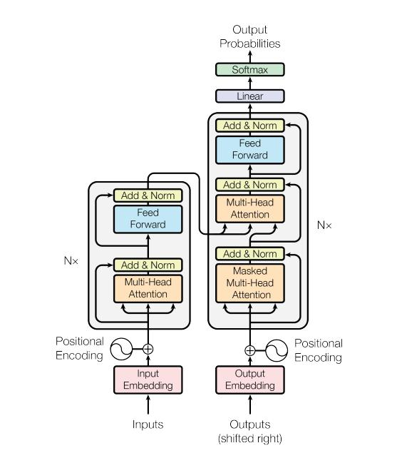
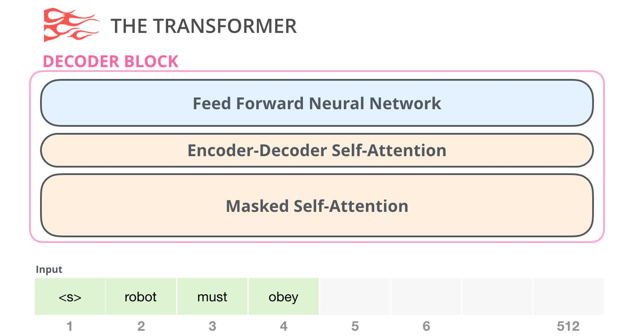
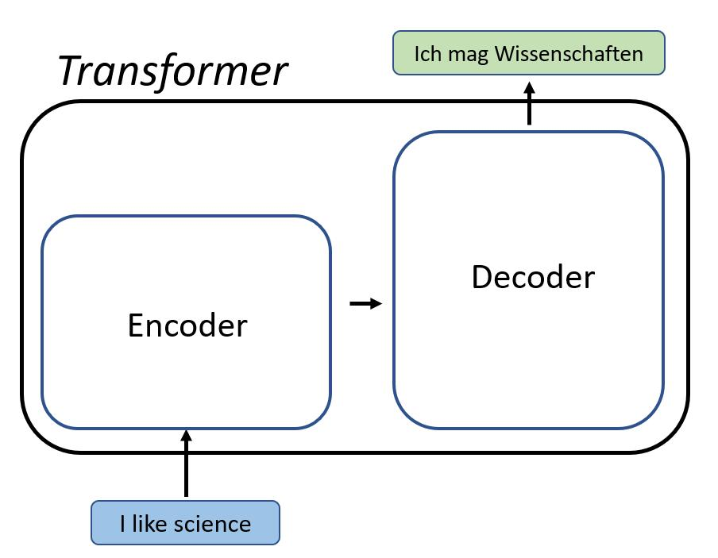

4. Types of Transformer Architectures

4.1 Encoder-Only Models
Examples: BERT
Used for:
- classification
- embeddings
- understanding tasks

4.2 Decoder-Only Models
Examples: GPT-4
Used for:
- text generation
- chat systems
- code generation

4.3 Encoder–Decoder Models
Used for:
- translation
- summarization

5. Self-Attention: The Core Mechanism
Self-attention answers:
“How important is every other word to this word?”

Example Sentence
The animal didn’t cross the street because it was too tired.

Self-Attention Visualization
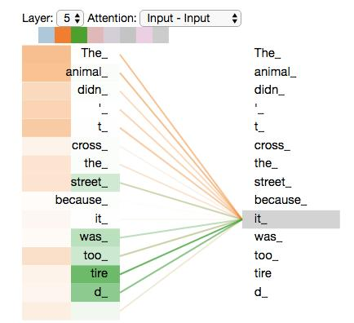

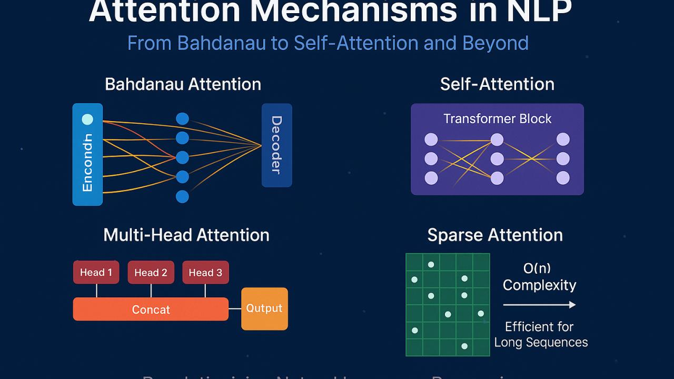
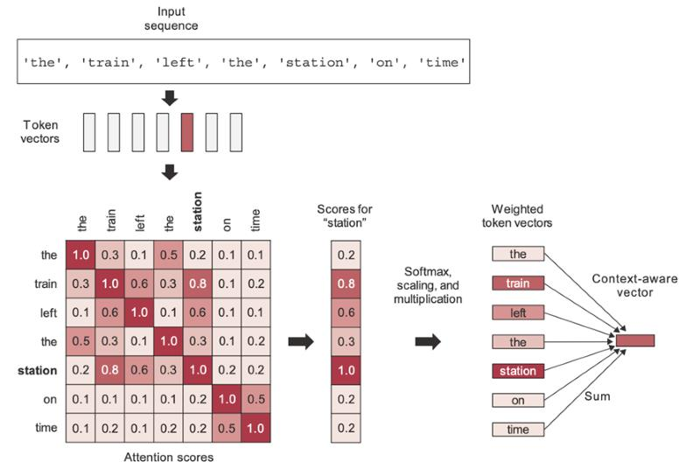
6

Key Insight:
- “it” refers to animal, not street
- The model learns this through attention weights

Bidirectional vs Unidirectional Attention

Bidirectional (Encoder)
- Looks both left and right
- Better for understanding

Unidirectional (Decoder)
- Looks only at past tokens
- Necessary for generation

6. Multi-Head Self-Attention
Instead of a single attention mechanism:
- Transformers use multiple attention heads

Why Multiple Heads?
Each head learns a different relationship:
- grammar
- syntax
- semantics
- pronoun resolution

Conceptual Diagram
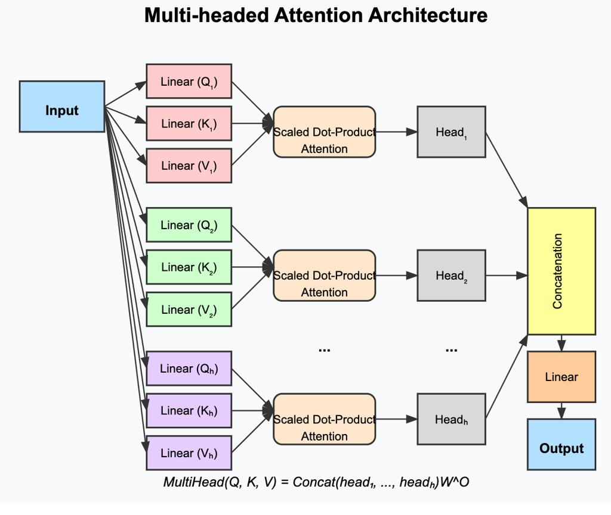
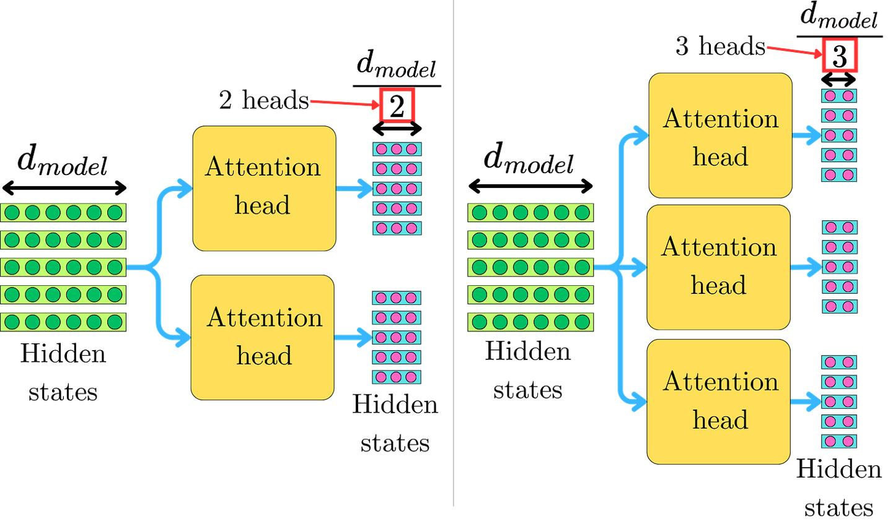
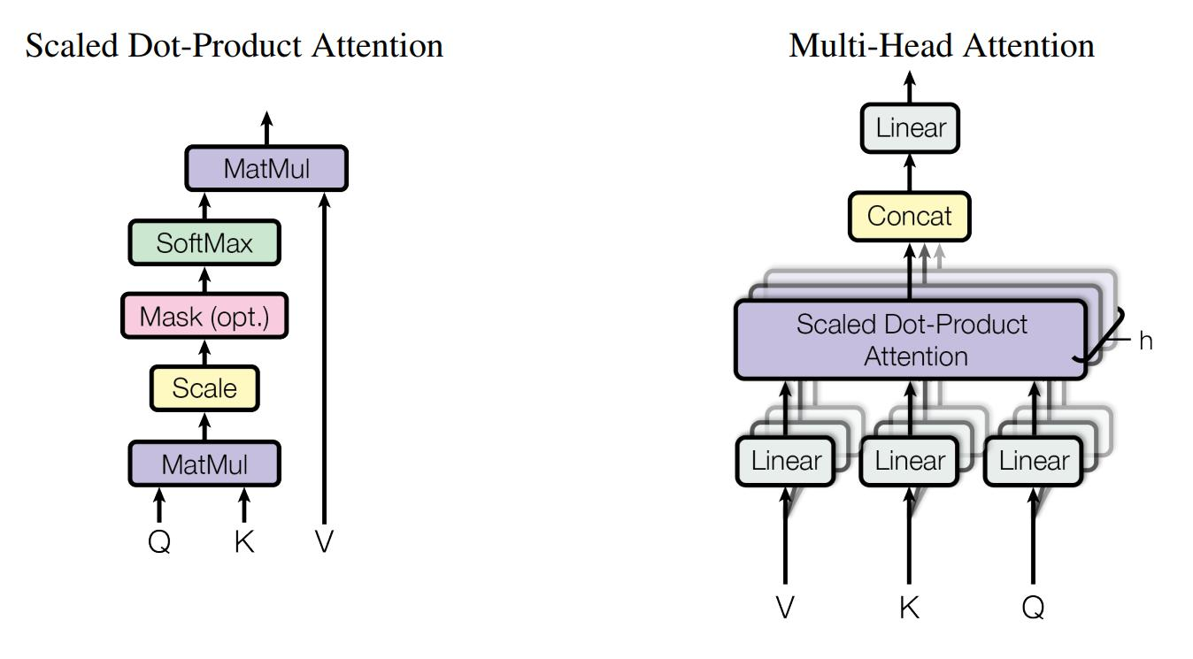
6

Multi-Layer Stacking
Transformers stack multiple layers:
- Early layers → syntax
- Middle layers → relationships
- Deep layers → abstract meaning

7. Computational Complexity
Self-attention compares every token with every other token:
𝑂(𝑁2⋅𝑆⋅𝐷)O(N2⋅S⋅D)
Where:
- 𝑁N = number of tokens
- 𝑆S = number of layers
- 𝐷D = number of heads
This explains why:
- LLMs are computationally expensive
- Scaling is challenging

8. How LLMs Are Trained

8.1 Training Data
- Massive text datasets
- Books, articles, web data

8.2 Masked Training (Self-Supervised Learning)
Example:
Original:
The residents of the sleepy town weren't prepared for what came next.
Masked:
The ___ of the sleepy town weren't prepared for ___ came next.
The model learns by predicting missing tokens.

8.3 Learning Process
- Predictions compared with actual tokens
- Loss computed
- Parameters updated via backpropagation

8.4 Pattern Learning Example
Input:
Oranges are traditionally ___ by hand.
Model learns:
- harvested
- picked

9. Instruction Tuning
After base training:
- Model is further trained on instructions
Example:
- Q&A datasets
- conversational prompts
This improves:
- usability
- alignment with human intent

10. Why Are Transformers So Large?
Modern Transformers have:
- billions or trillions of parameters
Reason:
Larger models consistently perform better
Trade-off:
Advantage | Cost
Higher accuracy | More compute
Better reasoning | More memory
Better generalization | More energy

11. How LLMs Generate Text
LLMs work like advanced autocomplete systems.

Example
Prompt:
What is the easiest trick to teach a dog?
Model predicts:
- likely sequences of tokens
- selects based on probability

Key Idea
LLM = probabilistic text generator
It repeatedly:
- Predicts next token
- Adds it to sequence
- Repeats

12. Benefits of LLMs

1. Natural Language Generation
- Produces fluent, human-like text

2. Versatility
- Works across many tasks

3. Generalization
- Can handle unseen prompts (to some extent)

13. Problems with LLMs

13.1 Hallucination
- Generates incorrect but convincing answers

13.2 Data and Training Cost
- Requires massive datasets
- High energy consumption

13.3 Bias
- Learns biases from training data

13.4 Inference Cost
- Running models is expensive

14. Conceptual Summary

Evolution of Language Models
Stage | Key Idea | Limitation
N-grams | Fixed context | Data sparsity
RNNs | Sequential memory | Vanishing gradients
Transformers | Self-attention | High cost

15. Final Takeaway
A Large Language Model is:
A Transformer-based neural network trained on massive text data to predict and generate tokens using self-attention.
It combines:
- large-scale data
- deep architectures
- probabilistic prediction
to produce:
- coherent language
- contextual understanding
- powerful generative capabilities

16. Key Terms
- Large Language Model (LLM)
- Transformer
- Encoder
- Decoder
- Self-attention
- Multi-head attention
- Parameter
- Hallucination
- Instruction tuning
- Unsupervised learning

Fine-Tuning, Distillation, and Prompt Engineering in LLMs

1. Foundation (Base) LLMs
A foundation LLM (also called base or pre-trained model) is trained on massive text data and learns:
- grammar
- vocabulary
- idioms
- general knowledge
Examples include:
- GPT-4
- BERT

Capabilities of Foundation Models
They can:
- generate fluent text
- answer general questions
- write creative content
However, they are not optimized for specific tasks like:
- classification
- regression
- domain-specific reasoning
Thus, they act as a platform, not a final solution.

2. Fine-Tuning: Adapting Models to Tasks

What is Fine-Tuning?
Fine-tuning is the process of training a pre-trained LLM on task-specific data to improve performance.

Key Idea
Start with a powerful general model → specialize it for a specific application

Example
Suppose you want:
- a legal assistant
- a medical chatbot
- a toxicity classifier
You fine-tune the model using domain-specific examples.

Fine-Tuning Process
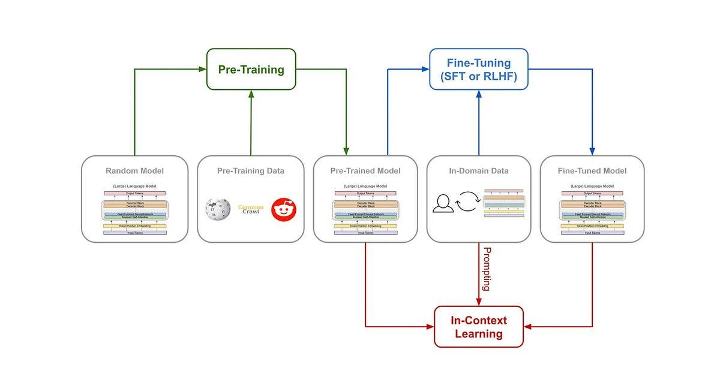
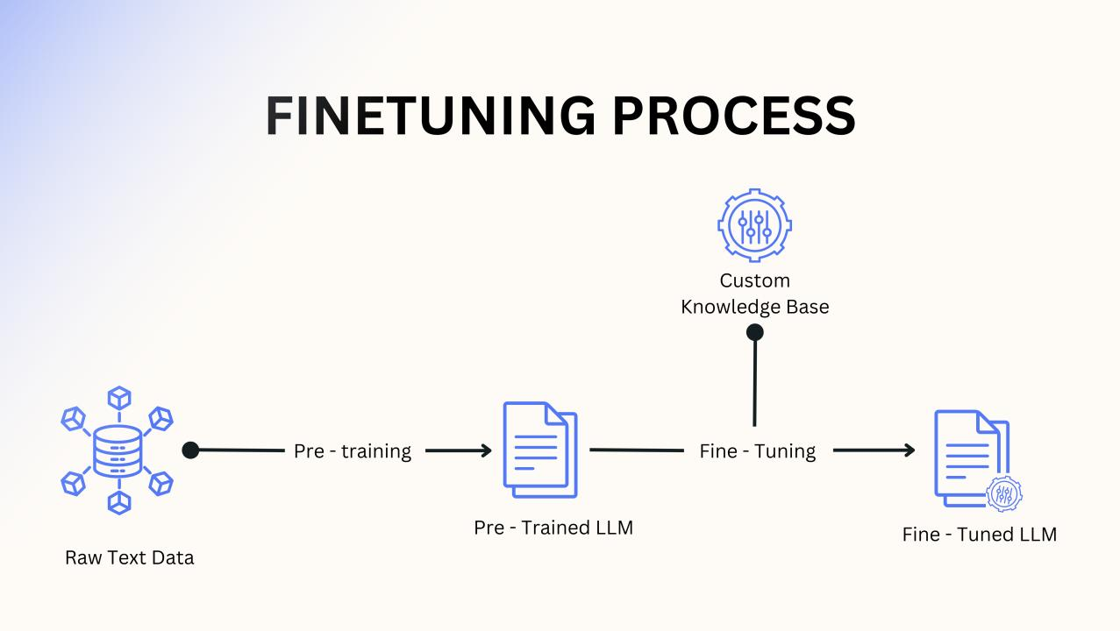
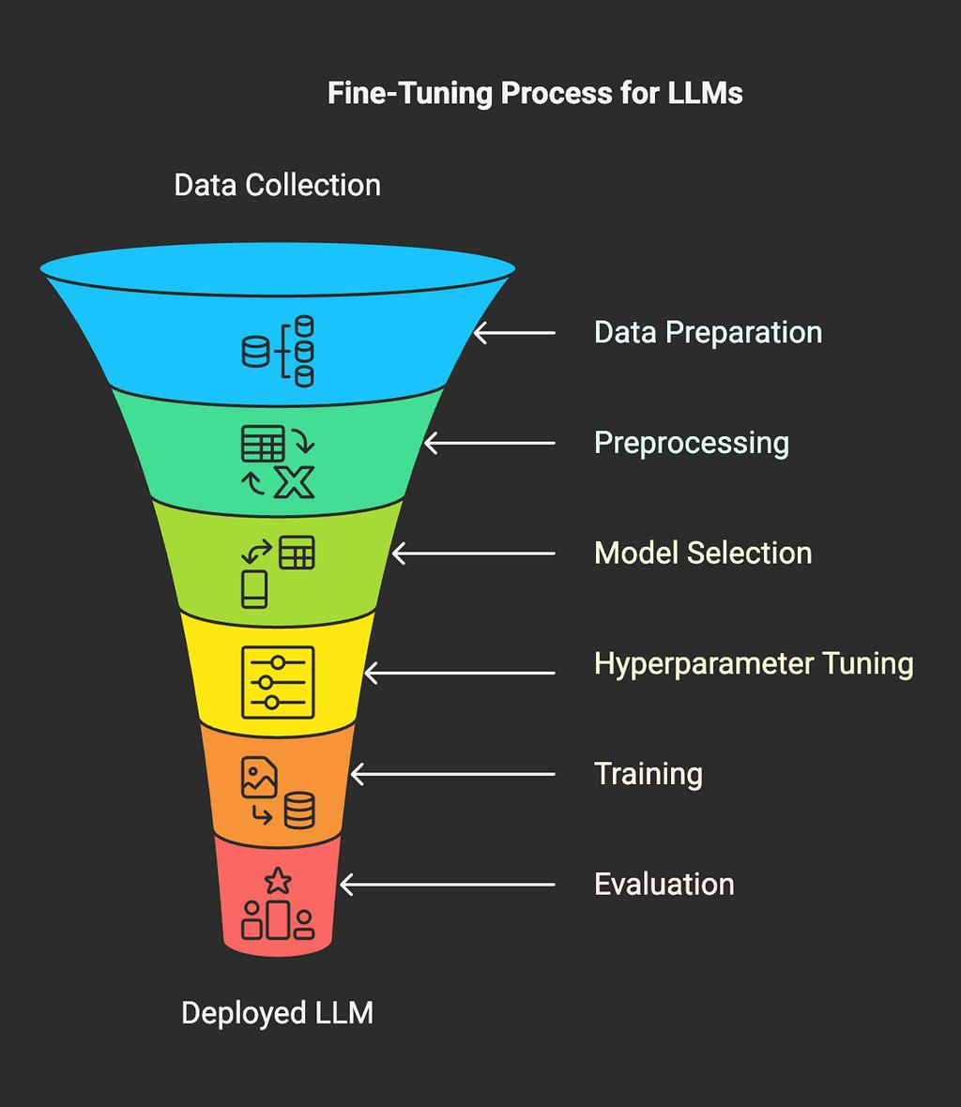
6

Steps:
- Start with foundation LLM
- Provide labeled examples
- Update model parameters via backpropagation
- Obtain specialized model

Important Properties

1. Small Data Requirement
- Sometimes only hundreds or thousands of examples

2. Same Number of Parameters
- A 10B parameter model remains 10B after fine-tuning

3. Better Task Performance
- More accurate predictions for specific tasks

Challenge: Computational Cost
Standard fine-tuning:
- updates all parameters
- requires high compute

Parameter-Efficient Fine-Tuning (PEFT)
Solution:
- update only a subset of parameters
- reduces cost significantly
Examples of PEFT methods:
- adapters
- LoRA (Low-Rank Adaptation)

3. Distillation: Making Models Smaller

What is Distillation?
Distillation transfers knowledge from a large model (teacher) to a smaller model (student).

Core Idea
Large model teaches a smaller, faster model

Distillation Workflow
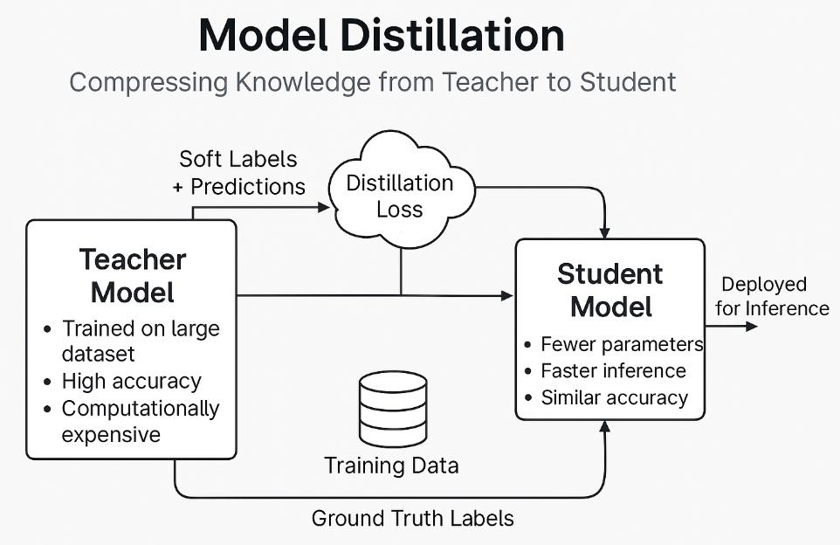
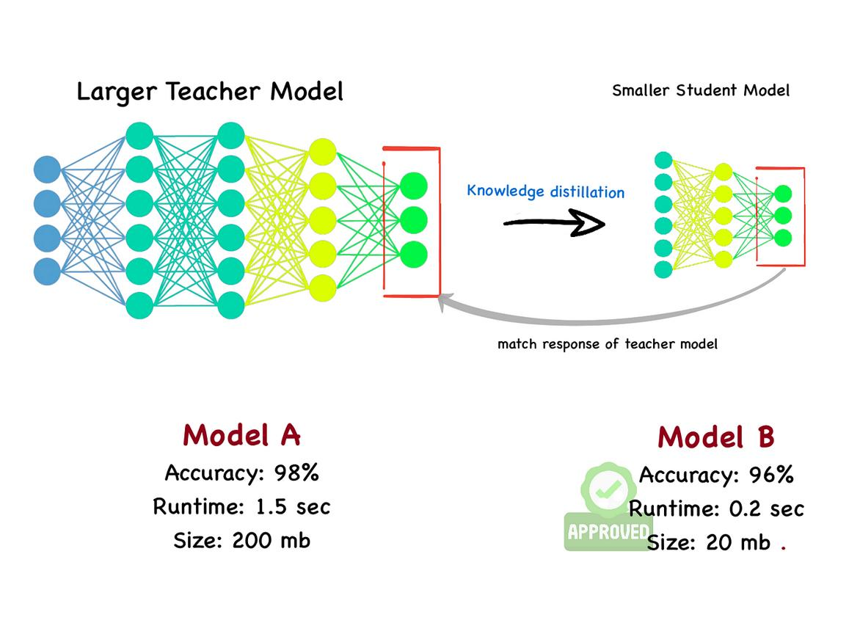
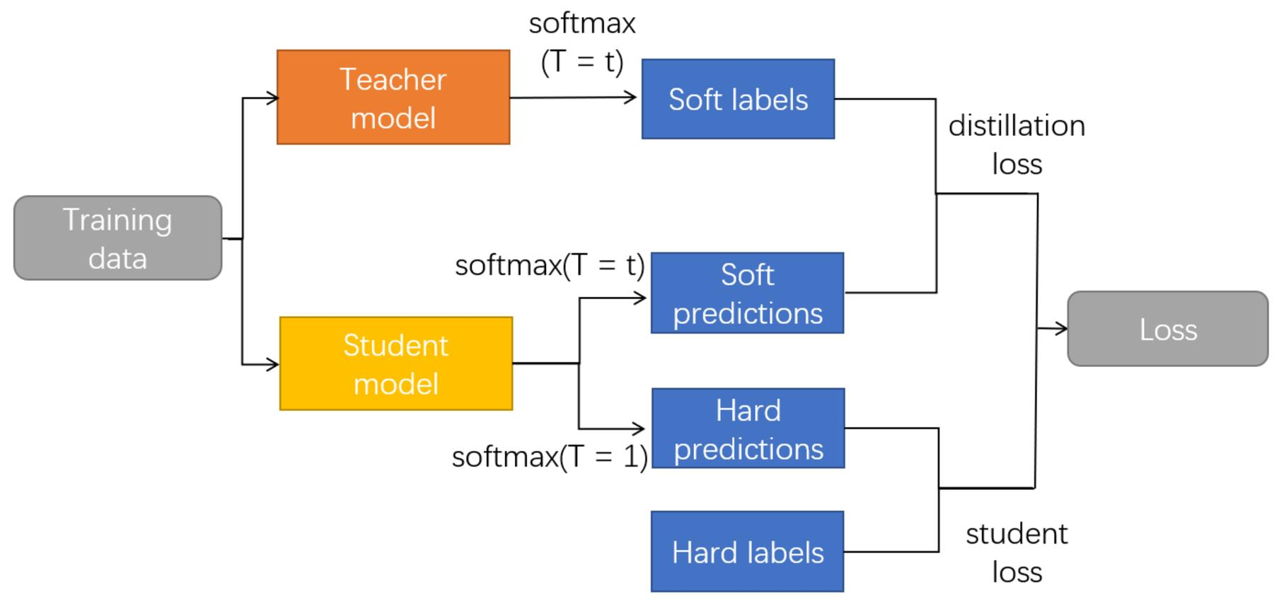

Steps:
- Teacher model generates predictions (labels or probabilities)
- These predictions create a new dataset
- Student model is trained on this dataset
- Student mimics teacher behavior

Example Use Case
Toxicity detection system:
- Large model labels comments offline
- Smaller model serves real-time predictions

Advantages
- Faster inference
- Lower memory usage
- Reduced energy consumption

Trade-Off
Feature | Teacher Model | Student Model
Accuracy | Higher | Slightly lower
Speed | Slower | Faster
Size | Large | Small

Soft Labels vs Hard Labels
Teacher can provide:
- Hard labels (e.g., toxic / not toxic)
- Soft scores (e.g., 0.85 toxicity probability)
Soft labels are better because they:
- provide richer learning signals
- improve student performance

4. Prompt Engineering

What is Prompt Engineering?
Prompt engineering is designing inputs (prompts) to guide an LLM’s output.

Key Idea
You don’t change the model — you change the input

Types of Prompting

4.1 Zero-Shot Prompting
No examples provided.
Example:
apple: ______
Problem:
- ambiguous
- may produce irrelevant output

4.2 One-Shot Prompting
One example provided.
Writing
peach: drupe
apple: ______
Expected output:
pome

4.3 Few-Shot Prompting
Multiple examples provided.
Writing
plum: drupe
pear: pome
lemon: ______

Why Prompting Works
LLMs are trained on patterns.
Providing examples:
- activates learned patterns
- improves output quality

Key Insight
Prompts act like “temporary training” without updating parameters

5. Offline vs Online Inference

Online Inference
- Model responds in real time
- Used in chatbots
Example:
- ChatGPT

Offline Inference (Bulk Inference)
- Predictions generated in advance
- Results cached

Example
Search systems:
- Precompute synonyms
- Store results
- Use instantly during queries

When to Use Offline Inference
- Tasks don’t require real-time updates
- Large models are too slow for live use

6. Responsible Use of LLMs

Bias Sources
LLMs inherit bias from:
- training data
- fine-tuning data
- distillation data

Risks
- unfair outputs
- misleading information
- harmful stereotypes

Best Practices
- audit datasets
- evaluate outputs
- apply fairness constraints

7. Conceptual Comparison

Fine-Tuning vs Distillation vs Prompt Engineering
Technique | Changes Model? | Purpose | Cost
Fine-Tuning | Yes | Specialization | High
Distillation | Yes (new model) | Efficiency | Medium
Prompt Engineering | No | Control output | Low

8. Key Takeaways

Fine-Tuning
- Specializes LLMs
- Improves task accuracy
- Keeps same model size

Distillation
- Reduces model size
- Improves efficiency
- Slightly reduces accuracy

Prompt Engineering
- No retraining required
- Fast and flexible
- Depends on prompt quality

9. Final Summary
A practical LLM system often combines all three:
- Pre-trained model → base knowledge
- Fine-tuning → task specialization
- Distillation → efficiency
- Prompt engineering → runtime control

10. Key Terms
- Fine-tuning
- Distillation
- Prompt engineering
- Zero-shot prompting
- Few-shot prompting
- One-shot prompting
- Offline inference
- Online inference
- Parameter-efficient tuning
- Backpropagation

