M. Umar Shahbaz

21F-9147

6B

GitHub: https://github.com/umar9147/21F-9147_6B_A1

**Web Programming**

**Assignment No 1**

**Task No 1**

<!DOCTYPE html>

<html>

<head>

<title>Task 1</title>

</head>

<body>

<p>Name: <b>M. Umar Shahbaz</b></p>

<br\>

<p>Roll No: <b>21F-9147</b></p>

<br\>

<p>Section: <b>6B</b></p>

<br\><br\>

<p>Computer Science student currently enrolled in</p><br\>

<ul><li>Web Programming</li><li>Artificial Intelligence</li><li>Software Engineering</li><li>PDC</li><li>TBW</li></ul>

<p>Field of Interest: <b>Artificial Intelligence</b></p>

</body>

</html>

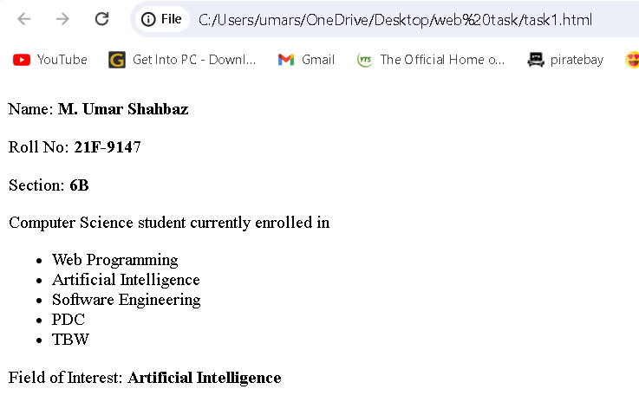

**Task No 2**

<!DOCTYPE html>

<html>

<head>

<title>Task 2</title>

</head>

<body>

<p><b>This text is bold.</b></p><br\>

<p><strong>This text is strong.</strong></p><br\>

<p><Big>This text is big.</Big></p><br\>

<p><i>This text is italic.</i></p><br\>

<p><em>This text is emphasize.</em></p><br\>

<p><output>This is computer output.</output></p><br\>

<p>This is <sub>subcript</sub> and <sup>superscript</sup></p><br\>

</body>

</html>

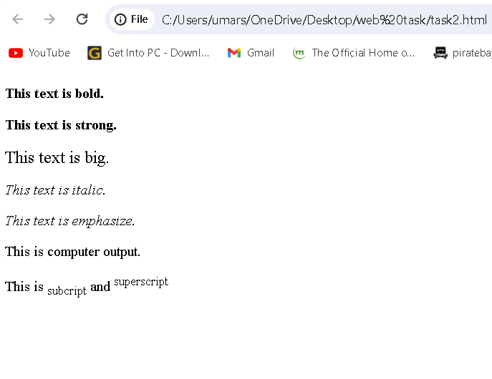

**Task No 3**

<!DOCTYPE html>

<html>

<head>

<title>Task 3</title>

</head>

<body>

<img src="fast_logo.png" alt="Fast-NU" width="1000" height="1000">

</body>

</html>



**Task No 4**

<!DOCTYPE html>

<html>

<head>

<title>Task 4</title>

</head>

<body>

<a href="https://www.nu.edu.pk/" target="_blank"><img src="fast_logo.png" alt="Fast-Nu"></a>

</body>

</html>

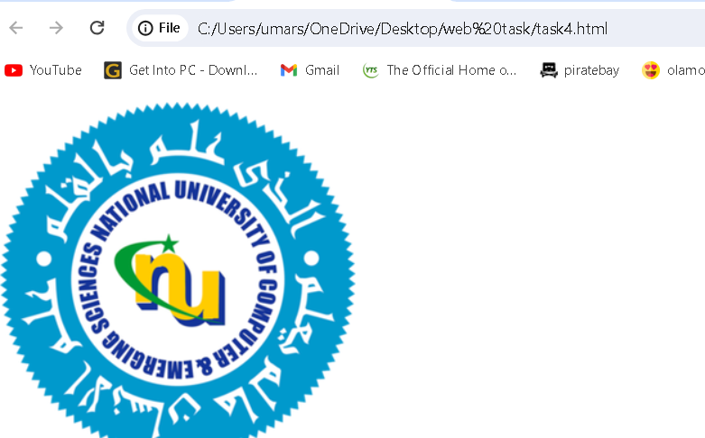

**Task No 5**

<!DOCTYPE html>

<html>

<head>

<title>Task 5</title>

</head>

<body>

<h1>HTML Lists</h1>

<br\>

<h2>Unordered List</h2>

<br\>

<p>We have books on variety of languages.</p><br\>

<ul><li>Oracle</li><li>Java</li><li>HTML</li><li>CSS</li></ul><br\>

<h2>Ordered List</h2><br\>

<p>Follow these steps to install java.</p><br\>

<ol><li>Download the software.</li><li>Extract the folder.</li><li>Double click to executable to run.</li></ol>

</body>

</html>

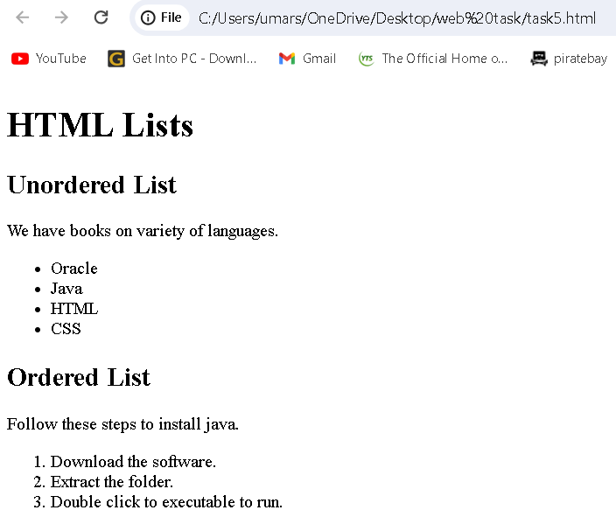

**Task No 6**

<!DOCTYPE html>

<html>

<head>

<title>Task 6</title>

<style>

table {

width: 500px;

height: 200px;

border-collapse: collapse;

}

th, td {

border: 1px solid black;

width: 150px;

height: 50px;

text-align: center;

}

</style>

</head>

<body>

<table>

<tr>

<th rowspan="3">April</th>

<th></th>

<th></th>

</tr>

<tr>

<td></td>

<td></td>

</tr>

<tr>

<td></td>

<td></td>

</tr>

<tr>

<td></td>

<td></td>

<td></td>

</tr>

<tr>

<td></td>

<td></td>

<td></td>

</tr>

</table>

</body>

</html>

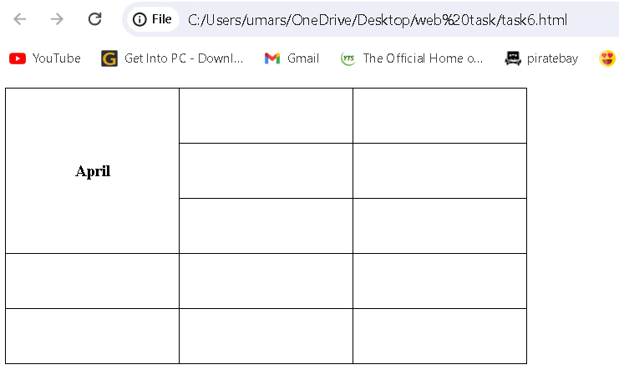

**Task No 7**

<!DOCTYPE html>

<html>

<head>

<title>Task 7</title>

<style>

table {

width: 500px;

height: 200px;

border-collapse: collapse;

}

th, td {

border: 1px solid black;

width: 150px;

height: 50px;

text-align: center;

}

</style>

</head>

<body>

<table>

<tr>

<th colspan="3">2022</th>

</tr>

<tr>

<td></td>

<td></td>

<td></td>

</tr>

<tr">

<td colspan="2" rowspan="2"><b>FIESTA</b></td>

<td></td>

</tr>

<tr>

<td></td>

</tr>

<tr>

<td></td>

<td></td>

<td></td>

</tr>

</table>

</body>

</html>

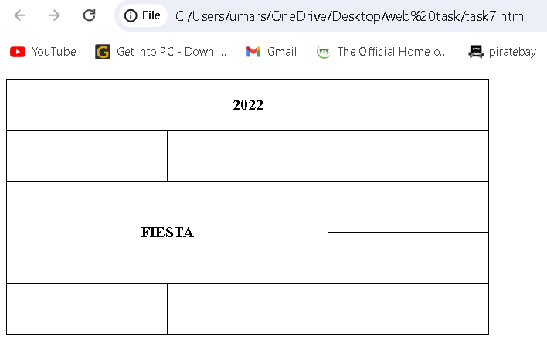

**Task No 8**

<!DOCTYPE html>

<html>

<head>

<title>Task 8</title>

</head>

<body>

<form>

<Label for="username">Username: </Label><br>

<input type="text" id="username" name="username"><br>

<Label for="email">Email: </Label><br>

<input type="text" id="email" name="email"><br>

<Label for="pswd">Password: </Label><br>

<input type="password" id="pswd" name="pswd"><br>

<Label for="c-pswd">Confirm Password: </Label><br>

<input type="password" id="c-pswd" name="c-pswd"><br>

<input type="reset">

<button type="button">Submit</button>

</form>

</body>

</html>

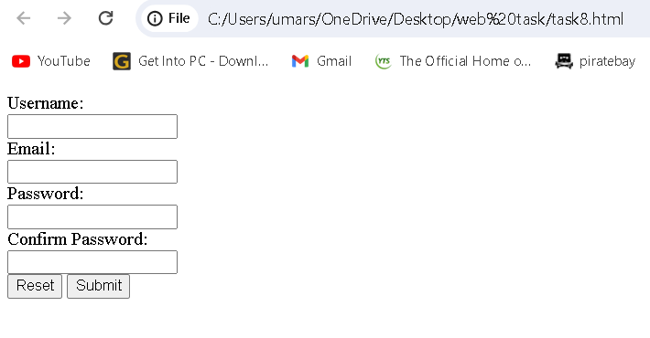

**Task No 9**

<!DOCTYPE html>

<html>

<head>

<style>

.btn {

text-align: center;

}

.heading {

text-align: center;

}

.info {

display: flex;

}

.contact {

width: 50%;

}

.contact1 {

width:50%;

}

.infor {

width: 100%;

box-sizing: border-box;

}

.lbles {

font-weight: bold;

display: inline-block;

width: 30%;

text-align: right;

padding-right: 10px;

box-sizing: border-box;

}

h3 {

margin-bottom: 10px;

}

.delivery_details {

text-align: center;

}

.required_field {

display: flex;

}

.extra {

margin-left:180px;

width: 33.33%;

}

</style>

<title>Task 9</title>

</head>

<body>

<form action="/action_page.php">

<div class="heading">

<h1>Pete's Pizza Delivery</h1>

<h3>Online Order Form</h3>

</div>

<div class="info">

<div class="contact">

<div class="infor">

<div class="lbles">

<label for="username">*Name:</label>

</div>

<input type="text" id="username" name="username"><br><br>

</div>

<div class="infor">

<div class="lbles">

<label>*Address:</label>

</div>

<input type="text"><br><br>

</div>

<div class="infor">

<div class="lbles">

<label>*Town/City:</label>

</div>

<input type="text"><br><br>

</div>

<div class="infor">

<div class="lbles">

<label>*Postcode:</label>

</div>

<input type="text"><br><br>

</div>

</div>

<div class="contact1">

<div class="infor">

<div class="lbles">

<label>*Tel:</label>

</div>

<input type="tel"><br><br>

</div>

<div class="infor">

<div class="lbles">

<label>*Email:</label>

</div>

<input type="email"><br><br>

</div>

</div>

</div>

<div class="heading">

<p><b>*required fields</b></p>

</div>

<div class="required_field">

<div class="extra">

<h3>Topping</h3>

<div>

<input type="radio" name="fav_language">

<label>Margherita</label><br>

<input type="radio" name="fav_language">

<label>Four Seasons</label><br>

<input type="radio" name="fav_language">

<label>Meat Feast</label>

</div>

</div>

<div class="extra">

<h3>Size</h3>

<input type="radio" id="small" name="fav_language" value="small">

<label for="small">Small</label><br>

<input type="radio" id="medium" name="fav_language" value="medium">

<label for="medium">Medium</label><br>

<input type="radio" id="large" name="fav_language" value="large">

<label for="large">Large</label>

</div>

<div class="extra">

<h3>Extras</h3>

<div class="infor">

<input type="checkbox">

<label>Mushrooms</label><br>

<input type="checkbox">

<label>Green peppers</label><br>

<input type="checkbox">

<label>Anchovies</label><br>

<input type="checkbox">

<label>Extra cheese</label><br><br><br>

</div>

</div>

</div>

<div class="delivery_details">

<label>Preffered delivery time: </label>

<input type="time">

<br><br>

<label>Delivery instructions:</label>

<textarea rows='4'></textarea>

</div><br>

<div class="btn">

<button type="submit">Submit Order</button>

</div>

</form>

</body>

</html>

