**M. Umar Shahbaz**

**21F-9147**

**6B**

**GitHub: https://github.com/umar9147/21F-9147_6B_A1_B-Part**

**Web Programming Assignment No 1 Part B**

**Task No 1**

**HTML:**

<!DOCTYPE html>

<html lang="en">

<head>

<meta charset="UTF-8">

<meta name="viewport" content="width=device-width, initial-scale=1.0">

<title>My Webpage</title>

<style>

h1 {

font-size: 36px;

}

</style>

<link rel="stylesheet" href="task1.css">

</head>

<body style = "background-color: blue;">

<div class="shadowstyle">

<h1>Name: M. Umar Shahbaz</h1>

<p>Roll Number: 21F-9147</p>

<p>Brief: Currently study in FAST-Nuces cfd BS(CS) 6th Semester</p>

</div>

</body>

</html>

**CSS:**

.shadowstyle {

box-shadow: 5px 5px 10px rgba(0, 0, 0, 0.5);

}

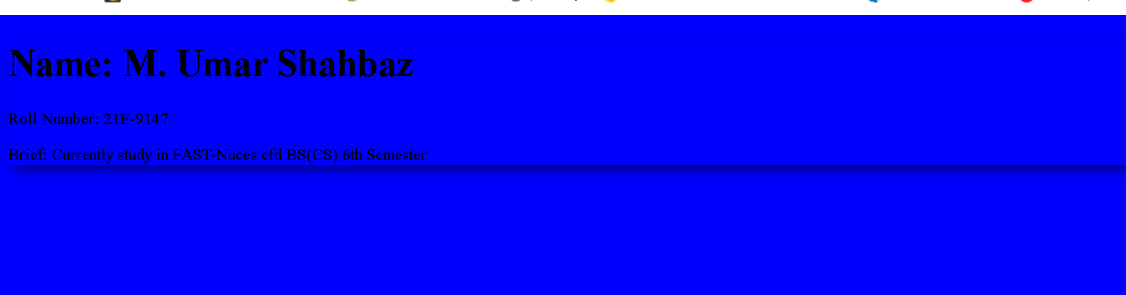

**Task No 2**

**HTML:**

<!DOCTYPE html>

<html lang="en">

<head>

<meta charset="UTF-8">

<meta name="viewport" content="width=device-width, initial-scale=1.0">

<link rel="stylesheet" href="task2.css">

<title>My Webpage</title>

<link rel="stylesheet" href="styling.css">

</head>

<body>

<div class="shadowstyle">

<h1>Start CSS Exercise</h1>

<h4>Good luck!</h4>

</div>

<button id="myButton" class="primaryButton">Start CSS Exercises ></button>

</body>

</html>

**CSS:**

.primaryButton {

background-color: rgb(15, 148, 15);

color: white;

padding: 10px 20px;

border: none;

border-radius: 5px;

cursor: pointer;

}

body {

background-color: rgb(37, 37, 40);

}

h1 {

font-size: 36px;

color: white

}

h4 {

color: white

}

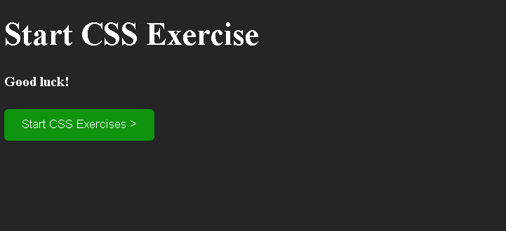

**Task No 3**

**HTML:**

<!DOCTYPE html>

<html>

<head>

<title>Contact Form</title>

<link rel="stylesheet" href="task3.css">

</head>

<body>

<div class="form-container">

<form action="/submit_form" method="post">

<label for="name">Your Name:</label>

<input type="text" id="name" name="name" required>

<label for="email">Your Email:</label>

<input type="email" id="email" name="email" required>

<label for="phone">Your Phone Number:</label>

<input type="tel" id="phone" name="phone" required>

<label for="message">Your Message:</label>

<textarea id="message" name="message" rows="4" required></textarea>

<button type="submit">Submit</button>

<button type="reset">Reset</button>

</form>

</div>

</body>

</html>

**CSS:**

body {

font-family: Arial, sans-serif;

margin: 0;

padding: 0;

}

.form-container {

width: 500px;

margin: 50px auto;

padding: 20px;

background-color: #f9f9f9;

border: 1px solid #ddd;

box-shadow: 0px 0px 10px rgba(0,0,0,0.1);

}

.form-container label {

display: block;

margin-bottom: 5px;

font-weight: bold;

}

.form-container input[type="text"],

.form-container input[type="email"],

.form-container input[type="tel"],

.form-container textarea {

width: 100%;

padding: 10px;

margin-bottom: 10px;

border: 1px solid #ddd;

border-radius: 4px;

box-sizing: border-box;

}

.form-container button[type="submit"] {

background-color: #4CAF50;

color: white;

padding: 10px 20px;

border: none;

border-radius: 4px;

cursor: pointer;

font-weight: bold;

}

.form-container button[type="reset"] {

background-color: #ddd;

color: #333;

padding: 10px 20px;

border: none;

border-radius: 4px;

cursor: pointer;

font-weight: bold;

margin-left: 10px;

}

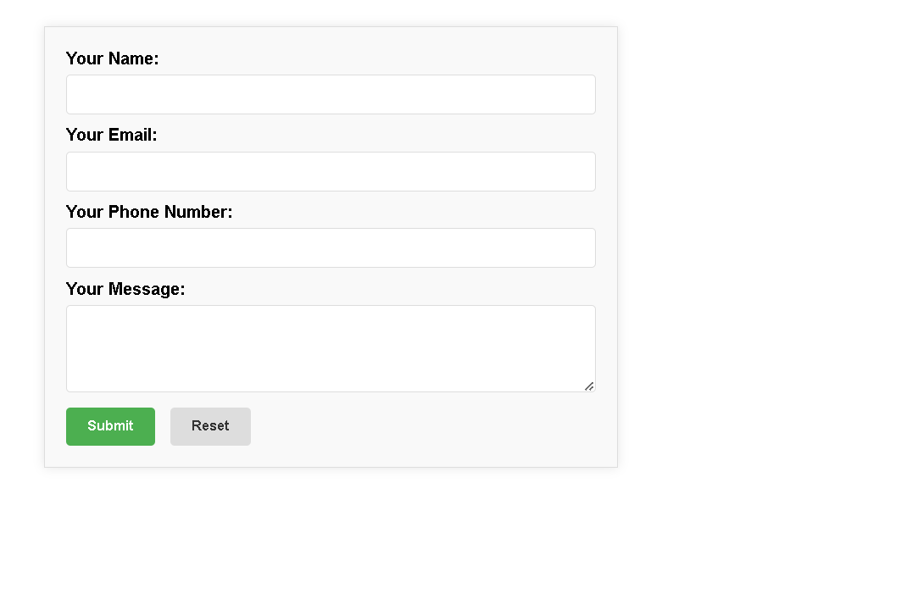

**Task No 4**

**HTML:**

<!DOCTYPE html>

<html>

<head>

<title>Task 4</title>

<link rel="stylesheet" href="task4.css">

</head>

<body>

<div class="polaroid">

<img src="task4-pic.png" alt="Norway" style="width:100%">

<div class="container">

<p>Cnique, Terre</p>

</div>

</div>

</body>

</html>

**CSS:**

div.polaroid {

width: 250px;

box-shadow: 0 4px 8px 0 rgba(0, 0, 0, 0.2), 0 6px 20px 0 rgba(0, 0, 0, 0.19);

text-align: center;

}

.polaroid img{

width: 200px;

height: 150px;

}

div.container {

padding: 2px;

}

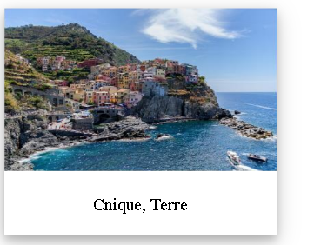

**Task No 5**

**HTML:**

<!DOCTYPE html>

<html>

<head>

<meta charset="utf-8">

<meta http-equiv="X-UA-Compatible" content="IE=edge">

<title></title>

<meta name="description" content="">

<meta name="viewport" content="width=device-width, initial-scale=1">

<link rel="stylesheet" href="task5.css">

</head>

<body>

<header>

<div class="MainHeading">

<div class="name">

<div class="Main">

<h1>M. Umar Shahbaz</h1>

<h2 id="h2AboutMe">Computer Scientist</h2>

</div>

<div class="Info">

<img src="umar.jpg" alt="Umar image">

</div>

</div>

<div id="Links">

<a class="links" href="https://github.com/umar9147" target="_main">

<i class="fa-brands fa-github"></i>

GitHub</a>

<a class="links" href="mailto:umarshahbaz237@gmail.com" target="_main">

<i class="fa-regular fa-envelope"></i>

umarshahbaz237@gmail.com</a>

<a class="links" id="end-link" href="https://pk.linkedin.com/" target="_main">

<i class="fa-brands fa-linkedin"></i>

LinkedIn</a>

</div>

</div>

<div class="About_Me">

<h1>About Me</h1>

<p>I am Passionate Computer Scientist</p>

<p>Currently, I am studying Computer Science at FAST-NU</p>

</div>

<div class="About_Me">

<h1>Personal Information</h1>

<ul>

<li><b>Date of Birth :</b> July 23, 2002 </li>

<li><b>Nationality :</b> Pakistan</li>

<li><b>Address :</b> Sahiwal, Rafi Gardens</li>

<li><b>Email :</b> umarshahbaz237@gmail.com</li>

<li><b>Phone Number :</b> 0308-8310480</li>

</ul>

</div>

<div class="About_Me">

<h1>Education</h1>

<ul>

<li><b>Degree:</b> Computer Science</li>

<li><b>Institution:</b> FAST NUCES</li>

<li><b>Graduation Year:</b> 2025</li>

</ul>

</div>

<div class="About_Me">

<h1>My Projects</h1>

<h3>Project 1</h3>

<p>Library Managment System (Database Integrated).</p>

<a href="https://github.com/umar9147/Windows-Form-Applications" target="_main"><button class="button" style="vertical-align:middle"><span>View Details</span></button></a>

<h3>Project 2</h3>

<p>Text Editor (Give suggestion of words & compress the file by using Huffman algorithm)</p>

<a href="https://github.com/umar9147/Data-Structures/commit/d88509c6be9f4ad833f255e1ab4bddf2364f54bd" target="_blank"><button class="button" style="vertical-align:middle"><span>View Details</span></button></a>

</div>

<div class="About_Me">

<h1>Skills</h1>

<ul>

<li>C++/C#/Python</li>

<li>Databases</li>

<li>Web Programming</li>

</ul>

</div>

<div class="end">

<p>Contact me at umarshahbaz237@gmail.com</p>

</div>

</header>

<section>

</section>

</body>

</html>

**CSS:**

body{

font-family: Arial, Helvetica, sans-serif;

}

.MainHeading {

background-color: lightslategray;

color: #fff;

display: flex;

flex-direction: column;

justify-content: space-between;

align-items: center;

border-width: 10px;

height: 265px;

}

.end{

background-color: lightslategray;

color: #fff;

display: flex;

flex-direction: column;

justify-content: space-between;

align-items: center;

border-width: 10px;

height: 100px;

}

#h2AboutMe{

margin-left: 20px;

}

.name{

display: flex;

justify-content: center;

gap:15px;

}

.Info{

padding-top: 20px;

}

.Main{

display:flex;

flex-direction: column;

}

.Info img{

width: 120px;

height: 150px;

object-fit: cover;

border: 5px solid lightgray;

border-radius: 10%;

}

#Links{

display: flex;

gap:10px;

}

body{

background-color: whitesmoke;

}

.About_Me{

box-shadow: 0 8px 16px 0 rgba(0,0,0,0.2), 0 6px 20px 0 rgba(0,0,0,0.19);

border-radius: 5px;

padding-left: 20px;

margin: 15px;

padding: 10px;

}

.About_Me {

transition: all 0.4s ease;

}

.button {

display: inline-block;

border-radius: 4px;

background-color: blue;

border: solid 1px;

border-color: blue;

color: #FFFFFF;

font-size: 12px;

padding: 20px;

width: 120px;

transition: all 0.5s;

cursor: pointer;

padding-bottom: 100;

}

.button span {

cursor: pointer;

display: inline-block;

position: relative;

transition: 0.5s;

}

.button span:after {

content: '\00bb';

position: absolute;

opacity: 0;

top: 0;

right: -20px;

transition: 0.5s;

}

.button:hover span {

padding-right: 8px;

}

.button:hover span:after {

opacity: 1;

right: 0;

}

.About_Me:hover {

transform: scale(1.025);

}

.About_Me h1 {

font-size: 24px;

}

.About_Me p {

font-size: 16px;

}

.links{

color: lightcyan;

text-decoration: none;

}

#Links{

padding-right: 40px;

}

.div2 {

background-color: green;

margin-top: 10px;

}

