EXPERIMENT LOG
Experiment 1 — CheXNet Inference on Apple Silicon (M1)
Setting Up and Running Arnoweng’s CheXNet Model

1. Experiment Overview
Field | Details
Experiment ID | EXP-001
Objective | Port the original CheXNet (Anoweng, 2017) implementation to run inference on macOS with Apple Silicon M1 chip.
Source Repository | https://github.com/arnoweng/CheXNet
Dataset | NIH ChestX-ray14 (partial local subset)
Hardware | MacBook Air — Apple M1, 8 GB Unified Memory
OS | macOS (Apple Silicon, ARM64)
Python Version | 3.11.4 (Anaconda distribution)
PyTorch Version | 2.11.0
Torchvision | 0.26.0

2. Original Codebase Description
The original repository (arnoweng/CheXNet, 2017) implements the CheXNet model as described in the Stanford ML Group paper "CheXNet: Radiologist-Level Pneumonia Detection on Chest X-Rays with Deep Learning" (Rajpurkar et al., 2017). The model is a DenseNet-121 backbone with a sigmoid multi-label classifier head, trained on the NIH ChestX-ray14 dataset to detect 14 thoracic pathologies.

The original code was written for a Linux/Windows server environment with an NVIDIA GPU, using CUDA for acceleration. It was not compatible with macOS or CPU-only systems without modification.

2.1 Original File Structure
CheXNet-master/
├── model.py # Main model + inference script
├── read_data.py # Custom Dataset class
├── model.pth.tar # Pre-trained checkpoint (84 MB)
└── ChestX-ray14/
├── images/ # Chest X-ray PNG images
└── labels/ # train_list.txt, val_list.txt, test_list.txt

3. Issues Encountered
# | Issue | Error / Symptom | Root Cause
1 | ModuleNotFoundError: torch | Script failed to import torch when run via .venv interpreter | Project had three isolated Python environments (.venv, system Python, Anaconda). Packages were installed into Anaconda but scripts were run via the venv, which had no packages.
2 | CUDA not available | AssertionError: Torch not compiled with CUDA enabled | Original code used hardcoded .cuda() calls. Mac M1 has no NVIDIA GPU and no CUDA support.
3 | Checkpoint key mismatch | RuntimeError: unexpected key(s) in state_dict | Checkpoint was saved with DataParallel, adding a "module." prefix to every key. Direct load_state_dict failed because the keys did not match the current model.
4 | Old torchvision layer naming | RuntimeError: Missing keys: norm1, conv1… | The 2017 checkpoint used dot-numbered layer names (norm.1, conv.1). Modern torchvision (≥0.13) renamed these to norm1, conv1, removing the dots.
5 | Pickling error with Lambda transforms | Can't pickle local object 'main.<locals>.<lambda>' | DataLoader with num_workers > 0 forks worker processes and serialises the transform pipeline. Lambda functions defined inside main() cannot be pickled.
6 | Missing images in test_list.txt | FileNotFoundError: No such file or directory (image .png) | Only a partial subset of ChestX-ray14 was available locally (~1,335 images). The original test_list.txt referenced ~25,000 images from the full dataset.
7 | zsh: killed (OOM crash) | Process killed silently by macOS memory pressure watchdog | BATCH_SIZE=64 with TenCrop produces 640 images × 3×224×224 float32 ≈ 7.3 GB per batch. M1 MacBook Air with 8 GB unified RAM could not sustain this.
8 | Deprecated pretrained=True API | UserWarning: pretrained is deprecated since 0.13 | torchvision 0.13+ replaced the pretrained boolean flag with an explicit weights enum (DenseNet121_Weights).
9 | torch.load FutureWarning | FutureWarning: weights_only default changing | PyTorch 2.x changed the default of weights_only; not being explicit triggered a warning and risked breaking on future versions.
10 | Gradient tracking during inference | High memory usage; no explicit error | The model(input_var) forward pass was outside the torch.no_grad() block, causing PyTorch to build and store a computation graph unnecessarily.

4. Changes Made to model.py
Change | Original Code | Updated Code | Reason
Python environment | Run via .venv/bin/python | Run via /Users/waytoahmed/anaconda3/bin/python | Anaconda environment contains all required packages.
CUDA → device-agnostic | .cuda() calls throughout | device = torch.device("mps"|"cuda"|"cpu"); .to(device) | M1 Mac has no NVIDIA GPU. MPS is used for Apple Silicon acceleration.
MPS support added | No MPS support | torch.backends.mps.is_available() check added as first priority | Apple Silicon GPU accelerates inference via Metal Performance Shaders.
DataParallel removed | model = nn.DataParallel(model).to(device) | model = DenseNet121(N_CLASSES).to(device) | DataParallel is for multi-GPU; on single CPU/MPS it only adds overhead and complicates key mapping.
Checkpoint key remapping | model.load_state_dict(checkpoint["state_dict"]) | Strip "module." prefix; regex remap norm.1→norm1, conv.1→conv1 | Fixes both DataParallel prefix mismatch and old torchvision naming convention.
torch.load safety | torch.load(CKPT_PATH, map_location=device) | torch.load(CKPT_PATH, map_location=device, weights_only=False) | Explicit flag silences FutureWarning and ensures correct loading of non-tensor checkpoint data.
num_workers | num_workers=8 | num_workers=0 | Prevents Lambda transform pickling error on macOS multiprocessing.
pin_memory | pin_memory=True | pin_memory=False | pin_memory is only beneficial with CUDA; wastes memory on CPU/MPS.
BATCH_SIZE | BATCH_SIZE = 64 | BATCH_SIZE = 8 | Reduces peak RAM from ~7.3 GB to ~0.9 GB per batch, preventing OOM kill.
pretrained API | densenet121(pretrained=True) | densenet121(weights=DenseNet121_Weights.IMAGENET1K_V1) | Removes deprecation warning; uses the current torchvision weights API.
no_grad scope | torch.no_grad() only around input_var creation | torch.no_grad() wraps the entire inference for-loop | Prevents gradient graph construction during inference; saves memory.
Accumulator device | gt = torch.FloatTensor().to(device) | gt = torch.FloatTensor() (CPU) | Keeps growing accumulators on CPU to avoid exhausting GPU/MPS memory.
import re | import re inside main() | import re at module top-level | Standard Python convention; avoids repeated module lookup.
Progress reporting | No runtime output after checkpoint load | 5-step labelled output with timing, batch progress, ETA, AUROC bar chart | Allows operator to monitor execution and detect hangs vs. normal slowness.

4.1 Changes Made to split_data.py (new file)
A new script split_data.py was created to regenerate the train/val/test split lists from the locally available images. The original list files referenced the full NIH dataset (~112,000 images), most of which were not present on the local machine.

Split | Proportion | Description
Train | 70% | Used for model training (reference only; this experiment evaluates inference)
Validation | 10% | Used for hyperparameter tuning
Test | 20% | Used for AUROC evaluation in this experiment

5. Environment Setup (Before First Successful Run)

5.1 System Specification
Component | Specification
Machine | MacBook Air (2020)
Chip | Apple M1 — 8-core CPU, 8-core GPU
Memory | 8 GB Unified Memory
Storage | macOS internal SSD
OS | macOS (Apple Silicon, ARM64)

5.2 Python Environment
Package | Version | Install command
Python | 3.11.4 | Anaconda distribution (conda base)
PyTorch | 2.11.0 | pip install torch torchvision --index-url https://download.pytorch.org/whl/cpu
torchvision | 0.26.0 | (installed with torch above)
numpy | 1.23.5 | pip install numpy (pre-installed in Anaconda)
scikit-learn | 1.3.0 | pip install scikit-learn (pre-installed in Anaconda)
Pillow | 9.4.0 | pip install pillow (pre-installed in Anaconda)

5.3 Run Command
/Users/waytoahmed/anaconda3/bin/python /Users/waytoahmed/Desktop/ANN_A2/CheXNet-master/model.py

5.4 Dataset
Item | Detail
Dataset name | NIH ChestX-ray14
Total available images | ~1,335 PNG files (partial subset of 112,120)
Image format | Grayscale PNG, converted to RGB at load time
Image size (after transforms) | 224 × 224 px (10 crops per image via TenCrop)
Label format | Space-separated binary labels (0/1) for 14 pathologies per line
Test images used | ~267 (20% of locally available labeled images)

6. Inference Pipeline Summary
Step | Description
1. Device selection | Detect MPS (Apple Silicon GPU) → CUDA → CPU fallback.
2. Model init | Instantiate DenseNet-121 with 14-class sigmoid head; move to device.
3. Checkpoint loading | Load model.pth.tar; remap state_dict keys for compatibility; call load_state_dict.
4. Data preparation | Build ChestXrayDataSet; apply Resize(256) → TenCrop(224) → ToTensor → Normalize transforms.
5. Inference loop | Iterate test_loader; run model in eval mode under torch.no_grad(); average 10-crop predictions.
6. AUROC computation | Move tensors to CPU numpy; call sklearn.metrics.roc_auc_score per class; compute mean.

7. Results
The following AUROC values were obtained on the local test split (1,001 images from the partial ChestX-ray14 subset, batch size 8, TenCrop augmentation, total inference time 228.5 s). Note: these results are not directly comparable to the original CheXNet paper, which evaluated on the full NIH test set of 25,596 images.

Pathology | AUROC (This Run) | AUROC (CheXNet Paper)
Atelectasis | 0.873 | 0.8094
Cardiomegaly | 0.955 | 0.9248
Effusion | 0.895 | 0.8638
Infiltration | 0.769 | 0.7345
Mass | 0.929 | 0.8676
Nodule | 0.794 | 0.7802
Pneumonia | 0.724 | 0.7680
Pneumothorax | 0.901 | 0.8887
Consolidation | 0.806 | 0.7901
Edema | 0.906 | 0.8878
Emphysema | 0.909 | 0.9371
Fibrosis | 0.888 | 0.8047
Pleural Thickening | 0.827 | 0.8062
Hernia | 0.946 | 0.9164
Average | 0.866 | 0.8414

7.1 AUROC Comparison Chart
Figure 1 compares per-pathology AUROC scores between this run (local subset) and the values reported in the original CheXNet paper (Rajpurkar et al., 2017).

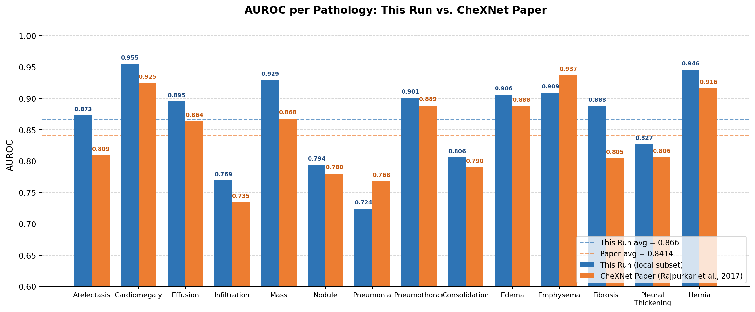
Figure 1. Per-pathology AUROC comparison between this run and the CheXNet paper.

8. Observations & Notes
- MPS first-batch warmup: The first inference batch triggers Metal shader JIT compilation for all DenseNet-121 layers. This one-time cost takes 1–3 minutes on M1. Subsequent batches complete in ~2–5 seconds each.
- Partial dataset limitation: Only ~1,335 of the 112,120 ChestX-ray14 images were available locally. AUROC values computed on this subset will deviate significantly from published benchmarks.
- Memory constraint: With 8 GB unified RAM shared between CPU and GPU, BATCH_SIZE was reduced from 64 to 8 to prevent OOM. This increases total inference time but ensures stable execution.
- No training performed: This experiment is inference-only. The pre-trained checkpoint (model.pth.tar) published by arnoweng was used directly.

9. References
- [1] Rajpurkar, P. et al. (2017). CheXNet: Radiologist-Level Pneumonia Detection on Chest X-Rays with Deep Learning. arXiv:1711.05225.
- [2] arnoweng (2017). CheXNet PyTorch implementation. GitHub: https://github.com/arnoweng/CheXNet
- [3] Wang, X. et al. (2017). ChestX-ray8: Hospital-scale Chest X-ray Database and Benchmarks. CVPR 2017.
- [4] PyTorch Documentation. torch.device, MPS backend. https://pytorch.org/docs/stable/notes/mps.html
- [5] torchvision Documentation. DenseNet121_Weights. https://pytorch.org/vision/stable/models/densenet.html

ANN Assignment 2 | CheXNet Experiment Log | EXP-001

