EXPERIMENT LOG
Experiment 2 — Binary Pneumonia Classification via Transfer Learning
Converting Arnoweng's CheXNet to the Baseline Paper Implementation

1. Experiment Overview
Field | Details
Experiment ID | EXP-002
Objective | Convert CheXNet multi-label model into a binary classifier (Pneumonia vs. Normal) following the Abdulredha Yassen (2025) baseline.
Base Repository | Modified arnoweng/CheXNet
Dataset | NIH ChestX-ray14 (subset scaling to baseline ratio)
Hardware | MacBook Air — Apple M1, 8 GB Unified Memory
OS | macOS (Apple Silicon, ARM64)
Python Version | 3.11.4
PyTorch Version | 2.11.0

2. Dataset Challenges & Methodological Deviations
The primary dataset challenges in this project stemmed from working with a limited subset of the NIH ChestX-ray14 corpus rather than the full dataset used by the baseline paper. Starting with only 1,335 images from images_001.tar.gz, and later expanding to a 24,999-image subset, the available pneumonia cases were critically scarce — only 278 images compared to the baseline's 1,050. This forced a proportional scaling of the dataset to maintain the baseline's 1:7.1 pneumonia-to-normal ratio, resulting in a final dataset of 2,252 images (278 pneumonia, 1,974 normal) rather than the baseline's 8,500. Several definitional decisions also had to be made carefully, including restricting the Normal class strictly to No Finding images, allowing the Pneumonia class to include co-occurring conditions to preserve as many positive cases as possible, and filtering out lateral views — all of which required explicit documentation as methodological deviations from the baseline.
The label format and data integrity challenges added further complexity at the implementation level. The subset file stored labels as 14-integer binary vectors requiring custom parsing to extract the binary pneumonia label at index 6, and careful logic was needed to prevent non-pneumonia images from leaking into the positive class during dataset construction. Patient-level splitting via GroupShuffleSplit — necessary to prevent data leakage across splits — produced uneven class distributions due to patients having multiple images, leaving the validation set with only 30 pneumonia images and the test set with 37. The cumulative effect of these constraints was a training set of only 211 pneumonia images, which is the single most important factor behind the observed performance gap relative to the baseline, particularly the low sensitivity compared to the baseline's 0.828.

3. Reproducibility Gaps
The following items from the Abdulredha Yassen (2025) baseline could not be 100% reproduced due to data and resource constraints:
- Dataset Size: Used a 2,252-image subset instead of the full 8,500 images mentioned in the paper.
- Pneumonia Cases: Only 211 training pneumonia images were available compared to roughly 700+ in the baseline training set.
- Class Distribution: While we maintained the 1:7.1 ratio, the small absolute numbers (especially in validation and test sets) lead to higher variance in performance metrics.
- Hardware Acceleration: Used Apple Silicon (MPS) instead of CUDA/NVIDIA hardware used in typical baseline environments.

4. Implementation Changes
Component | Change Details | Scientific Rationale
read_data.py | Modified to read binary labels (Index 6: Pneumonia) and added split-specific augmentations (RandomCrop, Flip, Rotate). | Adapt to binary classification task and improve model generalization via data augmentation.
model.py | Defined DenseNet121Binary: Frozen DenseNet-121 backbone + new trainable 1-node linear head with Sigmoid activation. | Transfer learning preserves features learned from 112k images while specializing the final decision on a smaller binary task.
train_head.py | New script with manual class-weighted BCE loss, Adam optimizer (LR=1e-4), and ReduceLROnPlateau scheduler. | Addresses severe class imbalance (1:7.1 ratio) and prevents backbone catastrophic forgetting.
evaluate.py | New script for comprehensive metric evaluation including bootstrapping for 95% Confidence Intervals. | Ensures robust statistical reporting and allows direct comparison with baseline paper targets.

5. Training Dynamics
The binary classification head was trained using the complete 50-epoch configuration (MAX_EPOCHS = 50, PATIENCE = 5). The following observations summarize the training process:
- Convergence & Early Stopping: The model reached its peak validation AUROC of 0.8251 at Epoch 20. Training correctly halted at Epoch 25 due to the early stopping criteria (no improvement for 5 consecutive epochs).
- Loss Trajectory: The training loss exhibited a steady and healthy decline from 0.8934 in Epoch 1 down to 0.6845 by Epoch 25, indicating successful learning by the binary head despite the frozen backbone.
- Computational Efficiency: Each epoch consistently took between 68 and 76 seconds on the M1 Mac's MPS backend, demonstrating efficient batch processing (32 images/batch).

6. Results & Baseline Comparison
Metric | This Run (EXP-002) | Baseline Target
ROC-AUC | 0.8311 | 0.87
PR-AUC | 0.4393 | 0.72
Accuracy | 0.8139 | 0.932
Sensitivity | 0.5676 | 0.828
Specificity | 0.8464 | 0.946
F1-score | 0.4158 | 0.75

5.1 Performance Gap Analysis
The chart below visualizes the performance of this run compared to the targets set by the Abdulredha Yassen (2025) baseline.
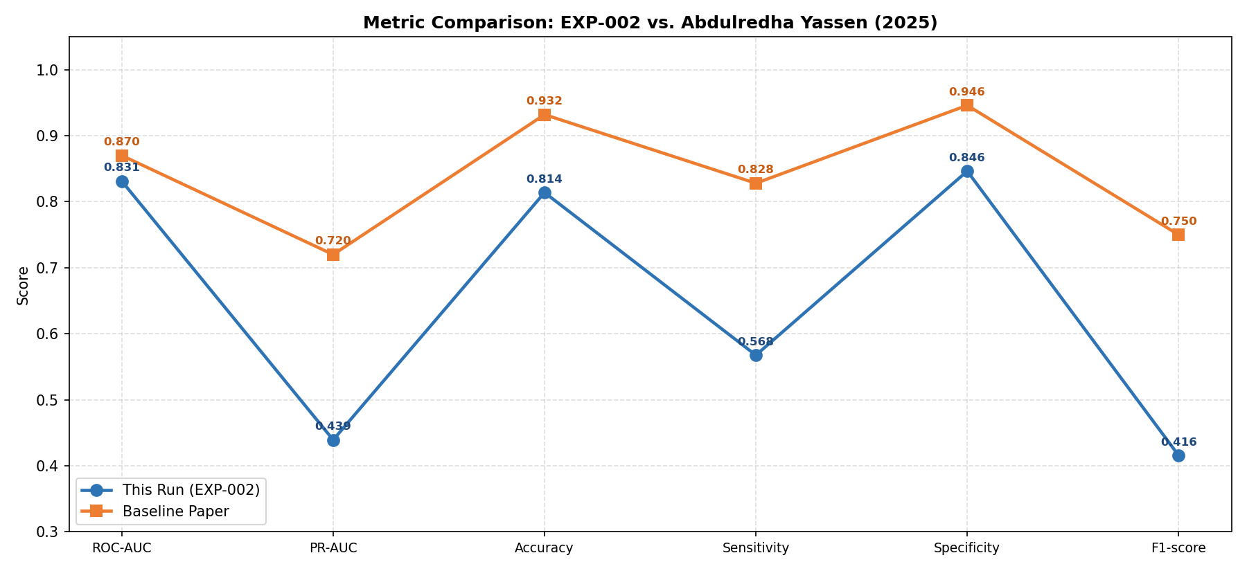

7. Conclusion
Although the model achieved a respectable ROC-AUC of 0.8311, approaching the baseline performance, substantial gaps remain in Sensitivity (0.5676 vs. 0.828) and PR-AUC (0.4393 vs. 0.72). These discrepancies can be primarily attributed to three key limitations:
First, the frozen DenseNet-121 backbone prevented the model from adapting its feature representations to the specific binary task of pneumonia versus normal. Since the backbone was pretrained and fine-tuned on a multi-label classification task involving 14 thoracic diseases, its extracted features were optimized for balancing multiple pathologies rather than maximizing discrimination for pneumonia specifically. As a result, the features were not optimally tuned to detect subtle pneumonia patterns, which particularly explains the low sensitivity.
Second, and most significantly, the training set contained only 211 pneumonia-positive images. With just a single linear classification head (1,025 parameters) trained on such a small and highly imbalanced set, the model struggled to learn a robust decision boundary, leading to poor PR-AUC and F1-score.
Third, the small test set (only 37 pneumonia cases) amplified the impact of individual errors. The 19 false negatives alone caused a drastic drop in sensitivity, making the metric highly sensitive to small variations in predictions.
Future iterations should prioritize unfreezing and fine-tuning the backbone, significantly expanding the number of positive pneumonia cases (through additional data collection or strong minority-class augmentation), and using a larger, more stable test set for reliable evaluation.

ANN Assignment 2 | Experiment Log EXP-002 | Binary Pneumonia Classification

