
SUBMITTED BY: HAZRAT UMAR, HAIDER UD DIN, MUHAMMAD KASHIF
SUBMITTED TO: Ms FAYAL ASHFAQ
CLASS: BSSE 2023-C
SUBJECT: SOFTAWRE DESIGN AND ARCHITECTURE
ROLL NO: 4309,4257,4381
SEMESTER: 5TH
SOFTWARE ENGINEERING

DATE: 06/02/2026

PROJECT: EXPLANABLE ai for mental health

CODE AND OUTPUT

Code:

import pandas as pd
import numpy as np
from typing import Tuple, Dict
from sklearn.preprocessing import StandardScaler

class DataPreprocessor:
"""
Simple data preprocessing pipeline for mental health datasets.
Handles missing values, outliers, normalization, and feature engineering.
"""

def __init__(self):
"""Initialize the preprocessor with standard scaler."""
self.scaler = StandardScaler()
self.fitted = False

def handle_missing_values(self, data: pd.DataFrame, strategy: str = 'mean') -> pd.DataFrame:
"""
Handle missing values in the dataset.

Args:
data: Input dataframe
strategy: 'mean', 'median', or 'drop'

Returns:
Dataframe with missing values handled
"""
if strategy == 'mean':
return data.fillna(data.mean())
elif strategy == 'median':
return data.fillna(data.median())
elif strategy == 'drop':
return data.dropna()
else:
raise ValueError(f"Unknown strategy: {strategy}")

def remove_outliers(self, data: pd.DataFrame, threshold: float = 3.0) -> pd.DataFrame:
"""
Remove outliers using z-score method.

Args:
data: Input dataframe
threshold: Z-score threshold (default 3.0)

Returns:
Dataframe without outliers
"""
z_scores = np.abs((data - data.mean()) / data.std())
return data[(z_scores < threshold).all(axis=1)]

def normalize_features(self, data: pd.DataFrame, fit: bool = True) -> pd.DataFrame:
"""
Normalize numeric features using StandardScaler.

Args:
data: Input dataframe
fit: Whether to fit the scaler (True for training data)

Returns:
Normalized dataframe
"""
if fit:
self.scaler.fit(data)
self.fitted = True

normalized = self.scaler.transform(data)
return pd.DataFrame(normalized, columns=data.columns, index=data.index)

def preprocess(self, data: pd.DataFrame, fit: bool = True) -> pd.DataFrame:
"""
Complete preprocessing pipeline.

Args:
data: Raw input dataframe
fit: Whether to fit scalers on this data

Returns:
Preprocessed dataframe
"""
# Step 1: Handle missing values
data = self.handle_missing_values(data, strategy='mean')

# Step 2: Remove outliers
data = self.remove_outliers(data, threshold=3.0)

# Step 3: Normalize features
data = self.normalize_features(data, fit=fit)

return data

class WearableDataProcessor(DataPreprocessor):
"""
Specialized processor for wearable activity data.
Handles features like step count, sleep duration, and circadian rhythms.
"""

def extract_temporal_features(self, data: pd.DataFrame) -> pd.DataFrame:
"""
Extract temporal features from wearable data.

Args:
data: Wearable data with temporal information

Returns:
Dataframe with additional temporal features
"""
processed = data.copy()

# Example: Calculate activity entropy (measure of activity variability)
if 'steps' in processed.columns:
processed['activity_entropy'] = self._calculate_entropy(processed['steps'])

# Calculate sleep consistency
if 'sleep_duration' in processed.columns:
processed['sleep_consistency'] = processed['sleep_duration'].rolling(window=7).std()

return processed

def _calculate_entropy(self, series: pd.Series) -> float:
"""Calculate entropy of a series."""
normalized = series / series.sum()
return -(normalized * np.log(normalized + 1e-10)).sum()

class TextDataProcessor(DataPreprocessor):
"""
Specialized processor for clinical text data.
Handles tokenization and text normalization.
"""

def clean_text(self, text: str) -> str:
"""
Basic text cleaning.

Args:
text: Raw text input

Returns:
Cleaned text
"""
# Convert to lowercase
text = text.lower()
# Remove extra whitespace
text = ' '.join(text.split())
return text

def process_interview_text(self, transcripts: list) -> pd.DataFrame:
"""
Process interview transcripts.

Args:
transcripts: List of interview texts

Returns:
Processed dataframe
"""
processed_texts = [self.clean_text(t) for t in transcripts]
return pd.DataFrame({'text': processed_texts})

def get_user_input_choice():
"""Get user choice for data type."""
print("\n" + "="*50)
print("DATA PREPROCESSING SYSTEM")
print("="*50)
print("\nSelect data type to process:")
print("1. Wearable Data (steps, sleep, heart rate)")
print("2. Text Data (interviews/transcripts)")
print("3. Use Sample Data")

choice = input("\nEnter your choice (1-3): ").strip()
return choice

def get_wearable_data():
"""Get wearable data from user input."""
print("\n--- WEARABLE DATA INPUT ---")
print("Enter wearable data (steps, sleep_duration, heart_rate)")

data_list = []
num_records = int(input("How many records do you want to enter? "))

for i in range(num_records):
print(f"\nRecord {i+1}:")
steps = float(input(" Steps: "))
sleep = float(input(" Sleep duration (hours): "))
hr = float(input(" Heart rate (bpm): "))

data_list.append({
'steps': steps,
'sleep_duration': sleep,
'heart_rate': hr
})

return pd.DataFrame(data_list)

def get_text_data():
"""Get text data from user input."""
print("\n--- TEXT DATA INPUT ---")
print("Enter interview transcripts or clinical notes")

texts = []
num_texts = int(input("How many text entries do you want to enter? "))

for i in range(num_texts):
text = input(f"\nEnter text {i+1}: ").strip()
if text:
texts.append(text)

return texts

# Example usage
if __name__ == "__main__":
choice = get_user_input_choice()

if choice == "1":
# Process wearable data
wearable_data = get_wearable_data()
wearable_processor = WearableDataProcessor()
processed_wearable = wearable_processor.preprocess(wearable_data)
print("\n" + "="*50)
print("PROCESSED WEARABLE DATA:")
print("="*50)
print(processed_wearable)

elif choice == "2":
# Process text data
text_data = get_text_data()
text_processor = TextDataProcessor()
processed_text = text_processor.process_interview_text(text_data)
print("\n" + "="*50)
print("PROCESSED TEXT DATA:")
print("="*50)
print(processed_text)

elif choice == "3":
# Use sample data for demonstration
print("\n--- USING SAMPLE DATA ---")

# Create sample wearable data
sample_wearable = pd.DataFrame({
'steps': [8000, 5000, 12000, 7500, 9000],
'sleep_duration': [7.5, 6.0, 8.0, 7.0, 6.5],
'heart_rate': [70, 72, 68, 75, 71]
})

# Process wearable data
wearable_processor = WearableDataProcessor()
processed_wearable = wearable_processor.preprocess(sample_wearable)
print("\nProcessed Wearable Data:")
print(processed_wearable)

# Process text data
sample_texts = [
"I feel very sad and hopeless these days",
"I'm having trouble sleeping and feeling tired"
]

text_processor = TextDataProcessor()
processed_text = text_processor.process_interview_text(sample_texts)
print("\nProcessed Text Data:")
print(processed_text)

else:
print("Invalid choice. Please select 1, 2, or 3.")

Output:

Enter simple [1] Wearable record
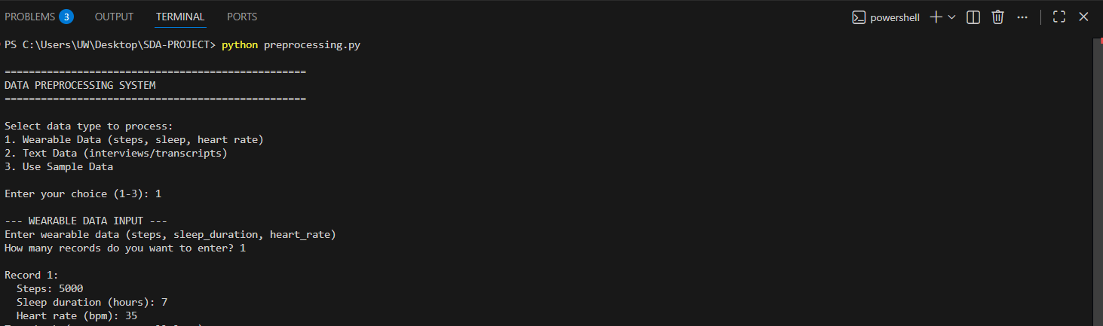

Enter simple [2] Wearable record
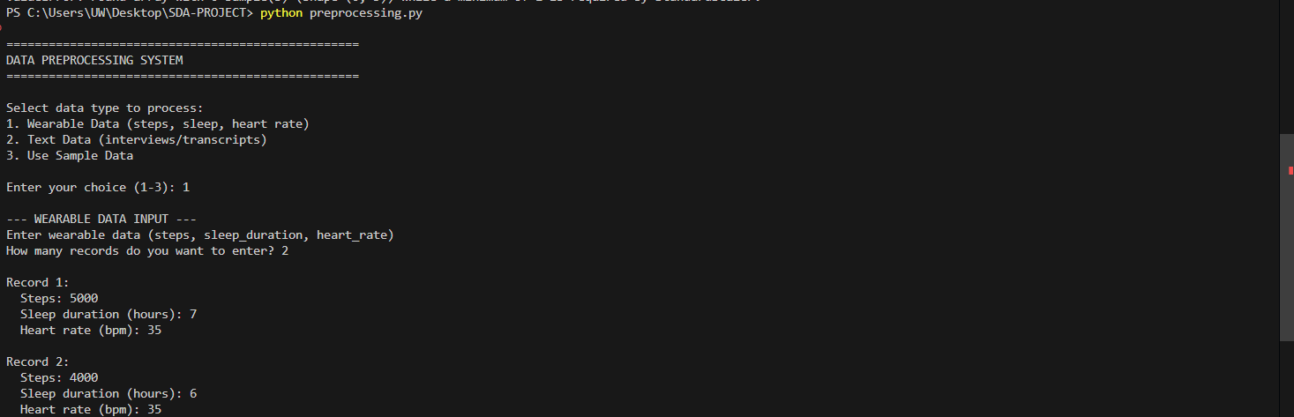

Enter [1] Text Data
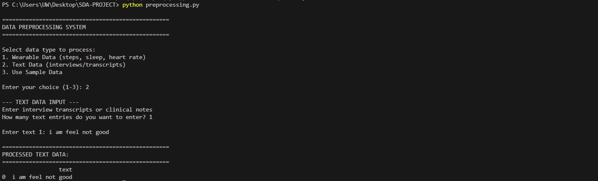

Enter [2] Text Data

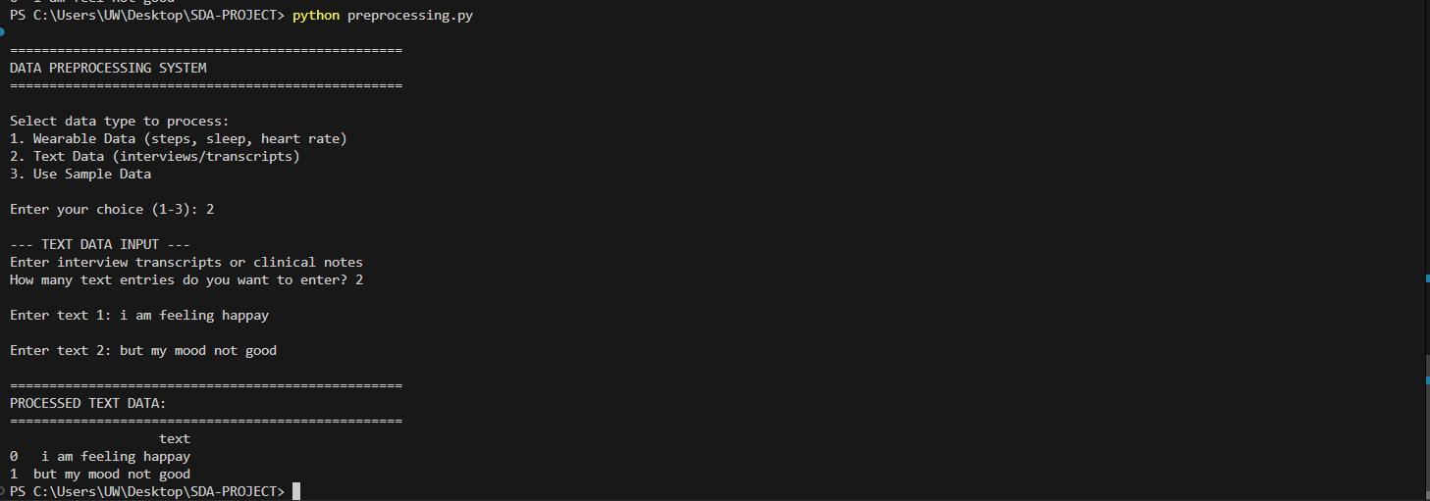

Record saved and process Data
