TASKKO · LAB 13
Colour Theory Applied to
the Taskko Prototype
Competitor palettes · the 60-30-10 rule · colour harmonies · colour temperature

Course | Mobile Application Development (MAD) — Lab 13: Colour Theory
Institution | Riphah International University, Lahore
Team | Umar Ahad Uddin Ahmed Usmani (SAP 60199) · Muhammad Sharjeel (SAP 59385)
App | Taskko — AI productivity, gamification & companion app for students
Tool | Adobe Color (color.adobe.com) for palette extraction & harmony rules
Date | 20 June 2026

1. Introduction & objectives
This lab applies colour theory to the Taskko prototype. Working from two competitor applications, we extracted their colour palettes, re-skinned the Taskko Home screen using the 60-30-10 ratio, demonstrated the five colour-harmony techniques on the prototype, and explored how colour temperature (warm / cool / neutral / achromatic) changes the feel of the app. The Home screen is used throughout as the representative prototype image because it contains the full range of UI roles — background, cards, statuses and a primary call-to-action.
Objectives addressed: (1) two competitor palettes via Adobe Color; (2) colour schemes applied with the 60-30-10 ratio; (3) the five harmonies — monochromatic, complementary, split-complementary, analogous and triadic; (4) application-type colours — warm, cool, neutral and achromatic.

2. Tool — Adobe Color (color.adobe.com)
All palettes in this report were produced with Adobe Color. Two of its modes were used:
- Extract Theme from Image — we uploaded a screenshot of each competitor app and let Adobe Color sample five representative swatches (its “Colorful / Muted / Deep” extraction modes), then read off the hex codes.
- Colour-wheel harmony rules — we set Taskko’s base hue (sky-blue, 197°) on the wheel and switched between the Monochromatic, Complementary, Split-Complementary, Analogous and Triadic rules to generate each harmony mathematically.
The 60-30-10 rule is an interior-design / UI convention: roughly 60% of the screen is a dominant (usually neutral) colour, 30% a secondary colour, and 10% a vivid accent reserved for the most important action. Every mock-up below follows it.

3. Competitor palettes

3.1 Habitica — gamified habit & to-do RPG
Habitica turns chores and study tasks into a role-playing game with health, experience and gold — the closest competitor to Taskko’s gamification layer. Its identity is strongly purple, with bright RPG stat colours (blue mana, red health, gold XP).
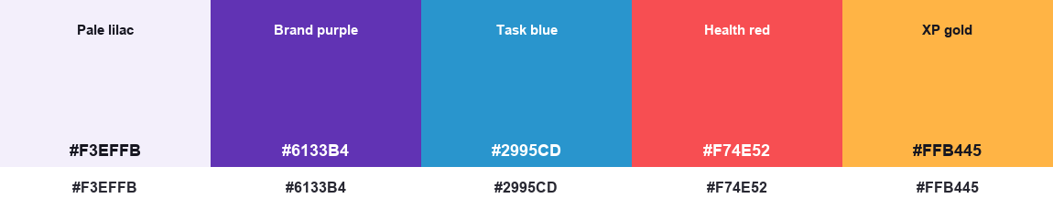
Five-swatch palette extracted from Habitica using Adobe Color.

3.2 Forest — focus / anti-distraction timer
Forest grows a virtual tree while you stay focused — a direct competitor to Taskko’s focus-session feature. Its palette is calm and natural: green-dominant with a gold “coin” reward accent.
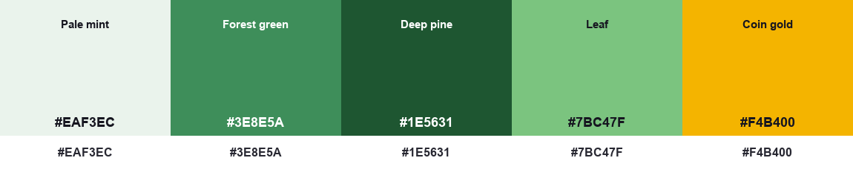
Five-swatch palette extracted from Forest using Adobe Color.

4. Applying the palettes with the 60-30-10 ratio
Each competitor palette was mapped onto the Taskko Home screen. The lightest tint becomes the 60% dominant background, the brand colour becomes the 30% secondary (cards, avatar, progress bars), and a vivid swatch becomes the 10% accent reserved for the “Next up” hero and the primary button.

4.1 Habitica skin
60% pale lilac background · 30% brand purple on the stat cards, avatar and progress · 10% XP-gold on the “Next up” hero and Start-now button.
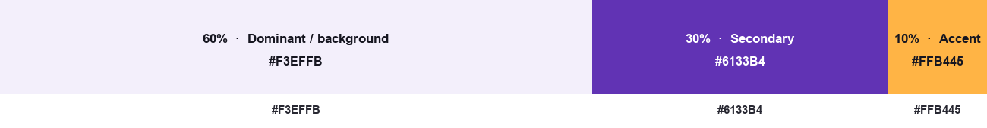
60-30-10 distribution for this skin.
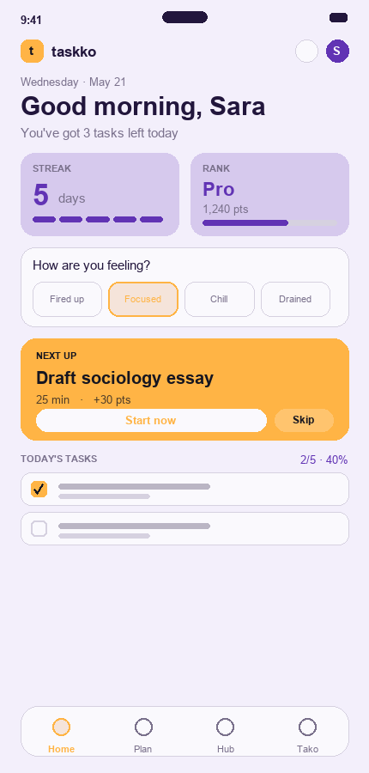
Taskko Home re-skinned in the Habitica palette.

4.2 Forest skin
60% pale mint background · 30% forest-green on the stat cards and progress · 10% coin-gold accent on the hero and primary action.
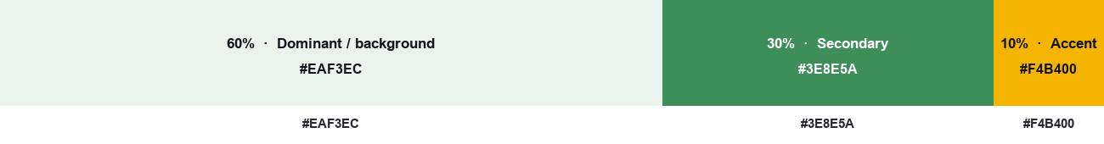
60-30-10 distribution for this skin.
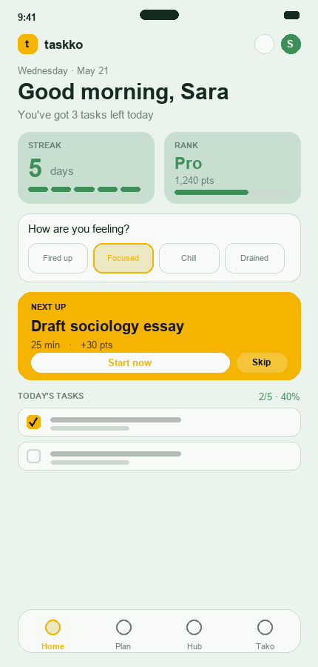
Taskko Home re-skinned in the Forest palette.

5. Colour-harmony techniques on the prototype
Using Taskko’s base hue (sky-blue, 197°) on the Adobe Color wheel, each harmony rule produces a different set of related hues. Below, each harmony is shown as its position on the colour wheel, its palette, and the Taskko Home screen recoloured with it (still following 60-30-10).

5.1 Monochromatic — 197° only — varied tints & shades
A single hue used in many tints and shades. Result: calm, cohesive and very low visual noise. Trade-off: little contrast, so the call-to-action is carried by the darkest shade.
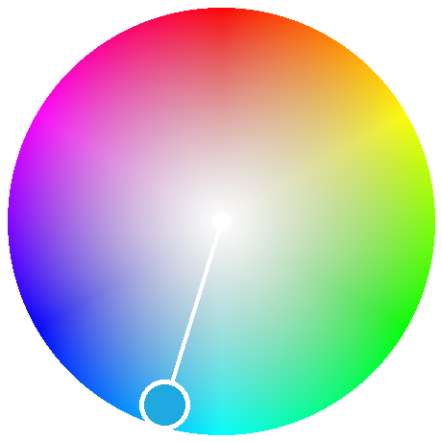  Harmony on the colour wheel | 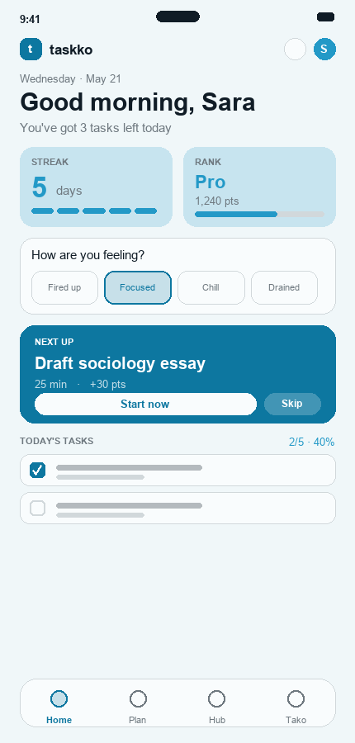  Taskko Home recoloured

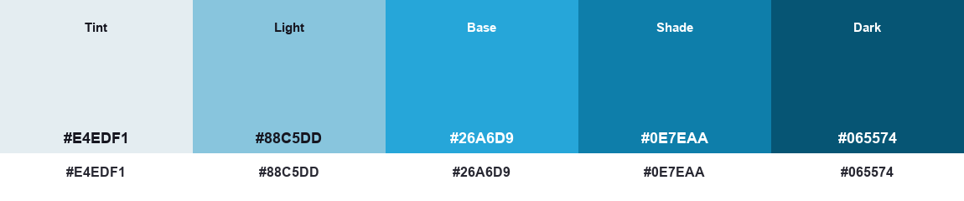
Monochromatic palette.

5.2 Complementary — 197° + 17° (opposite)
The base blue paired with its opposite, warm orange. Maximum contrast — the orange “Next up” hero pops hard against the blue UI. Excellent for a single strong CTA; used sparingly to avoid vibration.
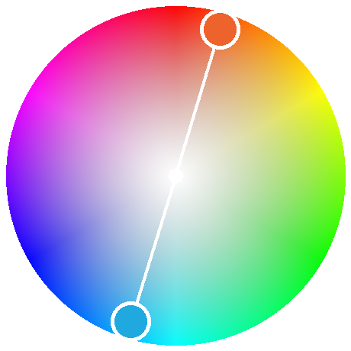  Harmony on the colour wheel | 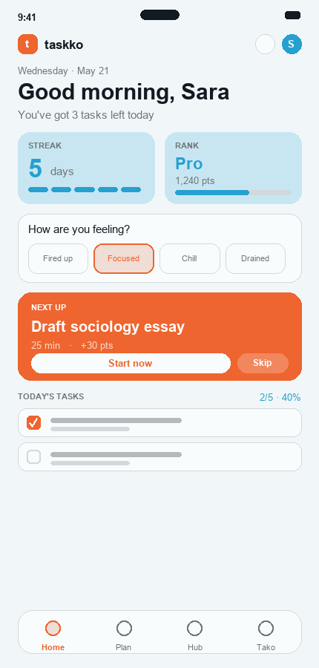  Taskko Home recoloured

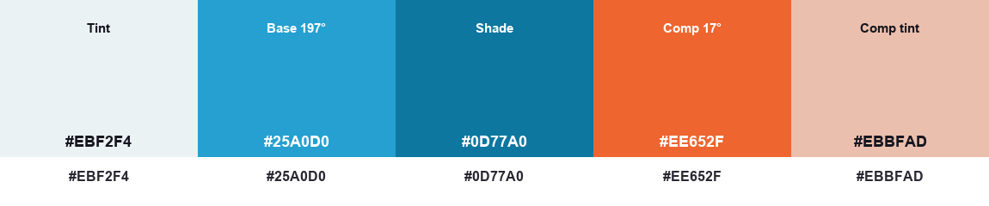
Complementary palette.

5.3 Split-Complementary — 197° + 347° + 47°
The base plus the two hues either side of its complement (rose & amber). Keeps complementary’s contrast but is softer and gives two accent options — easier to balance than pure complementary.
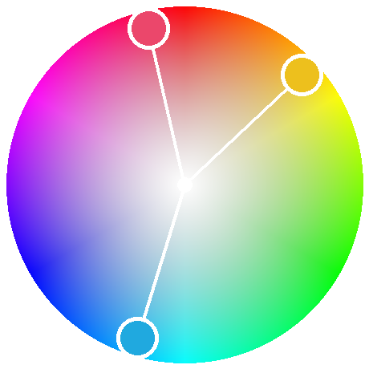  Harmony on the colour wheel | 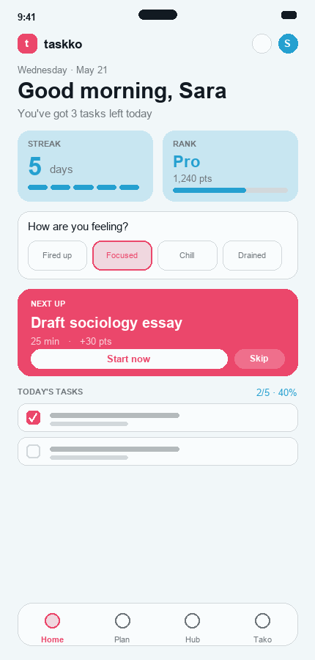  Taskko Home recoloured

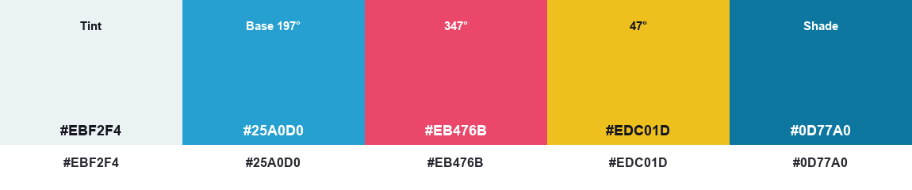
Split-Complementary palette.

5.4 Analogous — 167° + 197° + 227°
Three neighbours on the wheel (teal, blue, indigo). Very harmonious and serene — ideal for a focus app. Lower contrast, so the teal/indigo accents stay subtle and restful.
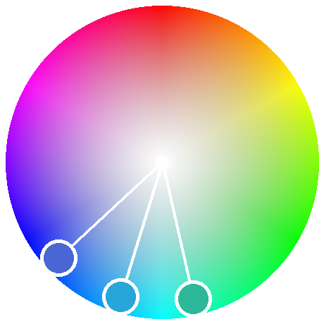  Harmony on the colour wheel | 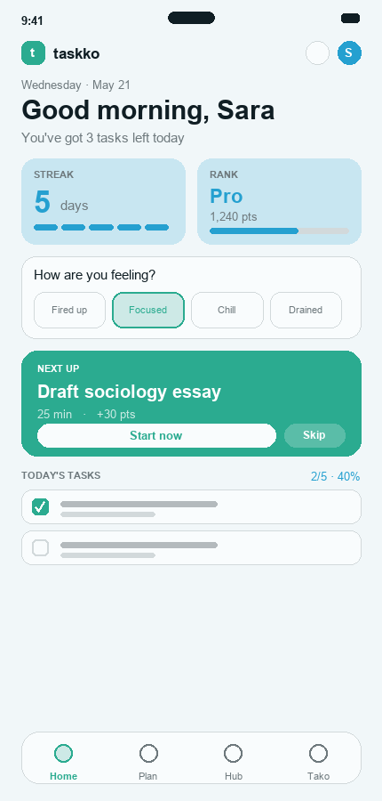  Taskko Home recoloured

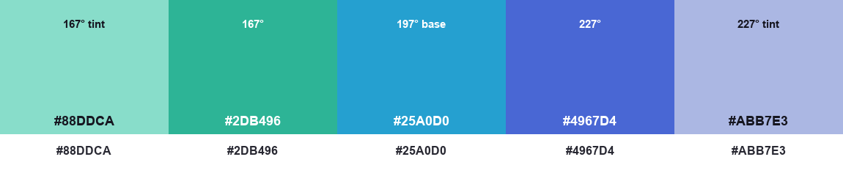
Analogous palette.

5.5 Triadic — 197° + 317° + 77°
Three evenly-spaced hues (blue, magenta, lime). Vibrant and playful — a good fit for the gamified side — but one hue (blue) must stay dominant with the other two as accents to avoid chaos.
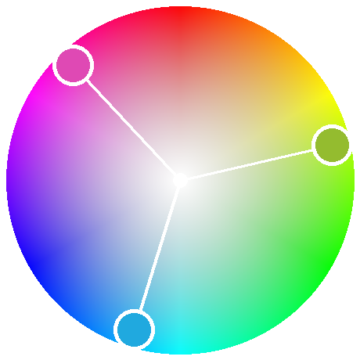  Harmony on the colour wheel | 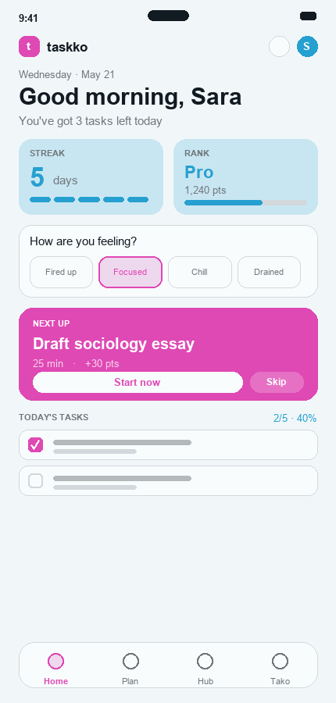  Taskko Home recoloured

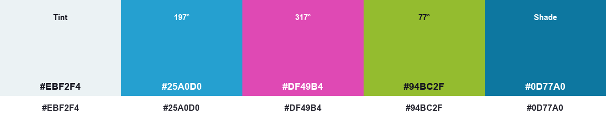
Triadic palette.

6. Application-type colours (temperature)
The same screen rendered in four colour temperatures, with the type of application each best suits.

6.1 Warm colours
Reds, oranges and yellows — energetic, urgent and motivating. Great for streaks, rewards and CTAs, but an all-warm UI can feel stressful across long study sessions. Best for food, fitness, sales and high-energy social apps.
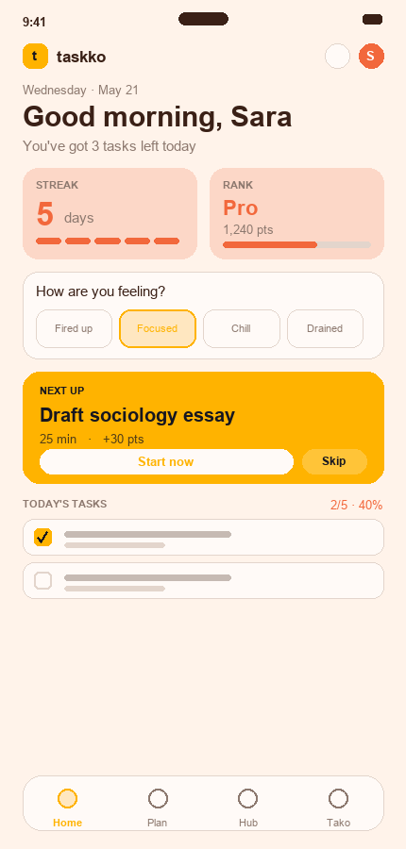  Taskko Home | 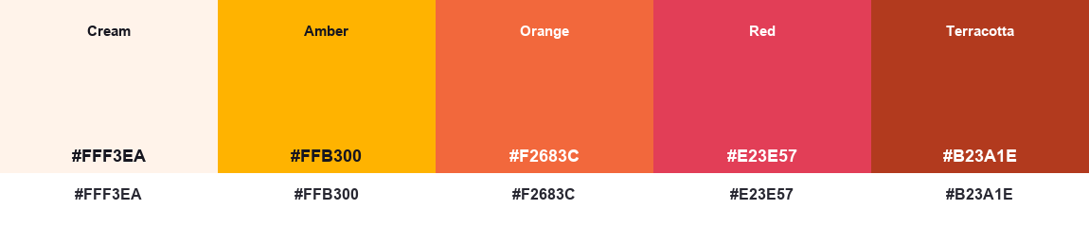  Palette

6.2 Cool colours
Blues, greens and purples — calm, trustworthy and focus-promoting. The best fit for Taskko’s core study/focus experience (and its real base hue). Best for productivity, finance, health and learning apps.
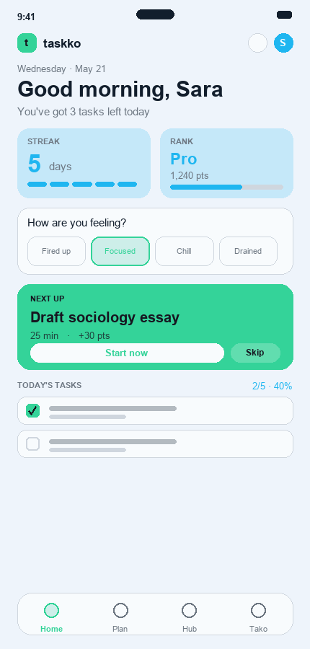  Taskko Home | 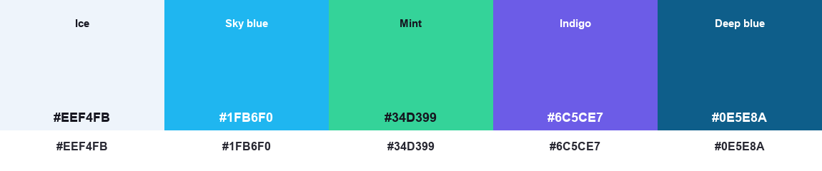  Palette

6.3 Neutral colours
Beiges, taupes, sage and warm greys — minimal, mature and low-fatigue. A quiet canvas that lets content and accents stand out; can feel dull on its own. Best for reading, journaling and premium/lifestyle apps.
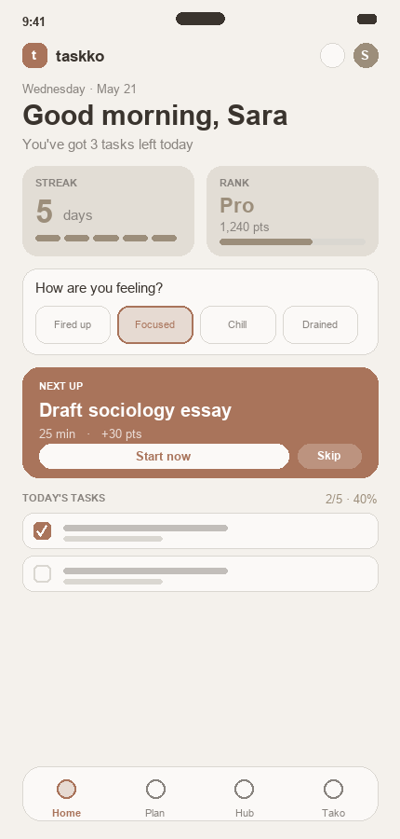  Taskko Home | 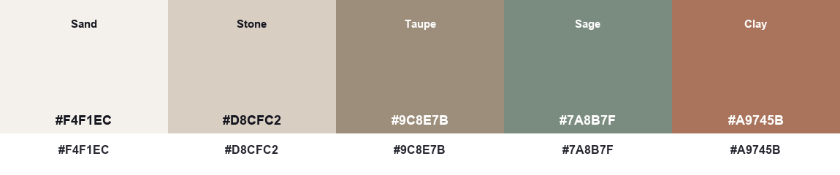  Palette

6.4 Achromatic colours
Black, white and greys only — pure tonal contrast and hierarchy. This is the accessibility / contrast baseline: if the layout reads clearly here, it works for low-vision users before any colour is added.
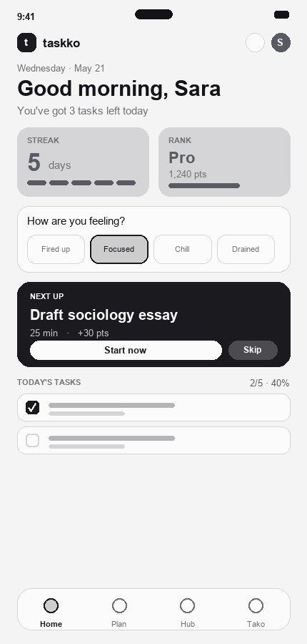  Taskko Home | 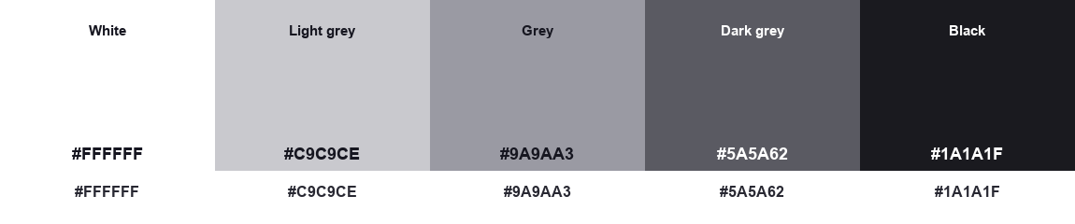  Palette

7. Conclusion — the recommended scheme for Taskko
Taskko is simultaneously a focus app (which wants calm) and a motivation/gamification app (which wants energy). The colour exercise points to a clear recipe that balances both:
- Cool base (60-30%): sky-blue for a calm, trustworthy, focus-friendly core.
- Warm accent (10%): a peach/gold accent on the “Next up” hero, streaks and rewards for motivation — a split-complementary pairing with the blue.
- Neutral background (the 60%): a near-white, lightly-tinted canvas to keep long sessions low-fatigue.
- Achromatic baseline: the layout is designed to read in greyscale first, guaranteeing contrast and accessibility before colour is layered on.
This is exactly the cool-blue + warm-accent + neutral direction that the complementary / split-complementary harmonies produced, and it matches Taskko’s real design tokens (#1FB6F0 sky-blue, #FF8A65 peach, neutral background). The competitor study confirmed it: Forest’s calm green base and Habitica’s reward-gold accent are two halves of the same idea — a calm core with an energetic reward accent.
Interactive prototype: https://www.figma.com/design/Xa83tCHsfbzIuGEJft8zAz/Taskko-%E2%80%94-App-Design

