TASKKO
Your AI Productivity Companion
Medium-Fidelity
Prototype Report
Design-process report · low-fidelity → medium-fidelity prototype

Course | HCI
Institution | Riphah International University, Lahore
Team | Umar Ahad Uddin Ahmed Usmani (SAP 60199) · Muhammad Sharjeel (SAP 59385)
Project | Taskko — an AI goal-breakdown, gamification & social-accountability app for students
Date | 20 June 2026
Figma prototype | https://www.figma.com/design/Xa83tCHsfbzIuGEJft8zAz/Taskko-%E2%80%94-App-Design?node-id=2-4&t=N74gmq2b50b5CMQl-1

This report accompanies the interactive Figma prototype and covers: (1) the changes carried from the low-fidelity sketches into the medium-fidelity prototype, (2) the rationale behind those changes, (3) the main tasks and the complete task-flow prototype, and (4) the software tools used besides Figma (with reasons and pros/cons).

1. Introduction
Taskko is a mobile app that tackles the student productivity crisis — overwhelming goals, no accountability and no motivation loop. It combines AI-powered goal breakdown, gamification (points, ranks, streaks, shields and badges), light social accountability (badge sharing, a weekly report card and a squad leaderboard) and an AI companion, “Tako”.
This document is the medium-fidelity stage of our design process. Following standard HCI practice, we moved from rough low-fidelity sketches to a structured, interactive prototype before committing to the final visual design and code. The sections below report exactly what changed between those stages, why, the main user tasks and the complete task flow we prototyped, and the supporting tools we used alongside Figma.

2. The main tasks of Taskko
Taskko is organised around four primary user tasks (plus an admin task on desktop). For this deliverable we prototyped the complete end-to-end flow of the signature task — turning a goal into a rewarded, completed study session — which chains T1–T4.
Main task | What the user is trying to do | Screens involved
T1 Get set up | Understand the value and create an account. | Splash → Onboarding → Sign up / Login
T2 Plan a goal with AI | Type a goal; get an editable, bite-sized plan committed to today. | AI Plan Studio (Goal → Break down → Customize)
T3 Do focused work | Pick a mood, start a focus session, complete tasks, earn points & streaks. | Home → Start now → Focus → task done
T4 Stay motivated | View badges, squad & report card, share wins; chat with Tako for support. | Gamification Hub · Tako chat
T5 Administer (admin) | Manage users, moderation, AI insights & settings. | Admin portal (desktop — outside the phone flow)

Signature task prototyped end-to-end: “From an overwhelming goal to a started, completed and rewarded study session” (T1 → T2 → T3 → T4).

3. Our fidelity process
We deliberately worked through three fidelity levels. Low fidelity locked the layout, content blocks and screen count on paper/grayscale wireframes. Medium fidelity turned those into structured digital wireframes with a real grid, a reusable component system, system states and clickable links between frames. High fidelity then layered the Taskko design tokens, type, mascot and motion to produce the branded, interactive Figma prototype that is shared with this report.
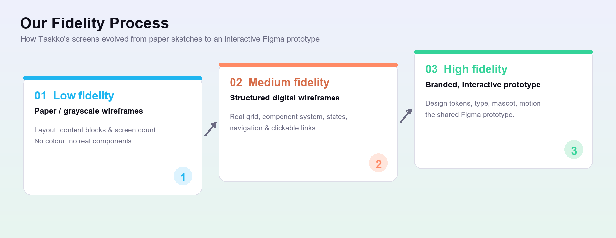
Figure 1 — Taskko's low → medium → high fidelity design process.

4. Changes from the low-fidelity sketches into the prototype
Two kinds of change were carried forward: global/structural decisions that affect every screen, and screen-specific changes. All of them were required to take the static sketches to a usable, clickable prototype.

4.1 Global / structural changes
- Consistent grid & spacing. Adopted a 402-px phone frame, an 8/12/16-px spacing scale and 20–28-px “bento” card radii — the sketches had no grid.
- Reusable component system. Buttons, inputs, cards, task rows, chips and the tab bar became shared components instead of one-off boxes.
- Persistent bottom navigation. Added a Home · Plan · Hub · Tako tab bar so the app’s structure is always visible and reachable.
- System-state screens. Introduced loading (AI generating), empty, error/retry and success-feedback states that the sketches lacked.
- Realistic content. Replaced placeholder “lorem” with representative copy to test true layout, overflow and hierarchy.
- Interactive links. Defined click links between frames — the decisive leap from static sketches to a navigable prototype.
- Consistent headers. Locked a wordmark + bell + avatar pattern on top-level screens and a back / title / overflow pattern on sub-screens.

4.2 Screen-by-screen changes
Screen | Low-fidelity sketch had… | …incorporated into the medium-fidelity prototype
Onboarding | A single welcome panel with a “Start” button. | Split into a 3-slide value tour (Plan / Streaks / Squad) with an animated 1/3 dot indicator, a persistent Skip, Next → Get started; both Skip and Get started route to Sign up.
Sign up / Login | Name, email, password fields and one button. | Added Google (& Apple) SSO above the fold, password helper + show/hide, a required Terms checkbox that keeps the CTA disabled until valid, inline validation, Forgot-password and a Sign-up ↔ Login cross-link.
Home | A header and a flat list of tasks. | A bento dashboard: time-aware greeting + tasks-left count, a Streak card (5-day visualizer + shields), a Rank card (points + progress bar to the next rank), a 4-mood check-in, a “Next up” hero CTA (Start now / Skip) and Today’s tasks with checkboxes and a done/percent header.
AI Plan Studio | A goal text box that produced a list of tasks. | A 3-step progress header (Goal → Break down → Customize), an AI loading state, editable task rows (edit / delete / add), per-task time + points, Regenerate, and Commit-to-Today.
Gamification Hub | A single grid of badges. | Three tabs (Badges / Squad / Report card), a “New badge!” highlight with Share / View, clearly distinct locked vs unlocked badges, a squad podium + ranked list with “you” highlighted, and a shareable weekly report card.
Tako chat | A message box and a send button. | A mascot + status/mode header, chat bubbles, a typing indicator, quick-prompt chips, and inline nudge cards with action buttons (Start a session / Remind me in 1h).

4.3 Visual before / after
The same five screens, shown as the low-fidelity wireframe next to the resulting prototype screen.
Onboarding
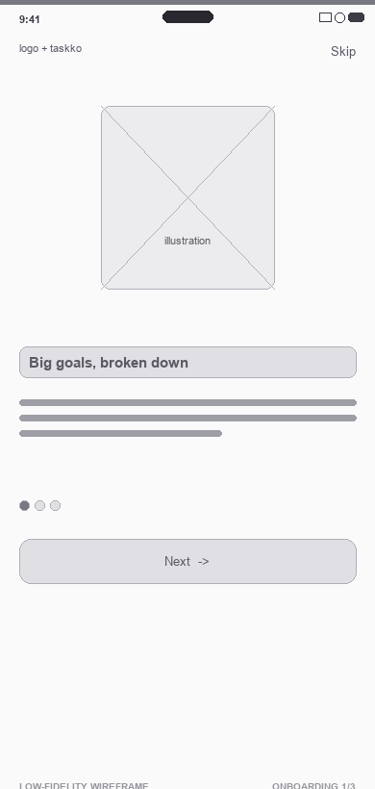 | 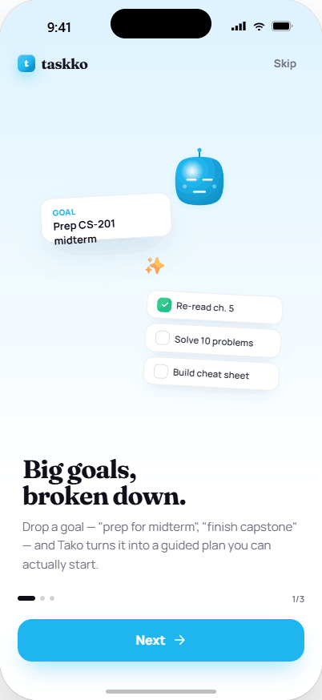
Low-fidelity wireframe | Medium / high-fidelity prototype

Sign up
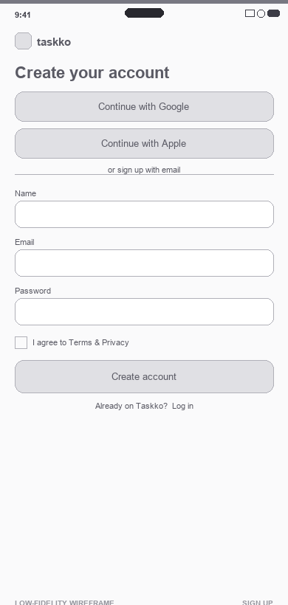 | 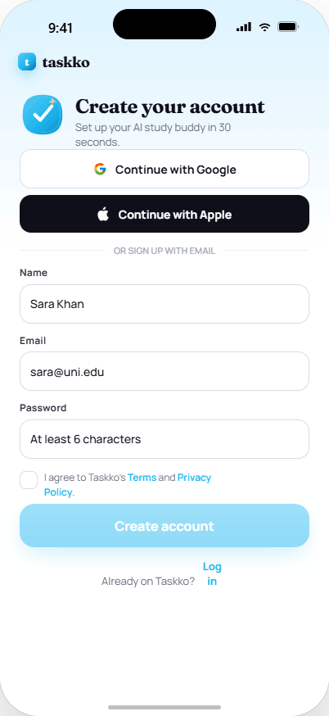
Low-fidelity wireframe | Medium / high-fidelity prototype

Home dashboard
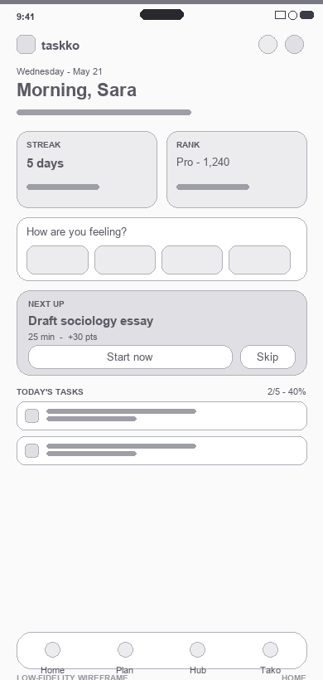 | 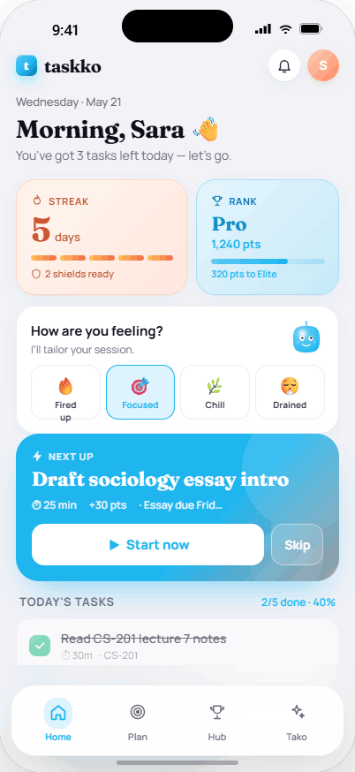
Low-fidelity wireframe | Medium / high-fidelity prototype

AI Plan Studio
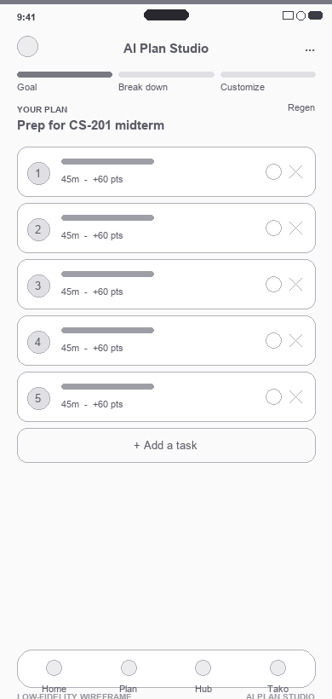 | 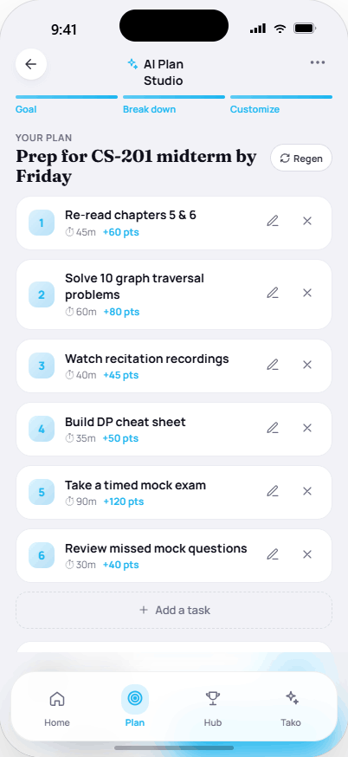
Low-fidelity wireframe | Medium / high-fidelity prototype

Gamification Hub
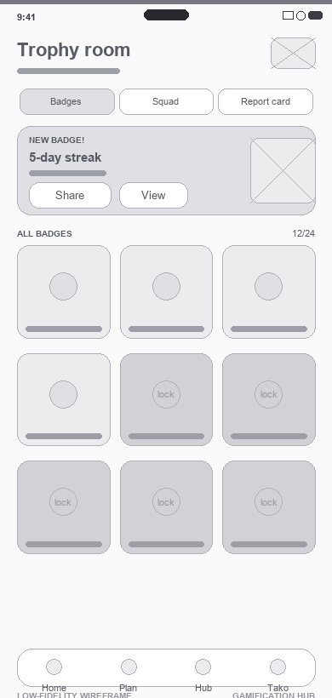 | 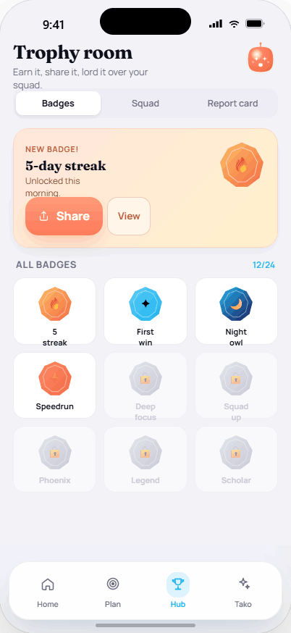
Low-fidelity wireframe | Medium / high-fidelity prototype

5. Rationale behind the changes
Every change above maps to a recognised HCI principle (Don Norman’s principles, Nielsen’s heuristics and Gestalt grouping) or a concrete usability goal. The table makes that mapping explicit.
Change | Why we made it (HCI rationale)
3-slide onboarding tour | Progressive disclosure lowers cognitive load and sets accurate expectations; the persistent Skip respects returning users. (Visibility, user control & freedom.)
SSO + validation + disabled CTA + Terms gate | Reduces friction (one-tap sign-in) and prevents input errors before they happen. (Constraints, error prevention, affordance.)
Streak & Rank cards with numbers + progress bars | Make the user’s status readable at a glance — bridging the Gulf of Evaluation. (Feedback, visibility of system status.)
“Next up” hero CTA | Makes starting the next task effortless and obvious — bridging the Gulf of Execution. (Visibility, affordance, single clear primary action.)
Mood check-in → session tuning | A control whose effect is logical and predictable. (Natural mapping.)
Bento cards grouping stats & tasks | Related information is visually grouped, reducing overwhelm. (Gestalt proximity / similarity, visual hierarchy.)
3-step Plan progress + loading/error states | The system always tells the user where they are and never crashes a flow. (Visibility of system status, graceful failure / reliability.)
Editable AI plan (edit / add / delete / regenerate) | Keeps the human in control of the automation, building trust. (User control & freedom.)
Locked vs unlocked badges + instant completion feedback | A clear, rewarding progress loop. (Feedback, recognition of progress.)
One-tap Share | Lowers the cost of social accountability to a single action. (Affordance, recognition over recall.)
Persistent tab bar | Consistent, always-available navigation. (Consistency & standards, recognition over recall.)
Quick-prompt chips & nudge action buttons | Let users act without typing or recalling commands. (Recognition over recall, actionable feedback.)
Consistent design tokens, type & contrast | Improves readability, accessibility and the aesthetic-usability effect across every screen.

6. Main task & the complete task-flow prototype
The complete flow we prototyped is the signature task: a student arrives, gets set up, hands an overwhelming goal to the AI, commits the resulting plan, runs a mood-tuned focus session, completes the task for points and a streak, and sees the reward in the Gamification Hub. Tako is reachable at any point for support.
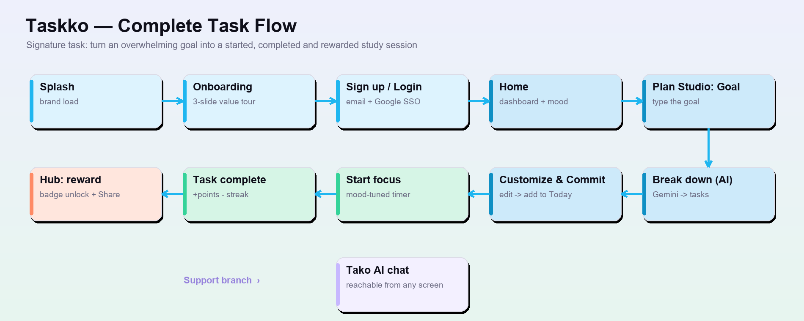
Figure 2 — The complete task flow, end to end. The full clickable version is in the Figma prototype.
Step-by-step walkthrough:
- 1. Splash → Onboarding. Brand load, then a 3-slide value tour the user can skip.
- 2. Sign up / Login. Create an account with email or Google SSO; land on Home.
- 3. Home. See streak, rank, points and today’s tasks; pick a mood that tunes the session.
- 4. AI Plan Studio. Type a goal → Gemini breaks it into bite-sized tasks → edit and Commit to Today.
- 5. Start focus. Launch a mood-tuned focus timer from the “Next up” hero on Home.
- 6. Task complete. Earn points, advance the streak, and get immediate feedback.
- 7. Gamification Hub. A badge unlocks; share it or view the weekly report card and squad leaderboard.
- ↗ Tako chat. Available anytime for quick prompts, motivation and actionable nudges.
View the complete clickable flow in Figma → https://www.figma.com/design/Xa83tCHsfbzIuGEJft8zAz/Taskko-%E2%80%94-App-Design

7. Software tools used besides Figma
Figma hosts the shared interactive prototype, but several other tools were used to design, generate and document it. Each is listed with why we chose it and its pros and cons.
Tool | Why we used it | Pros | Cons
Claude (Claude Design / Claude Code) | To generate the UI concept and the prototype handoff that the Figma screens recreate, plus the low-fi wireframes, this report and the deck. | Very fast ideation & iteration; produces design, code and documentation together; stays consistent with the design tokens; ideal for a small team. | Needs human review for visual polish & accuracy; not a pixel-precise canvas; can occasionally hallucinate; output depends on prompt quality.
HTML / CSS + Google Chrome | To render the screens as real, pixel-accurate UI and export them as the PNG frames used for handoff and in this document. | Pixel-accurate with real fonts/CSS; free; exact control; exportable to images; doubles as a head-start on the Flutter build. | Requires coding skill; no drag-and-drop or built-in commenting/sharing; slower than a WYSIWYG tool for quick mock-ups.
Python — Pillow, python-pptx, python-docx | To script the low-fidelity wireframes, the flow & fidelity diagrams, this Word report and the PowerPoint deck. | Fully scriptable & repeatable; precise and consistent; free & open-source; regenerate every artifact from source in seconds. | Code-first, not WYSIWYG; steeper learning curve; layout tuning is manual.
Google Fonts (Manrope, Fraunces, JetBrains Mono) | The type system — UI, display and numeric fonts that match the Taskko design tokens. | Free and open-licensed; high quality; many weights; web- and app-ready. | Must be embedded/self-hosted for offline use; adds load weight; attribution required per licence.
Microsoft Office (Word & PowerPoint) | The final submission formats for this report and the presentation. | Universally accepted in academia; easy to open, edit and comment; reliable printing and PDF export. | Proprietary; less precise design control than a design tool; formatting can drift across versions/machines.
Git & GitHub | Version control and backup for the design assets, prototype code and these documents. | Full history & rollback; off-site backup; easy collaboration; free public hosting. | Learning curve for non-developers; binary PNG assets don’t diff well; occasional merge conflicts.

8. The Figma prototype
The interactive prototype is shared as a single Figma file named “Taskko”. It contains all eight phone screens and the desktop admin portal, with the main task flow wired as clickable links so it can be played end-to-end in Present mode.
- Open: https://www.figma.com/design/Xa83tCHsfbzIuGEJft8zAz/Taskko-%E2%80%94-App-Design
- Play it: open the file and press the Present (▶) button, or use the share → “View prototype” link.
- Sharing: set the file/link to “Anyone with the link · can view” so evaluators can open it without a Figma account.
If a dedicated prototype “play” link is preferred for submission, it can be copied from Figma’s Share dialog (Share → Copy prototype link) and pasted alongside this report.

9. Conclusion
Moving Taskko from low-fidelity sketches to a medium-fidelity, clickable prototype forced every screen to earn its layout: a consistent grid and component system, real navigation, system states and — above all — interactive links that let us test the complete task flow before writing production code. Each change is grounded in an HCI principle aimed at the same goal: making it effortless for an overwhelmed student to start, finish and feel rewarded for their work.

