Preparatory Lab Exercises

# **Title: Boston Housing Price Prediction using Linear Regression**

This set of preparatory lab exercises is designed to help students build a strong foundation in data analysis, linear regression, and model evaluation using the Boston Housing Dataset. These exercises culminate in the development of an application that predicts house prices.

## **Exercise 1: Introduction to the Boston Housing Dataset**

* Objective: Load and explore the dataset
* Skills Developed:
* Loading datasets using sklearn.datasets
* Understanding dataset structure: features, targets, and metadata
* Tasks:
* Load Boston dataset
* Display feature names, shape, and target variable description
* Convert to pandas DataFrame

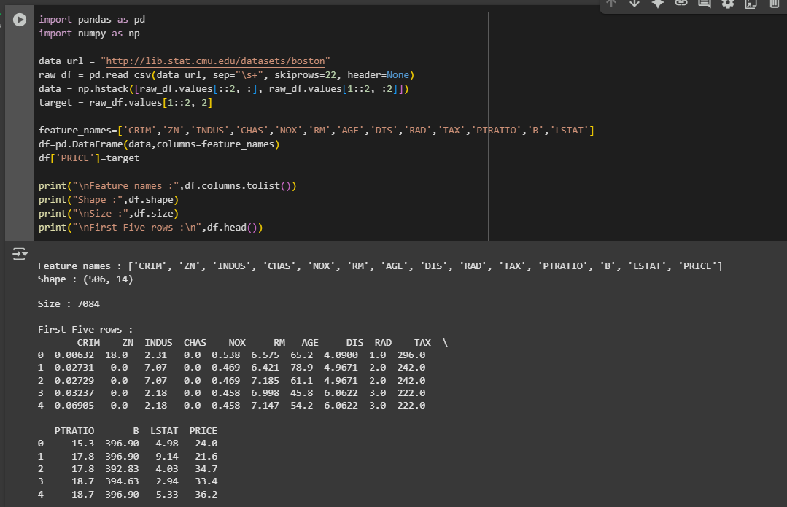

## **Exercise 2: Exploratory Data Analysis (EDA)**

* Objective: Analyze feature distributions and correlations
* Skills Developed:
* Data visualization using matplotlib and seaborn
* Handling missing values and outliers

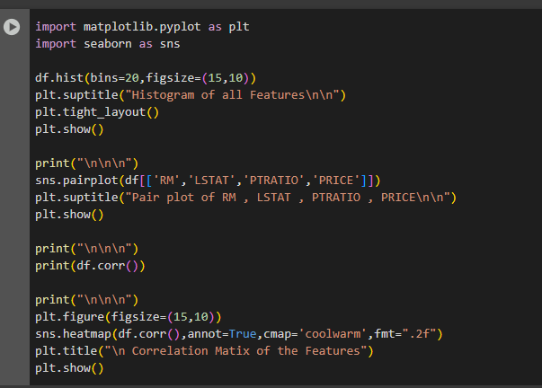

* Tasks:
* Plot histograms and pairplots

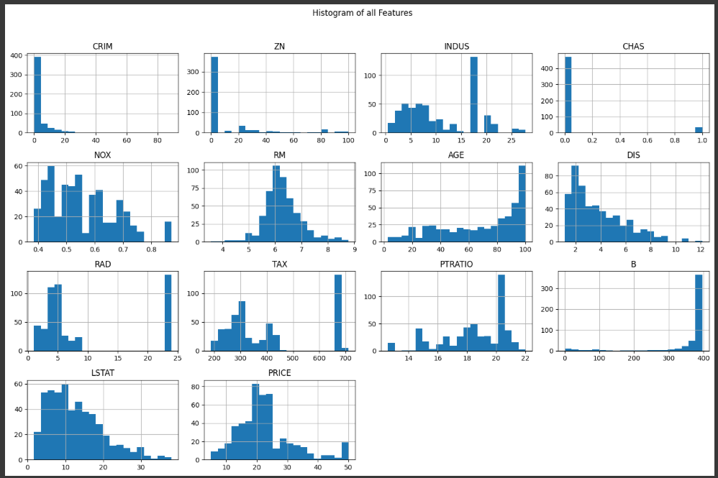

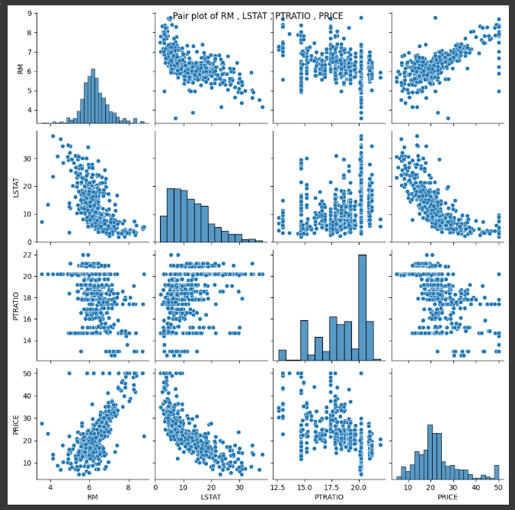

* Compute correlation matrix

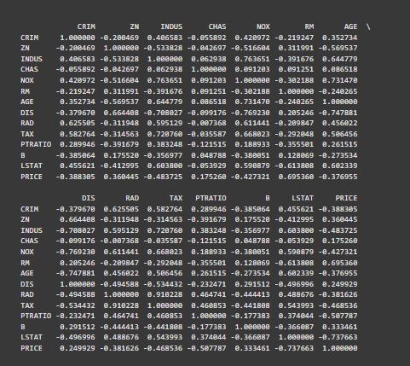

Heatmap visualization

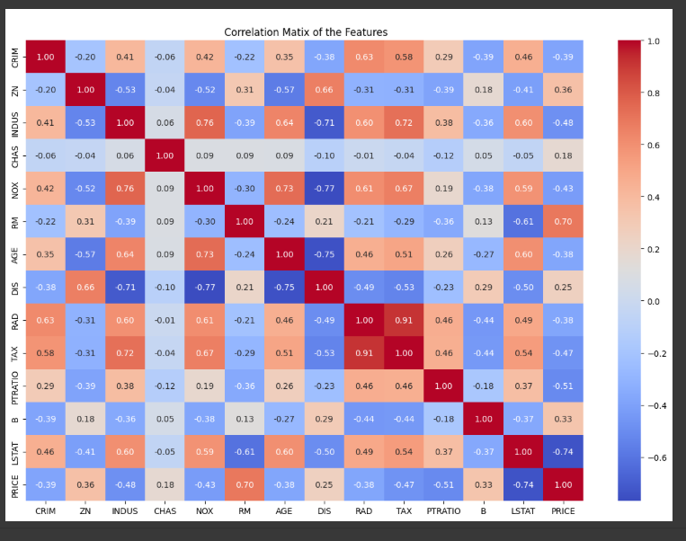

## **Exercise 3: Linear Regression with a Single Feature**

* Objective: Apply linear regression using one independent variable
* Skills Developed:
* Train/test split
* Using LinearRegression from sklearn.linear_model
* Tasks:
* Choose a single predictor (e.g., RM)
* Fit and evaluate model

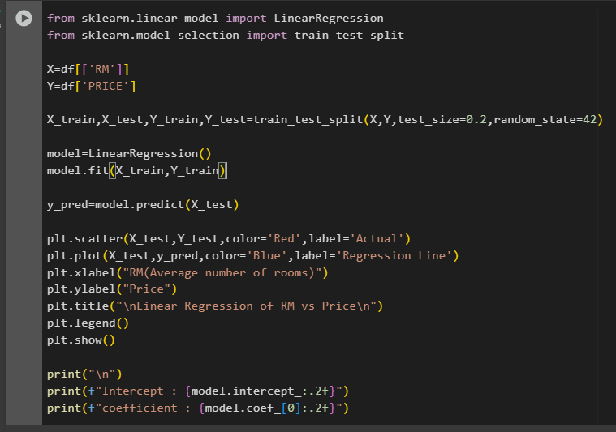

* Plot regression line

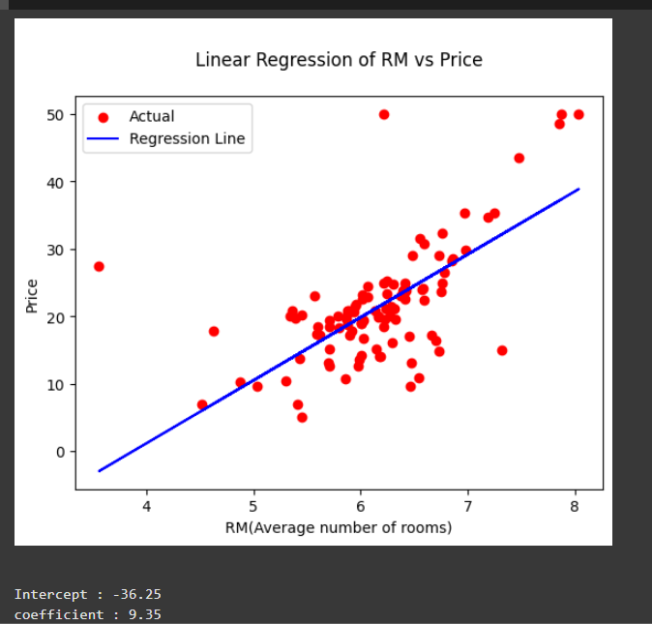

## **Exercise 4: Multiple Linear Regression**

* Objective: Train a model using multiple features
* Skills Developed:
* Multivariate regression
* Feature scaling (optional)
* Tasks:
* Use all features except the target
* Evaluate performance with MAE, MSE, RMSE, R²

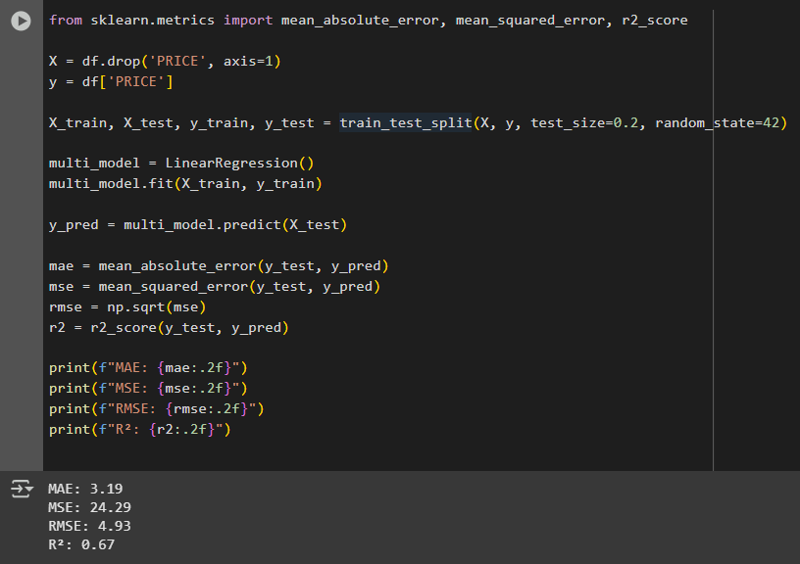

## **Exercise 5: Model Evaluation and Interpretation**

* Objective: Understand how to assess a regression model
* Skills Developed:
* Use metrics like mean_squared_error, r2_score
* Tasks:
* Evaluate on test data

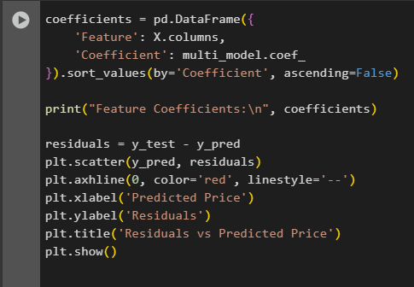

* Interpret coefficients

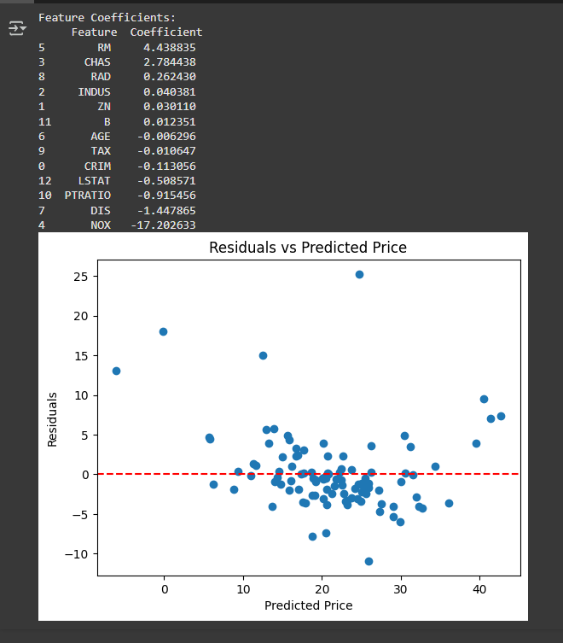\

## **Exercise 6 (Optional): Build a Simple GUI or CLI**

* Objective: Build a simple user interface to enter feature values and display predictions.
* Skills Developed:
* Using tkinter (GUI) or argparse (CLI)
* Model serialization with joblib or pickle
* Tasks:
* Create input form or CLI options
* Display prediction results