**1. pwd**

This command in Linux gives you the present working directory.

Example:

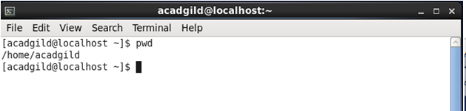

**2. vi**

VI is visual editor which comes default with LINUX/UNIX.

This command gives flexibility to edit the file with copy, paste options.

Example:

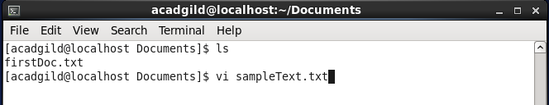

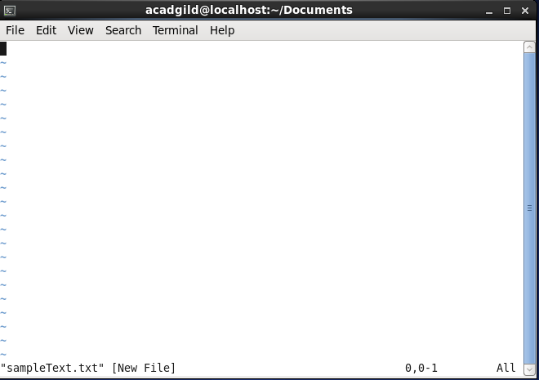

**3. touch**

The touch command is the easiest way to create new, empty files. It is also used to change the timestamps (i.e., dates and times of the most recent access and modification) on existing files and directories.

touch's syntax is **touch [option] file_name(s)**

When used without any options, touch creates new files for any file names that are provided as arguments (i.e., input data) if files with such names do not already exist. Touch can create any number of files simultaneously.

Thus, for example, the following command would create three new, empty files named file1, file2 and file3:

**touch file1 file2 file3**

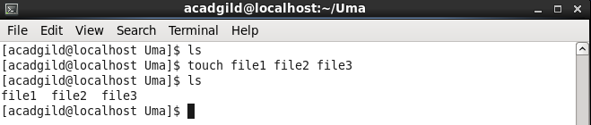

**4. mkdir**

mkdir command is used to make a new directory.

Example: as shown in the below screenshot

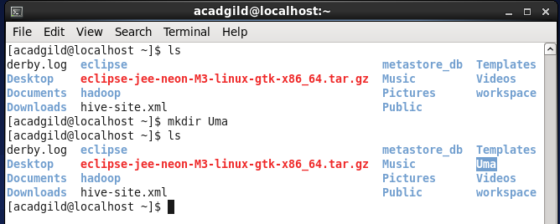

**5. rm**

The rm command is used for removing/deleting files

Example

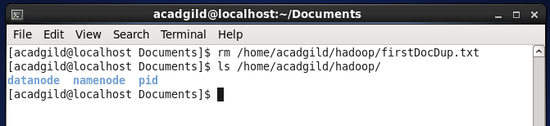

**6. ls**

ls command lets us list files of the directory where we are in.

Example:

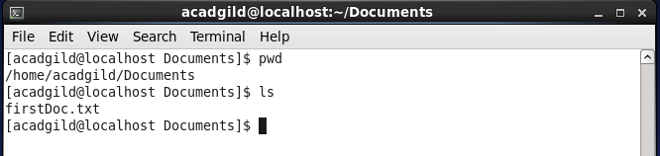

**7. echo**

echo is one of the most commonly and widely used built-in command for Linux bash and C shells, that typically used in scripting language and batch files to display a line of text/string on standard output or a file.

The syntax for echo is:

echo [option(s)] [string(s)]

Example:

**$ echo Tecmint is a community of Linux Nerds**

Outputs the following text: **Tecmint is a community of Linux Nerds**

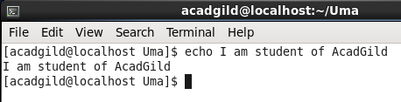

**8. cat**

The cat command is useful for concatenating multiple files -- or just for dumping a single text file to the screen.

Example:

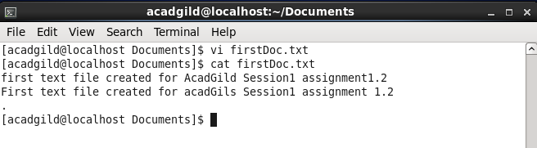

**9. who**

to list the users currently logged in to given machine;

to find out who is logged in

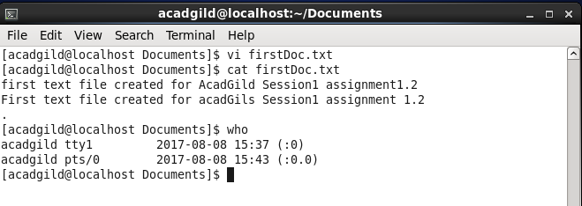

**10.cd**

'cd', lets you change your current working directory.

Example:

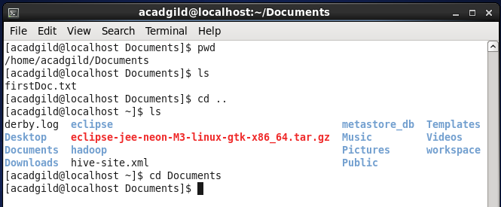

**11.date**

date command gives the curent date of the system we are on.

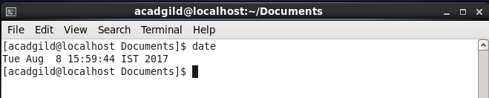

**12.cal**

cal command displays a conveniently-formatted calendar from the command line.

cal [options] [[[day] month] year]

Examples:

cal (Displays the calendar for this month.)

cal 12 2000 (Displays the calendar for December of the year 2000.)

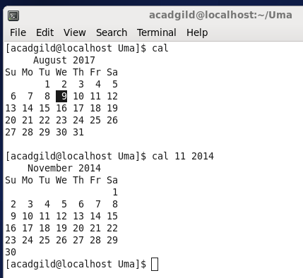

**13.mv**

mv command moves file from one directory to the other as shown in the below example.

Example:

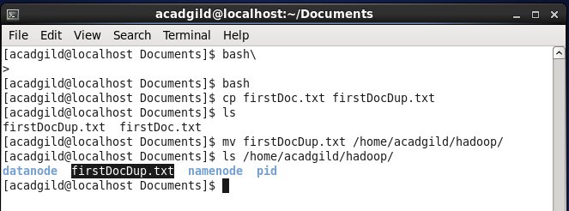

**14.cp**

The cp command will let you **c**o**p**y files.

Example

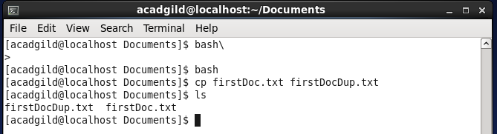

**15.which**

The Linux which command is used to find the location of a program.

The simplest form of the command is as follows:

**which <programname>**

For example to find the location of the Firefox web browser use the following command:

**which firefox**

