CLAUDE GATEWAY ON AZURE
Administrator Setup Guide
Step-by-step instructions, with the reasons behind each step, for building the gateway, Entra identity, quotas and team governance in the Azure portal
Audience: Azure administrators who are not expected to be developers.
Covers: prerequisites and how to prepare them; the architecture and request flow; how Foundry, API Management and Microsoft Entra ID trust each other; the Entra app registrations, roles and groups; personal tiers, team budgets and governance; running the setup; verifying every result in the Azure portal; onboarding developers; operations and troubleshooting.
Based on: admin/claude-gateway-setup.sh, admin/setup-teams-governance-claude-gateway.sh, the infra/ templates and the gateway policy in this repository.
Version: 1.0, October 2026
Contents
1. About this guide
2. The big picture
3. How a request flows and how trust works
4. Microsoft Entra objects: apps, roles and groups
5. How quotas and budgets work
6. Prerequisites
7. Preparing the prerequisites in the Azure portal
8. Decide your configuration
9. Running the setup script
10. Verify the result in the Azure portal
11. Team governance and quota integration
12. Onboarding developers
13. Reporting, monitoring and day-2 operations
14. Troubleshooting
Appendix A. Glossary
Appendix B. Entra objects at a glance
Appendix C. Quick command reference
Click a chapter title to jump to it. Use the Navigation pane (View > Navigation Pane) to move between sections.

1. About this guide
This guide walks an Azure administrator through building the Claude Gateway on Azure: a controlled front door that lets your developers use Claude models hosted in Microsoft Foundry, signed in with their normal work accounts, with personal and team usage limits (quotas) and cost reporting.
It is written for someone who is comfortable in the Azure portal but is not expected to be a developer or a network engineer. Every step says what to do, where to click, and why you are doing it, so you can follow along and still understand the design.

1.1 What you will have at the end
- A single gateway address that Claude Desktop, Claude Code and scripts use instead of talking to Foundry directly.
- Every developer signs in with Microsoft Entra ID (their work account). No shared passwords or API keys are handed out.
- Three personal tiers (Pro, Basic, Lite) that set each person's monthly dollar budget and speed limit.
- Optional team budgets: each team has a group of people, a pooled budget, and a list of Claude models it may use.
- Usage and cost dashboards, plus optional alerts.

1.2 How the guide is organised
Chapters | What they cover
2 - 3 | The big picture: architecture, how a request flows, and how Foundry, API Management and Microsoft Entra ID trust each other.
4 - 5 | The Entra objects the setup creates (three app registrations, app roles, groups) and how quotas work.
6 - 8 | Prerequisites, how to prepare each one in the Azure portal, and the configuration worksheet.
9 - 10 | Running the setup script, then checking each result in the Azure portal (with screenshots).
11 | Team governance and quota integration: groups, roles and the safe rollout from observe to enforce, including the manual portal steps.
12 - 14 | Onboarding developers, reporting and day-2 operations, troubleshooting, then reference appendices.

1.3 Symbols used in this guide
WHY THIS MATTERS
Explains the reason behind a step, so you know what breaks if you skip it.

TIP
A shortcut or a good habit.

CAUTION
Something that can cost money, lock users out or be hard to undo. Read before you act.

CHECK
How to confirm that a step worked before you move on.

1.4 About the screenshots
The Azure portal screenshots were captured from a real reference deployment of this solution (resource group rg-sombaner-foundry, API Management instance claude-apim-gateway-sombaner). Names, IDs and regions in your tenant will be different. Where the reference environment uses a different example name from the naming the setup script creates by default, the text says so. Names and e-mail addresses of individual people were removed from the images.
NOTE
The portal changes its look from time to time. If a button has moved, use the portal search box at the top of the page and type the name of the item (for example App registrations).
The reference environment runs API Management at the Basic v2 tier. The setup script's cost guidance and this guide recommend Standard v2 for production. Any v2 tier works with the gateway policy.

2. The big picture

2.1 The problem this solves
If you simply give developers a Foundry key or direct access to the Claude deployment, you cannot tell who used what, you cannot stop one person from spending the whole budget, and you cannot take access away from one person without rotating a shared secret. The gateway sits in front of Foundry and fixes that:
Need | How the gateway meets it
Know who is calling | Each developer signs in with Entra ID. The gateway sees the person's identity in the token.
No shared secrets | Developers hold no keys. The gateway itself reaches Foundry using an Azure managed identity (an identity owned by the Azure resource, with no password to leak).
Fair use per person | A tier (Pro / Basic / Lite) limits speed (tokens per minute), monthly tokens and monthly dollars for each person.
Budgets per team | Optional team profiles pool the limits of a whole team and can restrict which models a team may call.
Visibility | Every call is logged; a workbook and optional Grafana dashboard show usage and cost.
Instant control | Adding the Claude.Suspended role to a person blocks them at their next token refresh.

2.2 Architecture at a glance
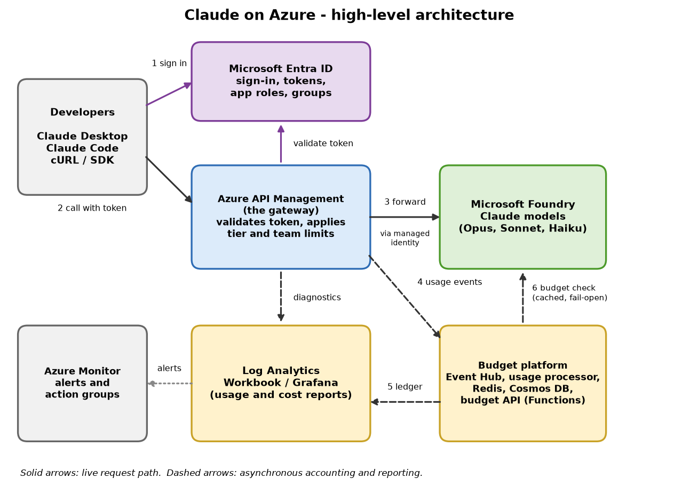
Figure 1: High-level architecture. Solid arrows are the live request; dashed arrows are background accounting.

2.3 The building blocks in plain language
Block | What it is | Why it is here
Microsoft Entra ID | Your organisation's identity service (formerly Azure Active Directory). | Signs people in, issues the tokens that prove who they are, and stores the groups and roles that decide what they may do.
Azure API Management (APIM) | A managed gateway service. Requests arrive at its address and a policy (a set of rules) is run on each one. | Checks the token, applies tier and team limits, then forwards allowed requests to Foundry.
Microsoft Foundry | The service hosting the Claude model deployments (Opus, Sonnet, Haiku). | Where the model actually runs. It only trusts the gateway's managed identity.
Event Hub | A high-volume message pipe. | APIM drops a usage record here after each call so accounting never slows the request.
Function apps (2) | Small pieces of code that run in Azure: a usage processor and a budget API. | The processor reads usage records and totals spend. The budget API answers APIM's question: is this person or team over budget?
Redis cache | A very fast in-memory store. | Holds month-to-date dollar counters and 'over budget' flags so the check takes milliseconds.
Cosmos DB | A database. | A permanent ledger of usage. If Redis is ever lost, totals are rebuilt from it.
Log Analytics workspace | Azure's log store. | Holds gateway logs, price tables and hourly roll-ups for reports and alerts.
Workbook / Grafana | Dashboards. | Show usage and cost by person, tier, team and model.

3. How a request flows and how trust works
This chapter explains what happens after setup, every time someone uses Claude. Understanding it makes the later configuration steps make sense.

3.1 The life of one request
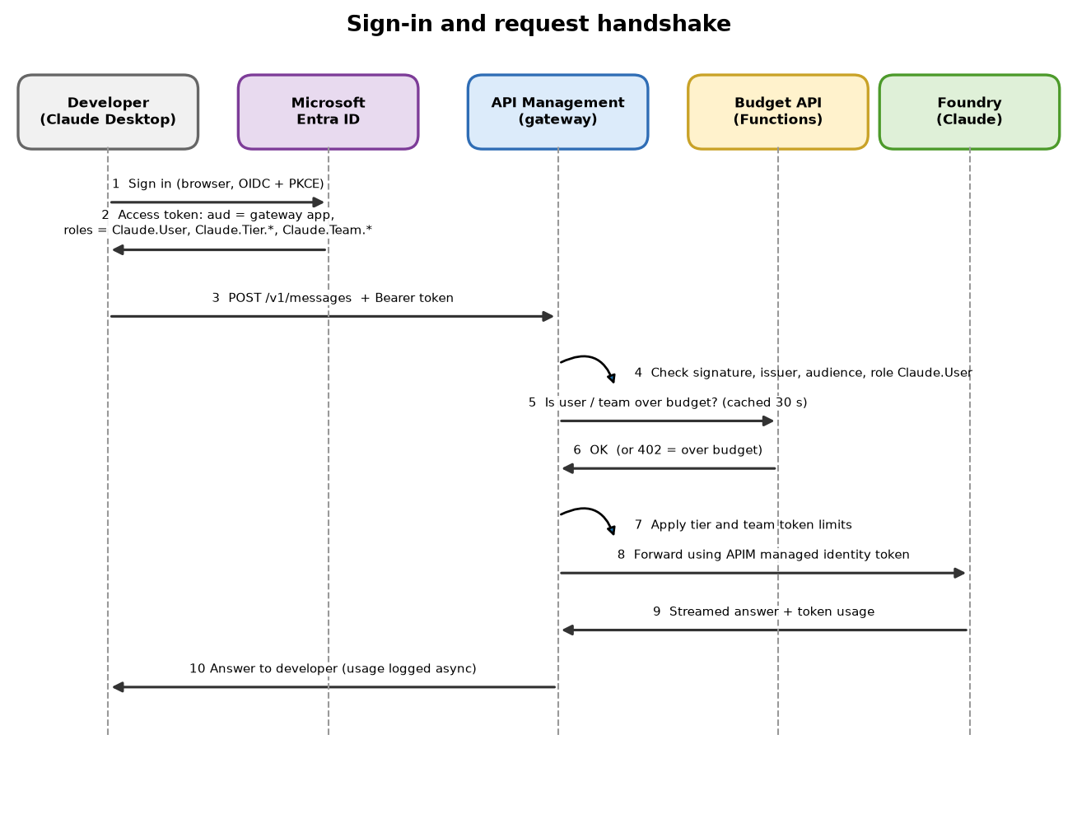
Figure 2: Sign-in and request handshake between the developer, Entra ID, the gateway, the budget API and Foundry.
- Sign in. The developer opens Claude Desktop (or Claude Code). A browser window opens at Microsoft's sign-in page. They sign in with their work account, exactly as for Microsoft 365.
- Token issued. Entra ID returns an access token. It is a signed digital pass that says who the user is and lists their roles (for example Claude.User and Claude.Tier.Pro). The roles come from the groups the person belongs to (chapter 4).
- Call the gateway. Claude sends each request to the gateway address with the token attached.
- Token check. The gateway verifies the token's signature, that it was issued by your tenant, that it was meant for this gateway (the audience), and that it contains the role Claude.User.
- Budget check. The gateway asks the budget API whether the person (and their team) is still inside the monthly dollar budget. The answer is cached for about 30 seconds.
- Limits. The gateway applies the tokens-per-minute and monthly token limits for the person's tier and the team profile.
- Forward to Foundry. If everything passes, the gateway calls Foundry using its own managed identity. The developer's token is never sent to Foundry.
- Answer returned. The reply streams back to the developer.
- Usage recorded. After the reply finishes, APIM writes a usage record to Event Hub and to Log Analytics. The processor turns it into dollars and updates Redis and Cosmos. This happens in the background.
WHY THIS MATTERS
Because the budget is updated in the background, enforcement is near-real-time (seconds to about a minute), not instant. A hard speed limit and monthly token limit inside the gateway act as a safety net that is always instant. This design keeps every request fast, and the budget check is designed to fail open (a budget-service outage does not stop developers working).

3.2 The three trust relationships
Three separate 'handshakes' make the system work. Each uses Microsoft Entra ID and none uses a stored password or key.
Handshake | Who proves what to whom | What makes it work
A. Developer to gateway | The developer proves who they are to APIM. | The Entra token. APIM validates the audience (the Gateway app registration), the issuer (your tenant), the v2 token format and the role Claude.User.
B. Gateway to Foundry | APIM proves it is an approved caller to Foundry. | APIM's system-assigned managed identity is given the Azure role Cognitive Services User on the Foundry account. APIM asks Entra for a token for Foundry and attaches it.
C. Gateway to budget API | APIM proves it is allowed to ask budget questions. | APIM's managed identity requests a token whose audience is the Budget API app registration. The function app's built-in authentication ('Easy Auth') accepts only tokens from APIM's identity.

3.3 Why a token for the gateway is different from a token for Foundry
The most common setup mistake is mixing up two audiences. A token is issued for one specific service. The developer's token is addressed to the Gateway app registration (its identifier looks like api://<gateway-client-id>). It is not valid for Foundry, and it should not be. APIM then gets a different token, addressed to Foundry, using its managed identity.
WHY THIS MATTERS
Keeping the two tokens separate means a developer's token is useless if it leaks to anyone calling Foundry directly, and Foundry never needs to know the individual developers exist. If the gateway audience is configured wrongly, every call fails with a plain 401 that does not say why, so the setup script validates this in preflight.

3.4 Which values must match
The setup script keeps these in step automatically. They are listed so you can recognise them when checking in the portal.
Where it appears | Value | Must equal
Gateway app registration, Application (client) ID | A GUID | APIM named value claude-gateway-audience; config gatewayAudience
Gateway app registration, Application ID URI | api://<gateway-client-id> | Config tokenResource; the scope developers request, api://<id>/access_as_user
Gateway app registration, token version | requestedAccessTokenVersion = 2 | Tokens carry the audience as the bare client ID
Budget API app registration, Application (client) ID | A GUID | APIM named value budget-api-audience; the function app's authentication setting
APIM managed identity | Object (principal) ID and application (client) ID | The client ID (not the object ID) is the identity the budget API accepts
Tenant ID | A GUID | APIM named value entra-tenant-id; the sign-in issuer URL

4. Microsoft Entra objects: apps, roles and groups
The setup creates or reuses three app registrations and, if you use team governance, one security group per team. This chapter explains each one and why it exists.

4.1 What is an app registration?
An app registration is how Entra ID learns about a piece of software. It gets a unique Application (client) ID, and it can define scopes (permissions) and app roles (labels that can be given to people or groups). Every app registration has a matching Enterprise application (also called a service principal) in your tenant. The registration is the definition; the enterprise application is where you assign people and groups.
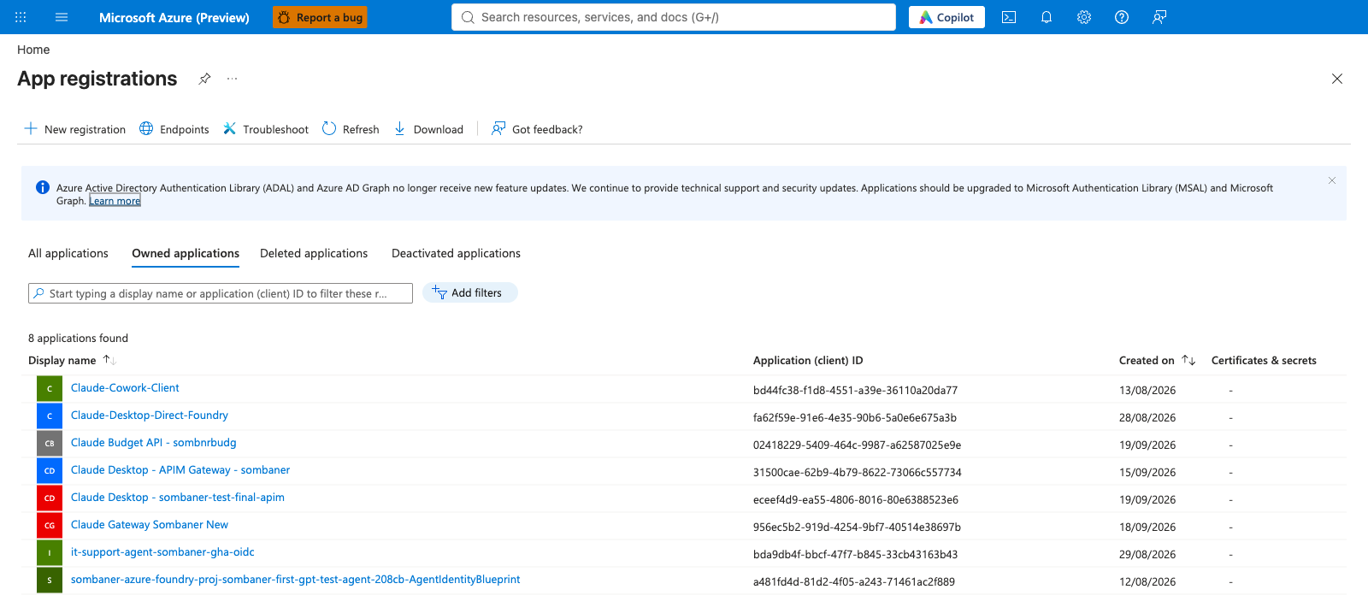
Figure 3: App registrations in the tenant. The gateway, Desktop and Budget API registrations are visible.

4.2 The three app registrations
App registration (default name) | Type | Purpose | Why separate?
Claude Gateway - <apim-name>  (set by gatewayDisplayName) | Web API (the thing being protected) | Defines the audience api://<id>, the delegated scope access_as_user, and every app role (Claude.User, tiers, teams, profiles). Tokens for developers are issued for this app. | It is the one identity the gateway trusts. All authorization decisions come from roles defined on it.
Claude Desktop - <apim-name> | Public client (a desktop/CLI program that cannot keep a secret) | Lets Claude Desktop (and the Claude Code helper) start a sign-in in the browser. Redirect addresses http://localhost and http://127.0.0.1/callback. | A program on a laptop cannot hold a secret, so it uses a public client and the PKCE sign-in method. It is pre-authorised for the gateway scope so users are not asked to consent.
Claude Budget API - <name-prefix> | Web API | The audience for APIM's own calls to the budget API function app. | Keeps the internal budget service reachable only by APIM's identity, not by developers.

The Gateway app registration, in the portal
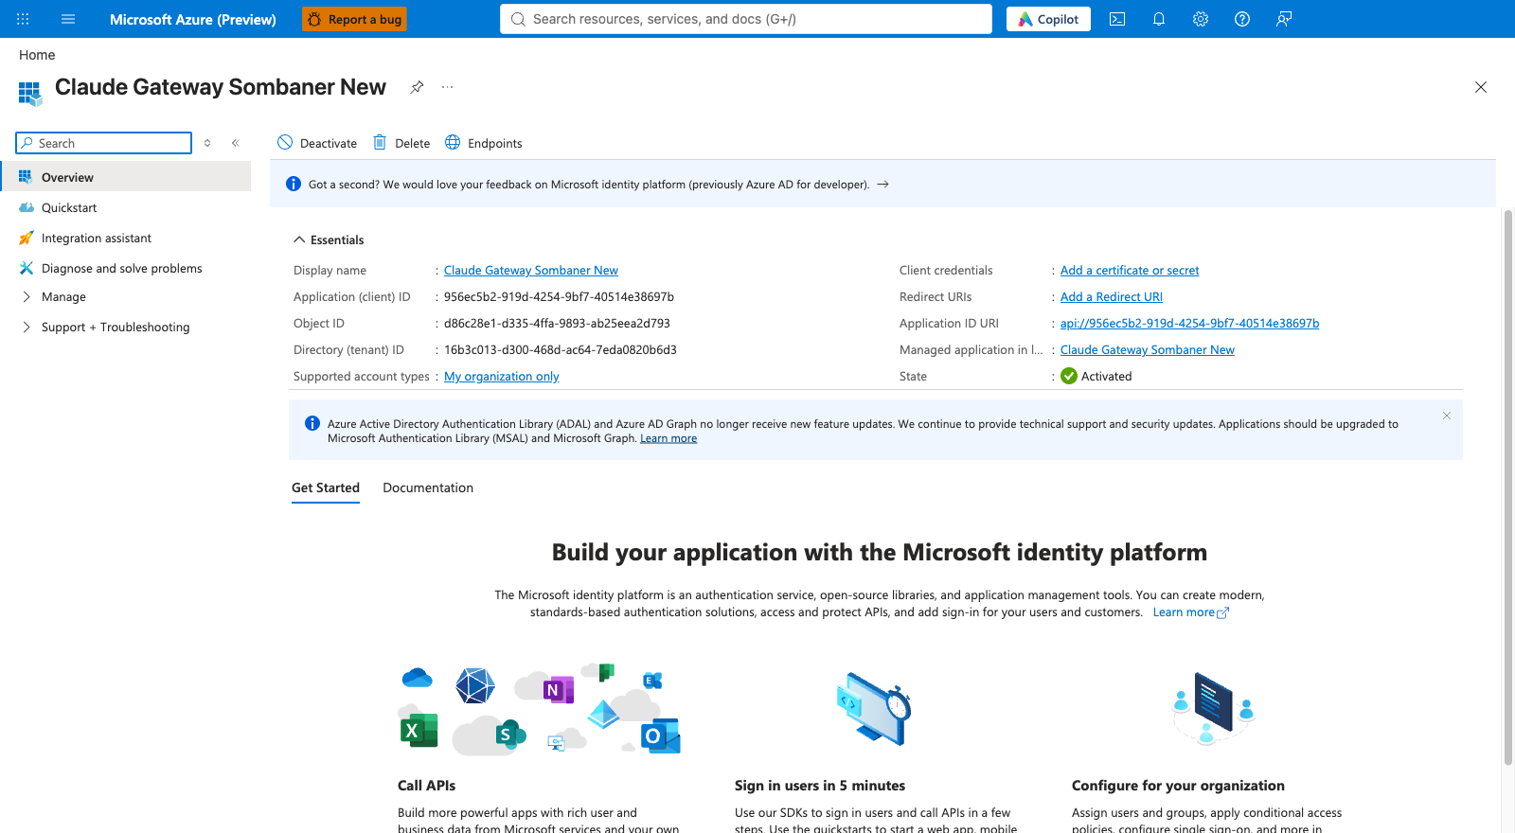
Figure 4: Gateway app registration: Application (client) ID and Application ID URI.
The Application (client) ID is the audience that APIM checks. The Application ID URI (api://...) is what a developer's sign-in asks for.
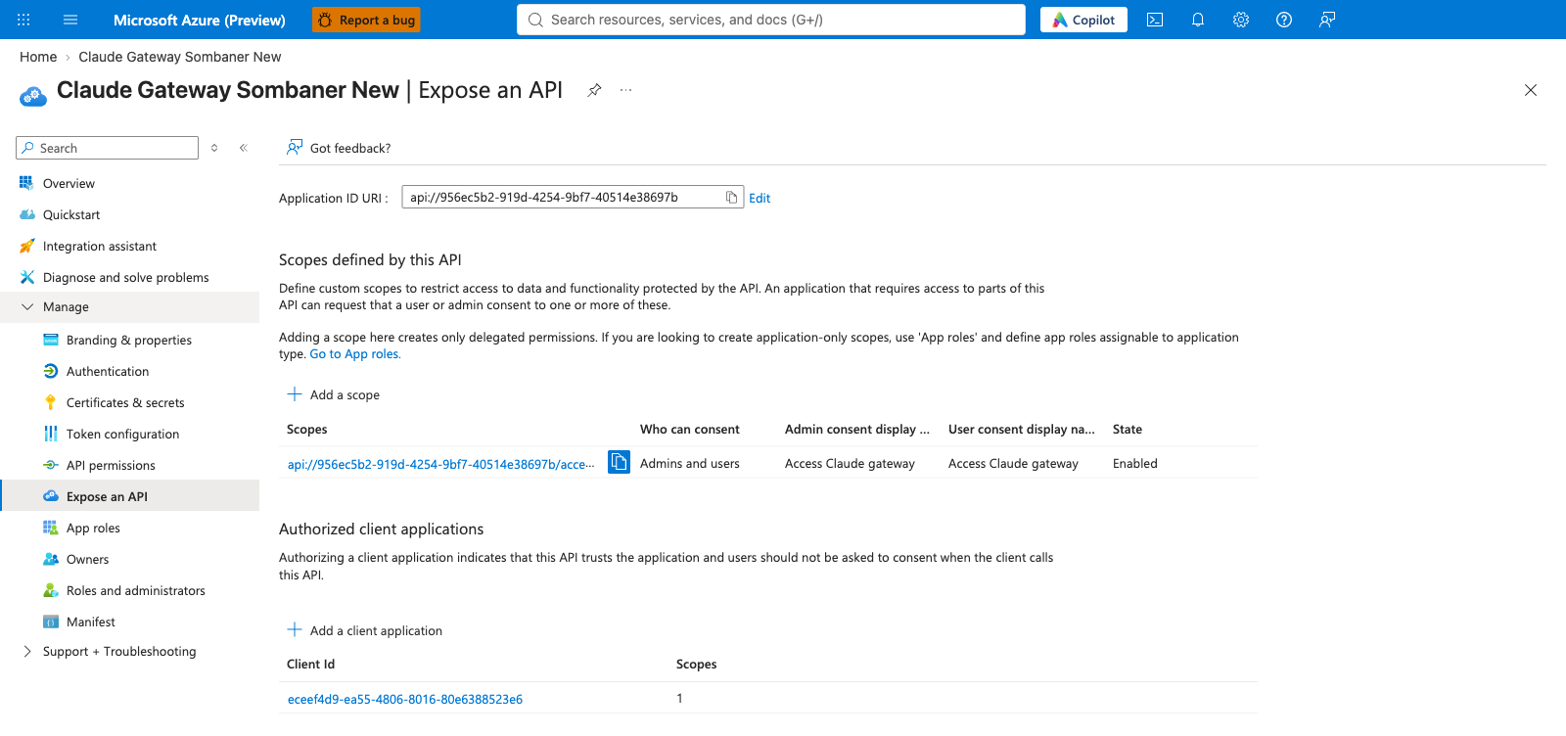
Figure 5: Expose an API: the access_as_user scope and the pre-authorised client application.
WHY THIS MATTERS
Scope `access_as_user` is the permission a developer's sign-in requests. It exists so Entra can issue a token for the gateway on behalf of the signed-in user.
Authorized client applications lists the Desktop app. Because it is pre-authorised, users do not see a consent screen the first time they sign in.

4.3 App roles: the labels the gateway reads
App roles are defined on the Gateway app registration. When a person who has a role signs in, the role names appear in the token's roles claim, and APIM's policy reads them.
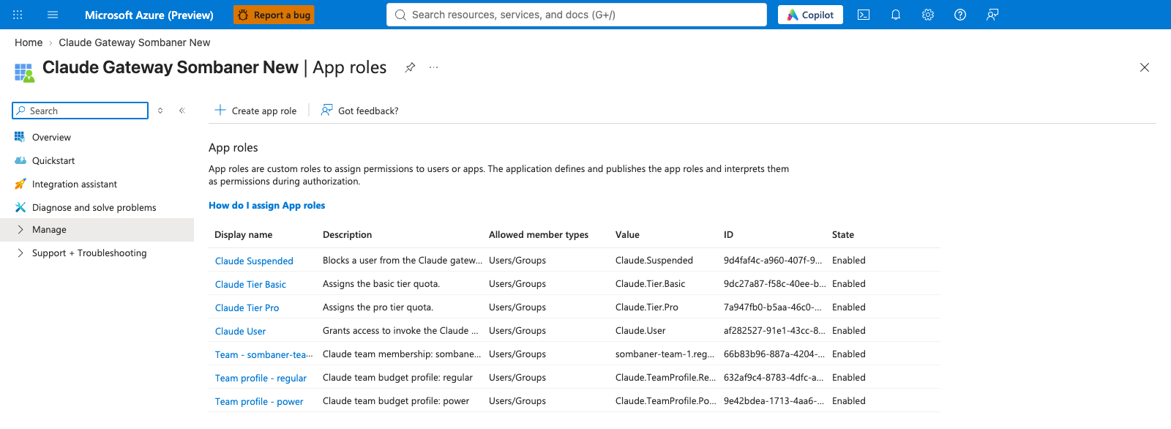
Figure 6: App roles on the Gateway app registration (reference environment).
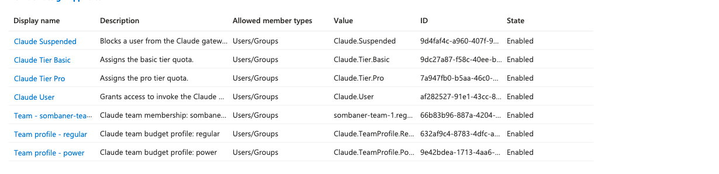
Figure 7: Zoomed view of the app roles table.
App role value | Meaning | Effect in the gateway
Claude.User | Basic permission to use the gateway. | Required. Without it the request is rejected with 401.
Claude.Tier.Pro / Claude.Tier.Basic (and optionally Claude.Tier.Lite) | The person's personal tier. | Picks the personal speed limit, monthly tokens and dollar budget. If a person has more than one, the higher wins (Pro, then Basic). If none, they get Lite, the cheapest tier, so a missing role never means unlimited.
Claude.Suspended | An administrator has blocked this person. | Request is refused with 403, header x-claude-denied-by: admin.
Claude.Team.<id> (you choose, e.g. Claude.Team.FDPO1) | Which team the person belongs to. | Attributes spend to the team and applies the team's model list.
Claude.TeamProfile.Power / Claude.TeamProfile.Regular | The budget profile of the team. | Sets the pooled team limits (see chapter 5).

WHY THIS MATTERS
Tier and suspension are app roles, not group names, on purpose. A token can only list a limited number of groups before Entra stops including them (called group overage). App roles have no such limit, so the gateway always sees the complete list of roles.

4.4 Groups and how they hand out roles
You could assign every person individually, but that becomes unmanageable. Instead the setup uses one Entra security group per team. You add people to the group, and the group is assigned the roles on the Gateway enterprise application. Everyone in the group inherits them.
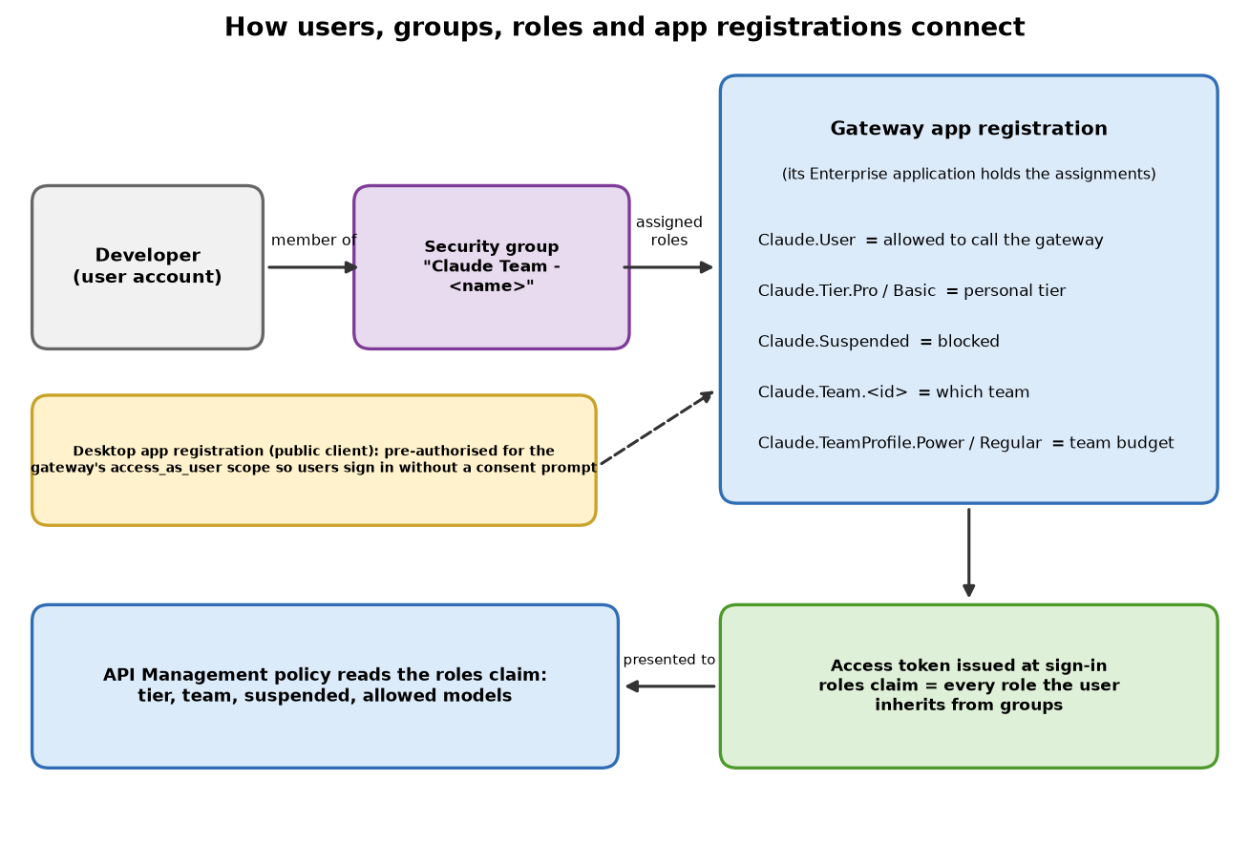
Figure 8: How users, groups, roles and app registrations connect.
Object | Default name | Purpose
Security group (one per team) | Claude Team - <team name> | Holds the team's members. It is assigned four roles on the Gateway enterprise application: Claude.User, the team's default personal tier, the team role, and the team profile.
Optional shared group | e.g. Claude Gateway Users | You may also use one group for people who just need Claude.User without a team.

What a team group looks like
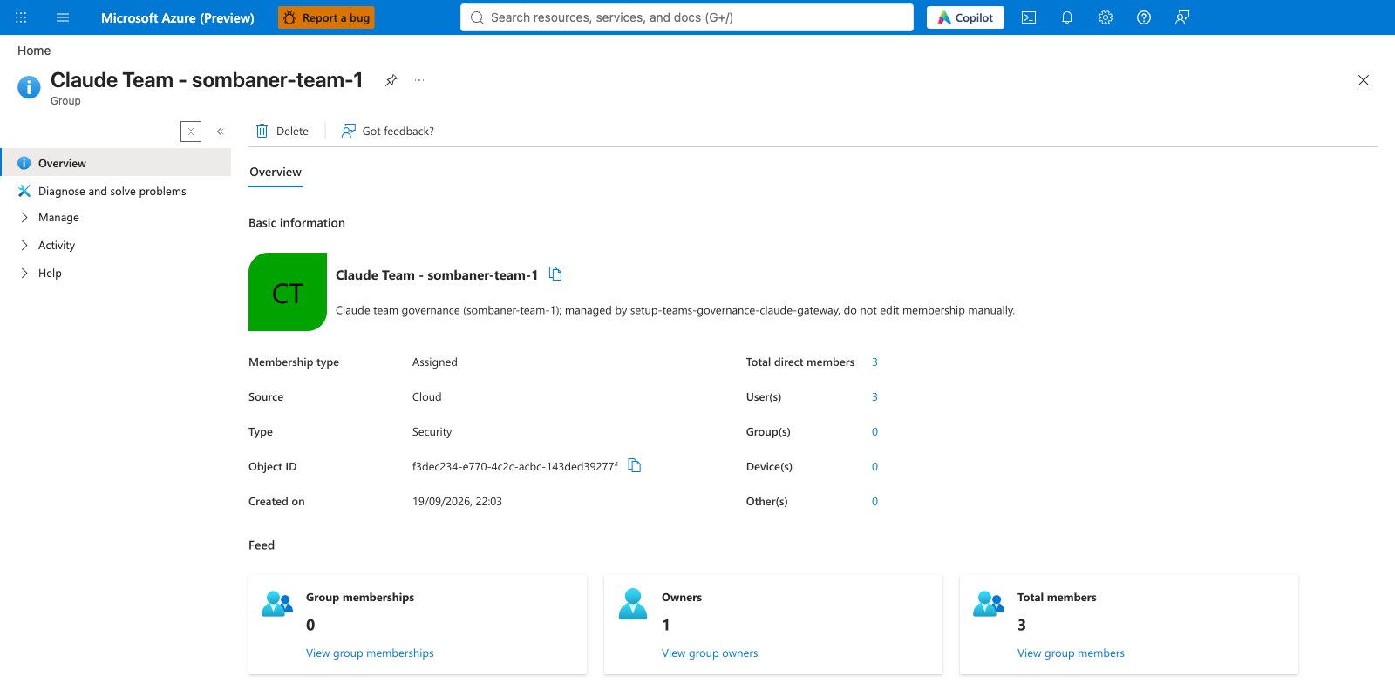
Figure 9: A team security group. The description marks it as managed by the governance script.
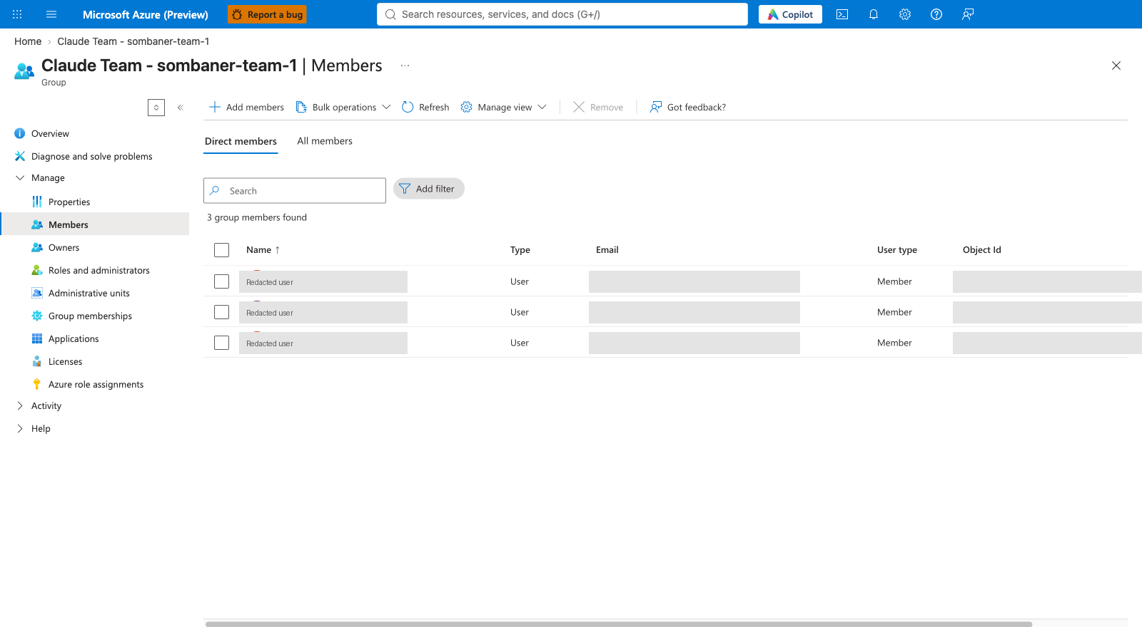
Figure 10: Group membership. Adding or removing a person here changes their access at their next sign-in. Names are redacted.

How the group is connected to the roles
Open Enterprise applications > the Gateway application > Users and groups. Each row is one group + role assignment. A team group appears four times, once per role.
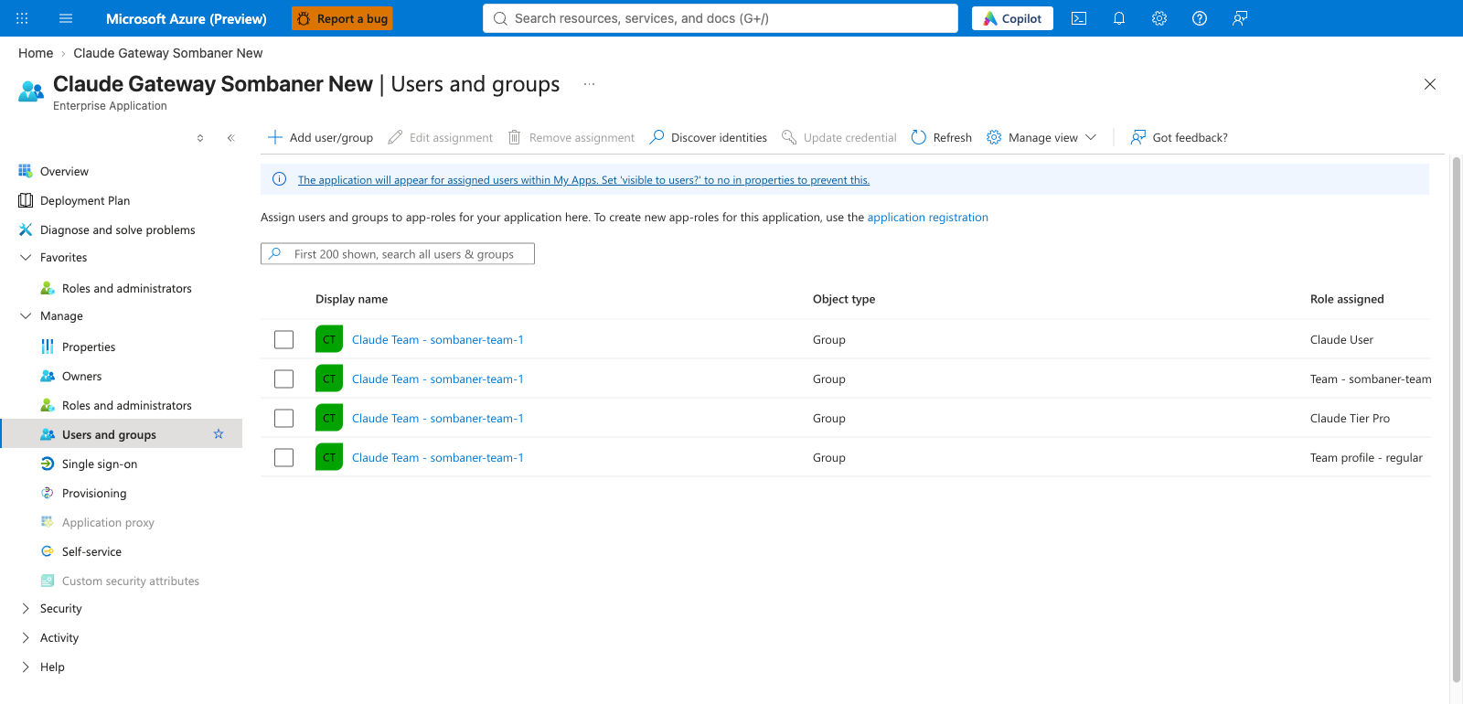
Figure 11: Users and groups on the Gateway enterprise application: one group assigned four roles.
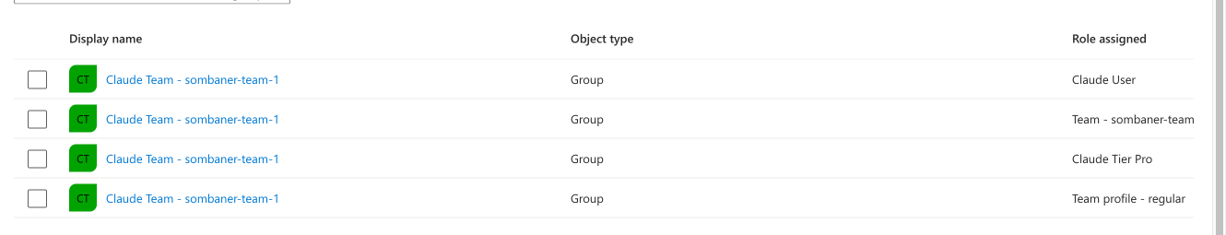
Figure 12: Zoomed view: the same group appears four times, once for each role (Claude User, team role, Claude Tier Pro, team profile).
WHY THIS MATTERS
This screen is the single most useful place to check access. If a developer cannot sign in or has the wrong tier, look here first: is their group listed, with the right roles?

The Desktop and Budget API registrations
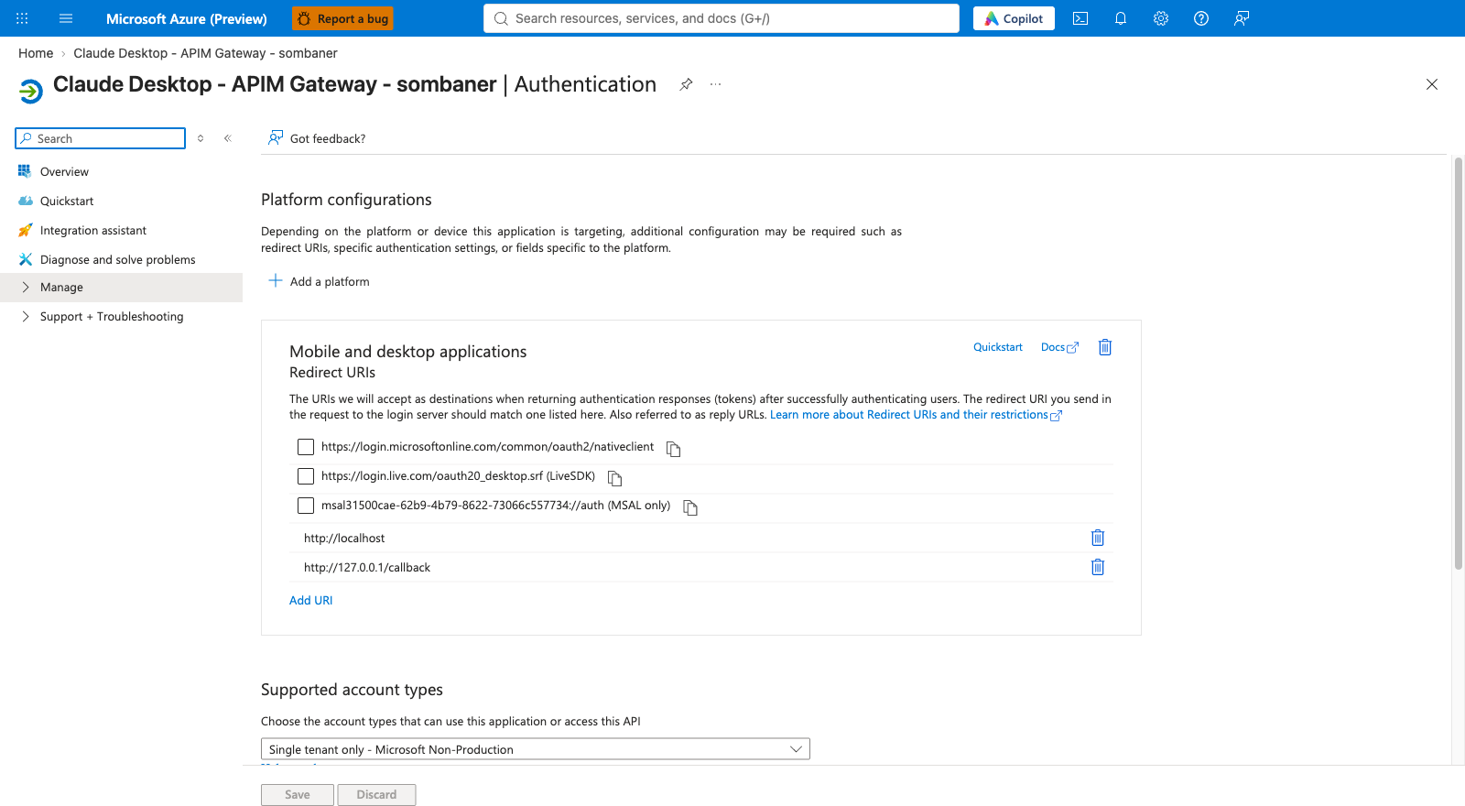
Figure 13: Desktop app: single-tenant public client with the localhost redirect addresses.
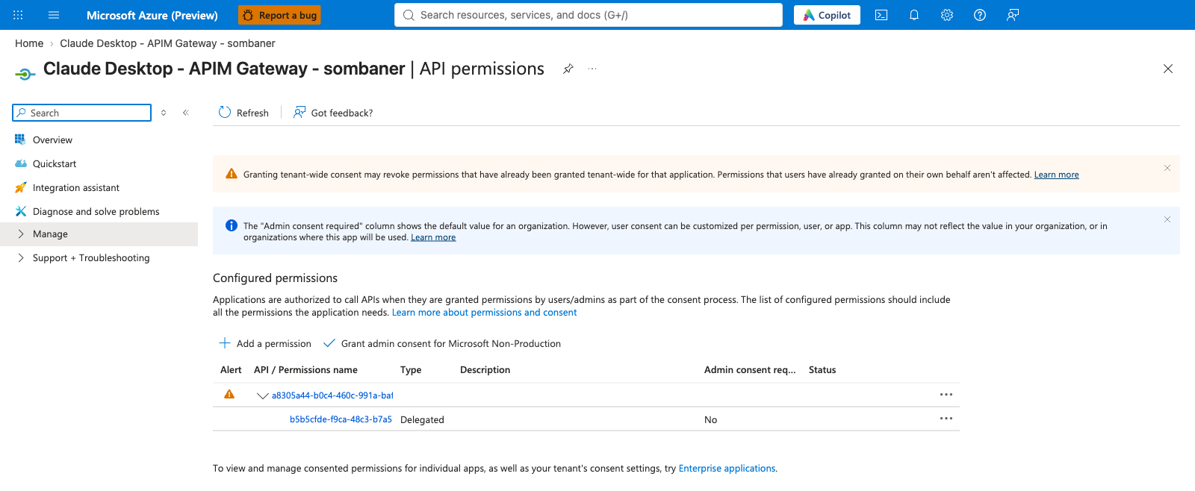
Figure 14: Desktop app: delegated permission to the Gateway API (admin consent not required).
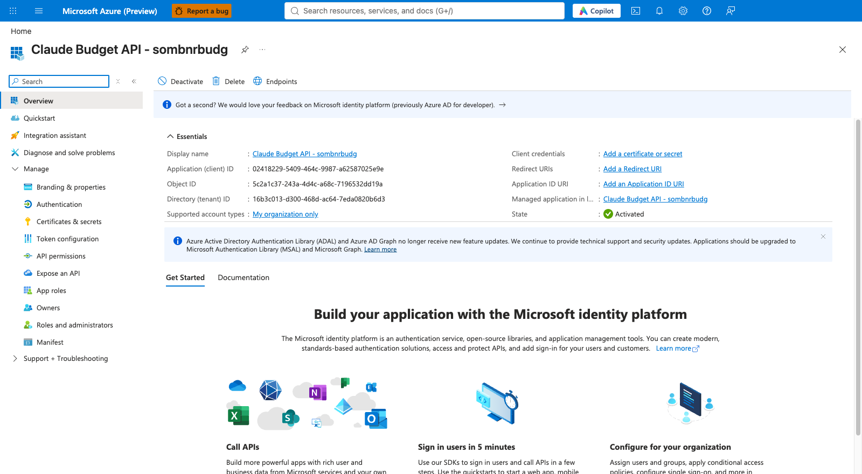
Figure 15: Budget API app registration. It has no secrets and no users; it only identifies the budget service.
NOTE
Licensing: assigning an app role to a group (rather than to individual users) needs a Microsoft Entra ID P1 or higher licence for the people involved. Check with your licence owner before relying on groups.

5. How quotas and budgets work

5.1 Three layers of protection
Layer | What it enforces | When it acts | If it fails
1. Token limits (in APIM) | Tokens per minute (speed) and tokens per month, per person and per team. | Instantly, on the request. | Always-on safety net.
2. Dollar budget (budget API + Redis) | Month-to-date dollars, per person and per team. | Within seconds to about a minute after spend. | Fails open: if the service is unreachable, requests are allowed.
3. Suspension (Entra role) | Manual block with Claude.Suspended. | At the person's next token. | n/a

5.2 Personal tiers
Each person has exactly one personal tier. The numbers below are the defaults in admin/setup.example.json (tiersConfig). You can change them before setup.
Tier | Entra role | Speed (tokens / min) | Monthly tokens (safety net) | Monthly dollars
Pro | Claude.Tier.Pro | 40,000 | 350,000,000 | $1,000
Basic | Claude.Tier.Basic | 20,000 | 175,000,000 | $500
Lite (default) | none needed | 4,000 | 35,000,000 | $100

5.3 Team profiles
A team profile is a budget that the whole team shares. Defaults (teamGovernance.profiles):
Profile | Entra role | Team speed (tokens / min) | Team monthly tokens | Team monthly dollars
Power | Claude.TeamProfile.Power | 500,000 | 700,000,000 | $2,500
Regular | Claude.TeamProfile.Regular | 100,000 | 175,000,000 | $1,000

WHY THIS MATTERS
Individual and team limits apply together. A person can be stopped by their own tier or by their team's pool, whichever is hit first. The team pool stops one team consuming the budget meant for everyone; the personal tier stops one person consuming the team's pool.

5.4 Where the numbers live
The setup writes the tier and profile numbers into APIM named values (shared settings the policy reads). You can see them in the portal, which is a quick way to confirm what is actually in force.
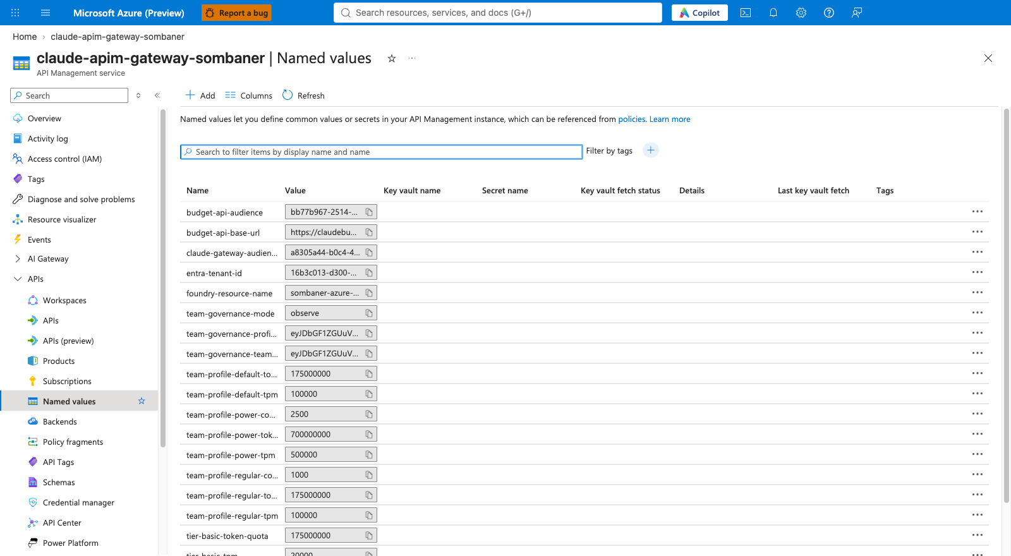
Figure 16: APIM named values: tier and team-profile limits, plus the audience, tenant and governance mode.
CAUTION
Do not edit these values by hand in the portal. The next run of the setup script will overwrite them from your configuration file. Change the configuration file and re-run the setup instead (chapter 13).

5.5 Governance modes: off, observe, enforce
Mode | What happens | Use it for
off | Team features are skipped. Individual tiers still work. | Gateway only, no teams yet.
observe | Teams are recognised and their usage and budgets are measured and shown in the workbook, but identity problems and model restrictions do not block anyone. | A trial period. Check that membership and numbers look right.
enforce | Everything in observe, plus a person whose team or profile role is missing or ambiguous is refused (403, x-claude-denied-by: identity), and models outside the team's allowed list are refused (403, x-claude-denied-by: team-model-policy). | Normal production running, after a successful observe period.

5.6 What the gateway checks, in order
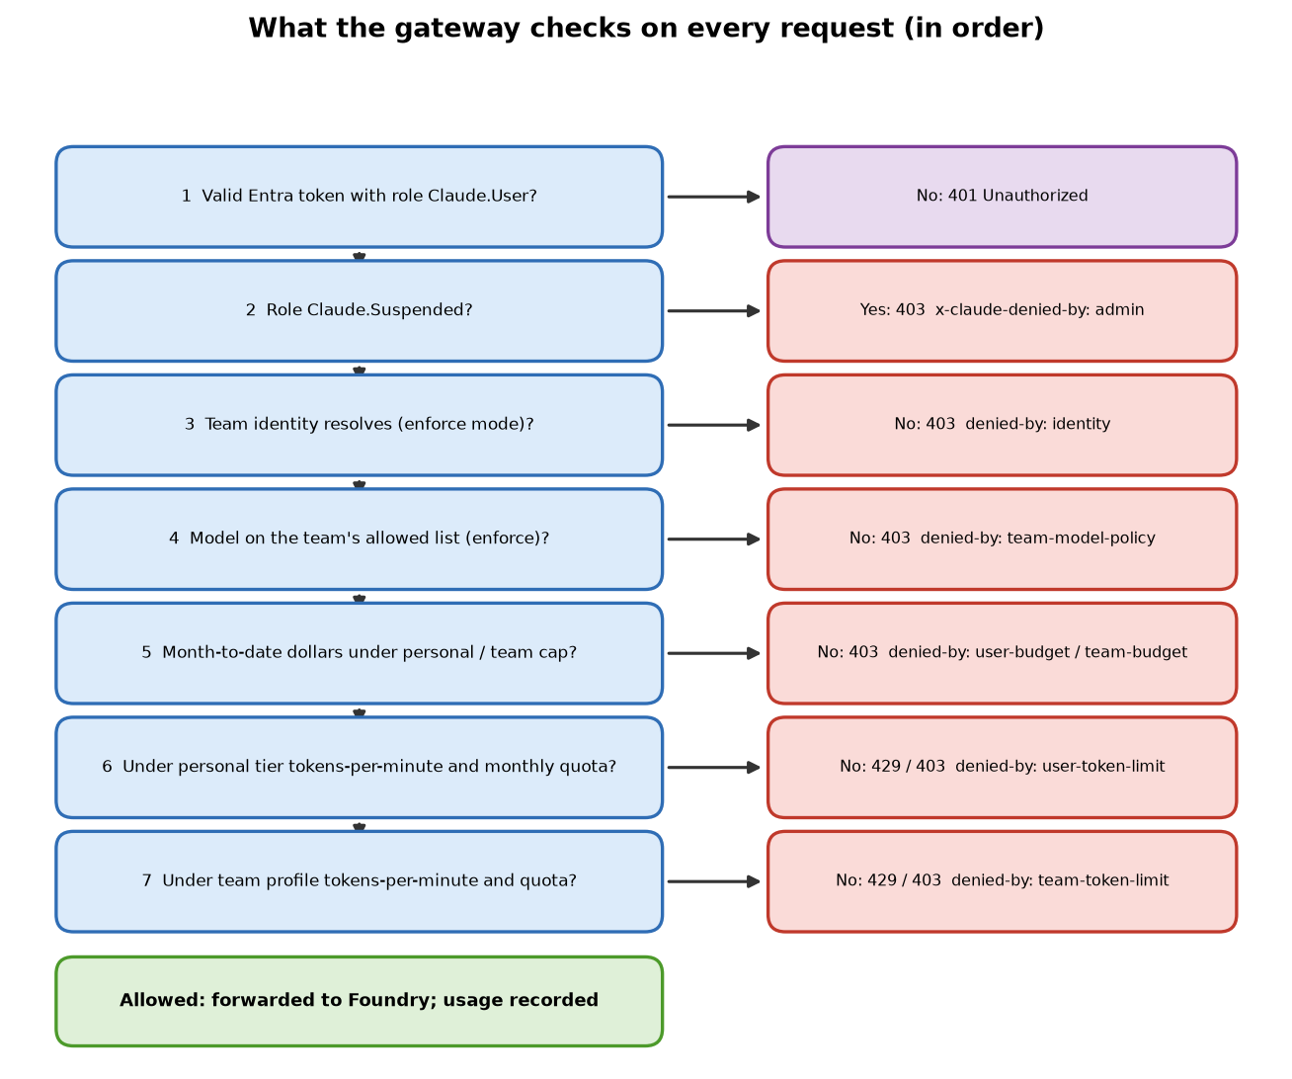
Figure 17: Order of checks and the response each failure produces.
Response | Header x-claude-denied-by | Meaning
401 | (none) | No valid token for this gateway, or the token lacks the Claude.User role: wrong audience, expired, wrong token version, or the person has no Claude.User role.
403 | admin | The person holds Claude.Suspended.
403 | identity | Enforce mode: team or profile role missing, or more than one.
403 | team-model-policy | The requested model is not on the team's allowed list.
403 | user-budget / team-budget | Month-to-date dollars exceeded the personal or team cap.
429 or 403 | user-token-limit / team-token-limit | Tokens-per-minute (429, try again shortly) or monthly token quota (403) reached.

NOTE
Cost is calculated from a price table (PRICES in snippets/15-load-pricing.py, in dollars per 1,000 tokens). Budget accounting is asynchronous and does not count cache-write tokens. You must review the prices against your own agreement before running the setup (chapter 7).

6. Prerequisites
Work through this checklist before running anything. Each item says why it is needed and where to prepare it. Chapter 7 shows the portal steps.

6.1 People and permissions
# | Requirement | Why you need it
P1 | An Azure subscription, and you hold Owner (or Contributor plus User Access Administrator) on the gateway resource group and the Foundry resource group. | The setup deploys resources and assigns Azure roles (for example, letting APIM call Foundry and letting the function apps reach Redis, Cosmos and Event Hub). Role assignment needs more than Contributor.
P2 | In Microsoft Entra ID, you can create app registrations, create groups, and assign app roles. Typical built-in roles: Application Administrator (or Cloud Application Administrator) and Groups Administrator. The setup's Microsoft Graph permissions include Application.ReadWrite.All, Group.ReadWrite.All and User.Read.All. | The script creates the three app registrations, the team groups and the role assignments. It signs in as you via Azure CLI and stores no Graph secret.
P3 | A tenant owner or Global Administrator is available to approve any admin consent prompt. | Some Graph permissions need a tenant-wide approval.
P4 | Microsoft Entra ID P1 (or higher) licence for the people in team groups. | Required for assigning app roles to groups.

6.2 Existing Azure resources
# | Requirement | Why you need it
R1 | A resource group for the gateway (new or empty is best). | Everything the setup creates lives here, so you can find it, secure it, and cost it as one unit.
R2 | A Microsoft Foundry account (resource) that already has Claude model deployments for Opus, Sonnet and Haiku, one of each family. | The gateway forwards to these. The setup checks they exist and records their deployment names.
R3 | A Log Analytics workspace in the same subscription. Note its full resource ID. | Receives gateway logs, price tables and the usage roll-ups the reports are built on.
R4 | Decide the region for APIM (for example centralus). The budget region must be the same as the APIM region. | The Event Hub that carries usage records must be in APIM's region. Cosmos DB and the workbook may use different regions.
R5 | Required resource providers registered on the subscription: Microsoft.ApiManagement, Microsoft.Insights, Microsoft.OperationalInsights, Microsoft.EventHub, Microsoft.Cache, Microsoft.DocumentDB, Microsoft.Storage, Microsoft.Web, Microsoft.Dashboard (only for Grafana). Also Microsoft.Quota for the quota check. | A provider is the switch that lets a subscription create that type of resource. If it is off, deployment fails.
R6 | Elastic Premium EP1 quota of at least 2 in the budget region. | The budget API runs on an EP1 plan with two always-ready instances, so the 30-second budget check is always fast.

6.3 Tools on the machine that runs the setup
Tool | Why it is needed
Azure CLI (az) with Bicep support, plus the quota extension | Signs in to Azure and Entra, creates the app registrations, and runs the infrastructure deployments.
jq | The setup script reads and builds JSON with it.
Python 3 with packages azure-identity, azure-monitor-ingestion, requests, redis | Loads the price table into Log Analytics and Redis, and identifies the signed-in user.
Azure Functions Core Tools v4 (func) | Publishes the two function apps.
Git | To download this repository.
macOS or Linux: bash. Windows: PowerShell 7.2 or newer (pwsh) | Runs the setup script. (Windows PowerShell 5.1 is not supported.)
Network access from your machine to Redis and to Azure Monitor ingestion | The script writes prices directly to both.

CAUTION
Cost. The gateway creates billable services: API Management (v2 tier), a Functions Elastic Premium plan with two always-ready instances, Redis, Cosmos DB, Event Hub, storage and monitoring, plus optional Grafana. Agree the budget with the subscription owner first. Nothing is deleted or purchased automatically beyond what the templates create.

7. Preparing the prerequisites in the Azure portal
Do each step below once. If your organisation already has the item (a Foundry account, a workspace), just note the names and IDs and skip to the next step.

Step 1. Confirm your tenant and subscription
- Go to https://portal.azure.com and sign in with your administrator account.
- Click your account name (top right) and choose Switch directory if needed. Make sure you are in the tenant that will host the gateway and your developers' accounts.
- In the search box type Subscriptions and open it. Open the subscription you will use and copy the Subscription ID.
- In the search box type Microsoft Entra ID, open it, and on the Overview page copy the Tenant ID.
WHY THIS MATTERS
The setup refuses to run if the signed-in tenant differs from the tenant in your configuration. Getting the right tenant now avoids confusing mid-run errors.

Step 2. Create the gateway resource group
- Search for Resource groups and click Create.
- Choose your Subscription, type a Resource group name (for example rg-claude-gateway) and pick a Region.
- Click Review + create, then Create.
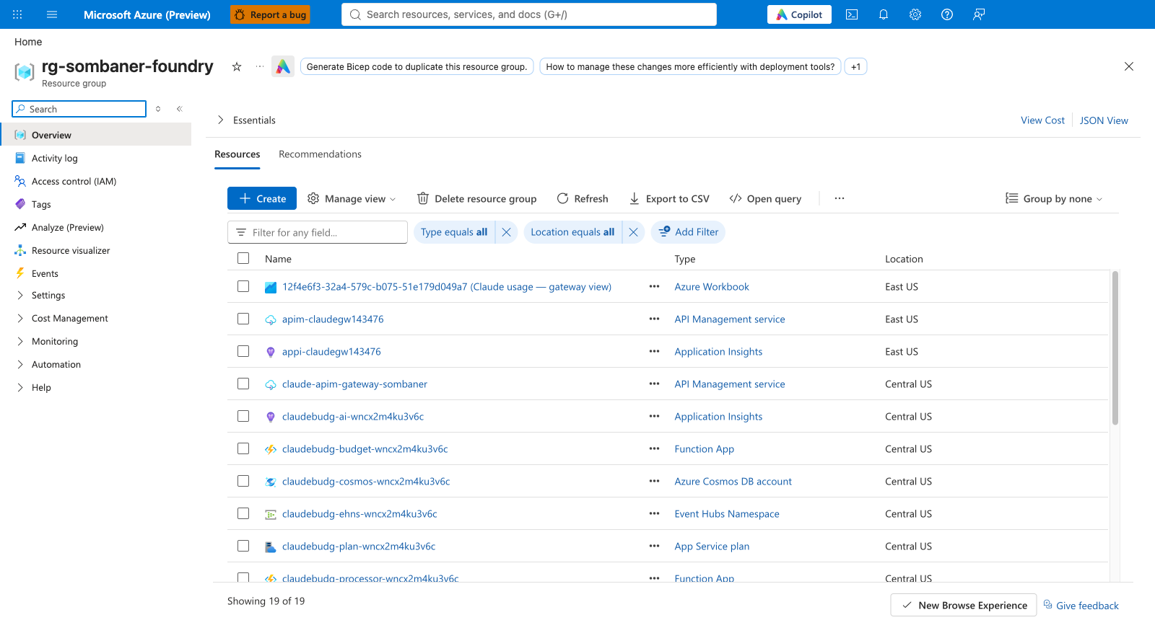
Figure 18: A resource group page. After setup, the gateway's resources appear in this list.
WHY THIS MATTERS
A dedicated resource group keeps the gateway separate from the Foundry account. It also makes cost reports and access control simple. The Foundry account and Log Analytics workspace can stay in their own groups.

Step 3. Make sure Foundry has the Claude models deployed
If you already have a Foundry account with Claude deployed, open its Overview page in the portal and write down the resource group and name.
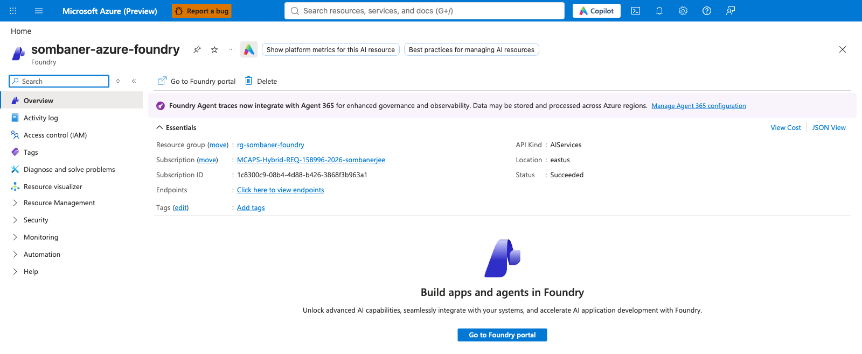
Figure 19: The Foundry account in the Azure portal. Note the account name and resource group.
If you need to deploy the models:
- On the Foundry account page click Go to Foundry portal (opens https://ai.azure.com).
- Open the Model catalog and search for Claude. Choose the Anthropic models you plan to offer (the guide's defaults are claude-opus-5, claude-sonnet-5 and claude-haiku-4-5).
- Click Deploy. Keep the default deployment name or note your own, and choose the hosting option Hosted on Azure.
- Repeat for each model family. Open Models + endpoints (or Deployments) and confirm each shows Succeeded.
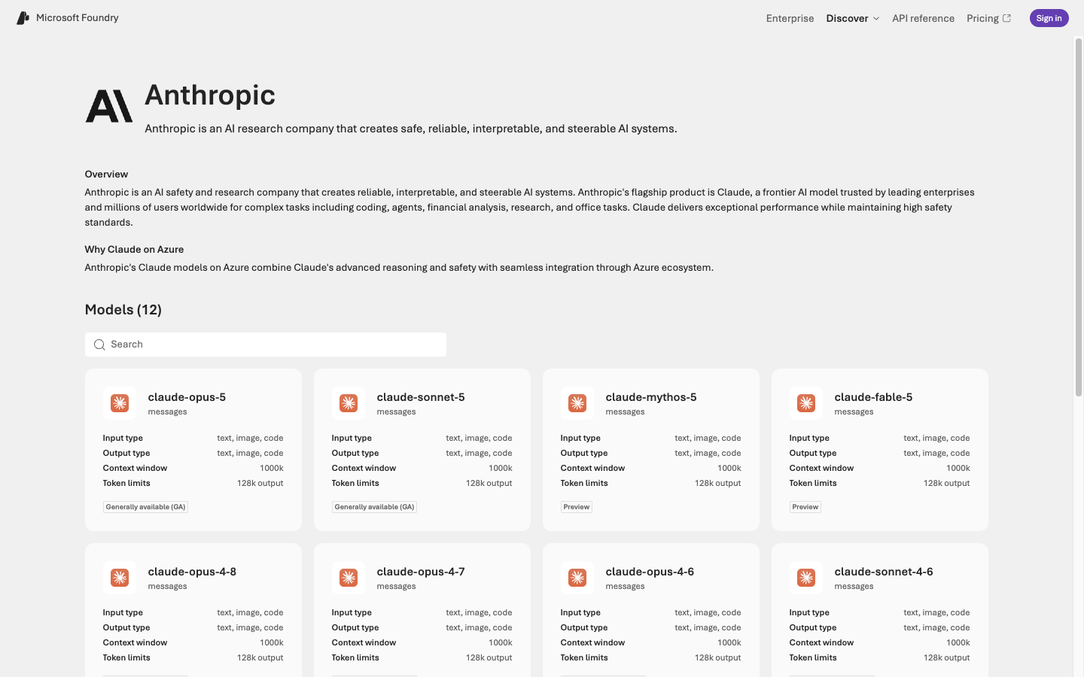
Figure 20: Anthropic models in the Foundry model catalog.
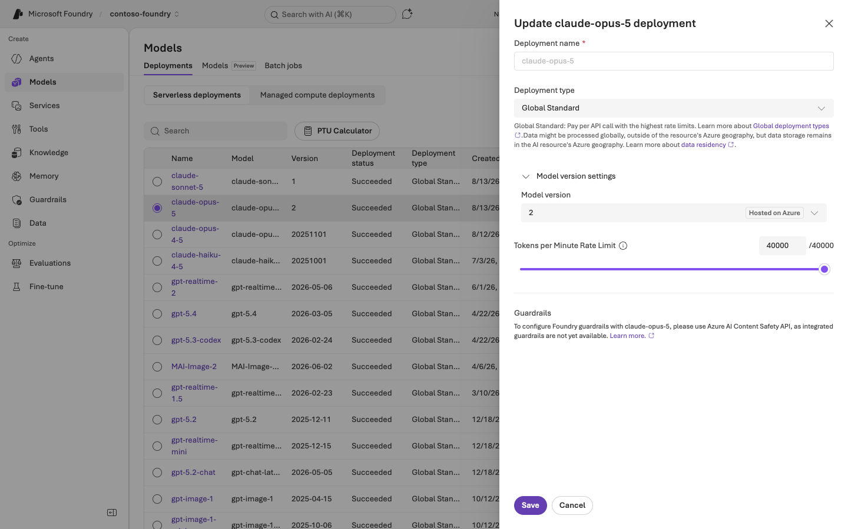
Figure 21: Choose the 'Hosted on Azure' option for the model version.
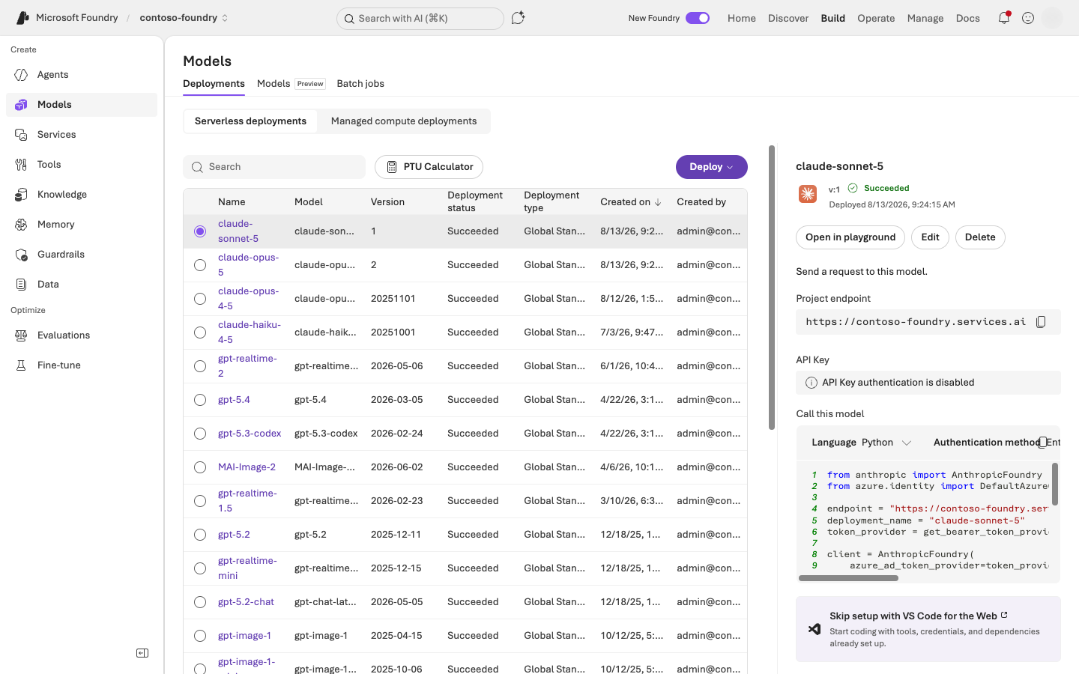
Figure 22: Deployments list: every Claude deployment should show Succeeded.
WHY THIS MATTERS
The gateway forwards to a specific deployment name. The setup script lists the deployments and expects exactly one per family (Opus, Sonnet, Haiku). If you have several, you will name the one to use in the configuration (chapter 8).

Step 4. Create or locate the Log Analytics workspace
- Search for Log Analytics workspaces. If you already have one in this subscription, open it. Otherwise click Create, choose the resource group and a name, pick a region, then Review + create.
- On the workspace Overview page, choose JSON View (top right of the Essentials panel) and copy the Resource ID. It looks like /subscriptions/<id>/resourceGroups/<rg>/providers/Microsoft.OperationalInsights/workspaces/<name>.
- Note the workspace's Location.
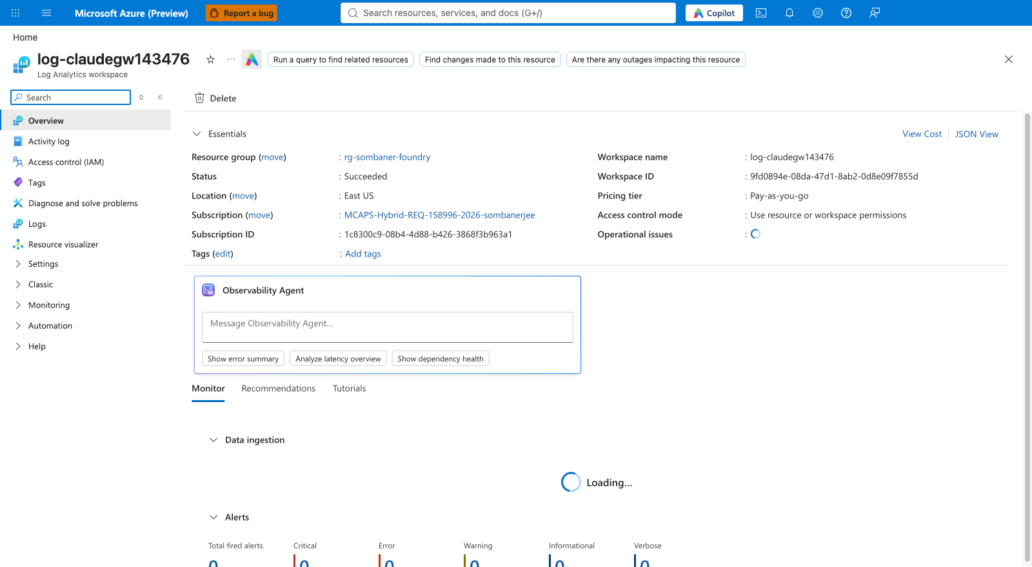
Figure 23: Log Analytics workspace Overview. Workspace name, resource group and location are shown.
WHY THIS MATTERS
The setup creates tables and a data collection rule inside this workspace and writes to it. It must already exist, be in the same subscription, and its stated location must match what you enter (the script checks).

Step 5. Register the resource providers
- Open Subscriptions, select your subscription, then Settings > Resource providers.
- In the filter box type each provider name from item R5 of chapter 6 in turn. If Status says NotRegistered, select the provider and click Register.
- Wait until each shows Registered.
TIP
You can instead set options.registerProviders to true in the configuration and let the setup register them. Registering by hand first is gentler if your organisation reviews subscription changes.

Step 6. Check the Elastic Premium (EP1) quota
- In the subscription, open Settings > Usage + quotas.
- Filter Provider to Microsoft.Web (App Service) and Location to your budget region (the same as APIM).
- Find the Elastic Premium EP1 line. The Limit must be 2 or more, and usage must leave room.
- If not, click Request increase (or choose a different region) and wait for approval before continuing.
WHY THIS MATTERS
The budget API runs on two always-ready EP1 instances so that the budget check never waits for a cold start. A quota shortfall is a very common cause of a failed deployment, and it can take days to approve, so check now.

Step 7. Install the tools
macOS (using Homebrew):
brew install azure-cli jq git python@3.11
brew tap azure/functions && brew install azure-functions-core-tools@4
az extension add --name quota
python3 -m pip install azure-identity azure-monitor-ingestion requests redis
Windows (using WinGet, in PowerShell 7):
winget install Microsoft.AzureCLI Microsoft.PowerShell jqlang.jq Git.Git Python.Python.3.11
winget install Microsoft.Azure.FunctionsCoreTools
az extension add --name quota
py -m pip install azure-identity azure-monitor-ingestion requests redis
NOTE
The setup does not install package managers or change security settings. If your organisation uses an approved software centre, install the same tools from there.

Step 8. Download the setup and sign in
git clone https://github.com/sombaner/claude-on-azure-sombaner.git
cd claude-on-azure-sombaner
az login --tenant <your-tenant-id>
az account set --subscription <your-subscription-id>
az account show --query "{tenant:tenantId, subscription:id}" -o table
CHECK
The last command must show your tenant ID and subscription ID. If either is wrong, repeat the login. The setup script checks this again and stops if they differ.

Step 9. Review the model price table
Open snippets/15-load-pricing.py and find the PRICES section. Compare the rates (dollars per 1,000 tokens, for input, output and cache) with your Azure agreement for each model you will offer.
WHY THIS MATTERS
Dollar budgets are only as accurate as these prices. A missing entry can make usage cost zero dollars, which would silently disable budget limits for that model. The setup will not continue until you confirm review by setting options.pricesReviewed to true.

8. Decide your configuration
The setup reads one configuration file. You can answer prompts interactively (the script builds the file for you) or copy admin/setup.example.json to admin/setup.local.json and edit it. Fill in this worksheet first.

8.1 Core settings
Setting | Your value | Notes
subscriptionId, tenantId |  | From chapter 7, step 1.
resourceGroup |  | Gateway resource group (step 2).
foundryResourceGroup, foundryAccountName |  | Where the Foundry account lives (step 3).
apimName |  | Globally unique across Azure. The gateway URL will be https://<apimName>.azure-api.net.
apimLocation (and budgetLocation) |  | Must be the same region.
cosmosLocation, workbookLocation |  | May differ; subject to regional availability.
workspaceResourceId, workspaceLocation |  | From step 4. Location must match the real workspace.
namePrefix |  | 3 to 11 lowercase letters or digits. Used to name the budget platform resources.
publisherEmail, publisherName |  | Contact shown on the APIM service.
gatewayDisplayName |  | Name of the Gateway app registration, e.g. Claude Gateway - <apim-name>. Must be unique.
models.opus / sonnet / haiku |  | Leave blank to auto-detect when exactly one deployment per family exists; otherwise type the deployment name.
options.pricesReviewed | false | Set to true after step 9.

8.2 Tiers and team governance
Setting | Your value | Notes
tiersConfig (pro / basic / lite) |  | Speed, monthly tokens and dollars per tier. Exactly these three names.
teamGovernance.mode | observe | Start with observe, move to enforce later (chapter 11).
teamGovernance.profiles |  | Team budget profiles (Power, Regular) and their Claude.TeamProfile.* role values.
For each team: name, role value, profile, default personal tier, allowed models, members |  | Members are listed by user principal name (sign-in name). A person can belong to only one team.
teamGovernance.actionGroupIds | [] | Optional: Azure Monitor action groups to receive governance alerts. Empty means no alert rules are created.

8.3 Optional features
Option | Default | What it does
options.workbook | true | Deploys the usage workbook.
options.summaryRule | false | Hourly roll-up table with 30-day interactive / 400-day total retention.
options.grafana | false | Managed Grafana dashboard. Needs name, location and an admin principal.
options.reconcile | false | One-time rebuild of Redis counters from the Cosmos ledger.
options.smokeTest | false | Sends one small, billable test request after setup.
options.checkEp1Quota | true | Checks the EP1 quota in preflight.
options.registerProviders | false | Registers resource providers for you.

WHY THIS MATTERS
Starting team governance in observe is deliberate. It lets you confirm that every person is in exactly one team and that the numbers look right, without anyone being blocked by a membership mistake.

9. Running the setup script
The infrastructure consists of a dozen deployment templates and two function apps. They are deployed by one script so they are built in the right order with the right identities. The script is safe to run again: it creates only what is missing and never deletes resources, directory objects or role assignments. Your role is to run it in three stages and check each result in the portal.

9.1 The order of events
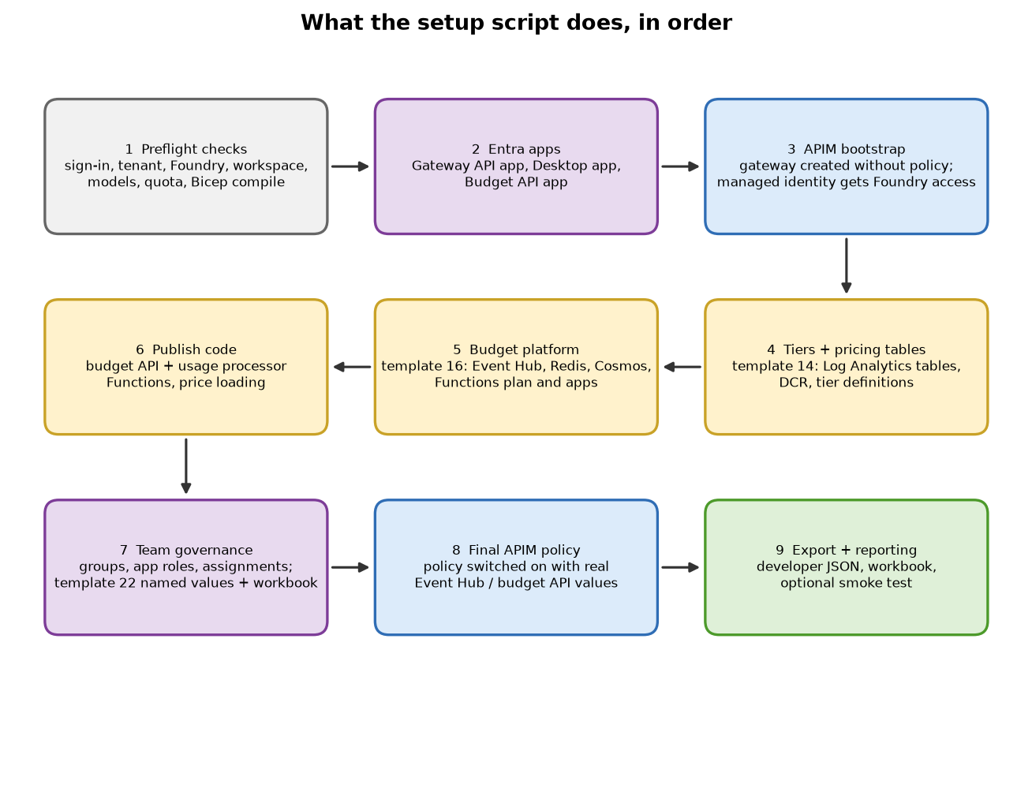
Figure 24: What the setup script does, in order.
Stage | What is created | Why in this order
1. Preflight | Nothing. Reads Azure and Entra. | Finds problems early: wrong tenant, missing model, quota, name clashes.
2. Entra apps | Gateway app (v2 tokens, api:// URI, access_as_user scope, Claude.User role); Desktop public client (pre-authorised); Budget API app. | APIM and the functions need these IDs to be configured.
3. APIM bootstrap | API Management without the policy, with its managed identity. That identity gets Cognitive Services User on Foundry. | The managed identity must exist first so later templates can grant it access.
4. Tiers + pricing tables | Custom tables and a data collection rule in Log Analytics; tier definitions. | Reports and price loading need these.
5. Budget platform | Event Hub, storage, Redis, Cosmos DB, EP1 plan, two function apps, Application Insights, role assignments. | Needs the APIM identity ID (to allow only APIM) and the Budget API audience.
6. Publish code | Loads prices into Log Analytics and Redis; publishes the budget API and usage processor functions. | The services must be running before the policy points at them.
7. Team governance | Team groups, app roles, role assignments, named values and workbook (only if mode is not off). | The policy reads these values.
8. Final APIM policy | Turns the policy on with the real Event Hub and budget API details. | Traffic is only governed once everything it depends on exists.
9. Export + reporting | Writes the developer handoff JSON; deploys the workbook; optional smoke test. | Gives you what developers need.

9.2 Step A: dry run (nothing is touched)
Interactive mode asks you the questions from the worksheet and builds admin/setup.local.json for you. A dry run only validates the file.
bash admin/claude-gateway-setup.sh --interactive --dry-run

# Windows (PowerShell 7):
./admin/claude-gateway-setup.ps1 -Interactive -DryRun
You will be asked, in order: subscription and tenant ID, publisher name, resource group, Foundry resource group, APIM name and location, workspace and workbook locations, publisher email, the gateway app name, the workspace resource ID, the Foundry name, the name prefix, and then whether to configure teams (team name, member e-mail addresses, profile, default tier, team role value and allowed models).
CHECK
The dry run ends with 'DRY RUN: configuration validated'. It makes no Azure calls, so it cannot tell you about permissions or quota; that is the next step.

9.3 Step B: preflight (read-only checks)
bash admin/claude-gateway-setup.sh --config admin/setup.local.json --stage preflight
Preflight confirms:
- you are signed in to the right tenant and subscription;
- the resource groups, the Foundry account and the workspace exist, and the workspace location matches;
- exactly one Claude deployment exists per family (or the names you gave exist);
- the Gateway app registration has v2 tokens, the identifier URI and an enabled Claude.User role (in interactive mode it creates the app for you);
- no existing resource is in a different region from the one you chose;
- EP1 quota allows at least two instances; and every Bicep template compiles.
WHY THIS MATTERS
No Azure resource is changed. Every failure here is cheap and quick to fix, so use this stage until it passes. Chapter 14 lists each error message and its remedy.

9.4 Step C: the full deployment
CAUTION
This creates billable resources and changes the gateway. For an existing gateway, run it in a maintenance window: updating the policy or function code can briefly affect traffic. A new gateway starts with a fail-open budget check, so do not onboard users until the checks in chapters 10 and 11 pass.

bash admin/claude-gateway-setup.sh \
--config admin/setup.local.json \
--non-interactive --yes --debug \
--log-file logs/claude-gateway-setup.log
- --yes is your explicit approval to make changes. Without it the script stops after reviewing.
- --debug prints timestamped progress; --log-file keeps a copy in a file you can send to support.
- The budget platform deployment is the slow part. In the reference run it took about 31 minutes. The whole run commonly takes 40 to 60 minutes. Leave the window open.
TIP
If the run stops part-way, fix the cause and run the same command again. The script reuses what exists. You can also resume a single stage with --stage reporting, --stage retention or --stage export.

10. Verify the result in the Azure portal
After the script finishes, walk through the portal in this order. Each check says what it proves.

10.1 The resources exist
- Open Resource groups and your gateway resource group.
- Confirm you can see the resources listed in the table below.
Figure 25: Resource group after setup: API Management, Function Apps, Cosmos DB, Event Hub, App Service plan, Application Insights and the workbook.
Resource type (portal name) | Name pattern | Purpose
API Management service | your apimName | The gateway.
Event Hubs Namespace | <prefix>-ehns-... | Carries usage records.
Function App (x2) | <prefix>-budget-..., <prefix>-processor-... | Budget API; usage processor.
App Service plan | <prefix>-plan-... (EP1) | Runs both function apps.
Azure Cache for Redis | <prefix>-redis-... | Fast month-to-date counters and flags.
Azure Cosmos DB account | <prefix>-cosmos-... | Permanent usage ledger.
Storage account | <prefix>st... | Function host storage (identity-based, no keys).
Application Insights | <prefix>-ai-... | Function app telemetry.
Data collection rule | dcr-claudeprice-... | Path for loading price data into Log Analytics.
Azure Workbook | Claude usage - gateway view | Usage and cost dashboard.
Managed Grafana (optional) | your grafanaName | Optional dashboard.

10.2 The deployments succeeded
Open the resource group, then Settings > Deployments. You should see numbered deployments such as 04-apim-gateway, 14-claude-tiers, 16-budget-platform, 22-team-governance and 09-workbook, each Succeeded.
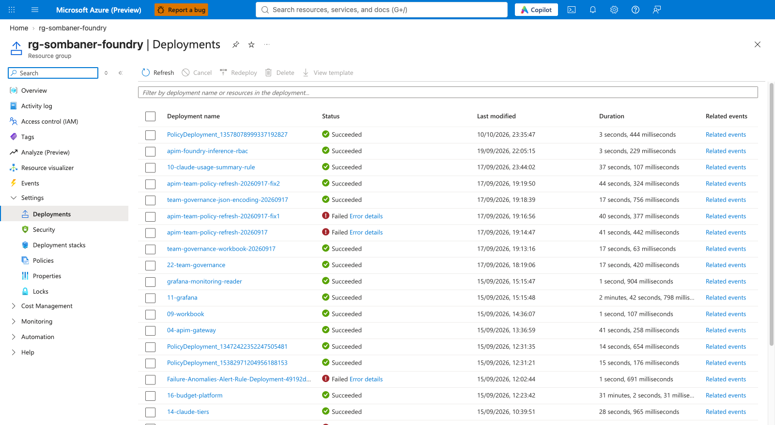
Figure 26: Deployment history. The numbered templates are this setup; other entries are created by Azure itself.
NOTE
Entries whose names do not match the numbered templates (for example PolicyDeployment... or Failure-Anomalies...) are normally created by Azure platform features and are not part of this setup.

10.3 The gateway (API Management)
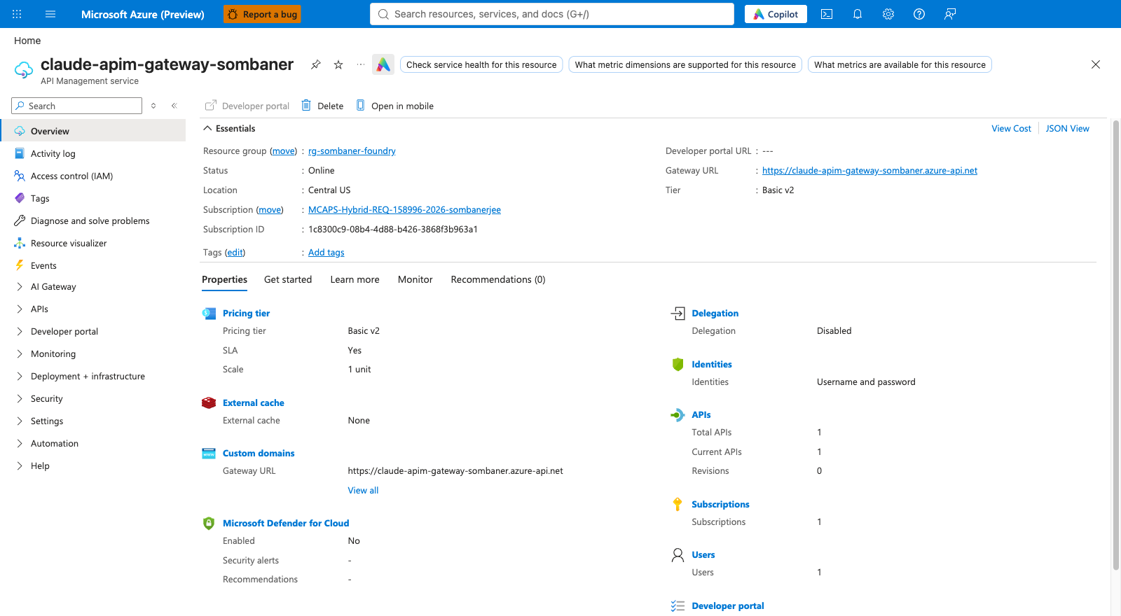
Figure 27: API Management Overview: status Online, a v2 tier and the gateway URL.
- Status is Online and the tier is a v2 tier (Basic v2, Standard v2 or Premium v2).
- Copy the Gateway URL. This is the address developers use (with /anthropic added).
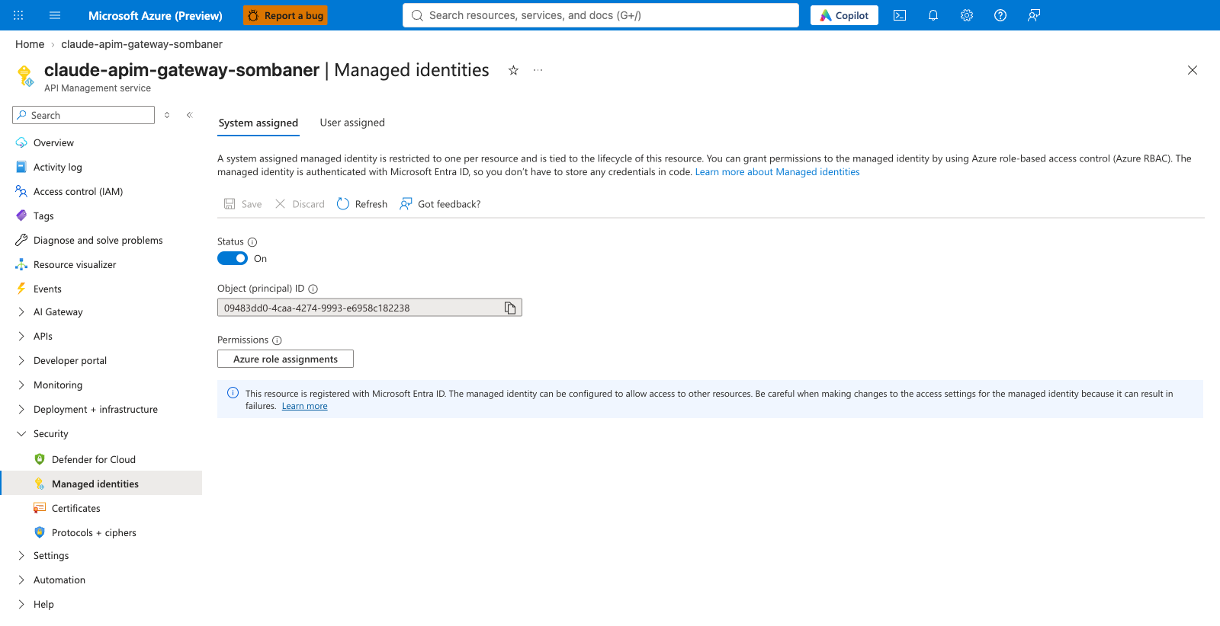
Figure 28: APIM Managed identities: the system-assigned identity is On.
WHY THIS MATTERS
This identity is how APIM signs in to Foundry and the budget API. Select Azure role assignments on this page to confirm it holds Cognitive Services User on the Foundry account.

CHECK
Open the Foundry account, then Access control (IAM) > Role assignments and search for the APIM name: it should hold Cognitive Services User.
Open APIM, then Named values: you should see the audience, tenant ID, tier and team-profile values, and team-governance-mode set as chosen (see Figure in chapter 5).

10.4 The budget platform
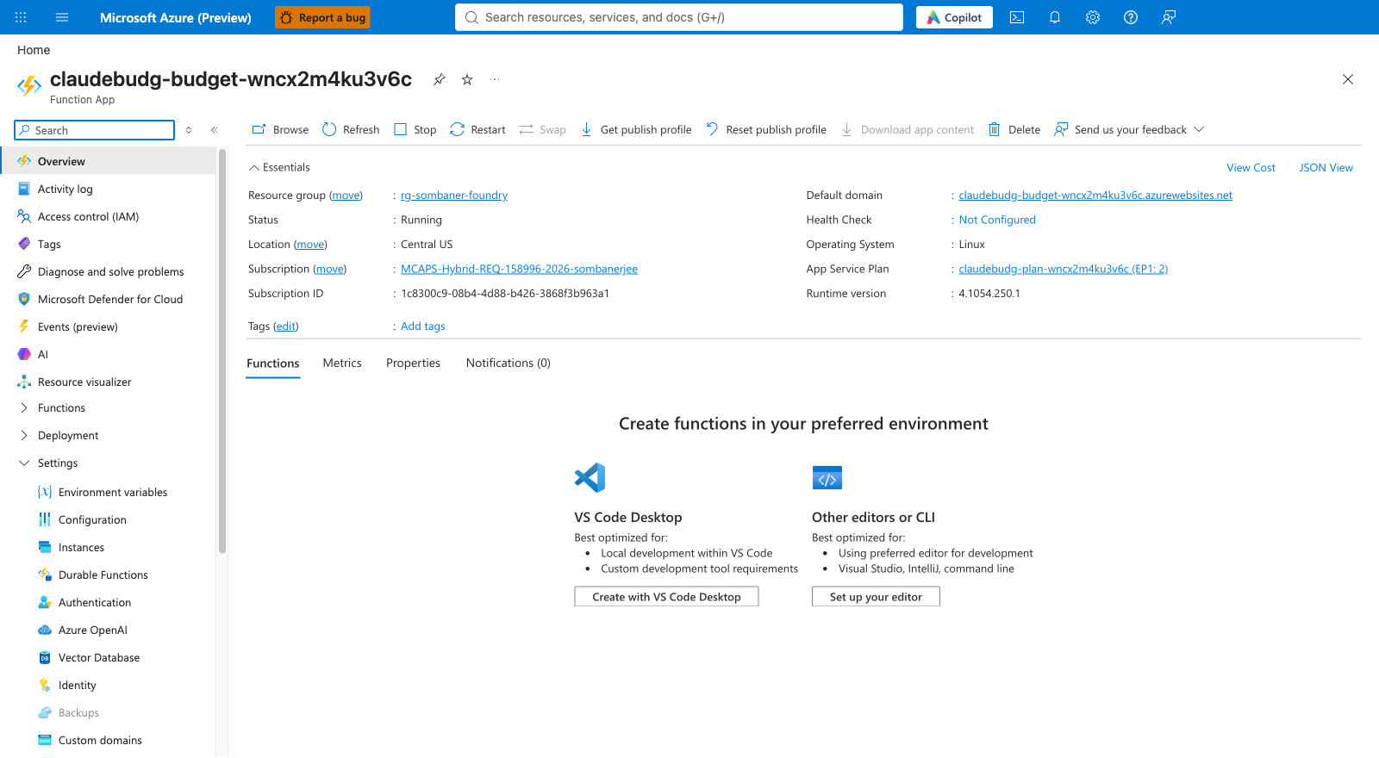
Figure 29: The budget API function app: status Running, on the EP1 App Service plan.
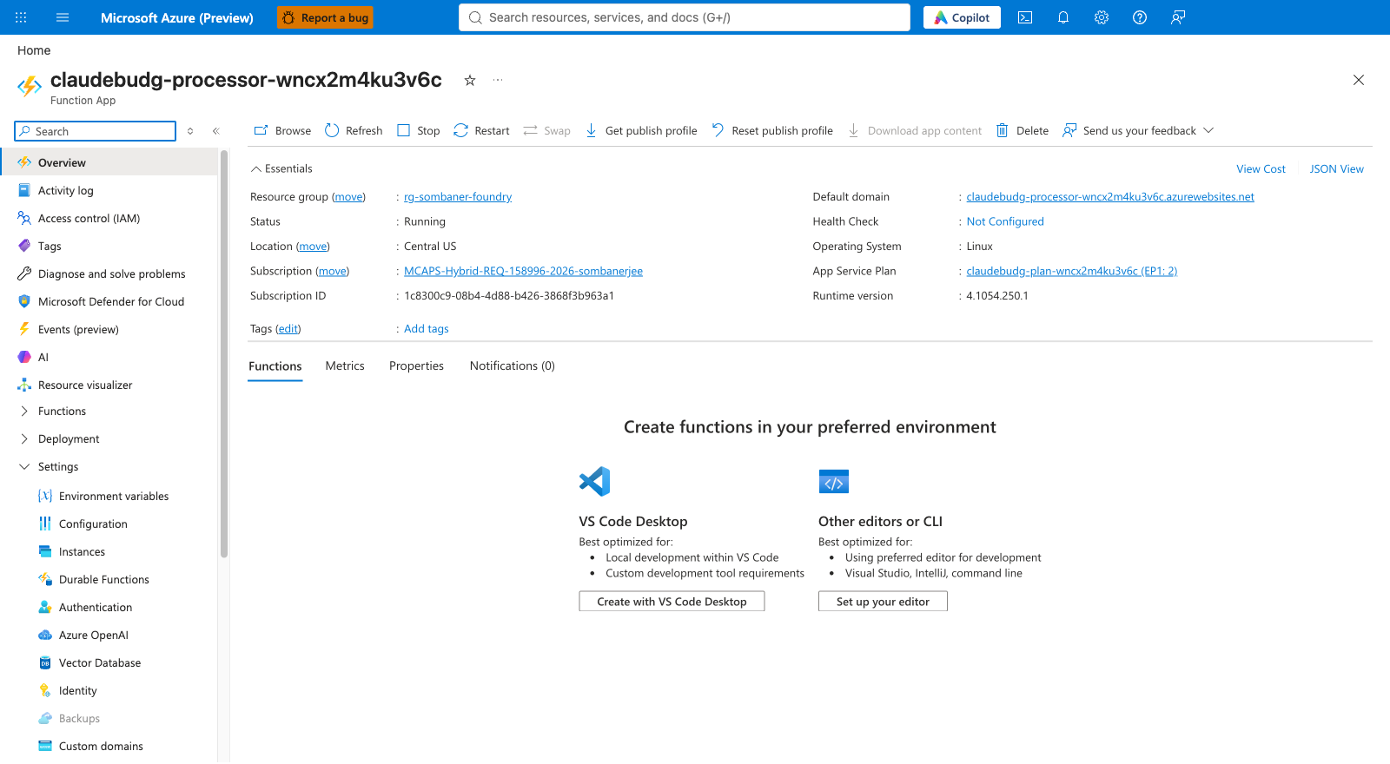
Figure 30: The usage processor function app: Running on the same plan.
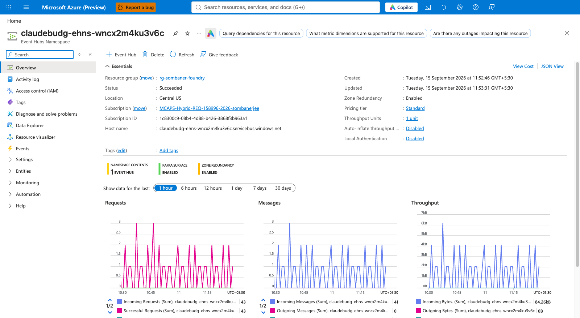
Figure 31: Event Hub namespace: once users make requests, Incoming Messages will show activity.
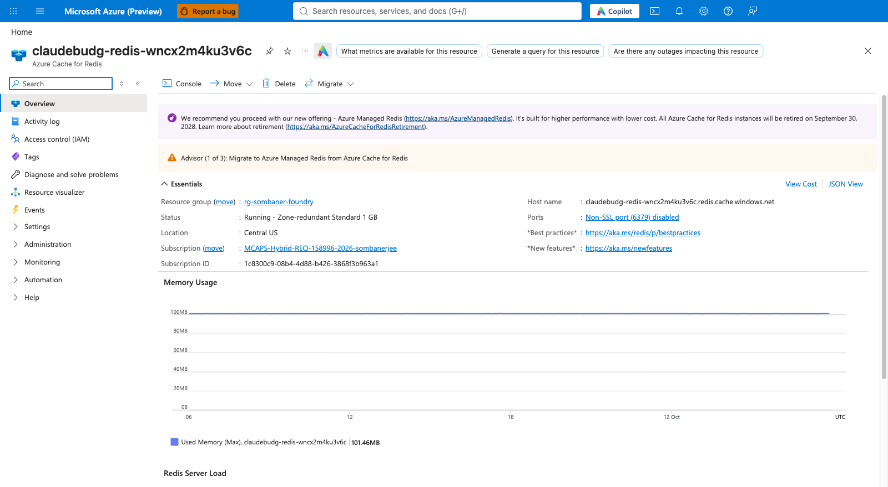
Figure 32: Redis cache: Running, with the host name used by the budget services.
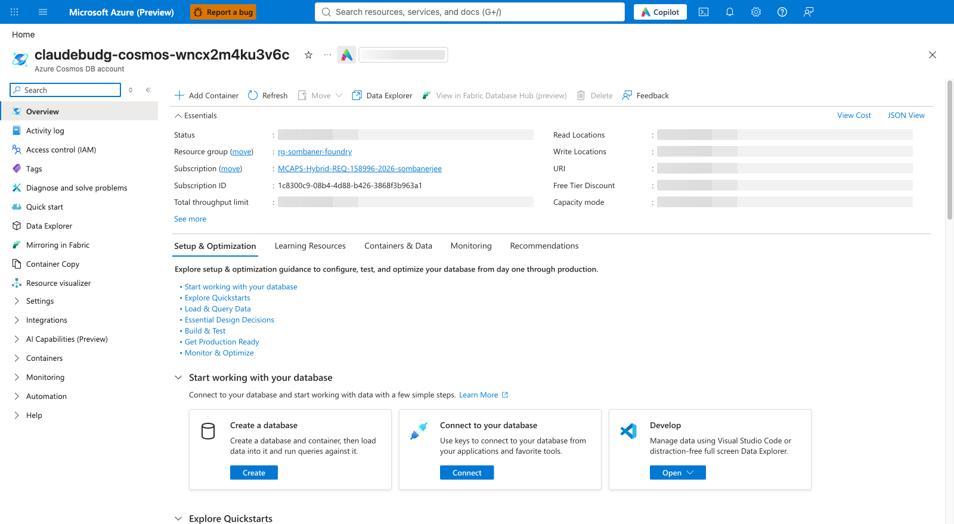
Figure 33: Cosmos DB account used as the permanent ledger.
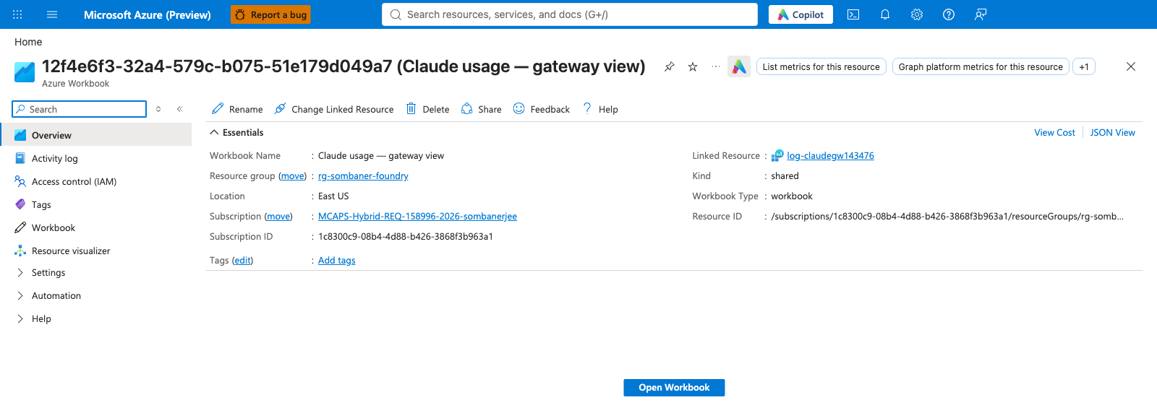
Figure 34: The usage workbook resource, linked to the Log Analytics workspace.

10.5 The Entra objects
- Open Microsoft Entra ID > App registrations > Owned applications and confirm the Gateway, Desktop and Budget API registrations (Figure in chapter 4).
- Open the Gateway registration: Expose an API shows access_as_user as Enabled; App roles shows Claude.User plus tier and team roles as Enabled.
- Open Enterprise applications > (Gateway) > Users and groups: each team group appears with its roles.
- Open the Desktop registration: Authentication shows the two localhost redirect addresses under Mobile and desktop applications; API permissions lists the Gateway scope.
WHY THIS MATTERS
These four checks cover every Entra link in the chain: the audience exists, the roles exist, the people have them, and the sign-in client is allowed to ask for the scope.

11. Team governance and quota integration
This is the final integration: connecting people to tiers, teams and budgets. The setup script can do all of it from your configuration file. This chapter shows how to do the same steps by hand in the Azure portal, which is useful to understand what the script did, to fix one person quickly, or if your organisation requires manual approval for directory changes.

11.1 What must be true for one person to be governed
Requirement | How it is satisfied
Person can reach the gateway at all | They are in a group assigned Claude.User (or have it directly).
Person gets the right personal tier | Their group is assigned exactly one tier role (Claude.Tier.Pro or Basic). No tier role means Lite.
Person is attributed to one team | They belong to exactly one team group, and that group is assigned one Claude.Team.* role and one Claude.TeamProfile.* role.
Person is allowed to use certain models | The team's allowedModels list (enforced when mode is enforce).

11.2 Option A: let the script do it (recommended)
The main setup already calls the team-governance script when teamGovernance.mode is observe or enforce. You can also run it on its own at any time. It only adds: it creates missing groups, roles, members and assignments, and never removes anything.
# 1. Offline validation of the configuration (no Azure calls)
bash admin/setup-teams-governance-claude-gateway.sh --config admin/setup.local.json --dry-run

# 2. Read-only comparison with what is really in Entra (reports drift; changes nothing)
bash admin/setup-teams-governance-claude-gateway.sh --config admin/setup.local.json --check

# 3. Apply the changes after reviewing steps 1 and 2
bash admin/setup-teams-governance-claude-gateway.sh --config admin/setup.local.json --yes \
--manifest-output logs/team-governance-manifest.json
WHY THIS MATTERS
--check is your safety net. It tells you exactly what would change. Keep the manifest file the script writes as audit evidence of who was put into which team.

11.3 Option B: do it by hand in the portal

Step 1. Make sure the roles exist on the Gateway app
- Go to Microsoft Entra ID > App registrations > Owned applications and open the Gateway registration.
- Select App roles. Confirm Claude.User, Claude.Tier.Pro, Claude.Tier.Basic, Claude.Suspended, and the team and profile roles you need are listed and Enabled.
- To add one, click Create app role and enter: Display name (for example Team - FDPO Team 1), Allowed member types = Users/Groups, Value (for example Claude.Team.FDPO1), a Description, and keep Do you want to enable this app role? ticked. Click Apply.
CAUTION
The Value is what the gateway reads, and it is case-sensitive. A profile role must be named Claude.TeamProfile.<Name> and the name must match the profile in your configuration. Never delete or rename an existing role that people already hold.

Step 2. Create the team's security group
- Go to Microsoft Entra ID > Groups > New group.
- Group type: Security. Group name: Claude Team - <team name>. Description: say that it is managed for Claude governance.
- Under Members, click No members selected, tick the team's people and click Select.
- Click Create.
WHY THIS MATTERS
A security group is the simplest object that can be given an app role. Naming every group Claude Team - ... makes them easy to find and audit.

Step 3. Assign the roles to the group
- Go to Microsoft Entra ID > Enterprise applications and open the Gateway application (same name as the app registration).
- Select Users and groups, then Add user/group.
- Under Users and groups click None selected, search for the team group, select it and click Select.
- Under Select a role pick Claude User, then click Assign.
- Repeat steps 2 to 4 for the group's personal tier role, its team role and its team profile role. Each role is a separate assignment. Four roles means four rows.
Figure 35: Result: the group appears once per assigned role.
CHECK
You should end with four rows per team: Claude User, one Tier role, one Team role and one Team profile role. Fewer rows means a quota or team rule will not apply.

Step 4. Add or remove a person later
- Open the team group and select Members.
- To add, click Add members. To remove, tick the person and click Remove.
- Ask the person to sign out of Claude and sign in again (or wait for their token to renew, normally within an hour).
WHY THIS MATTERS
Roles are written into the token when it is issued. Changing membership does not change a token already in use. This also means suspension takes effect at the person's next token, not instantly.

Step 5. Suspend or unsuspend a person
- Open the Gateway Enterprise application > Users and groups.
- To block a person: Add user/group, select the person, choose the role Claude Suspended, Assign.
- To restore access: tick that assignment and click Remove assignment.

11.4 Switch the governance mode safely
Phase | Mode | What you do | Move on when
1 | off | Deploy the gateway; personal tiers work. Teams are not yet measured. | Smoke test passes.
2 | observe | Create teams and groups. Developers use Claude normally. Review the workbook: is each team's usage recognised? Does anyone show an unexpected team or none? | At least a week of clean data, and every user is in exactly one team.
3 | enforce | Set teamGovernance.mode to enforce in the config and re-run the main setup. The model allowlists and identity checks now apply. | Ongoing. Watch for 403s with identity or team-model-policy.

CAUTION
Do not go straight to enforce. A person with no team role, or in two teams, will be refused in enforce mode. Observe mode shows these cases without hurting anyone.

11.5 Prove it works end to end
- As a test user in a team group, sign in to Claude Desktop (chapter 12) and send a short message.
- In the workbook, within a few minutes, find the request attributed to that person, their tier and their team.
- Test a refusal: temporarily give the test user the Claude.Suspended role, sign in again, and confirm a 403 with x-claude-denied-by: admin. Remove the role afterwards.
- Check that the Event Hub Incoming Messages chart shows activity and the two function apps show recent executions.
NOTE
Runtime budget enforcement still needs real traffic, delivery of usage events and a per-tier check. A successful deployment on its own is not proof that limits work.

12. Onboarding developers

12.1 Create the hand-off file
The setup writes a settings file for developers (developer/claude-client-configuration.json). You can recreate it at any time:
bash admin/claude-gateway-setup.sh --config admin/setup.local.json --stage export --yes
The file holds the gateway address, the sign-in issuer URL, the Desktop client ID, the scope and the model names. It contains no secrets.

12.2 Claude Desktop settings
In Claude Desktop, open the developer menu and Configure third-party inference. Choose Gateway as the connection, then copy the values from the JSON file.
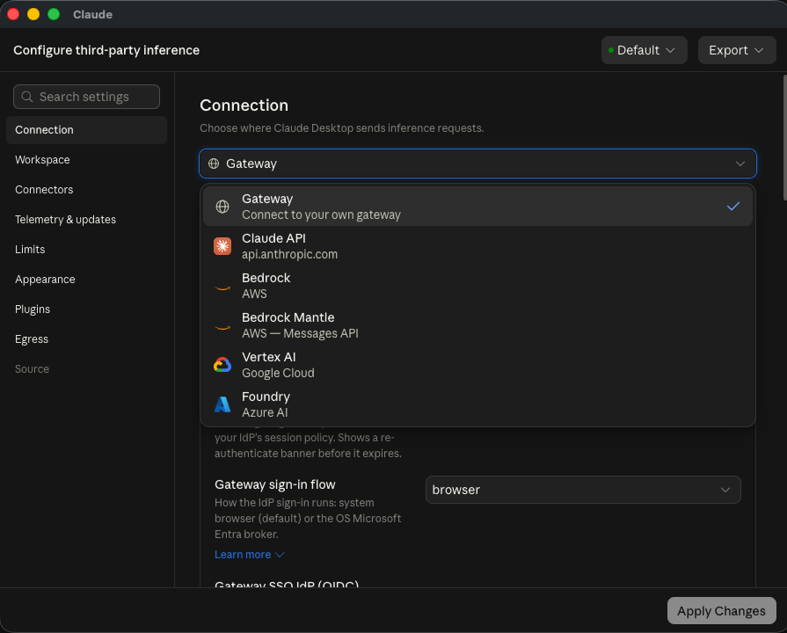
Figure 36: Claude Desktop: choose Gateway as the inference provider.
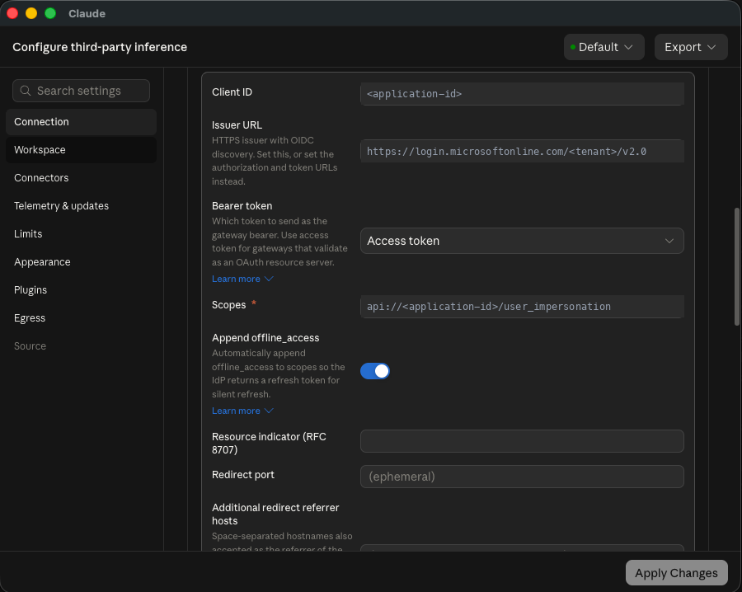
Figure 37: Claude Desktop: sign-in (OIDC) values come from the exported file. Use the Scopes value from your file.
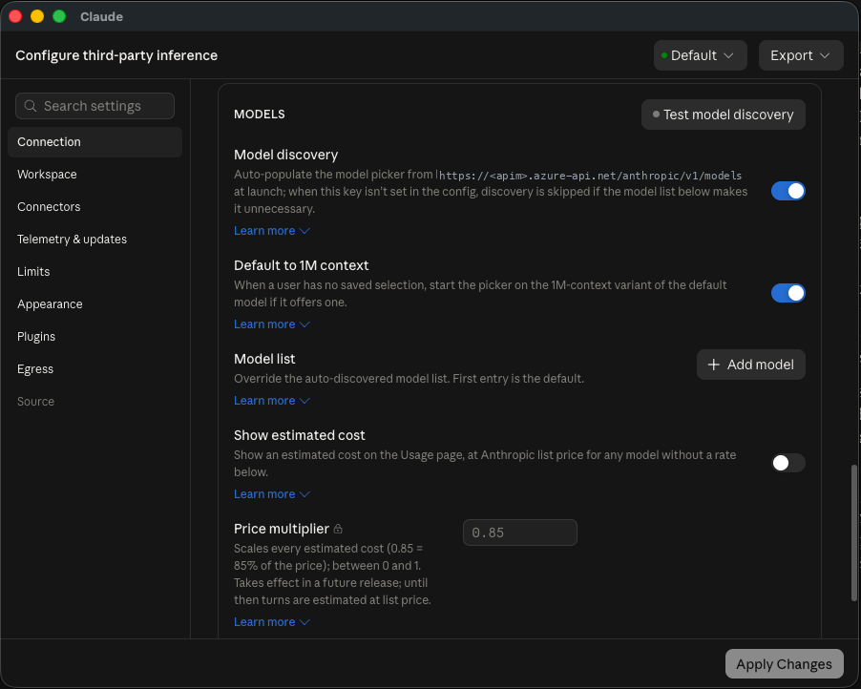
Figure 38: Claude Desktop: model names come from your Foundry deployments.
Desktop field | Value from the JSON file
Credential kind | interactive_sign_in (Interactive sign-in)
Gateway base URL | gatewayUrl (ends with /anthropic)
OIDC Client ID | gatewaySso.clientId, the Desktop app registration, not the Gateway ID
OIDC Issuer URL | gatewaySso.issuerUrl, https://login.microsoftonline.com/<tenant-id>/v2.0
Bearer token | Access token
Scopes | openid profile api://<gateway-client-id>/access_as_user
Model names | models.opus, models.sonnet, models.haiku

CAUTION
Screenshots in this guide, and the placeholder text shown inside Claude Desktop, are examples. Always use the values from your exported file. The scope must end in access_as_user for this gateway.

12.3 Claude Code and VS Code
Developers run the workstation script from the developer folder with the JSON file you give them. The first command is a rehearsal; the second signs in and runs one small test request.
bash setup-claude-workstation.sh --config ./claude-client-configuration.json --dry-run
bash setup-claude-workstation.sh --config ./claude-client-configuration.json --login --smoke-test
Developers need Azure CLI, a browser, and a Claude.User role (through a team group). The script obtains Entra tokens through Azure CLI.

12.4 Onboarding checklist
- The developer is a member of exactly one Claude Team - ... group (or the shared users group).
- That group is assigned the four roles (chapter 11).
- Mode is observe or enforce as intended.
- You have sent the JSON file and the right script.
- The developer signed in and a test message succeeded.

13. Reporting, monitoring and day-2 operations

13.1 Reports
- Workbook: In the portal, open the workbook resource and click Open Workbook. It shows usage, cost, tier and team views.
- Grafana (optional): set options.grafana and supply a name, location and admin identity; the script deploys Managed Grafana and imports the dashboard. The identity that imports must have Grafana permissions (Azure Owner alone is not enough).
- Alerts (optional): list Azure Monitor action group IDs in teamGovernance.actionGroupIds and the five governance alert rules are created.
- Retention: options.summaryRule keeps hourly roll-ups for 30 days interactive and 400 days total.

13.2 Everyday tasks
Task | How
Add a person to a team | Add them to the team group in Entra (chapter 11, step 4). Ask them to sign in again.
Move a person between teams | Remove from the old group and add to the new one. Never leave a person in two teams.
Change someone's personal tier | Change the tier role of the group they are in, or place them in a group assigned a different tier.
Suspend someone | Assign Claude.Suspended (chapter 11, step 5).
Add a team | Add a team to teamGovernance.teams in the config, run --check, then apply.
Change limits or prices | Edit tiersConfig / profiles or the PRICES table, then re-run the setup. Do not edit APIM named values directly.
Update the policy or function code | Re-run the setup in a maintenance window.
Rebuild counters after an incident | Set options.reconcile to true and re-run to rebuild Redis from the Cosmos ledger. It does not schedule itself.

13.3 What the script will never do
- Delete resources, groups, group members or role assignments.
- Purge a soft-deleted APIM service.
- Request or change quota.
- Store a Microsoft Graph secret or print a token.
WHY THIS MATTERS
Because the tooling is additive, the worst outcome of a mistaken run is an extra object, never a lost one. Removal is always a deliberate action by an administrator in the portal.

14. Troubleshooting

14.1 Setup script messages
Message (shortened) | Meaning and fix
Wrong Azure tenant; log in to the configured tenant. | az login --tenant <id> and az account set --subscription <id>; re-run.
Multiple Entra applications are named ... | Two registrations have the same display name. Delete or rename the duplicate, or give the unique ID in the configuration (budgetApiAudience, clientConfiguration.clientId).
Gateway app must set api.requestedAccessTokenVersion to 2 | Open the Gateway registration Manifest and set requestedAccessTokenVersion to 2 under api, or let interactive mode fix it.
Gateway app must define an enabled Claude.User app role | Create the role (chapter 11, step 1) and make sure it is Enabled.
EP1 limit must support at least two always-ready instances | Request EP1 quota or choose another region (chapter 7, step 6). The script never requests quota.
Existing resources are in another region | A resource with the same name prefix exists elsewhere. Keep the original region. Moving needs a separate approved migration.
Set models.opus: no unique deployment / A configured model is not deployed | Type the exact Foundry deployment name for that family in models.
Review PRICES ... set options.pricesReviewed=true | Review the price table (chapter 7, step 9), then set the option.
Review --dry-run, then pass --yes | Add --yes when you are ready to authorise changes.
APIM managed identity client ID not available yet | Azure is still propagating the identity. Wait a few minutes and re-run.
Python credential resolved to a different tenant | Your Azure CLI session is in another tenant. Sign in to the configured one.
Desktop client must be a single-tenant public client ... | The Desktop registration was edited. Restore the two redirect addresses and Supported account types = single tenant (see chapter 4).

14.2 Problems developers see
Symptom | Likely cause | What to check
401 with no detail | Wrong audience or token version; expired token; or no Claude.User role. | Gateway registration: client ID, api:// URI, token version 2. Developer's scope in the settings file. Group assigned Claude.User.
403, denied-by: admin | Person holds Claude.Suspended. | Gateway enterprise application, Users and groups.
401 even though they are in a team | No Claude.User role in the token, or the token was issued before the change. | Group has the four roles. Sign out and in.
403, denied-by: identity | Enforce mode: zero or more than one team/profile role. | Is the person in exactly one team group?
403, denied-by: team-model-policy | Model not on the team's list. | allowedModels for the team.
403, denied-by: user-budget or team-budget | Monthly dollars used up. | Workbook usage. Raise the tier/profile or wait for the new month.
429 | Tokens-per-minute limit. | Retry shortly; consider a higher tier.
Everyone gets the Lite tier | Tier role is not reaching the token. | Group assigned a Claude.Tier.* role on the Gateway enterprise app; user re-signed in.
Budget never triggers | Prices missing, or usage events not flowing. | Price table has the model; Event Hub incoming messages; function apps running.
Sign-in window shows consent or error | Desktop registration changed. | Authentication redirect addresses; API permissions; pre-authorised client.

TIP
When asking for help, send the log file from --log-file, the response status code, and the value of the x-claude-denied-by header. These three items usually identify the cause.

Appendix A. Glossary
Term | Meaning
Access token | A signed digital pass issued by Entra ID after sign-in. It lists who the user is and which roles they hold.
App registration / Enterprise application | The definition of an application in Entra ID / its instance in your tenant, where you assign users and groups.
App role | A named permission label defined on an app (for example Claude.User) that can be assigned to users or groups.
Audience (aud) | The service a token is meant for. The gateway rejects tokens meant for anything else.
Managed identity | An identity owned by an Azure resource (such as APIM) so it can authenticate without a stored password.
OIDC / PKCE | The standard browser sign-in method used by Claude Desktop. PKCE protects a sign-in by a program that cannot keep a secret.
Named value | A shared setting in API Management that policies can read.
Policy | The set of rules API Management runs on each request.
Tier | A personal limit set: speed, monthly tokens, monthly dollars (Pro, Basic, Lite).
Team profile | A pooled limit set for a team (Power, Regular).
Fail open | If a check cannot be performed, allow the request rather than block it.
TPM | Tokens per minute, the speed limit.

Appendix B. Entra objects at a glance
Object | Created by | Key facts | Why
Gateway app registration | Setup (interactive) or manual | Single tenant. Application ID URI api://<id>. v2 tokens. Scope access_as_user. App roles listed in chapter 4. | The audience APIM trusts and the place roles are defined.
Gateway enterprise application | Created with the registration | Holds Users and groups assignments. | Where you give groups their roles.
Desktop app registration | Setup | Public client. Redirects http://localhost, http://127.0.0.1/callback. Pre-authorised for the gateway scope. | Browser sign-in for Claude Desktop.
Budget API app registration | Setup | No secrets, no users. | Audience for APIM's calls to the budget API.
Team security groups | Governance script or manual | One per team; four role assignments each. | Hand out roles to many people at once.
APIM managed identity | Azure (with APIM) | System-assigned. Holds Cognitive Services User on Foundry. | Lets the gateway call Foundry with no key.

Appendix C. Quick command reference
# Sign in and select the subscription
az login --tenant <tenant-id>
az account set --subscription <subscription-id>

# Rehearse, check, then deploy
bash admin/claude-gateway-setup.sh --interactive --dry-run
bash admin/claude-gateway-setup.sh --config admin/setup.local.json --stage preflight
bash admin/claude-gateway-setup.sh --config admin/setup.local.json --yes --debug --log-file logs/claude-gateway-setup.log

# Team governance on its own
bash admin/setup-teams-governance-claude-gateway.sh --config admin/setup.local.json --check
bash admin/setup-teams-governance-claude-gateway.sh --config admin/setup.local.json --yes

# Regenerate the developer file
bash admin/claude-gateway-setup.sh --config admin/setup.local.json --stage export --yes

Useful portal addresses
Area | Where in the portal
App registrations | Microsoft Entra ID > App registrations > Owned applications
Role assignments to groups | Microsoft Entra ID > Enterprise applications > (Gateway) > Users and groups
Groups | Microsoft Entra ID > Groups > All groups
Gateway | API Management services > (your APIM) > Overview, APIs, Named values, Managed identities
Deployments | Resource groups > (gateway group) > Settings > Deployments
Quotas | Subscriptions > (subscription) > Usage + quotas
Resource providers | Subscriptions > (subscription) > Settings > Resource providers

