Coal – Project
Name: Umar Asghar
Roll: 24i – 2532
Section: BS – DS (B)

Rush Hour Taxi Game

VIDEO LINK:

i242532_DS-B_UmarAsghar_CoalProject.mp4

1.0 Introduction
This document provides a detailed technical specification for the "Rush Hour Taxi Game," an assembly-based simulation. Its purpose is to outline the core architecture, data structures, program flow, and logical procedures that govern the game's functionality. This specification serves as the foundational guide for developers and technical reviewers, detailing the game's internal design to support implementation and maintenance. The following sections begin with a high-level overview of the system architecture and program flow.

2.0 System Architecture and Program Flow
A well-defined program flow is the backbone of the application, dictating the sequence of operations from launch to termination. This structure ensures a stable and predictable user experience by establishing a clear hierarchy of control. This monolithic loop design is a common pattern in simple, single-threaded assembly applications, as it provides a clear, centralized control flow without the overhead of a more complex state machine.
The primary execution flow of the game is organized as follows:
- Initialisation: The program's entry point, the main procedure, begins execution by calling Randomize to seed the random number generator, ensuring variability in procedurally generated gameplay elements.
- Main Menu Loop: Immediately following initialisation, the main procedure establishes the primary application loop, identified by the MainMenuLoop label. This is not a separate procedure but rather the central hub of the main procedure itself. On each iteration, it calls DisplayMenu to present options and ReadChar to capture user input into the choice variable.
- Input Handling: A series of conditional jumps (je) evaluates the user's choice. Based on the input character ('1' through '6'), program control is routed to the corresponding procedure: StartNewGame, ContinueGame, ChangeDifficulty, ViewLeaderboard, ShowInstructions, or ExitGame. If the input is invalid, control jumps back to the MainMenuLoop label.
- Game Loop Execution: Selecting "Start New Game" (StartNewGame) or "Continue Game" (ContinueGame) transitions the program into the core gameplay state by invoking the GameLoop procedure, which manages all real-time game logic.
- Return to Menu: Upon exiting the GameLoop (e.g., by pressing the ESC key or finishing a game), program control returns to a jmp MainMenuLoop instruction, seamlessly re-entering the main menu.
- Program Termination: The only defined path to terminate the application is by selecting the "Exit" option, which calls the ExitGame procedure and halts execution.
This high-level flow is supported by a comprehensive set of data structures that maintain the game's state, which are detailed in the next section.

3.0 Core Data Structures and State Variables
Data structures are the fundamental building blocks of the game's memory and state. The variables and arrays defined in the .data segment establish the blueprint for every element within the game world, from player identity to the coordinates of every obstacle. Representing the game state in this manner is essential for tracking and manipulation throughout the program's execution.

3.1 Player and Taxi Data
These variables encapsulate the player's state, tracking identity, performance, taxi configuration, and current status within the game world.
Variable Name | Data Type / Size | Purpose
playerName | BYTE (50) | Stores the player's name as a null-terminated string.
playerScore | DWORD | Holds the player's current score.
taxiColor | BYTE | Defines the selected taxi type (1 for Yellow, 2 for Red).
taxiX | BYTE | Stores the taxi's current X-coordinate on the board.
taxiY | BYTE | Stores the taxi's current Y-coordinate on the board.
hasPassenger | BYTE | A boolean flag (0 or 1) indicating if the taxi is carrying a passenger.
passengerDestX | BYTE | Stores the X-coordinate of the current passenger's destination.
passengerDestY | BYTE | Stores the Y-coordinate of the current passenger's destination.
passengersDelivered | DWORD | Tracks the total number of passengers successfully dropped off.

3.2 Game World Entity Data
These data structures define the dynamic and static entities that populate the game environment, creating the interactive world the player navigates.
Variable Name | Data Type / Size | Purpose
board | BYTE (400) | A single-dimension array representing the 20x20 game grid (0=road, 1=wall). This is a common memory optimization; a cell at (x, y) is accessed via the index calculation y * BOARD_SIZE + x.
passengerCount | BYTE | The number of active passengers in the world.
passengerX | BYTE (5) | Array storing the X-coordinates of up to 5 passengers.
passengerY | BYTE (5) | Array storing the Y-coordinates of up to 5 passengers.
passengerActive | BYTE (5) | Array of flags indicating if a passenger is active (1) or picked up (0).
obstacleCount | BYTE | The number of obstacles on the board.
obstacleX | BYTE (15) | Array storing the X-coordinates of up to 15 obstacles.
obstacleY | BYTE (15) | Array storing the Y-coordinates of up to 15 obstacles.
obstacleType | BYTE (15) | Array defining the type of each obstacle (e.g., 1 for tree, 2 for box).
npcCarCount | BYTE | The number of non-player character cars in the game.
npcCarX | BYTE (8) | Array storing the X-coordinates of up to 8 NPC cars.
npcCarY | BYTE (8) | Array storing the Y-coordinates of up to 8 NPC cars.
npcCarDir | BYTE (8) | Array storing the current movement direction for each NPC car.
npcCarType | BYTE (8) | Array defining the type of each NPC car.
bonusCount | BYTE | The number of bonus items on the board.
bonusX | BYTE (5) | Array storing the X-coordinates of up to 5 bonus items.
bonusY | BYTE (5) | Array storing the Y-coordinates of up to 5 bonus items.
bonusActive | BYTE (5) | Array of flags indicating if a bonus is active (1) or collected (0).

3.3 Game State and System Variables
These variables are responsible for managing the overall game state, user selections, and low-level system operations like file handling and temporary data storage.
Variable Name | Data Type / Size | Purpose
gameMode | BYTE | Stores the selected game mode (e.g., 1 for Career).
difficulty | BYTE | Stores the selected difficulty level (1 for Easy, 2 for Medium, 3 for Hard).
gamePaused | BYTE | A boolean flag (0 or 1) indicating if the game is paused.
gameRunning | BYTE | A boolean flag (0 or 1) controlling the execution of the GameLoop.
choice | BYTE | Stores the user's character input from the main menu.
fileHandle | DWORD | Holds the handle for file I/O operations (saving, loading).
moveCounter | DWORD | A counter that increments each frame, used for timing NPC movement.
keyPressed | WORD | A WORD variable where the high byte (AH) stores the keyboard scan code and the low byte (AL) stores the ASCII character code, enabling differentiation between keys like the arrow keys and standard characters.
temp* variables | Various | Temporary storage for calculations (e.g., tempX, tempY, tempValue).

3.4 Leaderboard Data
These variables support the high score persistence system, allowing player achievements to be saved and displayed across game sessions.
Variable Name | Data Type / Size | Purpose
highScoreNames | BYTE (500) | Stores up to 10 player names, each allocated 50 bytes.
highScores | DWORD (10) | Array storing up to 10 high scores.
highScoreCount | BYTE | Tracks the current number of entries on the leaderboard.
Having defined what data is stored, the following section details how that data is manipulated and managed by the game's core procedures.

4.0 Key Procedures and Game Logic
The procedures contain the operational logic of the game, translating data into action. These routines are responsible for initializing the game state, handling user input, updating game entities, managing data persistence, and rendering the world to the screen.

4.1 Program Flow and State Management
These core procedures direct the overall application flow, managing transitions between the menu, gameplay, and other states.
- main: Serves as the program's entry point and contains the primary application loop (MainMenuLoop). It initializes the random number generator, then repeatedly displays the menu, captures input, and uses conditional jumps to dispatch control to other functions. It is the central navigation hub of the application.
- GameLoop: This is the heart of the active gameplay. The loop continues as long as the gameRunning flag is set to 1. In each iteration, it calls DisplayGame to render the screen, MoveNPCCars to update AI vehicles, and ReadKey to check for user input. It then processes key presses for taxi movement, pausing (P), actions (SPACEBAR), and exiting to the main menu (ESC). Upon exit, if the game ended normally (gameRunning is 0) and playerScore is greater than 0, it calls UpdateLeaderboard.
- PauseGame: This procedure toggles the gamePaused flag to 1, displays a "PAUSED" message, and enters a loop, waiting for the user to press 'P' again. Upon resumption, it sets gamePaused back to 0.

4.2 Game Initialisation (InitNewGame)
The InitNewGame procedure is the primary setup routine executed when a player starts a new game. It orchestrates the complete configuration of a fresh game session through a precise sequence of steps:
- User Configuration: It first calls SelectTaxi to allow the player to choose a vehicle. It then prompts for the playerName using ReadString and calls SelectGameMode to set the game type.
- State Reset: Core gameplay variables are reset to their default starting values. playerScore and passengersDelivered are set to 0, and the flags gameRunning is set to 1 and gamePaused is set to 0.
- World Generation: A series of generation procedures are called in sequence to build the game world: GenerateBoard creates the road/wall layout, PlaceTaxiStart sets the initial taxi position, and GeneratePassengers, GenerateObstacles, GenerateNPCCars, and GenerateBonusItems populate the board.

4.3 User Input and Controls
These procedures are responsible for translating player keyboard input into actions within the game world.
- Movement (MoveTaxiUp, MoveTaxiDown, MoveTaxiLeft, MoveTaxiRight): All movement procedures check board boundaries, verify the destination tile is a road via IsRoad, and check for entity occupation via CheckPositionFree. They then call CheckCollision to handle interactions and finally update the taxiX or taxiY coordinates.
  - Note: The validation logic is inconsistent across the four movement procedures. MoveTaxiUp updates the taxi's position regardless of a collision's outcome, whereas MoveTaxiDown, MoveTaxiLeft, and MoveTaxiRight block movement if CheckCollision returns a collision event. A future refactor should unify this logic into a single ValidateAndMove procedure to improve maintainability and predictability.
- Action (HandleSpacebar): This procedure implements dual-purpose logic. If hasPassenger is true, it checks if the taxi's coordinates match the passengerDestX and passengerDestY to attempt a drop-off. If hasPassenger is false, it attempts a pickup by checking if the absolute difference between the taxi's and an active passenger's coordinates is less than or equal to 1 on both the X and Y axes, effectively checking a 3x3 grid around the taxi.
- Scoring: Points are awarded or deducted based on events in HandleSpacebar and CheckCollision:
  - +10 points for a successful passenger drop-off.
  - +10 points for collecting a bonus item ($).
  - -5 points for colliding with a passenger (P).
  - Collision penalties are taxi-dependent:
    - Yellow Taxi vs. Obstacle: -4 points
    - Red Taxi vs. Obstacle: -2 points
    - Yellow Taxi vs. NPC Car: -2 points
    - Red Taxi vs. NPC Car: -3 points

4.4 Data Persistence
The save/load and leaderboard systems provide data persistence, enhancing player retention by preserving progress and high scores.
- SaveGame / LoadGame: These procedures manage the "savegame.txt" file. SaveGame uses CreateOutputFile and sequentially writes playerName, playerScore, taxiColor, taxiX, taxiY, hasPassenger, passengerDestX/Y (if a passenger is aboard), passengersDelivered, gameMode, and difficulty. LoadGame uses OpenInputFile to read playerName, playerScore, taxiColor, taxiX, taxiY, and hasPassenger to restore a session.
- UpdateLeaderboard / LoadLeaderboard: These procedures manage the "highscores.txt" file. LoadLeaderboard reads existing high score data. UpdateLeaderboard determines if the current playerScore qualifies for the leaderboard. If the board has fewer than 10 entries, the score is added. Otherwise, if the player's score is higher than the lowest score on the board, it replaces that entry. The procedure then writes the updated highScoreNames, highScores, and highScoreCount back to the file.

4.5 Rendering and Display (DisplayGame)
The DisplayGame procedure is responsible for rendering the entire game screen every frame, providing a visual representation of the current game state.
- HUD Display: The procedure uses Gotoxy to position the cursor. It displays the current Score, Passengers delivered, and the escapeMsg ("ESC: Main Menu") at the top-right. It also conditionally displays the carryingMsg if hasPassenger is 1.
- Board Rendering: It uses nested loops (DisplayRowLoop, DisplayColLoop) to iterate through each cell of the BOARD_SIZE x BOARD_SIZE grid.
- Character Determination (GetDisplayChar): For each grid cell, this procedure determines what to render based on a fixed priority: Taxi, Passenger, Destination, Obstacle, NPC Car, Bonus Item, and finally a Board tile. It returns the appropriate character and sets the correct text color. Key characters include 'T' (Taxi), 'P' (Passenger), '$' (Bonus), . (Road, ASCII 46), 178 (Wall), ASCII 5 (Tree), and ASCII 4 (Box, rendered as a diamond).
- Legend Display: After the board is drawn, a static legend is printed at the bottom of the screen to explain the meaning of the on-screen characters and symbols.
The functionality of these systems is configured by a set of constants, which are outlined in the final section.

5.0 Constants and Configuration
Constants provide a centralized and easily modifiable method for configuring core game parameters. Defining values like board dimensions and UI colors as constants improves code readability and maintainability by replacing "magic numbers" with descriptive names.

5.1 Game Mechanics Constants
These constants define the fundamental rules and boundaries of the game world.
Constant Name | Value & Purpose
BOARD_SIZE | 20: Defines the width and height of the game board, setting the play area to 20x20 tiles.
MAX_PASSENGERS | 5: Sets the maximum capacity of the passenger data arrays.
MIN_PASSENGERS | 3: Defines the minimum number of passengers that can be generated.

5.2 UI Color Constants
These constants map symbolic names to the numeric color codes used by the SetTextColor procedure. This system provides a consistent visual theme throughout the user interface.
Constant Name | Value & Purpose
TITLE_COLOR | 14 (Yellow): Used for the main game title on the menu screen.
MENU_COLOR | 11 (Light Cyan): Used for the menu option text.
ERROR_COLOR | 12 (Light Red): Used for error messages, such as "No saved game found!".
TAXI_YELLOW | 14 (Yellow): The display color for the yellow taxi.
TAXI_RED | 12 (Light Red): The display color for the red taxi.
DESTINATION_COLOR | 10 (Light Green): The color of the passenger drop-off destination marker ('D').
WALL_COLOR | 8 (Gray): The color used for rendering board walls.

SCREENSHOTS:
Main menu
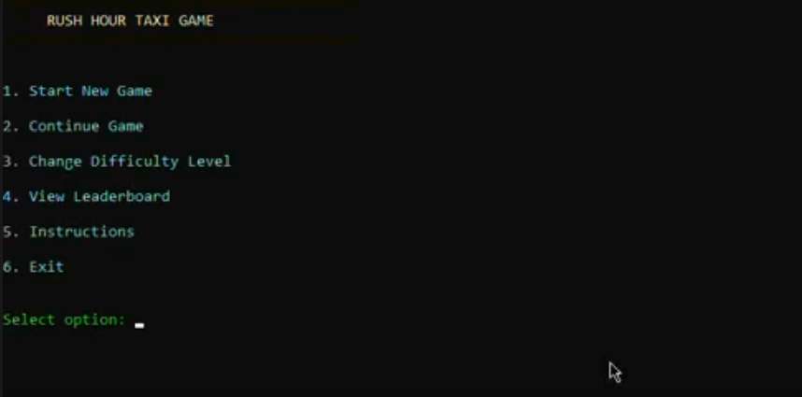

User choice of car
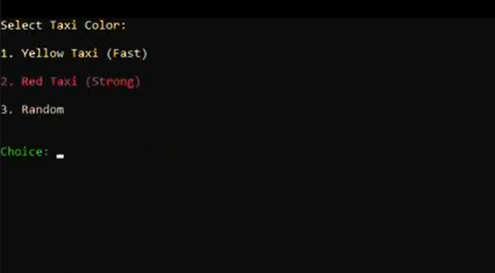
User name entry


Modes selection
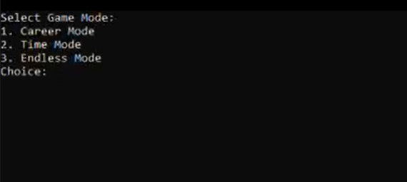

Game interface
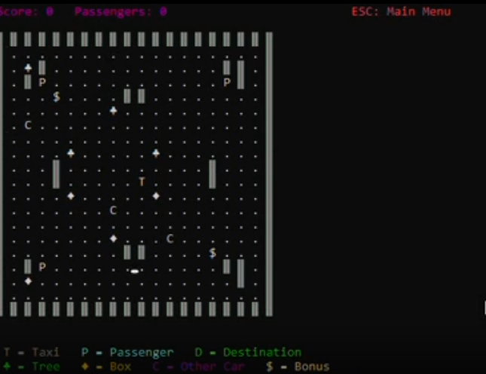
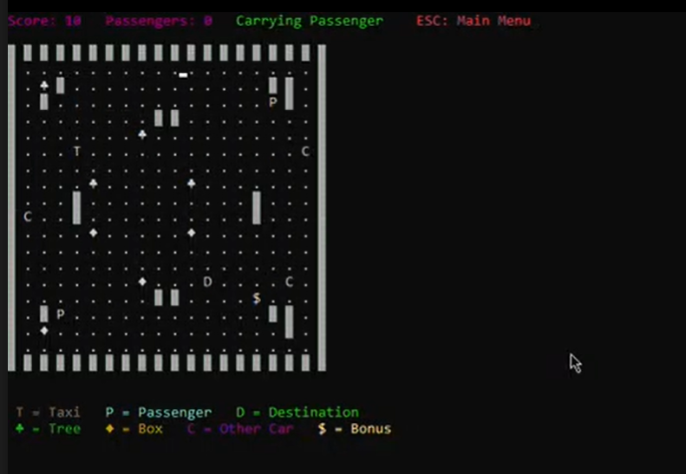
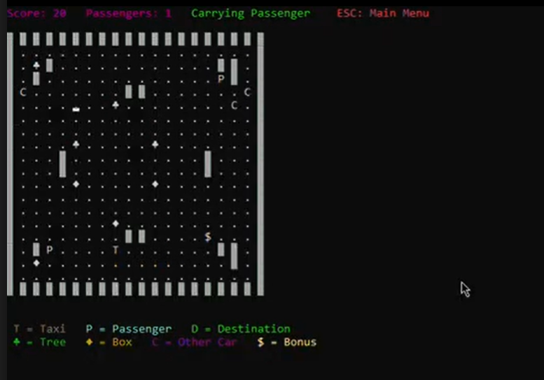

Score dec on passenger hitting (10 to 5):

