RFP submission for

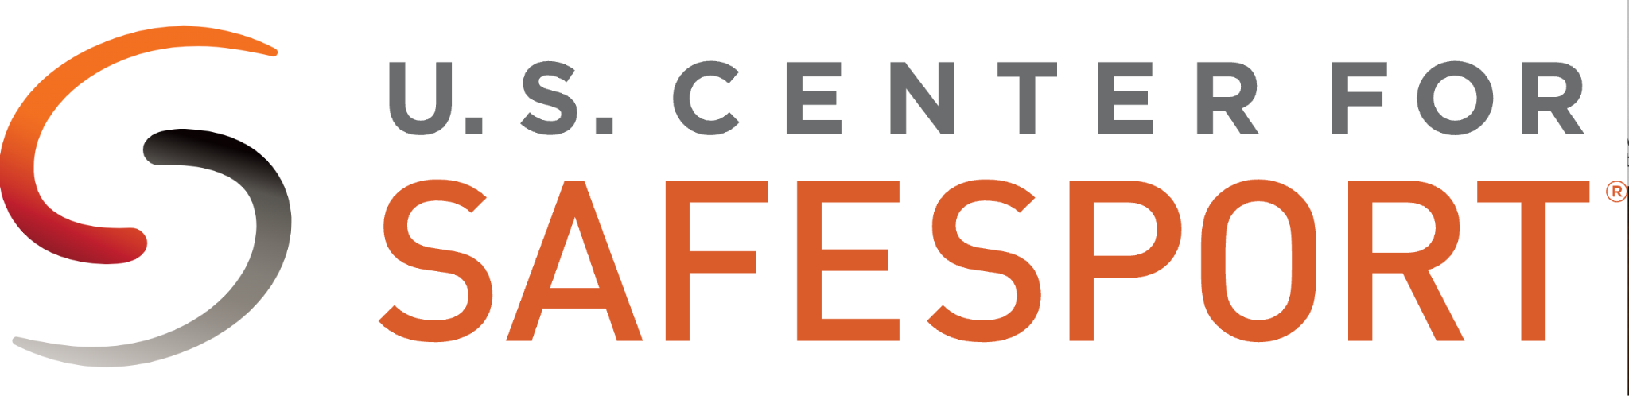

Proposal submitted by:
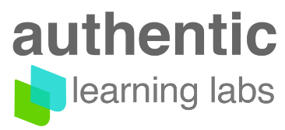

Date of Response: October 21, 2024

All pricing is valid for 90 days.

Contacts:
RFP team at Authentic, team@authenticlabs.io

Exec sponsor: Tamer Ali, Co-founder/CEO, tamer@authenticlabs.io

Cover
October 22, 2024

Dear stakeholders at US Center for SafeSport

We are honored to submit our proposal.

For over 20 years, Authentic team members have collaborated with leading nonprofit organizations in the successful implementation of mission critical learning.

We have and will continue to focus our roadmap and overall business strategy on this concept of delivering “learning that matters”.

Our clients represent leading institutions in their respective fields - they seek a technology partnership that can solve ongoing challenges to deliver high quality learning experiences to disparate audiences around the world.

These organizations typically have outgrown corporate, academic or open source solutions and seek a high performing solution to publish in scale and deliver with better user experience, integration capabilities and data analytics.

We built Simpatico to serve these needs while buttressing it with a team of conscientious, ed tech enthusiasts who believe in the power of learning tech to improve lives.

And to ensure success, Authentic acts as a SWAT team, providing quick support to collaborate with your team with technology, processes, and expertise. The goal is to design and develop superior learning products while implementing with our best efforts for sustained performance.

We will collaborate with your team to design, implement, and deliver the SafeSport program using our technology and seamlessly integrate the learning platform into the key systems of your ecosystem.

Our Understanding of the RFP is that you seek advanced learning tech functionality for both delivery and management of the program to support a diverse audience. We believe we are well positioned to meet and exceed your requirements. And as a key differentiator: we aim to support it with a highly attentive team.

We have followed the outline of the required format and hope that we have an opportunity to demonstrate our capabilities. We look forward to working with you throughout the selection process.

Best regards,

RFP Team at Authentic Labs
Executive sponsor: Tamer Ali, CEO and Cofounder

Table of Contents

Cover 1
1. Company Information 3
2. Demonstration of Experience 4
3. Pricing 7
Appendix 1a License Fees 8
Appendix 1b Setup Fees 8
Appendix 1c Billing Schedule 12
Appendix 2 Screenshots 12
Appendix 3 Case Studies 19

RFP requirements outline
- Full legal business name, including any DBAs: Authentic Learning Labs
- An official, signed, and authorized letter must accompany your proposal from an authorized executive to speak on behalf of the organization: letter from founder/CEO follows this page
- Pricing: detailed in Appendix 1, our pricing is based on license fees and one-time setup charges.
- Description of current clients/organizations, scope of your organization’s expertise, and three references from current clients: Included in the Company Information section
- Disclosures - please list if any clients include the U.S. Olympic & Paralympic Committee (USOPC) or any of the National Governing Bodies (NGBs) as recognized by the USOPC. And if so, certification regarding the protection of client information: not applicable
- In addition to completing the details in the RFP, please include screenshots and other representative samples of the learning management system functionalities including: provided in Appendix 2 and a corresponding slide deck tour of features meeting RFP requirements.

1. Company Information

1. Full legal business name, including any DBAs: Authentic Learning Labs

2. Primary business/headquarters address, and any other locations:
Main HQ, Chicago IL, 246 E Janata BLVD, suite 330, Lombard, IL 60148

3. Primary contact for the RFP submission: Tamer Ali, Executive Sponsor

4. Description of the ownership structure: Private Company, Employee Owned

5. Number of employees and contractors: 42

6. A brief history of the company and the year it was founded
- Founded in 2016 by ed-tech veterans, developers of Crowd Wisdom™ LMS (acquired in 2014.)
- Authentic’s product roadmap and business strategy from day one have focused on mission-based organizations and those entities with strategically aligned learning delivery as a primary objective.
- The majority of clients are non-profit organizations seeking to deliver learning as part of overall objectives.
- Product strategy is to offer advanced LMS technology for organizations growing beyond corporate or academic solutions. These programs deliver high profile programs that typically require advanced API integrations, better learning experiences, modern course publishing, and detailed data analytics.
- Simpatico’s API-centric model allows seamless integration to the platform ecosystems of the clients we serve while also enabling white labeled, modern experiences that are accessible to all learners and responsive to all devices.

7. Website(s) and social media handles:
web: authenticlabs.io , linkedin: https://linkedin.com/company/simpaticoplatform twitter: @learn_authentic

8. Data storage and management

- Data encryption both in transit (TLS 1.3) and at rest (AES-256), sensitive and PII can further be encrypted at the field level.
- Hourly, daily incremental, with weekly full backups.
- Backups retained geographically separate from production.
- Compliance with global and US-based data privacy and protection standards: GDPR, FERPA, California Consumer Privacy Act, NY SHIELD Act, Colorado CPA, and Virginia Consumer Data Protection Act
- 30-day backup retention policy with options for extended retention periods.

9. Regulatory and compliance procedure policy adherence

- We have an ongoing commitment to meeting regulatory standards including accessibility, privacy and data protection due to the nature of our work in the delivery of mission critical learning for organizations that deliver accredited and highly regulated programming.
- Our team actively monitors and implements both established and emerging regulatory requirements across federal, regional, and global levels.
- We leverage solutions from Amazon including AWS Macie (for personal sensitive information), AWS Security Hub, and additional procedures and tools to monitor and maintain compliance.
- Upon request, we will coordinate and document with your organization a governing charter of policy adherence and methods of evaluation, monitoring and reporting.

2. Demonstration of Experience
1. Identify a list of nonprofit, compliance, and/or sports related clients, if any, including a list of 3 clients with executive contacts for references.

All client contacts listed below are executive level. We kindly ask for the opportunity to alert them of the potential call before they are contacted.

Practising Law Institute (pli.edu) - leading nonprofit organization for Legal Education,
Brian Callen, Program Experience Platforms – R&D bcallen@pli.edu

ExamFx (examfx.com) - , highly focused compliance training in insurance pre-licensure that must meet regulatory guidelines in each US State. States require rules and constraints in courses and Simpatico supports this like A/B model of variation. Craig Maturey, VP of Development Craig.Maturey@ascendlearning.com

Association of periOperative Registered Nurses (aorn.org) - leading surgical nurses group,
Scott Poe, CIO spoe@aorn.org

American Academy of Orthopaedic Surgeons (aaos.org) - leading professional organization for Orthopaedics, Brian Moore, Education R&D and Innovation, bmoore@aaos.org

2. Describe the company’s client retention rate for the last 3 years.

96% retention rate. We have not lost any clients to dissatisfaction. Two (2) organizations have not renewed, either due to issues tied to their own internal platforms and programs or due to losing its funding source (as a nonprofit organization.)

3. Describe the company’s growth during the past 3 years.

- Averaging at least 38% growth in revenue from existing clients who have expanded usage.
- And 29% new client business from new organizations signed.
- Clients have typically selected Simpatico to address one or multiple issues with their current LMS where there is a weakness or gaps in its capabilities. In this case as we typically install and run in parallel until the solution is either decommissioned or Simpatico runs in parallel to complement the legacy platform.

4. Describe the investment in the platform planned for the next 3 years.

- A dedicated focus: At least 50% of our operating budget towards R&D to maintain leadership as the top enabling platform for seamless publishing and delivery of learning at scale.

- Continue to build out empowering functionality to help learning scale, interoperate with key systems, and make a better impact for our clients and their audiences.

- We see the market is continuously maturing, naturally causing more differentiation in the players and solutions. There are academic models like Canvas and D2L, and fast-to-implement corporate SaaS solutions like Docebo, Litmos, and Absorb. And there are open source solutions that are typically Academic-focused or first/second gen solutions like Moodle.

- Simpatico seeks to serve maturing and fast growing organizations that serve external audiences (members, channels, academic institutions, associations, extended enterprise and affiliates) with an API-centric platform and toolset to embed learning in the workflow of operations.

- These growing programs typically find gaps in current market solutions, and seek key functionality to improve: learner experience, integration capabilities, and data analytics, while also needing better capabilities to deliver globally with scale and localization support.

- We know AI is critically important: However we try to avoid merely adopting AI for the sake of it to claim “cutting edge status”. We attempt to properly, responsibly, and elegantly apply AI as it relates to our space- where it can bring the best value. We currently use AI for video transcription and translation, and assessment question development. We plan to further incorporate AI into our platform but will do so cautiously and without force-feeding it.

- Focus on continuous improvement of the APIs and capabilities to allow lifecycle LMS functionality to design, assemble, publish, and track learning. Currently a client can post JSON to our system and it will publish a full course including business rules and constraints.

- Continue to provide complementary functionality that is not typically easy to code in courses and learning technology- freeing our clients from demanding such needs from their teams. This is to empower learning publishers and advanced creators to leverage modern web technologies to deliver first class learning experiences. Examples include: video-based course player and an assessment engine for dynamic testing (advanced question types, scoring methods, randomization, et al). These features are typically not the strengths of authoring tools or LMS platforms.

5. Describe resources available to clients for implementation, development, product management, data
engineering, technical support services, and account management.

- Dedicated Technical resources with enterprise implementations including at team consisting of:

  - A team of 5 minimum staff: Software Architect, Software Developer, Project Lead, Product Quality Lead, and Migration specialist.

  - Also included will be a dedicated account manager and senior executive sponsor.

- Hackathon-like project-start to expedite the initial kickoff of implementation.

  - Kickoff is then followed by virtual Weekly meetings and collaboration via Slack or MS Teams (whichever is preferred - we are a Slack user internally but routinely work with clients on MS Teams as well.)

  - The goal is to release in iterations every 45 days with all core functionality in place for multiple pilots within a given project timeline.

6. Briefly share what makes the company outstanding or unique or particularly applicable to the organizations the Center serves.

- We see a critical need to deliver excellence in elearning with advanced learning technologies and the expert services to support them.

- We see the L&D and Elearning market missing an IBM or Accenture type that can bring senior level, technical resources to support implementations and ongoing success. And as such, we believe that the team supporting the software is critical in its success with the large scale implementations we seek.

- Our team has a keen focus working with our clients to adapt and configure our solutions while providing consultative guidance. We feel this is key in differentiating our services from a pure software approach. It may seem slower- however on the contrary it is longer lasting and ensures the success of the platform.

- Given this approach, we still seek to lead in technology as well: we seek to occupy the space as the go-to source for enabling learning technology for growing programs.

- We do not see a company focused on advanced web technologies to publish and deliver better learning, similar to how web technologies in Webflow and Squarespace have modernized website development.

- To be sure, many good LMS platforms exist, however they seem to be singular focused and mostly “inwardly” directed to train centralized corporate employee audiences, or student audiences.

- Simpatico will continue to serve organizations that base their mission or core strategy in learning.

- Our business and roadmap will continue to focus on executing this to deliver scalable web services to learning organizations to build and design deliver learning at scale, gracefully and with universal and fair access.

- And we will support advanced learning experiences and embed learning seamlessly in the operational workflows of our clients using API-centric approaches, webhooks, and the use of advanced delivery engines for video and assessment.

- We will continue to advance reusable, modern course layouts and templates, with logic for conditions and behaviors to free up our clients from the need to code everything.

Appendix 2 Screenshots

Please find print resolution level screenshots and online versions of the requested items.
Case Studies follow this section:
  - Learner experience
  - Dashboards for administrators
  - Course management interface
  - Course player
  - Reporting capabilities

Learner Experience

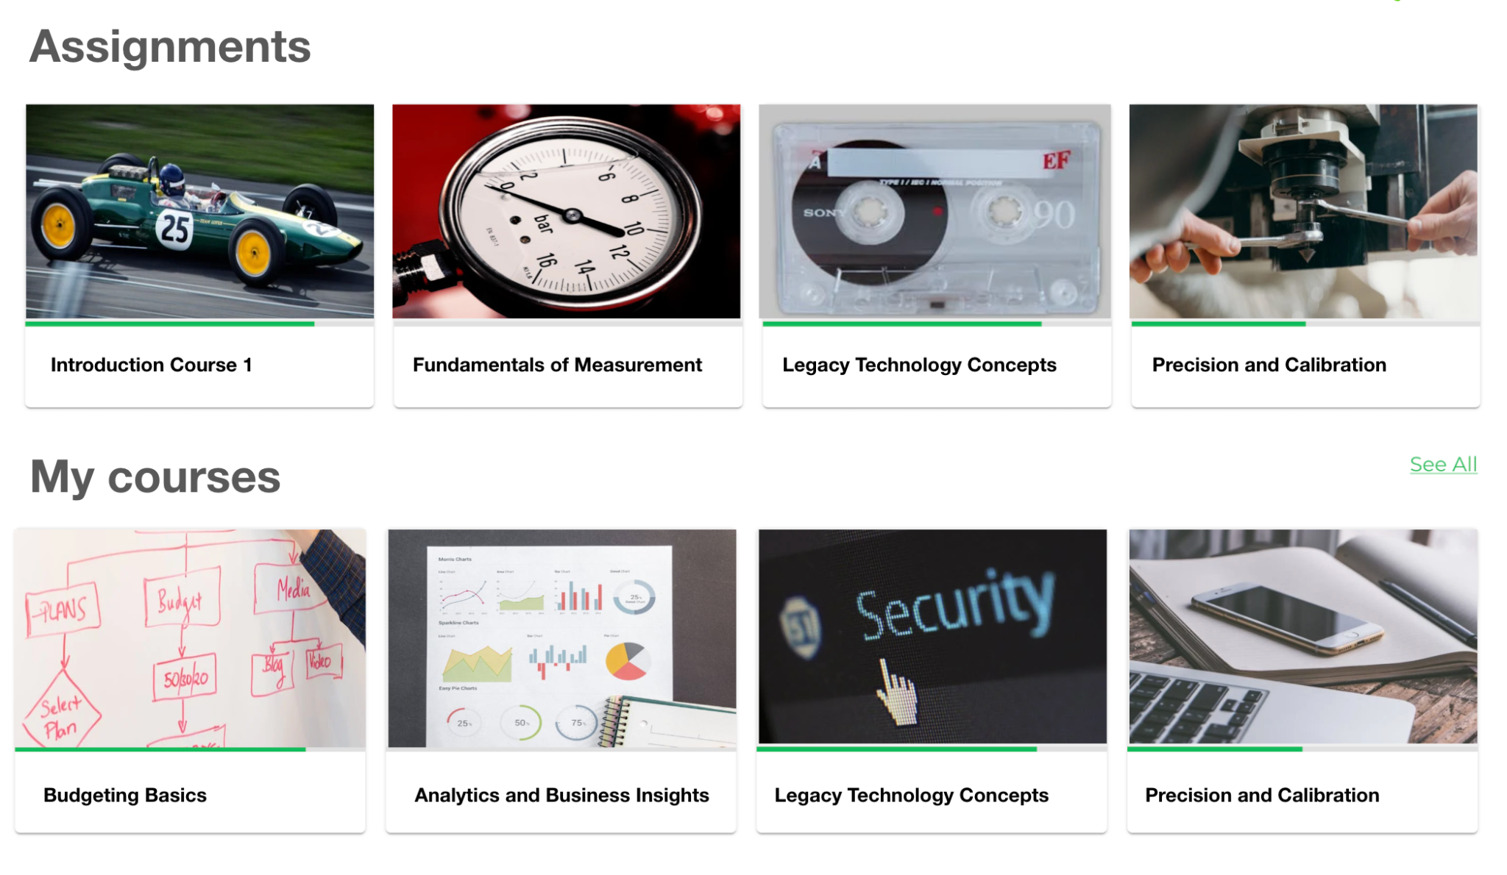

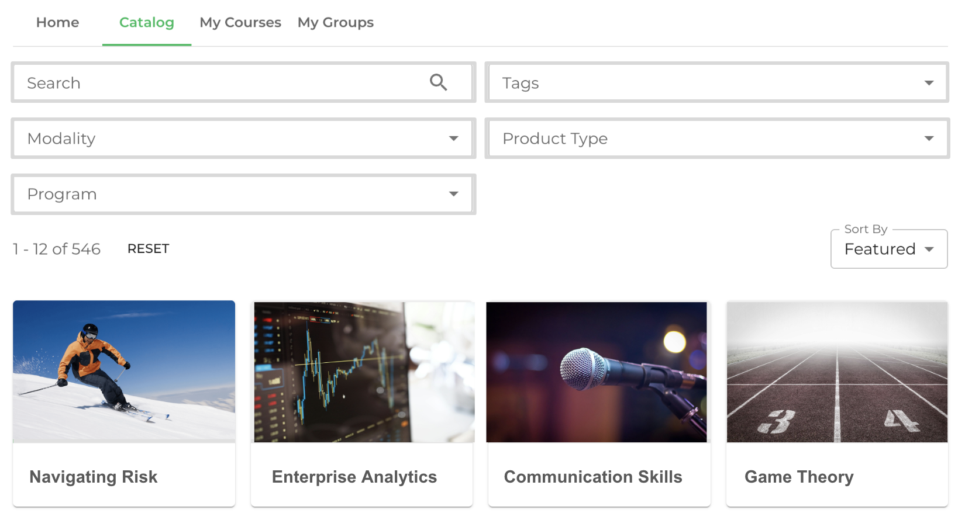

Dashboard for Administrators

(on following page)

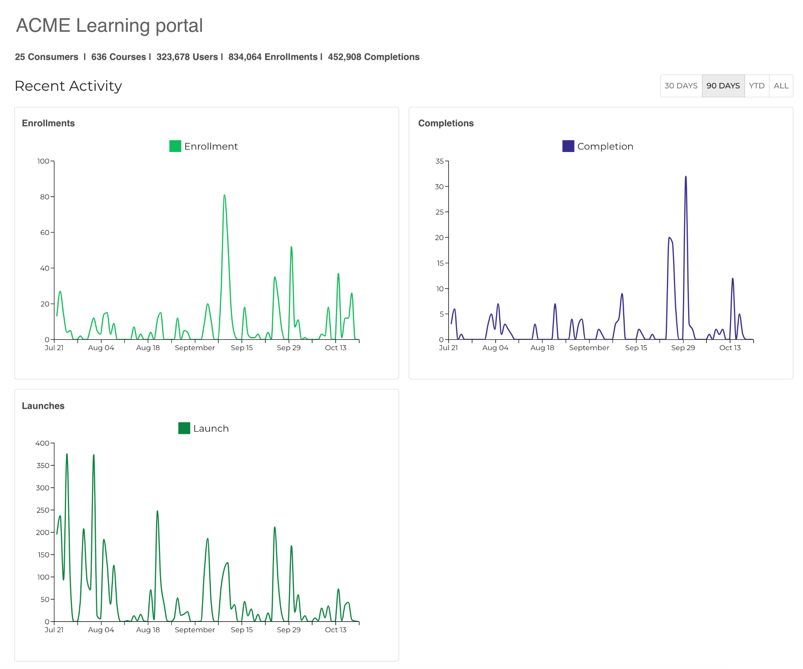

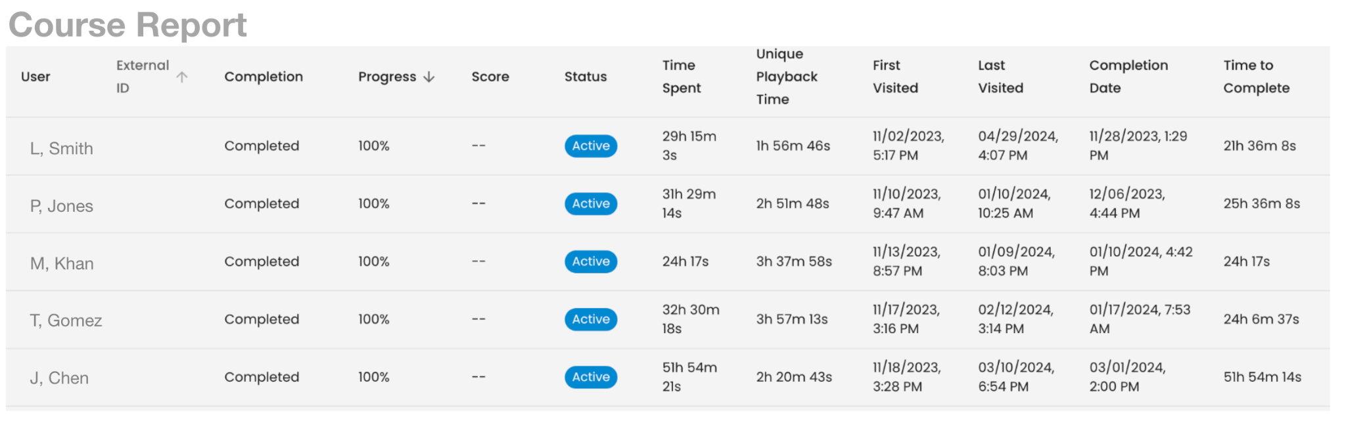

Course management interface

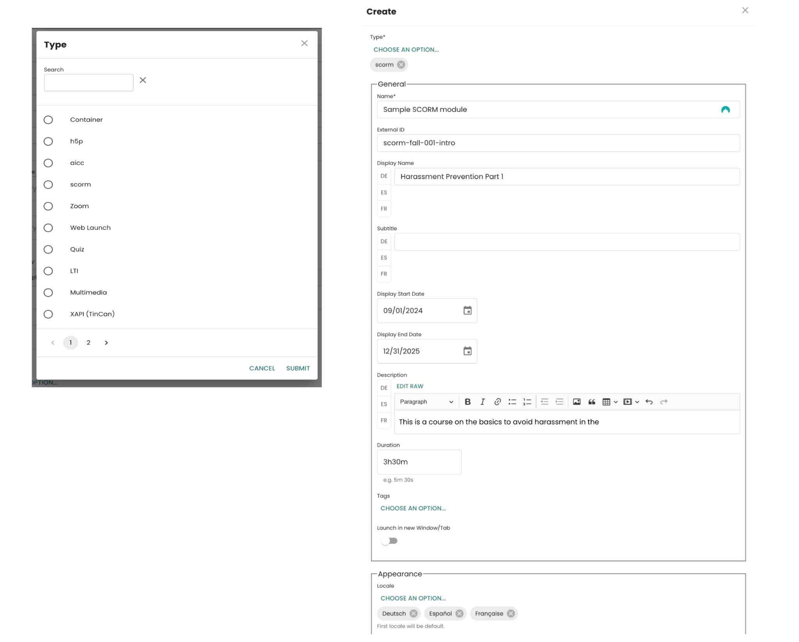

Course player

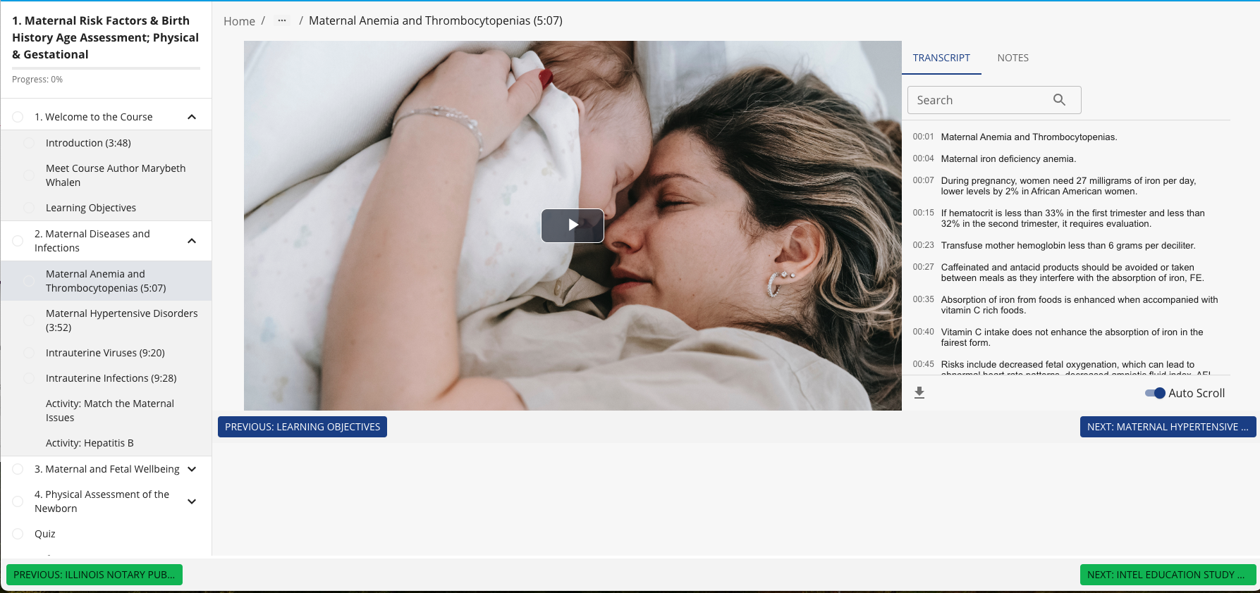

Course player

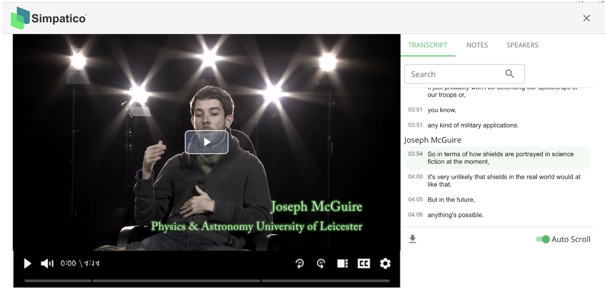

Course player

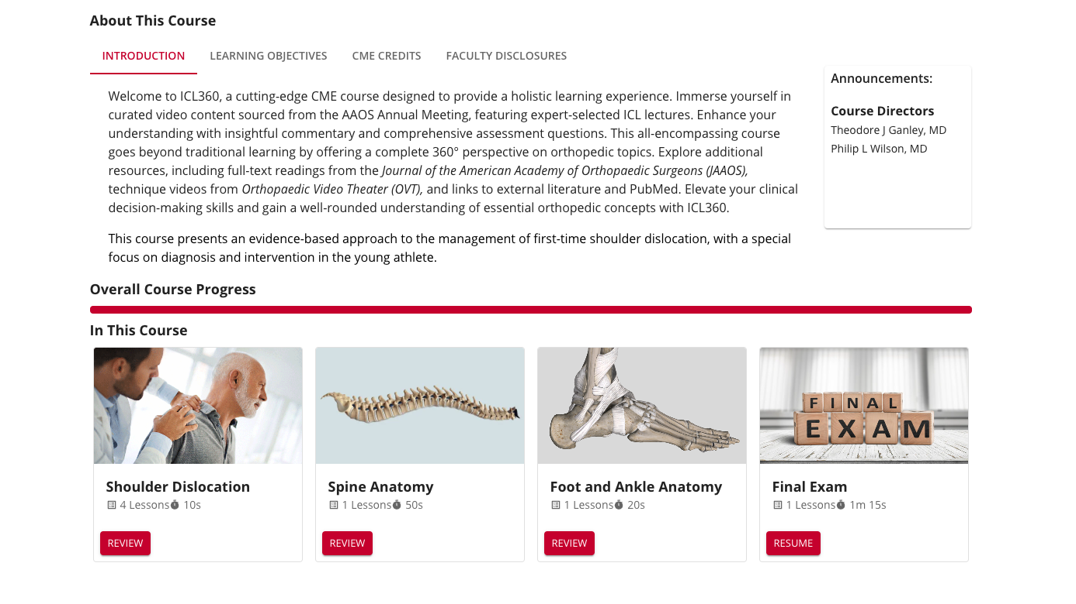

Reporting Capabilities

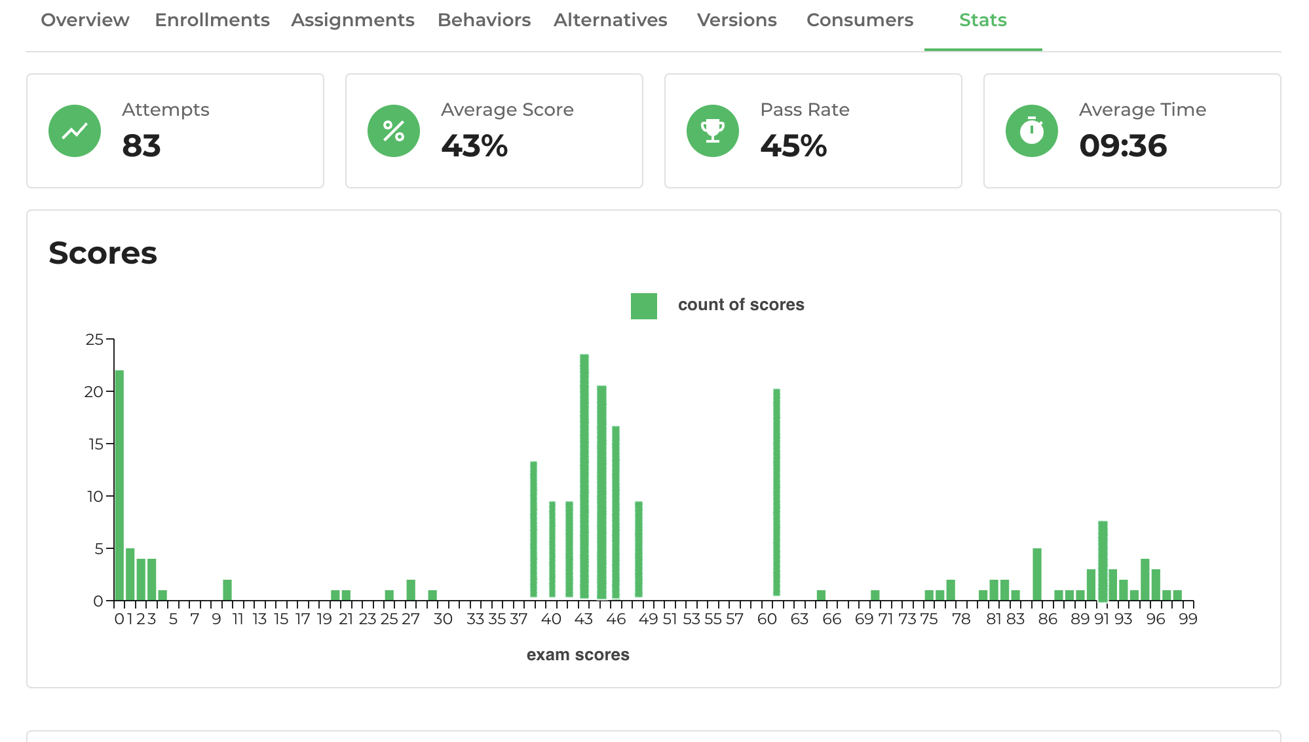

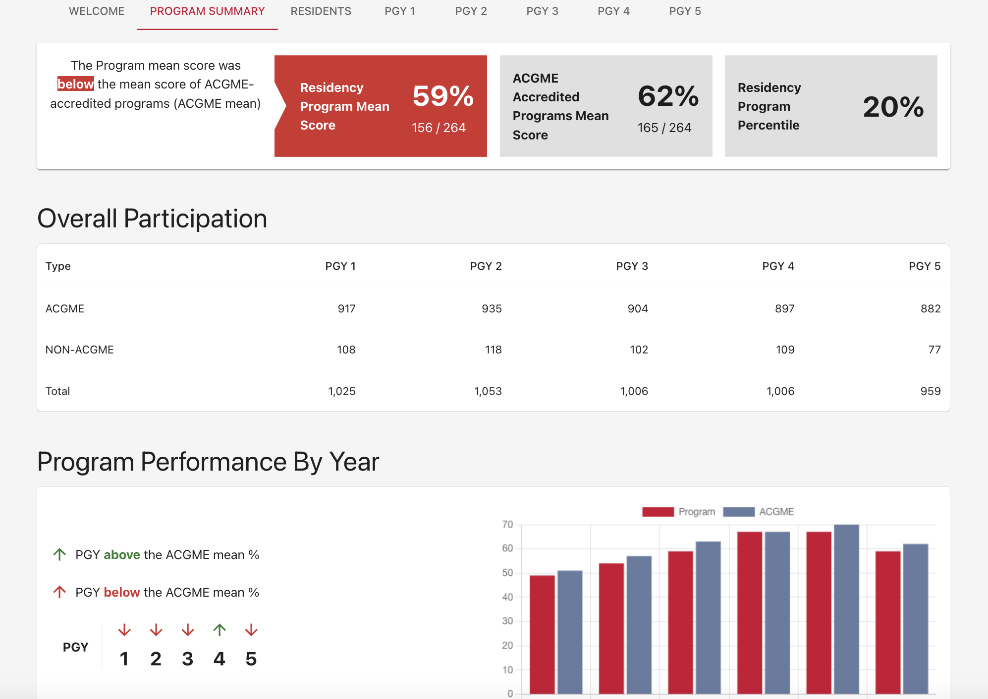

Appendix 3 Case Studies

Challenge  Migrate an existing, high-profile course that attracts professionals from around the world to take a hybrid (online and live) course run by leading experts in informatics. |  | Summary  Improve learner and instructor experience within a high-profile, time-sensitive boot camp course.  Background  SIIM's NIIC boot camp is a globally recognized certificate program attracting specialists from leading global institutions to partake in a 5-day live online hybrid course with self-paced activities and assignments.  
Solution
- Convert current course into existing LMS
- Design a new layout that simplifies access to each day of the 5-day bootcamp
- Organize content within each day and provide easy ways for instructors to post messages/announcements and show/hide course content.
- Assemble interactive quizzes and a final exam to complete for the certificate.
- Seamlessly integrate ZOOM live sessions from within the course, to facilitate lessons that run concurrently through each day.
- Convert video lectures to e-learning content with video and AI-generated transcripts, note-taking, and bookmarks.
- Track all learner participant data, including analytics on video usage.

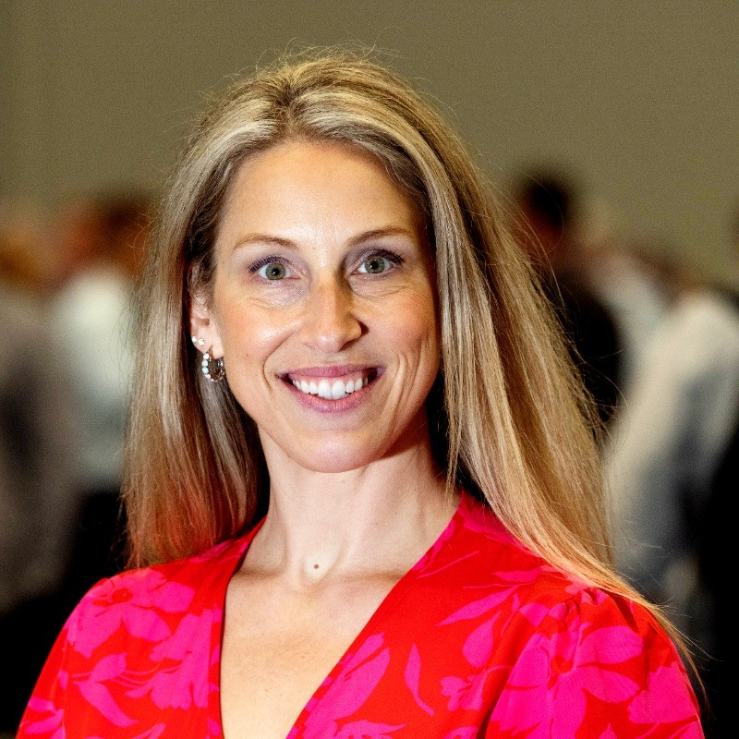
“The collaborative effort between Authentic Learning and SIIM has been transformative, seamlessly blending expertise in education and technology to create an unparalleled learner experience. Their innovative approach has set a new standard for SIIM Learning."

" The director and content authors all love the new look"

Nikki Medina
Director of Education & Content Development, SIIM
Result
The high pressure of a boot camp style necessitated a simplified UX and intuitive navigation. All went smoothly, with high praise from both participants and instructors and no technical difficulties despite the new experience and technology change.


Challenge  Limited analytics: The curriculum was challenged to offer key reporting data and insights to program directors who oversee the participating residents (the learners) who complete the online curriculum as an adjunct to their instruction onsite at the residency programs.  Ease of access to reporting insights: A key need was to embed these reports into the program directors' experience while making the data clear, actionable, and simple to understand—they could not be overwhelmed with too much data or clutter from spreadsheets or data dumps. |  | Summary  Address the needs of learners and instructors by providing better reports and analytics.  Background  AAOS is the leading organization providing professional education for the Orthopaedic surgery profession. AAOS offers the online ROCK curriculum to participating programs worldwide. The program is a critical companion to the clinical teaching programs conducted in orthopaedic residency programs worldwide.
Solution
- An intuitive dashboard: Authentic and AAOS collaborated on the design of new reports that highlighted key insights on learner performance. Program Directors quickly and effectively glean key metrics from a newly created central dashboard where they can easily monitor progress in the online curriculum.

- Embed insights where relevant: Reports appear directly within the course itself for participants and program directors. Participants see clear data visuals of performance and benchmarks against peers. Program directors see aggregate performance for their residents, with highlights of key indicators.

Result

This key curriculum, which covers the core body of knowledge in the specialty, has had high satisfaction rates and adoption. The success has brought interest in adding new report views and additions.


Figure 1: Program directors can clearly view time on course, number of visits, and performance by topic- compared to other programs worldwide.

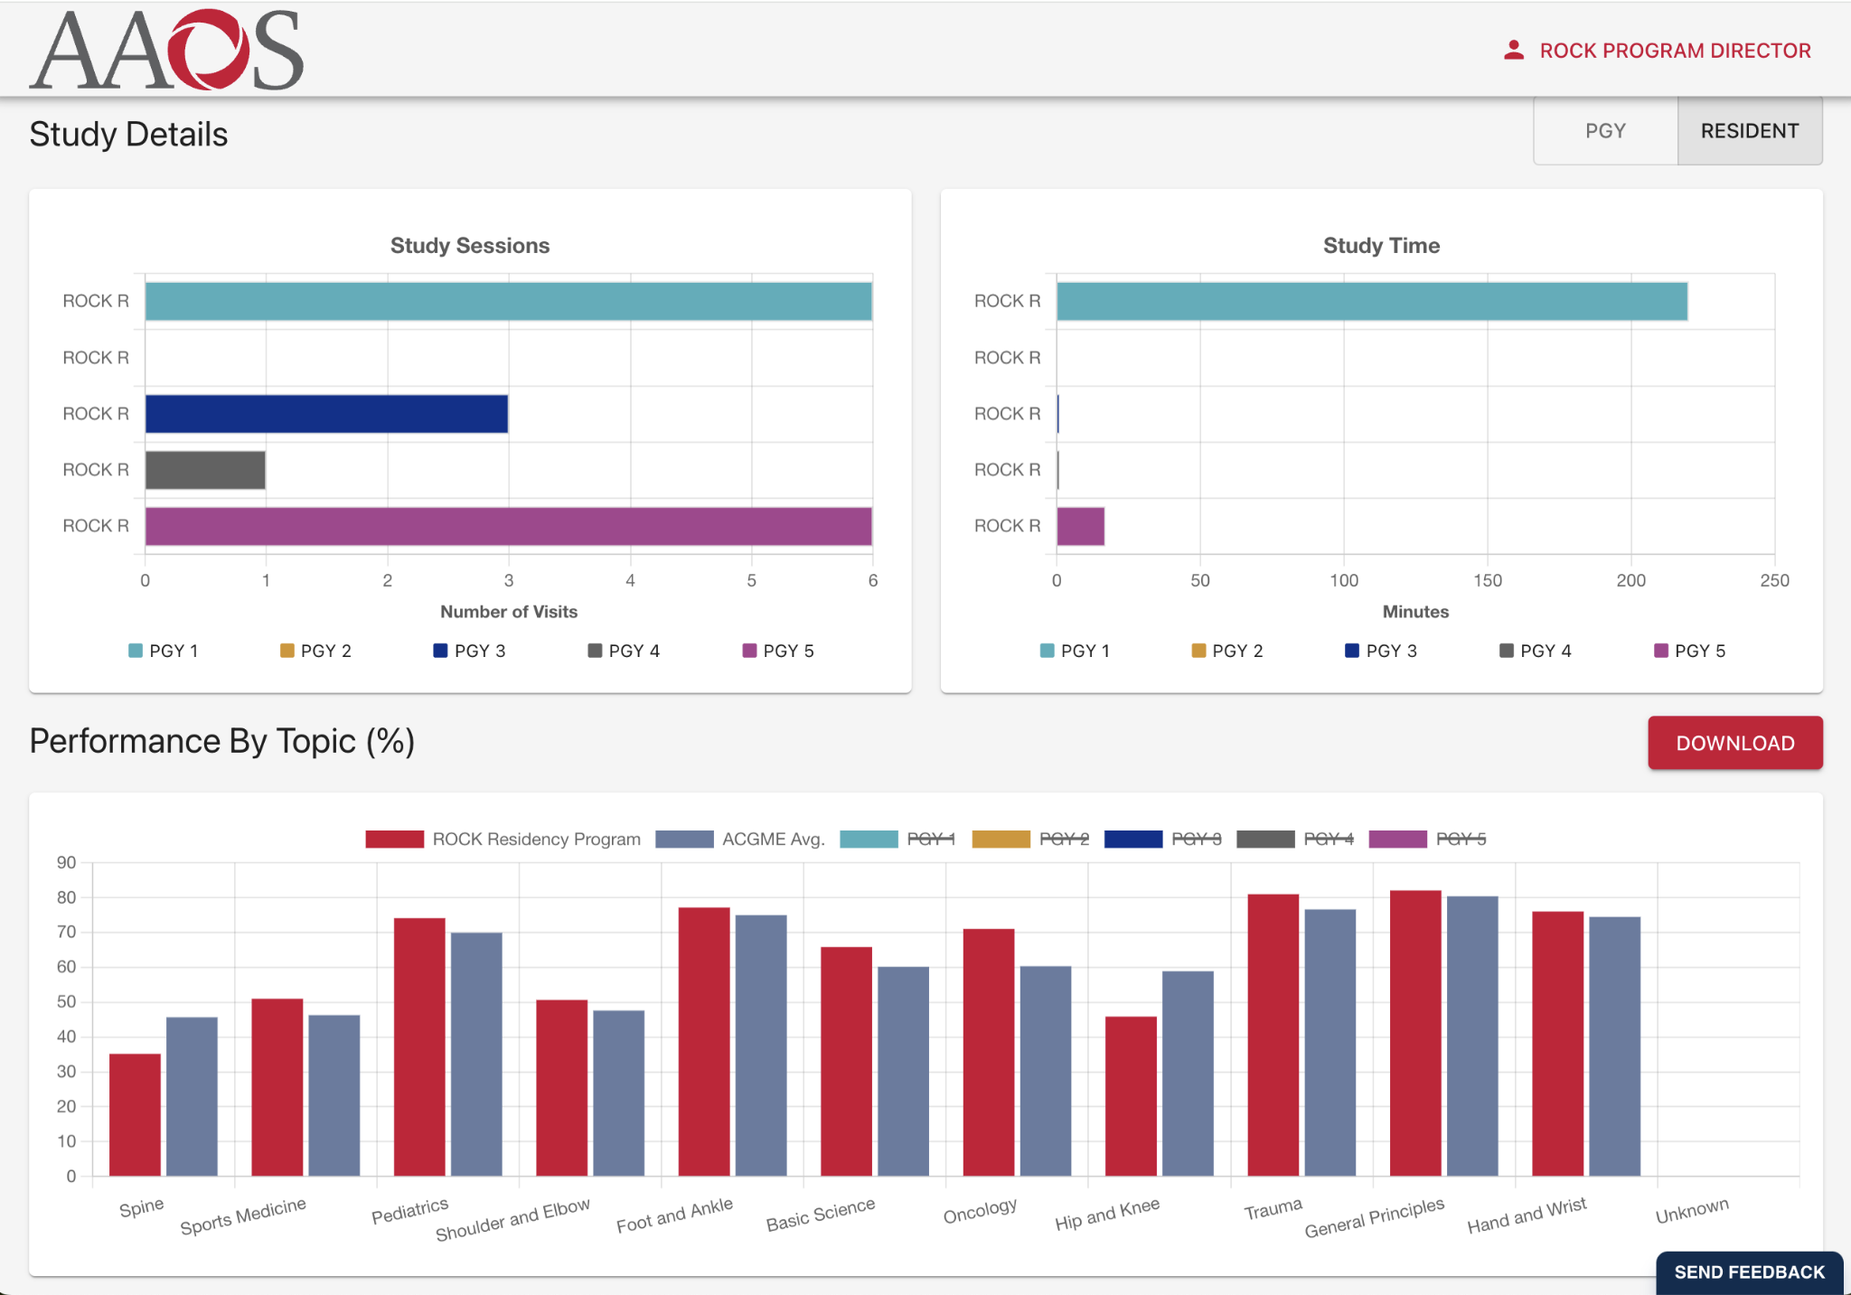

Figure 2: The roster of participants is presented clearly, with summary information on chapter progress and study time.
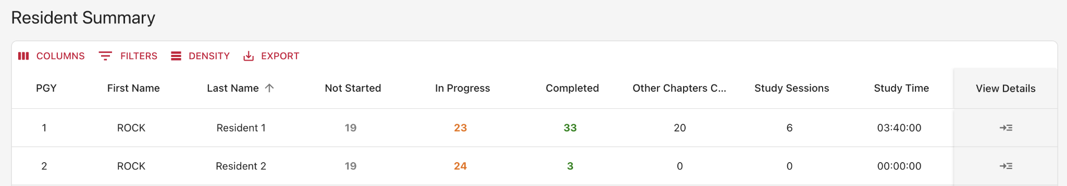


Challenge  Migrate existing program: Enhance an existing, highly successful program with live participants without disruption, migrating participants and their progress, while also improving the experience.  Better User Experience is key, given that these busy professionals are studying hundreds of hours and are likely working in demanding fields—some are changing careers to the legal profession from high-tech and engineering jobs.  Track all learner activity to provide participants with clear insights and predictive analytics. Also, because some participants need activity to report Continuing Education Units, all time and activities required detailed tracking and reconciliation. |  | Summary  Update a mission-critical licensure prep program.  Background  PLI is a world-renowned provider of education for the legal profession. Its patent Bar prep course is considered the leading program for aspiring Patent Bar attorneys preparing for the challenging Patent Bar exam. In fact, PLI-trained students have a documented higher success rate by taking and following the course process.
Solution
- A modern new course dashboard that centralized all the key learning resources, including hundreds of videos and drill & practice exams to prepare participants for the real bar exam.

- Rich tracking of each participant’s video and test attempt activity was presented in visualized reports to the participants and also tracked behind the scenes for administrators to track program usage.

- Seamless integration with a live document IP protection service to allow reference material to be shared in the course.
Result
A successful, seamless cutover happened over just a few hours, limiting disruption to course takers who demand access at their convenience due to their busy schedules. All progress and previous history (including video progress) were also migrated to allow participants to pick up where they last left off in the course.


The Patent Office course dashboard centralizes all key activities and simplifies navigation for participants. All course content and features link to this page. | 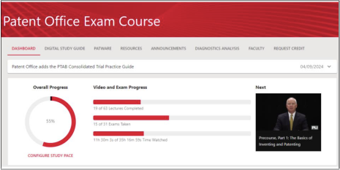

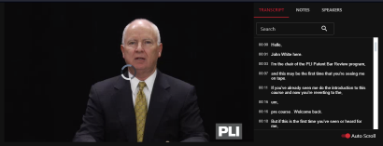 | The course features hours of videos and drill & practice exams to prepare participants for the real exam. Clear indicators of progress offer real-time views for participants.

Exams, digital document storage, Continuing Education credit claims, and visualized diagnostic reports are all part of the course offering. | 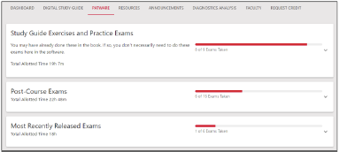

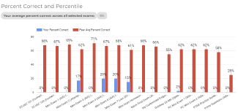 | Analysis of learner performance provides clear insights on strengths and weaknesses in topics.

Thank you for your time and consideration

The RFP response team at Authentic

