My program outputs the % of samples containing a variant for early and late samples in files with the format like this where column 1 is the location and instrument, column 2 is the % of variant in early samples and column 3 is the % of variant in late samples:



Note: -1 means that the variant does not occur at that location. These -1 entries should be replaced with 0 when making a stacked bar graph.

The spreadsheet “early_late_groups_3_locations.xlsx” rearranges the columns from several tables like this and includes calculations to produce the stacked bar graph below.

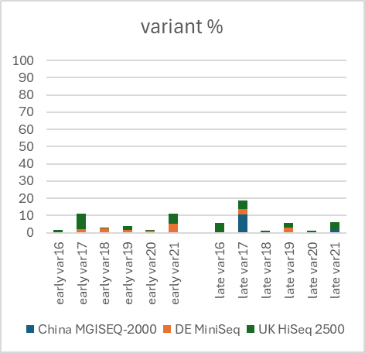

Please write Python code to read in the data from these files and rearrange the columns to produce a table like the table below and produce a stacked bar graph like the graph above.



The column with zeros produces the gap between early and late sets of bars and is not needed in the table.