Data Technician Week 5
Workbook
Azure Data Fundamentals

Name:
Course Date:
Table of contents
Day 1: Task 1 3
Day 1: Task 2 4
Day 1: Task 3 5
Day 2: Task 1 6
Day 3: Task 1 10
Day 3: Task 2 11
Day 3: Task 3 12
Day 4: Task 1 13
Day 4: Task 2 14
1. Scenario Background 14
2. Data Laws and Regulations 14
3. Azure Service Recommendations 14
4. Data Types and Data Modelling 14
5. Data Storage Formats and Structures in Azure 15
6. Additional Considerations 15
Submission Guidelines: 15
Course Notes 18
Additional Information 19

Day 1: Task 1

Please research and complete the below questions relating to key concepts of cloud.

Be prepared to discuss the below in the group following this task.

What can cloud computing do for us in the real-world? | In practical terms, cloud computing means trading clunky, expensive hardware for flexible, on-demand internet services. It’s a shift from owning tools to renting power, allowing you to focus on your goals rather than managing servers.  Key Practical Uses  - Instant Scaling: You can "dial up" your tech capacity during busy periods and scale back down when things quieten, ensuring you only pay for what you actually use.  - Seamless Teamwork: It keeps everyone on the same page by hosting files and apps in one central hub—like Google Workspace—making remote work smooth and synchronised.  - Built-in Safety: Your data is backed up across multiple global locations. If your local office has a power cut or a crash, your business stays online without missing a beat.  - Smart Tools: It gives you easy access to high-end tech like AI and data analytics that would otherwise be too expensive or complex to run on your own.
How can it benefit a business? | Reliable service-based model. It essentially allows you to "rent" world-class infrastructure so you can focus on growth rather than maintenance.  Core Business Advantages  - Reduced Overheads: You eliminate the high upfront cost of buying and cooling servers, switching instead to a predictable monthly subscription or pay-as-you-go model.  - On-Demand Scaling: Whether you have 10 users or 10,000, you can instantly adjust your capacity. This ensures you never pay for idle power or crash during a traffic surge.  - Operational Resilience: With data backed up across global networks, your business is protected against local hardware failures or site disasters, ensuring minimal downtime.  - Global Access: Teams can collaborate securely from any location. This creates a "single source of truth" for your data, which is vital for remote or hybrid work.
What’s the alternative to cloud computing? | The primary alternative is On-Premises Infrastructure, where your business owns and maintains its own physical hardware. Instead of "renting" space from a provider, you host everything in-house.  Top Alternatives  - On-Premises: You buy and manage your own servers and data centres. This offers total control over your data but requires high upfront costs and a dedicated IT team for maintenance.  - Private Cloud: You use cloud technology (like virtualisation) but on hardware dedicated solely to your company. It’s more secure than a public cloud but more expensive to run.  - Edge Computing: Data is processed locally on specific devices (like factory sensors or smart cameras) rather than sent to a remote data centre. This is essential for tasks requiring zero lag.  - Hybrid Infrastructure: A "best of both worlds" approach where you keep sensitive files on local servers while using the public cloud for less critical, high-traffic tasks.
What cloud providers can we use, what are their features and functions? | Features AWS Azure GCP  Primary Strength Maturity & Scale: The largest service catalogue (200+) and most extensive global infrastructure. Enterprise Integration: Best-in-class for businesses already using Windows, Active Directory, and Office 365. Data & AI Innovation: Industry leader in big data analytics, machine learning, and Kubernetes.  Compute EC2: Massive variety of instance types; Lambda for serverless. Virtual Machines: Seamless Windows Server integration; Azure Functions for serverless. Compute Engine: Custom machine types for precise resource allocation; Cloud Functions for serverless.  Storage S3: The industry standard for highly durable object storage. Blob Storage: Cost-effective with strong hybrid cloud tiering. Cloud Storage: High-performance global buckets with a single unified API.  Databases RDS & Aurora: Highly mature managed relational databases; DynamoDB (NoSQL). Azure SQL: Managed SQL Server; Cosmos DB for globally distributed NoSQL. Vertex AI: Advanced tools leveraging Google's search and YouTube AI expertise.  Hybrid Cloud AWS Outposts: Extends AWS hardware to your local data centre. Azure Arc & Stack: Unified management of on-prem, edge, and multi-cloud resources. Anthos: Managed Kubernetes platform that runs across multiple clouds and on-prem.

Day 1: Task 2

Please research the below cloud offerings, explain what they are and examples of use cases.

Cloud Offerings | Explain what it is | When / how might you use this service in the real-world?
IaaS (Infrastructure as a service) | Infrastructure as a Service (IaaS) is the most flexible category of cloud computing. Instead of buying physical servers and networking gear, you "rent" the raw building blocks—like virtual servers, storage space, and networks—over the internet.  In this model, the provider manages the physical hardware, but you are responsible for managing the operating systems, apps, and data you put on them. | - Software Development and Testing: Teams can quickly "spin up" and "tear down" different environments to test new code without waiting for physical hardware to arrive.  - Website Hosting: Large websites use IaaS to manage their own web servers. This is often cheaper and more scalable than traditional web hosting for sites with high traffic.  - High-Performance Computing (HPC): Tasks that require massive "crunching power"—like weather forecasting, financial modelling, or scientific research—can use thousands of virtual servers for a few hours.  - Big Data Analysis: Storing and processing huge datasets requires massive storage and memory. IaaS allows you to scale these resources up instantly when you need to run a complex report.  - Backup and Recovery: Businesses use IaaS to create "mirrors" of their data in different global locations, ensuring they can get back online quickly if their main office has an outage.
PaaS (Platform as a service) | Platform as a Service (PaaS) is a cloud layer designed for developers. It provides a ready-to-use framework that allows them to build, run, and manage applications without the headache of maintaining the underlying infrastructure (like servers, storage, and networking).  Think of IaaS as buying the raw ingredients to cook a meal, while PaaS is like using a fully equipped professional kitchen—you just bring your recipes (code) | - API Development: Developers use PaaS to build and manage APIs (software "connectors") that allow different applications to talk to each other.  - Agile Software Development: It streamlines the "DevOps" process. Teams can code, test, and deploy apps in one environment, significantly speeding up time-to-market.  - Business Analytics: Many PaaS platforms include built-in tools that allow businesses to analyze their data and find patterns without setting up complex database clusters.  - Internet of Things (IoT): PaaS is often used to manage the massive streams of data coming from smart devices, providing the backend logic and "triggers" needed to make them work.
SaaS (Software as a service) | Software as a Service (SaaS) is the most common cloud model for end-users. It delivers fully functional applications directly through your web browser or a mobile app. You don’t manage hardware, operating systems, or even the underlying code—you simply subscribe and use the software.  Think of it as a "turnkey" solution where the provider handles everything from security updates to server maintenance. | - Customer Relationship Management (CRM): Sales teams use SaaS platforms like Salesforce to track leads and customer interactions without installing complex software on every laptop.  - Business Productivity: Tools like Google Workspace and Microsoft 365 allow teams to collaborate on docs and emails in real-time from any device.  - Human Resources & Payroll: HR departments use platforms like Workday or BambooHR to manage employee data and payroll securely in the cloud.  - Communication & Collaboration: Apps like Slack and Zoom are pure SaaS models, providing instant communication infrastructure without the need for on-site servers.

Day 1: Task 3

Please research the below terms and explain what they are, when they would be appropriate and a real-world example of where it could be implemented (i.e. what type of organisation).

Public Cloud | This is the most common model where services are delivered over the public internet. You share "space" on the same physical servers as other companies (multi-tenancy), but your data remains isolated and secure.  - Best for: Startups, small-to-mid businesses, and high-growth apps.  - Examples: AWS, Microsoft Azure, Google Cloud.  - Benefit: Zero maintenance and massive scalability.
Private Cloud | The cloud infrastructure is dedicated entirely to one organisation. It can be hosted in your own data centre or by a third-party provider.  - Best for: Government agencies, banks, or large enterprises with strict security and compliance needs.  - Examples: VMware, OpenStack.  - Benefit: Maximum privacy and total control over the environment.
Hybrid Cloud | A "best of both worlds" approach that connects a Private Cloud (or on-premises server) to a Public Cloud. It allows data and apps to move between the two as needed.  - Best for: Businesses that want to keep sensitive data on-site but use the public cloud to handle traffic spikes ("Cloud Bursting").  - Examples: Azure Stack, AWS Outposts.  - Benefit: Extreme flexibility and cost-optimisation.
Community Cloud | A shared environment used by several organisations that have similar requirements and goals (e.g., the same industry, security needs, or compliance laws).  - Best for: Healthcare providers sharing patient data or universities collaborating on global research projects.  - Benefit: Costs are spread across several organisations while maintaining higher privacy than a public cloud

Day 2: Task 1

Describe, with examples, the three major areas that the Computer Misuse Act deals with.

Area | Description | Example
Hacking (Unauthorised access to computer material) | An illegal method of trying to access data that one is not authorised to have access to | Accessing a school’s network to view exam papers without authorisation and logging into someone else’s social media account without permission  -Guessing, stealing someone’s password
Unauthorised access with intent to commit further offenses/crimes | Breaking into a system with the intention of doing something illegal with it. | Hacking into online banking account to transfer money  Accessing a company’s payroll system to steal employees’ details for fraud
Unauthorised Acts with Intent to Impair the Operation of a Computer | Intentionally causing harm or disruption to computer or network | Spreading viruses, worms or ransomware etc  Installing malware to slow down or disable computers!  Deleting or corrupting files  Using DDoS to crash website etc

The computer misuse act 1990 is an act where an individual can be criminalised because of computer related offense. Describe three extra powers that the Police and Justice Act 2006 (Computer Misuse) has added.

Description
Penalties (longer prison sentences):
• A hacker breaking into a government or large company system could now face several years in prison instead of only a short sentence or fine.
• This acts as a stronger deterrent to serious hackers and cyber criminals.

Making or Supplying Hacking Tools Illegal
- Writing and selling a password-cracking program.
- Sharing malware or virus-creation kits online.
- Providing DDoS attack tools to others.
This means a person can be prosecuted even if they have not yet hacked a system, simply for supplying tools designed for illegal use.

New Offence of “Impairing a Computer”:

- Launching a Denial of Service (DoS/DDoS) attack on a website.
- Spreading ransomware that locks files.
- Deliberately installing malware to damage a company network.
This gave police stronger legal grounds to charge individuals who cause service disruption or data damage, even if they did not steal information.

Look at the below website to answer the questions:
https://www.gov.uk/personal-data-my-employer-can-keep-about-me

Write down three items of data which a company can store about an employee.
Name, Address, National Insurance number

Give three more examples of data that an employer can only store if they first get the employee’s permission.
Race, religion, genetics etc

Conduct further research to answer the below questions.

Question | Answer
Provide one example of: Copyright infringement | Downloading newly released films from a piracy website and sharing with friends without paying or getting permission from the distributor. It’s illegal because the person is copying and distributing someone else’s work without legal authorisation or permission.
Provide one example of: Plagiarism | Copying paragraphs from a website or books and putting them into a school assignment without referencing the original author.  This is plagiarism because you are using someone else’s ideas without giving credit.
What are two consequences of copyright infringement and software piracy? | 1. Legal Consequences  A person can be taken to court and may receive large fines, a criminal record, or even a prison sentence depending on how serious the offence is. Companies and individuals who share or sell illegal copies can face very heavy penalties.  2. Financial and Security Risks  Pirated software often contains viruses, malware, or spyware which can damage computers, steal personal data, or cause loss of files. This can lead to extra repair costs and loss of important information.
Give three possible consequences for individuals when using pirated software | Security risk – pirated software’s often contains viruses, spyware or ransomware etc which can damage the computer/delete files/steal personal information’s such as password.  Legal Consequences- downloading pirated software can lead to fines, prosecution or criminal record if caught as piracy is illegal.  No updates/supports – illegal software do not receive official updates, security updates or customer support which means the program may stop working randomly and become unsafe/unreliable over time.

Listed below are some laws which we have covered today:

1. Computer Misuse Act 1990
2. Police and Justice Act 2006 (Computer Misuse)
3. Copyright, Designs and Patents Act 1988
4. Copyright (Computer Programs) Regulations 1992
5. The Health and Safety (Display Screen Equipment) Regulations 1992
6. Data Protection Act 2018
7. Consumer Rights Act 2015
- Insert a number in the first column of each row to match each of the statements with one of the above Acts.

- One of statements is incorrect and not illegal. For this statement, write ‘Not illegal’.

Act number | Clause
4 | With some exceptions, it is illegal to use unlicensed software
7 | Any product, digital or otherwise, must be fit for the purpose it is supplied for
1 | Unauthorised modification of computer material is illegal
Not illegal | It is illegal to create or use a hacking tool for penetration testing
6 | Personal data may only be used for specified, explicit purposes
5 | Employers must provide their computer users with adequate health and safety training for any workstation they work at
2 | It is illegal to distribute hacking tools for criminal purposes
3 | It is illegal to distribute an illicit recording
6 | Personal data may not be kept longer than necessary
1 | Gaining unauthorised access to a computer system is illegal
5 | Employers must ensure that employees take regular and adequate breaks from looking at their screens
2 | It is illegal to prevent or hinder access (e.g. by a denial-of-service attack) to any program or data held in any computer
6 | Personal data must be accurate and where necessary kept up to date

Day 3: Task 1

Please complete the below lab (3) ‘Explore relational data in Azure’ and paste evidence of the completed lab in the box provided.

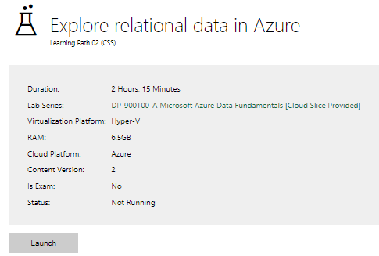

Completed lab | 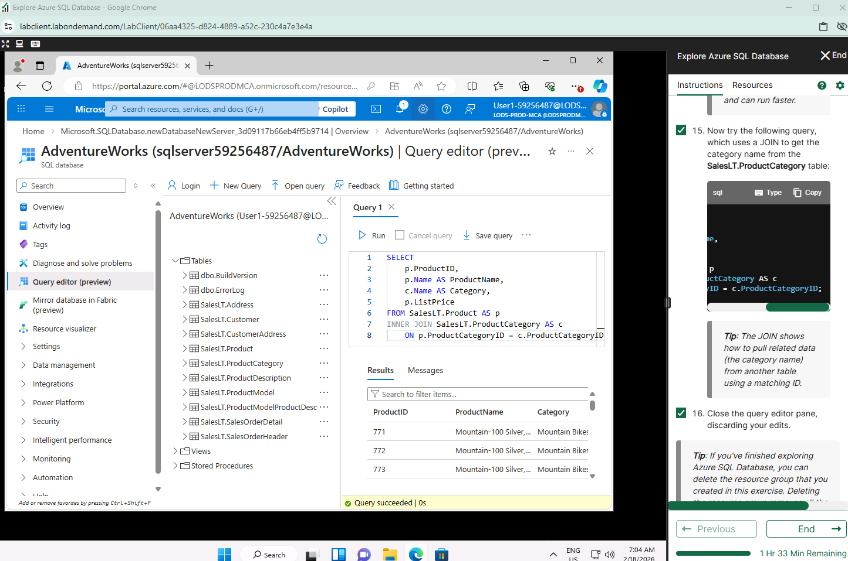

Day 3: Task 2

Please complete the below lab (4) ‘Explore non-relational data in Azure’ and paste evidence of the completed lab in the box provided.

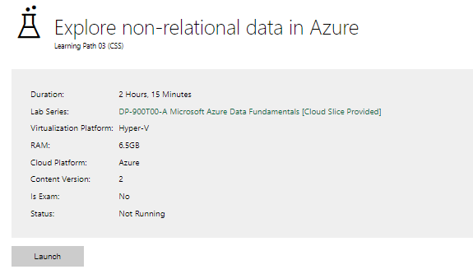

Completed lab | 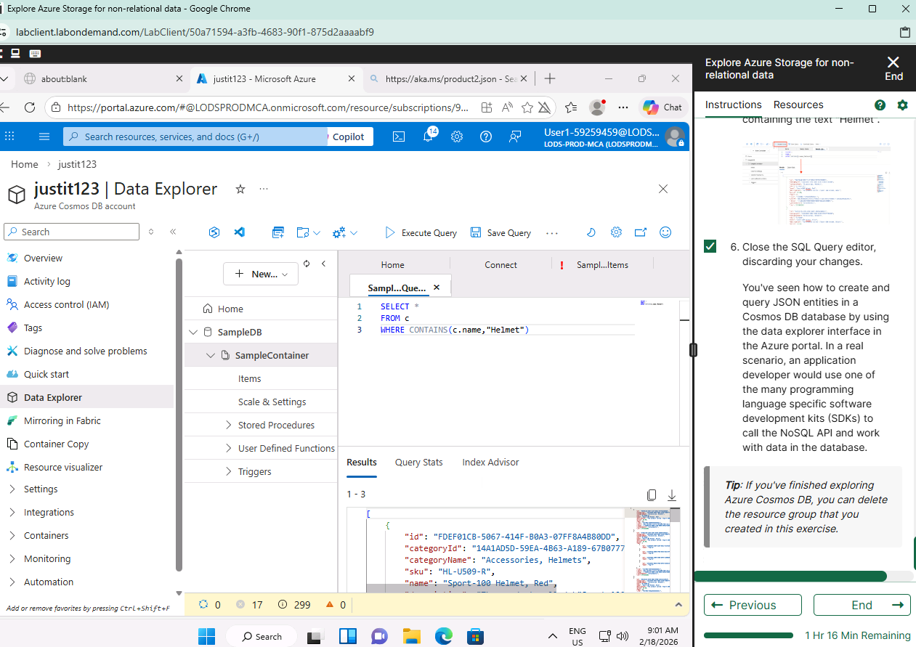

Day 3: Task 3

Please complete the below lab (5) ‘Explore data analytics in Azure’ and paste evidence of the completed lab in the box provided.

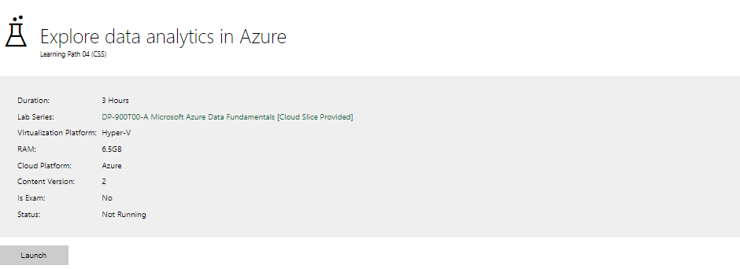

Completed lab | 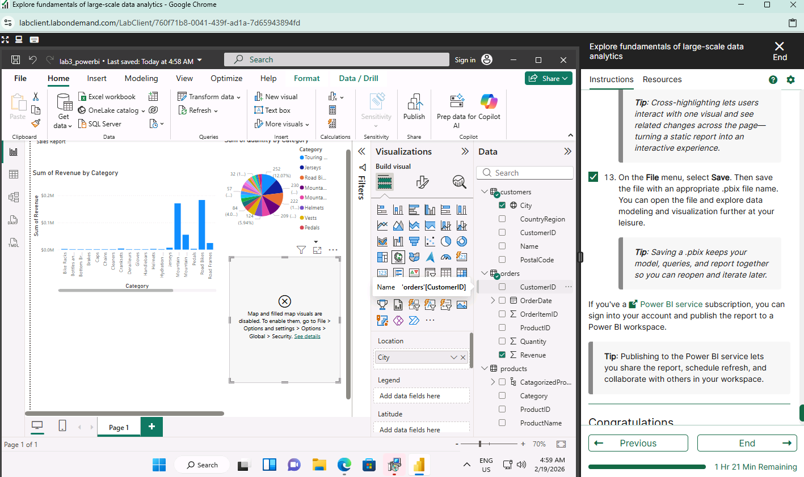

Day 4: Task 1

In your teams, complete the Azure DP-900 practice exam and paste your result below – this is open book and please research and discuss your answers as a team.

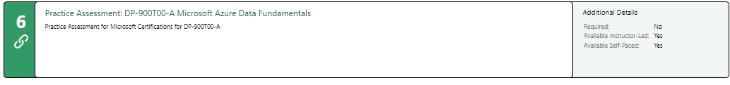
Result | 46/50 = 92%

Day 4: Task 2

1. Scenario Background
"Paws & Whiskers" is a growing pet shop that aims to improve its business by analysing sales, customer information, and inventory data. Currently, the data is collected manually or stored in spreadsheets. Management is interested in transitioning to Microsoft Azure to streamline data storage, analysis, and reporting, enabling them to make data-driven decisions.

2. Data Laws and Regulations
Identify and explain the data laws and regulations relevant to handling customer data within the proposal. Ensure you cover the following points:
- GDPR Compliance: Highlight the importance of adhering to the General Data Protection Regulation (GDPR), particularly as it relates to storing and processing customer information.
- Data Protection Act (DPA) 2018: Outline how the DPA 2018 may affect the way "Paws & Whiskers" collects and stores data, ensuring compliance with UK laws on data privacy.
- Other Industry Standards: Research any additional data protection standards or regulations that may apply to pet shop data, particularly if they involve sensitive or payment information.

3. Azure Service Recommendations
Recommend Microsoft Azure services that would suit the company’s data analysis needs and explain why these services are suitable. Your recommendations should include:
- Data Storage: Identify suitable storage options, such as Azure Blob Storage or Azure SQL Database, and discuss the benefits of each for storing large datasets, including inventory, sales transactions, and customer details.
- Data Analysis Tools: Recommend tools such as Azure Machine Learning for customer behaviour analysis or Azure Synapse Analytics for analysing sales trends.
- Data Integration and Automation: Explain how services like Azure Data Factory could automate data collection and integration processes, improving efficiency.

4. Data Types and Data Modelling
Define the types of data "Paws & Whiskers" will need to work with and describe your approach to data modelling:
- Data Categories: Identify key data types, such as customer demographics, transaction history, pet inventory, and product categories.
- Data Modelling Approach: Outline how you would structure this data using a relational model or a data warehouse approach, considering factors like tables, entities, relationships, and primary keys.

5. Data Storage Formats and Structures in Azure
Discuss how you would store data within Azure and the formats you would recommend:
- Data Formats: Specify recommended formats (e.g., CSV for raw data imports, JSON for structured data, Parquet for analytics) and explain why these formats are suitable for specific data types.
- Data Security and Encryption: Include recommendations for securing data using Azure’s built-in encryption features and access controls to ensure compliance with data privacy regulations.

6. Additional Considerations
Provide any other considerations that might enhance data handling and efficiency in Azure, such as:
- Backup and Disaster Recovery: Outline a backup plan using Azure Backup or Azure Site Recovery to safeguard against data loss.
- Data Visualisation: Discuss potential use of Power BI within Azure for creating dashboards that provide management with real-time insights into sales and customer trends.
- Future Scalability: Comment on how Azure services can scale as the business grows, accommodating larger datasets and more complex analyses.

Submission Guidelines:
- Structure: Ensure your report is well-organised, with sections for each task (e.g., Data Laws, Azure Services, Data Types, etc.).
- Formatting: Include headings, bullet points where appropriate, and any visuals or diagrams that support your explanations.
- References: Cite any resources or regulations referenced in the report.
- Length: Aim for 1500-2000 words.

Paws & Whiskers: Azure Data Modernisation Proposal

1. Introduction
“Paws & Whiskers” is a growing UK pet shop seeking to modernise its data management processes. The company maintains customer information along with sales transactions and inventory data through manual entry and spreadsheet documentation. The method prevents business growth because it creates opportunities for people to make mistakes and it blocks researchers from performing substantial data evaluations.
The proposal describes a Microsoft Azure solution which provides secure and expandable infrastructure to handle organized data storage and automated system connections and analytical processing and UK data protection regulations compliance.

2. Data Laws and Regulations
2.1 UK GDPR Compliance
As “Paws & Whiskers” processes personal data, compliance with UK GDPR is mandatory.
Key Principles
Lawfulness, Fairness, Transparency
Customers need to understand what happens to their collected data. The organization needs to use two legal bases for data processing which include contract execution for order management and customer marketing consent acquisition.
Purpose Limitation
The organization needs to use customer data only for its stated business functions which include running sales operations and operating loyalty programs.
Data Minimisation
The collection of data needs to be restricted to only what is essential for the process. Full card details should not be stored.
Accuracy
The organization needs to keep its customer database and business transaction records both accurate and up to date.
Storage Limitation
Organizations need to determine exact periods for keeping customer data through their customer data retention schedules.
Integrity and Confidentiality (Security)
The system requires technical security measures which protect data from unauthorized access and security system breaches.
Accountability
The organisation needs to show its compliance through:
- Policies
- Staff training
- Access logs
- Risk assessments
- Data processing documentation
Data Subject Rights
- Customers must be able to:
- Access their data
- Correct inaccuracies
- Request deletion (where lawful)
- Restrict processing

2.2 Data Protection Act (DPA) 2018
The DPA 2018 supports UK GDPR and requires:
- Clear governance structures
- Breach response procedures
- Organizations need to submit reports about major data breaches to the ICO through their system within 72 hours when such reporting becomes necessary
- Appropriate organisational and technical safeguards
Microsoft Azure acts as a data processor, but “Paws & Whiskers” remains the data controller and is ultimately responsible.

2.3 Additional Regulations
PCI DSS
If processing card payments, PCI DSS may apply. The recommended approach is to use a PCI-compliant payment gateway so cardholder data is not stored within Azure.
PECR
Marketing emails and electronic communications must comply with PECR, requiring clear consent and opt-out options.

3. Azure Service Recommendations
3.1 Data Storage
• Cost-effective
Azure SQL Database
• Structured relational database
• High availability
• Automatic backups
• Transparent Data Encryption (TDE)
• The system provides benefits to all users including customers and sales teams and their pets and their products and their suppliers.
Azure Blob Storage
• Scalable object storage
- The system accepts unprocessed data through this platform which functions as its entry point.
• The system enables users to work with CSV and JSON and Parquet file formats.
Recommended Architecture:
Raw Data (Blob) → Cleaned Operational Data (SQL) → Analytics Layer (Synapse/Power BI)

  - Data Integration
Azure Data Factory

- The system automatically extracts data from spreadsheet files and Point of Sale system output reports.
• The system performs all necessary ETL/ELT transformation operations.
- The system runs its daily pipelines through its automated scheduling system which operates every day.
• Reduces manual data handling errors
3.3 Analytics
Azure Synapse Analytics
- Data warehouse functionality
- Trend analysis
- Large-scale querying
- Integrates with Power BI
Azure Machine Learning (Future Phase)
- Demand forecasting
- Customer segmentation
- Product recommendations

4. Data Types and Data Modelling
4.1 Data Categories
- Customer demographics
- Sales transactions
- Pet inventory
- Product inventory
- Supplier information
- Store and operational data

4.2 Data Modelling Approach
Operational Model (Azure SQL)
Customers
CustomerID (PK), FirstName, LastName, Email, Phone, LoyaltyStatus, MarketingPreferences
Products
ProductID (PK), ProductName, Category, Price, Cost, SupplierID (FK)
Pets
PetID (PK), Species, Breed, Age, Price, SupplierID (FK)
Suppliers
SupplierID (PK), SupplierName, LeadTime
Stores
StoreID (PK), Location
SalesOrders
OrderID (PK), CustomerID (FK), StoreID (FK), OrderDate, TotalAmount
SalesOrderLines
OrderLineID (PK), OrderID (FK), ProductID (FK nullable), PetID (FK nullable), Quantity

Analytical Model (Star Schema)
FactSales
Links to:
- DimCustomer
- DimProduct
- DimPet
- DimSupplier
- DimStore
- DimDate
This structure improves performance and reporting clarity.

5. Data Storage Formats
CSV – Raw imports
JSON – Semi-structured integrations
Parquet – Optimised analytics format
Workflow:
Raw CSV → SQL Cleaning → Parquet for Analytics

6. Data Security and Encryption
To meet UK GDPR security requirements:
Encryption at rest – SQL TDE and Storage Encryption
Encryption in transit – TLS/HTTPS
Access control – Azure AD + RBAC
Network security – Private Endpoints, VNets
Monitoring – SQL Auditing, Azure Monitor, Log Analytics
Backup – Automated SQL backups + Geo-replication
Retention policies must define data lifecycle management.

7. Backup and Disaster Recovery
- Point-in-time restore
- Geo-redundant backups
- Defined RPO/RTO targets
- Regular testing of restoration procedures

8. Data Visualisation
Power BI dashboards can provide:
- Sales performance trends
- Customer purchasing behaviour
- Inventory alerts
- Profit margins
- Seasonal forecasting

9. Future Scalability
Azure supports:
- Increasing SQL compute tiers
- Expanding Blob Storage
- Adding new data sources
- Introducing AI models
- Supporting multi-store growth
This ensures long-term sustainability without infrastructure redesign.

10. Conclusion
Through the migration to Microsoft Azure, “Paws & Whiskers” can both modernise its data architecture while remaining compliant with UK GDPR and DPA 2018 regulations.
By implementing secure storage, automated integration, structured modelling, and high-scalability analytics, the company will gain operational efficiency, develop robust data governance, and enable data to support its future growth.
Through careful, responsible implementation including security controls, retention policies, and accountability documentation, the company will securely support customer trust and pass compliance audits.
References (Harvard Style)
European Union (2016) General Data Protection Regulation (EU) 2016/679.
GOV.UK (2018) Data Protection Act 2018. Available at: https://www.legislation.gov.uk
Information Commissioner’s Office (ICO) (2023) Guide to the UK GDPR. Available at: https://ico.org.uk
Information Commissioner’s Office (ICO) (2023) Guide to PECR.
PCI Security Standards Council (2022) PCI DSS Quick Guide.
Microsoft (2024) Azure Documentation – SQL, Blob Storage, Data Factory, Synapse.

Course Notes

It is recommended to take notes from the course, use the space below to do so, or use the revision guide shared with the class:

Additional Information

We have included a range of additional links to further resources and information that you may find useful, these can be found within your revision guide.

END OF WORKBOOK

Please check through your work thoroughly before submitting and update the table of contents if required.

Please send your completed work booklet to your trainer.

